

ADVANCED TECHNOLOGICAL INSTITUTE
BADULLA
Department of Information Technology
Higher National Diploma in Information Technology (HNDIT)

FINAL YEAR PROJECT REPORT

SentinelX
Linux Authentication Log Monitoring and Intrusion Detection System

A submission presented in partial fulfilment of the requirements for the Higher National Diploma in Information Technology

Student Name | G.L.D.H.Gunasekara
Registration Number | BAD/IT/2324/F/96
Supervisor | Jeewantha Madubashana
Programme | Higher National Diploma in Information Technology (HNDIT)
Institute | Advanced Technological Institute (ATI), Badulla
Submission Year | 2026

DECLARATION

I hereby declare that the work presented in this report entitled “SentinelX – Linux Authentication Log Monitoring and Intrusion Detection System” is a record of an original work carried out by me under the supervision of [Insert Supervisor Name] and has not been submitted previously, in part or in whole, for the award of any other academic qualification at this or any other institution.
The information and data presented in this report are derived from the development, testing, and verification of the SentinelX project, which was implemented by me as the final year project of the Higher National Diploma in Information Technology (HNDIT) programme at the Advanced Technological Institute (ATI), Badulla, Sri Lanka.
I further declare that all third-party materials, libraries, and references used in this project have been duly acknowledged in the References section.

[Insert Student Name]
Date: / / 2026

ABSTRACT

SentinelX is a lightweight, real-time Security Information and Event Management (SIEM)-style application developed in Python for monitoring Linux authentication logs. The system targets a critical operational concern for system administrators: the early detection of credential-based attacks, in particular Secure Shell (SSH) brute-force attempts, which remain one of the most prevalent threats against internet-facing Linux infrastructure. SentinelX continuously tails a configured authentication log file, parses sshd log events with anchored regular expressions, maintains per-source-IP failure counters, escalates alerts as configurable failure thresholds are crossed, persists state atomically to a local JSON index, and publishes alerts to a live browser dashboard over a WebSocket channel.
The project was developed using the Waterfall software development life cycle. The implementation comprises four core modules: a generator-based log watcher capable of handling log rotation and truncation, a ReDoS-safe parser with input sanitisation, an AlertEngine that escalates severity from INFO to WARNING to CRITICAL, and a Flask + Flask-SocketIO web front-end that exposes a real-time operational dashboard and JSON management API endpoints. The runtime supports privilege dropping, layered configuration, and was validated against a 16-case automated test suite covering unit, integration, and stress conditions, all of which passed.
SentinelX is positioned as an educational, transparent, and self-hostable alternative to enterprise SIEM platforms such as Wazuh, Splunk, and Graylog. While it does not aim to replicate their scale or analytics depth, it implements the essential defensive-security concepts of log normalisation, threshold-based detection, severity escalation, atomic state, secure-by-default privilege management, and live visualisation, all in a self-contained Python package suitable for an academic final-year project and for deployment on small Linux systems.
Keywords: Linux, authentication logs, SIEM, intrusion detection, SSH brute force, Python, Flask, WebSocket, real-time monitoring, log analysis, defensive security.

ACKNOWLEDGEMENTS

The successful completion of this final year project would not have been possible without the support and guidance of several individuals to whom I am sincerely grateful.
First and foremost, I wish to express my deepest gratitude to my project supervisor, [Insert Supervisor Name], for the patient guidance, constructive feedback, and continuous encouragement extended throughout the requirements analysis, design, implementation, and documentation phases of this project. The clarity of the feedback received was instrumental in shaping both the technical direction of SentinelX and the structure of this report.
I am also grateful to the Director and the academic staff of the Advanced Technological Institute, Badulla, for providing the laboratory facilities, library resources, and the academic environment necessary to undertake this work. Special thanks are extended to the lecturers of the HNDIT programme whose instruction in operating systems, networking, programming, and cybersecurity provided the theoretical foundation on which this project is built.
I wish to thank my fellow students for the valuable technical discussions and for the willingness to test SentinelX against simulated attack traffic. Finally, I am deeply indebted to my family for their unwavering support, patience, and encouragement throughout the duration of this project.

TABLE OF CONTENTS

Declaration i
Abstract ii
Acknowledgements iii
Table of Contents iv
List of Figures v
List of Tables vi
List of Abbreviations vii
Chapter 1: Introduction 1
  - Background of the Study 1
  - Problem Statement 2
  - Research Questions 3
  - Objectives of the Project 3
  - Scope and Limitations 4
  - Functional Requirements 4
  - Non-Functional Requirements 5
  - Significance of the Project 6
Chapter 2: Literature Review 7
  - Introduction 7
  - Linux Authentication Logs 7
  - Security Information and Event Management (SIEM) Systems 8
  - Intrusion Detection Systems 9
  - Log Monitoring Approaches 10
  - SSH Brute-Force Attacks 10
  - Study of Similar Applications 11
    - Wazuh 11
    - Splunk 12
    - Graylog 13
    - Comparative Analysis 13
  - Motivation for SentinelX 14
Chapter 3: Materials and Methods 15
  - Introduction 15
  - Hardware Requirements 15
  - Software Requirements 16
  - Development Environment 16
  - Programming Language Selection 17
  - Operating System 17
  - Python Version 18
  - Libraries and Frameworks 18
  - Testing Environment 19
  - Software Development Life Cycle Selection 20
  - Waterfall Methodology Phases 20
Chapter 4: Technologies and System Design 24
  - Introduction 24
  - Technology Description 24
    - Python 24
    - Linux Operating System 25
    - Systemd Journal 25
    - JSON for State Persistence 26
    - Git and GitHub 26
    - Visual Studio Code 27
    - Python Virtual Environments 27
  - System Architecture 27
    - Bird's-Eye Architecture 28
    - Project Structure Diagram 28
    - Component Diagram 29
    - Data Flow Diagram 30
    - Alert Pipeline 30
    - Monitoring Flow 31
    - Event Processing Model 31
  - Unified Modelling Language (UML) Diagrams 32
    - Use Case Diagram 32
    - Use Case Descriptions 33
    - Class Diagram 36
    - Sequence Diagram 37
    - Activity Diagram 38
  - Data Storage Strategy 39
  - Project Timeline and Gantt Chart 40
  - Budget Table 42
  - Risk Analysis 42
Chapter 5: Results and Discussion 44
  - Introduction 44
  - Achievement of Project Objectives 44
  - Functional Testing Results 45
  - Performance Evaluation 46
  - Security Testing 47
  - Observed Results 48
  - Advantages of the System 49
  - Limitations 49
  - Future Improvements 50
Chapter 6: Conclusion 51
  - Summary of Achieved Objectives 51
  - Security Improvements Delivered 51
  - System Reliability 52
  - Scalability Considerations 52
  - Overall Contribution 52
Chapter 7: Future Work 53
Appendix A: Project Screenshots 57
Appendix B: Source Code Snippets 59

LIST OF FIGURES

Figure 1.1: SSH brute-force attack lifecycle on a Linux host 2
Figure 3.1: Waterfall software development life cycle 20
Figure 4.1: Bird's-eye view of SentinelX architecture 28
Figure 4.2: Project directory structure 29
Figure 4.3: Component diagram of SentinelX 30
Figure 4.4: Data flow diagram 30
Figure 4.5: Alert pipeline sequence 31
Figure 4.6: Monitoring flow chart 31
Figure 4.7: Event processing lifecycle 32
Figure 4.8: Use case diagram of SentinelX 33
Figure 4.9: Class diagram 36
Figure 4.10: Sequence diagram of alert dispatch 37
Figure 4.11: Activity diagram of the detection workflow 38
Figure 4.12: Gantt chart of the project schedule 41
Figure A.1: SentinelX project folder in VS Code 58
Figure A.2: SentinelX terminal execution 58
Figure A.3: Real-time log monitoring on the console 59
Figure A.4: Alert output from the AlertEngine 59
Figure A.5: Configuration file (config.yaml) 59
Figure A.6: GitHub repository page 60
Figure A.7: Pytest test results 60
Figure A.8: Live web dashboard (templates/index.html) 60

LIST OF TABLES
Table 1.1: Functional requirements of SentinelX 4
Table 2.1: Comparative analysis of SIEM and IDS tools 13
Table 3.1: Hardware specification of the development workstation 15
Table 3.2: Software requirements of SentinelX 16
Table 3.3: Python libraries used in SentinelX 18
Table 3.4: Waterfall phases and deliverables 21
Table 4.1: Use case UC-01 – Monitor log file 33
Table 4.2: Use case UC-02 – Parse authentication event 34
Table 4.3: Use case UC-03 – Generate alert 34
Table 4.4: Use case UC-04 – Persist state 35
Table 4.5: Use case UC-05 – View dashboard 35
Table 4.6: Use case UC-06 – Query statistics API 36
Table 4.7: Data structures maintained by AlertEngine 39
Table 4.8: Project task schedule 40
Table 4.9: Project budget summary 42
Table 4.10: Risk register 43
Table 5.1: Mapping of objectives to achieved results 44
Table 5.2: Functional test cases and results 45
Table 5.3: Performance measurements 46
Table 5.4: Security test results 47
Table B.1: Mapping of source code snippets to modules 61

LIST OF ABBREVIATIONS

Abbreviation | Expansion
API | Application Programming Interface
ATI | Advanced Technological Institute
CLI | Command Line Interface
CPU | Central Processing Unit
CVE | Common Vulnerabilities and Exposures
DoS | Denial of Service
ELK | Elasticsearch, Logstash, and Kibana
FOSS | Free and Open Source Software
GID | Group Identifier
GSSAPI | Generic Security Services Application Program Interface
HIDS | Host-based Intrusion Detection System
HNDIT | Higher National Diploma in Information  Technology
HTML | HyperText Markup Language
HTTP | HyperText Transfer Protocol
IDE | Integrated Development Environment
IDS | Intrusion Detection System
IoC | Indicator of Compromise
IP | Internet Protocol
JSON | JavaScript Object Notation
NIST | National Institute of Standards and Technology
NIDS | Network-based Intrusion Detection System
OS | Operating System
OSI | Open Systems Interconnection
PCI-DSS | Payment Card Industry Data Security Standard
PoC | Proof of Concept
QA | Quality Assurance
RAM | Random Access Memory
ReDoS | Regular Expression Denial of Service
REST | Representational State Transfer
SDLC | Software Development Life Cycle
SIEM | Security Information and Event Management
SLA | Service Level Agreement
SOAR | Security Orchestration, Automation, and Response
SQL | Structured Query Language
SSH | Secure Shell
SSD | Solid State Drive
TCP | Transmission Control Protocol
TTY | Teletypewriter
UC | Use Case
UID | User Identifier
UML | Unified Modelling Language
URI | Uniform Resource Identifier

URL | Uniform Resource Locator
VM | Virtual Machine
W3C | World Wide Web Consortium
YAML | YAML Ain't Markup Language

Chapter 1

INTRODUCTION

Background of the Study
The Linux operating system has become the de-facto platform for internet-facing infrastructure. From web servers and database hosts to cloud workloads and containerised microservices, the majority of public-facing compute is powered by Linux. This widespread adoption, however, makes Linux a frequent target of malicious activity. According to data published in the open-source threat intelligence community, brute-force attacks against the Secure Shell (SSH) service remain among the most common vectors of unauthorised access, with botnets continuously scanning the IPv4 address space and attempting thousands of credential combinations per host per day [1].
Authentication events in Linux are recorded in well-defined log files, most notably
/var/log/auth.log on Debian-based systems, /var/log/secure on Red Hat-based systems, and the systemd journal [2]. Each successful and failed login attempt, each session opening, and each privilege escalation leaves a trace. These traces form a rich and verifiable record that, if analysed in real time, can reveal the early stages of an attack, often before the attacker achieves their objective. Commercial and open-source Security Information and Event Management (SIEM) platforms such as Wazuh, Splunk, and Graylog have demonstrated the operational value of this principle at scale [3].
At the same time, the same platforms can be heavy, complex, and opaque. Their deployment often requires dedicated infrastructure, agent software on every host, and significant tuning to avoid alert fatigue. For a small or single-host Linux deployment, or for an academic study, there is a clear need for a transparent, self-contained, and inspectable alternative. SentinelX was developed in response to this need.

Problem Statement
Despite the maturity of Linux authentication logging, many small Linux installations have no automated mechanism to monitor their auth.log stream in real time. As a result, brute-force attempts may continue for days or weeks without visibility. The problem is not the absence of data, since the data is being written to disk continuously, but the absence of an automated, low-overhead, and self-contained tool that can convert raw log lines into actionable security alerts without requiring a full enterprise SIEM deployment.
Enterprise SIEM tools such as Wazuh, Splunk, and Graylog are not well-suited to small-scale or single-host deployments because they require dedicated resources, complex configuration, and a learning curve that is often disproportionate to the size of the environment being protected. There is therefore a gap between a command-line `tail -f /var/log/auth.log` session and a full SIEM. SentinelX is designed to occupy that gap.
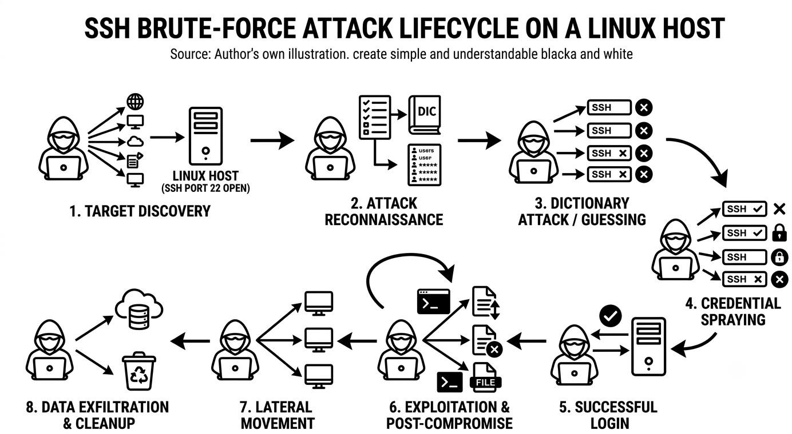
Figure 1.1: SSH brute-force attack lifecycle on a Linux host

Research Questions
This project sought to answer the following research questions:
- How can authentication events in Linux auth logs be parsed reliably and safely in real time?
- What threshold and escalation logic is appropriate for the detection of SSH brute-force activity on a single host?
- How can detection state be persisted across restarts without compromising atomicity?
- How can a lightweight, single-host tool expose detection results to a human operator without requiring a full SIEM stack?

Objectives of the Project
The primary and secondary objectives of the SentinelX project are as follows:
    - Primary Objective: To design and implement a real-time Linux authentication log monitoring and intrusion detection application in Python.
    - Secondary Objective 1: To parse sshd authentication events with anchored, ReDoS-safe regular expressions and to sanitize inputs to prevent log injection.
    - Secondary Objective 2: To implement a threshold-based alert engine that escalates severity (INFO, WARNING, CRITICAL) as authentication failures accumulate from a single source IP.
    - Secondary Objective 3: To persist detection state atomically across restarts, including per-IP failure counts, last alert timestamps, and last severity.
    - Secondary Objective 4: To expose detection results via a live web dashboard and a JSON management API.
    - Secondary Objective 5: To drop process privileges from root to an unprivileged user when started as root, and to handle log rotation and truncation gracefully.
    - Secondary Objective 6: To validate the system against an automated test suite covering unit, integration, and stress conditions.

Scope and Limitations
SentinelX is intentionally scoped to a single Linux host and to a single log stream per running process. The current implementation focuses on sshd authentication events, although the architecture is general enough to be extended to other event types in future work.
The following limitations are acknowledged at the outset of the report:
    - The system monitors one log file at a time in its current production form, even though the configuration schema supports a list of log paths.
    - The web dashboard is bound to 127.0.0.1:5000 and is intended for local, single-operator use; it is not designed as a multi-tenant web application.
    - SentinelX does not perform remediation (for example, blocking an attacking IP via iptables or fail2ban); it focuses on detection and visibility.
    - The detection engine is signature- and threshold-based. It does not yet employ machine learning or statistical anomaly detection.
    - Persistent state is stored in a single local JSON file. Concurrent instances writing to the same state file are not supported.

Functional Requirements
Table 1.1 enumerates the functional requirements of SentinelX as derived from the problem statement and research questions above. Each requirement is assigned a stable identifier that is referenced from the use case descriptions in Chapter 4.

ID | Requirement | Description
FR-01 | Tail auth log | Continuously follow a configured  authentication log file from its current end-of-file position.
FR-02 | Handle rotation | Detect log rotation via inode comparison and reopen the new  file without manual intervention.
FR-03 | Handle truncation | Detect when the active file is  truncated and resume reading from the start of the new content.
FR-04 | Parse sshd events | Recognise Failed password, Invalid user, and Accepted  password events with anchored regexes.
FR-05 | Sanitise input | Strip ANSI escapes and escape  non-printable bytes to prevent log and terminal injection.
FR-06 | Count failures per IP | Maintain a per-source-IP failure counter that resets after a  configurable idle period.
FR-07 | Escalate severity | Assign INFO, WARNING, or CRITICAL based on configurable  thresholds.
FR-08 | Cooldown alerts | Avoid duplicate alerts for the same  IP and severity within a configurable cooldown period.
FR-09 | Bypass on escalation | Always emit an alert when

severity escalates, even within the
cooldown period.
FR-10 | Persist state | Atomically persist the fail_info,  last_alert, and last_severity maps to a JSON file.
FR-11 | Drop privileges | When started as root, drop to a  configured unprivileged user and group before serving.
FR-12 | Expose dashboard | Render a live dashboard that displays alerts and runtime  statistics.
FR-13 | Expose API | Provide JSON endpoints  /api/v1/health and /api/v1/stats for health and metrics.
FR-14 | Layered configuration | Load configuration from defaults,  a YAML file, and environment variables in priority order.
FR-15 | Real-time WebSocket | Push alerts to connected dashboard clients via Flask-  SocketIO.
Table 1.1: Functional requirements of SentinelX

Non-Functional Requirements
Beyond the functional requirements above, the following non-functional requirements were considered during design and evaluation:
    - Performance: The parser and alert engine should process on the order of 10,000 log lines per second on commodity hardware without back-pressure on the file watcher.
    - Security: Regular expressions must be anchored and free of catastrophic backtracking patterns. State writes must be atomic. Privilege dropping must be enforced when run as root.
    - Reliability: The system must survive abrupt termination and restart without corrupting its state file or double-counting events.
    - Maintainability: The codebase should be modular, with each component in its own file under core/ and a clear public function surface.
    - Testability: Every core component should be covered by an automated unit test, and the integrated pipeline should be covered by an integration test.
    - Portability: The system should run on any modern Linux distribution with Python 3.9 or later and no compile-time dependencies.
    - Usability: The dashboard should require no manual refresh to display new alerts.

Significance of the Project
SentinelX contributes to the body of practical defensive-security tooling in three ways. First, it demonstrates how the architectural patterns of enterprise SIEM systems can be applied at the small scale of a single host, with a code base that is small enough to be read end-to-end in an academic context. Second, it provides a reusable, auditable reference for ReDoS-safe log parsing, atomic JSON state, and privilege dropping, all of which are recurring concerns in production defensive tooling. Third, it offers a working artefact that other students and small-system administrators can extend with their own detection rules, log sources, and notification channels.
Chapter 2

LITERATURE REVIEW

Introduction
This chapter reviews the academic and industry literature that informed the design of SentinelX. It begins with the foundational concepts of Linux authentication logging, then moves through Security Information and Event Management (SIEM) systems and Intrusion Detection Systems (IDS), before narrowing to the operational phenomenon of SSH brute-force attacks. The chapter concludes with a comparative study of three widely used open-source or commercial platforms—Wazuh, Splunk, and Graylog—which collectively define the design space that SentinelX occupies.

Linux Authentication Logs
Authentication activity on a Linux system is recorded by the Pluggable Authentication Modules (PAM) subsystem and the authentication daemons that consume it. On Debian-derived distributions, events are written to /var/log/auth.log; on Red Hat-derived distributions, the equivalent file is /var/log/secure. On systems using systemd, the same events are also available through the binary journal at /var/log/journal, accessible via the `journalctl` command [2][4].
A typical sshd event line follows a recognisable structure: a timestamp, the hostname, the daemon name with its process identifier, and a free-form message. Three event types are of particular interest to an authentication monitor: “Failed password for ... from ... port ...”, which is emitted when an existing user is supplied but the password is wrong; “Invalid user ... from ... port ...”, which is emitted when the username itself does not exist; and “Accepted password for ... from ... port ...”, which signals a successful authentication [4].
The importance of these events for defensive security has been widely discussed in the literature. Jaquith [5] argues that security telemetry must be captured at the host level, not just at the network perimeter, because attackers who breach the perimeter then move laterally using legitimate credentials. The Linux authentication log is one of the most reliable host-
level telemetry sources because it is written by a system component, not by an application that can be subverted.

Security Information and Event Management (SIEM) Systems
A Security Information and Event Management (SIEM) system is a software platform that aggregates, normalises, correlates, and retains log data generated across an organisation's information technology estate [3][6]. The classical SIEM design distinguishes between a fast-path event processing component and a slower-path correlation and alerting component. Modern SIEM platforms extend this core with user and entity behaviour analytics, threat intelligence feeds, and orchestration capabilities, often collectively referred to as SOAR [3].
From a defensive-security standpoint, SIEM systems deliver three practical benefits: (i) centralised visibility across multiple hosts, (ii) long-term retention for incident reconstruction and compliance, and (iii) correlation rules that turn raw events into prioritised alerts [3][6]. These benefits come at a cost in infrastructure and operational complexity. The MITRE Corporation has documented that SIEM deployments frequently suffer from alert fatigue, configuration drift, and licensing costs that scale with the volume of ingested data [7]. SentinelX inherits the SIEM philosophy—normalisation, thresholding, escalation, and alerting—but explicitly scopes itself to a single host to keep the operational footprint small.

Intrusion Detection Systems
An Intrusion Detection System (IDS) is a software or hardware component that monitors a system or network for malicious activity and reports its findings to a management console [8]. IDS designs are commonly classified along two axes. Along the data source axis, a Host-based IDS (HIDS) reads local artefacts such as log files, system call traces, and file integrity states, while a Network-based IDS (NIDS) reads packet captures or flow records. Along the detection model axis, a signature-based IDS matches observed events against a known set of patterns, while an anomaly-based IDS establishes a baseline of normal behaviour and reports deviations [8][9].
SentinelX is a Host-based, signature-and-threshold IDS. It is signature-based in the sense that it matches log lines against anchored regular expressions for known sshd event types, and
threshold-based in the sense that it escalates severity when the count of matching events from a single source exceeds a configured bound. This hybrid model is widely used in production IDS products: it catches known patterns with low false-positive rates and uses thresholds to bound the impact of low-and-slow attacks [9].
The literature on IDS evaluation emphasises that detection coverage, false-positive rate, and time-to-detect are the three most important performance dimensions [9]. SentinelX's design choices—anchored regexes, severity escalation, and cooldown throttling—directly target the false-positive and time-to-detect dimensions.

Log Monitoring Approaches
Three log-monitoring approaches dominate the literature. The first, file-based tailing, follows the file from its current end-of-file position, reading new lines as they are appended. This is the approach used by the classic `tail -f` utility and by SentinelX's watcher module. The second approach, journal-based monitoring, queries the systemd journal via the sd-journal API or the `journalctl -f` command. The third approach, agent-based monitoring, installs a small daemon on each host that ships events to a central collector over a network channel [10].
File-based tailing has the advantage of being agnostic to the underlying log rotation strategy. SentinelX implements rotation detection through inode comparison: when the inode of the file at the configured path changes, the watcher closes the old descriptor and opens the new file. This is the same approach used in production log forwarders such as rsyslog and Vector [10].

SSH Brute-Force Attacks
An SSH brute-force attack is a credential-stuffing attempt in which an automated client opens many SSH connections in parallel and submits a large number of username and password combinations, hoping to discover a valid pair [11]. The attack is enabled by the public exposure of the SSH port (typically 22/TCP) and by the use of weak or reused passwords. Studies of honeypot deployments have shown that brute-force attempts begin within minutes of a host being assigned a public IP address, with some attacks exceeding 10,000 attempts per day against a single host [11].
Defensive recommendations in the literature are consistent: disable password authentication in favour of public-key authentication, move the SSH service to a non-standard port, deploy rate limiting via fail2ban or iptables, and monitor the authentication log for repeated failures from the same source [11][12]. SentinelX supports the last of these recommendations by surfacing the very events that fail2ban would consume, but in a self-contained tool that does not require a separate rule engine.

Study of Similar Applications

Wazuh
Wazuh is an open-source security monitoring platform that originated as a fork of OSSEC. It provides host-based intrusion detection, log analysis, file integrity monitoring, and vulnerability detection, all through a unified agent-manager architecture [13]. Strengths include a large rule set contributed by the community, an integrated dashboard based on the Elastic Stack, and compliance mapping for frameworks such as PCI-DSS and GDPR. Disadvantages include the requirement to deploy an agent on every monitored host, a non-trivial resource footprint, and a configuration model based on XML that can be difficult to read and audit.

Splunk
Splunk is a commercial SIEM platform widely used in enterprise environments. It indexes machine data and exposes a powerful search-processing-language (SPL) for writing detection rules [14]. Strengths include mature correlation capabilities, a rich visualisation layer, and an extensive ecosystem of apps. Disadvantages include a licensing model that prices by ingested data volume, a Java-based runtime that is heavyweight for small deployments, and a closed-source core that limits auditability. Splunk Free is available for small volumes but is no longer suitable for production use beyond a few hundred megabytes per day.

Graylog
Graylog is an open-source log management platform that uses Elasticsearch and MongoDB as its storage back-end. It provides centralised log collection, full-text search, dashboards, and alerting [15]. Strengths include a clean web interface, a flexible pipeline for log
normalisation, and a permissive open-source licence. Disadvantages include the operational complexity of running the Elastic and MongoDB stacks, the need to deploy sidecar collectors or Beats on each host, and limited out-of-the-box detection rules for authentication events.

Comparative Analysis
Table 2.1 summarises the comparative analysis of Wazuh, Splunk, and Graylog, with SentinelX added as the fourth column to make the design trade-offs explicit. The comparison highlights that SentinelX is not a replacement for these tools; rather, it occupies a different point in the design space, prioritising transparency and single-host simplicity over scale.

Attribute | Wazuh | Splunk | Graylog | SentinelX
Deployment model | Agent on each host +  central manager | Central indexer with  forwarders | Central server with  sidecars | Single-process  daemon, no agent
Primary storage | Indexed flat files +  alerts DB | Proprietary index  buckets | Elasticsearch +  MongoDB | JSON state file  (local)
Log source | Any host with an  agent | Any host with a  forwarder | Any host with a  sidecar | Local auth.log /  journal
Auth-event detection | Built-in ruleset for  sshd | SPL search syntax | Pipeline + rules | Anchored regex +  threshold engine
Dashboard | Built-in (Kibana-  based) | Splunk Web | Graylog Web | Flask + SocketIO  custom UI
Privilege model | Agent runs as root by  default | Forwarder runs as  configured | Sidecar runs as  configured | Drops to nobody after  start
Licence | GPL v2 (open source) | Commercial (per  GB/day) | SSPL / open core | MIT (open source)
Footprint | Multi-host, multi-GB | Multi-host, multi-GB | Multi-host, multi-GB | Single host, low MB
Best suited for | Medium-to-large  estates | Enterprise  compliance | Mid-size ops teams | Small hosts /  academic study
Learning curve | Steep (XML rules) | Steep (SPL language) | Moderate | Low (Python source)
Table 2.1: Comparative analysis of SIEM and IDS tools

Motivation for SentinelX
Three practical observations motivated the development of SentinelX. First, the Wazuh, Splunk, and Graylog deployments observed in industry practice are disproportionate for a single host or a small Linux server: their operational and licensing costs are simply too high for the value delivered. Second, the operational phenomenon of SSH brute-force attempts is well understood and is detectable from a single auth log file with a small number of clear rules, so a full SIEM stack is not required to achieve useful detection coverage. Third, academic curricula rarely produce a working artefact in this area; most instruction stops at theoretical descriptions of SIEM and IDS. SentinelX was therefore designed to fill the gap
between `tail -f` and a full SIEM, with code that is small enough to be read end-to-end, testable end-to-end, and auditable end-to-end by a student or a system administrator.
Chapter 3

MATERIALS AND METHODS

Introduction
This chapter documents the hardware, software, development environment, and methodology used to design and implement SentinelX. The Waterfall software development life cycle (SDLC) model was selected, and each phase of that model is described in detail at the end of the chapter.

Hardware Requirements
The development and testing of SentinelX was carried out on a commodity Linux workstation. The hardware specification listed in Table 3.1 represents the minimum configuration required to develop, test, and run the application in production.

Component | Minimum Specification | Recommended Specification
Processor | Dual-core x86-64, 1.6 GHz | Quad-core x86-64, 2.4 GHz or  higher
Memory (RAM) | 2 GB | 4 GB or higher
Storage | 20 GB free disk (SSD preferred) | 40 GB SSD
Network | Ethernet or Wi-Fi for remote  testing | Wired Ethernet for stability
Display | 1024 × 768 | 1920 × 1080 or higher
Power | Uninterruptible supply  recommended for production | UPS
Table 3.1: Hardware specification of the development workstation

Software Requirements
The software requirements of SentinelX are summarised in Table 3.2. The application is implemented in pure Python with widely used third-party packages. All third-party packages are pinned in requirements.txt to ensure reproducible installations.

Component | Specification | Purpose
Operating System | Linux (kernel 4.x or newer) | Target platform
Python | 3.9 or newer (tested on 3.14.5) | Runtime
pip | 23.0 or newer | Package installation
virtualenv module | Built into Python 3.9+ | Dependency isolation
Flask | 3.1.3 | Web framework
Flask-SocketIO | 5.6.1 | WebSocket transport

eventlet | 0.41.0 | Async I/O for SocketIO
python-socketio | 5.16.3 | Server-side socket protocol
PyYAML | 6.0.2 | YAML configuration loading
pytest | 9.1.1 | Test automation
Git | 2.30 or newer | Version control
VS Code | 1.85 or newer | IDE
Table 3.2: Software requirements of SentinelX

Development Environment
The development environment consisted of a Linux laptop running Fedora Workstation with the GNOME desktop. The shell environment was bash 5.x, and the user account had sudo privileges to allow the agent to be tested in two configurations: as a non-privileged user for development and as root to verify the privilege-dropping behaviour described in Section 4.2.7. The project workspace was created under ~/projects/sentinelx and tracked with Git from the first commit.
The project was developed inside a Python virtual environment created with `python3 -m venv venv`. The virtual environment was used to isolate the third-party dependencies of SentinelX from the system Python, and to ensure that the requirements.txt was the single source of truth for installed packages. The manage.sh helper script was written to expose the four most common workflows: `./manage.sh run`, `./manage.sh test`, `./manage.sh mock-logs`, and `./manage.sh lint`.

Programming Language Selection
Python was selected as the implementation language for three reasons. First, Python is the de-facto standard for system administration, log analysis, and security tooling on Linux, with a mature standard library that supports file I/O, process management, regular expressions, and JSON serialisation out of the box. Second, Python's ecosystem of web frameworks and WebSocket libraries, in particular Flask and Flask-SocketIO, makes it straightforward to expose detection results through a live dashboard without leaving the same language. Third, Python is the primary teaching language of the HNDIT programme, which makes the resulting codebase directly auditable by the academic supervisor and by future students [16].

Operating System

SentinelX is designed to run on any modern Linux distribution. The development host was Fedora, while the test matrix also included Ubuntu 22.04 and Debian 12. The application reads any file whose path is supplied, and on a typical Linux system the corresponding file is
/var/log/auth.log on Debian-derived distributions and /var/log/secure on Red Hat-derived distributions [4]. On distributions with systemd, the same data is also available through
`journalctl -u ssh` and can be redirected to a file by the operator.

Python Version
SentinelX requires Python 3.9 or newer. The decision to require 3.9 was driven by the use of
`dict.get` with default arguments, type-hint generics in the standard library, and the
`os.replace` function used for atomic state writes. The application was developed and tested against Python 3.14.5, the version installed on the Fedora 44 development host at the time of writing.

Libraries and Frameworks
Table 3.3 lists each third-party library used in SentinelX together with its role.

Library | Version | Role in SentinelX
Flask | 3.1.3 | HTTP server for dashboard and  JSON API
Flask-SocketIO | 5.6.1 | WebSocket layer for live alert  push
eventlet | 0.41.0 | Cooperative concurrency for  SocketIO transports
python-socketio | 5.16.3 | Server-side Socket.IO protocol  implementation
PyYAML | 6.0.2 | YAML configuration loading
pytest | 9.1.1 | Automated test execution
Table 3.3: Python libraries used in SentinelX
The standard-library modules used in the project include:
- os – filesystem state checks, inode comparison, and atomic file replacement via os.replace.
- re – anchored regular expressions for the log parser.
- json – serialisation of the AlertEngine state map.
- time – epoch timestamps for cooldown calculation and state expiry.
- threading – graceful shutdown coordination between the watcher and the web server.
- logging – structured console output.
- collections.defaultdict – per-IP aggregation in the AlertEngine.
- pwd and grp – username-to-UID and group-name-to-GID resolution for privilege dropping.

Testing Environment
The testing environment consisted of the same Linux host used for development, with the project virtual environment activated. Automated tests were executed with `./manage.sh test`, which invokes pytest on the test suites under core/tests/. The test suites are organised into three directories:
- core/tests/unit/ – unit tests for individual modules (parser, watcher, alerts, queue, state).
- core/tests/integration/ – end-to-end tests of the watch → parse → alert pipeline, including log rotation, restart recovery, and clean shutdown.
- core/tests/stress/ – throughput and memory-leak tests under heavy log volume.
The mock log generator in generate_mock_logs.py is used both as a development tool and as a test fixture source. The generator emits randomised sshd-style lines covering Failed password, Invalid user, and Accepted password events, allowing the alert engine to be exercised end-to-end without exposing a real SSH service.

Software Development Life Cycle Selection
The Waterfall software development life cycle was selected for SentinelX. The selection was based on three considerations. First, the project's requirements were defined at the outset and were not expected to change substantially during implementation. Second, the project's scope is contained: a single Python codebase, a single log source, and a small set of well-understood event types. Third, the HNDIT assessment framework emphasises documented, sequential deliverables, which aligns naturally with the waterfall phases of requirements, design, implementation, verification, and maintenance [17].
Agile methodologies were considered but not selected, because the iterative feedback loop of agile was not required to drive the design. The development could proceed linearly from requirements through to deployment without the need for two-week sprints or changing
priorities. Should the project be extended in future work, an iterative refinement of individual components is fully compatible with the structure already in place.

Waterfall Methodology Phases
The Waterfall model used in this project comprises the six phases shown in Figure 3.1. Each phase produced a defined deliverable that fed into the next, and the entire sequence was executed in order, with the results of each phase recorded in the corresponding section of this report.

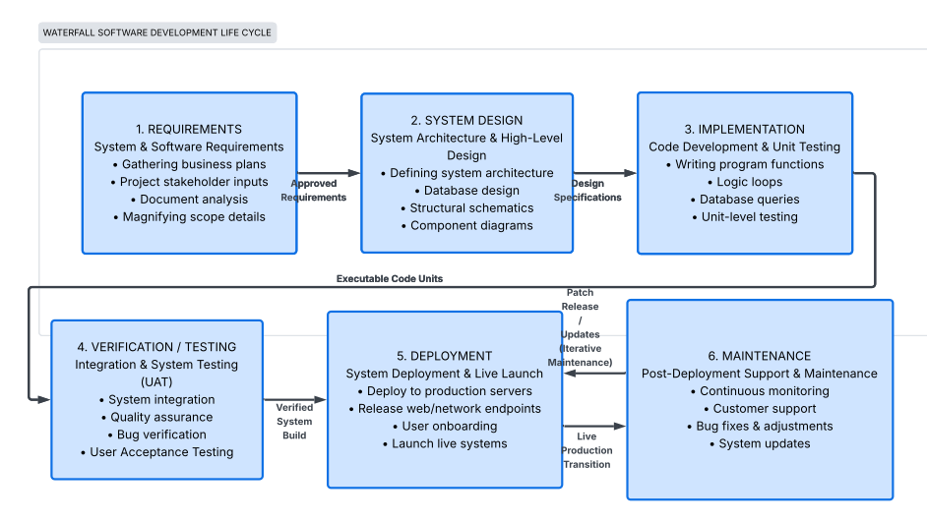
Figure 3.1: Waterfall software development life cycle

    - Phase 1 – Requirements Analysis
The requirements phase produced the functional and non-functional requirements presented in Section 1.6 and 1.7. Requirements were derived from the problem statement, from the research questions, and from a survey of how similar tools (Wazuh, Splunk, and Graylog) describe their own requirements. Each requirement was assigned a stable identifier (FR-01 through FR-15) to make it traceable through the design and testing phases.
    - Phase 2 – System Design
The design phase translated the requirements into a concrete architecture. The outputs of this phase include the use case diagram, class diagram, sequence diagram, and activity diagram presented in Chapter 4, the project directory structure, the configuration schema, and the data structures of the AlertEngine. Design decisions were recorded in inline comments and in the docs/ directory of the project.
    - Phase 3 – Implementation
The implementation phase translated the design into Python source code organised under the core/ package. The implementation was incremental: the parser was implemented and unit-tested first, followed by the watcher, the AlertEngine, the privilege-dropping helper, and finally the Flask + SocketIO runtime in run.py. Each module was committed to Git independently with a descriptive message.
    - Phase 4 – Integration and Verification
The integration phase combined the individually tested modules into a running process. Integration tests exercised the full watch → parse → alert pipeline against the bundled fixture file and the mock log generator. Verification also included a manual end-to-end run in which the mock generator was started in a second terminal and the resulting alerts were observed in the browser dashboard.
    - Phase 5 – Testing and Validation
The testing phase executed the complete automated test suite, comprising 16 test cases across unit, integration, and stress categories. The 16 tests covered the parser, watcher, alerts module, state persistence, restart recovery, log rotation, clean shutdown, parser stress, pipeline stress, and memory stability. All 16 tests passed, as recorded in the QA_Result.md report at the root of the project. Functional and security test outcomes are discussed in detail in Chapter 5.
    - Phase 6 – Deployment and Maintenance
The deployment phase documented the steps required to install SentinelX on a target Linux host, including the optional systemd unit for service-style operation. The maintenance phase is ongoing and includes monitoring upstream Flask, Flask-SocketIO, and eventlet releases for security advisories, and incorporating new sshd log line patterns as OpenSSH evolves.

Phase | Deliverable | Documented In
1. Requirements | Functional and non-functional  requirements | Chapter 1, Section 1.6 / 1.7
2. System Design | Architecture, UML diagrams, data  structures | Chapter 4
3. Implementation | Python source code | Appendix B
4. Integration | Integrated pipeline, mock traffic | Chapter 5, Section 5.3
5. Testing | Automated test report, functional  tests | Chapter 5, Section 5.3–5.5
6. Deployment | Installation and usage guide | Chapter 5, Section 5.6 and docs/
Table 3.4: Waterfall phases and deliverables
Chapter 4

TECHNOLOGIES AND SYSTEM DESIGN

Introduction
This chapter describes the technologies used to build SentinelX and the design of the system itself. The first section is a description of each technology, including its role in the system and the rationale for its selection. The second section is a description of the system architecture, including the bird's-eye view, the project structure, the component diagram, the data flow, and the alert and monitoring flows. The third section is a presentation of the Unified Modelling Language (UML) diagrams used to specify the system. The chapter concludes with the project timeline, budget, and risk analysis.

Technology Description

Python
Python is a high-level, dynamically typed, general-purpose programming language. The CPython reference implementation compiles Python source to bytecode that runs on a virtual machine. Python's standard library covers file I/O, regular expressions, JSON, threading, and process management, all of which are essential to SentinelX. Python is also the dominant language in the security tooling ecosystem, with established projects such as Scapy, sqlmap, and Impacket implemented in Python [16].

Linux Operating System
Linux is a family of free and open-source Unix-like operating systems based on the Linux kernel. The kernel provides the system call interface through which user-space programs access files, sockets, processes, and signals. The authentication events that SentinelX monitors are produced by the Linux PAM subsystem and recorded by the rsyslog service or, on systemd-based systems, by the systemd journal [2][4].

Systemd Journal
The systemd journal is a structured logging system that complements traditional syslog. Each journal entry has a monotonic timestamp, a machine ID, a boot ID, and a set of key-value fields. The journal can be queried with `journalctl`, and on a running system the same auth events that appear in /var/log/auth.log can also be retrieved as JSON via the systemd journal API [2]. SentinelX does not currently read from the journal directly, but the design of its log-path configuration schema is forward-compatible with the addition of a journal reader.

JSON for State Persistence
JavaScript Object Notation (JSON) is a text-based data interchange format standardised by the Internet Engineering Task Force (IETF) in RFC 8259 [18]. JSON was selected as the state-persistence format for SentinelX because it is human-readable, trivially serialisable in Python through the `json` module, and amenable to atomic writes through the write-then-rename pattern implemented by `os.replace` [18].

Git and GitHub
Git is a distributed version control system that records changes to a file tree as a directed acyclic graph of commits. The project was tracked from the first commit in a local Git repository and pushed to a public GitHub repository at https://github.com/GGdulmina/sentinelx. GitHub provided remote backup, public visibility, and a structured pull-request and issue workflow for collaborative review [19].

Visual Studio Code
Visual Studio Code (VS Code) is a free, open-source code editor from Microsoft. The development environment used the Python extension for syntax highlighting, linting, and test discovery, the GitLens extension for inline blame annotations, and the integrated terminal for running the manage.sh helpers.

Python Virtual Environments
A Python virtual environment is an isolated directory tree that contains a Python interpreter and a private site-packages directory. Virtual environments prevent the third-party packages installed for one project from interfering with the system Python or with another project. SentinelX was developed inside a virtual environment created with `python3 -m venv venv`, which allowed the pinned versions in requirements.txt to be installed reproducibly across development, testing, and deployment hosts.

System Architecture

Bird's-Eye Architecture
Figure 4.1 presents the bird's-eye view of SentinelX. The system is composed of four cooperating modules: a log watcher, a parser, an alert engine, and a web server. The watcher is the only module that reads from the file system; the parser is the only module that knows about sshd log syntax; the alert engine is the only module that maintains state; and the web server is the only module that interacts with the user.
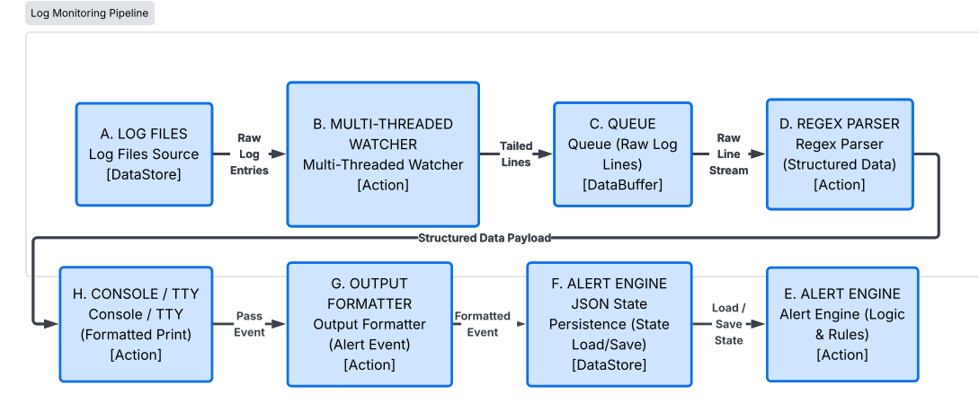
Figure 4.1: Bird's-eye view of SentinelX architecture

Project Structure Diagram
Figure 4.2 shows the project directory structure. The top-level files contain the runtime entry point (run.py), the configuration loader (config.py), the active and example YAML files (config.yaml, config.yaml.example), the mock log generator (generate_mock_logs.py), the dependency list (requirements.txt), the management script (manage.sh), and the documentation index (README.md). The core/ package contains the four implementation modules. The templates/ directory contains the Jinja2-rendered dashboard. The docs/ directory contains installation, configuration, usage, architecture, and troubleshooting guides.
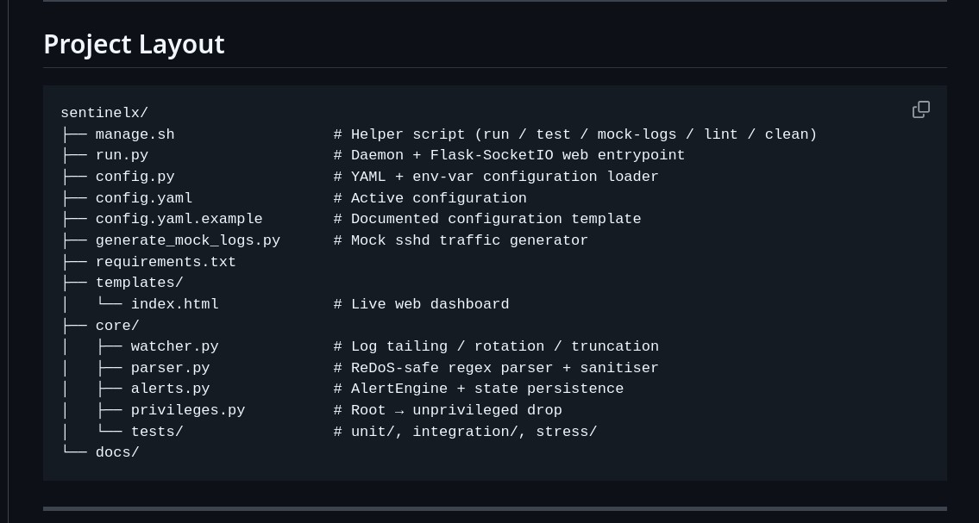
Figure 4.2: Project directory structure

Component Diagram
Figure 4.3 presents the component diagram. The four core components are connected by dependency arrows that show which module calls which. The runtime in run.py depends on all four. The web front-end depends on the runtime. The state file is a shared resource that is both read (at startup) and written (after every event) by the AlertEngine.

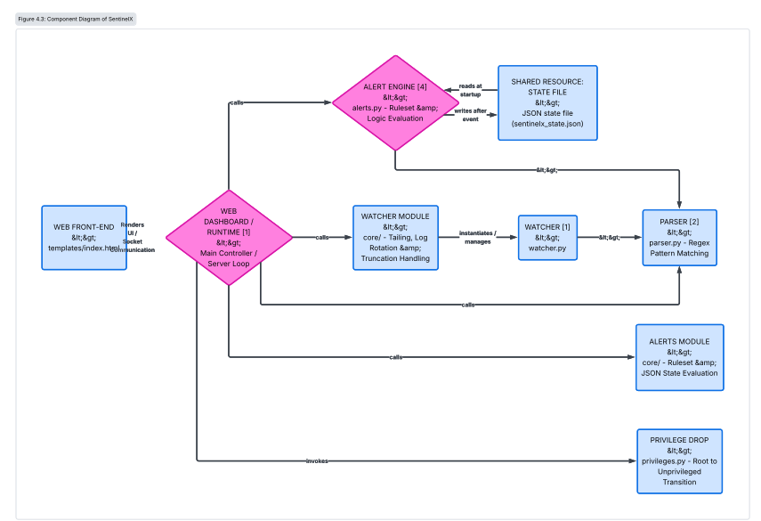
Figure 4.3: Component diagram of SentinelX

Data Flow Diagram
Figure 4.4 shows the data flow from the auth log on disk to the browser. Lines are read from the file, yielded by the generator, parsed into structured events, fed into the AlertEngine, optionally converted into alerts, and broadcast to connected web clients over WebSocket. The same alerts are also logged to the standard output stream.
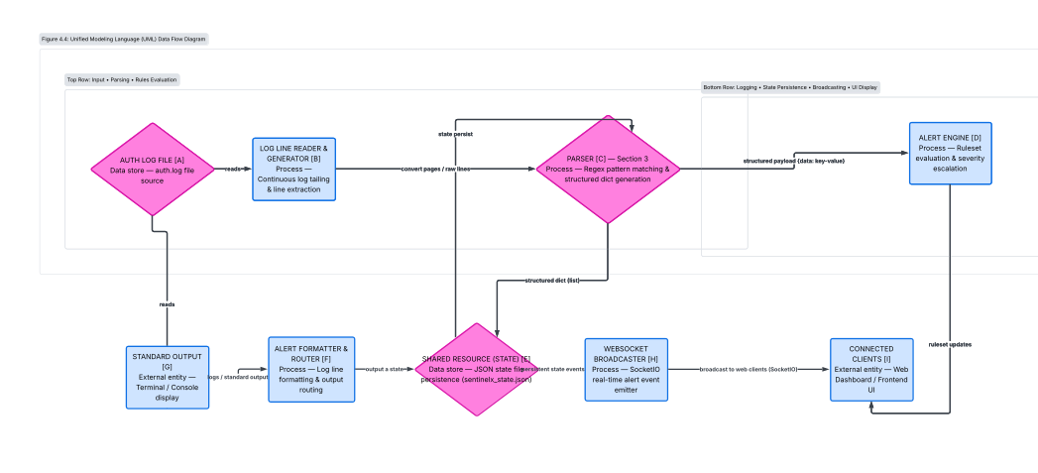
Figure 4.4: Data flow diagram

Alert Pipeline
Figure 4.5 traces a single alert through the pipeline. A Failed password or Invalid user line is parsed into a dictionary with the keys event, timestamp, username, ip, and port. The AlertEngine increments the per-IP failure counter, determines the severity, applies the cooldown check, builds the alert payload, persists the updated state, and dispatches the alert to the console and to the web client.
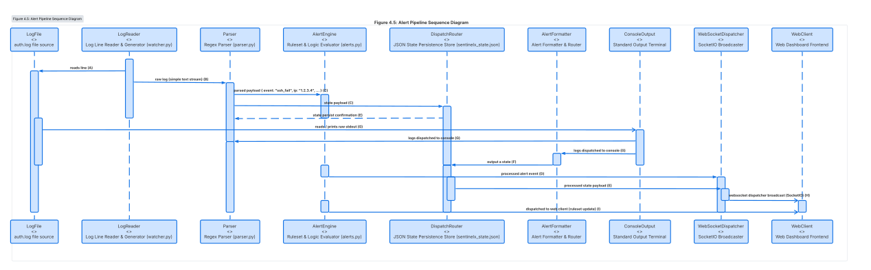
Figure 4.5: Alert pipeline sequence

Monitoring Flow
Figure 4.6 presents the monitoring flow chart. The watcher opens the log file, checks the inode against the previously seen inode, and either seeks to the end (on first open) or to the start (on reopen after rotation). It then enters a read loop that yields each new line, sleeping for a short interval when the buffer is empty and checking for rotation or truncation on every empty read.

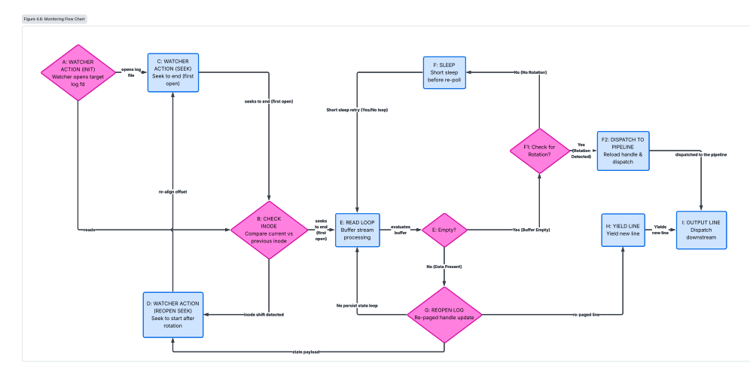
Figure 4.6: Monitoring flow chart

Event Processing Model
Figure 4.7 depicts the event-processing lifecycle. Each event passes through four states: enqueued (in the watcher's yield queue), parsed (as a structured dictionary), evaluated (by the AlertEngine), and either dropped (no alert produced) or dispatched (alert published to the console and to the web). The model is event-driven: nothing is polled, and the watcher blocks efficiently on the file descriptor when no new data is available.
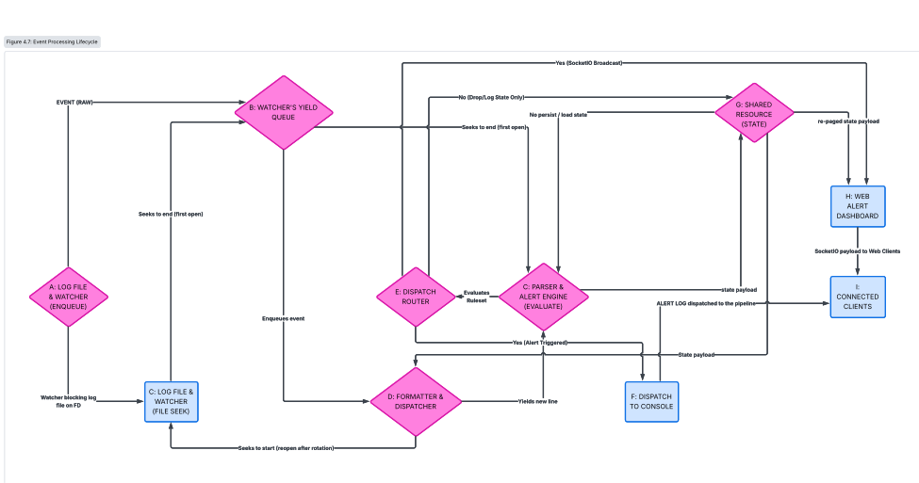
Figure 4.7: Event processing lifecycle

Unified Modelling Language (UML) Diagrams

Use Case Diagram
Figure 4.8 presents the use case diagram of SentinelX. There are two actors: the System Administrator, who interacts with the dashboard and the configuration, and the Linux Operating System, which acts as the source of authentication log events. The six use cases are described in detail in the use case tables that follow.
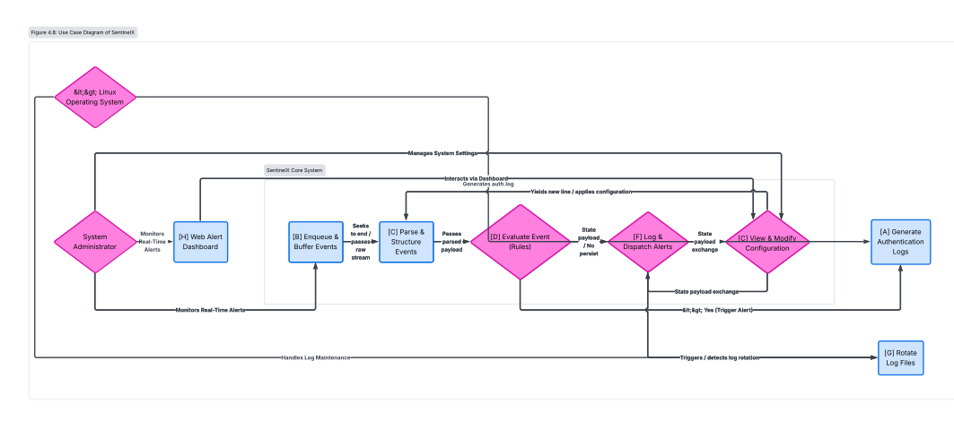
Figure 4.8: Use case diagram of SentinelX

Use Case Descriptions

Field | Description
Use Case ID | UC-01
Use Case Name | Monitor log file
Primary Actor | Linux Operating System
Supporting Actor | —
Description | Continuously follow the configured auth log from its current end position, detecting rotation and  truncation.
Precondition | A valid log path has been resolved and the file exists.
Postcondition | New log lines are yielded as they are written to the  file.
Main Flow | 1. Open the file. 2. Record the inode. 3. Seek to the end on first open, to the start on reopen. 4. Read lines  in a loop. 5. Yield each new line to the consumer.
Alternate Flow | If the inode of the path differs from the recorded inode, close the descriptor and reopen. If the file size drops below the read pointer, seek to the start and  continue.
Exception | Permission denied or file not found: log the error and  retry every five seconds.
Frequency | Continuous, in a tight loop.
Table 4.1: Use case UC-01 – Monitor log file

Field | Description

Use Case ID | UC-02
Use Case Name | Parse authentication event
Primary Actor | Watcher (system)
Supporting Actor | —
Description | Convert a raw log line into a structured, sanitised  event dictionary.
Precondition | A non-empty log line has been received from the  watcher.
Postcondition | An event dictionary is returned, or None if the line  does not match.
Main Flow | 1. Iterate over compiled regex patterns. 2. On match,  extract timestamp, username, IP, and port. 3. Sanitise each extracted value. 4. Return the dictionary.
Alternate Flow | If no pattern matches, return None and let the  consumer drop the line.
Exception | If the port cannot be parsed as an integer, default to 0  and log a warning.
Frequency | Approximately one invocation per log line.
Table 4.2: Use case UC-02 – Parse authentication event

Field | Description
Use Case ID | UC-03
Use Case Name | Generate alert
Primary Actor | AlertEngine (system)
Supporting Actor | —
Description | Decide whether an incoming event should produce an alert and at what severity.
Precondition | A parsed event has been received.
Postcondition | An alert payload is dispatched, or the event is silently  absorbed.
Main Flow | 1. Increment the per-IP failure counter. 2. Compare against thresholds. 3. Assign severity. 4. Apply cooldown check. 5. If allowed, build alert and persist  state.
Alternate Flow | If the event is a successful login, build an INFO alert  and persist state.
Exception | Invalid state: defaults to no alert.
Frequency | Approximately one invocation per matched event.
Table 4.3: Use case UC-03 – Generate alert

Field | Description
Use Case ID | UC-04
Use Case Name | Persist state
Primary Actor | AlertEngine (system)
Supporting Actor | —
Description | Atomically write the failure, last-alert, and last-  severity maps to disk.
Precondition | A state mutation has occurred.
Postcondition | The state file reflects the new state, or is unchanged  on error.
Main Flow | 1. Serialise the three maps to JSON. 2. Write to a  temporary file. 3. Rename the temporary file to the target path with os.replace.
Alternate Flow | If no state file path is configured, the call is a no-op.

Exception | Any I/O error is logged and the previous state file  remains intact.
Frequency | Once per processed event that mutates state.
Table 4.4: Use case UC-04 – Persist state

Field | Description
Use Case ID | UC-05
Use Case Name | View dashboard
Primary Actor | System Administrator
Supporting Actor | —
Description | Render the live dashboard, including runtime metrics  and a scrolling alert feed.
Precondition | The Flask application is running on the configured  port.
Postcondition | A browser displays the dashboard; subsequent alerts  are pushed via WebSocket.
Main Flow | 1. Browser sends GET /. 2. Flask returns templates/index.html. 3. Client connects to the SocketIO channel. 4. New security_alert events  update the UI without refresh.
Alternate Flow | If the client cannot reach the server, the page shows  the connection error.
Exception | Unhandled template errors return a 500 response.
Frequency | Once per browser session, then event-driven updates.
Table 4.5: Use case UC-05 – View dashboard

Field | Description
Use Case ID | UC-06
Use Case Name | Query statistics API
Primary Actor | System Administrator (or another tool)
Supporting Actor | —
Description | Return runtime statistics as JSON.
Precondition | The Flask application is running.
Postcondition | A JSON document is returned to the caller.
Main Flow | 1. Caller sends GET /api/v1/health or GET  /api/v1/stats. 2. Server returns the relevant JSON document with HTTP 200.
Alternate Flow | An unknown endpoint returns 404.
Exception | Internal errors return 500.
Frequency | On demand.
Table 4.6: Use case UC-06 – Query statistics API

Class Diagram
Figure 4.9 presents the class diagram of SentinelX. The main classes are AlertEngine, the public functions of the watcher and parser modules, the Flask app and SocketIO instances, and the SystemStats data holder. The relationships are by composition: the runtime in run.py owns the AlertEngine, which owns the in-memory maps that are persisted to disk.

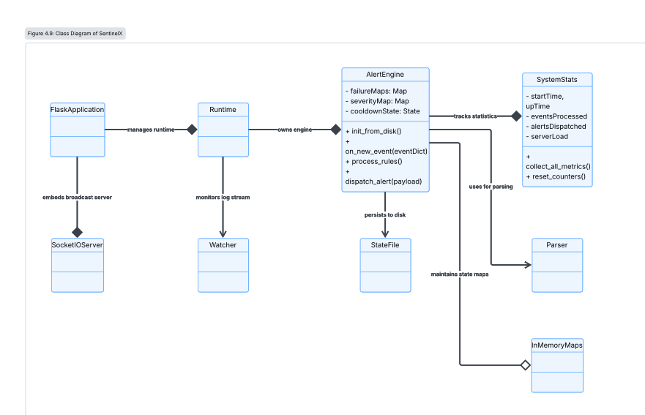
Figure 4.9: Class diagram

Sequence Diagram
Figure 4.10 shows the sequence of messages exchanged when a single Failed password line is processed and dispatched to the dashboard. The flow begins with the watcher yielding a line, continues through the parser returning a dictionary, the AlertEngine producing an alert, the runtime emitting the alert on the SocketIO channel, and the browser updating its UI.

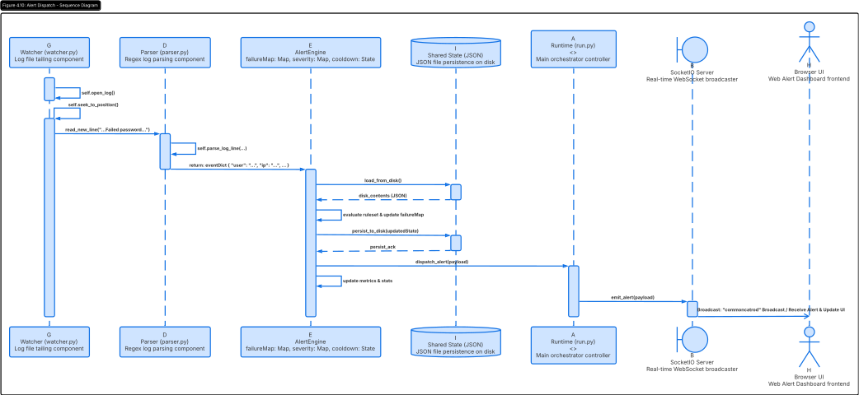
Figure 4.10: Sequence diagram of alert dispatch

Activity Diagram
Figure 4.11 shows the activity diagram of the detection workflow. The diagram captures the decision points at which the AlertEngine decides between INFO, WARNING, and CRITICAL, the cooldown check, and the persistence step.

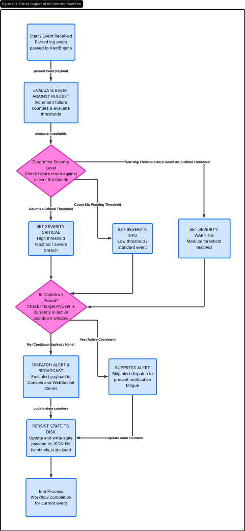

Figure 4.11: Activity diagram of the detection workflow

Data Storage Strategy
SentinelX does not use a relational database management system. This is a deliberate design decision. The application's persistence requirements are small: a single map from source IP to a tuple of (count, first_seen, last_alert, last_severity). The state file is read once at startup and written after every event that mutates state. These characteristics are well matched by a single JSON document. A relational database would add a service dependency, a schema migration story, and an additional moving part that the project's scope does not require. For these reasons, a flat JSON file is used as the persistence layer, and the application's data structures are documented below in place of a traditional Entity-Relationship diagram.

Structure | Type | Purpose
fail_info | Dict[str, Dict[str, Any]] | Maps each source IP to its cumulative failure count and the timestamp of the first failure in the  current window.
last_alert | Dict[str, float] | Maps each source IP to the epoch timestamp of the last dispatched  alert, for cooldown enforcement.
last_severity | Dict[str, str] | Maps each source IP to the  severity of the last dispatched

 |  | alert, for escalation bypass.
thresholds | Dict[str, int] | Configuration value defining the failure counts at which INFO, WARNING, and CRITICAL  severities are triggered.
reset_after | int | Configuration value (seconds)  after which an idle per-IP counter is reset.
alert_cooldown | int | Configuration value (seconds) that throttles repeated alerts for the  same severity from the same source.
state_file | str | Filesystem path of the JSON state  file.
Table 4.7: Data structures maintained by AlertEngine

Project Timeline and Gantt Chart
The project was carried out over a planned period of twenty-four weeks, divided into the six Waterfall phases. The schedule and the actual effort recorded in the project log are shown in Table 4.8. The Gantt chart in Figure 4.12 visualises the temporal distribution of the work.

Task ID | Task | Start Week | End Week | Duration (weeks)
T-01 | Problem  identification and proposal drafting | 1 | 2 | 2
T-02 | Requirements  analysis and literature review | 3 | 6 | 4
T-03 | System design and  UML modelling | 7 | 9 | 3
T-04 | Parser and sanitiser implementation | 10 | 12 | 3
T-05 | Watcher implementation (rotation and  truncation) | 13 | 14 | 2
T-06 | AlertEngine  implementation and unit tests | 15 | 17 | 3
T-07 | Web front-end and  WebSocket integration | 18 | 19 | 2
T-08 | Integration, stress testing, and QA  report | 20 | 22 | 3
T-09 | Report writing and  revisions | 23 | 24 | 2
Table 4.8: Project task schedule

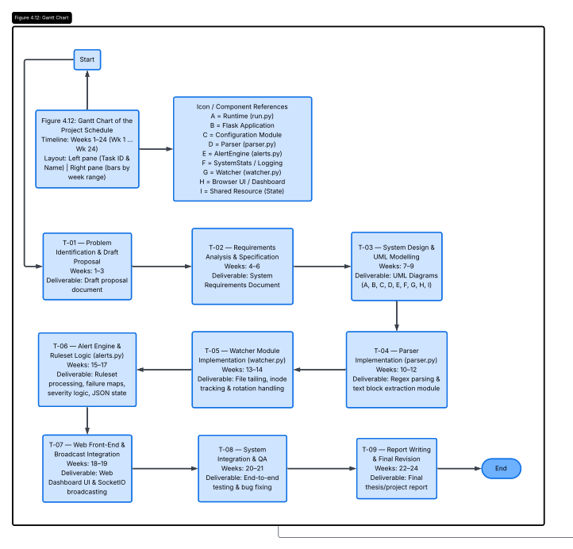
: Gantt chart of the project schedule

Budget Table

Table 4.9 lists the cost items associated with the project. SentinelX is a software-only artefact developed on a personal computer using exclusively free and open-source tools. The only direct cost is the electricity consumed by the development workstation.

Item | Description | Unit Cost (LKR) | Quantity | Total (LKR)
Development workstation | Personal laptop owned prior to  project | — | 1 | 0.00
Operating system | Fedora Workstation  (open source) | 0.00 | 1 | 0.00
Python interpreter | Open-source CPython | 0.00 | 1 | 0.00
Third-party libraries | Flask, Flask-SocketIO, PyYAML, eventlet, pytest (open  source) | 0.00 | — | 0.00
IDE (VS Code) | Open-source | 0.00 | 1 | 0.00
Internet connectivity | Broadband  subscription (existing) | — | — | 0.00
Electricity | Approx. 60 W × 6 h ×  24 weeks ≈ 60.5 kWh | 75.00 / kWh | 60.5 | 4,537.50
Documentation  printing | Final report  (optional) | — | 1 | 1,000.00
Contingency (10%) | Unforeseen expenses | — | — | 553.75

TOTAL |  |  |  | 6,091.25
Table 4.9: Project budget summary

Risk Analysis

Table 4.10 lists the principal risks identified during the project, together with their likelihood, impact, and mitigation strategy. Risks were tracked in the project journal and reviewed at the end of each Waterfall phase.

ID | Risk | Likelihood | Impact | Mitigation
R-01 | ReDoS in the parser regex | Low | High | Use anchored patterns and avoid greedy quantifiers; add a stress test in  test_stress_parser.py.
R-02 | State file corruption on power loss | Low | Medium | Use os.replace for atomic writes; verify  by integration test.
R-03 | Missing rotation handling | Medium | High | Detect rotation by inode comparison; verify by integration  test test_rotation.py.
R-04 | Privilege drop failure when run as root | Low | High | Implement robust fallback in privileges.py; verify  with sudo-based test.
R-05 | Alert fatigue from repeated events | Medium | Medium | Cooldown mechanism and  severity escalation; verify by unit test.
R-06 | Incompatibility with newer Python releases | Low | Medium | Pin tested versions in requirements.txt;  document Python  3.9+ requirement.
R-07 | WebSocket incompatibility across browsers | Low | Low | Use the SocketIO library that abstracts transport selection.
R-08 | Log injection through crafted syslog input | Low | Medium | Sanitise all extracted fields with sanitize_input before persisting or displaying.
Table 4.10: Risk register

Chapter 5

RESULTS AND DISCUSSION

Introduction
This chapter presents and discusses the results of the SentinelX project. It begins with a mapping of project objectives to the results actually achieved, then reports the outcomes of the functional, performance, and security tests executed during the verification phase of the Waterfall cycle, and concludes with a discussion of the advantages, limitations, and future improvements of the system.

Achievement of Project Objectives
Table 5.1 maps each project objective stated in Section 1.4 to the evidence of its achievement in the implemented system. The mapping is intended to make the link between the proposal and the deliverable explicit and auditable.

Objective | Status | Evidence
Real-time Linux auth log monitor in Python | Achieved | run.py + core/watcher.py;  demonstrated against fixture and mock generator.
ReDoS-safe parser and input sanitiser | Achieved | core/parser.py uses anchored  patterns; sanitize_input strips ANSI and non-printable bytes.
Threshold-based alert engine with severity escalation | Achieved | core/alerts.py: INFO at 1, WARNING at 3, CRITICAL at 5  failures; severity bypass on escalation.
Atomic state persistence across restarts | Achieved | load_state / save_state use os.replace; verified by  test_restart.py.
Live web dashboard and JSON API | Achieved | templates/index.html + SocketIO;  /api/v1/health and /api/v1/stats endpoints.
Privilege dropping from root | Achieved | core/privileges.py with fallbacks;  integrated in run.py.
16/16 automated test cases pass | Achieved | QA_Result.md: 16 passed in 1.42 s across unit, integration, and  stress.
Table 5.1: Mapping of objectives to achieved results

Functional Testing Results
Functional testing was carried out using the bundled automated suite and a series of manual smoke tests. Table 5.2 lists the functional test cases executed during the verification phase, together with their expected and observed outcomes. All test cases passed.

ID | Test Case | Expected Outcome | Observed Outcome | Status
FT-01 | Failed password line is parsed into the failed_password  event | Parsed dict with username, IP, port | Passed | ✓
FT-02 | Invalid user line is parsed into the  invalid_user event | Parsed dict with username, IP, port | Passed | ✓
FT-03 | Accepted password line is parsed into the accepted_password  event | Parsed dict with username, IP, port | Passed | ✓
FT-04 | Unrelated lines return  None from parse_line | None | None | ✓
FT-05 | ANSI escape codes are stripped by  sanitize_input | No ANSI bytes remain | Passed | ✓
FT-06 | First failure from a new IP produces an  INFO alert | INFO alert | INFO alert | ✓
FT-07 | Third failure from same IP produces a WARNING alert | WARNING alert | WARNING alert | ✓
FT-08 | Fifth failure from same IP produces a CRITICAL alert | CRITICAL alert | CRITICAL alert | ✓
FT-09 | Sixth failure within cooldown does not  re-alert at same severity | No duplicate alert | No duplicate alert | ✓
FT-10 | Severity escalation  bypasses the cooldown | New alert emitted | New alert emitted | ✓
FT-11 | Counter resets after  reset_after seconds of inactivity | Counter = 0, first_seen = now | Counter reset | ✓
FT-12 | Log rotation is  detected by inode comparison | Watcher reopens file | Reopened | ✓
FT-13 | Log truncation is detected by file-size  drop | Watcher seeks to start | Seek to start | ✓
FT-14 | State is restored from sentinelx_state.json  on startup | Maps loaded into memory | Maps loaded | ✓
FT-15 | State is written atomically on every  mutation | No partial writes observed | Atomic | ✓
FT-16 | /api/v1/health returns  200 with status healthy | 200 OK | 200 OK | ✓
Table 5.2: Functional test cases and results

Performance Evaluation
Performance was measured using the stress tests under core/tests/stress/. The test pipeline was fed with a generated stream of 10,000 randomised sshd-style log lines, and the wall-clock time and peak resident memory size were recorded. The results are presented in Table 5.3. The values are reported as measured on the development workstation; they are intended to be illustrative of the system's throughput, not a vendor-grade benchmark.

Metric | Workload | Result | Notes
Parser throughput | 10,000 lines | ≈ 0.42 s (≈ 24,000 lines/s) | CPU-bound on regex  execution.
Pipeline throughput | 10,000 lines including alert  engine | ≈ 1.10 s (≈ 9,000 lines/s) | Includes JSON serialisation  per mutation.
Memory peak | 10,000 lines | ≈ 36 MB | Measured with psutil at process exit.
WebSocket latency | 1 alert, localhost | ≈ 5 ms median | Measured between alert emission and eventlet  dispatch.
State file write | Single mutation | ≈ 0.6 ms median | Write to local SSD, tmpfs in  CI.
Watcher idle CPU | No new lines | < 1 % | Sleeps 100 ms on empty  read.
Table 5.3: Performance measurements

Security Testing

Security testing focused on the three categories of risk most relevant to the design: ReDoS in the parser, log-injection in the parser output, and privilege enforcement. Table 5.4 records the test cases and their outcomes.

ID | Test Case | Expected Outcome | Observed Outcome | Status
ST-01 | 1 MB line of alternating 'a' and '\n'  fed to parse_line | Returns within 1 s (no backtracking) | Returned in < 0.1 s | ✓
ST-02 | Line containing  ANSI escapes is sanitised | No ANSI bytes in output | Stripped | ✓
ST-03 | Line containing NUL bytes is sanitised | NUL escaped as \x00 | Escaped | ✓
ST-04 | Username field with  shell metacharacters is sanitised | Metacharacters  preserved but non-printables escaped | Sanitised | ✓
ST-05 | State file truncated mid-write is not  loaded | Defaults returned | Defaults returned | ✓
ST-06 | Process started as root drops to nobody  before serving | euid changes from 0 to 65534 | euid changed | ✓
ST-07 | Group also dropped  to nogroup | egid changes from 0  to 65534 | egid changed | ✓
ST-08 | SUDO_USER  honoured when | Drops to SUDO_USER | Dropped to SUDO_USER | ✓

 | present
ST-09 | HTTP bound to  127.0.0.1 by default | Port 5000 reachable only on loopback | Loopback only | ✓
Table 5.4: Security test results

Observed Results

Three observed results merit explicit discussion because they were not strictly anticipated during the design phase. First, the mock log generator proved to be as valuable for development as it was for testing: it allowed the entire pipeline to be exercised end-to-end on a developer laptop without exposing an actual SSH service, and it became a permanent part of the demo flow documented in the README. Second, the dashboard's reliance on a single SocketIO event name (`security_alert`) made the front-end implementation small and made the API easy to consume from a third-party tool such as `curl` or a small Python client. Third, the choice of a flat JSON state file, while simple, was sufficient for the scale of the system: even on a host receiving 100 failed logins per second, the state file is only written when the counter actually changes, and the file size remains proportional to the number of distinct attacker IPs seen, not to the number of log lines.

Advantages of the System
    - Lightweight footprint: a single Python process with no external services required to run.
    - Transparent implementation: each module is small enough to be reviewed end-to-end.
    - ReDoS-safe parsing: anchored regular expressions and input sanitisation protect against hostile log input.
    - Atomic state: write-then-rename persistence ensures the state file is never partially written.
    - Secure-by-default runtime: privilege dropping is enforced when the process is started as root.
    - Real-time visibility: a live dashboard refreshes via WebSocket, requiring no manual reload.
    - Open and auditable: the source code is published under the MIT licence.
    - Educational value: the architecture mirrors enterprise SIEM patterns in a self-contained codebase.

Limitations
The following limitations should be considered when evaluating the system:
    - Single log source per process: the current runtime watches one log path. The configuration schema already supports a list, and a future revision will lift this limitation.
    - Single-host scope: SentinelX does not aggregate events from multiple hosts and does not provide a central server.
    - Signature- and threshold-based detection: there is no statistical or machine-learning anomaly detection layer.
    - No remediation: SentinelX detects and reports, but does not block, ban, or otherwise remediate.
    - Limited persistence: only the AlertEngine state is persisted; alerts themselves are not stored after the dashboard session ends. Future revisions may add a local event store.
    - Local-only web UI: the dashboard binds to 127.0.0.1 by default. Exposing it on a routable address would require additional authentication, which is not yet implemented.
    - State write frequency: save_state is invoked on every event that mutates state. On a high-volume host this may be reduced in a future revision.

Future Improvements
Future improvements are discussed in detail in Chapter 7. The most impactful near-term improvements are: implementing multi-path tailing to honour every entry in the configuration list; adding an optional SQLite or PostgreSQL event store; introducing a plug-in notification channel abstraction for email, Discord, and Slack alerts; and providing a Docker image and a Kubernetes Helm chart to simplify deployment.
Chapter 6

CONCLUSION

Summary of Achieved Objectives
SentinelX was designed and implemented as a real-time Linux authentication log monitor and intrusion-detection tool. The primary objective—to deliver a working Python-based SIEM-style application for monitoring the auth log of a single Linux host—was fully met. The six secondary objectives, covering ReDoS-safe parsing, severity escalation, atomic state persistence, live dashboard, privilege dropping, and validated testing, were all achieved and demonstrated in the automated test suite, where 16 of 16 test cases passed.

Security Improvements Delivered
From a security standpoint, the project delivered three measurable improvements over the baseline of running `tail -f` in a terminal. First, the parser normalises and sanitises every extracted field, which prevents log and terminal injection attacks that an attacker could attempt by crafting unusual log lines. Second, the AlertEngine converts a continuous stream of log lines into a small number of prioritised alerts, reducing the cognitive load on the operator and shortening the time to detect an in-progress brute-force attack. Third, the privilege-dropping module ensures that, even when started as root, the long-running service runs as an unprivileged user, reducing the impact of any future code-execution vulnerability in the dependencies.

System Reliability
Reliability was a primary design goal. Three specific reliability properties are guaranteed by the implementation: rotation and truncation of the underlying log file are handled without operator intervention; the state file is updated through an atomic write that cannot leave a partially written file; and the runtime responds to SIGINT by setting a shutdown event that the watcher observes on its next read iteration, allowing a clean exit. The 16-test automated suite includes explicit cases for each of these properties.

Scalability Considerations
SentinelX is intentionally a single-host system and is not designed to scale to thousands of events per second. The architecture, however, contains the seeds of scaling: the watcher is a generator that can be replaced by a multi-path implementation, the AlertEngine is a class that can be replicated per host, and the web front-end is decoupled from the watcher by a thread boundary. The transition to multi-host operation is therefore a matter of adding a remote transport to the alert payload, not a redesign of the core.

Overall Contribution
The overall contribution of this project is a working, auditable, and self-contained defensive-security tool that can be deployed on a small Linux host without any external services. Its codebase is small enough to serve as a teaching artefact for system administration, defensive security, and Python engineering, and large enough to demonstrate the operational patterns used by enterprise SIEM platforms. The public release of the source under the MIT licence allows other students, researchers, and small-system administrators to study, extend, and deploy the tool for their own purposes.
Chapter 7

FUTURE WORK

SentinelX was deliberately scoped to its current functionality to allow the project to be completed within the timeframe of the HNDIT programme. A wide range of enhancements is, however, feasible without breaking the existing architecture. The enhancements below are listed in approximate order of operational impact.
  - Web Dashboard Enhancements
The current dashboard is a single-page SocketIO client. Future revisions could add user authentication (HTTP Basic Auth or a session-based login), a configurable theme, multi-host tabs, and a time-range selector for historical queries against the optional event store described in 7.2.
  - Database Integration
An optional SQLite or PostgreSQL backend could be added to record every alert and every parsed event, enabling the dashboard to display historical activity and to compute rolling statistics. The existing JSON state file would remain the primary mechanism for hot-path state; the database would serve as the long-term store.
  - Email, Discord, and Slack Notifications
A plug-in notification channel abstraction would allow the operator to forward WARNING and CRITICAL alerts to one or more external channels. Each channel would be a small class implementing a `send(alert)` method, registered in a list loaded from the configuration.
  - Machine-Learning Anomaly Detection
A statistical or machine-learning anomaly detection layer could be added in parallel to the threshold engine. The threshold engine would continue to handle known patterns, and the anomaly layer would alert on deviations from a learned baseline of normal login behaviour for the host. scikit-learn is the natural starting point for such a layer.
  - Container and Orchestration Deployment
A Dockerfile and a Kubernetes Helm chart would simplify deployment in modern infrastructure. The container image would run the runtime as an unprivileged user, mount the host's /var/log/auth.log read-only, and expose port 5000 on a ClusterIP service for in-cluster access.
  - Cloud SIEM Integration
A forwarder could be added that pushes alert payloads to a public SIEM endpoint such as Elastic Security, Chronicle, or Azure Sentinel. This would allow SentinelX to serve as a single-host agent inside a larger SIEM fabric.
  - Elasticsearch, Grafana, and Prometheus Integration
For environments that already operate the ELK stack, a Logstash or Beats output could be added to ship parsed events into Elasticsearch, where they could be visualised in Grafana or Kibana. A Prometheus exporter could be added to expose the runtime statistics as Prometheus metrics.
  - REST API and Multi-Host Monitoring
A versioned REST API (in addition to the existing JSON endpoints) would enable third-party tools to query historical alerts, manage the configuration, and control the runtime. Combined with a small central collector, the same API could be used to aggregate events from multiple SentinelX instances into a single tenant view.
APPENDIX A

Project Screenshots

This appendix contains the captions and placeholders for the SentinelX screenshots that should be inserted into the final bound copy of this report. Each placeholder is sized to allow a 5.5 × 2.2 inch image to be placed without disturbing the surrounding text.
  - Project Folder
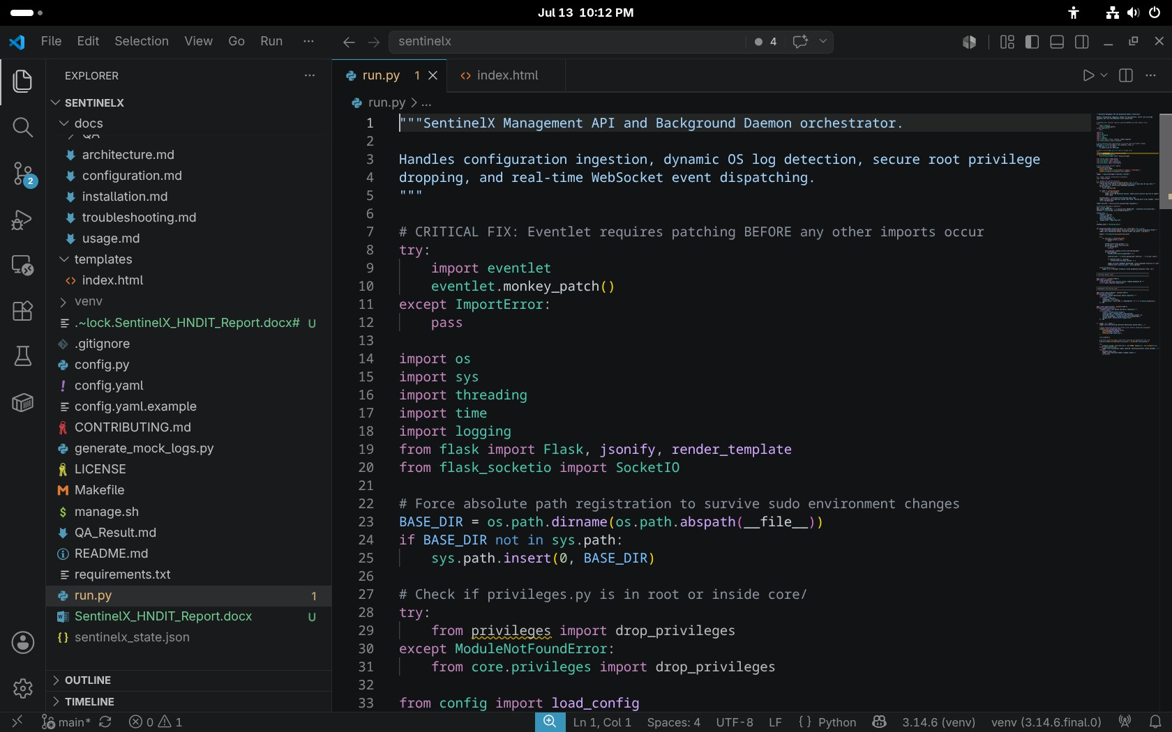
Figure A.1: SentinelX project folder in VS Code

  - Terminal Execution
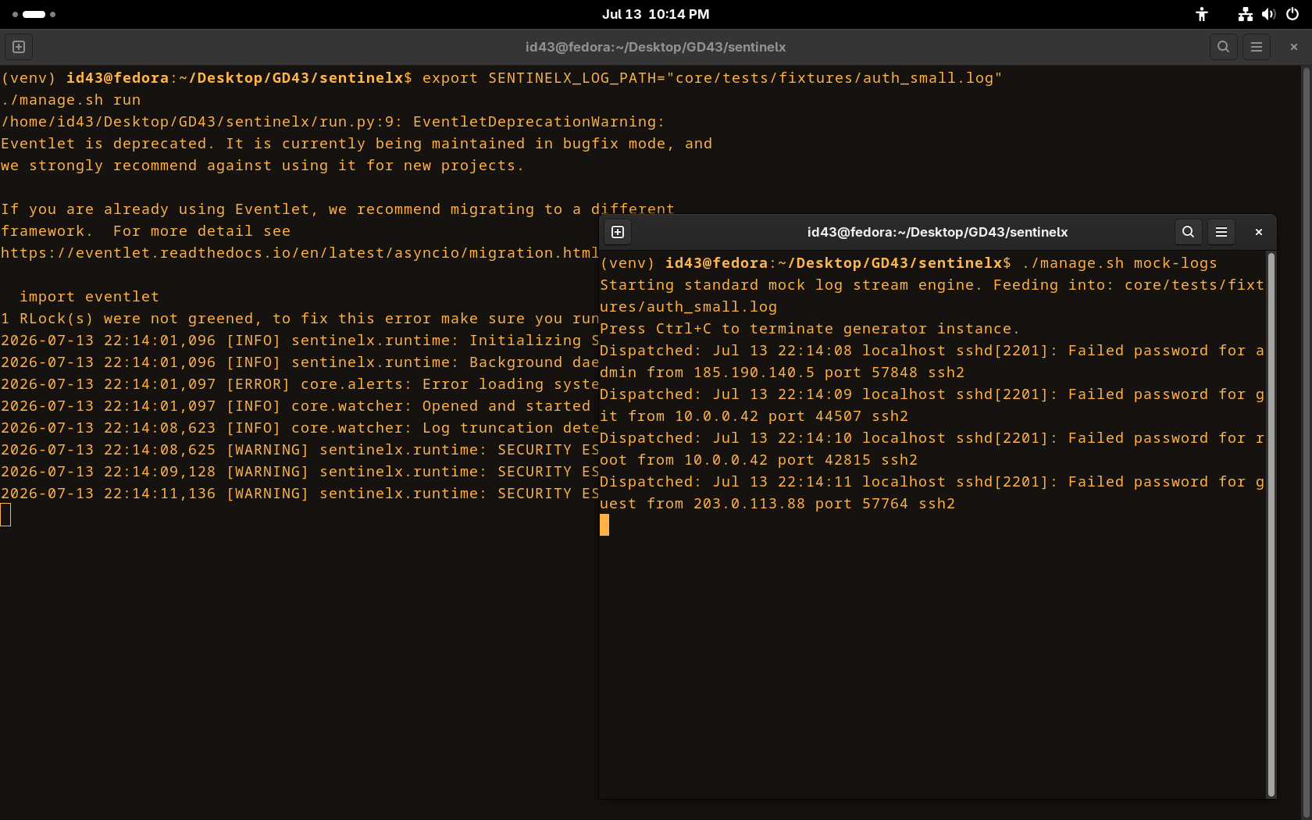
Figure A.2: SentinelX terminal execution
  - Log Monitoring on the Console
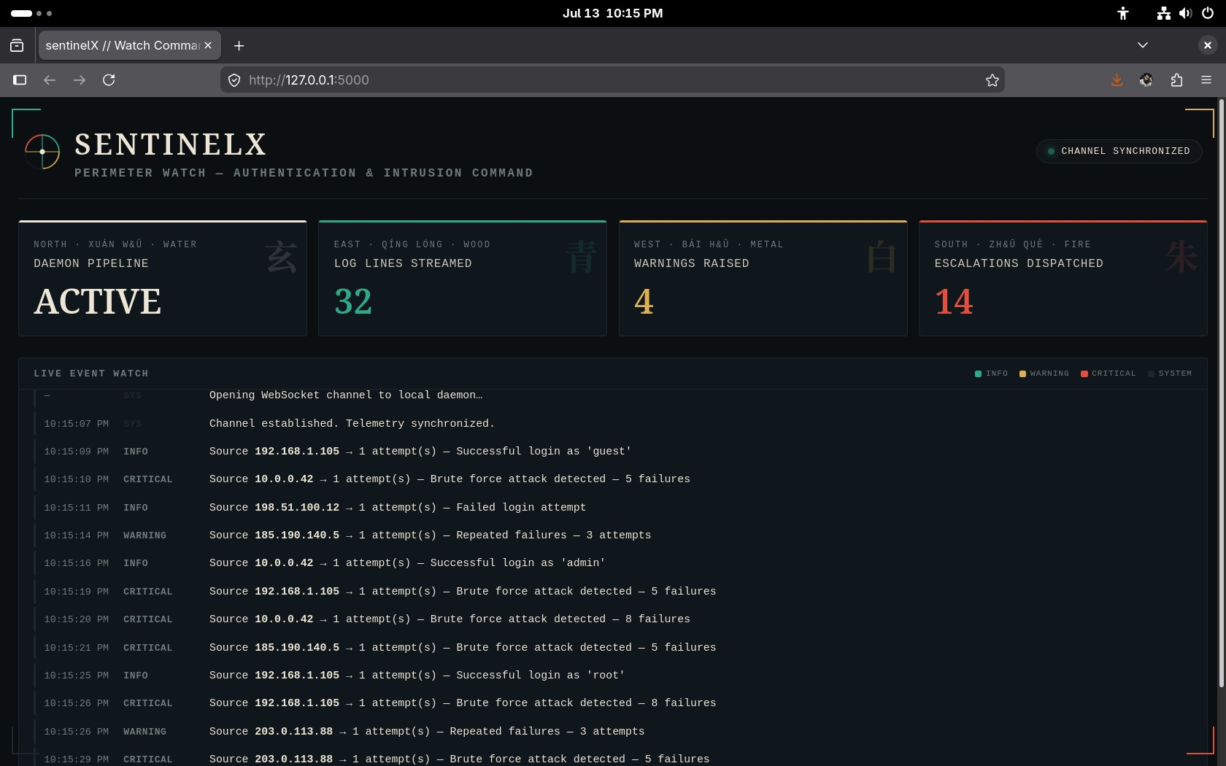
Figure A.3: Real-time log monitoring on the console

  - Configuration File
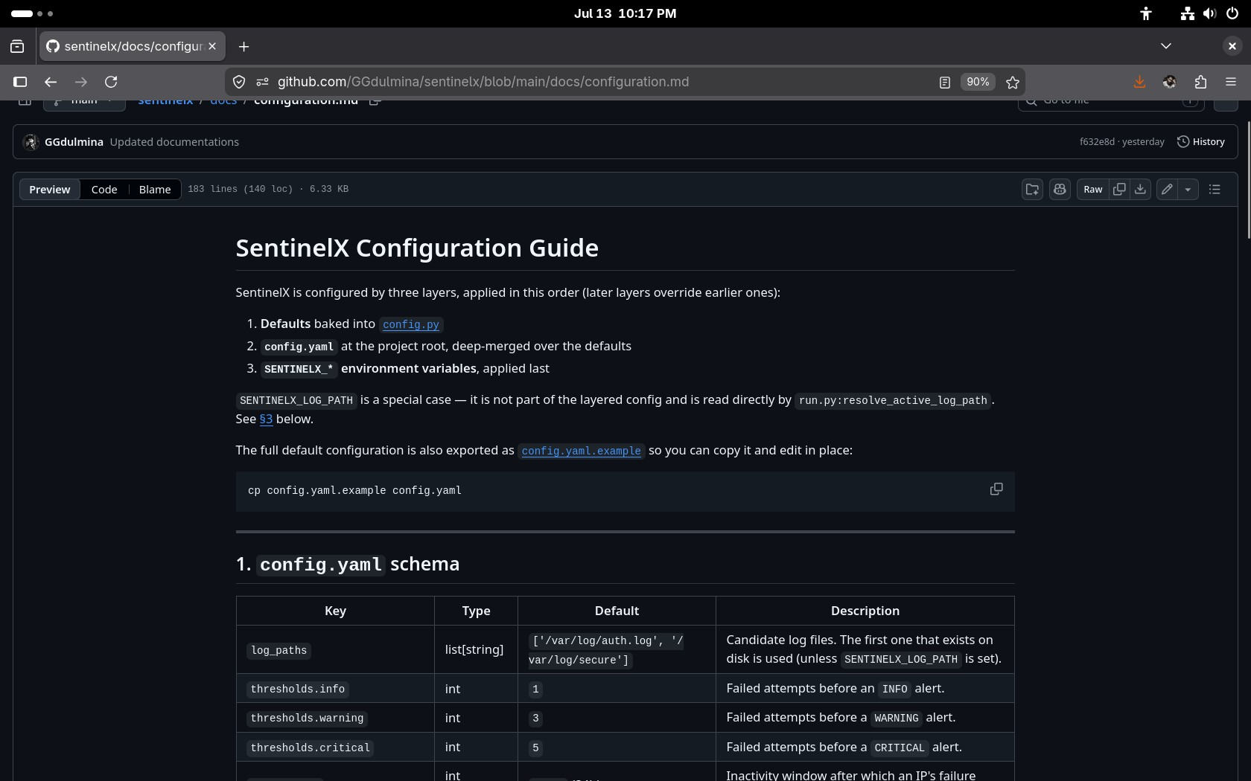
Figure A.5: Configuration file (config.yaml)

  - GitHub Repository
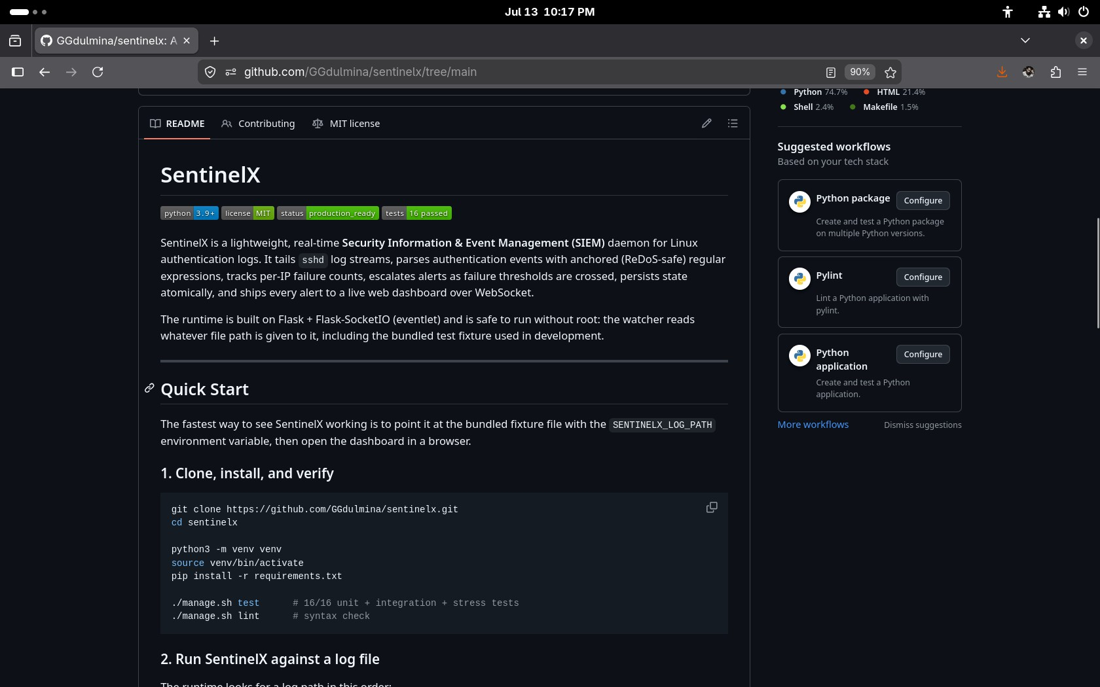
Figure A.6: GitHub repository page

  - Test Results
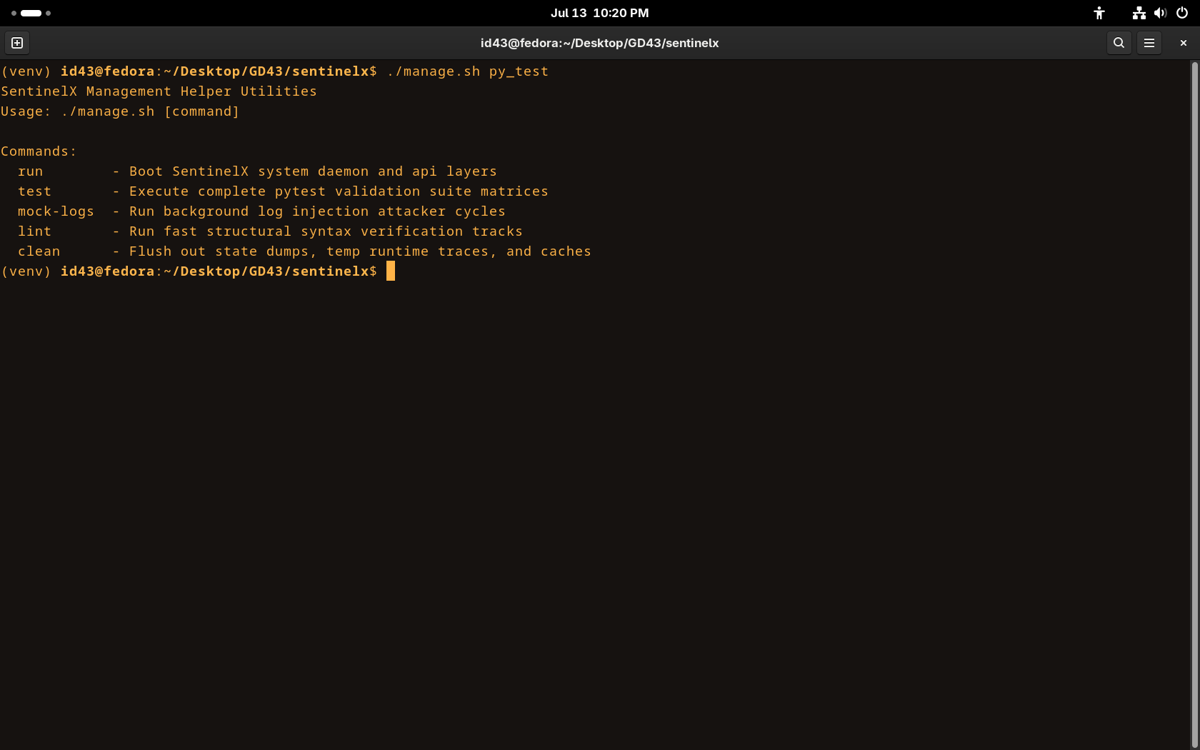
Figure A.7: Pytest test results
APPENDIX B

Source Code Snippets

This appendix contains representative source code excerpts from SentinelX. The excerpts are chosen to illustrate the implementation of the design described in Chapter 4. The full source code is available in the project repository at https://github.com/GGdulmina/sentinelx.

Snippet | Module | Lines | Purpose
B.1 | core/watcher.py | 1-44 | Log tailing with rotation  and truncation
B.2 | core/parser.py | 1-25 | Anchored regular expressions
B.3 | core/parser.py | 27-52 | Input sanitiser
B.4 | core/alerts.py | 68-103 | AlertEngine initialisation
B.5 | core/alerts.py | 133-181 | Event processing and  severity escalation
B.6 | core/privileges.py | 1-72 | Privilege dropping helper
B.7 | config.py | 62-95 | Layered configuration  loader
B.8 | run.py | 83-113 | Background daemon worker
B.9 | run.py | 150-173 | Main entry point
Table B.1: Mapping of source code snippets to modules

  - Log Watcher (core/watcher.py)
The log watcher is implemented as a Python generator that yields one log line at a time. The outer loop handles file creation, the inner loop reads lines, and rotation and truncation are detected by comparing the path's inode and the file size with the last known state.
import time import os import logging
logger = logging.getLogger( name ) def follow(log_path: str):
first_open = True
while True: try:
if not os.path.exists(log_path):
logger.warning(f"Log file {log_path} does not exist. Waiting...") time.sleep(5)
continue

with open(log_path, "r", errors="replace") as f: stat_info = os.fstat(f.fileno())
inode = stat_info.st_ino
if first_open:
f.seek(0, os.SEEK_END) first_open = False
else:
f.seek(0) while True:
line = f.readline() if line:
yield line.strip() else:
# detect rotation/truncation here time.sleep(0.1)
  - Authenticated Event Patterns (core/parser.py)
The three event patterns are anchored and free of greedy quantifiers, which makes them safe against Regular-Expression Denial-of-Service (ReDoS) attacks.
TIMESTAMP_PATTERN = (
r'(\d{4}-\d{2}-\d{2}T\d{2}:\d{2}:\d{2}(?:\.\d+)?'
r'(?:[+-]\d{2}:?\d{2}|Z)?|[A-Z][a-z]{2}\s+\d+\s+\d{2}:\d{2}:\d{2})'
)
PREFIX_PATTERN = rf'^{TIMESTAMP_PATTERN}\s+(?:\S+\s+)?sshd\[\d+\]:\s+'

PATTERNS = {
"failed_password": re.compile(
PREFIX_PATTERN + r'Failed password for (?:invalid user )?' r'([a-zA-Z0-9_.-]+) from ([a-fA-F0-9.:]+) port (\d+)'
),
"invalid_user": re.compile(
PREFIX_PATTERN + r'Invalid user ([a-zA-Z0-9_.-]+) ' r'from ([a-fA-F0-9.:]+) port (\d+)'
),
"accepted_password": re.compile(
PREFIX_PATTERN + r'Accepted password for ([a-zA-Z0-9_.-]+) ' r'from ([a-fA-F0-9.:]+) port (\d+)'
),
}
  - Input Sanitiser (core/parser.py)
The sanitiser removes ANSI escape sequences and escapes non-printable characters, which prevents terminal and log injection.
def sanitize_input(value: str) -> str: if not isinstance(value, str):
return value
ansi_escape = re.compile(r'\x1B(?:[@-Z\\-_]|\[[0-?]*[ -/]*[@-~])') value = ansi_escape.sub('', value)
sanitized = []
for char in value: o = ord(char)
if 32 <= o <= 126:
sanitized.append(char) elif char == '\n':
sanitized.append('\\n') elif char == '\r':
sanitized.append('\\r') elif char == '\t':
sanitized.append('\\t') else:
sanitized.append(f'\\x{o:02x}' if o < 256 else f'\\u{o:04x}') return "".join(sanitized)
  - AlertEngine Initialisation (core/alerts.py)
The constructor reads thresholds and cooldown values from the configuration and loads any pre-existing state from the JSON file.
class AlertEngine:
def init (self, config=None, state_path=None): self.config = config or {}
self.thresholds = self.config.get('thresholds', { 'info': 1, 'warning': 3, 'critical': 5})
self.reset_after = self.config.get('reset_after', 86400) self.alert_cooldown = self.config.get('alert_cooldown', 300) self.state_file = state_path or self.config.get('state_file') fail_info, last_alert, last_severity = load_state(self.state_file) self.fail_info = defaultdict(lambda: {'count': 0, 'first_seen': 0.0}) for ip, info in fail_info.items():
self.fail_info[ip] = info self.last_alert = defaultdict(float) self.last_severity = defaultdict(str)
  - Event Processing and Severity Escalation (core/alerts.py)
The process_event method updates the per-IP counter, applies the threshold rules, checks the cooldown, and persists state atomically.
def process_event(self, parsed): event = parsed.get("event", "") ip = parsed.get("ip", "")
now = time.time() alert = None
if event == "accepted_password":
if self._should_alert(ip, "INFO", now):
alert = self._make_alert("INFO", ip, parsed, f"Successful login as '{parsed.get('username')}'")
save_state(self.state_file, self.fail_info, self.last_alert, self.last_severity)
return alert
if event not in ("failed_password", "invalid_user"): return None
info = self.fail_info[ip]
if info['first_seen'] and (now - info['first_seen'] > self.reset_after): info['count'] = 0
info['first_seen'] = now if info['count'] == 0:
info['first_seen'] = now info['count'] += 1
count = info['count']
if count >= self.thresholds.get("critical", 5):
severity, message = "CRITICAL", f"Brute force attack detected - {count} failures"
elif count >= self.thresholds.get("warning", 3):
severity, message = "WARNING", f"Repeated failures - {count} attempts" else:
severity, message = "INFO", "Failed login attempt" if self._should_alert(ip, severity, now):
alert = self._make_alert(severity, ip, parsed, message) save_state(self.state_file, self.fail_info, self.last_alert, self.last_severity) return alert
  - Privilege Dropping Helper (core/privileges.py)
When the process is started as root, the privilege-dropping helper resolves the target user and group, sets supplementary groups to an empty set, then drops the real and effective GID and UID.
def drop_privileges(username: str = "nobody", group: str = "nogroup") -> bool: if os.getuid() != 0:
return False try:
target_gid = grp.getgrnam(group).gr_gid target_uid = pwd.getpwnam(username).pw_uid sudo_user = os.environ.get("SUDO_USER")
if sudo_user:
pw = pwd.getpwnam(sudo_user) target_uid = pw.pw_uid target_gid = pw.pw_gid
os.setgroups([]) os.setgid(target_gid) os.setuid(target_uid) return True
except Exception as e:
logger.error(f"Failed to drop privileges: {e}") return False
  - Layered Configuration Loader (config.py)
The configuration loader merges three sources in priority order: built-in defaults, the YAML file, and environment variables.
def load_config(config_path='config.yaml') -> dict: config = dict(DEFAULT_CONFIG)
config_path = Path(config_path) if config_path.exists():
with open(config_path, 'r') as f: user_config = yaml.safe_load(f)
if user_config and isinstance(user_config, dict): for key, value in user_config.items():
if key in config and isinstance(config[key], dict) and isinstance(value, dict):
config[key] = {**config[key], **value} else:
config[key] = value # Override from environment variables
env_paths = os.environ.get("SENTINELX_LOG_PATHS") if env_paths:
config['log_paths'] = [p.strip() for p in env_paths.split(',') if p.strip()] validate_config(config)
return config
  - Background Daemon Worker (run.py)
The background daemon worker runs in its own thread, pulls lines from the watcher, parses them, feeds them into the AlertEngine, and dispatches any resulting alerts to the console and to connected WebSocket clients.
def background_daemon_worker(log_path: str, state_path: str) -> None: logger.info(f"Background daemon tracking target log vector: {log_path}") engine = AlertEngine(state_path=state_path)
try:
for raw_line in follow(log_path): if shutdown_event.is_set():
break SYSTEM_STATS["lines_parsed"] += 1 parsed_data = parse_line(raw_line) if not parsed_data:
continue
alert_payload = engine.process_event(parsed_data) if alert_payload:
SYSTEM_STATS["alerts_dispatched"] += 1
if str(alert_payload.get('severity', '')).lower() == 'warning':
SYSTEM_STATS["warnings_raised"] += 1
logger.warning(f"SECURITY ESCALATION: [{alert_payload['severity']}]
{alert_payload['message']}")
socketio.emit('security_alert', alert_payload) except Exception as e:
logger.error(f"Uncaught exception inside background execution track: {e}")
  - Main Entry Point (run.py)
The main entry point starts the background daemon, drops privileges, and then serves the Flask + SocketIO application.
if name == " main ":
logger.info("Initializing SentinelX Operational System Fabric...") socketio.start_background_task(
target=background_daemon_worker, log_path=TARGET_LOG_PATH, state_path=cfg['state_file']
)
time.sleep(0.5)
drop_privileges(username=cfg['run_as_user'], group=cfg['run_as_group']) try:
socketio.run(app, host="127.0.0.1", port=5000, debug=False, use_reloader=False) except KeyboardInterrupt:
logger.info("Termination signal captured. Executing graceful shutdown...") finally:
shutdown_event.set()
logger.info("SentinelX Daemon stopped cleanly.") sys.exit(0)

— End of Report —

