**MANUAL GUIDE**

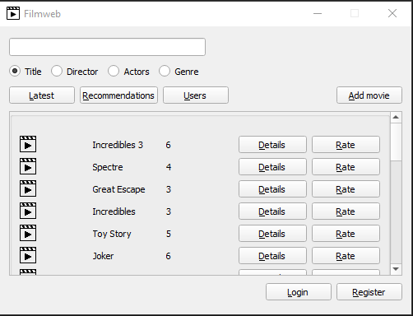

This the main window that you will see after opening the app. You can find all of the movies or users from database.Here you can also log in by pressing login button.

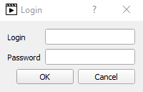

Login dialog screen that appears after pressing login button.

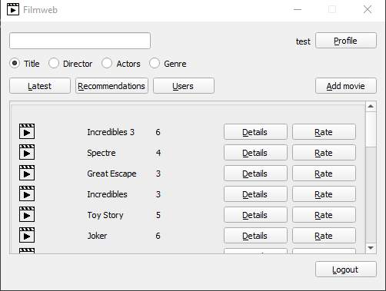

By successfully logginin your window will change to that.From here you can access profile window by pressing profile button or going to users scroll box by pressing users button and pressing profile on one of the users.

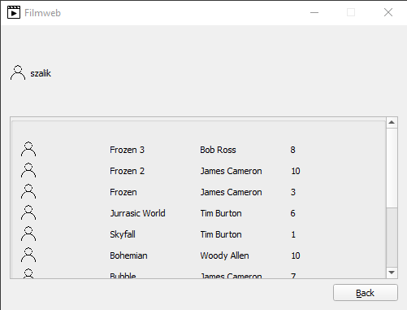

Profile window.

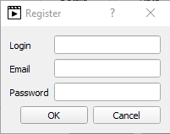

You can also register in the main window by pressing Register button.After pressing Register button this dialog will appear.

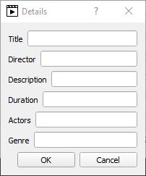

You can also add new movies by pressing add movie button and filling up this dialog.

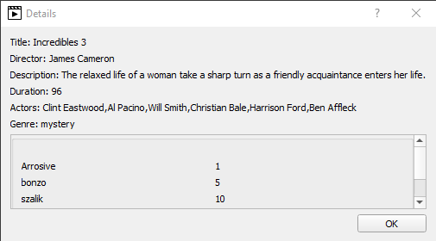

To rate movie press rate button near details button.You have to be logged to access it.

To access movie details press the details button of one of the movies in the scroll box.

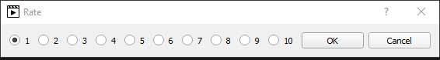

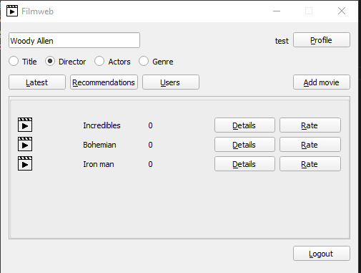

You can also use search bar to find your favourite movies. Choose one of the categories that you want to search by ( title,director,actors or genre) input your favourite director ( Woody Allen) and press enter.

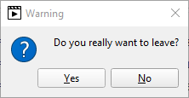

When you will want to exit the application message box will appear asking you „Do you really want to leave.”