MICS 2016 Programming Contest Problems

General Instructions:

- Programs should read from standard input (keyboard) and write to standard output (screen)

- The programming contest will be three hours in duration.

- The team correctly solving the most problems within the three hours will be declared the winner. In the event that more than one team solves the same number of problems, the team solving them in the least total time will be declared the winner.

- Each incorrect submission results in a 20 minute time penalty, so it is important that teams minimize incorrect submissions.

- During the contest, the network must only be used to submit contest problems or ask questions and get responses from the contest officials.

- Teams will not be allowed to use any electronic devices, including (but not limited to) calculators, PDAs, cellular phones, and mp3/tape players. Teams may not bring CDs, DVDs, USB flash drives, or any other form of digital media.

- Teams may bring textbooks and paper documents. Teams may also use any documentation that has been installed as part of the contest machine.

Use the PC^2 Team interface to request clarification, but judges are in Wright Hall room 339 if you have any issues during the contest.

Problem 1—UNI

Professor Plum fondly recalls the previous MICS hosted by the University of Northern Iowa in 2012. He wants you to write a program to generate ASCII art printing “UNI” horizontally for a sign to hang on the back of the van on the trip to Cedar Falls. Since he is unsure of the door's dimensions, he wants your program to take as input a positive integer scaling factor. The first several scaling factors with corresponding letter dimensions (height x width) are specified by the following table:

Scaling Factor | U and N Letter Dimension  (# chars × # chars)  NOTE: first line of U or N is all spaces | I Letter Dimension  (# chars × # chars) | Line Width of Letters  (# characters) | Blank Spaces  Between Letters
1 | 4 × 5 | 4 × 5 | 1 | 1
2 | 6 × 10 | 6 × 10 | 2 | 2
3 | 8 × 15 | 8 × 15 | 3 | 3
4 | 10 × 20 | 10 × 20 | 4 | 4
5 | 12 × 25 | 12 × 25 | 5 | 5

A scaling factor of 1 would produce:
_____
| | |\ | |
| | | \ | |
\___/ | \| __|__

A scaling factor of 2 would produce:
__________
|| || ||\\ || __________
|| || || \\ || ||
|| || || \\ || ||
||______|| || \\ || ____||____
\\______// || \\|| __________

Input Format
The input contains a single line with a positive integer scaling factor for the sign.

Output Format
The output should contain the ASCII art for the sign corresponding to the scaling factor specified by the input.

Input Sample
4

Output Sample (NOTE: dots shown where spaces would occur in actual output)
················································____________________
||||············||||····||||\\\\········||||····____________________
||||············||||····||||·\\\\·······||||····____________________
||||············||||····||||··\\\\······||||····____________________
||||············||||····||||···\\\\·····||||············||||········
||||············||||····||||····\\\\····||||············||||········
||||____________||||····||||·····\\\\···||||····________||||________
||||____________||||····||||······\\\\··||||····____________________
||||____________||||····||||·······\\\\·||||····____________________
\\\\____________////····||||········\\\\||||····____________________

Problem 2—Quiz Grader

Professor Plum has some funny ideas about teaching. One is his quirky quiz scoring since he believes that answering two or more questions correctly in a row should be worth more points than answering the same questions correctly (but not consecutively). When he hand-grades quizzes, he places an X or O (meaning incorrect and correct, respectively) by each question to generate a string of X’s and O’s that’s the same length as the number of questions on the quiz. He computes the total score using the simple rule: the n^{th} correct answer in a row is worth n points. Thus, “XOXXXXOOOX” is worth 1 + 1 + 2 + 3 = 7 points.
He wants you to write a program to grade a set of quizzes using the above grading scheme.

Input Format
The first line contains a positive integer n specifying the number of quizzes to grade. The next line contains a string of upper-case letters A-H corresponding to the correct answers of the multiple-choice quiz. The following n lines contain a student’s name terminated by a colon (“:”) followed by strings of letters A-H corresponding to the student’s multiple-choice quiz answers. All the strings for the key and student answers are the same length.

Output Format
The output will consist of n lines containing each student’s name in all upper-case, a space, and their quiz score using Professor Plum’s above grading scheme. The order of the output lines must be alphabetically (ascending order) by last name with the first name being the used secondarily.

Input Sample
5
ADECCAHBBH
Sally Smith:ADECCAHBBH
Jane Doe:ADBCCAHAAA
Tom Jones:GGGGGGGGGG
John Smith:BDECGAHCBG
BILLY SMITH:BDFCDAEBCH

Output Sample
JANE DOE 13
TOM JONES 0
BILLY SMITH 5
JOHN SMITH 10
SALLY SMITH 55

Problem 3—Word Jumble

Professor Plum likes to work the “JUMBLE” word-puzzle in the daily newspaper. Each puzzle consists of several 5-to-7 letter words which have been scrambled. The goal of the puzzle is to unscramble the words.
On rare occasions Professor Plum gets stumped by a word or two on a puzzle. He wants you to write a program that takes in a list of scrambled words and for each one produce a list of matching dictionary words.

Input Format
The first line contains a positive integer n specifying the number of scrambled words. The following n lines contains one scrambled word per line. The next line contains a positive integer d specifying the number of words in the dictionary. The remaining d lines contain one dictionary word in alphabetical order.

Output Format
The output will consist of n lines corresponding with each scrambled word. Each line will start with the scrambled word followed by a colon (“:”), then each matching dictionary word proceeded by a space. The dictionary words found should be in alphabetical order. If no matches found, then the string “ no match in dictionary” should be printed.

Input Sample
6
uzzyf
xyz
sternae
mmocno
risstf
oswdr
127142
a
aah
aahed
aahing
aahs
aal
aalii
aaliis
aals
aardvark
aardvarks
aardwolf
.
.
zymurgies
zymurgy
zyzzyva
zyzzyvas

Output Sample
uzzyf: fuzzy
xyz: no match in dictionary
sternae: earnest eastern nearest
mmocno: common
risstf: firsts
oswdr: sword words
Problem 4—NASCAR SMS

Professor Plum’s least favorite sport is NASCAR, but he really likes the upcoming Daytona 500. Watching the cars go around the track gives him a headache, but fortunately his cellphone provider offers an SMS-based race update feature. Just before the start of the race, he receives a text message containing the starting lineup by (nonnegative integers) car number. During the race, he will receive a text message each time one car passes another car.
From this information, he wants you to write a program to determine 1st, 2nd, and 3rd place winners.

Input Format
The first line contains a positive integer n specifying the number of cars in the race. The next n lines contains the starting lineup. The remaining lines contain pairs of car numbers with the first car number passing the second car number. At the end of the file, the pair -1 -1 denotes the end of the race.

Output Format
The output consists of three lines: the first line is “First Place: ” followed by the car number finishing in first place, the second line is “Second Place: ” followed by the car number finishing in second place, and the third line is “Third Place: ” followed by the car number finishing in third place. (Note: a single space follows the colon)

Input Sample
4
32
15
1
17
15 32
1 32
1 15
17 32
15 1
32 17
-1 -1

Output Sample
First Place: 15
Second Place: 1
Third Place: 32

Problem 5—Combination Lock

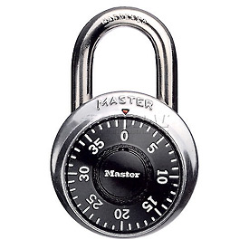
Professor Plum likes to fiddle with combination padlocks while he watches TV. His favorite is a MasterLock brand (see picture). It has 40 numbers (0-39) arrayed clockwise around the dial. A combination consists of 3 of these numbers, say 15 25 8. To open the lock, he always does the following steps:
- turn the dial clockwise 2 full turns from its initial starting position
- continue turning clockwise and stop at the first number of the combination
- turn the dial counter-clockwise 1 full turn
- continue turning counter-clockwise and stop at the second number of the combination
- turn the dial clockwise again and stop at the third number
- finally pull down hard on the body of the lock and it will open.
Given the initial position of the dial and the combination for the lock, he wants you to write a program to determine how many numbers you need to rotate through (both clockwise and counterclockwise) while opening the lock.

Input Format
The first line of the input contains an integer count of the number combinations to solve. Each of the remaining lines will consist of four integers: the starting position on the dial followed by the three number combination.

Output Format
For each combination in the input, one line of output should be produced containing either the total number of dial positions traversed, or the word “Error”. “Error” should be produced if the starting position or any number in the combination is illegal (i.e., not between 0 and 39 inclusive).

Input Sample
4
0 17 21 35
0 14 22 56
10 5 10 15
40 8 50 20

Output Sample
173
Error
165
Error

Problem 6—“W”inning Sort

Professor Plum likes to buy one ticket to a daily lottery game called Pick-4. In Pick-4 you pick four unique numbers between 1 and 1000, and the computer randomly picks four unique numbers between 1 and 1000. You win if all four of your numbers match the computers in the exact order. Needless to say, you don’t win often.

Professor Plum has an idea for picking his Pick-4 numbers for every day of the month using a “W” sort (“W” for “W”inning). Before each month starts he picked his luckiest 124 unique numbers between 1 and 1000, then arranged them into a sequence from most-lucky to least-lucky. He wants you to write a program to perform a “W” sort on this sequence of numbers to determine the Pick-4 numbers for every day of the month.

A “W” sort is easily described by a diagram. The array is thought of as four “legs” of the W with each leg filled from top to bottom. The sequence of lucky numbers is scanned from most-lucky to “least-lucky” with the legs filled in the order: first leg, fourth leg, second leg and third leg before repeating.
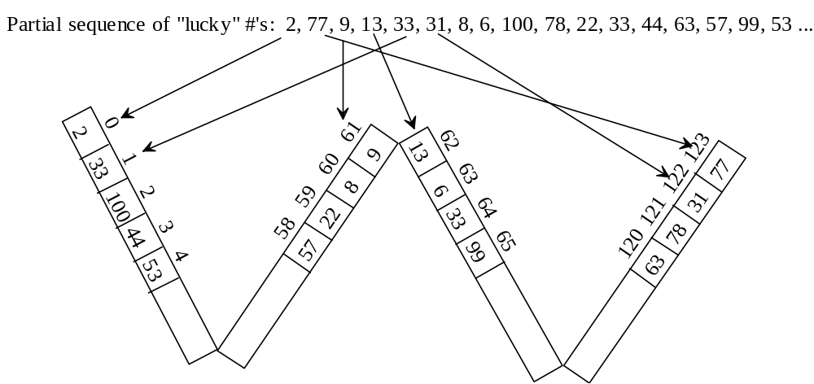
After the “W” sort, the Pick-4 numbers for every day of the month are found by scanning the array from index 0 to index 123 with groups of four numbers being a Pick-4. In the above example the 1st of the month’s Pick-4 numbers are from indices 0 to 3 (i.e., Pick-4 of 2 33 100 44), the 2nd of the month’s Pick-4 numbers are from indices 4 to 7, the 3rd of the month’s Pick-4 numbers are from indices 8 to 11, etc. The 31st of the month’s Pick-4 numbers are from indices 120 to 123 (i.e., Pick-4 numbers of 63, 78, 31, 77).

Input Format
A single line of input contains the sequence of 124 lucky numbers ordered from most to least lucky.

Output Format
The Pick-4 numbers ordered by day of the month. Each line contains the day of the month (1-31), a colon (‘:’) and the four Pick-4 numbers each proceeded by a space.

Input Sample (partial – full input would have 124 integers)
2 77 9 13 33 31 8 6 100 78 22 33 44 63 57 99 53 … <remaining omitted>

Output Sample (partial – full output would have 31 lines for each day of the month)
1: 2 9 13 77
...
16: 8 9 13 6
...
31: 63 78 31 77
Problem 7—Recursive Definition

Professor Plum struggled with recursion initially, but he grew to love it! His favorite recursive definition is:
M(n) = n for all n < 3,
M(3) = 10, and
M(n) = M(n-2) - M(n-4) + M(n-5) - M(n-8) for all n > 3.

Input Format
The first line of input contains a positive integer count of the number of integers to follow. Each integer n will be on a line by itself and will be used to compute M(n).

Output Format
One output line corresponding to each input number. Each output line is of the format “M(n) = d” where n is the input number value and d is the corresponding function value. A space is on both sides of the equal sign.

Input Sample
5
8
15
-5
10
35

Output Sample
M(8) = 11
M(15) = 12
M(-5) = -5
M(10) = 15
M(35) = -1201

Problem 8—Secret Message

Professor Plum’s wife enjoys reading “spy” novels. She likes to send him encoded messages. He hates it, but at least her encryption scheme is fairly simple. She uses a Vigenere cipher which is a form of substitution cipher based on a keyword. She always uses the same keyword for a month. This month’s keyword is “bobwhite” so Professor Plum has the following Vigenere cipher table on his office bulletin board which using the keyword “bobwhite”.
# | a | b | c | d | e | f | g | h | i | j | k | l | m | n | o | p | q | r | s | t | u | v | w | x | y | z | Position
1 | b | c | d | e | f | g | h | i | j | k | l | m | n | o | p | q | r | s | t | u | v | w | x | y | z | a | 1 | 9 | 17
2 | o | p | q | r | s | t | u | v | w | x | y | z | a | b | c | d | e | f | g | h | i | j | k | l | m | n | 2 | 10 | 18
3 | b | c | d | e | f | g | h | i | j | k | l | m | n | o | p | q | r | s | t | u | v | w | x | y | z | a | 3 | 11 | 19
4 | w | x | y | z | a | b | c | d | e | f | g | h | i | j | k | l | m | n | o | p | q | r | s | t | u | v | 4 | 12 | 20
5 | h | i | j | k | l | m | n | o | p | q | r | s | t | u | v | w | x | y | z | a | b | c | d | e | f | g | 5 | 13 | 21
6 | i | j | k | l | m | n | o | p | q | r | s | t | u | v | w | x | y | z | a | b | c | d | e | f | g | h | 6 | 14 | 22
7 | t | u | v | w | x | y | z | a | b | c | d | e | f | g | h | i | j | k | l | m | n | o | p | q | r | s | 7 | 15 | 23
8 | e | f | g | h | i | j | k | l | m | n | o | p | q | r | s | t | u | v | w | x | y | z | a | b | c | d | 8 | 16 | 24

To encrypt a message, the first character of the message uses row 1 (‘a’ maps to a ‘b’, ‘b’ maps to a ‘c’, …, ‘z’ maps to an ‘a’). The second character of the message uses row 2 (‘a’ maps to a ‘o’, ‘b’ maps to a ‘p’, …, ‘z’ maps to an ‘n’). If the message is longer than the keyword, then every 8th character uses the same row (e.g., characters of the message at position 1, 9, 17, 25, etc. all use row 1). However, Professor Plum’s wife copies the non-letter characters (spaces, punctuation, digits, etc.) without incrementing the position in the message.

Input Format
The first line of input contains only the keyword used to encrypt the message. The second line of input contains a positive integer n specifying the number of decrypted lines to follow. The remaining n lines of input are the encrypted message to decode.

Output Format
The output should contain the decoded message formatted exactly like the input message. Only the letters have been decrypted with non-letters copied directly from the input to the output. Case of the letters is also preserved.

Input Sample
bobwhite
3
Nsfp ig mlf Ioevv
tx 11:00 QA.
-Twt

Output Sample
Meet by the Union
at 11:00 PM.
-Sam

