Pecknic

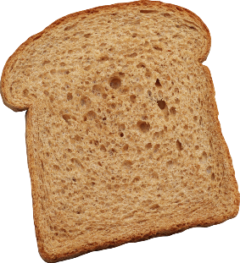

***“These f&*#ing seagulls won’t leave me alone!”*** – Miguel Campos

This page: Table of Contents and Team Member Listing

|  |  |  |
| --- | --- | --- |
| Table of Contents  [1 Game Overview](https://n-xovwktmtjsnaxyc2mwes2xu7pohqedmdm6zjw5q-2lu-script.googleusercontent.com/userCodeAppPanel)  [2 High Concept](https://n-xovwktmtjsnaxyc2mwes2xu7pohqedmdm6zjw5q-2lu-script.googleusercontent.com/userCodeAppPanel)  [3 Unique Selling Points](https://n-xovwktmtjsnaxyc2mwes2xu7pohqedmdm6zjw5q-2lu-script.googleusercontent.com/userCodeAppPanel)  [4 Platform Minimum Requirements](https://n-xovwktmtjsnaxyc2mwes2xu7pohqedmdm6zjw5q-2lu-script.googleusercontent.com/userCodeAppPanel)  [5 Competitors / Similar Titles](https://n-xovwktmtjsnaxyc2mwes2xu7pohqedmdm6zjw5q-2lu-script.googleusercontent.com/userCodeAppPanel)  [6 Synopsis](https://n-xovwktmtjsnaxyc2mwes2xu7pohqedmdm6zjw5q-2lu-script.googleusercontent.com/userCodeAppPanel)  [7 Game Objectives](https://n-xovwktmtjsnaxyc2mwes2xu7pohqedmdm6zjw5q-2lu-script.googleusercontent.com/userCodeAppPanel)  [8 Game Rules](https://n-xovwktmtjsnaxyc2mwes2xu7pohqedmdm6zjw5q-2lu-script.googleusercontent.com/userCodeAppPanel)  [9 Game Structure](https://n-xovwktmtjsnaxyc2mwes2xu7pohqedmdm6zjw5q-2lu-script.googleusercontent.com/userCodeAppPanel)  [10 Game Play](https://n-xovwktmtjsnaxyc2mwes2xu7pohqedmdm6zjw5q-2lu-script.googleusercontent.com/userCodeAppPanel)  [10.1 Game Controls](https://n-xovwktmtjsnaxyc2mwes2xu7pohqedmdm6zjw5q-2lu-script.googleusercontent.com/userCodeAppPanel)  [10.2 Game Camera](https://n-xovwktmtjsnaxyc2mwes2xu7pohqedmdm6zjw5q-2lu-script.googleusercontent.com/userCodeAppPanel)  [10.2.1 HUD](https://n-xovwktmtjsnaxyc2mwes2xu7pohqedmdm6zjw5q-2lu-script.googleusercontent.com/userCodeAppPanel)  [10.2.2 Maps](https://n-xovwktmtjsnaxyc2mwes2xu7pohqedmdm6zjw5q-2lu-script.googleusercontent.com/userCodeAppPanel)  [11 Players](https://n-xovwktmtjsnaxyc2mwes2xu7pohqedmdm6zjw5q-2lu-script.googleusercontent.com/userCodeAppPanel)  [11.1 Characters](https://n-xovwktmtjsnaxyc2mwes2xu7pohqedmdm6zjw5q-2lu-script.googleusercontent.com/userCodeAppPanel)  [11.2 Metrics](https://n-xovwktmtjsnaxyc2mwes2xu7pohqedmdm6zjw5q-2lu-script.googleusercontent.com/userCodeAppPanel)  [11.3 States](https://n-xovwktmtjsnaxyc2mwes2xu7pohqedmdm6zjw5q-2lu-script.googleusercontent.com/userCodeAppPanel)  [11.4 Weapons](https://n-xovwktmtjsnaxyc2mwes2xu7pohqedmdm6zjw5q-2lu-script.googleusercontent.com/userCodeAppPanel)  [12 Player Line-up](https://n-xovwktmtjsnaxyc2mwes2xu7pohqedmdm6zjw5q-2lu-script.googleusercontent.com/userCodeAppPanel)  [13 NPC](https://n-xovwktmtjsnaxyc2mwes2xu7pohqedmdm6zjw5q-2lu-script.googleusercontent.com/userCodeAppPanel)  [13.1 Enemies](https://n-xovwktmtjsnaxyc2mwes2xu7pohqedmdm6zjw5q-2lu-script.googleusercontent.com/userCodeAppPanel)  [13.1.1 Enemy States](https://n-xovwktmtjsnaxyc2mwes2xu7pohqedmdm6zjw5q-2lu-script.googleusercontent.com/userCodeAppPanel)  [13.1.2 Enemy Spawn Points](https://n-xovwktmtjsnaxyc2mwes2xu7pohqedmdm6zjw5q-2lu-script.googleusercontent.com/userCodeAppPanel)  [13.2 Allies / Companions](https://n-xovwktmtjsnaxyc2mwes2xu7pohqedmdm6zjw5q-2lu-script.googleusercontent.com/userCodeAppPanel)  [13.2.1 Ally States](https://n-xovwktmtjsnaxyc2mwes2xu7pohqedmdm6zjw5q-2lu-script.googleusercontent.com/userCodeAppPanel)  [13.2.2 Ally Spawn Points](https://n-xovwktmtjsnaxyc2mwes2xu7pohqedmdm6zjw5q-2lu-script.googleusercontent.com/userCodeAppPanel)  [14 Art](https://n-xovwktmtjsnaxyc2mwes2xu7pohqedmdm6zjw5q-2lu-script.googleusercontent.com/userCodeAppPanel)  [14.1 Setting](https://n-xovwktmtjsnaxyc2mwes2xu7pohqedmdm6zjw5q-2lu-script.googleusercontent.com/userCodeAppPanel)  [14.2 Level Design](https://n-xovwktmtjsnaxyc2mwes2xu7pohqedmdm6zjw5q-2lu-script.googleusercontent.com/userCodeAppPanel)  [14.3 Audio](https://n-xovwktmtjsnaxyc2mwes2xu7pohqedmdm6zjw5q-2lu-script.googleusercontent.com/userCodeAppPanel)  [15 Procedurally Generated Content](https://n-xovwktmtjsnaxyc2mwes2xu7pohqedmdm6zjw5q-2lu-script.googleusercontent.com/userCodeAppPanel)  [15.1 Environment](https://n-xovwktmtjsnaxyc2mwes2xu7pohqedmdm6zjw5q-2lu-script.googleusercontent.com/userCodeAppPanel)  [15.2 Levels](https://n-xovwktmtjsnaxyc2mwes2xu7pohqedmdm6zjw5q-2lu-script.googleusercontent.com/userCodeAppPanel)  [15.3 Artificial Intelligence NPC](https://n-xovwktmtjsnaxyc2mwes2xu7pohqedmdm6zjw5q-2lu-script.googleusercontent.com/userCodeAppPanel)  [15.4 Visual Arts](https://n-xovwktmtjsnaxyc2mwes2xu7pohqedmdm6zjw5q-2lu-script.googleusercontent.com/userCodeAppPanel)  [15.5 Audio](https://n-xovwktmtjsnaxyc2mwes2xu7pohqedmdm6zjw5q-2lu-script.googleusercontent.com/userCodeAppPanel)  [15.6 Minimum Viable Product (MPV)](https://n-xovwktmtjsnaxyc2mwes2xu7pohqedmdm6zjw5q-2lu-script.googleusercontent.com/userCodeAppPanel)  [16 Wish List](https://n-xovwktmtjsnaxyc2mwes2xu7pohqedmdm6zjw5q-2lu-script.googleusercontent.com/userCodeAppPanel)   |  | | --- | |  | | Game Development Team Members    PRODUCER  Miguel Campos    PRODUCTION MANAGER  Miguel Campos    PRODUCTION COORDINATOR  Miguel Campos  GAME DESIGNERS  Miguel Campos  SYSTEMS/IT COORDINATOR  Miguel Campos  PROGRAMMERS  Miguel Campos  TECHNICAL ARTISTS  Miguel Campos  AUDIO ENGINEERS  Miguel Campos  UX TESTERS  Miguel Campos |

|  |
| --- |
|  |

# 1 Game Overview

Title: Pecknic

Platform: PC Standalone, VR (Coming soon)

Genre: First-Person 3D Action

Rating: (10+) ESRB

Target: Casual gamer (aging from 12 - 30)

Release date: February, 2019

Publisher: AndTech, LLC.

Description: This game is a single player action packed beat ‘em up! The game is focused around a quick 5 minute game time and the focus is on destroying incoming seagulls. Try to beat your high score and protect your bread!

# 2 High Concept

Seagulls won’t stop trying to come after your bread, and you’ve only got your fists to settle the situation. Seagulls will spawn all over the map and head towards their nests in the skies, after which they’ll plummet and descend upon some of your food. Protect your food at all costs, the player can use his fists using the mouse buttons to punch away the incoming seagulls.

# 3 Unique Selling Points

Custom Shader

Amazing Bird Sounds

Fast Action Punching Game

Procedurally Generated Content means no game is every the same!

# 4 Platform Minimum Requirements

PC, MAC AND LINUX STANDALONE OS: Windows XP SP2+, Mac OS X 10.8+, Ubuntu 12.04+, SteamOS+ Graphics card: DX9 (shader model 2.0) capabilities; generally everything made since 2004 should work

# 5 Competitors / Similar Titles

BulletBall

Punch-Out!!!

Fortnite

# 6 Synopsis

Seagulls won’t stop trying to come after your bread, and you’ve only got your fists to settle the situation. Show these seagulls who’s boss and beat them down out of the sky with your ‘*Shotgun Fists!™*’.

# 7 Game Objectives

The objective of the game is to survive as long as possible by protecting all of your bread on the map.

# 8 Game Rules

A player is spawned in a small enclosed “park” zone. This zone will change every game ensuring tons of future fun. The player can move around and look up and down, they will use their ‘*Shotgun Fists!™*’ in order to fight away the seagulls.

# 9 Game Structure

Main Menu => Gameplay (Endless) => Losing Screen.

# 10 Game Play

## 10.1 Game Controls

W => Move Forward

S => Move Backwards

A => Strafe Left

D => Strafe Right

Mouse => Aim

Left Click => Left ‘*Shotgun Fist!™*’ Punch

Right Click => Right ‘*Shotgun Fists!™*’ Punch

## 

## 10.2 Game Camera

### 10.2.1 Player

### The game camera is in first person as shown below.

### 10.2.1 HUD

At the top you can see a health bar represented by bread, and a score along with how many seagulls you’ve slain.

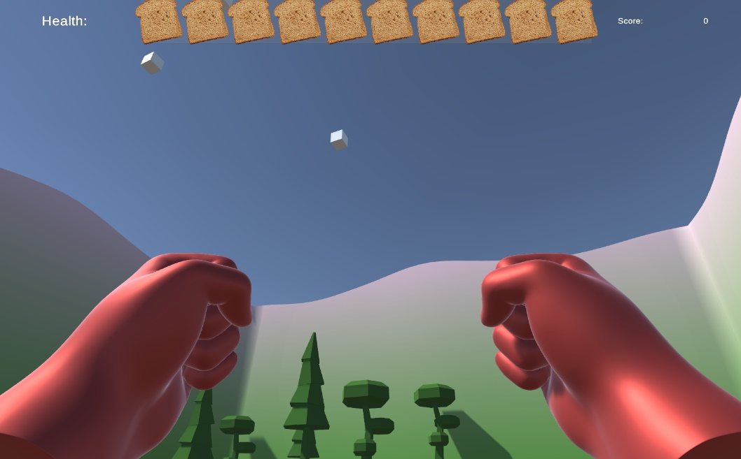

### 10.2.2 Maps

Procedurally generated maps change every time you hit start.

# 

# 11 Players

## 11.1 Characters

There is only 1 character, ‘*Shotgun Fists!™*’-man is the only playable character.

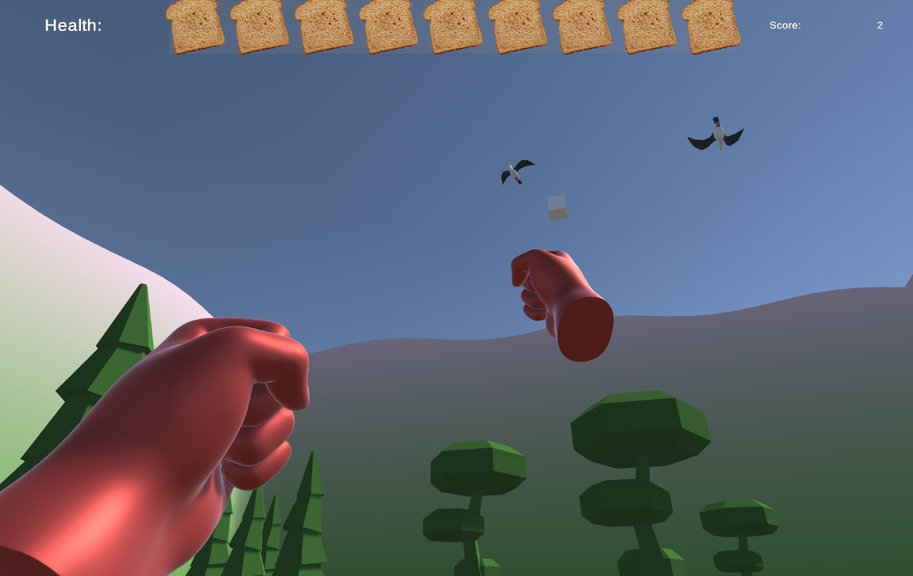

## 11.2 Metrics

Arms fly 3 meters forward, and the punch duration is .2 seconds.

## 11.3 States

Idle: When the player has done nothing both arms will be resting near the camera.

Punching: Each fist may throw a punch individually, this can be seen by the fist moving forward quickly.

## 11.4 Weapons

‘*Shotgun Fists!™*’ is your only weapon.  
  
 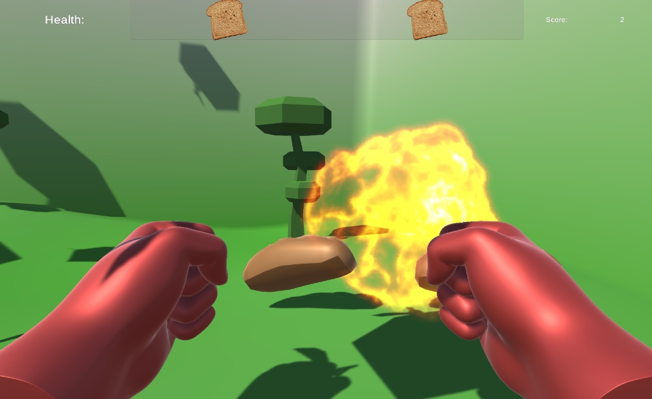

# 13 NPC

## 13.1 Enemies

The seagull is the only enemy in the game.

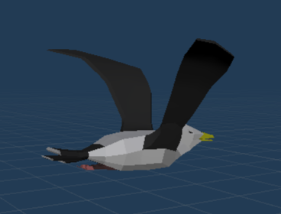

### 13.1.1 Enemy States

A seagull can approach food (bread) or it will approach the nest.

### 13.1.2 Enemy Spawn Points

The enemy is set to spawn randomly within the maps space. The spawn points are randomized for each spawn.

# 14 Art

## 14.1 Setting

You are at a small park, defending your food.

## 14.2 Level Design

The player is enclosed in a small procedurally generated map, random trees will spawn to make it more difficult to walk in reverse. Players are encouraged to look up as often as possible.

## 14.3 Audio

Whimsical music was added, the idea was to make the punches feel satisfying so I went ahead and added a shotgun sound effect.

# 15 Procedurally Generated Content

## 15.1 Environment

The environment is procedurally generated, the heightmap is determined using a PerlinNoise class. This heightmap is used to help determine the rest of the locations for spawning.

## 15.2 Levels

Each level is procedurally generated, the entire terrain is generated first and then all of the enemies and environment and critical structures will be placed.

## 15.3 Artificial Intelligence NPC

Birds are set to randomly select a piece of bread and approach and seek accordingly. Once bread is found it will approach and seek a random nest as well.

## 15.4 Visual Arts

A custom shader was made for the environment, small materials were created for the various colors.

## 15.5 Audio

There are 3 audio clips:

1. There is a “squawk” sound that is played over random intervals on every seagull that spawns.
2. There is a long “music” track which is just environmental squawking noises.
3. There is a short “explosion” sound that is played everytime a bird is punched to death.

# 16 Wish List

1. Different Fists to Equip
2. Different Environments.
3. Ant enemies.
4. Multiplayer
5. Long range punching turrets.
6. VR.