1. Introduction to Python
Python is a high-level, interpreted programming language known for its simplicity and readability. It supports multiple programming paradigms and is widely used in web development, data analysis, artificial intelligence, and more.

Example Code
print('Hello, World!')

2. Variables and Data Types
Variables are used to store data. Python supports various data types including integers, floats, strings, and booleans.
Variable
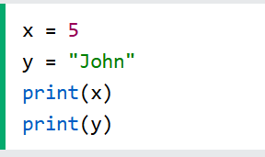
DataType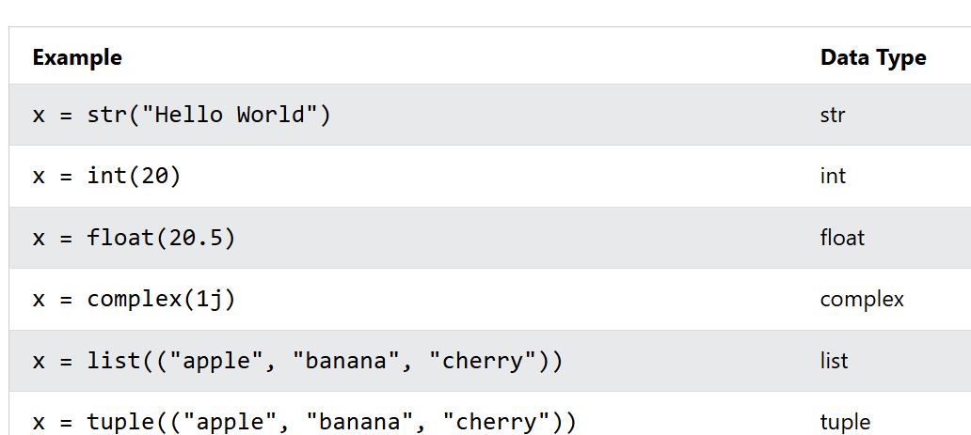

To find the type of the variable we use the line
x=5
print(type(x))
3. Python String Functions
Strings in Python are sequences of characters enclosed in single or double quotes. Python provides many built-in string methods to manipulate and analyze strings.
1. len()
Definition: Returns the length of the string.
text = "Hello"
print(len(text)) # Output: 5

2. lower() / upper()
Definition: Converts all characters to lowercase or uppercase.
text = "Python"
print(text.lower()) # Output: python
print(text.upper()) # Output: PYTHON

3. strip() / lstrip() / rstrip()
Definition: Removes whitespace from both ends (strip), left (lstrip), or right (rstrip).
text = " Hello "
print(text.strip()) # Output: "Hello"
print(text.lstrip()) # Output: "Hello "
print(text.rstrip()) # Output: " Hello"

4. replace(old, new)
Definition: Replaces all occurrences of a substring with another.
text = "I like apples"
print(text.replace("apples", "bananas")) # Output: I like bananas

5. split(separator)
Definition: Splits the string into a list using the specified separator.
text = "apple,banana,grape"
print(text.split(",")) # Output: ['apple', 'banana', 'grape']

6. join(iterable)
Definition: Joins elements of an iterable into a single string using the string as a separator.
fruits = ["apple", "banana", "grape"]
print(", ".join(fruits)) # Output: apple, banana, grape

7. find(substring) / index(substring)
Definition: Returns the index of the first occurrence of a substring. find() returns -1 if not found, index() raises an error.
text = "hello world"
print(text.find("world")) # Output: 6
print(text.index("world")) # Output: 6

8. startswith(prefix) / endswith(suffix)
Definition: Checks if the string starts or ends with the given substring.
text = "hello world"
print(text.startswith("hello")) # Output: True
print(text.endswith("world")) # Output: True

9. isalpha() / isdigit() / isalnum()
Definition: Checks if all characters are alphabetic, digits, or alphanumeric.
print("abc".isalpha()) # True
print("123".isdigit()) # True
print("abc123".isalnum())# True

10. capitalize() / title()
Definition: Capitalizes the first character or each word.
text = "hello world"
print(text.capitalize()) # Output: Hello world
print(text.title()) # Output: Hello World

11. `swapcase()`
Definition: Swaps the case of each character in the string (uppercase becomes lowercase and vice versa).
python
text = "Hello World"
print(text.swapcase()) # Output: hELLO wORLD
4. Python Boolean Types
In programming you often need to know if an expression is True or False.
You can evaluate any expression in Python, and get one of two answers, True or False.
When you compare two values, the expression is evaluated and Python returns the Boolean answer:
print(10 > 9) // True
print(10 == 9) // False
print(10 < 9) // False

5. Python Collections (Arrays)

There are four collection data types in the Python programming language

List is a collection which is ordered and changeable. Allows duplicate members.

Tuple is a collection which is ordered and changeable. Allows duplicate members.

Set is a collection which is unordered, unchangeable*, and unindexed. No duplicate members.

Dictionary is a collection which is ordered** and changeable. No duplicate members.
1. List
- Definition: Ordered, mutable (changeable), and allows duplicate elements.
- Syntax: my_list = [1, 2, 3]
Common Functions:
mylist = [1, 2, 3, 4]

mylist.append(5) # Adds 5 to the end
mylist.insert(1, 10) # Inserts 10 at index 1
mylist.remove(2) # Removes the first occurrence of 2
mylist.pop() # Removes and returns the last item
mylist.sort() # Sorts the list

2. Tuple
- Definition: Ordered, immutable (cannot be changed), and allows duplicates.
- Syntax: my_tuple = (1, 2, 3)
Common Functions:
mytuple = (10, 20, 30)

print(mytuple.count(20)) # Counts occurrences of 20
print(my_tuple.index(30)) # Returns index of 30

3. Set
- Definition: Unordered, mutable, and does not allow duplicates.
- Syntax: my_set = {1, 2, 3}
Common Functions:
myset = {1, 2, 3}

myset.add(4) # Adds 4 to the set
myset.remove(2) # Removes 2 from the set
myset.discard(5) # Removes 5 if present, no error if not
my_set.clear() # Removes all elements
Set Operations:
a = {1, 2, 3}
b = {3, 4, 5}

print(a.union(b)) # {1, 2, 3, 4, 5}
print(a.intersection(b)) # {3}
print(a.difference(b)) # {1, 2}

4. Dictionary
- Definition: Unordered (as of Python 3.7, insertion order is preserved), mutable, and stores key-value pairs.
- Syntax: my_dict = {'name': 'Alice', 'age': 25}
Common Functions:
mydict = {'name': 'Alice', 'age': 25}

print(mydict['name']) # Access value by key
mydict['age'] = 26 # Update value
mydict['city'] = 'Chennai' # Add new key-value pair
del mydict['name'] # Delete key-value pair
print(mydict.keys()) # Get all keys
print(mydict.values()) # Get all values
print(mydict.items()) # Get all key-value pairs
6. Loop and condition Statement

if Statement
Used for conditional execution.
x = 10

if x > 0:
print("x is positive")
elif x == 0:
print("x is zero")
else:
print("x is negative")

match Statement (Python 3.10+)
Used for pattern matching, similar to switch in other languages.
statuscode = 404

match statuscode:
case 200:
print("OK")
case 404:
print("Not Found")
case 500:
print("Server Error")
case _:
print("Unknown Status")

for Loop
Used to iterate over a sequence (like a list).
fruits = ["apple", "banana", "cherry"]

for fruit in fruits:
print(f"I like {fruit}")

while Loop
Used to repeat as long as a condition is true.
count = 0

while count < 5:
print(f"Count is {count}")

7. Functions in python
A function in Python is a reusable block of code that performs a specific task. Functions help organize code, reduce repetition, and improve readability.
🔹 Basic Syntax
def function_name(parameters):
# code block
return result
🔹 Types of Function Arguments in Python
Python supports several types of function arguments:
Type | Description
Required/Positional | Must be passed in the correct order
Default | Has a default value if not provided
Keyword | Passed using key=value format
Variable-length (*args) | Accepts multiple positional arguments
Variable-length (**kwargs) | Accepts multiple keyword arguments

1. Positional Arguments
def greet(name, age):
print(f"{name} is {age} years old.")

greet("Guru", 30)

🔹 2. Default Arguments
def greet(name, age=25):
print(f"{name} is {age} years old.")

greet("Guru") # Uses default age
greet("Guru", 30) # Overrides default

🔹 3. Keyword Arguments
def greet(name, age):
print(f"{name} is {age} years old.")

greet(age=30, name="Guru") # Order doesn't matter

🔹 4. Variable-Length Positional Arguments (*args)
- Collects extra positional arguments into a tuple.
def addnumbers(*args):
print("Arguments:", args)
print("Sum:", sum(args))

addnumbers(10, 20, 30)

🔹 5. Variable-Length Keyword Arguments (**kwargs)
- Collects extra keyword arguments into a dictionary.
def showinfo(kwargs):
for key, value in kwargs.items():
print(f"{key}: {value}")

showinfo(name="Guru", role="Engineer", location="Chennai")

🔹 6. Combining All Argument Types
def fullfunction(name, age=25, skills, *details):
print(f"Name: {name}, Age: {age}")
print("Skills:", skills)
print("Details:", details)

fullfunction("Guru", 30, "Python", "Django", location="Chennai", company="TechCorp")
Output:
Name: Guru, Age: 30
Skills: ('Python', 'Django')
Details: {'location': 'Chennai', 'company': 'TechCorp'}

🔹 Argument Unpacking with * and **
You can also unpack arguments when calling a function:
def greet(name, age):
print(f"{name} is {age} years old.")

args = ("Guru", 30)
kwargs = {"name": "Guru", "age": 30}

greet(args) # Unpacks tuple
greet(*kwargs) # Unpacks dictionary
8. Array and their function in python
Python lists are dynamic arrays. Here are the most useful functions:
Function | Description | Example
append() | Adds an element to the end | arr.append(5)
insert() | Inserts element at a specific index | arr.insert(2, 10)
extend() | Adds multiple elements | arr.extend([6, 7])
remove() | Removes first occurrence of a value | arr.remove(10)
pop() | Removes and returns element at index | arr.pop(1)
index() | Returns index of first occurrence | arr.index(20)
count() | Counts occurrences of a value | arr.count(30)
sort() | Sorts the array in ascending order | arr.sort()
reverse() | Reverses the array | arr.reverse()
clear() | Removes all elements | arr.clear()
copy() | Returns a shallow copy | new_arr = arr.copy()
9.Python OOPS concept
Python OOPs (Object-Oriented Programming) – Full Concept
Python supports Object-Oriented Programming (OOP), which is a programming paradigm based on the concept of objects and classes. It helps organize code, promote reusability, and model real-world entities.

Key OOP Concepts in Python
Concept | Description
Class | Blueprint for creating objects
Object | Instance of a class
Inheritance | Ability to inherit properties and methods from another class
Polymorphism | Ability to use a unified interface for different data types

1. Class and Object
class Person:
def init(self, name, age): # Constructor
self.name = name
self.age = age

def greet(self):
print(f"Hello, my name is {self.name} and I am {self.age} years old.")

# Creating an object
p1 = Person("Guru", 30)
p1.greet()

2. Inheritance
Inheritance allows one class to inherit the attributes and methods of another.
class Animal:
def speak(self):
print("Animal speaks")

class Dog(Animal):
def speak(self):
print("Dog barks")

d = Dog()
d.speak() # Output: Dog barks

3. Polymorphism
Polymorphism allows different classes to be treated through the same interface.
class Cat:
def sound(self):
print("Meow")

class Dog:
def sound(self):
print("Bark")

def makesound(animal):
animal.sound()

makesound(Cat())
make_sound(Dog())
10.Python RegEx
Function Description
findall Returns a list containing all matches
search Returns a Match object if there is a match anywhere in the string
split Returns a list where the string has been split at each match
sub Replaces one or many matches with a string

Character Description Example
[] A set of characters "[a-m]"
\ Signals a special sequence (can also be used to escape special characters) "\d"
. Any character (except newline character) "he..o"
^ Starts with "^hello"
$ Ends with "planet$"
* Zero or more occurrences "he.*o"
+ One or more occurrences "he.+o"
? Zero or one occurrences "he.?o"
{} Exactly the specified number of occurrences "he.{2}o"
Character | Description | Example | Try it
\A | Returns a match if the specified characters are at the beginning of the string | "\AThe"
\b | Returns a match where the specified characters are at the beginning or at the end of a word  (the "r" in the beginning is making sure that the string is being treated as a "raw string") | r"\bain"  r"ain\b"
\B | Returns a match where the specified characters are present, but NOT at the beginning (or at the end) of a word  (the "r" in the beginning is making sure that the string is being treated as a "raw string") | r"\Bain"  r"ain\B"
\d | Returns a match where the string contains digits (numbers from 0-9) | "\d"
\D | Returns a match where the string DOES NOT contain digits | "\D"
\s | Returns a match where the string contains a white space character | "\s"
\S | Returns a match where the string DOES NOT contain a white space character | "\S"
\w | Returns a match where the string contains any word characters (characters from a to Z, digits from 0-9, and the underscore _ character) | "\w"
\W | Returns a match where the string DOES NOT contain any word characters | "\W"
\Z | Returns a match if the specified characters are at the end of the string | "Spain\Z"

