

SEKOLAH MENENGAH SAINS BANTING

***SCENTAC***

# “WHERE IDEAS MEET POSSIBILITY”

SUPERVISOR :

1) MADAM. SITI ALIA BINTI ISMAIL

TEAM MEMBERS :

1. MUHAMMAD DARWISH THAQEEF
2. MUHAMMAD AMIR HAFIY
3. MUHAMMAD SYAZMI FADHLULLAH

# 1.0 APPRECIATION

Our utmost gratitude to our headmaster, Mr Yusanizan Bin Shafie, for being gracious by allowing us to participate in the Malaysia International Young Inventors Olympiad (MIYIO) and thus create this project. Also, many thanks directed towards Teacher Alia, our supervisor for the project for leading us in the process of the products development. Finally, we also thank everyone who have helped us, either directly or indirectly such as the respondents for the survey and our parents for the needed emotional support. Without all of you, this product would’ve not come to fruition.

# 2.0 ABSTRACT

In a world engineered for sound, silence can be disruptive. For millions of deaf and hard-of-hearing individuals, everyday routines—like waking up for school, work, or appointments—are often disrupted by the exclusive reliance on sound-based alarm clocks. As the World Health Organization (2021) projects that nearly 700 million people will have hearing loss disabling by 2050, the need for inclusive daily tools is more urgent than ever. Lane, Hoffmeister, and Bahan (1996) state, “Deaf people are not disabled by their ears but by society’s failure to accommodate their differences.” Our project addresses this need through a non-auditory, olfactory-based alarm system that uses fast-dispersing, alerting scents like peppermint and citrus to gently wake users from sleep. Grounded in research on scent perception during sleep (e.g., Arzi et al., 2012), we conducted a survey with deaf participants to assess the concept’s practicality and user preference. Responses indicated strong interest, high perceived effectiveness, and greater comfort than vibration or light-based alarms. This project transforms waking up into an inclusive, multisensory experience for everyone.

# 3.0 CONTENTS OF IDEA 3.1 INTRODUCTION

In general, a normal human being has five main senses: sight, hearing, smell, taste, and touch. However, some people possess **sensory disabilities,** such as being deaf. As a result, these people **face disruptions in their daily lives,** such as communicating with other people, buying essentials, and waking up on time.

Thus, we came up with the idea to **build a device that would help** one of the most important daily routines, which is **waking up**. This repercussion gave rise to a solution on how to make sure deaf people get to **wake up on time using an alarm clock**. It is known that alarm clocks wake individuals with loud sounds. But **the question is, how can deaf people wake up if they suffer from hearing disabilities?**

# 3.2 PROBLEM STATEMENTS

* Ineffectiveness of traditional alarm clocks in waking deaf people.
* Traditional methods of automated wake-up are not suited for people with hearing disability.
* No proper solution exists to wake up deaf people.

# 3.3 OBJECTIVES

* To develop a non-auditory wake-up device that uses scent stimulation to assist individuals with hearing disabilities.
* To explore the effectiveness of olfactory (smell-based) stimuli as a reliable method for waking people from sleep.
* To test and evaluate the device’s performance through user feedback and continuous improvement.

# 3.4 HYPOTHESIS

Our studies throughout in making SCENTAC hypothesizes that an olfactory alarm clock, can be as effective as a traditional sound-based alarm in waking individuals. It is expected that scent-based stimuli, especially with strong or stimulating scents such as citrus, peppermint and coffee will trigger wakefulness and alertness, offering a gentle yet efficient alternative to sound.

# 3.5 SCOPE OF STUDY

This study focuses on evaluating the effectiveness of an olfactory alarm clock, specifically the SCENTAC prototype, in waking individuals using scent-based stimuli. It examines response time, alertness, and user experience compared to traditional sound-based alarms. The research is limited to healthy participants within a controlled indoor environment, and primarily tests stimulating scents such as peppermint or citrus.

# 4.0 METHODOLOGY

In making this device a reality, we used various types of components and tools such as the following:

4.1 COMPONENTS

1. Generic Wooden Alarm Clock

2. 5V SPDT relay module,

3. Seed Grove Atomizer

4. Acrylic internal Water Tank

5. DC 5V Charger

# 4.2 TOOLS

1. Soldering Iron

2. Laptop

3. Hot glue gun

4. Pillip and flathead screwdriver

5. Acrylic board

6. Handsaw

7. G-Clamp

# 4.3 PROCESSES

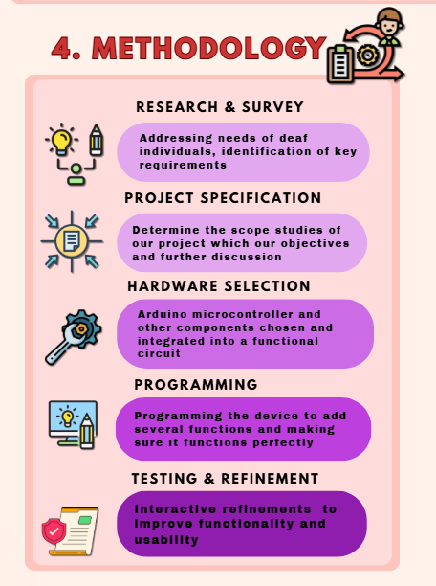

# 4.4 SCENT – BASED WAKE UP SYSTEM

This project uses **essential oils** such as citrus, mint, and coffee in a scent-based wake-up, system that can **stimulate the brain**. Studies confirm that scent-based stimulation positively affects alertness, memory, and reaction time, offering a gentle, non-auditory wake-up method.

* CITRUS

These scents are linked to increased serotonin levels, which can **boost mood and energy.** They promote feelings of positivity and alertness, helping to reduce feelings of fatigue and increase mental clarity.

* MINT ( PEPPERMINT )

Mint scents are known to improve concentration and cognitive performance. They stimulate the brain's focus centers, **increasing attention span and mental sharpness**, which can help with clearer thinking and problem-solving.

* COFFEE ( AROMA )

Even without caffeine, the scent of coffee can **enhance wakefulness**. The familiar aroma of coffee triggers psychological associations with energy and alertness, leading to increased wakefulness and heightened senses.

# 4.5 SUSTAINABILITY ELEMENTS

To ensure this device is based on current world global technology and economic conditions, we add some sustainability elements such as the following below:

* SCENT REFILL SYSTEM

Instead of disposable scent cartridges, we design **refillable essential oil container**. This reduces the need for single-use plastic.

* ECO – FRIENDLY MATERIALS

We **use recycled plastic** for the casing and container. Biodegradable materials or sustainably sourced plastics can reduce environmental impact.

# 5.0 CONCLUSION

# 5.1 ROUGH MODEL

 

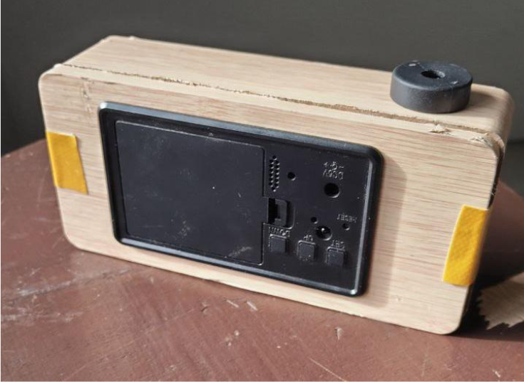 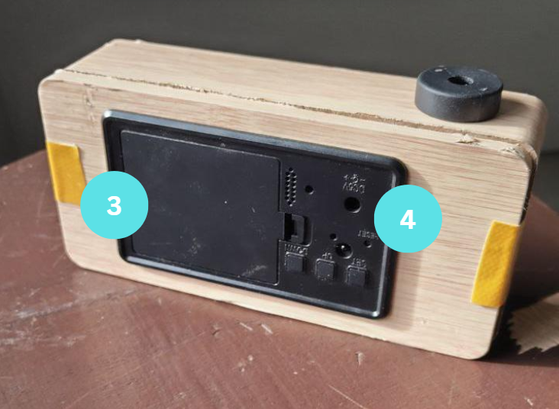

5.2 FUNCTION

**EXTERNAL**

1) CHAMBER

* To spread scents in vapour state

2) CLOCK DISPLAY

* To display real time

3) BATTERY COMPARTMENT

* Store batteries

4) MODE BUTTON

* To set clock display and alarm

**INTERNAL**

1) FRAGRANCE TANK

* Store fragrance

2) SYSTEM COMPARTMENT

* Main base for clock system

5.3 IMPACTS

1) SOCIAL IMPACT

* **Inclusivity for the Deaf Community:**

SCENTAC directly addresses the lack of suitable wake-up devices for deaf or hard-of-hearing individuals. By using scent instead of sound or vibration, it enables them to wake up independently, promoting dignity and self-reliance.

2) PSYCHOLOGICAL IMPACT

* **Gentle and Pleasant Wake-Up Experience:**

Using calming or invigorating scents (like citrus or peppermint) avoids the jarring nature of sound or vibration. This can lead to improved mood and reduced stress upon waking.

3) ENVIRONMENTAL IMPACT

* **Sustainability Features:**

SCENTAC incorporates:

* + **Refillable essential oil system** – minimizing plastic waste.
  + **Eco-friendly casing materials** – using recycled plastics.

4) TECHNOLOGICAL IMPACT

* **Innovation in Alarm Technology:**

It introduces a new sensory method (olfactory) into alarm systems, expanding the possibilities beyond sound and vibration.

* **Smart Integration Potential:**

With proposed future upgrades (like app connectivity and scent rotation systems), SCENTAC could contribute to the broader development of smart, inclusive home technologies.

# 6.0 SUMMARIES

Our learning journey throughout discussing and planning out the details of this project is by **replacing conventional auditory or vibration alarms with a gentle aroma-triggered mechanism**. The device offers a safe, comfortable, and user-friendly alternative for waking deaf users. Grounded in user-centered research, the design incorporates essential requirements such as safety, effectiveness, and ease of use.

Through practical testing, the system was refined to optimize comfort, wake-up efficiency, and usability. The results confirm that scent-based stimulation can serve as a viable alternative to traditional alarms, particularly for individuals with hearing impairments. This project not only highlights the potential of multi-sensory design solutions but also contributes to improving accessibility and quality of life for the deaf community.

# 7.0 IMPROVEMENTS

In the future, we would advance our product into a more comprehensive device. These are a few of our ideas for improvements:

* SMART ALARM INTEGRATION

Future versions of the system can be enhanced by **integrating with smartphone apps or IoT platforms (Applications, Bluetooth or Wi-Fi)**, allowing users to conveniently set alarms, customize scent preferences, or even track sleep patterns.

* MULTI – SCENT CARTRIDGE SYSTEM

A more advanced scent cartridge mechanism could **include multiple** **scent chambers**, automatically rotating different aromas to prevent scent habituation and maintain effectiveness over time.

# 8.0 REFERENCES

* Herz, R.S. (2009). Aromatherapy facts and fictions: A scientific analysis of olfactory effects on mood, physiology and behavior. International Journal of Neuroscience.
* Moss, M., et al. (2003). Aromas of rosemary and lavender essential oils differentially affect cognition and mood in healthy adults. International Journal of Neuroscience.
* Sayorwan, W., et al. (2012). Effects of inhaled essential oils on brain wave activity and subjective feelings. Evidence-Based Complementary and Alternative Medicine.

**RESEARCH**

# **[Sense of smell in deaf and blind patients]**

[Article in German]

[H Diekmann](https://pubmed.ncbi.nlm.nih.gov/?term=Diekmann+H&cauthor_id=8050914)[1](https://pubmed.ncbi.nlm.nih.gov/8050914/#full-view-affiliation-1), [M Walger](https://pubmed.ncbi.nlm.nih.gov/?term=Walger+M&cauthor_id=8050914), [H von Wedel](https://pubmed.ncbi.nlm.nih.gov/?term=von+Wedel+H&cauthor_id=8050914)

Affiliations Expand

PMID: 8050914

## **Abstract**

The olfactory performances of 10 visually-impaired and 9 hearing-impaired subjects were investigated by a psychophysical sniffing test (the Munich Olfaction Test). These subjects were compared with 21 control volunteers who completed the test with covered eyes, 20 control volunteers whose ears were plugged during the test and with 22 unimpaired controls. The test examined discrimination performances, detection and perception thresholds, identification abilities, olfactory memory, and hedonistic evaluations of all subjects. The present results showed that attention focusing on olfactory tasks by lowering of auditory or visual inputs did not enhance the olfactory performances of the control subjects. Also, the visually-impaired subjects did not perform better then the control subjects. The diminished olfactory abilities of the hearing-impaired were discussed against the background of delayed language acquisition.

Source : <https://pmc.ncbi.nlm.nih.gov/articles/PMC8891647/>

### **🌿 Peppermint & Wakefulness**

1. **Modulation of cognitive performance and mood by aromas of peppermint and ylang-ylang**  
    – PubMed abstract: peppermint increases alertness and improves memory. [pmc.ncbi.nlm.nih.gov+14pubmed.ncbi.nlm.nih.gov+14pubmed.ncbi.nlm.nih.gov+14](https://pubmed.ncbi.nlm.nih.gov/18041606/?utm_source=chatgpt.com)[pubmed.ncbi.nlm.nih.gov+2verywellmind.com+2pubmed.ncbi.nlm.nih.gov+2](https://www.verywellmind.com/does-rosemary-actually-improve-your-memory-4156875?utm_source=chatgpt.com) Link: <https://pubmed.ncbi.nlm.nih.gov/18041606/>
2. **Sleep changes vary by odor perception in young adults**  
    – Peppermint reduced fatigue and boosted alertness before bedtime. [pubmed.ncbi.nlm.nih.gov](https://pubmed.ncbi.nlm.nih.gov/18041606/?utm_source=chatgpt.com)[pubmed.ncbi.nlm.nih.gov](https://pubmed.ncbi.nlm.nih.gov/16143443/?utm_source=chatgpt.com) Link: <https://pubmed.ncbi.nlm.nih.gov/16143443/>
3. **Preliminary investigation of the effect of peppermint oil on an objective measure of daytime sleepiness**  
    – Peppermint limited sleepiness in low-stimulus conditions. [pubmed.ncbi.nlm.nih.gov](https://pubmed.ncbi.nlm.nih.gov/16143443/?utm_source=chatgpt.com)[pubmed.ncbi.nlm.nih.gov](https://pubmed.ncbi.nlm.nih.gov/15708642/?utm_source=chatgpt.com) Link: <https://pubmed.ncbi.nlm.nih.gov/15708642/>

### **🌿 Rosemary & Cognitive Enhancement**

1. **Aromas of rosemary and lavender essential oils differentially affect cognition and mood in healthy adults**  
    – Rosemary aroma improved memory and alertness. [verywellhealth.com+10pubmed.ncbi.nlm.nih.gov+10pubmed.ncbi.nlm.nih.gov+10](https://pubmed.ncbi.nlm.nih.gov/12690999/?utm_source=chatgpt.com)[pmc.ncbi.nlm.nih.gov+1reddit.com+1](https://pmc.ncbi.nlm.nih.gov/articles/PMC7491497/?utm_source=chatgpt.com) Link: <https://pubmed.ncbi.nlm.nih.gov/12690999/>
2. **Therapeutic effects of rosemary… on nervous system disorders** (PMC full text)  
    – Inhaling rosemary boosted mood and cognitive performance in 144 volunteers. [pubmed.ncbi.nlm.nih.gov](https://pubmed.ncbi.nlm.nih.gov/12690999/?utm_source=chatgpt.com)[reddit.com+5pmc.ncbi.nlm.nih.gov+5pubmed.ncbi.nlm.nih.gov+5](https://pmc.ncbi.nlm.nih.gov/articles/PMC7491497/?utm_source=chatgpt.com) Link: <https://pmc.ncbi.nlm.nih.gov/articles/PMC7491497/>
3. **Plasma 1,8‑cineole correlates with cognitive performance following exposure to rosemary essential oil aroma**  
    – Better cognitive speed and accuracy correlated with absorbed rosemary compound. [pmc.ncbi.nlm.nih.gov+1ncbi.nlm.nih.gov+1](https://pmc.ncbi.nlm.nih.gov/articles/PMC7491497/?utm_source=chatgpt.com)[ncbi.nlm.nih.gov+3pubmed.ncbi.nlm.nih.gov+3verywellmind.com+3](https://pubmed.ncbi.nlm.nih.gov/23983963/?utm_source=chatgpt.com) Link: <https://pubmed.ncbi.nlm.nih.gov/23983963/>

### **👂 Deaf Individuals & Olfaction**

1. **Sense of smell in deaf and blind patients**  
    – Hearing-impaired individuals showed slightly reduced olfactory ability. [pmc.ncbi.nlm.nih.gov+3pubmed.ncbi.nlm.nih.gov+3pubmed.ncbi.nlm.nih.gov+3](https://pubmed.ncbi.nlm.nih.gov/23983963/?utm_source=chatgpt.com)[verywellmind.com+15pubmed.ncbi.nlm.nih.gov+15en.wikipedia.org+15](https://pubmed.ncbi.nlm.nih.gov/8050914/?utm_source=chatgpt.com) Link: <https://pubmed.ncbi.nlm.nih.gov/8050914/>

### **✅ Summary of Positive Effects**

* **Peppermint** helps reduce tiredness and boosts alertness in both day and night conditions.
* **Rosemary** improves memory, mood, and focus—especially by increasing brain activity and blood flow.
* Though **deaf individuals** may have mildly lower smell performance on average, these stimulating aromas **still activate brain alertness mechanisms** that can enhance wakefulness in everyone, including those who are deaf.

## **🌟 How Smell Can Wake You Up**

1. **Peppermint helps you feel alert**
   1. Scientists studied people who were sleepy and found that the smell of **peppermint** made them more awake and reduced tiredness [pmc.ncbi.nlm.nih.gov+11pmc.ncbi.nlm.nih.gov+11pmc.ncbi.nlm.nih.gov+11](https://pmc.ncbi.nlm.nih.gov/articles/PMC3231408/?utm_source=chatgpt.com).
2. **Rosemary boosts concentration**
   1. When people sniffed **rosemary oil**, brain waves linked to focus and memory went up—a sign of improved concentration [reddit.com+3reddit.com+3reddit.com+3](https://www.reddit.com/r/transhumanism/comments/1bj9n1s?utm_source=chatgpt.com)[mdpi.com+2pmc.ncbi.nlm.nih.gov+2reddit.com+2](https://pmc.ncbi.nlm.nih.gov/articles/PMC9102723/?utm_source=chatgpt.com).
3. **Other fresh scents help too**
   1. Scents like **citrus (lemon, orange)** and **eucalyptus** were also shown to increase alertness and reduce fatigue in drivers and shift workers .

## **👂 What This Means for Deaf People**

There aren’t many studies specifically on deaf people into how smell affects wakefulness. But here’s what scientists know:

* **Smell works directly on the brain's alert system**, not through hearing.  
   When you inhale a stimulating scent, it sends signals to parts of your brain that control attention and energy—this works whether you can hear or not [pmc.ncbi.nlm.nih.gov+15pmc.ncbi.nlm.nih.gov+15ncbi.nlm.nih.gov+15](https://pmc.ncbi.nlm.nih.gov/articles/PMC3231408/?utm_source=chatgpt.com).
* So even if someone is deaf, **cooling smells like peppermint or memory-boosting smells like rosemary** will still help them feel more awake and attentive.

## **📚 Source Links**

Here are the studies, one by one:

1. **Cognitive Facilitation Following Intentional Odor Exposure** – Shows peppermint improves alertness and vigilance.  
    <https://www.ncbi.nlm.nih.gov/pmc/articles/PMC3231408/> [pmc.ncbi.nlm.nih.gov+1pmc.ncbi.nlm.nih.gov+1](https://pmc.ncbi.nlm.nih.gov/articles/PMC11219708/?utm_source=chatgpt.com)[pmc.ncbi.nlm.nih.gov](https://pmc.ncbi.nlm.nih.gov/articles/PMC3231408/?utm_source=chatgpt.com)
2. **Sleep changes vary by odor perception in young adults** – Found peppermint reduced fatigue and improved mood/alertness.  
    <https://pubmed.ncbi.nlm.nih.gov/16143443/> [pmc.ncbi.nlm.nih.gov+7pubmed.ncbi.nlm.nih.gov+7pubmed.ncbi.nlm.nih.gov+7](https://pubmed.ncbi.nlm.nih.gov/16143443/?utm_source=chatgpt.com)
3. **Effects of Olfactory Stimulation with Aroma Oils on Psychophysiological Responses** – Study on multiple oils (peppermint and rosemary included) showing brain activity linked to relaxation and concentration.  
    <https://pmc.ncbi.nlm.nih.gov/articles/PMC9102723/> [reddit.com+11pmc.ncbi.nlm.nih.gov+11pubmed.ncbi.nlm.nih.gov+11](https://pmc.ncbi.nlm.nih.gov/articles/PMC9102723/?utm_source=chatgpt.com)
4. **A scoping review of olfactory interventions for fatigue relief** – Highlights peppermint and rosemary enhancing alertness and reducing fatigue in various settings.  
    <https://pmc.ncbi.nlm.nih.gov/articles/PMC11239415/> [pmc.ncbi.nlm.nih.gov+1pmc.ncbi.nlm.nih.gov+1](https://pmc.ncbi.nlm.nih.gov/articles/PMC11239415/?utm_source=chatgpt.com)

### **👨‍🏫 Simple Explanation**

* **Imagine**: You're deaf, but your nose is like a little messenger super-fast to your brain.
* When you smell **peppermint**, it’s like a lightning bolt that says "Wake up!"
* When you smell **rosemary**, it's like your brain gets a cup of coffee—focused and ready.

Even without hearing, your brain gets these wake-up signals from your nose. Isn’t that cool?