Week 4 Assignment
Azure Cloud Fundamentals and Data Pipeline Implementation using ADF

For this week's assignment, I worked on setting up the basic building blocks of Azure cloud and used them to create a data pipeline in Azure Data Factory (ADF). I used the Superstore sales CSV file as the dataset for the whole exercise. Below are the screenshots for each task along with what I did at each step.

Task 1: Resource Group
I started by creating a resource group called resogp-cei-w4 under the Azure for Students subscription, in the Central India region. This resource group is where all the other resources for this week (storage account and data factory) are kept together.
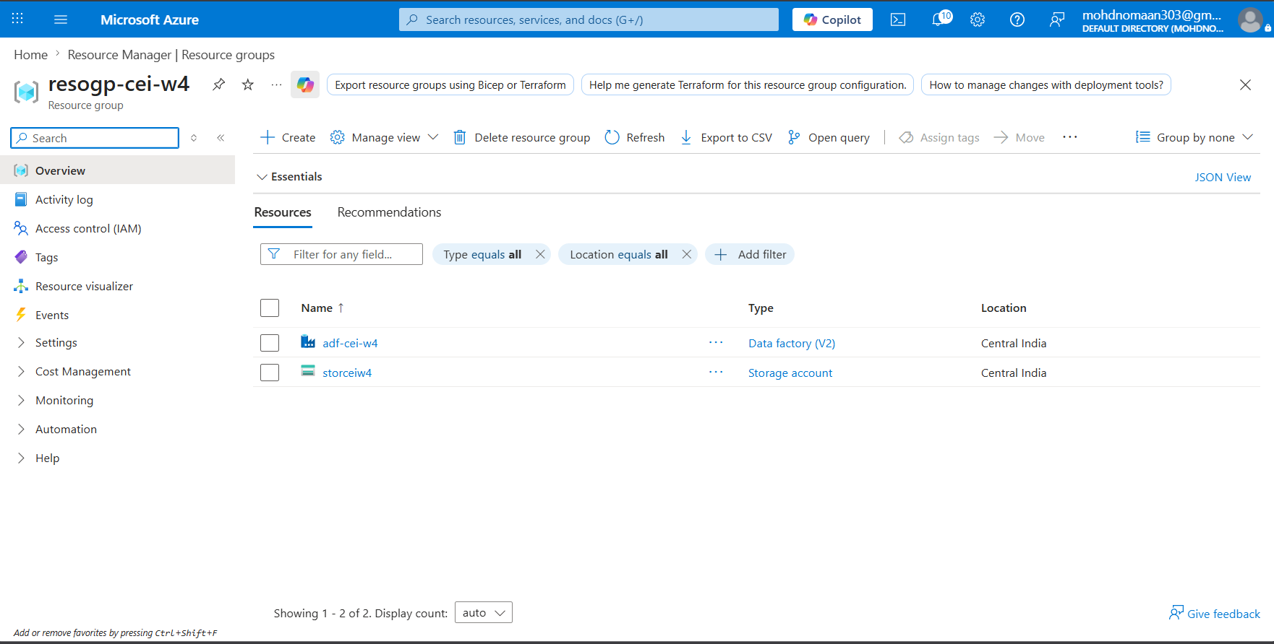
Resource group resogp-cei-w4 showing the storage account and data factory inside it

Task 2: Storage Setup
Next I created a storage account named storceiw4, and inside it a blob container called superstore-container. I uploaded the Superstore_raw.csv file into this container, which is the source file used later in the pipeline.
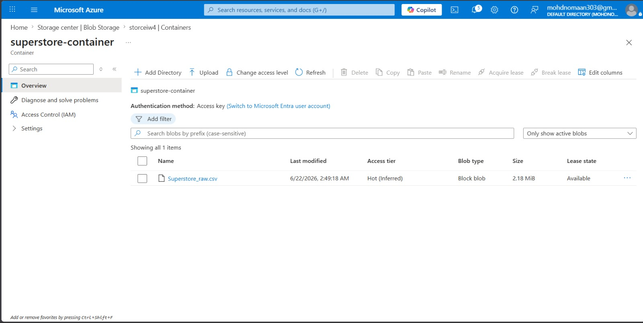
superstore-container showing Superstore_raw.csv uploaded (2.18 MiB)

Task 3: ADF Basics
I created an Azure Data Factory (adf-cei-w4) and opened ADF Studio to explore the Author, Monitor and Manage sections. Under Manage, I created a Linked Service called ls_superstore_blob that connects ADF to the blob storage account. Then I created two datasets — one for the source file and one for the destination file — both using this linked service.
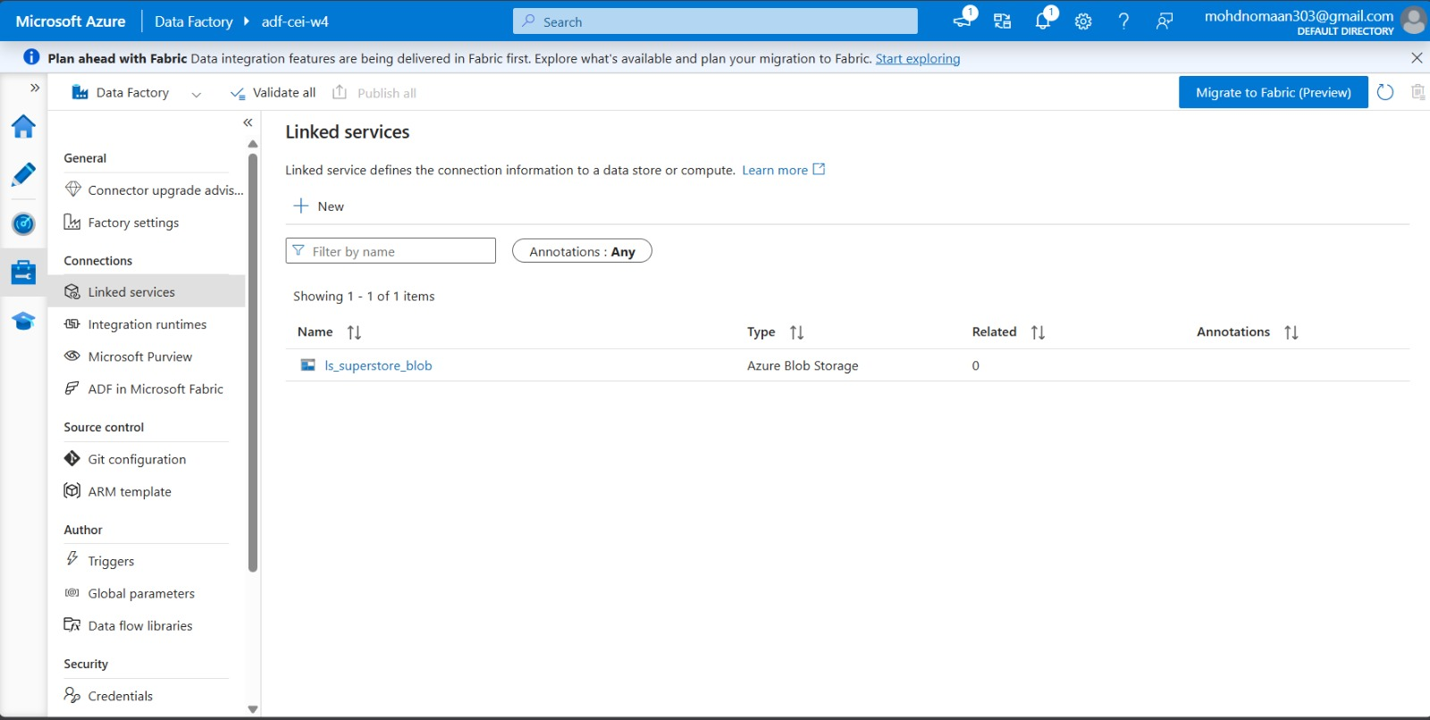
Linked service ls_superstore_blob connected to Azure Blob Storage
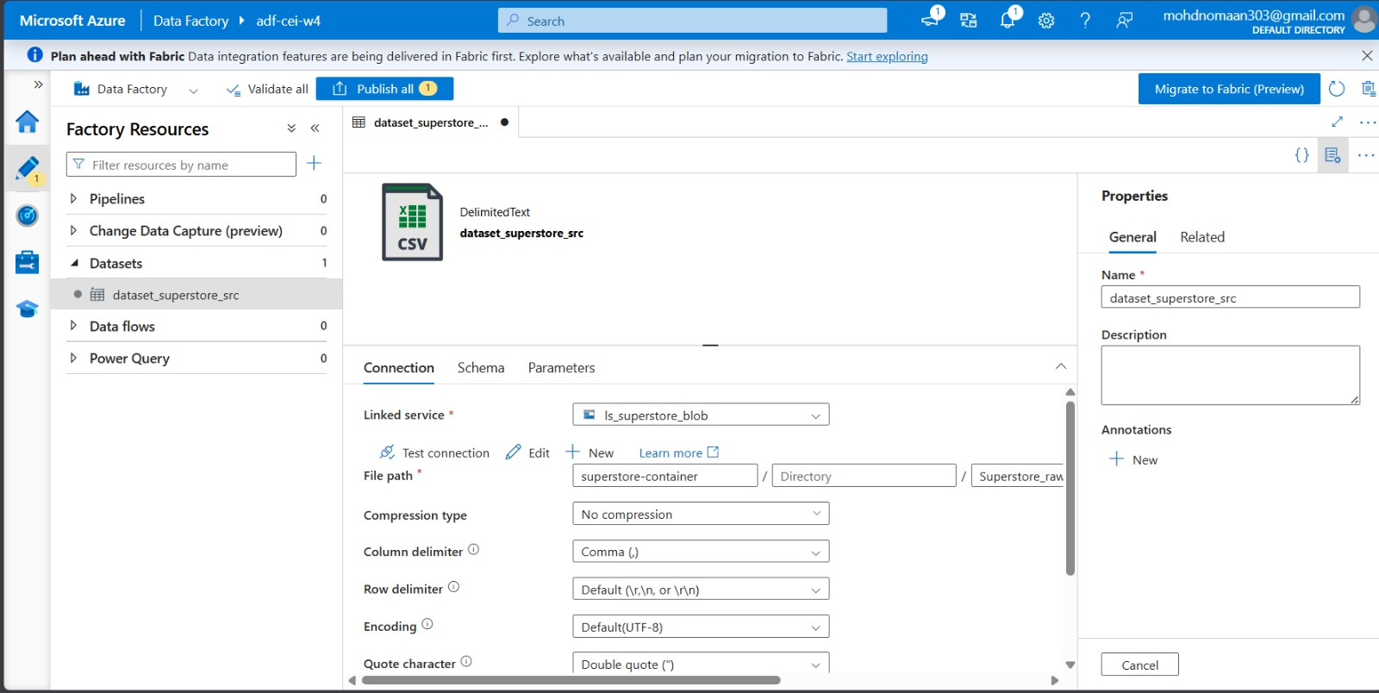
Source dataset dataset_superstore_src pointing to Superstore_raw.csv
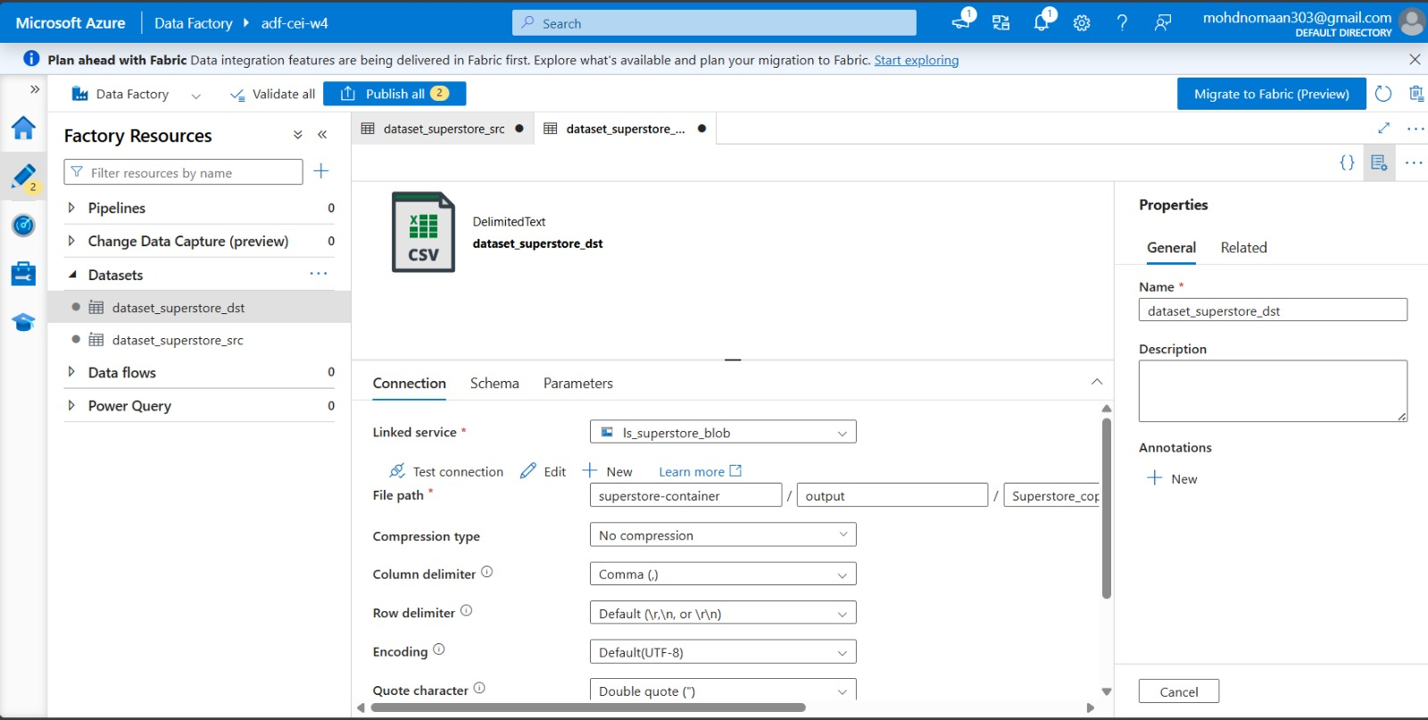
Destination dataset dataset_superstore_dst pointing to output/Superstore_copy.csv
I then added a Get Metadata activity in the pipeline to read details about the source file, like its name, type and size, just to confirm ADF could actually read the file properly before copying it.
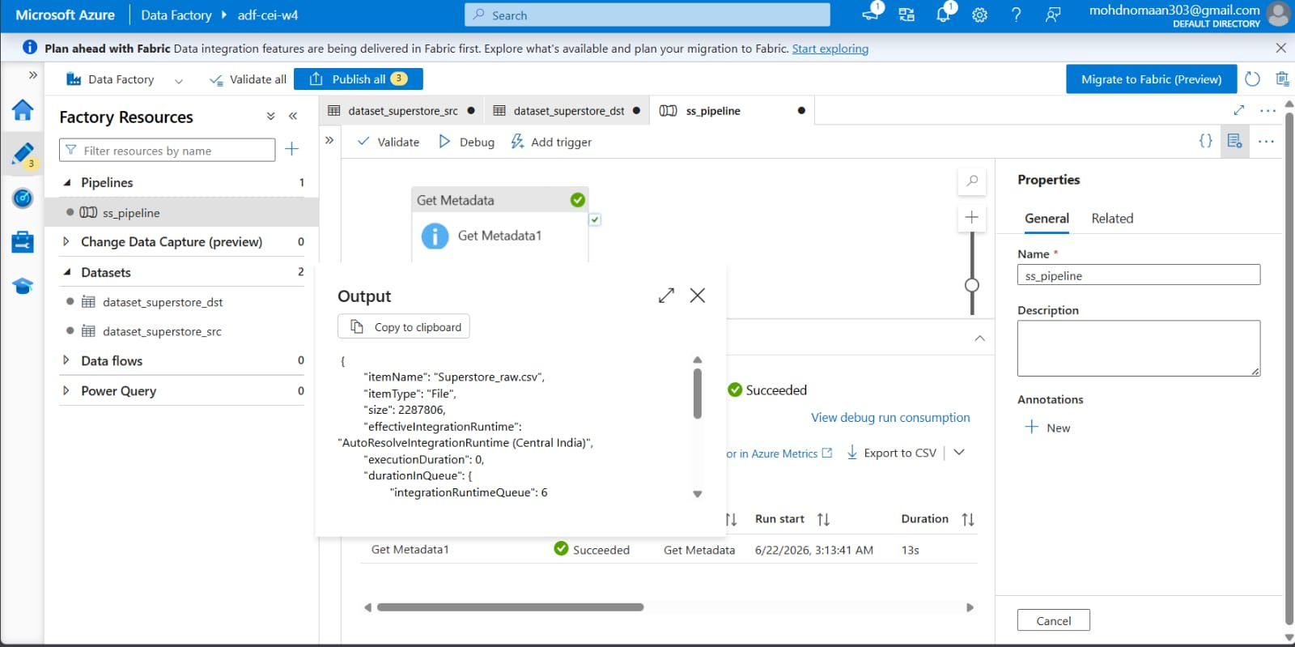
Get Metadata activity output showing file name, type and size of Superstore_raw.csv
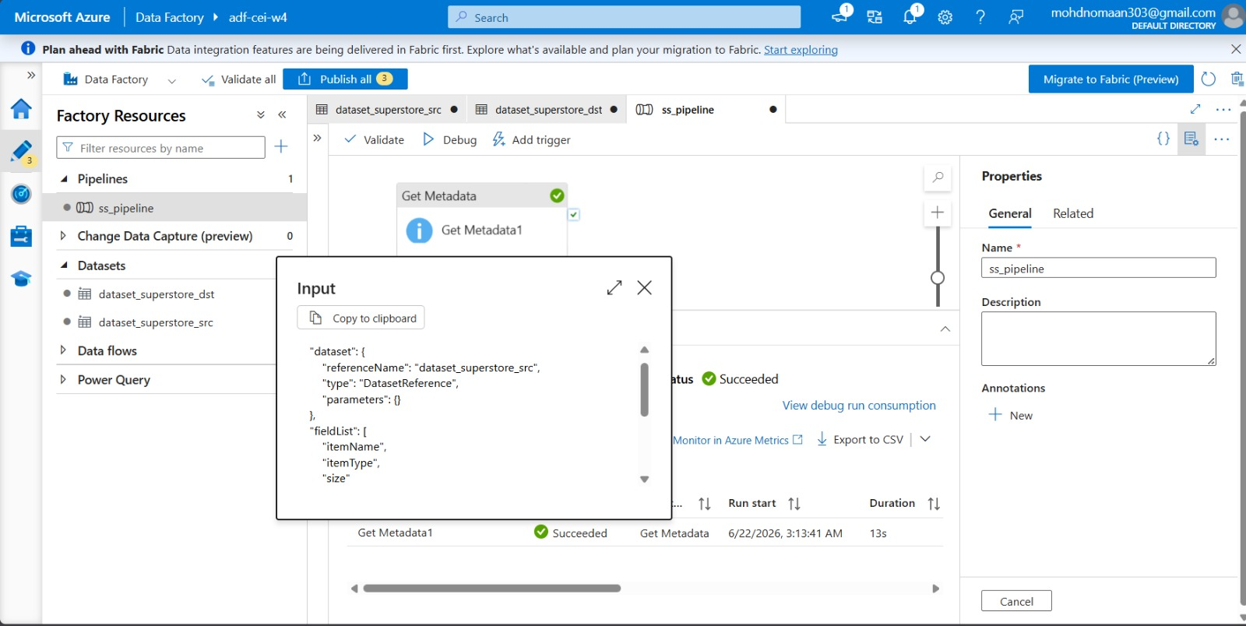
Get Metadata activity input showing the dataset reference and field list used

Task 4: Pipeline Development
For the pipeline itself, I added a Copy Data activity after Get Metadata. Since I was asked to also include a ForEach activity, I set up Get Metadata to read the child items of the container (instead of a single file), and used that list as the input for ForEach. Inside the ForEach loop, I placed the Copy Data activity so that it copies whatever files are found. I connected Get Metadata to ForEach using the success (green) path so the copy only runs after the metadata check passes.
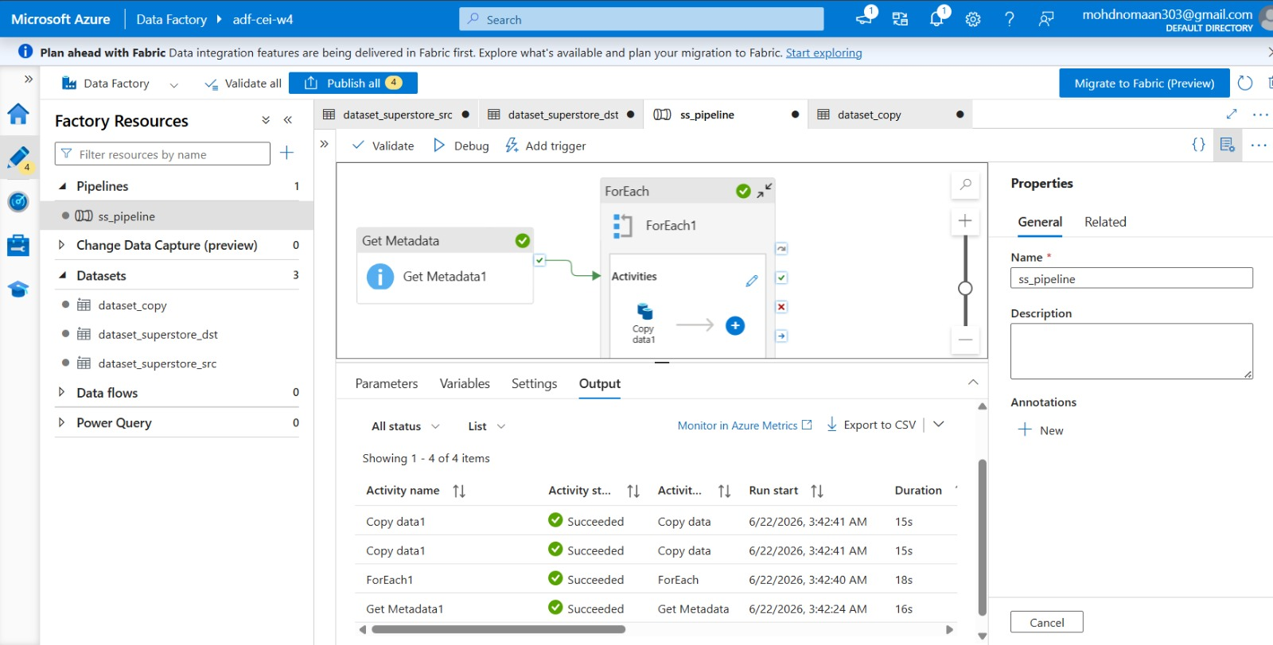
Pipeline design: Get Metadata1 connected to ForEach1, with Copy data1 running inside the loop

Task 5: Pipeline Execution
I ran the pipeline using Debug mode. All four steps (Get Metadata1, ForEach1, and Copy data1 running twice inside the loop) completed with a Succeeded status.
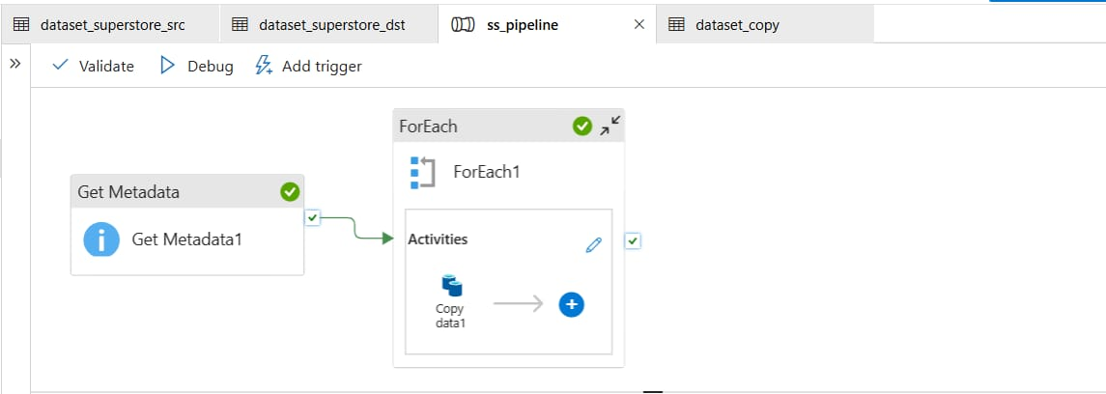
Pipeline canvas after a successful debug run — all activities show a green tick

Task 6: IAM Roles
For access control, I went to the storage account's Access Control (IAM) section and assigned myself the Reader and Contributor roles. I also gave the Data Factory's managed identity the Storage Blob Data Contributor role on the storage account, so that ADF itself has permission to read and write blobs without using my personal account.
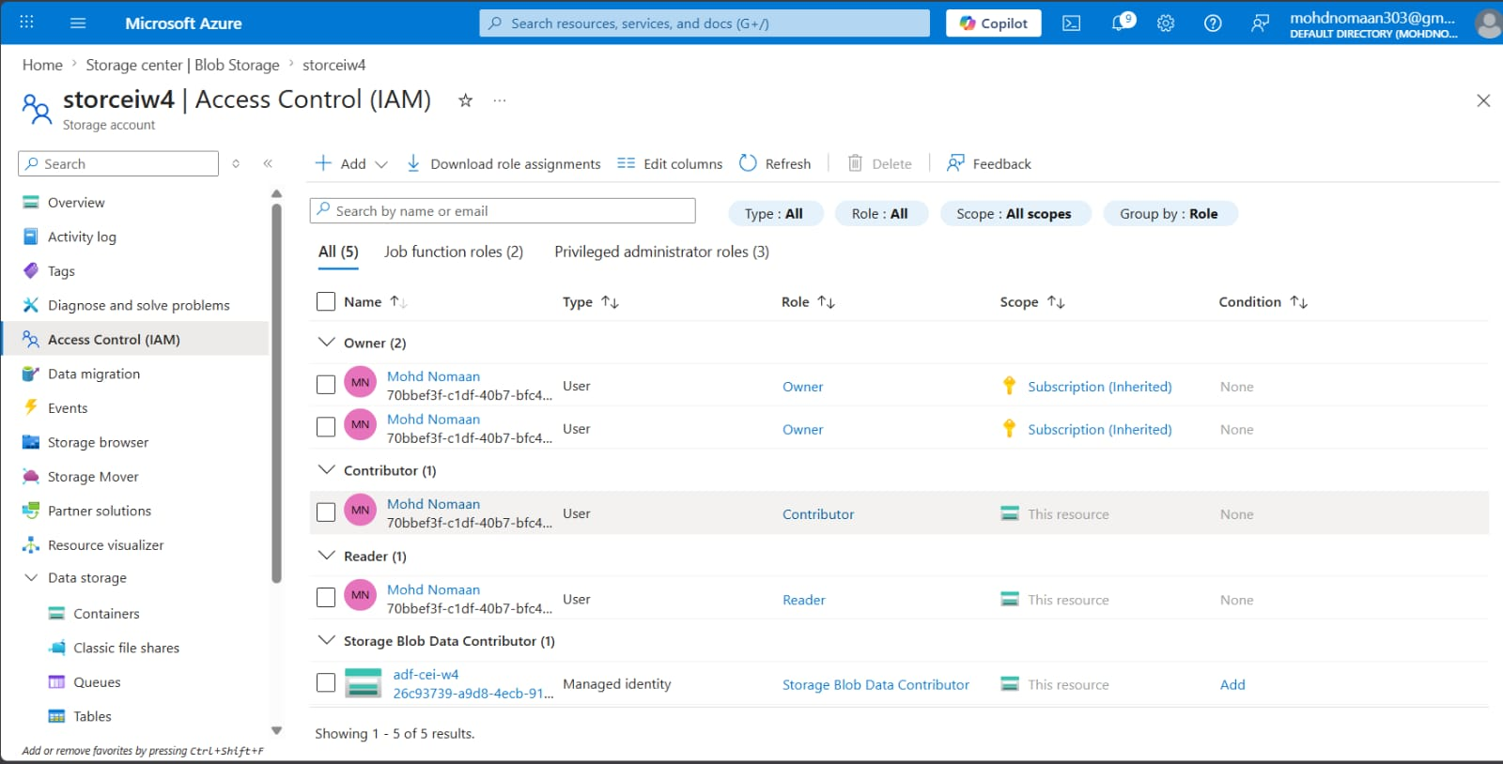
IAM role assignments on storceiw4 — Reader, Contributor (me) and Storage Blob Data Contributor (ADF managed identity)

Mini Project — Complete Pipeline (CSV Read + Process via ADF)
The mini project asked for a complete pipeline that reads a CSV file from Blob Storage and processes it using ADF, with a metadata check and the data copied to a new location. This is essentially the same pipeline built above (ss_pipeline), so I am using the same setup as proof for this part too:
- Source: Superstore_raw.csv in superstore-container (Blob Storage)
- Linked Service + Dataset + Pipeline: ls_superstore_blob, dataset_superstore_src/dst, ss_pipeline
- Process: Get Metadata check followed by Copy Data (inside ForEach)
- Destination: output/Superstore_copy.csv (new location in the same container)
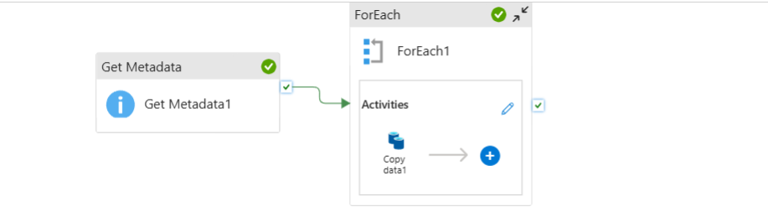
Pipeline design used for the mini project
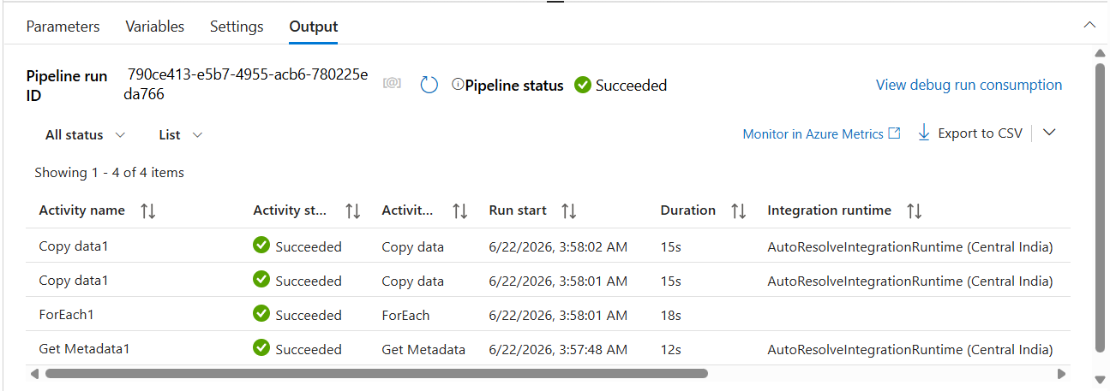
Pipeline run output — status Succeeded, all activities completed
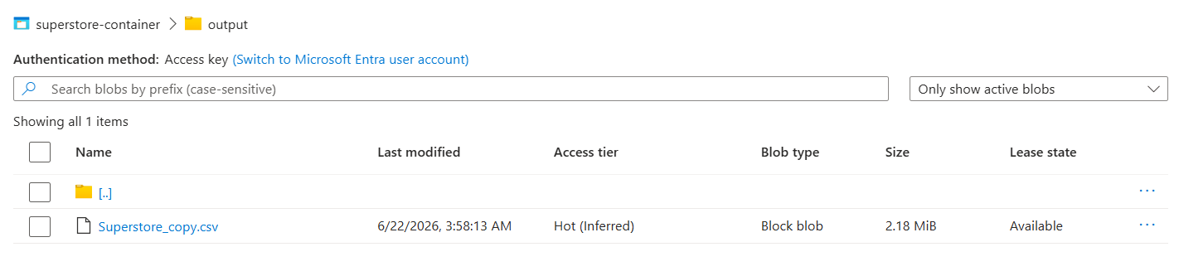
Destination folder showing Superstore_copy.csv after the pipeline ran
Overall, the pipeline successfully read the CSV from Blob Storage, validated its metadata using Get Metadata, and copied it to a new destination file using Copy Data — confirming that the pipeline executed successfully, the data was copied, and the metadata was validated as required.

