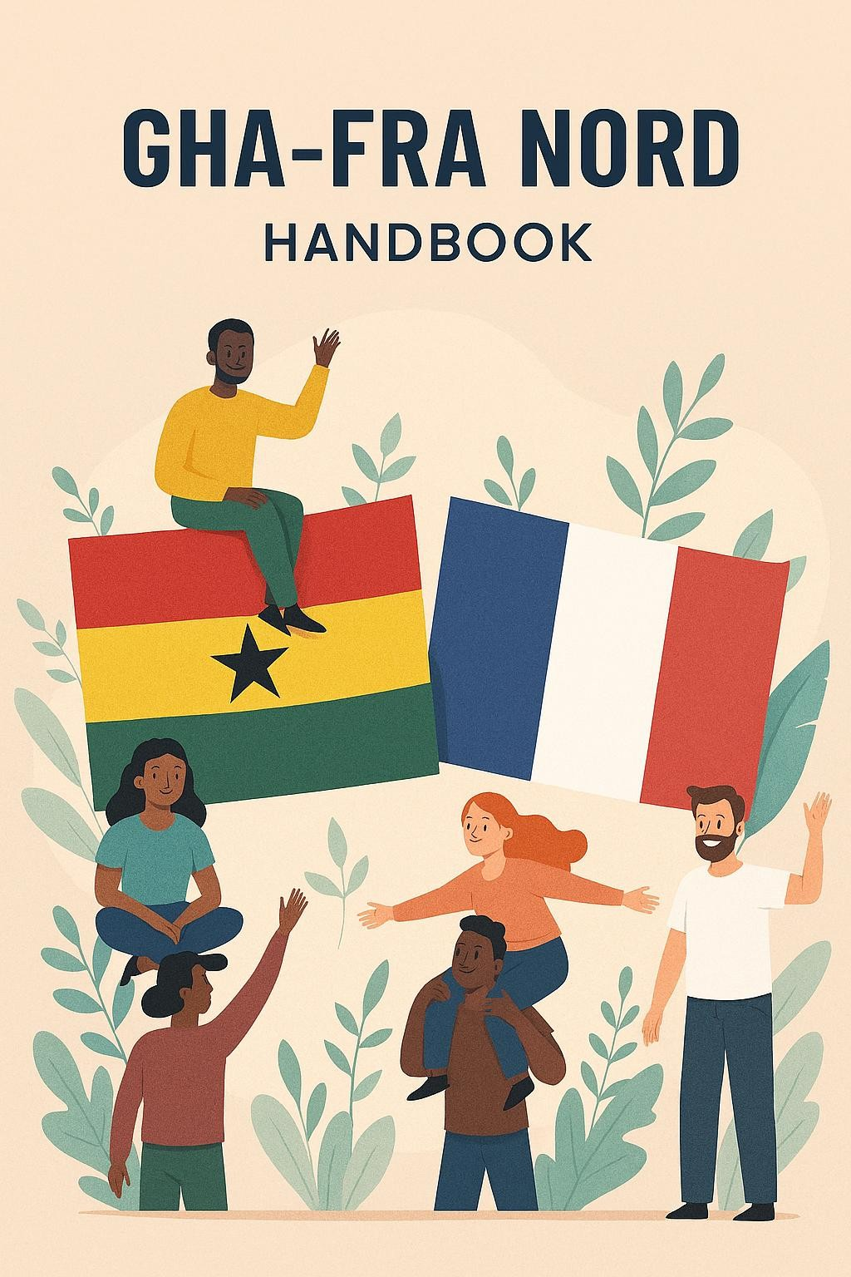

2025

Dear Members, Friends, and Fellow Ghanaians,

Akwaaba! It is with great joy and pride that I welcome you to Lille, Hauts-de-France and to GHA-FRA NORD.
Whether you have just arrived in France or have called Lille home for many years, this association exists for you. We are a community built on shared roots, mutual support, and a deep belief in the strength of unity. Our mission is simple yet powerful: to help every Ghanaian in Lille feel seen, supported, and empowered to thrive culturally, socially, and professionally.
This handbook is more than a collection of information. It reflects our values: solidarity, inclusion, and cultural pride. Inside, you’ll find practical guidance on settling in, accessing services, participating in our events, and connecting with others who share your journey.
As president, I am continually inspired by the resilience, generosity, and talent within our community. I invite you to get involved, volunteer, share your ideas, attend our events, and help shape the future of our association. Together, we can build a vibrant, welcoming space where every Ghanaian feels at home and every voice matters.
On behalf of the entire leadership team, I thank you for being part of this journey. May this handbook serve as a helpful companion as you navigate life in Lille and contribute to our growing community.
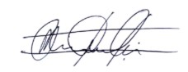
With warm regards and in unity,

Mustapha Abdulai GHA-FRA President

Gha-Fra Nord also known as GhaFra was created on the 30th of March 2024 in Lille, France. Due to the increasing number of Ghanaians mostly students in Lille, it became necessary to have an organization that sought the wellbeing and integration of Ghanaians in Lille. Hence, it was decided at a meeting held on March 30, 2024, in Lille to establish a non-profit association in accordance with the provisions of the law on companies and associations of May 1, 2019.
The association started with 25 members and currently consists of about
150 members. The members of Gha-Fra Nord include students, professionals as well as retired citizens. The association is officially registered in the French state under the association number W595044222 and recognized by the Embassy of Ghana, Paris France. Gha-Fra Nord also has partnerships with various associations both locally (in France) and internationally.

Our vision is to empower and unite the Ghanaian community in France (Lille) to thrive and succeed, fostering a supportive environment where every individual can achieve their full potential and contribute positively to society.
Our mission is to establish a vibrant and inclusive community that advocates for the rights and well-being of Ghanaians residing in France, particularly in the Nord region.
Through collective action and collaboration, we aim to:
- Provide comprehensive support and guidance to Ghanaian students and professionals navigating the challenges of integration into the French system and lifestyle.
- Assist individuals with visa renewal, residence permit, and legal issues, ensuring their rights are protected and upheld.
- Serve as the official political representative body, liaising with the city councils in the Nord, universities attended by Ghanaian students, employer companies, and the Ghanaian embassy in France to address community concerns
- Address the diverse needs of struggling Ghanaians and university students, including financial, social, legal, and administrative support, to facilitate their successful integration and well-being.
- Foster collaboration with other organizations, both locally and internationally, to promote intercultural understanding and socioeconomic development initiatives that benefit the Ghanaian community and broader society in France.

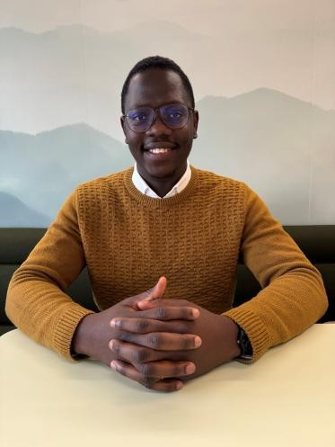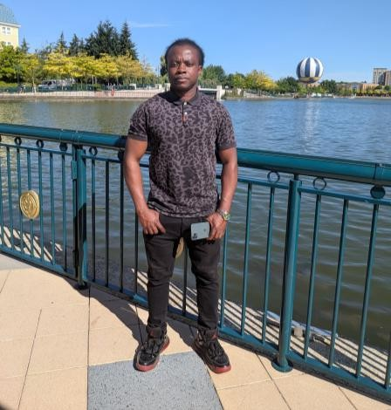

Felix OFORI-AGYEMANG
President
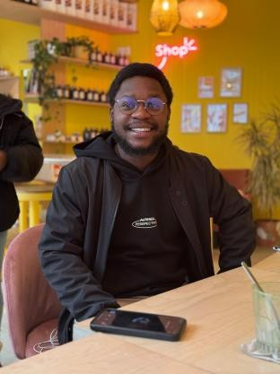
Earl Kenneth BEMPONG Treasurer
Mustapha ABDULAI Vice president
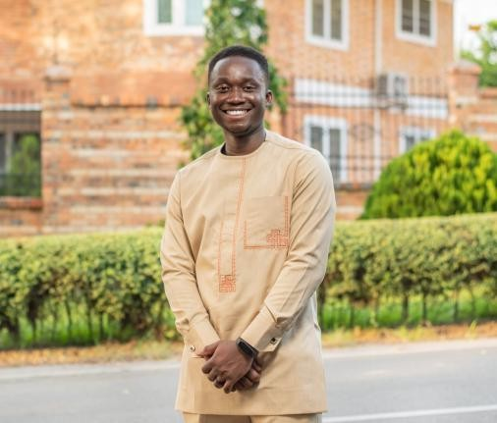
Benedict OWUSU-DOUBREH Int’l Relations & Projects Coordinator
Keziah ACKORA-PRAH
General secretary
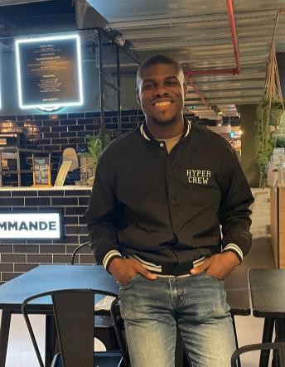
Kwaku ANTWI ADDO
Media and Technical Head

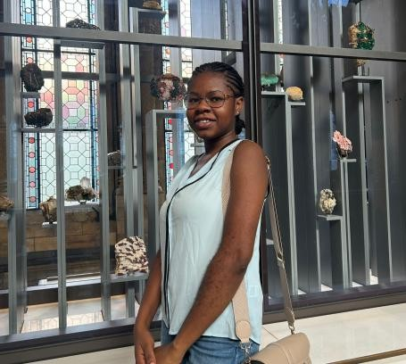


Mustapha ABDULAI President

Emmanuel BAIDOO Treasurer


Felix OFORI-AGYEMANG
Vice president
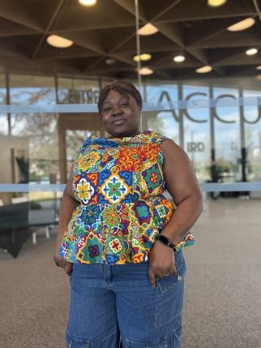
Estherlla TAMAKLOE Int’l Relations & Projects Coordinator
Shine Afi KUWORNU
General secretary


Joshua Opoku AGYEMANG
Media and Technical Head

- Membership
- You must be Ghanaian to become a member. The board of directors accepts member candidates. The executive committee checks membership application for approval. .
- Working members are obliged to pay monthly dues of 10 euros and non-
working members pay 5 euros.

COMMUNITY ETHICS
- Respecting Authority
- We honour the leadership entrusted to serve our community.
- We acknowledge and respect the roles of elected leaders and committees.
- We follow due process in resolving issues, addressing concerns with humility and maturity.
- We attend meetings punctually and participate attentively.
- We express disagreement respectfully and support collective decisions once made.
- We recognize that authority is service, not privilege and we support those
who lead with accountability
- Respect and Tolerate Each Other
- We are a family of diverse individuals bound by a shared identity.
- Every member deserves dignity, regardless of background, tribe, gender, or status.
- We listen to one another without judgment and value different perspectives.

- Respect and Tolerate Each Other
- We refrain from gossip, divisive comments, or actions that create factions.
- We forgive quickly and choose peace over pride.
- We embrace diversity as a source of strength and wisdom.
- Respect the Values and Principles of the Community
- We are guided by the values of Solidarity, Integrity, Empowerment, Cultural Pride, and Service.
- We represent our community and our homeland with dignity in all settings.
- We take responsibility for our actions, knowing they reflect on the entire group.
- We contribute actively to programs, discussions, and community events.
- We uphold honesty, transparency, and fairness in all dealings.
- We protect the reputation of the community through our conduct, both in public and online.
- Live in Solidarity with Each Other
- We stand together as one people in joy, in struggle, and in growth.
- We look out for one another, especially newcomers and those in need.
- We offer help, encouragement, and kindness wherever possible.
- We celebrate each other’s successes and support one another through challenges.
- We contribute to community projects, dues, and volunteering efforts.
- We remain united in advocacy when one member faces hardship, we respond collectively.

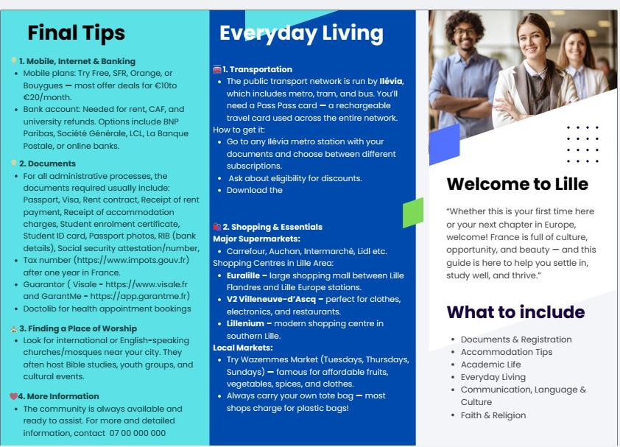

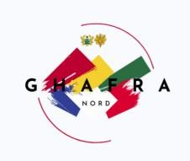
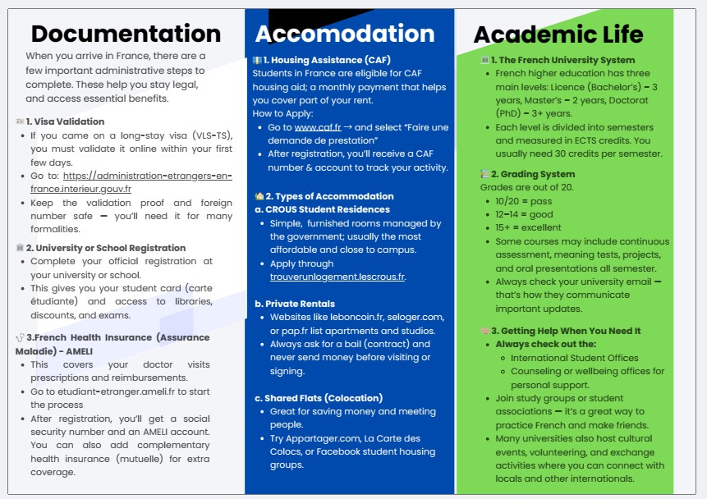

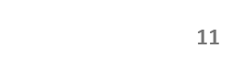

Gha-Fra has lots of activities and events all-year round. Mark your
calendars so you don’t miss a beat.
- The General assembly of Gha-Fra is held every year in January
usually the last Saturday of the month
- Fresher’s Welcome Party is held every year in September. Date is communicated upon confirmation of venue
- October is officially GHA-FRA month hence all activities are centered around highlighting GHA-FRA
- GHA-FRA Bronya Afahy3 takes place every December
- Monthly meetings are also held to discuss issues and developments in GHA-FRA
- Every Saturday, there is GHA-FRA sports where sporting activities take place at Complexe Sportif Jacqueline Auriol (Wazemmes)

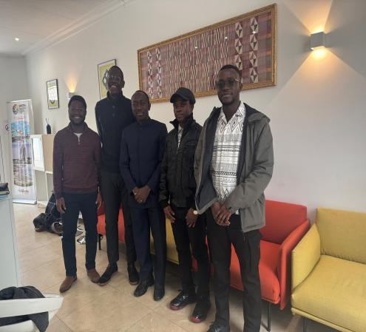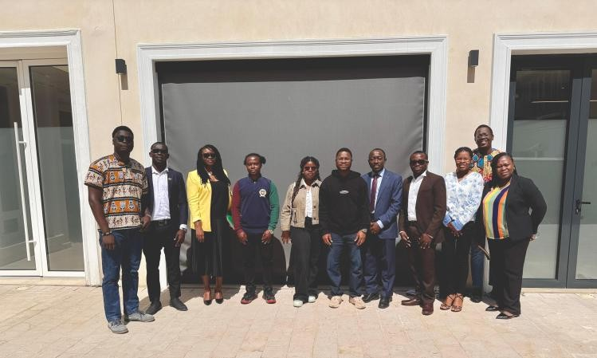
Courtesy call on the Head of Consular, Embassy of Ghana, Paris
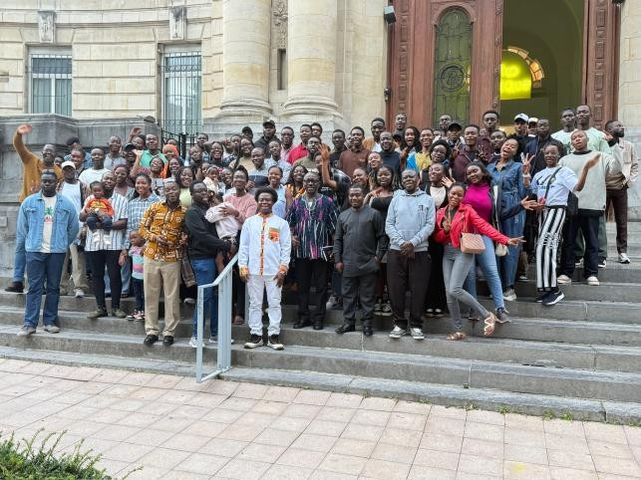
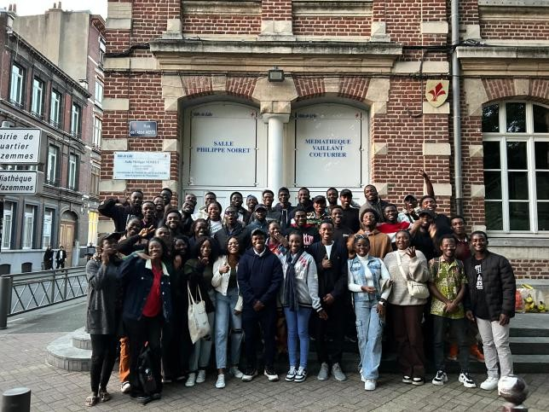
GhaFra Freshers Welcome Party
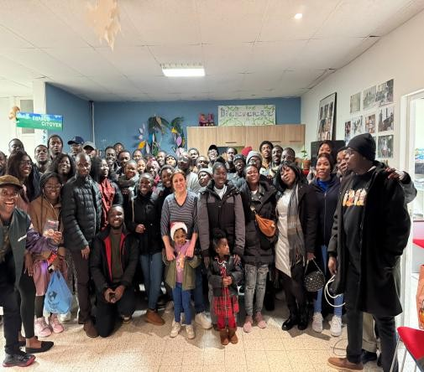
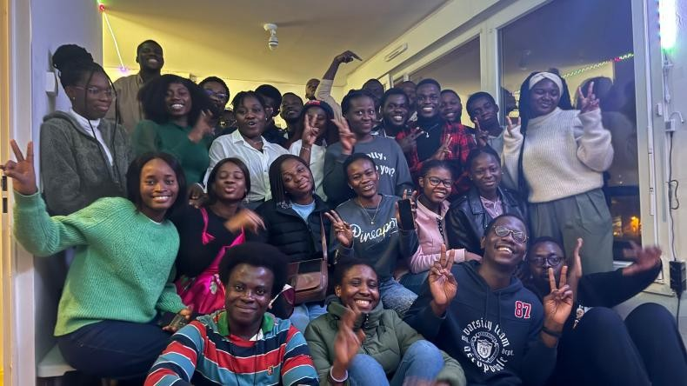
GhaFra Christmas party

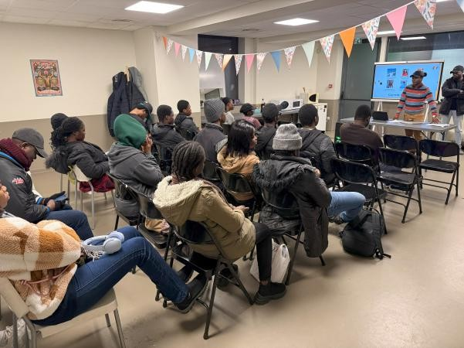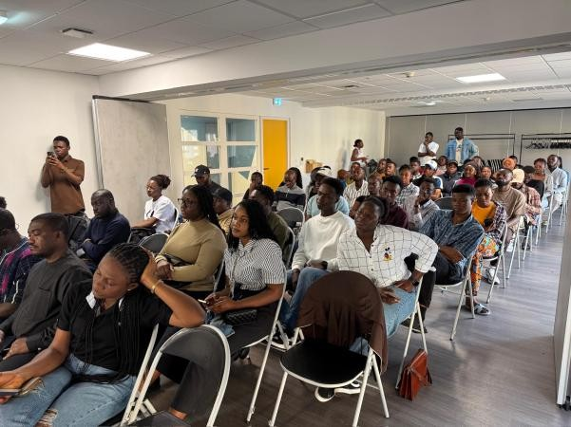
GhaFra General Meeting

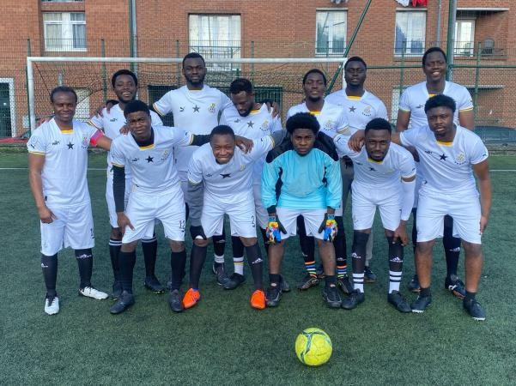
GhaFra Sports

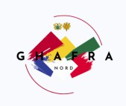
EDITORIAL TEAM
- Felix OFORI-AGYEMANG – Lead editor
- Jesse James OWUSU
- Mustapha ABDULAI
- Shine Afi KUWORNU

CONTACT US


https://www.linkedin.com/company/ghafra-nord/


https://www.instagram.com/ghafra_nord/

 https://www.facebook.com/p/Ghafra-NORD-61578953407441/

 ghafra.nord@gmail.com


+33743336440 / +33766883486 /+33767052876

