Diagram

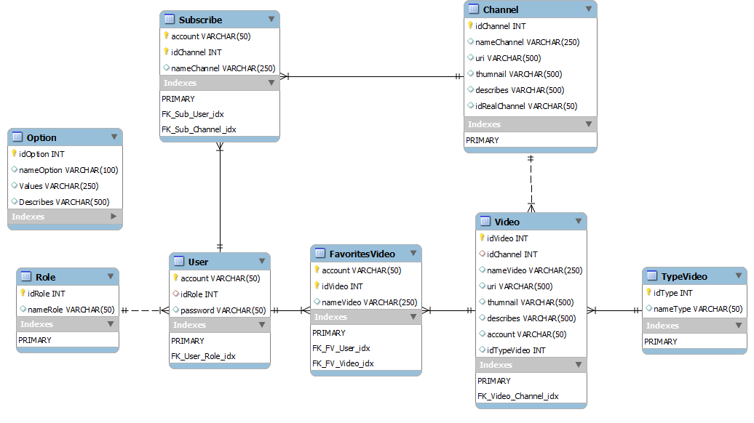

|  |  |  |  |
| --- | --- | --- | --- |
| **Table : Option** | | | |
| Column | Type | Description | Reference |
| idOption | Int | Id of option | Auto incremental, primary key |
| nameOption | Varchar(100) | Name of option |  |
| Values | Varchar(250) | Value of option |  |
| Describes | Varchar(500) | Describe of option |  |

|  |  |  |  |
| --- | --- | --- | --- |
| **Table : Role** | | | |
| Column | Type | Description | Reference |
| idRole | Int | Id of role | Auto incremental, primary key |
| nameRole | Varchar(50) | Name of role |  |

|  |  |  |  |
| --- | --- | --- | --- |
| **Table : Subscribe** | | | |
| Column | Type | Description | Reference |
| idChannel | Int | Id of channel | Primary key, FK link to idChannel of table Channel |
| Account | Varchar(50) | Account of user | Primary key, FK link to account of table User |
| nameChannel | Varchar(250) | Name of channel |  |

|  |  |  |  |
| --- | --- | --- | --- |
| **Table : User** | | | |
| Column | Type | Description | Reference |
| Account | Varchar(50) | Account of user | Primary key |
| Role | Int | Id Role of user | FK link to idRole of table Role |
| Password | Varchar(50) | Password of user |  |

|  |  |  |  |
| --- | --- | --- | --- |
| **Table : FavoritesVideo** | | | |
| Column | Type | Description | Reference |
| Account | Varchar(50) | Account of user | Primary key, FK link to account of table User |
| idVideo | Int | Id of video | Primary key, , FK link to id video of table Video |
| nameChannel | Varchar(250) | Name of channel |  |

|  |  |  |  |
| --- | --- | --- | --- |
| **Table : Channel** | | | |
| Column | Type | Description | Reference |
| idChannel | Int | Id of channel | Auto incremental, unique, primary key |
| nameChannel | Varchar(250) | Name of channel |  |
| Uri | Varchar(500) | url of channel |  |
| Thumnail | Varchar(500) | Logo of channel |  |
| Describes | Varchar(500) | Describe of channel |  |
| idRealChannel | Varchar(50) | Id real get from youtube of channel |  |

|  |  |  |  |
| --- | --- | --- | --- |
| **Table : Video** | | | |
| Column | Type | Description | Reference |
| idVideo | Int | Id of video | Primary key, unique, Auto incremental |
| idChannel | Int | Id of channel | FK link to idChannel of table Channel |
| nameVideo | Varchar(250) | Name of video |  |
| Uri | Varchar(500) | Uri of video |  |
| Thumnail | Varchar(500) | Picture of video |  |
| Describes | Varchar(500) | Describes of video |  |
| Account | Varchar(50) | Account of user | FK link to account of table User |
| typeVideo | Int | Type of video | FK link to id type of table TypeVideo |

|  |  |  |  |
| --- | --- | --- | --- |
| **Table : Video** | | | |
| Column | Type | Description | Reference |
| idType | Int | Id of type video | Primary key, Auto incremental |
| nameType | Varchar(50) | Name of type video |  |