



Гр. Бургас, ПГКПИ

Team:

Георги Дряновски (Scrum Trainer) GHDryanovski@codingburgas.bg

Йоан Танев (Front End) YHTanev@codingburgas.bg

Виктор Киров (Back End) VRKirov@codingburgas.bg

Максимилиян Димов (Code Checker) MKDimov19@codingburgas.bg

…

# Content:

Content: 2

History of Tic-Tac-Toe 3

Team 4

1. Scrum Trainer 4

2. Front End 4

3. Back End 4

4. Code Checker 4

Why are logic games important? 5

1. Improves concentration 5

2. Improves your IQ 5

3. Improves memory 5

4. Qualities such as perseverance, patience and calmness develop 5

5. Improves planning skills 6

6. Improves social skills 6

7. Improves cognitive abilities 6

8. Improves motor skills 6

Used Technology 7

Visual Studio Code 7

Our functions explained 8

Block Schemes of our code 9

Resume of the project 22

# History of Tic-Tac-Toe

Tic-tac-toe is a paper-and-pencil game for two players, X and O, who take turns marking the spaces in a 3×3 grid. The player who succeeds in placing three of their marks in a horizontal, vertical, or diagonal row is the winner. It is a solved game with a forced draw assuming best play from both players.

Games played on three-in-a-row boards can be traced back to ancient Egypt, where such game boards have been found on roofing tiles dating from around 1300 BCE.

An early variation of tic-tac-toe was played in the Roman Empire, around the first century BC. It was called terni lapilli (three pebbles at a time) and instead of having any number of pieces, each player only had three, thus they had to move them around to empty spaces to keep playing. The game's grid markings have been found chalked all over Rome. Another closely related ancient game is three men's morris which is also played on a simple grid and requires three pieces in a row to finish, and Picaria, a game of the Puebloans.

## Team

### Scrum Trainer

They are skilled in software development and/or product management. They are experts in Scrum and have extensive experience applying, leading, teaching, and coaching it.

### Front End

A front-end web developer is responsible for implementing visual elements that users see and interact with in a web application. They are usually supported by back-end web developers, who are responsible for server-side application logic and integration of the work front-end developers do.

### Back End

A back-end web developer is responsible for server-side web application logic and integration of the work front-end developers do. Back-end developers are usually write the web services and APIs used by front-end developers and mobile application developers.

### Code Checker

They are the people who check and test the code constantly for mistakes and errors insuring errorless workflow.

## Why are logic games important?

Benefits of logic games

### Improves concentration

Logic games require attention. Therefore, they help to increase the level of concentration in children and adults. In most games, if your level becomes easy, you can always increase the difficulty of the game, which will require your brain to think more deeply.

### Improves your IQ

Each of the games contributes to the development of the speed of thinking that is so necessary in real life. Logic games successfully solve all problems related to erudition, speed of reaction and the volume of perception of information.

### Improves memory

The most obvious, but no less important advantage of logic games! Nothing improves the ability to remember, like the systematic increase of one's own efficiency in logic games.

The positive effect can be seen in the first month, especially the benefit in people who initially had poor memory. Here everything is like in sports - progress comes with training!

### Qualities such as perseverance, patience and calmness develop

### Improves planning skills

As you play, you will need to count or think a few steps ahead. The problem of procrastination will disappear in whole or in part. They will help you learn determination and organization, as well as how to divide a complex problem into smaller, solvable parts. They will also help increase confidence to take on bigger challenges.

### Improves social skills

The most important factor that can significantly change a person's life is the ability to communicate with people. Logic games are one of the main ways to get rid of complexes and improve interpersonal skills. Group games will encourage verbal communication and teamwork.

### Improves cognitive abilities

Logical tasks come down to finding a solution to a problem. You will have to use your critical thinking to solve the riddle and the best part is that in this type of games you cannot cheat.

### Improves motor skills

In fact, logic games such as the Rubik's Cube, the Tower of Hanoi, Jenga, various mazes with balls and others, in addition to developing attention, also improve fine motor skills, coordination between eyes and hands! Mobility is especially important for both children and adults. Therefore, of course, you can also focus on assembling puzzles, complex machines, robots and more.

## Used Technology

### Visual Studio Code

|  |  |
| --- | --- |
| HTML | Hypertext Markup Language (HTML) is the standard markup language for documents designed to be displayed in a web browser. |
| CSS | CSS is the language for describing the presentation of Web pages, including colors, layout, and fonts. |
| JAVASCRIPT | JavaScript is an interpretive programming language distributed with subsequent Web browsers. Supports object-oriented and functional programming style. |
| PHP | PHP is a recursive acronym for "PHP: Hypertext Preprocessor". PHP is a server side scripting language that is embedded in HTML. It is used to manage dynamic content, databases, session tracking, even build entire e-commerce sites. |

Visual Studio Code is a streamlined code editor with support for development operations like debugging, task running, and version control. It aims to provide just the tools a developer needs for a quick code-build-debug cycle and leaves more complex workflows to fuller featured IDEs, such as Visual Studio IDE.

## Our functions explained

|  |  |
| --- | --- |
| **drawBoard()** | **Function that gives every space a unique id, so we know exactly where to put the player’s move on the gameData Array** |
| **minimax(gameData, PLAYER)** | Function that has base information   1. looks for empty spaces and saves all moves and their evaluations 2. Loops over the empty spaces to evaluate them, gets the id of the empty space, back up the space, make the move for the player, saves the move’s id and evaluation 3. Moves evaluation, then restores them and save move to moves array 4. We use algorithm for maximizer and minimizer and return |
| **getEmptySpaces(gameData)** | Function that gets empty spaces |
| **getIJ(id)** | Function that gets i and j of a space |
| **isWinner(gameData, player)** | Function that checks for a winner |
| **isTie(gameData)** | Function that checks for a tie |
| **showGameOver(player)** | Function that shows game over |
| **drawOnBoard(player, i, j)** | Function (draw on board) is for x, y position of the image is the x, y of the clicked space |
|  |  |

## Block Schemes of our code

This is the block scheme of the game.js file which explains how the game plays with separate functions.

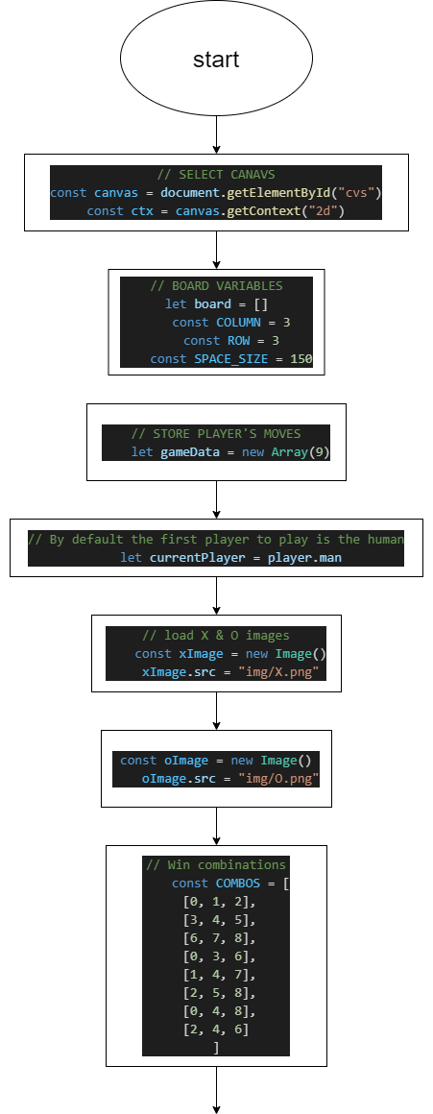

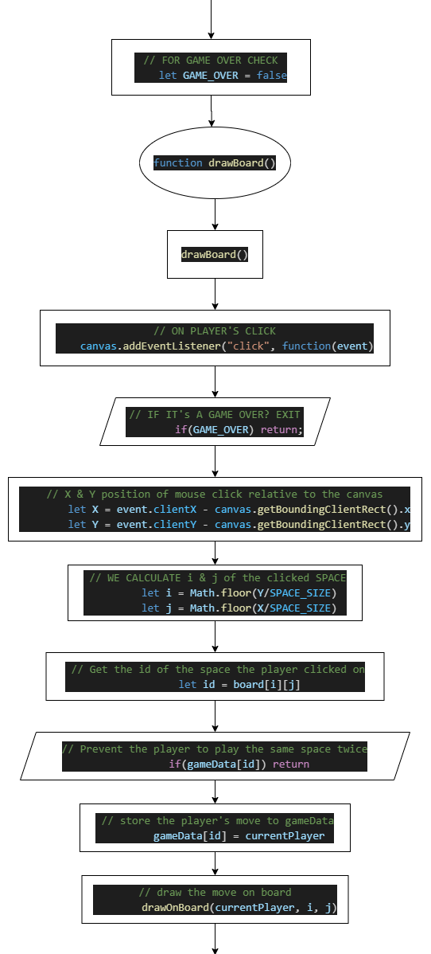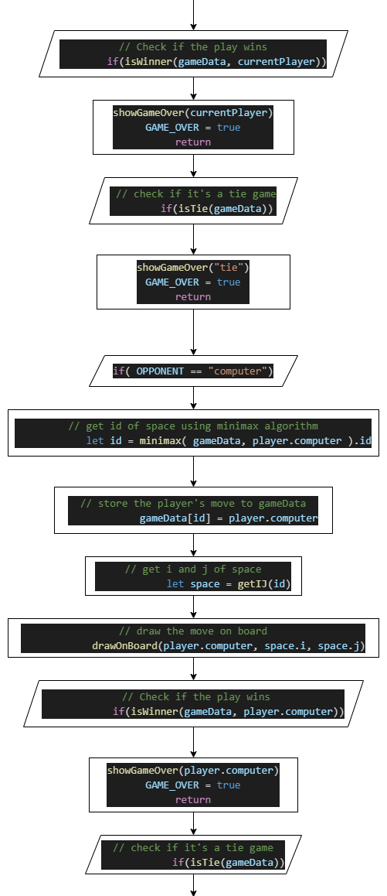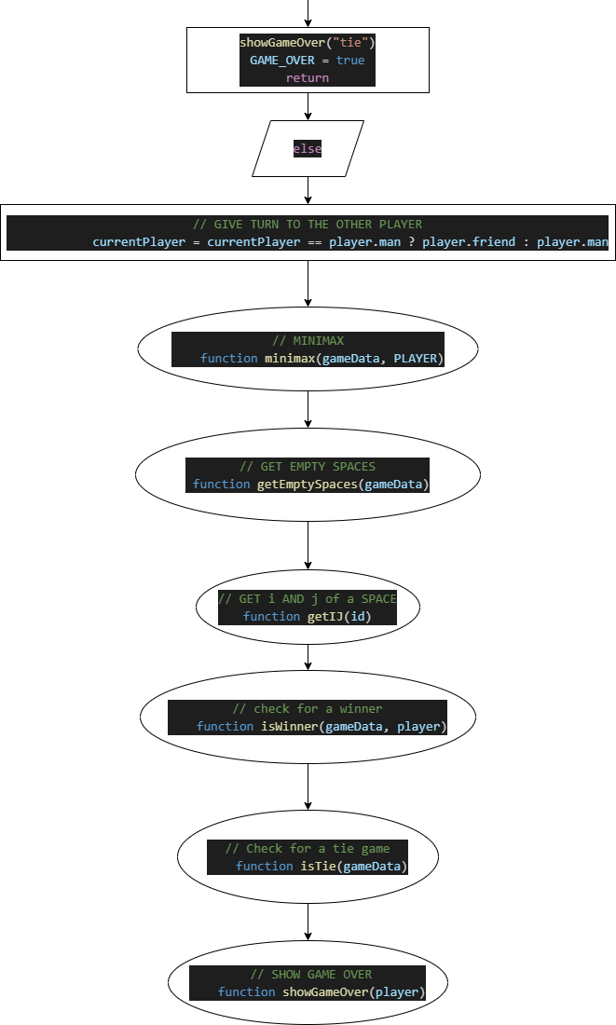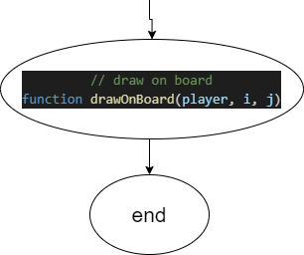

1. Function: drawBoard

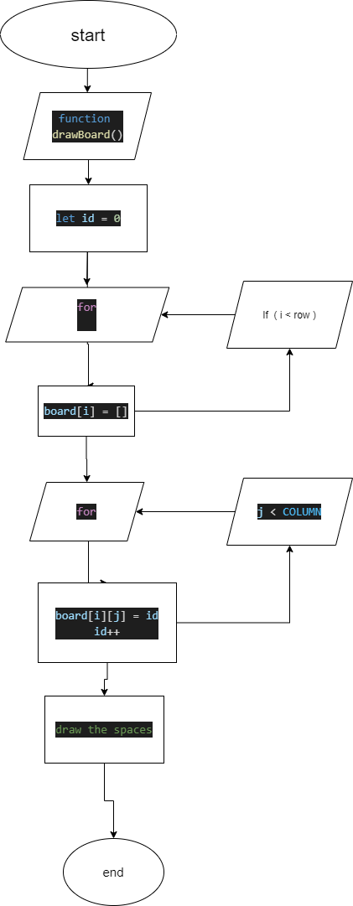

1. Function: drawOnBoard

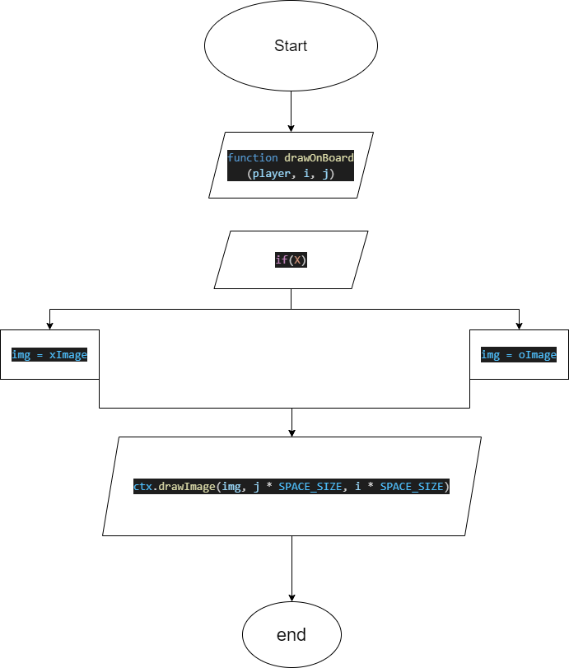

1. Function: getEmptySpaces

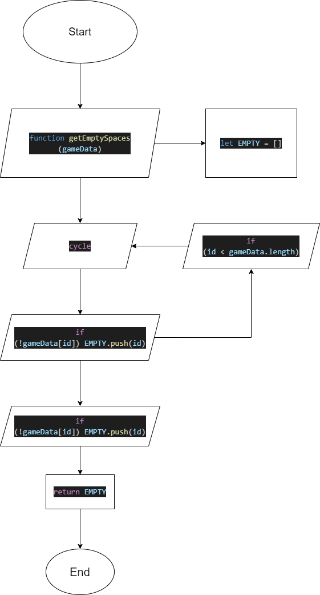

1. Function: getIJ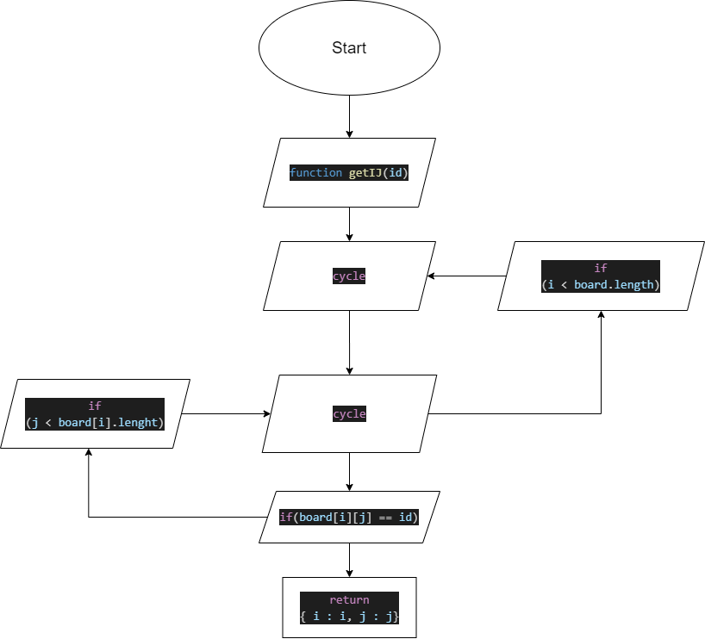
2. Function: isTie

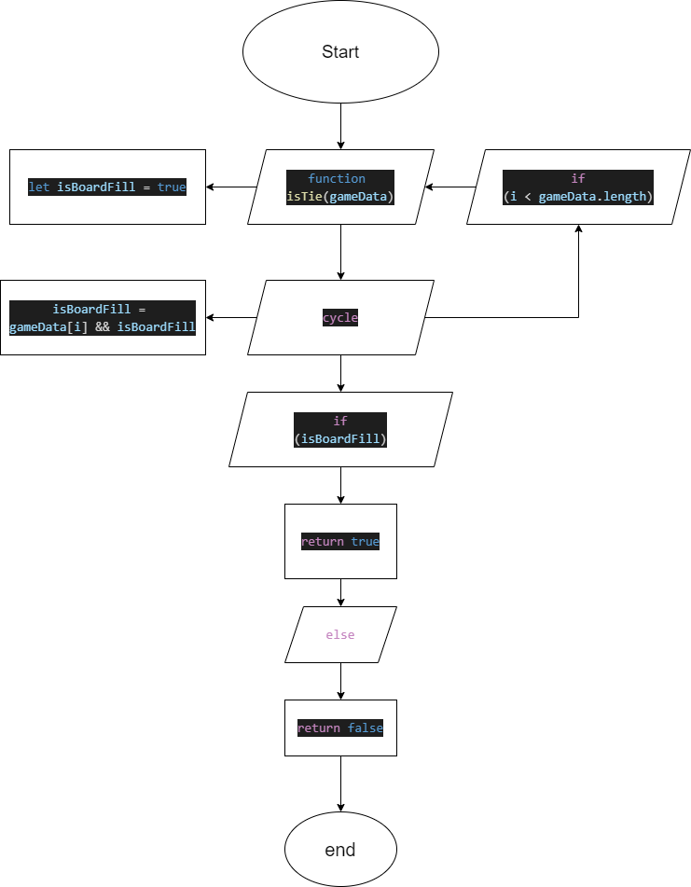

1. Function: isWinner

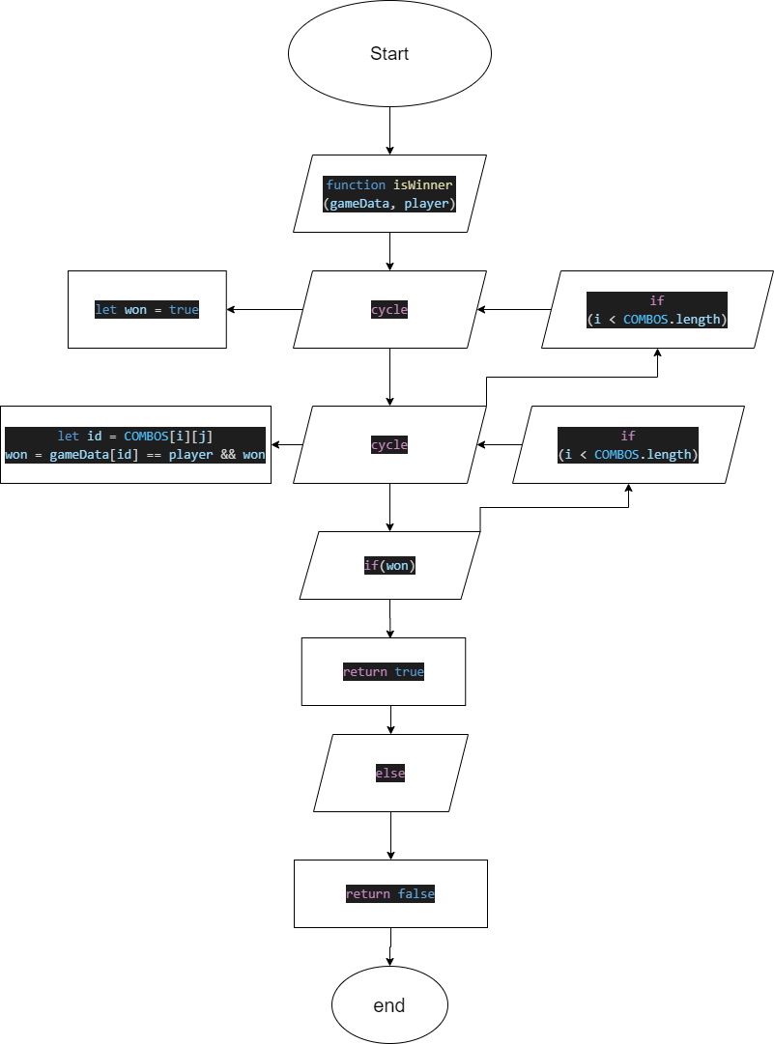

1. Function: minimax

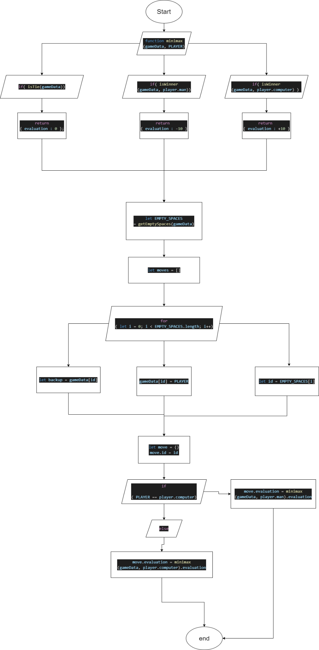

1. Function: showGameOver

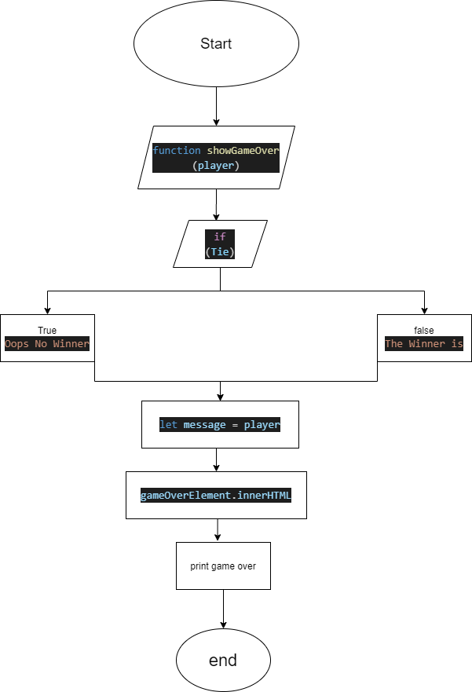

## Resume of the project

We are TYPHON. The task is to create a Math game. We had a month to complete the task. The only technologies we were able to use were C++ or HTML5 & CSS3 & Javascript. We decided to use HTML5 & CSS3 & Javascript and our goal was to create a Tic Tac Toe game with Artificial Intelligence. We got along with the goal and did a pretty good job for the given time. Most things we learnt are javascript and php which we used for the user system. We thank “Technologica” for the project.

…