Merging DBH remeasurement data and tree rings to infer tree growth response to climate

Margaret Evans – University of Arizona LTRR

Kent Holsinger – University of Connecticut Storrs

Don Falk – University of Arizona SNRE

Alex Arizpe – University of Arizona LTRR

Tyson Swetnam – USGS

Flurin Babst – WSL

**Motivation**

Understanding and predicting tree growth is important from multiple perspectives (carbon stocks, ecosystem services, hydrology, anticipating forest change). Forests in the western U. S. are undergoing profound change and are predicted to be particularly vulnerable to the climate change forecast for the 21st century. In order to anticipate climate change-driven changes in western U. S. forests, including change in growth, we need to better estimate how tree growth is influenced by weather (variation in temperature and precipitation from year to year).

We focus on developing a model that can make better use of two powerful and complementary data sources relevant to the problem of inferring the response of tree growth to weather variation. The first data type is “remeasurement” data collected in Forest Inventory and Analysis (FIA) plots. There are ~70,000 such plots in the eight interior western U. S. states. The diameter at breast height (DBH) and height of trees is measured at each visit, at approximately 10-year intervals, yielding estimates of tree growth over that interval. The second data type is tree cores, which have the advantage of annual resolution, but are much less numerous than FIA plots. A Bayesian hierarchical model following Clark et al. (2007) will allow us to fuse the two data sources.

*Objective*

Our objective here is to develop a prototype of this model with data collected in Monument Canyon, in the Jemez Mountains of northwestern New Mexico. Because of the great topographic diversity at this site, forest types range from X to Y to Z. Further, thinning (2006-7) and prescribed burning (2012) treatments were applied to some plots. This offers the opportunity to wrestle with the diverse forest types and fire effects so characteristic of forests in the western U. S.

**Methods**

*Old Data (DBH, cores)*

70 forest plots (50*50m each) were established on an 8*9 grid in 2003, with plot centers 500 m distant from one another. Fire history was sampled in every plot (n=70). In a subset of 50 of the plots, demographic data were collected, including the diameter at breast height (DBH) of every tree >20 cm DBH (>25 cm DBH threshold for Ponderosa pine). In a 20*50m subplot, every tree was cored (following the same size threshold), and in a 10*10m inner plot, all trees were cored, regardless of size, capturing the smaller end of the size spectrum. Some of these “old” cores are measured and dated, others are not. A subset of 16 of the plots have been revisited every year since their establishment and tree condition recorded. Stem maps (x,y location of every tree meeting size thresholds) exist for all 50 “demography” plots.

*New Data (DBH, cores)*

In Feb and April, 2015, Alex Arizpe and I revisited a total of 16 plots and collected a second measurement of DBH (units cm) and height (units m) from every tagged tree (>20 cm in the 50*50m plot, no minimum size threshold in the 10*10m inner plot). Note that standard forestry practice is to measure DBH at 1.3 m on the upslope side of a tree. It’s not clear that this was the protocol in 2004. We did not follow this protocol in 2014, so measurement error is certainly present. New cores were collected from ~15-20 trees per plot, randomly stratified across four size classes (0-20 cm, 20-35 cm, 35-50 cm, and 50+ cm DBH). From the first 8 plots sampled, we have a total of 256 trees with DBH measurements, and 66 trees with increment cores, thus the total sample size should be about double that.

Two types of data files were generated. First are plot-level csv files with DBH measurements (etc.) for each tree in a plot. Second are rwl files with increment growth data, with each tree as a column and each row a year. Cores were crossdated and measured (units μm) from 1980 to 2014.

*Covariate Data*

PRISM – PRISM data (monthly Tmean, Tmax, and Prcp at 4 km resolution) were downloaded from <http://prism.oregonstate.edu/recent/>. These are the AN81m data (Jan 1981-Jan 2015). Units for Temp are degrees C, for precip are mm. PRISM data are located on Evans’ desktop (Eth). At this resolution (4km), all plots have the same climate data. That is, we essentially have a single climate data point for all plots. Flurin Babst has also provided vapor pressure deficit (VPD) data, from a data product he developed from CRU. I will likely buy higher resolution PRISM data at some point… The 800 m resolution PRISM monthly temperature and precipitation data are the highest resolution historical weather data that I’m aware of.

*Analysis*

The overall design of the statistical model includes two observation models (one each for DBH and tree cores, respectively) which feed into a process model of tree growth. In the Clark et al. (2007) model, the key equation linking to two data types states the obvious: that the difference between DBH at time t+1 and time t must equal the growth increment comparing time t+1 to time t (i.e., tree ring increment). Actually, it seems to me that the latter should be multiplied by 2 (Clark doesn’t mention this but he must have done this, since there is a tree-ring increment on either side of the cross section of a tree to add):

DBHt+1 – DBHt = 2(INCt)

More specifically, the DBH and increment data are modeled on a log scale, and they are modeled as a function of a mean and variance (Equation 1, Clark et al. 2007). The process model then decomposes this mean and variance term and attributes them to fixed and random effects. A proposed list of fixed and random effects for our model is in the following table:

|  |  |  |  |
| --- | --- | --- | --- |
| **Variable** | **Fixed vs. Random** | **Level** | **Scale** |
| Size at time t (S) | Fixed | Tree | Continuous |
| Height ratio at time t (HR) | Fixed | Tree | Continuous |
| Plot basal area (PBA) | Fixed | Plot | Continuous |
| Fire | Fixed | Plot | Indicator or time-since-fire? |
| Fire damage | Fixed | Tree | ?? |
| Thinning | Fixed | Plot | Indicator? |
| Change in plot basal area (ΔBA) | Fixed | Plot | Continuous |
| 800m PRISM data (WP, VPD, GSI…) | Fixed | Plot*Year | Continuous |
| EEMT (EEMT) | Fixed | Plot *or* Plot*Year | Continuous |
| Plot ID | Random | Plot | Indicator |
| Species ID | Random | Species | Indicator |
| *Others? Growing season index?* |  |  |  |

Height ratio is the ratio of a given tree’s height compared to the tallest tree on a plot, or the mean height of some group of tallest trees on a plot. Fire and thinning variables need to be discussed with Don. Change in plot basal area would be tested to see if it can capture, on a continuous scale, and in one variable, the effect of fire and/or thinning vs. the absence of these treatments. That is, the growth of trees in a plot very much depends upon whether the forest is filling up or emptying out, with the former suppressing growth and the latter potentially leading to “release” from competition and hence accelerated growth. Plot ID would be a random effect to capture other sources of variation among plots not captured by the PRISM variables, EEMT, plot basal area, and change in plot basal area (e.g., soil depth, soil type, parent material…). Species random effects would allow us to borrow strength across species.

*Notes on the calculation of plot basal area.* DBH data for each tree was converted to basal area/tree (BA = ((DBH/2)2 * 3.14159). The total basal area of “large trees” (i.e., above the 20 cm DBH threshold for all species but PIPO, and above the 25 cm DBH threshold for PIPO) was multiplied by 4 to convert to a per hectare basis. The total basal area of “small trees” (below the 20/25 cm DBH threshold, censused in the 10*10m inner plot) was multiplied by 100 to convert to a per hectare basis. The two were summed and divided by 10,000 to convert to m2/hectare.

*Weather covariates*

Before building regressions of tree growth, it behooves us to explore a variety of climate variables, i.e., temperature, precipitation, and vapor pressure deficit (VPD), and which months tree growth is sensitive to these climate variables. Flurin Babst has generated climate response functions (as they’re known in the dendro literature) – correlations between detrended growth increment (from tree-rings) and monthly T and P (and VPD) data (see Figure 1). What you see in Figure 1a is that the detrended growth increment is positively correlated with precipitation in the preceding Sept-Oct (i.e., Sept-Oct 2013 precip vs. 2014’s growth increment) and positively correlated with the current year’s April and May precip. In Figure 1b you see that detrended growth increment is negatively correlated with temperature in the same months (previous year’s Sept-Oct, current year’s Apr-Jun). Higher temperatures in those months are bad for growth, more water in those months is good for growth. This is typical of this site and across the SW U. S., i.e., tree growth is precipitation-limited.

We can also see this pattern of climate sensitivity illustrated by looking at scatterplots of the data. In Figure 2a-c (also created by Flurin), you see the plot-level mean detrended growth (n=11 for the moment) in each year (1981:2014) plotted as a (declining) function of the 4km PRISM Mean T data for the months April, May, and June. In Figure 2d-e you see plot-level detrended growth as an increasing function of precipitation in April and May.

An additional pattern that is of interest is shown in Figure 2f and h. Here you see a unimodal response of detrended growth to precipitation in the current year’s Jan and March. More precipitation is good, up to a point, after which, growth declines. This is the pattern one might expect under a simplistic view of the climatic niche – there should be a decline in performance at the extremes of a given climatic niche variable, which is responsible for limiting the species’ geographic distribution. I’m not sure about the mechanism behind this unimodal response to Jan and March precip (and why is the pattern not there in February?), but this pattern is suggestive, and seems to me suggests we might want to include it in the regression model of growth.

Beyond the PRISM data, another possibility is EEMT (effective energy and mass transfer) - a variable derived from PRISM 800m temperature and precipitation data, as well as PRISM 4 km resolution dew point data. In the EEMT pipeline, the PRISM temperature and vapor pressure deficit (VPD) data are modified based on 10m resolution incoming solar radiation data (thus accounting for slope and aspect) to create a local (plot-level) estimate of potential productivity (locally-modified VPD, locally-modified temperature, and precipitation). Tyson Swetnam is working up EEMT data at high resolution (10 m) in the Jemez Mountains, with Craig Rasmussen and iPlant (as part of an NSF-funded CZO grant based at the University of Arizona).

*Converting from diameter to basal area*

We’ve discussed using biomass rather than diameter (both as a response and a predictor). This follows from basic rules of demography: vital rates (such as growth) are best modeled as a function of size, and size is best captured in terms of total biomass, not diameter. For the moment, we will model size in terms of basal area (BA), which is easily derived from DBH (BA = πr2, where r = ½DBH). At some later point, we might use forestry (allometric) equations to convert DBH plus height into an estimate of biomass, then model biomass as a response. But the below figure illustrates that BA tracks biomass quite nicely (from Bowman et al. 2012).

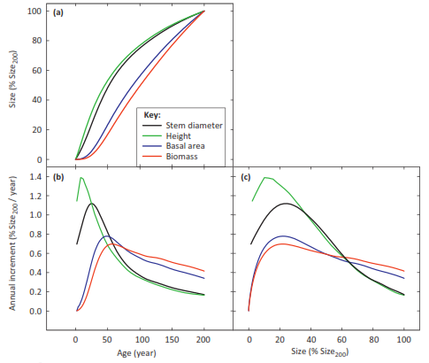

*Model*

Putting the above together, here is a proposed equation for the process model:

ln(basal area increment) = ln(S) + HR + PBA + ΔPBA + climate variables + EEMT + plot + species

*What if…*

The data that we’ll have (a set of trees with two DBH measurements and two tree cores, 2003 and 2015, respectively) will allow us to pose several “what if…” questions.

1. What happens to the inference of climatic niche if you have fewer tree cores than DBH measurements? …Much, much fewer tree cores??
2. What happens to the inference of climatic niche if the trees from which you have DBH measurements are not the same trees from which you have cores? (zero overlap in the sampling of the two data types)
3. What happens to the inference of climatic niche if you have tree cores that do not overlap the DBH census interval? (is the climatic niche of growth stable over time, after correcting for change in tree size?)
4. How does climate sensitivity change with size class? Tree cores are typically taken from large, old individuals – does this bias the inference of climatic niche?

**References**

Bowman, D. M. J. S., R. J. W. Brienen, E. Gloor, O. L. Phillips, and L. D. Pryor. 2012. Detecting trends in tree growth: not so simple. Trends in Plant Science 18: 11-17.

Clark et al. 2007. Tree growth inference and prediction from diameter censuses and ring widths. Ecological Applications 17: 1942-1953.

Rasmussen. 2012. Thermodynamic constraints on effective energy and mass transfer and catchment function. Hydrol. Earth Syst. Science 16: 725-739.

|  |  |  |  |  |  |  |  |  |  |  |  |
| --- | --- | --- | --- | --- | --- | --- | --- | --- | --- | --- | --- |
| Plot# | Forest type | elev | slope | aspect | substrate | soil | EEMT | BA m2/h 2004 | BA m2/h 2014 | Fire | Thin |
| 113 |  |  | 13 | 184 | T | 1 |  | 15.99 |  |  |  |
| 125 |  |  | 12 | 318 | P | 2 |  | 28.56 |  |  |  |
| 127 |  |  | 5 | 280 | T | 3 |  | 56.97 |  |  |  |
| 137 |  |  | 11 | 335 | T | 2 |  | 22.99 |  |  |  |
| 141 |  |  | 4.5 | 178 | A | 4 |  | 27.37 |  |  |  |
| 143 |  |  |  |  | P | 2 |  | 13.43 |  |  |  |
| 145 |  |  |  |  | T | 2 |  | 28.66 |  |  |  |
| 147 |  |  | 15 | 339 | A | 3 |  | 17.92 |  |  |  |
| 149 |  |  | 4.5 | 176 | P | 2 |  |  |  |  |  |
| 151 |  |  |  |  | T | 4 |  |  |  |  |  |
| 154 |  |  | 16.5 | 310 | T | 2 |  | 24.70 |  |  |  |
| 156 |  |  | 18 | 123 | T | 3 |  |  |  |  |  |
| 158 |  |  |  |  | P | 5 |  |  |  |  |  |
| 162 |  |  |  |  | T | 2 |  | 28.40 |  |  |  |
| 164 |  |  | 19 | 348 | T | 2 |  | 28.27 or 21.54 |  |  |  |
| 166 |  |  | 11 | 256 | T | 2 |  |  |  |  |  |

T=tuff, P=pumice, A=alluvium

1=A dystrochrept, 2=M eutroboralf, 3=A udorthent, 4=E glossoboralf, 5=T ustorthent

Figure 1. Absolute growth increments from 11 of the 16 plots were detrended, then correlated with PRISM 4 km temp and precip data.Tree growth is negatively sensitive to temperature and VPD (not shown) vs. positively sensitive to precipitation. No surprises here. The critical seasons are the previous year's Sept-Oct and the current growth year's April-May. The strong correlation with current year's Sept-Oct is spurious – the growth season at this site ends by the end of August or beginning of September.

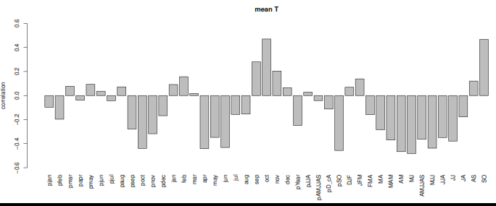

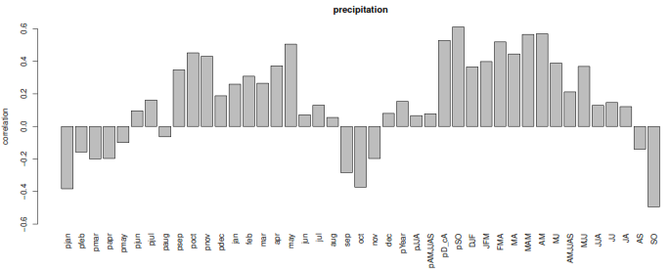

Figure 2.

a,b,c

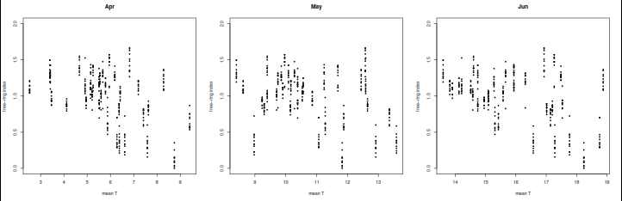

d,e

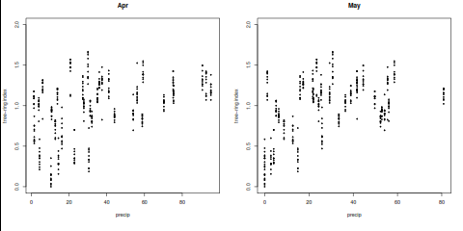

f,g,h

