Table 3 Carbon and Root Distribution

Ranae Dietzel

January 23, 2017

library(tidyr)  
library(dplyr)  
library(ggplot2)  
library(plotrix)  
  
this_theme<-theme_bw()+  
 theme(#panel.grid.major = element_blank(),  
 #panel.grid.minor = element_blank(),  
 panel.background = element_blank(),  
 axis.line = element_line(),  
 legend.position='none', legend.title=element_blank(),  
 legend.text = element_text(size=12),  
 axis.title.x = element_text(size=22,vjust=-0.5),  
 axis.title.y = element_text(size=22,angle=90, vjust=1.2),  
 axis.text.x = element_text(colour="black", size=18),  
 axis.text.y = element_text(colour="black", size=18),   
 strip.text = element_text(colour="black", size=18))  
  
theme_set(this_theme)  
  
  
  
ds2<-read.csv("../Data/Equivalent root and C for 5 cm, each plot.csv", header=TRUE)  
  
fake<-tibble(trt = c("CC", "PF", "P"), plot = c("12", "32", "13"), depth = c("105", "105", "105"),  
 root = c(NA, NA, NA), rootC = c(.0001, .0001, .0001), carbon = c(NA, NA, NA))  
ds2<-rbind(ds2, fake)  
  
ds2<-ds2%>%  
 select(-plot)%>%  
 mutate(depth = ifelse((depth == 2.5), 0,  
 ifelse((depth == 10.0), 10,  
 ifelse((depth == 22.5), 20,  
 ifelse((depth == 45.0), 45,  
 ifelse((depth == 80.0), 80, 105))))))%>%  
 group_by(trt, depth)%>%  
 summarise_each(funs(mean(., na.rm = TRUE), std.error(., na.rm = TRUE)))  
  
  
ds2_depths_possible <- expand.grid(  
 depth = seq(from=min(ds2$depth), max(105), by=5), #Decide resolution here.  
 trt = c("CC", "P", "PF"),  
 stringsAsFactors = FALSE  
)  
  
ds2_intpolated <- ds2 %>%   
 right_join(ds2_depths_possible, by=c("trt", "depth")) %>% #Incorporate locations to interpolate  
 group_by(trt)%>%  
 mutate(  
 rootC_interpolated = spline(x=depth, y=rootC_mean , xout=depth, method="natural")$y,  
 carbon_interpolated = spline(x=depth, y=carbon_mean, xout=depth, method="natural")$y  
 ) %>%   
 ungroup()  
  
#ds2_intpolated_rev <- within(ds2_intpolated, depth <- ordered(depth, levels = rev(sort(unique(depth)))))  
  
cc<-ds2_intpolated%>%filter(trt == "CC")  
pf<-ds2_intpolated%>%filter(trt == "PF")  
p<-ds2_intpolated%>%filter(trt == "P")  
  
###Table 3, is this you? Yes. It is.  
sumprops<-ds2_intpolated%>%  
 group_by(trt)%>%  
 mutate(totalrootC = sum(rootC_interpolated),   
 totalcarbon = sum(carbon_interpolated))%>%  
 mutate(proprootC = rootC_interpolated/totalrootC,  
 propcarbon = carbon_interpolated/totalcarbon)  
  
  
ggplot(sumprops, aes(x=-depth, y=proprootC)) +  
 geom_line(color="green", size=1.2) +  
 geom_line(aes(y=propcarbon), color="brown", size=1.2) +  
 coord_flip()+  
 facet_wrap(~trt)

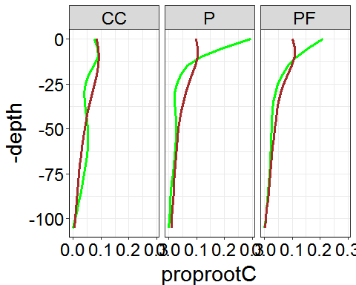

split<-sumprops%>%  
 mutate(place = ifelse((depth %in% c(0:20)), "top", "bottom"))%>%  
 group_by(trt, place)%>%  
 summarise(splitC = sum(carbon_interpolated), splitR = sum(rootC_interpolated))%>%  
 group_by(trt)%>%  
 mutate(totalrootC = sum(splitR),   
 totalcarbon = sum(splitC))%>%  
 mutate(proprootC = splitR/totalrootC,  
 propcarbon = splitC/totalcarbon)  
  
knitr::kable(split, digits = 2, caption = "Above vs below 20 cm")

Above vs below 20 cm

|  |  |  |  |  |  |  |  |
| --- | --- | --- | --- | --- | --- | --- | --- |
| trt | place | splitC | splitR | totalrootC | totalcarbon | proprootC | propcarbon |
| CC | bottom | 89.97 | 0.43 | 0.70 | 161.14 | 0.62 | 0.56 |
| CC | top | 71.17 | 0.27 | 0.70 | 161.14 | 0.38 | 0.44 |
| P | bottom | 85.00 | 1.26 | 4.42 | 164.13 | 0.28 | 0.52 |
| P | top | 79.14 | 3.16 | 4.42 | 164.13 | 0.72 | 0.48 |
| PF | bottom | 76.54 | 0.85 | 2.32 | 153.20 | 0.37 | 0.50 |
| PF | top | 76.66 | 1.47 | 2.32 | 153.20 | 0.63 | 0.50 |