Root turnover table

Ranae Dietzel

December 2, 2016

## Loading tidyverse: ggplot2  
## Loading tidyverse: tibble  
## Loading tidyverse: tidyr  
## Loading tidyverse: readr  
## Loading tidyverse: purrr  
## Loading tidyverse: dplyr

## Conflicts with tidy packages ----------------------------------------------

## filter(): dplyr, stats  
## lag(): dplyr, stats

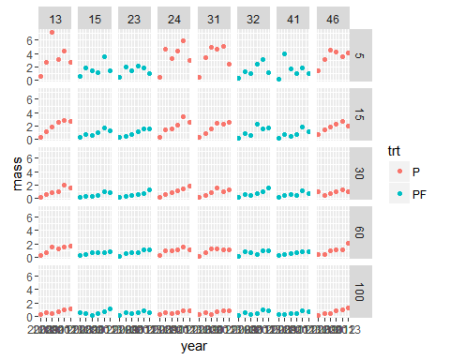

## Source: local data frame [6 x 3]  
## Groups: year [3]  
##   
## year trt total  
## <int> <chr> <dbl>  
## 1 2009 P 5.111186  
## 2 2009 PF 3.272305  
## 3 2010 P 7.484041  
## 4 2010 PF 2.305638  
## 5 2011 P 7.575919  
## 6 2011 PF 3.420595

Root pool decomposition, masses in g/m^2

|  |  |  |  |  |  |  |
| --- | --- | --- | --- | --- | --- | --- |
| trt | input | gain | loss | pool | k | mrt |
| Prairie2010 | 367 | 104 | 263 | 748 | 0.35 | 2.85 |
| FertilizedPrairie2010 | 146 | 62 | 84 | 231 | 0.37 | 2.74 |
| Prairie2011 | 387 | 78 | 309 | 758 | 0.41 | 2.45 |
| FertilizedPrairie2011 | 168 | 55 | 113 | 342 | 0.33 | 3.02 |
| Maize2010 | 56 | 18 | 38 | 44 | 0.86 | 1.16 |
| Maize2011 | 48 | 16 | 31 | 47 | 0.67 | 1.50 |