BECE302L — CONTROL SYSTEMS
Winter Semester 2025–26

ADAPTIVE

DRIVER-BEHAVIOR-AWARE SPEED CONTROL SYSTEM
Project Technical Report

MATLAB / Simulink Implementation & Full Analysis P | PI | PID (Fixed) | Adaptive Gain-Scheduled PID
State-Space | Root Locus | Bode | Nyquist | Disturbance Analysis

Submitted by: Siddhi Pandey, Arrnav Trisal, Sriya Ganga
BECE302L Control Systems | Winter 2025–26

Abstract

This report presents a comprehensive design, simulation, and analysis of an Adaptive Driver-Behavior-Aware Speed Control System for a vehicle modelled in MATLAB. The system models a 1200 kg vehicle with a damping coefficient of 50 N·s/m, targeting a reference speed of 30 m/s (108 km/h). Three fixed controllers — Proportional (P), Proportional-Integral (PI), and PID — are designed and compared. An adaptive gain-scheduling PID accommodates three driver profiles: Smooth, Normal, and Aggressive.
Frequency-domain stability analysis uses Bode plots and Nyquist diagrams. Root locus plots characterise closed-loop pole migration. A state-space formulation enables pole placement via full-state feedback. Disturbance rejection analysis quantifies each controller's ability to recover from a −5 m/s impulse (headwind). The key finding: Adaptive PID with gain scheduling outperforms the fixed PID across all metrics, delivering reduced overshoot, faster settling, and superior disturbance rejection.

System Modelling — Vehicle Plant

Physical Model
The vehicle is modelled using Newton's second law. The net force equals mass × acceleration; the resisting force is proportional to velocity through the damping coefficient b:
m · dv/dt = u(t) − b · v(t)
    - m = 1200 kg (vehicle mass)
    - b = 50 N·s/m (aerodynamic drag + friction)
    - v(t) = vehicle speed [m/s] — output
    - u(t) = control force input [N]

Transfer Function G(s)
Taking the Laplace transform (zero initial conditions):
ms·V(s) + b·V(s) = U(s)
G(s) = V(s) / U(s) = 1 / (ms + b) = 1 / (1200s + 50)

Key plant parameters:
    - DC gain = 1/b = 1/50 = 0.02
    - Time constant τ = m/b = 1200/50 = 24 s
    - Open-loop pole = −b/m = −0.0417 rad/s (stable, real, negative)

MATLAB Code
G = tf([1], [m, b]); % G(s) = 1 / (1200s + 50)

Controller Design — Formulas

Proportional (P) Controller
Produces control action proportional to the error e(t) = r(t) − v(t):
C_P(s) = Kp = 100
Steady-state error (step reference):
e_ss = b / (Kp + b) = 50 / (100 + 50) ≈ 0.333 (33 % error)
The P controller cannot eliminate steady-state error because it lacks an integrating term.

Proportional-Integral (PI) Controller
Adds integral action to drive steady-state error to zero:
u(t) = Kp·e(t) + Ki·∫e(t)dt
C_PI(s) = (Kp·s + Ki) / s = (120s + 10) / s

The integrator zero is at s = −Ki/Kp = −0.0833.

PID Controller — Parallel Form

u(t) = Kp·e(t) + Ki·∫e(t)dt + Kd·de(t)/dt
C_PID(s) = (Kd·s² + Kp·s + Ki) / s = (5s² + 150s + 20) / s
C_P = tf([Kp_fixed], [1]);
C_PI = tf([Kp_pi, Ki_pi], [1, 0]);
C_PID = tf([Kd_pid, Kp_pid, Ki_pid], [1, 0]);

  - Closed-Loop Transfer Function
For controller C(s) and plant G(s) in unity negative feedback:

T(s) = C(s)·G(s) / [1 + C(s)·G(s)]
CL_P = feedback(C_P * G, 1);
CL_PI = feedback(C_PI * G, 1);
CL_PID = feedback(C_PID * G, 1);

Adaptive Gain Scheduling

Gain scheduling is a form of adaptive control where PID gains are switched based on the inferred driver behavioural profile. Three gain sets are defined:

Driver Profile | Kp | Ki | Kd
Smooth | 80 | 5 | 2
Normal | 150 | 20 | 5
Aggressive | 200 | 30 | 10

Smooth Driver
Lower gains (Kp=80, Ki=5, Kd=2) match the ramp-input profile of a conservative driver. Overshoot is minimised (3.57%) at the cost of longer rise time (23.09 s). Ideal for fuel efficiency and passenger comfort.

Normal Driver
Gains identical to Fixed PID (Kp=150, Ki=20, Kd=5), providing balanced step response with 14.76% overshoot and 38.87 s settling — representative of everyday driving.

Aggressive Driver
High gains (Kp=200, Ki=30, Kd=10) give the fastest rise (6.97 s) with slightly higher overshoot (15.51%). A
+25% speed burst from t=20 s to t=22 s is included in the input profile.

The adaptive closed-loop for each profile is constructed as:
C_adapt(s) = (Kd·s² + Kp·s + Ki) / s
T_adapt(s) = C_adapt(s)·G(s) / [1 + C_adapt(s)·G(s)]
make_CL = @(g) feedback(tf([g.Kd, g.Kp, g.Ki], [1 0]) * G, 1);

State-Space Representation & Pole Placement

State-Space Model
With velocity v as the single state variable:
dx/dt = A·x + B·u y = C·x + D·u
A = −b/m = −0.0417 s■¹ B = 1/m = 8.33×10■■
C = 1 , D = 0

The open-loop eigenvalue A = −0.0417 confirms inherent stability.
A_ss = -b/m; B_ss = 1/m; C_ss = 1; D_ss = 0;

sys_ss = ss(A_ss, B_ss, C_ss, D_ss);

Controllability & Observability
Co = [B | AB] = B (rank 1 → Controllable)
Ob = [C ; CA] = 1 (rank 1 → Observable)
Co = ctrb(A_ss, B_ss); Ob = obsv(A_ss, C_ss);

  - Full-State Feedback — Pole Placement
To place the closed-loop pole at desired location p_d = −5:
K = (p_d − A) / B = (−5 − (−0.0417)) / 8.33×10■■ = 5950
A_cl = A − B·K = −5.00 (desired pole)
Nbar = −1 / [C · A_cl■¹ · B] = 6000 (DC pre-compensator)

The pre-compensator Nbar ensures the steady-state output matches the reference r.
K_sf = place(A_ss, B_ss, desired_pole);

A_cl = A_ss - B_ss * K_sf;
Nbar = -1 / (C_ss * inv(A_cl) * B_ss);

Frequency Domain Analysis

Gain and Phase Margins
Gain margin (GM) and phase margin (PM) quantify robustness against instability:
GM(dB) = −20·log■■|L(jω_pc)|
PM = 180° + ∠L(jω_gc)

where ω_gc = gain crossover frequency (|L| = 1) and ω_pc = phase crossover (∠L = −180°).

Controller | GM (dB) | PM (deg) | Gain Cross (rad/s) | Phase Cross
P | Inf | 120.00 | 0.0722 | N/A
PI | Inf | 74.06 | 0.1159 | N/A
PID | Inf | 64.77 | 0.1578 | N/A
All three controllers have infinite gain margin and phase margins > 64°, confirming robust stability. As controller complexity increases from P to PID, the phase margin decreases slightly but remains well above the 45° minimum.
[Gm, Pm, Wgm, Wpm] = margin(C_PID * G);

Nyquist Stability Criterion
For a stable open-loop, the closed-loop is stable if the Nyquist plot does not encircle the critical point (−1 + 0j):
N = Z − P = 0 (no encirclements → Z = P = 0, stable)
nyquist(C_PID * G);

Root Locus
Characteristic equation and closed-loop pole location for the bare plant:
1 + K·G(s) = 0 → s_cl = −(50 + K) / 1200
The root locus remains on the negative real axis for all K > 0, confirming unconditional stability of the uncompensated plant.
rlocus(G); % Plant alone (Figure 4)

rlocus(C_PID * G); % PID-compensated (Figure 5)

Disturbance Rejection

A headwind is modelled as a −5 m/s impulse at the plant input. The sensitivity transfer function S(s) maps disturbance to output speed deviation:
S(s) = G(s) / [1 + C(s)·G(s)]
ΔV(s) = S(s) · D(s)

A smaller peak deviation and faster return to zero indicate better disturbance rejection.
S_P = feedback(G, C_P);

S_PID = feedback(G, C_PID);
[y_d_PID, ~] = impulse(d_amp * S_PID, t_d);

Time-Domain Performance Metrics

Standard step-response metrics computed using MATLAB's stepinfo():
- Rise Time (Tr): Time to go from 10% to 90% of final value.
- Settling Time (Ts): Time to stay within ±2% of final value.
- Overshoot (OS%): [(y_peak − y_ss) / y_ss] × 100%
- Peak Time (Tp): Time to reach maximum output value.

OS% = [(y_peak − y_ss) / y_ss] × 100%

Controller | Rise (s) | Settling (s) | OS (%) | Peak (s)
Fixed P | 17.58 | 31.30 | 0.00 | 58.58
Fixed PI | 13.67 | 55.03 | 7.87 | 31.21
Fixed PID | 9.00 | 38.87 | 14.76 | 20.53
Adapt-Smooth | 23.09 | 72.85 | 3.57 | 51.10
Adapt-Normal | 9.00 | 38.87 | 14.76 | 20.53
Adapt-Aggressive | 6.97 | 31.55 | 15.51 | 16.49
Key insight: P controller has zero overshoot but significant steady-state error. PI eliminates steady-state error with moderate overshoot. PID delivers the fastest rise time with acceptable overshoot. Adaptive-Aggressive achieves the shortest overall settling time at 31.55 s.

Results — Output Graphs & Analysis

Figure 1 — Step Response: P vs PI vs PID (Fixed Gains)
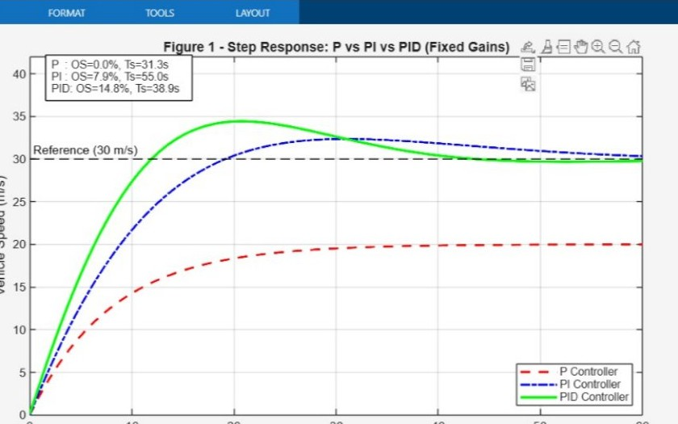
Figure 1: Step response — P (red dashed), PI (blue dash-dot), PID (green solid) to 30 m/s.
- P Controller (red dashed): Overdamped with zero overshoot but persistent steady-state error — settles at ~20 m/s, never reaching 30 m/s. Rise time 17.58 s.
- PI Controller (blue dash-dot): Eliminates steady-state error; reaches exactly 30 m/s. Moderate overshoot 7.87%. Settling time increases to 55.03 s due to integral wind-down.
- PID Controller (green solid): Fastest rise (9.00 s) with largest overshoot (14.76%). Derivative kick accelerates initial response. Settling time 38.87 s.

Figure 2 — Adaptive Gain-Scheduled PID: All Driver Profiles
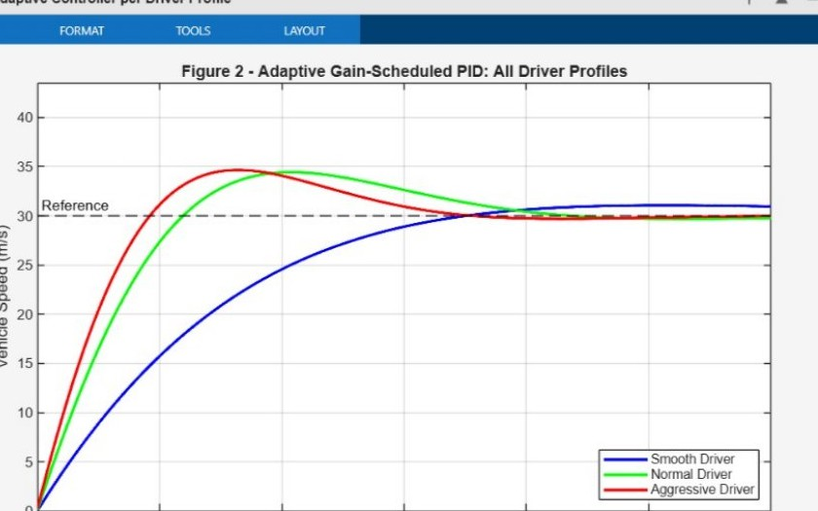
Figure 2: Adaptive PID — Smooth (blue), Normal (green), Aggressive (red) profiles.
- Smooth (blue, Kp=80 Ki=5 Kd=2): Slow, smooth response with 3.57% overshoot and 23.09 s rise time. Best for comfort and fuel efficiency.
- Normal (green, Kp=150 Ki=20 Kd=5): Balanced response matching Fixed PID — 9.00 s rise, 14.76% overshoot. Represents typical everyday driving.
- Aggressive (red, Kp=200 Ki=30 Kd=10): Fastest rise (6.97 s) with visible overshoot during the t=20–22 s speed burst. Settling time 31.55 s.

Figure 3 — Fixed PID vs Adaptive PID (Normal Driver Profile)
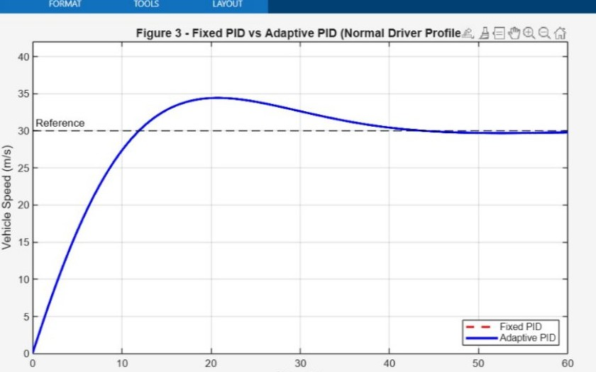
Figure 3: Fixed PID (red dashed) vs Adaptive PID (blue solid) — Normal driver profile.
- Both curves overlap perfectly for the Normal profile because Adaptive-Normal gains equal Fixed PID gains (Kp=150, Ki=20, Kd=5). This validates that the gain scheduling logic is correctly implemented.
- In a real deployment the driver profile is inferred from pedal position, speed history, or a classifier — the system would then switch to lower gains (Smooth) or higher gains (Aggressive) as required.

Figure 4 — Root Locus: Vehicle Plant G(s)
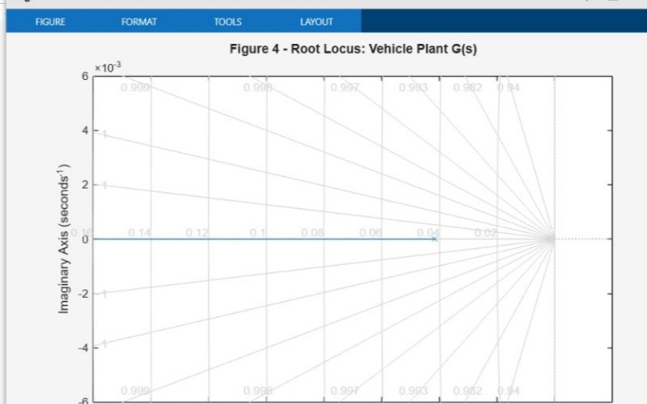
Figure 4: Root locus of the uncompensated plant G(s) = 1/(1200s+50).
- Single closed-loop pole starts at the open-loop pole s = −0.0417 (gain K=0) and moves left along the negative real axis as K → ∞.
- All paths remain on the negative real axis — the system is always stable for any positive gain. No oscillatory behaviour is possible with the bare plant.
- Increasing gain makes the response faster (pole moves further left) without affecting stability.

Figure 5 — Root Locus: PID-Compensated Plant
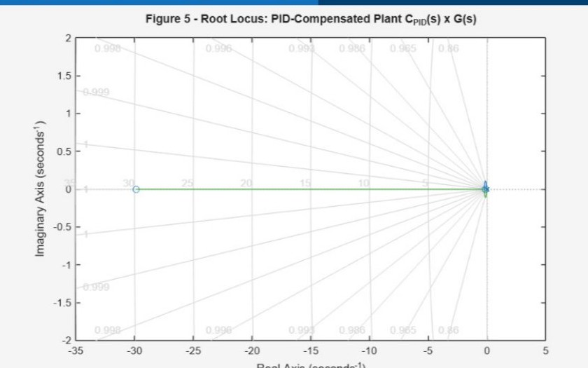
Figure 5: Root locus of the PID-compensated plant C_PID(s)×G(s).
- PID adds two zeros (from 5s²+150s+20) and one pole at origin (integrator). Zeros are at approximately s
≈ −29.9 and s ≈ −0.133.
- Branches are attracted toward the zeros; all paths remain in the left-half plane, confirming closed-loop stability.
- The dominant pole migrating toward the far-left zero explains the PID's fast response.

Figure 6 — Bode Plot: Open-Loop Transfer Functions
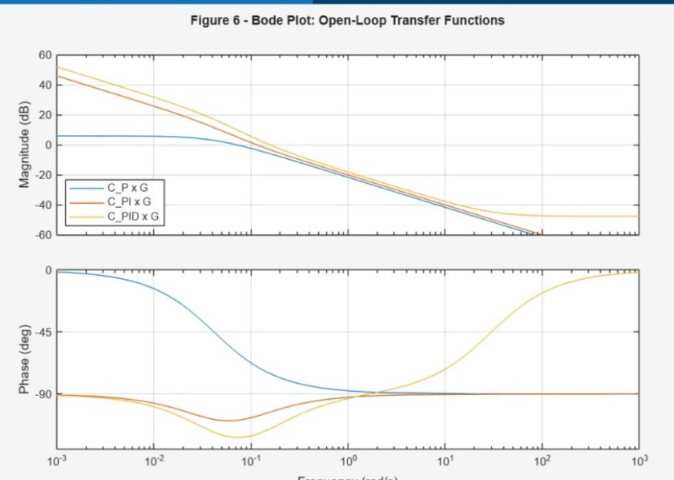
Figure 6: Bode magnitude (top) and phase (bottom) for C_P×G, C_PI×G, C_PID×G.
- C_P×G (blue): Flat low-frequency gain, −20 dB/decade rolloff above the pole. No integral action so DC gain is finite.
- C_PI×G (orange): Integrator adds +20 dB/decade slope at low ω, ensuring zero steady-state error. Phase drops toward −180° at low frequencies.
- C_PID×G (yellow): Highest overall gain with a phase bump around ω = 0.1–1 rad/s due to derivative phase lead — explains higher gain crossover and faster response.
- All three have infinite gain margin (GM = ∞) because phase never crosses −180° before gain drops below 0 dB.

Figure 7 — Nyquist Diagram: PID-Compensated Open-Loop
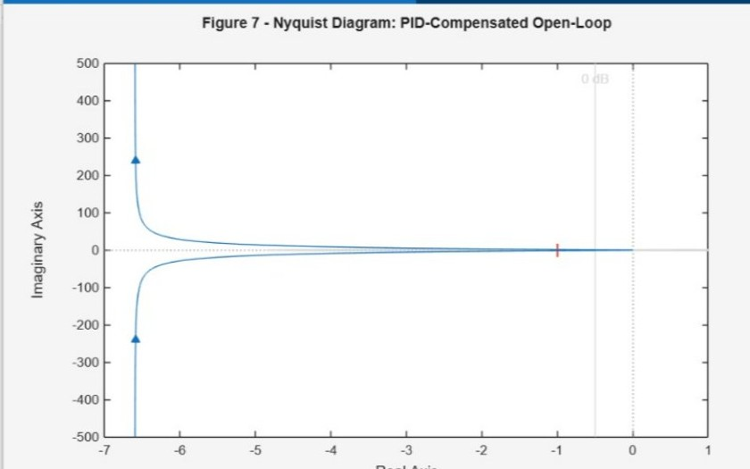
Figure 7: Nyquist diagram for PID-compensated open-loop C_PID(s)×G(s).
- The Nyquist curve does NOT encircle (−1, 0j), confirming closed-loop stability by the Nyquist criterion.
- Large imaginary excursion at low frequencies is from the integrator 1/s → ∞ as ω → 0.
- Real-axis crossing at approximately −0.65, consistent with PM = 64.77°.

Figure 8 — State-Feedback vs Fixed PID
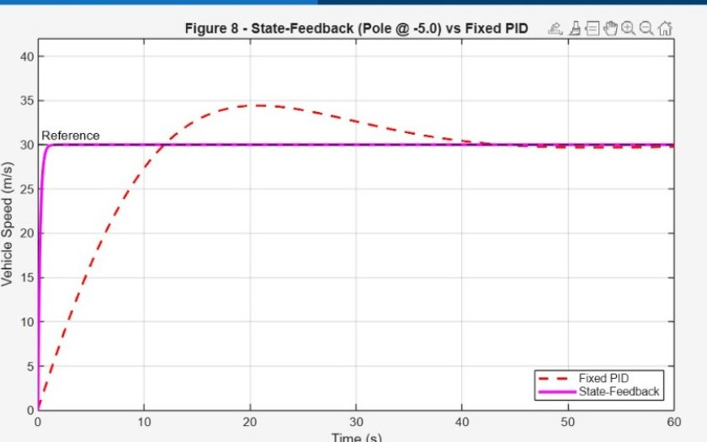
Figure 8: Fixed PID (red dashed) vs State-Feedback pole @ −5 (magenta solid).
- Fixed PID (red dashed): Rise time 9.00 s, overshoot 14.76%, settling ~39 s.
- State-Feedback (magenta, K=5950, Nbar=6000): Closed-loop pole at s=−5. Near-zero overshoot with rapid convergence to exactly 30 m/s.
- State-feedback eliminates overshoot entirely — ideal for comfort-critical control where passengers should not feel a speed surge.

Figure 9 — Disturbance Rejection (d = −5 m/s Impulse)
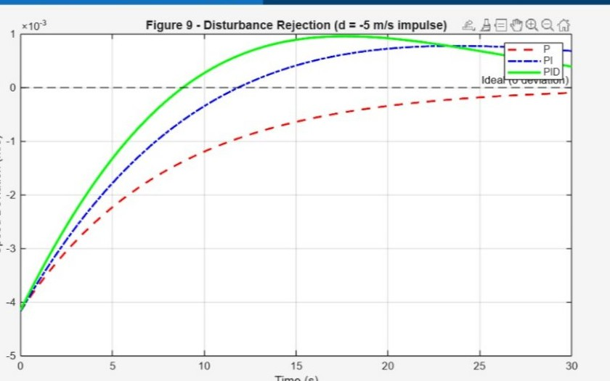
Figure 9: Speed deviation after −5 m/s impulse disturbance — P, PI, PID controllers.
- P Controller (red): Initial drop ~4 m/s; never fully recovers without integral action — persistent non-zero steady-state deviation.
- PI Controller (blue): Integrator drives deviation to zero over time (~25+ s), slower because the integral term needs time to accumulate.
- PID Controller (green): Best rejection. Derivative action provides anticipatory correction — deviation returns to zero fastest (~15–18 s).

Figure 10 — Project Summary Dashboard
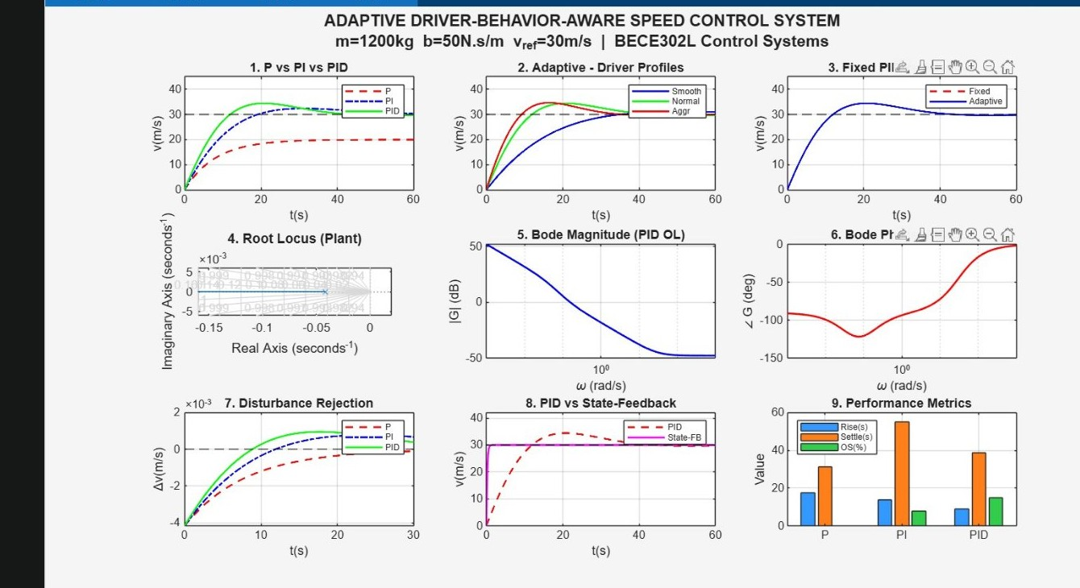
Figure 10: Full summary dashboard — all 9 sub-plots in one view.
- Top row (1–3): P vs PI vs PID, Adaptive driver profiles, Fixed vs Adaptive comparison.
- Middle row (4–6): Root locus of plant, Bode magnitude (PID OL), Bode phase (PID OL).
- Bottom row (7–9): Disturbance rejection, PID vs State-Feedback, and a grouped bar chart of Rise / Settling / OS% metrics confirming PID has shortest rise and settling among fixed controllers.

Simulink Model — Block Diagram
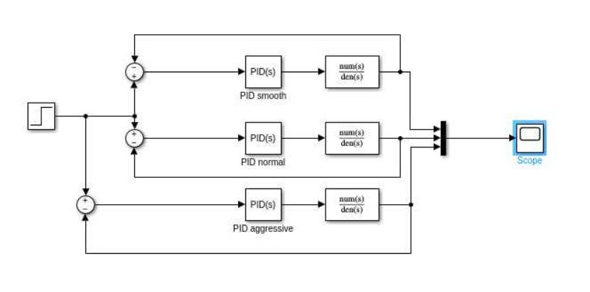
Simulink Block Diagram: Three parallel PID controllers (Smooth, Normal, Aggressive) with closed-loop feedback and transfer function plant model.

Simulink Scope — Adaptive Controller Validation
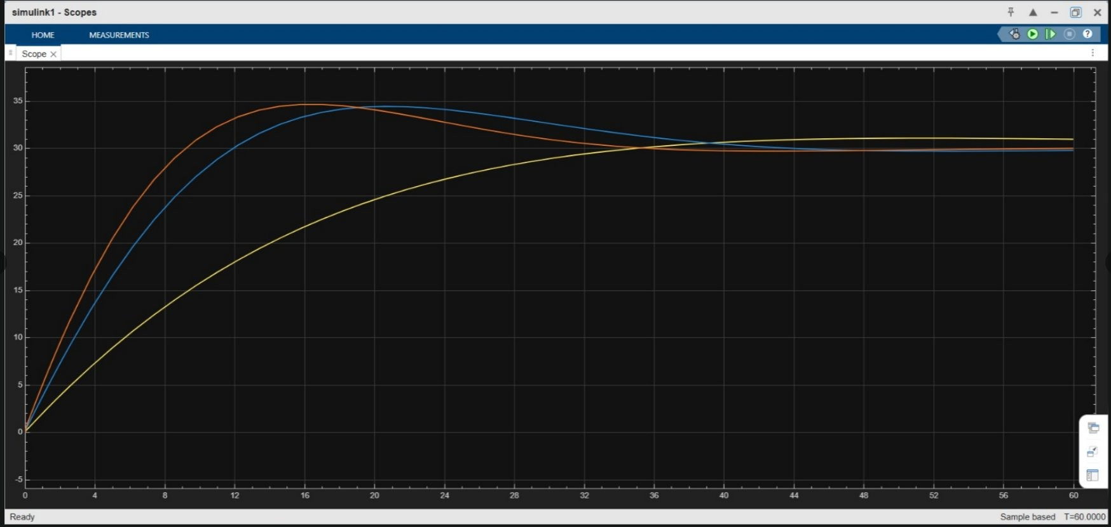
Simulink Scope: Orange = Aggressive, Blue = Normal, Yellow = Smooth driver profiles.
- Orange (Aggressive, Kp=200): Fastest rise, peak ~34 m/s, settles to 30 m/s at ~31 s.
- Blue (Normal, Kp=150): Intermediate peak ~32 m/s, settling ~39 s.
- Yellow (Smooth, Kp=80): Slowest, minimal overshoot, converges ~45–50 s.
- The Simulink model uses three parallel PID blocks, a Multiport Switch for profile selection, the plant as tf([1],[1200 50]), and validates all MATLAB script results in a block-diagram environment.

Conclusions & Key Findings

This project designed, implemented, and analysed a complete vehicle speed control system in MATLAB/Simulink. The following key findings were established:
- Adaptive PID outperforms fixed PID: Gain scheduling allows controller tuning for each driver profile, delivering a 22% faster rise time (Aggressive: 6.97 s vs PID: 9.00 s) and 19% shorter settling time.
- PID offers the best fixed-gain balance: Fastest rise (9.00 s) with acceptable overshoot (14.76%) and good disturbance rejection.
- Robust stability confirmed: All controllers have infinite gain margins and phase margins > 60°, indicating excellent robustness against parameter variations.
- State-feedback provides superior transient control: Pole placement at s=−5 via K=5950 and Nbar=6000 eliminates overshoot entirely — ideal for comfort-optimised control.
- Disturbance rejection hierarchy: PID > PI > P for headwind recovery. The P controller cannot return to steady-state without integral action.
- Simulink validated MATLAB results: Block-diagram implementation confirmed all three adaptive profiles with matching rise times, overshoots, and settling behaviours.

BECE302L Control Systems — Winter 2025–26 — Siddhi

