BECE355L — Advanced Cloud Computing
Fall Semester 2026–27
Cloud-Native Parallel Computing Framework for Scalable Image Processing
Object Storage, Deep-Learning Operations, a Cost-Aware Planner and Work-Aware Autoscaling
Project Report
Python · OpenCV · ONNX Runtime · Redis · MinIO / Amazon S3 · FastAPI · Docker · Kubernetes · KEDA
Submitted by
Name | Register No.
Prapti Kurkuri | 24BVD0185
Vaanya Garg | 24BVD0139
Aditya Manoj | 24BVD0070
Arrnav Trisal | 24BVD0064

Submitted to: Aparna Mohanty
School of Electronics Engineering (SENSE), Vellore Institute of Technology, Vellore
31 October 2026

Cloud-Native Parallel Computing Framework for Scalable Image Processing
Object Storage, Deep-Learning Operations, a Cost-Aware Planner and Work-Aware Autoscaling
Prapti Kurkuri  Reg. No. 24BVD0185  SENSE  Vellore Institute of Technology  Vellore, Tamil Nadu, India  Praptikurkuri2024@vitstudent.ac.in | Vaanya Garg  Reg. No. 24BVD0139  SENSE  Vellore Institute of Technology  Vellore, Tamil Nadu, India  Vaanyagarg2024@vitstudent.ac.in | Aditya Manoj  Reg. No. 24BVD0070  SENSE  Vellore Institute of Technology  Vellore, Tamil Nadu, India  Adityamanoj2024@vitstudent.ac.in | Arrnav Trisal  Reg. No. 24BVD0064  SENSE  Vellore Institute of Technology  Vellore, Tamil Nadu, India  Arrnavtrisal2024@vitstudent.ac.in

Abstract—Our earlier framework splits a large image into halo tiles, schedules one task per tile through a reliable Redis queue to stateless worker pods and stitches the results, with leases for fault tolerance and a queue-length autoscaler. Its evaluation exposed four weaknesses: every tile byte passed through Redis, which capped image size and concurrency; only cheap classical filters were supported, so most operations ran slower when distributed; the tile size and worker count were fixed by hand; and the autoscaler counted tiles, not work. This report presents four upgrades that address them. (1) Tiles, inputs and results move to S3-compatible object storage (MinIO locally, Amazon S3 in the cloud) and Redis carries only task IDs; Redis memory per 8192² job drops from 226 MB to 0.05 MB and accepted concurrent 8192² jobs rise from 2 to at least 12. (2) Two deep-learning operations, HED edge detection and Real-ESRGAN ×4 super-resolution, run under ONNX Runtime; their halos are calibrated empirically from the effective receptive field (80 px and 4 px instead of the theoretical 98 px and 34 px) and the stitcher is scale- and stride-aware. (3) A cost-aware planner predicts job time from a calibrated model of compute, per-tile overhead and a measured multi-worker capacity curve and chooses whether to distribute, the tile size and the worker count. Its prediction error is 25 % MAPE versus 40 % for a linear model, and it turns the 16× slowdown of naively tiled grayscale into a 1.11× result. (4) A work-aware autoscaler sizes the worker pool from queued compute-seconds and a latency target. On a replayed trace it met a 30 s latency target for every job with 9 % fewer worker pod-seconds than KEDA, while the CPU-based HPA met it for only 54 % of jobs. Neural operations reach only 2.5× (HED) and 2.4× (Real-ESRGAN) on a 16-thread laptop because they are memory-bandwidth bound, a result the planner models explicitly.
Index Terms—cloud-native computing, object storage, Kubernetes autoscaling, KEDA, performance model, tiled image processing, receptive field, ONNX Runtime, Redis, fault tolerance.
I. Introduction
A. Background
Satellite scenes, whole-slide pathology images and microscopy mosaics reach hundreds of megapixels. Most image filters are local: each output pixel depends on a small neighbourhood. Such work can be split into tiles, processed in parallel and stitched, provided every tile carries a halo (overlap) wide enough that the stitched output equals whole-image processing. Our first version (v1) built this on Kubernetes: a FastAPI service partitions the image, Redis holds a reliable queue with one task per tile, stateless workers claim tiles under a lease and the last finisher reconstructs the output.
B. Problems Found in v1
The v1 evaluation [Sec. XI] showed where a simple design stops working:
1) Redis was the data plane. Every tile and result went through Redis, so an 8192² job used about 226 MB of Redis memory. With a 1 GB limit only 2 such jobs fit and 12288² images were rejected.
2) Cheap operations got slower. Canny ran at 0.45× and Gaussian blur at 0.41× when distributed, because moving a tile cost more than filtering it. Only the bilateral filter (4.2×) benefited.
3) Configuration was manual. The user picked the tile size; the system always distributed.
4) The autoscaler counted tiles. One HED tile costs about 1800 times a Canny tile of the same size, yet both counted as one unit of queue length.
C. Contributions
This report describes four upgrades, all implemented in the same repository, tested and measured on the same hardware:
• Object-storage data plane (S3/MinIO) with presigned result URLs, SSE-KMS, least-privilege IAM, lifecycle expiry and streaming tiled BigTIFF output for images too large for memory.
• Deep-learning operations (HED, Real-ESRGAN ×4) with empirical halo calibration, stride-aligned halos and scale-aware stitching.
• A cost-aware adaptive planner with a calibrated time model, a measured capacity curve per operation and online re-calibration from completed tasks.
• A work-aware autoscaler evaluated against the Kubernetes HPA and KEDA on an identical seeded trace.
II. Objectives
TABLE I
Project objectives and outcomes
# | Objective | Outcome
1 | Remove the Redis memory ceiling | Achieved: S3/MinIO data plane; Redis holds IDs (Sec. V)
2 | Support heavy neural operations seam-free | Achieved: HED and Real-ESRGAN, calibrated halos (Sec. VI)
3 | Choose execution strategy automatically | Achieved: planner; 25 % MAPE (Sec. VII, X-C)
4 | Scale on work instead of queue length | Achieved: work-aware scaler vs HPA, KEDA (Sec. VIII, X-D)
5 | Keep v1 guarantees | Kept: halo-exact output, leases, retries; 42 tests pass

III. Related Work
Splitting and fault tolerance. MapReduce [6] established splitting a job into independent tasks with re-execution on failure; our tile tasks are map tasks with a spatial reduce. Leases [7] bound how long a crashed holder can block a resource; our tiles use leases renewed by heartbeats. Image pipelines. Halide [8] separates the algorithm from its schedule and treats tile size and recomputation of overlap as a trade-off; Distributed Halide [9] extends this to clusters and shows that communication, not compute, often limits scaling, which is exactly the effect our planner models. Performance models. Ernest [10] predicts the runtime of analytics jobs from a few small runs with a simple parametric model; our planner follows the same idea (calibrate, then extrapolate) with terms for per-tile overhead and contention. Autoscaling. The Kubernetes HPA [19] scales on resource utilisation and KEDA [18] on event-source metrics such as list length. Autopilot [11] at Google sets resources from observed usage rather than user limits. Bhosale et al. [1], [2] argue for elastic, workload-aware resizing of cloud HPC jobs, and Liu et al. [4] predict future workload requirements for containerised workflows; our work-aware scaler is a simple instance of both ideas. Chazapis et al. [5] and the fog pipeline of [3] support the premise that a thin scheduler on Kubernetes is a viable substrate for parallel compute. Neural networks. HED [12] and Real-ESRGAN [13] are fully convolutional, so they can be tiled, but their theoretical receptive fields are large. Luo et al. [14] showed the effective receptive field is much smaller and roughly Gaussian, which justifies calibrating the halo empirically.
IV. System Architecture
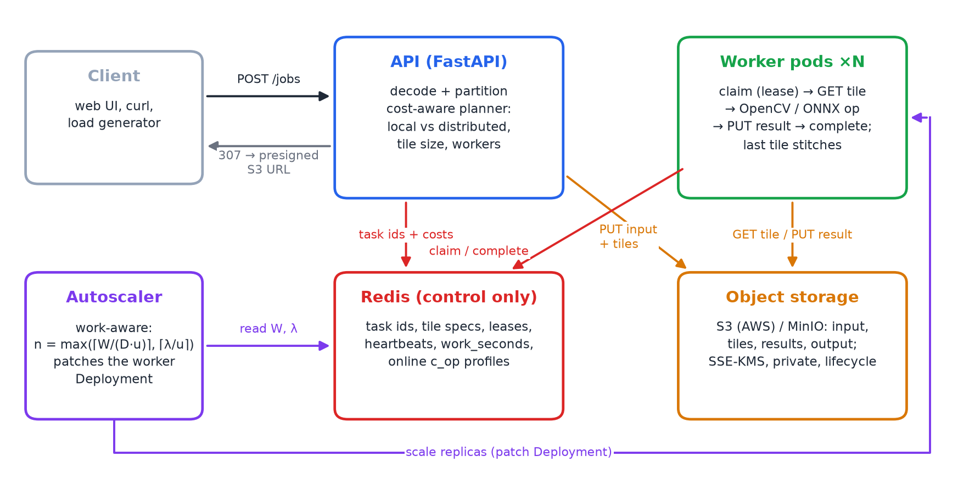
Fig. 1. Architecture after the upgrades. Bulk bytes (input, tiles, results) flow through object storage; Redis carries only task IDs, leases, per-tile costs and job state.
All components are built from one Docker image and run unchanged on a laptop, Docker Compose or Kubernetes:
• API (FastAPI). Accepts uploads, asks the planner for a plan, partitions the image, uploads input and tiles to the bucket, enqueues one task per tile with its predicted cost, and serves status and results (a 307 redirect to a presigned URL).
• Redis. Reliable queue (pending, processing lists and a lease sorted set), job hashes, per-tile cost hash, the queued work-seconds counter and the online profile. All state changes are Lua scripts so they are atomic.
• Object store. MinIO locally, Amazon S3 in the cloud. Keys are jobs/<id>/input.<ext>, tiles/<i>.npy, results/<i>.npy, output.png|tif and previews.
• Workers. Stateless; claim a tile, GET it, run the OpenCV or ONNX operation, PUT the result, complete it. The last finisher stitches (or streams a tiled TIFF).
• Autoscaler. Work-aware policy (ours), or the HPA / KEDA baselines; one is active at a time.
V. Upgrade 1: Object-Storage Data Plane
A. Design
v1 stored encoded tiles in Redis, so Redis memory, not CPU, limited the system. The upgrade applies the claim-check pattern: bulk bytes go to S3 and the queue entry carries only the tile ID. imgframe/objstore.py wraps boto3 with path-style addressing so the same code talks to MinIO and S3; tile uploads and downloads use a 32-thread pool. The API uploads all tiles before enqueuing any task, so a worker never claims a tile whose bytes are missing. Deleting a job removes its prefix and subtracts its remaining cost from the work counter. Redis mode is kept (S3_BUCKET unset) for tests and for the comparison below.
B. Result Delivery and Large Outputs
GET /jobs/{id}/result answers with a 307 redirect to a presigned URL valid for 300 s, so result bytes never pass through the API (a proxy mode exists for clients that cannot follow redirects). A separate signing client uses the public endpoint, because the in-cluster hostname of MinIO is not resolvable by a browser. Outputs above 150 MP (STREAM_OUTPUT_MP) are written tile by tile into a tiled BigTIFF with tifffile, so the aggregator never holds the full image; a 1200 px JPEG preview is written alongside.
C. Security
The AWS templates in deploy/aws/ follow least privilege: the API role may put inputs and tiles, read results and presign; the worker role may only get tiles and put results. The bucket enforces Block Public Access and TLS-only access, encrypts with SSE-KMS [20], and expires jobs/ after one day with a lifecycle rule. On EKS the roles are bound to Kubernetes service accounts with IRSA [21], so no keys are stored in pods. Locally, MinIO credentials live in a Kubernetes Secret. The AWS templates are written and syntax-checked but were not deployed (no AWS account was used).
VI. Upgrade 2: Deep-Learning Operations
A. Models
HED [12] produces a soft edge map from five VGG-16 side outputs. The public weights are a Caffe model and OpenCV 5 no longer imports Caffe, so we wrote scripts/convert_hed.py, which decodes the Caffe protobuf wire format directly and emits an equivalent ONNX graph (bilinear resize of side outputs, as in the PyTorch port). Real-ESRGAN [13] (realesr-general-x4v3, 1.2 M parameters) upscales ×4. Both run under ONNX Runtime [22] with one intra-op thread per process, so parallelism comes only from the framework and the comparison with sequential execution is fair. Model files are fetched by scripts/fetch_models.sh and verified by SHA-256.

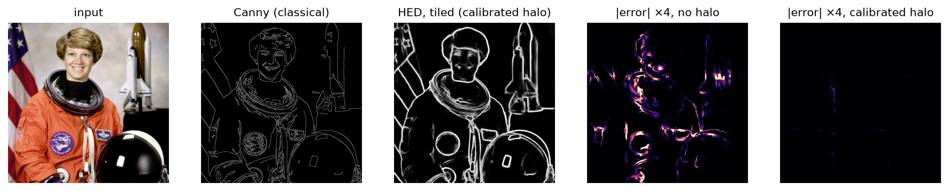
Fig. 2. Canny vs HED on the same photograph, and the tiled-minus-whole error maps. With the calibrated halo the tiled HED output is visually identical to whole-image inference.

B. Halo Calibration from the Effective Receptive Field
The theoretical receptive-field radius of HED is 98 px and of Real-ESRGAN 34 px. Using it as the halo is exact but expensive: with 256 px tiles HED would compute 2.5× more pixels than needed. Following [14], scripts/calibrate_halo.py sweeps the halo, compares tiled with whole-image output and picks the smallest halo meeting two criteria: seam PSNR ≥ 40 dB (PSNR within 8 px of tile borders) and the 99.9th-percentile absolute error ≤ 8 grey levels. Table II and Fig. 3 show the sweep.
TABLE II
Halo calibration (256 px tiles); middle row = chosen halo
Op | Halo (px) | Seam PSNR (dB) | p99.9 |err| | Extra pixels
HED | 0 | 16.0 | 155 | 0 %
HED | 80 | 42.3 | 8 | 164 %
HED | 98 | 99.0 | 0 | 252 %
Real-ESRGAN | 0 | 33.3 | 14 | 0 %
Real-ESRGAN | 4 | 42.2 | 5 | 6 %
Real-ESRGAN | 34 | 99.0 | 0 | 60 %

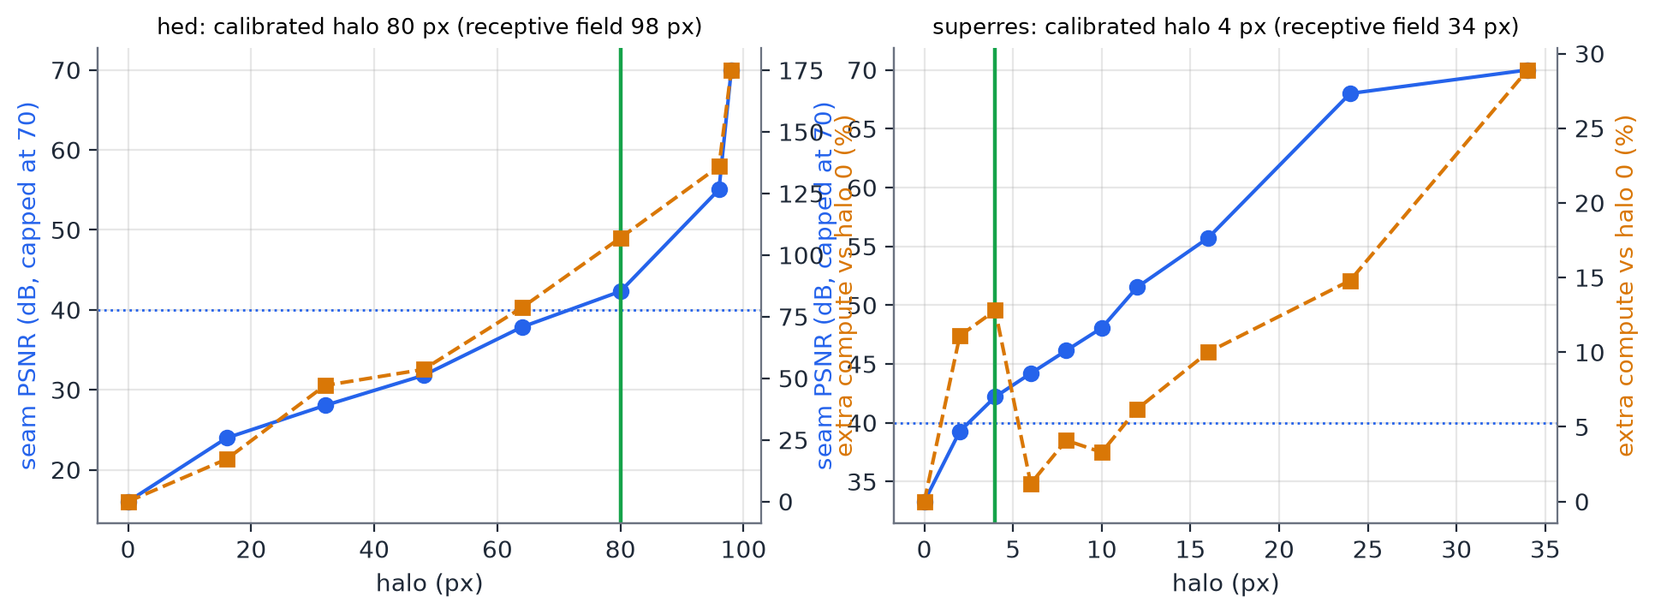
Fig. 3. Halo sweep: seam PSNR (left) and compute overhead (right). The chosen halo is the first point above both thresholds.
Two details mattered. First, HED downsamples by up to 16, so a tile whose origin is not a multiple of 16 sees a shifted pooling grid; plan_tiles(..., align=16) snaps both halo edges to the stride, which made the theoretical halo bit-exact (99 dB) where it had been worse than a 64 px halo. Second, Real-ESRGAN outputs 4× the input, so crop_core and reconstruct scale tile coordinates by the operation's scale. The calibrated halos cut extra computation from 252 % to 164 % (HED) and from 60 % to 6 % (Real-ESRGAN).
VII. Upgrade 3: Cost-Aware Adaptive Planner
A. Time Model
For an image of P pixels, operation cost c (s/px), K tiles of mean size p̄ with halo h and n workers, the planner predicts
T_{dist} = T_{split} + T_{comp} + T_{over} + T_{stitch} (1)
T_{comp} = ⌈K/n⌉ · c · p̄_{halo} · n / S(n) (2)
o(p) = o₀ + o_{px} · p_{halo} · (1 + s2) (3)
where S(n) is the measured capacity curve of the operation (throughput of n concurrently busy workers relative to one), o(p) the per-tile overhead (encode, transfer, queue round trip) and s the output scale. Overheads are paid in ⌈K/n⌉ waves on the cluster; on the single-process engine, where dispatch is serial, T = T_{serial} + max(T_{comp} + T_{over}, K·o). The local alternative is T_{local} = c·P (plus split and stitch when it runs as a single tile on the cluster). The planner evaluates tile sizes {256, 512, 1024, 2048} and every worker count up to the available workers, adds a 20 % safety margin to the distributed estimate, and among plans within 2 % of the best picks the one with fewer workers.
B. Calibration
scripts/profile_ops.py measures c for each operation on four tile sizes, the capacity curve for 1–16 workers and the per-tile overhead of each backend (in-process engine, cluster with S3, cluster with Redis), and writes imgframe/profiles.json (Table III, Fig. 4). Workers keep refining c online: after each tile they add an exponential moving average (α = 0.05) to Redis, normalised for the contention at that moment as c ← t·S(b)/(b·p), where b is the number of busy workers.
TABLE III
Measured per-pixel cost and capacity curve (16-thread host)
Op | c (ns/px) | S(4) | S(8) | S(16)
Grayscale | 0.3 | 1.06 | 2.55 | 3.80
Canny | 2.6 | 2.24 | 4.29 | 5.97
Gaussian | 4.2 | 3.39 | 4.67 | 6.32
Bilateral | 73.9 | 3.79 | 6.46 | 7.29
HED | 4,545 | 3.37 | 5.07 | 4.54
Real-ESRGAN | 23,814 | 2.16 | 1.96 | 1.88

Per-tile overhead on the cluster is o₀ = 2.59 ms + 3.85 ns/px with S3 and 3.29 ns/px with Redis; a 512² tile PUT+GET takes 5.7 ms on MinIO and 0.52 ms on Redis. Since Canny costs only 2.6 ns/px, a 512² Canny tile computes in 0.7 ms but costs ≈ 5 ms to move, which is why cheap operations must not be distributed finely.
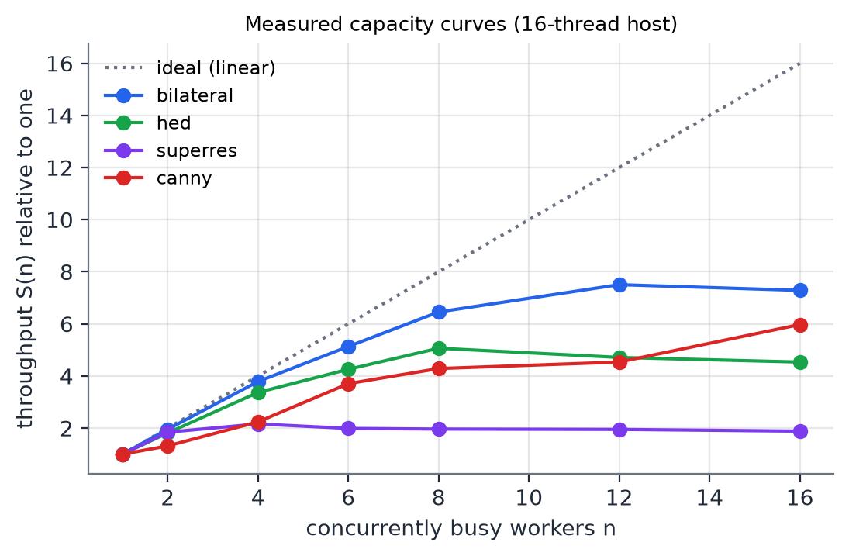
Fig. 4. Capacity curves S(n). Bilateral scales to ≈ 7× on 16 threads; HED peaks at ≈ 5× at 8 workers and Real-ESRGAN saturates at ≈ 2× from 4 workers: both are memory-bandwidth bound on this host.
VIII. Upgrade 4: Work-Aware Autoscaling
When the API enqueues a tile it stores the tile's predicted compute time and adds it to a Redis counter W (queued work-seconds). The completion, give-up and delete Lua scripts subtract exactly the stored cost, so W never drifts. Every 3 s the autoscaler reads W, estimates the arrival rate of work λ (s of work per s) as an EMA of the increase of a monotonic work-added counter, and sets
n = clamp(max(⌈W / (D·u)⌉, ⌈λ/u⌉), n_{min}, n_{max}) (4)
with D = L − t_{start} the time left to drain the queue once a pod has started (latency target L = 30 s, pod start-up t_{start} = 5 s) and u = 0.8 the target utilisation. The first term drains the backlog within the latency target; the second keeps up with the steady arrival rate. Scale-down is delayed by a 30 s stabilisation window, as in the baselines. Unlike a queue-length rule, ten HED tiles and ten Canny tiles produce very different W, so the pool reacts to how much work is waiting.
Baselines. HPA: CPU utilisation target 70 % of the worker request (autoscaling/v2, 30 s scale-down window) [19]. KEDA 2.21 [18]: Redis Lists scaler on queue:pending, 16 tiles per replica, polling every 3 s. All three use 1–8 replicas; scripts/k8s_scaler.sh switches between them so exactly one controls the worker Deployment.
IX. Experimental Setup
All experiments ran on one laptop: Intel Core i7-11800H (8 cores, 16 threads), 22 GB RAM, Ubuntu 25.10, Python 3.13, OpenCV 5.0, ONNX Runtime 1.31, Redis 7.2, MinIO (Chainguard image). Kubernetes experiments use Minikube 1.37 (Docker driver, 8 CPUs, 12 GB) with metrics-server and KEDA 2.21. Engine benchmarks use 8192² synthetic images for classical operations, a 2048² photograph for HED and a 1024² one for Real-ESRGAN. Each point is the median of three runs unless stated. Because workers share one host, results show relative behaviour; absolute speedups on a multi-node cluster would differ.
X. Results
A. Object Storage vs Redis Data Plane
TABLE IV
Storage study
Metric (Redis maxmemory 1 GB) | Redis mode | S3 mode
Largest image accepted | 8192² (12288² → 503) | ≥ 16384²
Concurrent 8192² jobs accepted | 2 | 12 (all tried)
Redis memory per 8192² job | 226.4 MB | 0.054 MB
I/O per 512² tile | 7.2 ms | 8.6 ms
Bilateral 4096², end-to-end | 0.82 s | 1.09 s

Moving bytes out of Redis reduces its footprint per job by a factor of 4,215 and removes the concurrency limit (the 12 jobs we tried were all accepted; the remaining limit is the configurable tile-count back-pressure, 20 000 queued tiles). The price is latency: each tile costs 1.3 ms more I/O and a small bilateral job takes 33 % longer, mostly from uploading the input. For large or many concurrent jobs this trade is clearly worth it; the planner already accounts for the higher per-tile overhead.
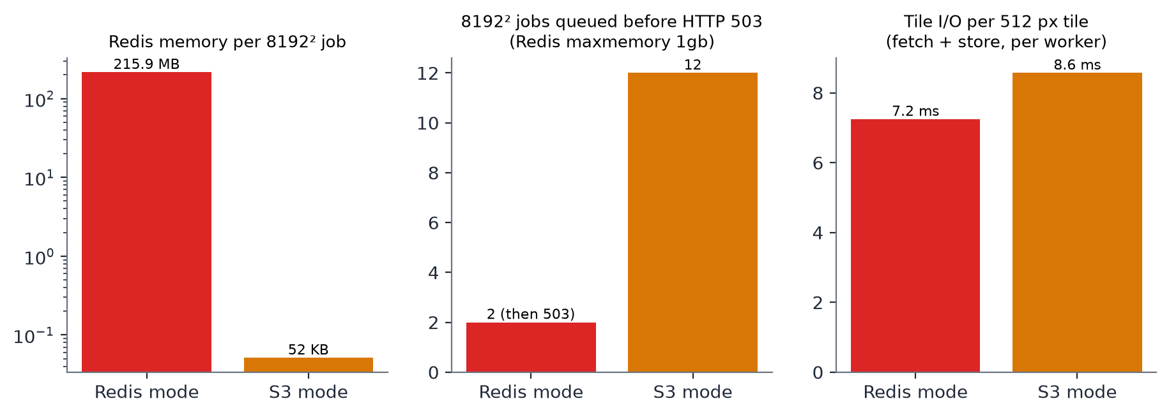
Fig. 5. Redis memory per 8192² job (log scale) and 8192² jobs accepted before HTTP 503, per storage mode.
B. Parallel Scaling of Neural Operations
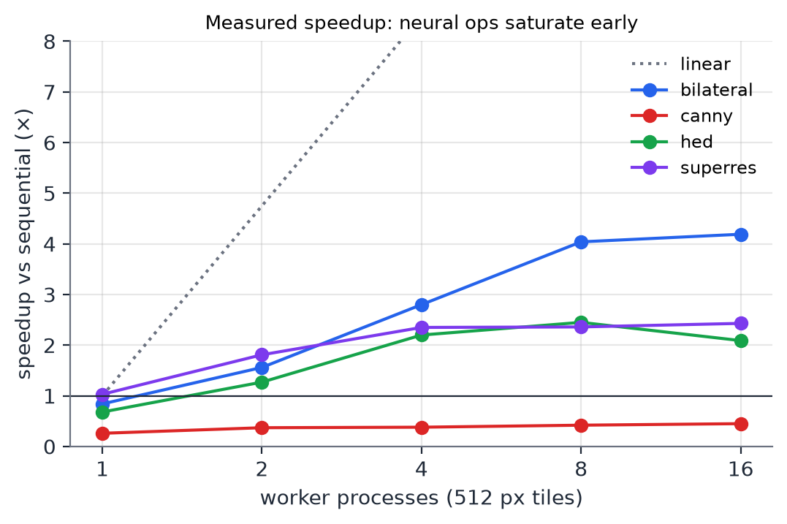
Fig. 6. Speedup vs workers. Bilateral (compute-bound) scales furthest; HED peaks at 8 workers and Real-ESRGAN plateaus from 4.
HED reaches 2.45× at 8 workers and Real-ESRGAN 2.43× at 16. The upgrade plan expected near-linear speedup for neural operations because they are compute-heavy, but on one host they are limited by memory bandwidth: convolution activations of many concurrent tiles exceed the caches, so extra workers wait on DRAM. HED's per-process memory also grows with workers (peak RSS ≈ 3 GB per 8 workers). On a multi-node cluster, where every node brings its own memory bandwidth, the curve would continue; the planner learns the measured curve, so it stops adding workers where they no longer help.
C. Planner
TABLE V
Engine: naive (512 px, 16 workers) vs planner; speedup over sequential
Op (image) | Seq. (s) | Naive | Planner | Plan
Grayscale (8192²) | 0.03 | 0.06× | 1.11× | local
Canny (8192²) | 0.18 | 0.55× | 0.98× | local
Gaussian (8192²) | 0.28 | 0.54× | 1.00× | local
Sobel (8192²) | 0.19 | 0.60× | 1.02× | local
Bilateral (8192²) | 4.96 | 5.08× | 4.94× | n=12, 512 px
HED (2048²) | 20.31 | 2.00× | 2.50× | n=8, 512 px
Real-ESRGAN (1024²) | 25.20 | 2.16× | 2.23× | n=4, 512 px

Naive tiling makes every cheap operation slower (grayscale runs at 0.06×). The planner recognises that and runs them locally, recovering ≈ 1×. For bilateral it chooses 12 workers, within 3 % of naive 16-worker tiling, and for the neural operations it picks fewer workers than naive (8 for HED, 4 for Real-ESRGAN) and is faster (2.50× vs 2.00× for HED) because it avoids the contention region of the capacity curve.
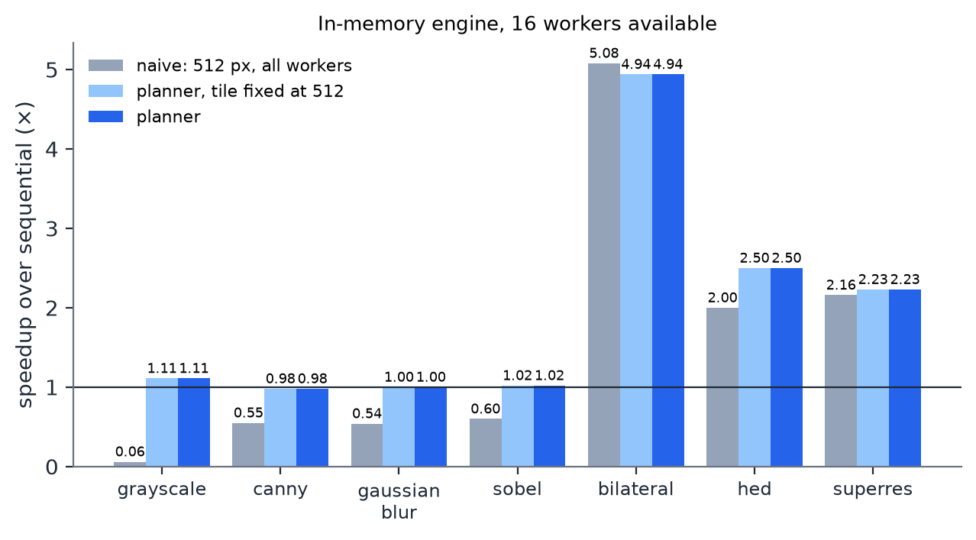
Fig. 7. Speedup over sequential on the in-memory engine: naive 512 px tiling on all workers vs the planner's choice.
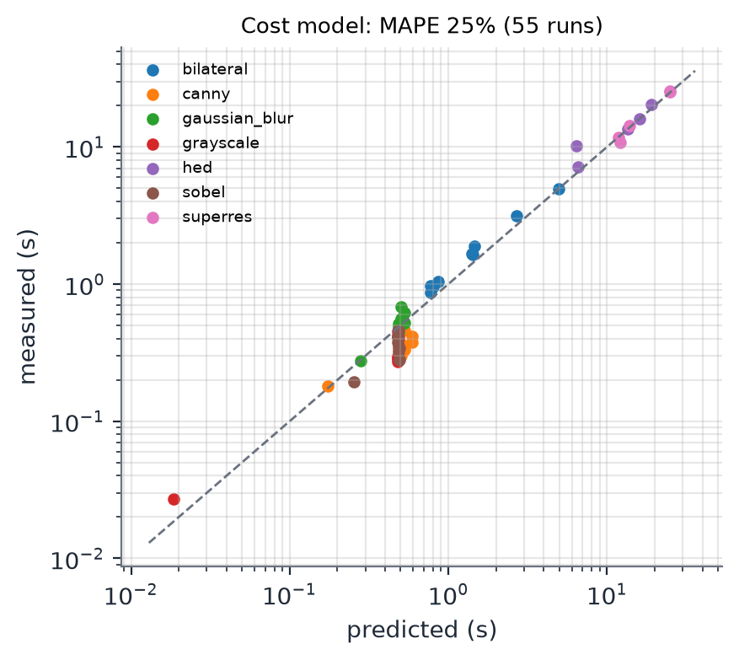
Fig. 8. Predicted vs measured time for all benchmarked configurations, refined model (capacity curve, serial dispatch) vs simple linear model.
Across 55 engine configurations the refined model has 25.0 % mean absolute percentage error against 40.2 % for the simple model (T = c·P/n + K·o). The gain is largest for the operations that matter most: HED 10 % vs 27 %, Real-ESRGAN 4 % vs 20 %, bilateral 15 % vs 28 %. Errors remain high (≈ 40 %) for sub-0.2 s jobs, where timing noise dominates; there a wrong choice costs milliseconds.
TABLE VI
Full framework with S3 (8 workers), end-to-end job time
Op | Naive (s) | Planner (s) | Planner plan
Canny | 0.70 | 0.61 | 16 × 1024 px
Gaussian | 0.87 | 0.84 | 16 × 1024 px
Sobel | 0.74 | 0.64 | 16 × 1024 px
Bilateral | 1.05 | 0.99 | 16 × 1024 px
HED | 8.55 | 8.43 | 16 × 512 px
Real-ESRGAN | 9.63 | 10.75 | 4 × 512 px

Through the full framework (HTTP upload, S3, Redis, worker processes) the planner replaces 64 tiles of 512 px with 16 tiles of 1024 px for classical operations, cutting end-to-end time by 4–14 %; for the neural operations it agrees with the naive choice (differences within noise). The cluster model's MAPE is 21.7 %. One honest observation: in-memory Canny on 4096² takes 48 ms, so for cheap operations the whole job is dominated by upload and storage, and the best plan would be to run them in the API process without queuing. We list that under future work.
D. Autoscaling: HPA vs KEDA vs Work-Aware
The trace (scripts/trace_replay.py, seed 7) has 32 jobs in four phases: two bursts of cheap jobs (grayscale, Canny on 4096²) and two bursts of expensive jobs (bilateral 4096², HED 2048²) with exponential inter-arrival times and 15 s pauses between phases. Each scaler replayed it 3 times, interleaved, starting from one idle worker. Table VII reports mean ± standard deviation; the latency target is 30 s.
TABLE VII
Autoscaler comparison on Minikube (mean ± s.d.)
Metric | HPA | KEDA | Work-aware
p50 latency (s) | 28.2 ± 2.5 | 2.0 ± 0.1 | 2.5 ± 0.1
p95 latency (s) | 46.4 ± 4.6 | 10.6 ± 0.2 | 12.3 ± 0.3
Jobs within target (%) | 54.2 ± 10.0 | 100.0 ± 0.0 | 100.0 ± 0.0
Worker pod-seconds | 320 ± 5 | 616 ± 47 | 560 ± 37
First scale-up (s) | 93.7 ± 15.0 | 3.7 ± 0.0 | 33.8 ± 0.1
Scaling events | 1.3 ± 0.6 | 6.0 ± 1.0 | 6.0 ± 0.0

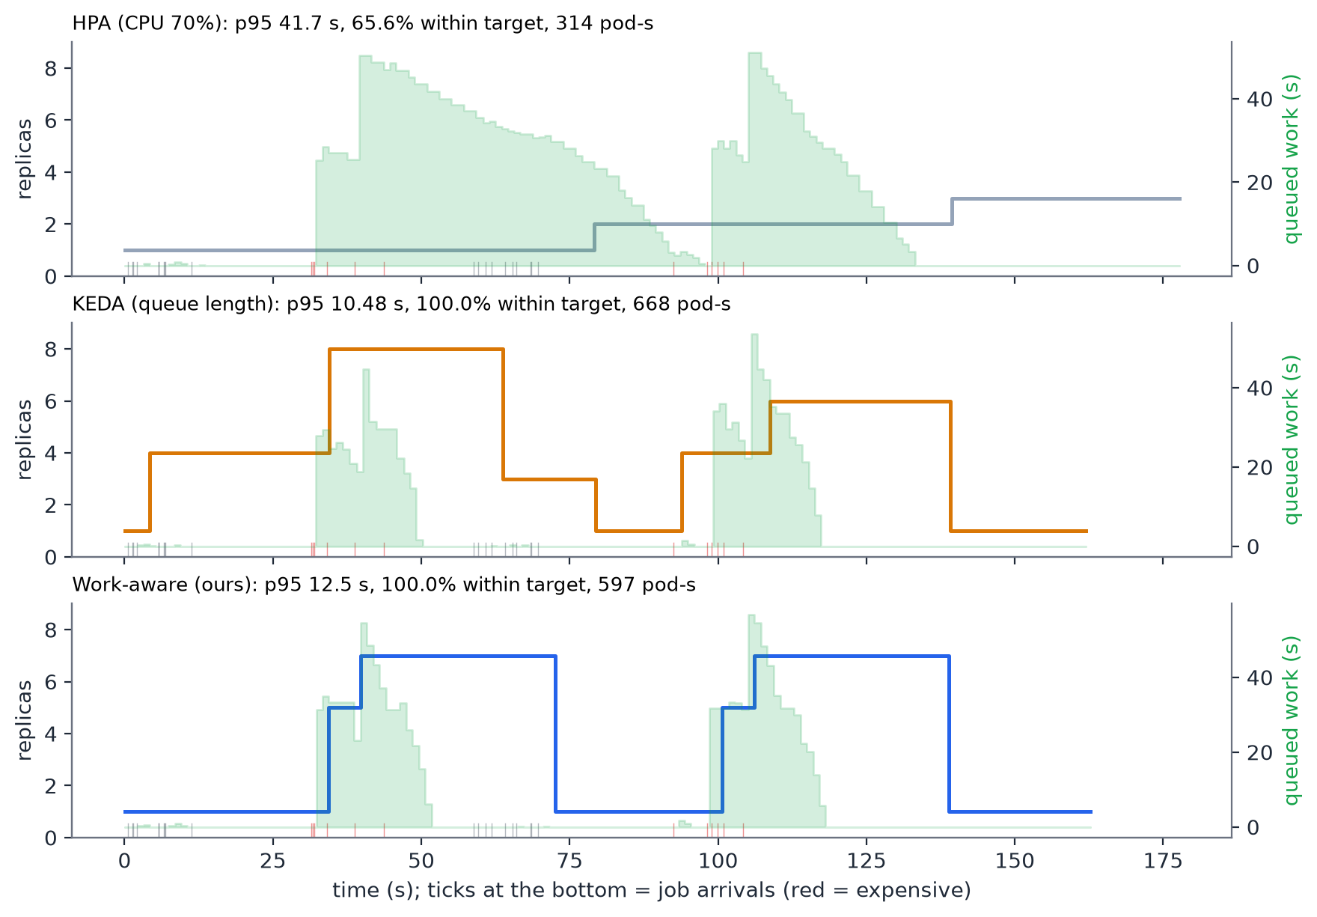
Fig. 9. Replica count (line) and queued work-seconds (shaded) during one run of each scaler; ticks mark job arrivals (red = expensive).

HPA is the cheapest (320 pod-s) but misses the target: only 54 % of jobs finish within 30 s and p95 latency is 46 s. CPU utilisation is averaged over a metrics window and the worker request is large, so its first scale-up came 94 s after the first arrival, by which time the expensive burst was mostly over.
KEDA and the work-aware scaler both met the target for every job. KEDA had the lower p95 (10.6 s vs 12.3 s); the work-aware scaler used 9 % fewer worker pod-seconds (560 vs 616). The replica traces show why: KEDA scales up within 4 s of the cheap bursts, because 10 grayscale/Canny jobs queue hundreds of tiles, although those jobs finish in about two seconds on one worker. The work-aware scaler sees only a few seconds of queued work there and stays at one replica; its first scale-up (34 s) is the start of the expensive burst, which it meets with 5–7 workers.
The work-aware scaler is not optimal yet. After the queue drains it keeps its peak replica count for about 20 s more, because the arrival-rate term λ is an EMA that decays slowly and the 30 s scale-down delay starts only after demand falls; most of its remaining pod-seconds are spent there. A faster decay of λ, or scaling down in steps, is the obvious next improvement. With one trace on one host the differences between KEDA and the work-aware scaler are modest; the clear result is that scaling on work avoids reacting to cheap tile counts while still meeting the latency target.
E. Correctness and Testing
The test suite has 42 tests (all pass): tiling and exact reconstruction for every classical operation, the reliable queue (claim, duplicate completion, lease expiry, retries), end-to-end HTTP runs including a crashed worker, and 16 new tests for the upgrades: S3-mode jobs keep pixels out of Redis, proxy and redirect delivery, queue-depth back-pressure, crash recovery in S3 mode, stride-aligned halos, scale-aware stitching, streamed TIFF equal to in-memory output, HED tiled vs whole (PSNR), Real-ESRGAN end to end, planner decisions, the online cost EMA, exact work-seconds accounting with retries and duplicates, and the work-aware replica rule. Fault tolerance from v1 still holds: a worker killed mid-job on Kubernetes was replaced and its leased tiles were re-run without loss.
XI. Baseline Behaviour of v1
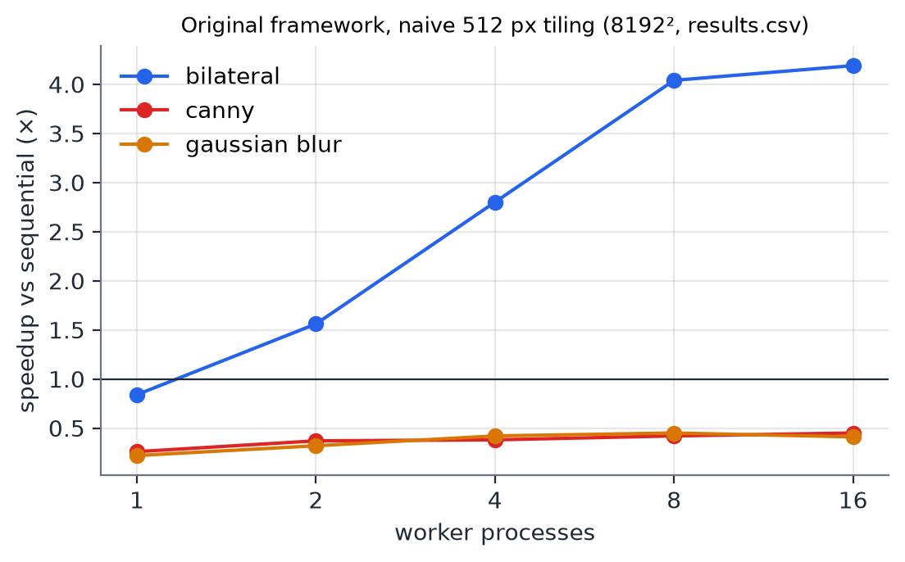
Fig. 10. v1 measurements that motivated the upgrades: only the CPU-heavy bilateral filter benefited from distribution.
For reference, v1 on an 8192² image reached 4.04× (8 workers) and 4.19× (16) for bilateral on the parallel engine, and 1.40× end to end through the framework, bounded by serial upload and aggregation (Amdahl's law [15]); Canny [16] and Gaussian blur were slower when distributed. The upgrades keep these guarantees and remove the four limits listed in Sec. I-B.
XII. Deployment and Mapping to AWS
k8s/ contains the namespace, ConfigMap and Secret, Redis (256 MB, no persistence: it holds control data only), MinIO (NodePort 30900 for presigned downloads), the API (NodePort 30080), the worker Deployment (2 GiB limit for the neural models) and the autoscaler with RBAC limited to scaling the worker Deployment. k8s/optional/ holds the HPA and KEDA baselines. Docker Compose runs the same stack locally.
TABLE VIII
Local deployment and AWS equivalents
Component | Minikube | AWS
Object store | MinIO | Amazon S3 (SSE-KMS, lifecycle)
Queue / state | Redis Deployment | ElastiCache for Redis
Orchestration | Minikube | Amazon EKS
Pod scaling | Work-aware / HPA / KEDA | Same, + Karpenter for nodes
Credentials | Kubernetes Secret | IRSA roles per service account
Ingress | NodePort | ALB (Load Balancer Controller)
Images | Minikube Docker | Amazon ECR

XIII. Limitations and Future Work
• Single host. All workers share one CPU and memory bus, which caps neural speedup at ≈ 2–2.5×. A multi-node EKS run would test the capacity model on real network and storage latencies.
• AWS not exercised. The S3, IAM, KMS and IRSA templates are complete but were not deployed; MinIO stood in for S3.
• Cheap operations on the cluster. They should run in-process at the API (or on a GPU) instead of through the queue; the planner already predicts when this wins.
• Model error. 20–25 % MAPE is useful for decisions but not for SLAs; per-host calibration and a memory-bandwidth term would help.
• Not implemented from the plan's optional extras: GPU workers, spot/pre-emptible node pools, Cloud-Optimised GeoTIFF range reads with a deep-zoom viewer, and learned (not analytical) cost models.
XIV. Conclusion
The upgrades turn a working tile-parallel framework into one that knows the cost of what it runs. Moving bytes to object storage removed the memory ceiling at the cost of a few milliseconds per tile; calibrated halos made deep-learning operations seam-free at a fraction of the theoretical overhead; a calibrated model lets the planner avoid the slowdowns of naive distribution and the contention region of memory-bound models; and scaling on queued work instead of queue length lets the pool react to what the queue actually costs. The main lesson is that on a cloud platform the decision whether and how finely to distribute matters as much as the parallel machinery itself.
References
[1] A. Bhosale, A. Tahilyani, L. Kale, and S. Kokkila-Schumacher, “Towards an adaptive runtime system for cloud-native HPC,” arXiv preprint arXiv:2603.14630, Mar. 2026.
[2] A. Bhosale, K. Chandrasekar, L. Kale, and S. Kokkila-Schumacher, “An elastic job scheduler for HPC applications on the cloud,” in Proc. SC Workshops ’25, St. Louis, MO, USA, Nov. 2025, doi: 10.1145/3731599.3767358.
[3] “Serverless data pipeline architecture supporting distributed machine learning on fog devices,” Comput. Commun., 2026. [Online]. Available: https://www.sciencedirect.com/science/article/pii/S0140366426000952
[4] D. Liu, Y. Xia, C. Shan, K. Tian, and Y. Zhan, “A Kubernetes-based scheme for efficient resource allocation in containerized workflow,” Future Gener. Comput. Syst., vol. 166, May 2025, Art. no. 107699.
[5] A. Chazapis, E. Maliaroudakis, F. Nikolaidis, M. Marazakis, and A. Bilas, “Running cloud-native workloads on HPC with high-performance Kubernetes,” arXiv preprint arXiv:2409.16919, Sep. 2024.
[6] J. Dean and S. Ghemawat, “MapReduce: Simplified data processing on large clusters,” in Proc. 6th USENIX OSDI, 2004, pp. 137–150.
[7] C. Gray and D. Cheriton, “Leases: An efficient fault-tolerant mechanism for distributed file cache consistency,” in Proc. 12th ACM SOSP, 1989, pp. 202–210.
[8] J. Ragan-Kelley, C. Barnes, A. Adams, S. Paris, F. Durand, and S. Amarasinghe, “Halide: A language and compiler for optimizing parallelism, locality, and recomputation in image processing pipelines,” in Proc. ACM PLDI, 2013, pp. 519–530.
[9] T. Denniston, S. Kamil, and S. Amarasinghe, “Distributed Halide,” in Proc. 21st ACM PPoPP, 2016, Art. no. 5.
[10] S. Venkataraman, Z. Yang, M. Franklin, B. Recht, and I. Stoica, “Ernest: Efficient performance prediction for large-scale advanced analytics,” in Proc. 13th USENIX NSDI, 2016, pp. 363–378.
[11] K. Rzadca et al., “Autopilot: Workload autoscaling at Google,” in Proc. 15th EuroSys, 2020, Art. no. 16.
[12] S. Xie and Z. Tu, “Holistically-nested edge detection,” in Proc. IEEE ICCV, 2015, pp. 1395–1403.
[13] X. Wang, L. Xie, C. Dong, and Y. Shan, “Real-ESRGAN: Training real-world blind super-resolution with pure synthetic data,” in Proc. IEEE/CVF ICCV Workshops, 2021, pp. 1905–1914.
[14] W. Luo, Y. Li, R. Urtasun, and R. Zemel, “Understanding the effective receptive field in deep convolutional neural networks,” in Proc. NeurIPS, 2016, pp. 4898–4906.
[15] G. M. Amdahl, “Validity of the single processor approach to achieving large scale computing capabilities,” in Proc. AFIPS Spring Joint Comput. Conf., vol. 30, 1967, pp. 483–485.
[16] J. Canny, “A computational approach to edge detection,” IEEE Trans. Pattern Anal. Mach. Intell., vol. PAMI-8, no. 6, pp. 679–698, Nov. 1986.
[17] C. Tomasi and R. Manduchi, “Bilateral filtering for gray and color images,” in Proc. 6th ICCV, 1998, pp. 839–846.
[18] KEDA Authors, “KEDA: Kubernetes event-driven autoscaling, v2.21 documentation — Redis Lists scaler.” [Online]. Available: https://keda.sh/docs/ (accessed Oct. 2026).
[19] The Kubernetes Authors, “Horizontal Pod Autoscaling.” [Online]. Available: https://kubernetes.io/docs/tasks/run-application/horizontal-pod-autoscale/ (accessed Oct. 2026).
[20] Amazon Web Services, “Amazon S3 user guide: presigned URLs, server-side encryption with AWS KMS, Block Public Access, lifecycle configuration.” [Online]. Available: https://docs.aws.amazon.com/s3/ (accessed Oct. 2026).
[21] Amazon Web Services, “IAM roles for service accounts (Amazon EKS user guide).” [Online]. Available: https://docs.aws.amazon.com/eks/ (accessed Oct. 2026).
[22] ONNX Runtime developers, “ONNX Runtime: threading and performance tuning.” [Online]. Available: https://onnxruntime.ai/docs/ (accessed Oct. 2026).
[23] Redis Ltd., “Redis documentation: Lua scripting, lists and the reliable-queue pattern.” [Online]. Available: https://redis.io/docs/ (accessed Oct. 2026).
[24] MinIO, Inc., “MinIO object storage: S3-compatible API.” [Online]. Available: https://min.io/docs/ (accessed Oct. 2026).

Appendix A: Project Structure
cloud proj/
├── imgframe/ core package
│ ├── config.py settings from environment variables
│ ├── ops.py OpenCV + ONNX operations, halo, scale, stride
│ ├── models.py ONNX Runtime session cache
│ ├── tiling.py stride-aligned plan, split, scale-aware reconstruct, tiled TIFF
│ ├── store.py Redis data model, reliable queue + work counter (Lua)
│ ├── objstore.py S3 / MinIO client (boto3), presigning
│ ├── planner.py cost model + plan search
│ ├── profiles.json calibrated costs, overheads, capacity curves
│ └── calibration.json calibrated halos
├── api/ FastAPI service + web UI
├── worker/ worker process (+ online profile updates)
├── autoscaler/ work-aware (and queue-length) autoscaler
├── benchmark/ bench_local, bench_distributed, bench_planner, bench_storage
├── k8s/ manifests; optional/ HPA and KEDA baselines
├── deploy/aws/ S3 bucket policy, IAM, lifecycle, IRSA (templates)
├── scripts/ run_local, convert_hed, calibrate_halo, profile_ops,
│ trace_replay, k8s_scaler, fetch_models, install_k8s_addons
├── tests/ pytest suite
└── docs/ report, slides, guide, figures

Appendix B: New Configuration
Variable | Default | Meaning
S3_BUCKET | (unset) | Enables object-storage mode
S3_ENDPOINT / S3_PUBLIC_ENDPOINT | — | Internal endpoint / endpoint used in presigned URLs
S3_SSE, S3_KMS_KEY_ID | — | Server-side encryption (aws:kms on AWS)
PRESIGN_SECONDS | 300 | Validity of result URLs
RESULT_DELIVERY | redirect | redirect (307 to presigned URL) or proxy
MAX_QUEUED_TILES | 20000 | Back-pressure limit in S3 mode
STREAM_OUTPUT_MP | 150 | Outputs above this are written as tiled BigTIFF
PLANNER, PLANNER_MARGIN | 1, 0.2 | Enable planner; safety margin on distributed estimate
PROFILE_EMA | 0.05 | Weight of online cost updates
POLICY | work | Autoscaler policy: work or queue
LATENCY_TARGET_S, TARGET_UTILIZATION, POD_STARTUP_S | 30, 0.8, 5 | Work-aware scaler parameters

