BECE355L — Advanced Cloud Computing
Cloud-Native Parallel Image Processing
How to Run — Detailed Guidebook
Setup from a fresh clone, the three ways to run the framework (local, Docker Compose, Kubernetes), the web UI and REST API, the cost-aware planner, the work-aware autoscaler and its baselines, and how to reproduce every result in the report.
Name | Register No.
Prapti Kurkuri | 24BVD0185
Vaanya Garg | 24BVD0139
Aditya Manoj | 24BVD0070
Arrnav Trisal | 24BVD0064

Repository: github.com/GHOSTALERT/cloud-native-ing-proc

Contents
1. What you are running
2. Prerequisites
3. One-time setup
4. Mode A: local run (no Docker)
5. Using the web UI
6. Using the REST API
7. Mode B: Docker Compose
8. Mode C: Kubernetes (Minikube)
9. Autoscalers: work-aware, KEDA and HPA
10. Reproducing every result in the report
11. Deploying on AWS (S3, IAM, KMS, EKS)
12. Configuration reference
13. Troubleshooting

1. What you are running
A large image is uploaded to a REST API. A cost-aware planner predicts how long the job will take locally and distributed, and picks the faster plan, the tile size and the worker count. The image is cut into tiles with overlapping halos; the tiles are stored in S3-compatible object storage (MinIO locally, Amazon S3 on AWS) and only their ids go into a Redis task queue. Worker processes or pods claim tiles with a lease, run an OpenCV filter or a neural network (HED edges, Real-ESRGAN 4× super-resolution), store the result in object storage, and the worker that finishes the last tile stitches the final image. A work-aware autoscaler sizes the worker Deployment from the predicted compute-seconds waiting in the queue.
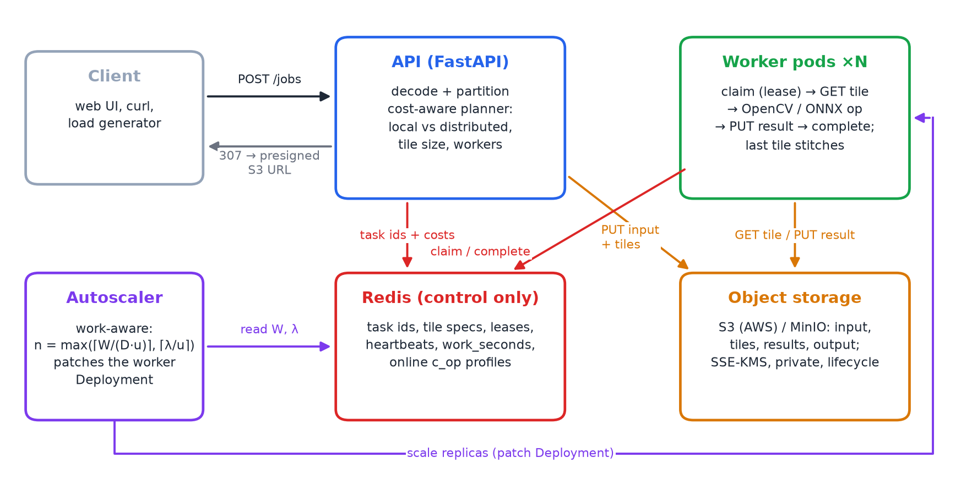
Figure 1. System architecture after the four upgrades.
Table 1. Repository layout
Folder | What is inside
imgframe/ | core library: config, ops (OpenCV + ONNX), tiling, Redis store + queue, object store, planner, models
api/ | FastAPI service and the web UI (index.html)
worker/ | worker process (claim → fetch → process → store → aggregate)
autoscaler/ | work-aware / queue-length autoscaler for Kubernetes
benchmark/ | benchmarks; results in benchmark/results/
scripts/ | run_local, model and MinIO fetchers, calibration, profiling, load tests, K8s helpers
k8s/ | Kubernetes manifests; optional/ holds the HPA and KEDA baselines
deploy/aws/ | S3 bucket policy, IAM policies, lifecycle rule, KMS setup script, IRSA service accounts
docs/ | report, slides, this guide, figures and the scripts that build them
tests/ | pytest suite (43 tests)

2. Prerequisites
Everything was developed and tested on Ubuntu (x86-64, 16 hardware threads, 22 GB RAM). Any recent Linux works; macOS works for modes A and B.
Table 2. Software prerequisites
Software | Needed for | How to get it
Python 3.12 or 3.13 + venv | everything | sudo apt install python3 python3-venv
git, curl, gcc, make | cloning, downloads, building Redis | sudo apt install git curl build-essential
Docker | modes B and C, and fetching the MinIO binary | sudo bash scripts/install_k8s_tools.sh
Minikube + kubectl | mode C | same script (installs Docker, Minikube v1.37, kubectl v1.34)
LibreOffice | only to rebuild the PDF documents | sudo apt install libreoffice
Firefox | only to recapture UI screenshots | preinstalled on Ubuntu

Tip: Nothing in modes A and B needs root. Redis and MinIO run from .tools/bin inside the project.

3. One-time setup

3.1 Clone and create the Python environment
git clone https://github.com/GHOSTALERT/cloud-native-ing-proc.git
cd cloud-native-ing-proc
python3 -m venv .venv
.venv/bin/pip install -r requirements-dev.txt
If python3 -m venv fails because ensurepip is missing (Debian/Ubuntu without python3-venv), create the venv without pip and let the system pip install into it:
python3 -m venv --without-pip .venv
pip3 --python .venv/bin/python install -r requirements-dev.txt

3.2 Redis and MinIO binaries (for mode A)
bash scripts/build_redis.sh # compiles redis-server 7.2.5 into .tools/bin (about 1 minute)
bash scripts/fetch_minio.sh # copies the MinIO server binary into .tools/bin (needs Docker)
MinIO no longer publishes binaries or Docker Hub images, so fetch_minio.sh copies the binary out of Chainguard's open-source build (cgr.dev/chainguard/minio). Without .tools/bin/minio, run_local.py falls back to the original all-in-Redis storage mode, so the framework still runs.

3.3 Neural network weights
bash scripts/fetch_models.sh # ~125 MB download, checksums verified
This downloads the official HED Caffe model (Xie & Tu) and the Real-ESRGAN general-x4v3 ONNX export, and converts HED to models/hed.onnx with scripts/convert_hed.py (OpenCV 5 dropped its Caffe importer, so the converter decodes the caffemodel itself and rebuilds the network for ONNX Runtime). Without the weights the hed and superres operations are simply hidden from the UI and /ops.

3.4 Sample images and the test suite
.venv/bin/python scripts/make_samples.py # samples/astronaut_2048.png, synthetic_8192.png
.venv/bin/python -m pytest -q # 43 passed
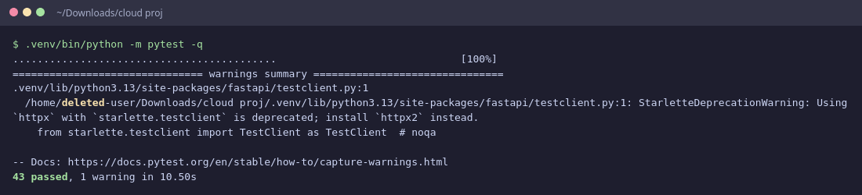
Figure 2. The test suite: 43 tests, including S3 mode, neural tiling, planner and work accounting.

4. Mode A: local run (no Docker)
scripts/run_local.py starts Redis, MinIO, the API and N worker processes on this machine:
.venv/bin/python scripts/run_local.py --workers 4
# API ready at http://127.0.0.1:8000 (4 workers, redis ..., storage MinIO http://127.0.0.1:9000)
Open http://127.0.0.1:8000 in a browser. Stop everything with Ctrl+C.

4.1 Scripted demos
# one job, checked pixel-by-pixel against whole-image processing
.venv/bin/python scripts/run_local.py --workers 4 --demo --op bilateral --size 4096

# neural edge detection on the sample photo, planner decides the tiling
.venv/bin/python scripts/run_local.py --workers 8 --demo --op hed --image samples/astronaut_2048.png

# 4x super-resolution of a 512 px image (output 2048 px)
.venv/bin/python scripts/run_local.py --workers 4 --demo --op superres --size 512

# fault tolerance: SIGKILL a worker mid-job; its tiles are retried, the result is still exact
.venv/bin/python scripts/run_local.py --workers 4 --demo --kill-worker --op bilateral --tile-size 256
Table 3. run_local.py options
Option | Meaning
--workers N | number of worker processes (default 4)
--storage s3|redis | s3 (default when MinIO is present): pixels in MinIO; redis: original mode
--tile-size auto|N | auto lets the planner decide; a number forces naive tiling with that size
--op NAME | canny, sobel, gaussian_blur, sharpen, grayscale, bilateral, hed, superres
--image PATH / --size N | input image for --demo, else a generated N×N image
--port, --redis-port, --minio-port | change the ports (8000, 6390, 9000) if they are in use

Tip: The demo's pixel-agreement line is the correctness check: 100 % for local filters, ≥ 99.9 % for Canny, and ≥ 40 dB seam PSNR for the neural ops at their calibrated halos.

5. Using the web UI
1) Choose an image (PNG/JPEG/TIFF) and an operation.
2) Leave Tile size on auto to let the planner choose local vs distributed and the tile size, or type a number (256, 512, …) to force naive tiling.
3) Press Process. The progress bar counts finished tiles; the right-hand panel shows the plan, the storage mode, per-phase timings, and the planner's predicted time next to the measured one.
4) When the job is done, the result appears next to the original. Full-resolution links are short-lived presigned S3 URLs (5 minutes by default); huge outputs are offered as a tiled TIFF.
5) The Cluster card shows queued work in compute-seconds (the autoscaler's input), pending and in-progress tiles, retries, live workers and Redis memory.
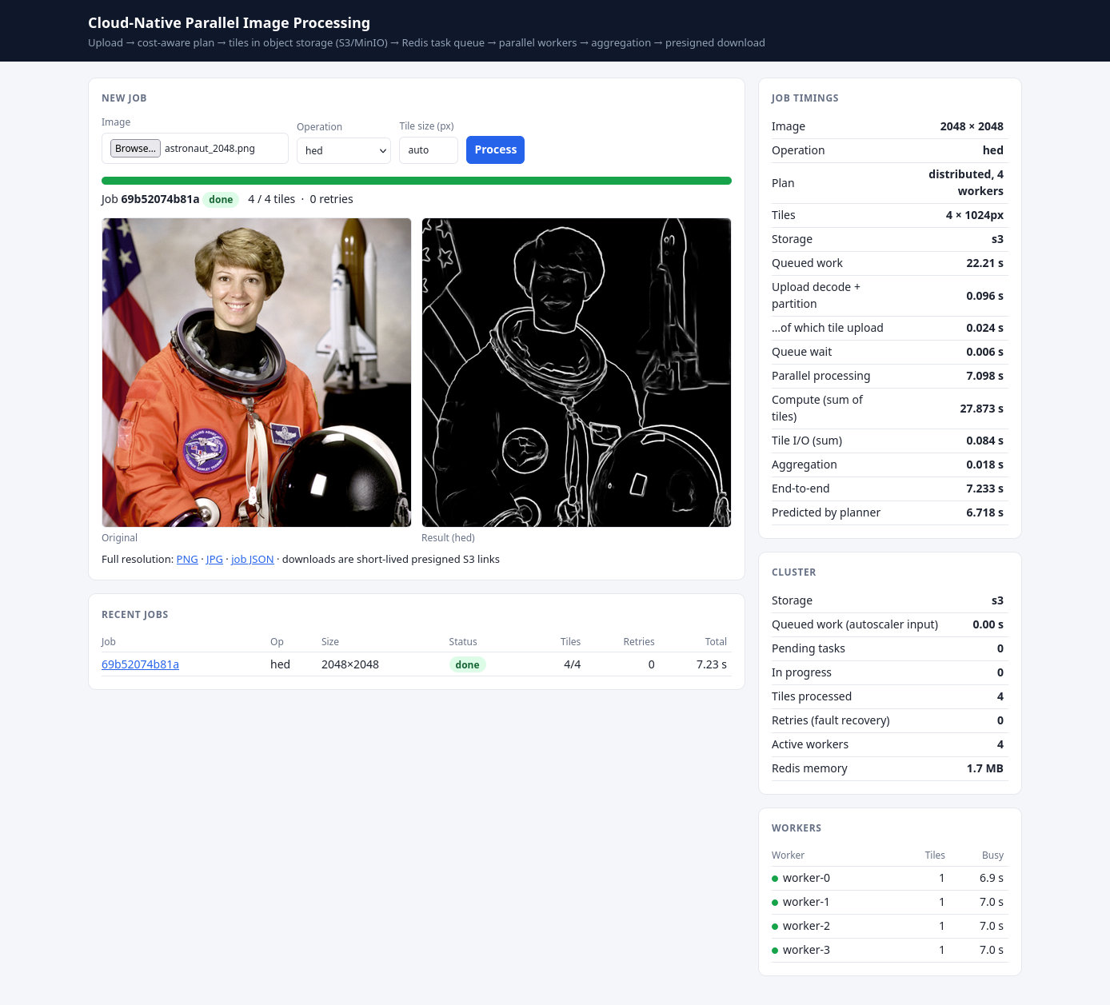
Figure 3. Web UI after an HED job planned automatically.
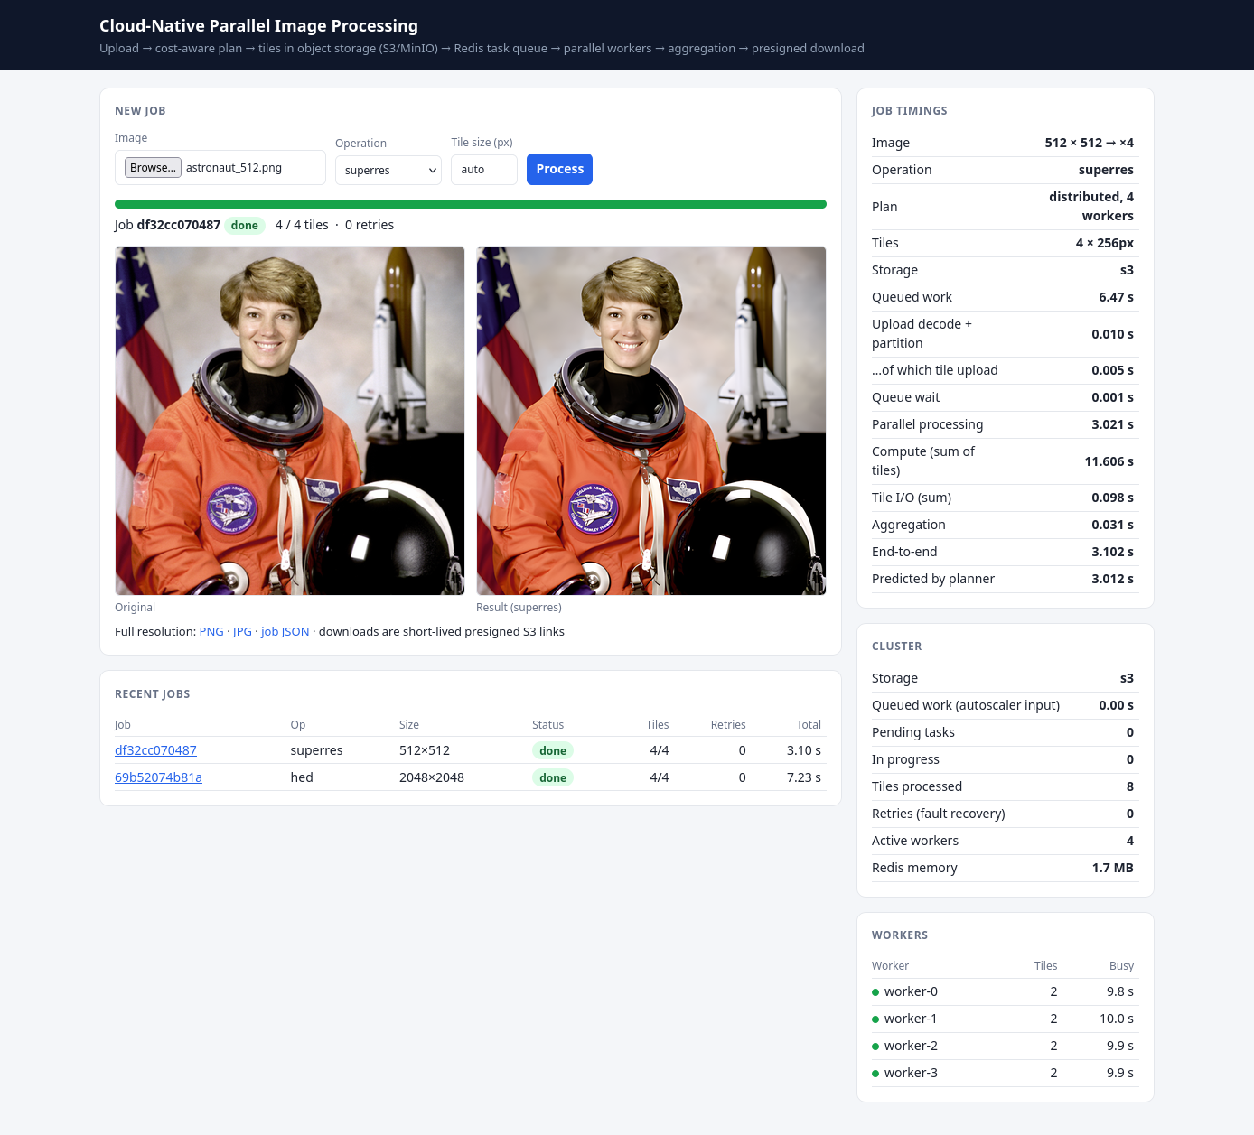
Figure 4. 4× super-resolution job: the plan, scale factor and presigned download.

6. Using the REST API
Table 4. REST endpoints
Method + path | Purpose
POST /jobs (form: file, op, tile_size=auto|N) | submit an image; returns the job with its plan
GET /jobs, GET /jobs/{id} | list jobs / status, progress, plan, timings
GET /jobs/{id}/result?format=png|jpg|webp|tif&max_side=N | final image (S3 mode: 307 redirect to a presigned URL)
GET /jobs/{id}/url?format=… | the presigned URL as JSON, with its expiry
GET /jobs/{id}/preview | downscaled copy of the upload
DELETE /jobs/{id} | delete the job and its objects
GET /plan?op=&width=&height=&workers= | dry run of the planner (nothing is queued)
GET /metrics | queue depth, queued work-seconds, workers, retries, Redis memory
GET /ops, GET /healthz, GET /docs | operations, health check, Swagger UI

API=http://127.0.0.1:8000
curl -s -F file=@samples/astronaut_2048.png -F op=hed $API/jobs | python3 -m json.tool
curl -s $API/jobs/<id> | python3 -m json.tool # status, plan_mode, predicted_s, timings
curl -sL -o edges.png $API/jobs/<id>/result # -L follows the presigned redirect
curl -s "$API/plan?op=canny&width=8192&height=8192" # why is canny run locally?
curl -s $API/metrics | python3 -m json.tool
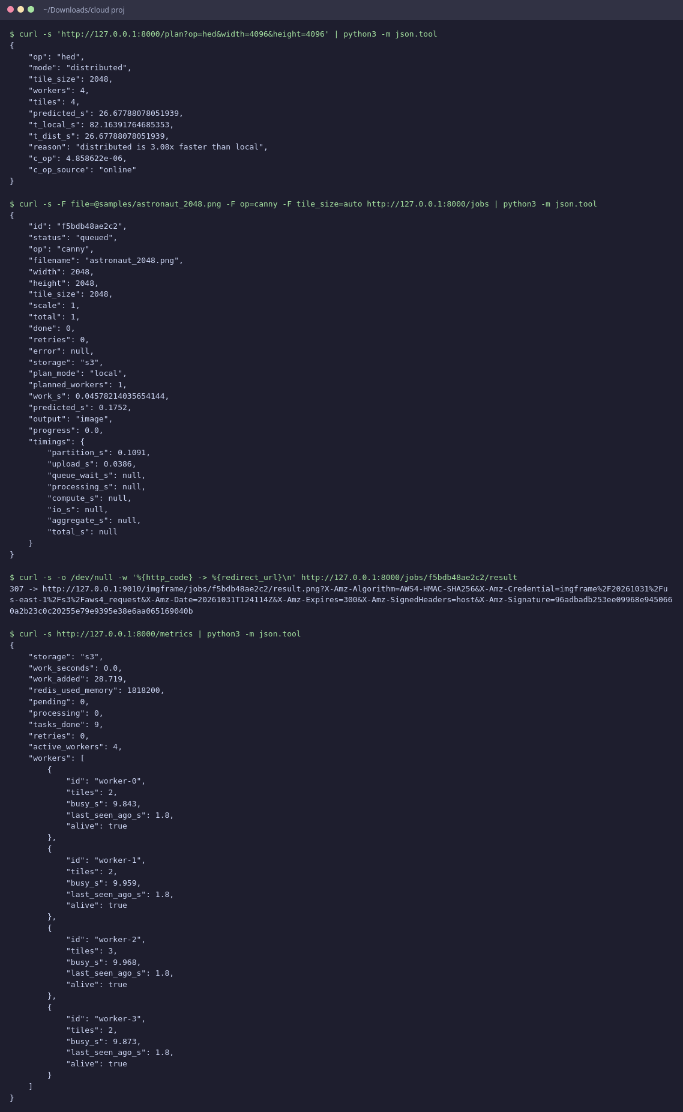
Figure 5. Submitting a job and asking the planner with curl.

7. Mode B: Docker Compose
Compose runs Redis (capped at 256 MB: it only holds control data now), MinIO, the API and four workers from one image. Fetch the models first; they are baked into the image.
bash scripts/fetch_models.sh
docker compose up --build --scale worker=4
# UI http://localhost:8000 MinIO (presigned downloads) http://localhost:9000
bash scripts/kill_worker.sh compose # optional: crash a busy worker during a job
docker compose down

8. Mode C: Kubernetes (Minikube)

8.1 Start the cluster and build the image inside it
minikube start --driver=docker --cpus=8 --memory=12g
eval $(minikube docker-env)
docker build -t imgframe:latest .

8.2 Deploy
kubectl apply -f k8s/
kubectl -n imgframe set env deploy/api S3_PUBLIC_ENDPOINT=http://$(minikube ip):30900
kubectl -n imgframe get pods -w # redis, minio, api, autoscaler, worker(s) Running
echo http://$(minikube ip):30080 # the web UI
The second command matters: presigned URLs are signed for a host name, and the browser reaches MinIO through the NodePort 30900 on the Minikube IP.
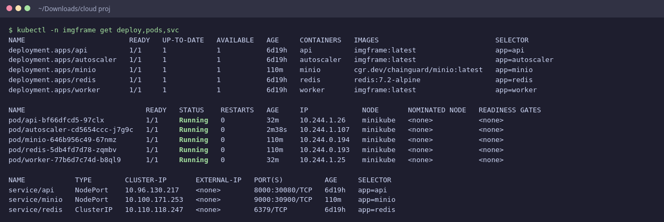
Figure 6. All components running on Minikube.
Table 5. Kubernetes manifests
Manifest | Creates
00-namespace.yaml | namespace, ConfigMap (Redis/S3 settings, PLANNER_WORKERS=8), demo S3 credentials
10-redis.yaml | Redis 7.2, 256 MB, control data only
15-minio.yaml | MinIO object store, NodePort 30900
20-api.yaml | API Deployment + NodePort 30080
30-worker.yaml | worker Deployment (1 CPU, 2 GiB limit each)
40-autoscaler.yaml | work-aware autoscaler + RBAC to scale the worker Deployment
optional/hpa-cpu.yaml | baseline: CPU-based HorizontalPodAutoscaler (70 %)
optional/keda-scaledobject.yaml | baseline: KEDA scaling on Redis list length

8.3 Demos on the cluster
API=http://$(minikube ip):30080
.venv/bin/python scripts/load_test.py --api $API --jobs 6 --op bilateral --size 4096
kubectl -n imgframe logs -f deploy/autoscaler # scaling decisions with W and λ
bash scripts/kill_worker.sh k8s # self-healing: crash a busy worker pod

9. Autoscalers: work-aware, KEDA and HPA
Exactly one scaler may own the worker Deployment. Install the two baselines once, then switch with the helper script:
bash scripts/install_k8s_addons.sh # metrics-server addon + KEDA 2.21 (one time)
bash scripts/k8s_scaler.sh work # ours: replicas from queued compute-seconds
bash scripts/k8s_scaler.sh keda # KEDA: 16 pending tiles per worker
bash scripts/k8s_scaler.sh hpa # HPA: 70 % CPU
bash scripts/k8s_scaler.sh queue # our autoscaler with the original queue-length rule
The work-aware rule is replicas = clamp(max(⌈W/(D·u)⌉, ⌈λ/u⌉), MIN, MAX) with W the predicted seconds of queued work, λ its arrival rate, D the latency target (LATENCY_TARGET_S minus POD_STARTUP_S) and u the target utilization. Tune it with kubectl -n imgframe set env deploy/autoscaler LATENCY_TARGET_S=20.

9.1 Replaying the comparison trace
bash scripts/run_autoscale_comparison.sh 3 # ~45 min: 3 runs x (hpa, keda, work), interleaved

# or one run by hand:
bash scripts/k8s_scaler.sh keda
.venv/bin/python scripts/trace_replay.py --api http://$(minikube ip):30080 --label keda --run 1
.venv/bin/python docs/make_figures.py autoscale
The driver switches the scaler, waits until the queue is empty and the Deployment is back at one ready worker, waits 20 s more so HPA and KEDA see an idle sample, and then replays the trace. Runs are interleaved (hpa, keda, work, hpa, ...) so slow drift on the host affects all three alike.
Each run replays the same seeded Poisson trace (bursts of cheap grayscale/Canny jobs, then bursts of bilateral/HED jobs) and writes benchmark/results/autoscale/<scaler>_run<N>.json with per-job latency, p50/p95, jobs within the target, worker pod-seconds, scaling events and time to first scale-up.

10. Reproducing every result in the report
Table 6. Commands that regenerate each result (run from the repository root with .venv/bin/python)
Result | Command | Output in benchmark/results/
Halo calibration (HED, Real-ESRGAN) | python scripts/calibrate_halo.py | halo_calibration.json/.png; imgframe/calibration.json
Cost-model profiles | python scripts/profile_ops.py | imgframe/profiles.json
Original naive-tiling benchmark | python -m benchmark.bench_local --size 8192 | results.csv, charts.png
Planner vs naive, model accuracy | python -m benchmark.bench_planner | planner_engine.json/.png
Planner on the full framework | python -m benchmark.bench_planner --cluster --workers 8 | planner_cluster.json
Redis vs S3 storage study | python -m benchmark.bench_storage | storage_study.json
Autoscaler comparison (Minikube) | bash scripts/run_autoscale_comparison.sh 3 | autoscale/<scaler>_run<N>.json
Screenshots | python scripts/capture_screenshots.py --k8s | docs/screenshots/_v2.png
All report figures | python docs/make_figures.py | docs/figures/*.png
Report, slides, this guide | python docs/build_report.py; python docs/build_slides.py; python docs/build_guide.py | docs/*.docx, .pdf, .pptx

Watch out: Benchmarks measure wall-clock time: close other heavy programs and do not run two benchmarks at once. Numbers will differ on other hardware; the planner adapts because it reads profiles.json, so re-run profile_ops.py on a new machine first.

11. Deploying on AWS (S3, IAM, KMS, EKS)
The deploy/aws/ templates implement the security controls from Module 4. They were written for this project but not executed (no AWS account was used); review them before running.
1) Create the bucket, a customer-managed KMS key, default SSE-KMS encryption, Block Public Access, a bucket policy that denies unencrypted or non-TLS requests, the lifecycle rule and two least-privilege IAM policies: BUCKET=my-imgframe REGION=ap-south-1 bash deploy/aws/setup_s3.sh.
2) Create IAM roles imgframe-api and imgframe-worker with those policies and trust for EKS IRSA; apply deploy/aws/irsa-serviceaccounts.yaml and add serviceAccountName to the api and worker Deployments.
3) In the ConfigMap: remove S3_ENDPOINT, set S3_BUCKET, S3_SSE=aws:kms, S3_KMS_KEY_ID and S3_MANAGE_BUCKET=0; delete the s3-credentials Secret and the MinIO manifest.
4) Push the image to ECR, change imagePullPolicy to IfNotPresent and apply the remaining manifests.
Table 7. Least-privilege split between the two service roles
Role | May do | Cannot do
API | PUT jobs/*/input.*, tiles/*, result.*; GET outputs; delete jobs | read tiles or results; touch other prefixes
Worker | GET tiles/results; PUT results and outputs; delete tiles/results after stitching | write inputs; delete outputs; list the bucket outside jobs/

12. Configuration reference
Table 8. Environment variables
Variable | Default | Meaning
REDIS_URL | redis://localhost:6379/0 | Redis connection
S3_BUCKET | (empty) | set → object-storage mode; empty → all-in-Redis mode
S3_ENDPOINT / S3_PUBLIC_ENDPOINT | (AWS) / = endpoint | S3 API for the services / host used in presigned URLs
S3_SSE, S3_KMS_KEY_ID | (none) | server-side encryption (aws:kms + key ARN)
S3_MANAGE_BUCKET | 1 | create bucket + lifecycle at start (MinIO); 0 on AWS
PRESIGN_SECONDS | 300 | lifetime of download URLs
RESULT_DELIVERY | redirect | redirect (307 to S3) or proxy (stream through the API)
MAX_QUEUED_TILES | 20000 | back-pressure in S3 mode (HTTP 503 beyond it)
STREAM_OUTPUT_MP | 150 | outputs above this many megapixels are streamed to a tiled TIFF
MODEL_DIR | ./models | ONNX weights
PLANNER, PLANNER_MARGIN | 1, 0.2 | planner on/off; distribute only if ≥ 20 % faster
PLANNER_WORKERS | 0 (= live workers) | workers the planner may assume (8 on Kubernetes)
PROFILE_EMA | 0.05 | weight of each new tile in the online c_op estimate
TILE_SIZE | 512 | tile size when the planner is off
LEASE_SECONDS, HEARTBEAT_SECONDS, MAX_RETRIES | 15, 3, 3 | fault-tolerance timing
WORKER_PROCS, OPENCV_THREADS | 1, 1 | process slots per worker; threads per op (also ONNX Runtime)
CHAOS_CRASH_RATE | 0 | probability a worker crashes mid-tile (fault injection)
POLICY | work | autoscaler rule: work or queue
LATENCY_TARGET_S, TARGET_UTILIZATION, POD_STARTUP_S | 30, 0.8, 0 | work-aware rule parameters
MIN_WORKERS, MAX_WORKERS, SCALE_DOWN_DELAY | 1, 8, 30 | autoscaler bounds and scale-down delay
IDLE_SCALE_DOWN_S | 10 | work mode: once nothing is queued or running for this long, drop to MIN_WORKERS

13. Troubleshooting
Table 9. Common problems
Symptom | Cause and fix
Port 8000 already in use | another run_local.py or Compose stack is running: stop it, or pass --port, --redis-port, --minio-port
.tools/bin/minio missing | run bash scripts/fetch_minio.sh, or use --storage redis
hed/superres missing from the list | weights not downloaded: bash scripts/fetch_models.sh
HTTP 503 on upload | back-pressure: the queue (S3 mode) or Redis memory (Redis mode) is full; the client retries after Retry-After
Result link fails in the browser (Kubernetes) | presigned host is wrong: set S3_PUBLIC_ENDPOINT=http://$(minikube ip):30900 on the api
Pods stuck in ErrImageNeverPull | image built outside Minikube: run eval $(minikube docker-env) and rebuild
HPA shows <unknown> CPU | metrics-server not ready: minikube addons enable metrics-server, wait a minute
no matches for kind ScaledObject | KEDA not installed: bash scripts/install_k8s_addons.sh
Worker pod OOMKilled on HED | raise the worker memory limit in k8s/30-worker.yaml or use 512 px tiles
Benchmarks much slower than the report | other load on the machine, or different hardware: re-run scripts/profile_ops.py

