Design/Implementation

In this phase based on the crime data the clustering can be done. Using the Indian crime data the crime areas are identified using the fuzzy clustering technique the clusters are identified. Compared to the other clustering techniques fuzzy techniques take less time to cluster the data and identifies the crime areas. Using the fcm clustering algorithm the degree of membership of each cluster is calculated and identifies the clusters using the algorithm steps the crime areas are identified. Finally the crime areas are identified based on the crime data. Which type of crime occurred very frequently is identified. After loading the crime data the noisy data is removed that means duplicate values are deleted and the ready based on the state names the crime areas are identified based on crime types of crimes are identified based on the location. The highly occurred crime areas and low crime rate areas are identified this can be represented in the graphical format.

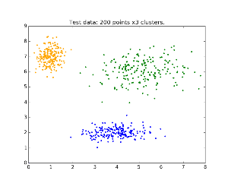

Fig. 1. Clustering of crime data

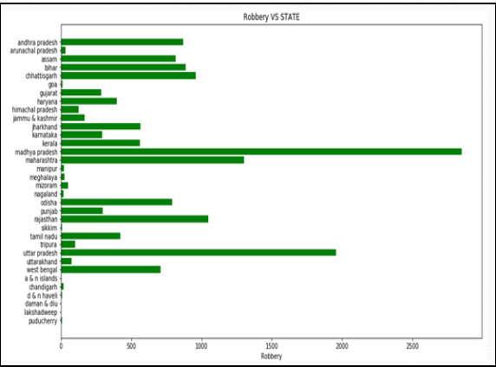

Fig. 2. Robbery rate in india

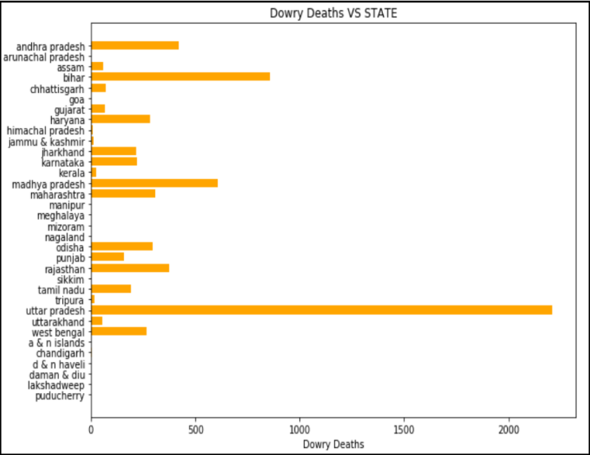

Fig. 3. Dowry Deaths in india

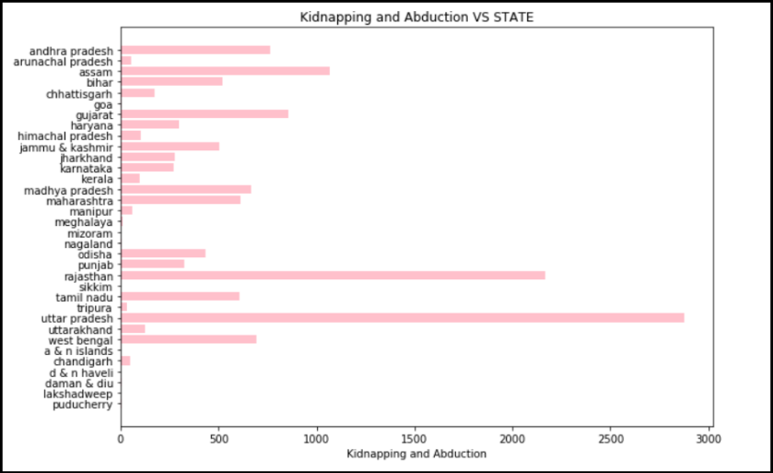

Fig. 4. Kidnapping rate in india