TEXT SENTIMENT ANALYSER
A Hybrid Rule-Based and Machine Learning Framework for Sentiment and Emotion Analysis of English and Code-Mixed Hinglish Text
Sudhanshu Shrivastav¹, Audarsh Singh Rathore¹, Ravi Kumar Bhardwaj¹
Abhishek Singh Sengar²
¹ B.Tech Student, Department of Computer Science and Engineering, Maharana Institute of Professional Studies, Kanpur, Uttar Pradesh, India
² Assistant Professor and Project Guide, Department of Computer Science and Engineering, Maharana Institute of Professional Studies, Kanpur, Uttar Pradesh, India
(Affiliated to Dr. A.P.J. Abdul Kalam Technical University, Lucknow)
Abstract. Indian social-media users commonly type Hindi in the Latin alphabet and switch to English inside the same sentence, a writing style popularly called Hinglish. Sentiment tools designed for English handle such text poorly: Romanised Hindi opinion words are missing from their lexicons, spellings are not standardised, and Hindi places the negator after the word it modifies. This paper presents Text Sentiment Analyser, a privacy-preserving system that labels English and Hinglish text as Positive, Neutral or Negative and profiles its emotional content. The system joins three families of technique: natural language processing for language identification, spelling normalisation and n-gram features; a transparent knowledge-based engine with a bilingual weighted lexicon and rules for pre- and post-negation, intensifiers and contrastive conjunctions; and machine learning in the form of multinomial Naive Bayes, logistic regression and a probabilistic hybrid of rules and Naive Bayes. Supporting modules detect Plutchik’s eight basic emotions, aspect-level opinions and sarcasm cues, and explain every verdict word by word. Five engines were compared with stratified five-fold cross-validation on a balanced pilot corpus of 210 texts. The English-only lexicon scored 55.2% accuracy, the Hinglish-aware engine 92.4% (95% CI 88.6–95.7), Naive Bayes 65.9% and the hybrid 82.1% on average over five random splits; the hybrid’s gain over Naive Bayes is statistically significant (McNemar p < 0.001). Because the lexicon was compiled alongside the corpus, the rule-based score should be read as an optimistic bound, and ablation, learning-curve and error analyses are used to show where each component actually contributes. The complete application runs offline inside a web browser.
Keywords: Sentiment analysis, Code-mixed text, Hinglish, Natural language processing, Machine learning, Lexicon-based methods, Naive Bayes, Emotion detection, Hybrid model, Explainable AI

Introduction:
A. Background and Motivation
Sentiment analysis, also called opinion mining, is the computational study of the opinions, evaluations and feelings that people express in written language. It supports a wide range of applications, from mining product reviews and tracking brand reputation to triaging customer complaints and measuring public opinion [1–3]. The best-known tools in the field, such as the rule-based analysers VADER [4] and SO-CAL [5] and the supervised classifiers popularised by Pang et al. [6], were built and tested almost entirely on English. India presents a very different linguistic setting. Many users shift between Hindi and English within one sentence and type Hindi words with a Roman keyboard, which is the default input method on most smartphones [7, 8]. The resulting mixed style, usually called Hinglish, is illustrated by a comment such as “movie acchi nahi thi but songs mast the” (the movie was not good, but the songs were great).
Such text defeats English tools for three separate reasons. The first concerns vocabulary. Hindi words such as bakwas (rubbish), zabardast (excellent) and bekaar (useless) carry strong polarity, yet they do not appear in English lexicons, so an English analyser treats them as neutral. The second concerns spelling. Romanised Hindi has no agreed orthography, and the single word bahut (very) is typed as bahot, bhot, bohot or bht, while accha (good) appears as acha, achha, acchi or achi. The third concerns word order. Hindi puts the negator after the word it negates (acchi nahi thi, literally “good not was”), whereas English puts it before (was not good); a negation window that looks forward, as English heuristics do, therefore points the wrong way. Earlier studies have shown that code-mixing harms language identification, part-of-speech tagging and sentiment classification alike [9–11].
This paper describes Text Sentiment Analyser, a sentiment and emotion analysis system for English and Hinglish that combines three groups of technology. Natural language processing supplies language identification, spelling normalisation, tokenisation, lexical analysis and n-gram feature extraction [12]. Knowledge-based artificial intelligence supplies a hand-built and fully explainable rule engine. Machine learning supplies Naive Bayes, logistic regression and a probabilistic hybrid of rules and learned probabilities. All processing takes place on the client, so the user’s text never leaves the device, and an optional REST interface is offered on the local machine only.
B. Problem Statement
English-only sentiment tools mishandle Hinglish in three recurring ways: they do not recognise Romanised Hindi opinion words, they apply negation to the wrong word because Hindi negators follow the word they modify, and they treat every spelling variant as an unknown token. In practice, a large share of Hinglish comments is therefore labelled Neutral, and both genuine praise and genuine complaints are lost. Supervised classifiers could in principle learn this vocabulary, but they need labelled Hinglish data, which academic and small-business projects rarely possess. The problem addressed here is to build a system that classifies the sentiment of English and Hinglish text reliably when labelled data are scarce, explains its decisions, and protects the privacy of the text it analyses.
C. Objectives
The work pursues five objectives: (i) to design a Hinglish-aware rule-based engine that includes spelling normalisation, bilingual negation handling, intensifiers and contrast rules; (ii) to train and compare Naive Bayes and logistic regression classifiers on a labelled corpus; (iii) to propose a hybrid model that fuses the rule engine with Naive Bayes and to measure when fusion is beneficial; (iv) to add emotion, aspect, sarcasm and explanation modules that make every prediction interpretable; and (v) to evaluate all engines with transparent and reproducible statistics while reporting limitations openly.
D. Contributions and Organisation
The paper makes four contributions. (1) It provides a complete, dependency-free implementation of a Hinglish sentiment and emotion pipeline whose linguistic resources comprise 292 English and 184 Hinglish lexicon entries, 28 Hindi intensifiers and 94 spelling-variant mappings. (2) It compares five engines under repeated stratified cross-validation and supports the comparison with bootstrap confidence intervals, Cohen’s kappa and McNemar tests. (3) It reports component ablations, a sweep of the hybrid weight and learning curves that reveal which design decisions matter. (4) It offers an error taxonomy and a measured complexity analysis of the algorithms. The remainder of the paper is organised as follows. “Literature Review” surveys prior work in the format of a structured review; “Methods and Materials” describes the system, corpus and protocol; “Results” reports the measurements; “Figures and Tables” collects the extended exhibits; and “Discussion” and “Conclusion” interpret the findings and their limits.

Literature Review:
This section reviews the literature that informs the design of Text Sentiment Analyser. Each study is summarised in terms of its aim, its method and its relevance to the present work, and the most relevant studies are tabulated in the review summary chart (Table 1). The review concentrates on research published between 2020 and 2026, supplemented by the foundational studies on which recent work builds.
A. Surveys and Foundations of Sentiment Analysis
[3] Birjali et al. (2021) presented a comprehensive survey of sentiment analysis that classified existing techniques into lexicon-based, machine-learning and hybrid families. The study examined the challenges common to all three, including negation, domain dependence, sarcasm and multilingual text. It concluded that hybrid designs often combine the interpretability of lexicons with the adaptability of learning, which motivates the hybrid engine proposed in this paper.
[13] Wankhade et al. (2022) reviewed sentiment analysis methods, applications and open challenges across document, sentence and aspect levels. The review compared feature-extraction schemes and classifiers and stressed that most resources target English. It identified code-mixed and low-resource languages as an important gap, which is the gap addressed here.
[14] Nandwani and Verma (2021) surveyed sentiment analysis together with emotion detection from text. The authors described emotion models such as Plutchik’s wheel and Ekman’s basic emotions and compared lexicon-based, machine-learning and deep-learning detectors. Their review supports the decision to report emotions alongside polarity, because the two signals complement each other.
[15] Ligthart et al. (2021) carried out a tertiary study that analysed systematic reviews of sentiment analysis. They found that support vector machines and Naive Bayes remain the most frequently used classical classifiers, while deep networks dominate recent work. The study highlights that classical models remain valuable baselines, which justifies their inclusion in our comparison.
[16] Bordoloi and Biswas (2023) proposed a generic design framework for sentiment analysis systems that runs from data collection and pre-processing through feature extraction to classification and visualisation. Their framework closely matches the pipeline adopted in this project, and their discussion of pre-processing reinforces the importance of normalising noisy social-media text.
[17] Tan et al. (2023) reviewed sentiment-analysis approaches and benchmark datasets and outlined future research directions. [18] Rodríguez-Ibánez et al. (2023) focused specifically on social-media platforms, and [19] Jim et al. (2024) reviewed recent NLP-based advances and persisting difficulties such as informal language, emojis and code-switching. Together these reviews show that informal, multilingual social-media text is still an open problem.
[20] Jain et al. (2021) systematically reviewed machine-learning applications for consumer sentiment analysis of online reviews, and [21] Hartmann et al. (2023) measured the accuracy of sentiment methods across 272 datasets used in marketing research. Hartmann et al. found that transfer-learning models are the most accurate but that lexicon-based methods still offer speed and transparency. Earlier syntheses by Medhat et al. [22] and Zhang et al. [23] provide the historical background for these findings.
B. Lexicon-Based, Rule-Based and Hybrid Methods
[4] Hutto and Gilbert (2014) proposed VADER, a parsimonious rule-based model for social-media sentiment. VADER combines a human-validated lexicon with five heuristics covering punctuation, capitalisation, degree modifiers, the contrastive conjunction but and negation, and normalises the summed valence into a compound score. The compound-score formula and several heuristics of our rule engine follow VADER, but VADER has no knowledge of Hindi vocabulary or Hindi word order.
[5] Taboada et al. (2011) developed SO-CAL, a lexicon-based calculator that models intensification and negation as systematic modifications of word polarity. Their “shift” treatment of negation, which attenuates rather than simply inverts polarity, inspired the attenuated negation factor used in this work. Related lexicon systems such as SentiStrength [24] and the NRC-Canada system [25] confirmed that lexicon features are well suited to short informal text.
[26] Cambria et al. (2022) introduced SenticNet 7, a neurosymbolic framework that unites commonsense knowledge with sub-symbolic learning to make sentiment analysis explainable. The work argues that symbolic knowledge supplies transparency that purely statistical models lack, which matches the explainability goal of the present system.
[27] Catelli et al. (2022) compared a lexicon-based analyser with a BERT-based classifier on Italian text. BERT achieved higher accuracy, but the lexicon approach was faster, required no training data and was easier to interpret. Their comparison mirrors the trade-off examined in this paper for Hinglish.
[28] Mudinas et al. (2012) and [29] Appel et al. (2016) demonstrated that combining lexicons with machine-learning classifiers yields more robust sentence-level sentiment analysis than either approach alone. More recently, [30] Kaur and Sharma (2023) proposed a hybrid feature-extraction model for consumer reviews, and [31] Alsayat (2022) used an ensemble of deep language models for social-media sentiment. These studies motivate our probabilistic fusion of a rule engine with Naive Bayes.
C. Machine Learning and Deep Learning Methods
[6] Pang et al. (2002) showed that Naive Bayes, maximum-entropy and support-vector-machine classifiers trained on bag-of-words features outperform keyword lists chosen by humans for movie-review classification. [32] Wang and Manning (2012) later showed that bigram features with simple linear models remain strong baselines. These findings justify the unigram-plus-bigram features and linear models used in this study.
[33] Kim (2014) applied convolutional neural networks to sentence classification, and [34] Devlin et al. (2019) introduced BERT, whose pre-trained transformer representations raised the state of the art across many tasks. [35] Dang et al. (2020) and [36] Yadav and Vishwakarma (2020) compared deep architectures for sentiment analysis and noted that their accuracy depends heavily on large labelled corpora.
[37] Tan et al. (2022) proposed RoBERTa-LSTM, a hybrid of a transformer encoder and a recurrent network, and reported gains over baseline models on IMDb, Twitter airline and Sentiment140 data. [38] Alaparthi and Mishra (2021), [39] Bello et al. (2023) and [40] Kokab et al. (2022) likewise found transformer models superior to classical baselines on English reviews and tweets when enough training data were available.
[41] Barbieri et al. (2020) released TweetEval, a unified benchmark for tweet classification, and [42] Barbieri et al. (2022) extended it with XLM-T, a multilingual Twitter language model evaluated for sentiment in eight languages. [43] Pérez et al. (2021) released pysentimiento, an open toolkit for multilingual social-media analysis. None of these resources covers Romanised Hinglish directly, which leaves room for a dedicated system.
D. Code-Mixing and Hinglish Language Processing
[7] Bali et al. (2014) analysed English-Hindi code-mixing on Facebook and showed that switching occurs frequently within sentences. [9] Barman et al. (2014) showed that code-mixing makes word-level language identification difficult, and [10] Vyas et al. (2014) reported similar difficulties for part-of-speech tagging. These studies justify the language-identification and normalisation stage of our pipeline.
[44] Doğruöz et al. (2021) surveyed code-switching from linguistic, social and technological perspectives and called for language technologies that respect how bilingual speakers actually write. [45] Winata et al. (2023) systematically reviewed decades of code-switching research in NLP and found that Hindi-English is among the most studied pairs but that resources remain limited and fragmented.
[46] Aguilar et al. (2020) proposed LinCE and [47] Khanuja et al. (2020) proposed GLUECoS, two centralised benchmarks for code-switched NLP that include Hindi-English sentiment tasks. Khanuja et al. reported that multilingual BERT fine-tuned on synthetic code-switched text improves performance. [48] Santy et al. (2021) further studied how code-mixing interacts with multilingual BERT.
[49] Tarunesh et al. (2021) and [50] Rizvi et al. (2021) proposed methods and tools for generating synthetic code-mixed text, while [51] Kodali et al. (2022) introduced a syntactic measure of English-Hindi code-mixing. [52] Srivastava and Singh (2020; 2021) released the PHINC parallel corpus and the HinGE dataset [53], and [54] Gautam et al. (2021) studied code-mixed translation. These resources point to a growing Hinglish ecosystem that future versions of our system could use.
[55] Nayak and Joshi (2022) built L3Cube-HingCorpus, a large unlabelled Hinglish corpus, and pre-trained HingBERT models on it. The models outperformed general multilingual BERT on several code-mixed tasks. Pre-trained Indic models such as MuRIL [56] and IndicBERT [57] pursue the same direction and are natural candidates for comparison in future work.
E. Sentiment Analysis of Code-Mixed Text
[58] Joshi et al. (2016) introduced a Hindi-English Facebook comment dataset and a sub-word LSTM model. The model was 4–5% more accurate than traditional approaches and outperformed the then-available Hindi-English system by 18%. The study shows the value of sub-word information but also the dependence of neural models on labelled data.
[11] Patra et al. (2018) summarised the SAIL Code-Mixed shared task at ICON-2017, which provided Hindi-English and Bengali-English tweets labelled with three sentiment classes, and nine teams submitted systems. [59] Sarkar (2018) described a multinomial Naive Bayes entry with n-gram and SentiWordNet features that placed third. Together they establish the three-class formulation used here and show that Naive Bayes is competitive on code-mixed text.
[60] Patwa et al. (2020) organised SemEval-2020 Task 9 (SentiMix), a shared task on sentiment analysis of Hinglish and Spanglish tweets. Most top-ranked teams fine-tuned multilingual transformers, and the task now serves as the standard benchmark for code-mixed sentiment. Our pilot corpus is much smaller, so a comparison with SentiMix is left to future work.
[61] Srinivasan (2020) showed that multilingual BERT can be fine-tuned effectively on Hinglish without special code-mixing machinery. [62] Ma et al. (2020) combined XLM-R [63] with focal loss to cope with class imbalance, and [64] Kumar et al. (2020) strengthened a convolutional network with self-attention. These systems achieved strong results but require GPUs and thousands of labelled tweets.
[65] Singh and Lefever (2020) used cross-lingual word embeddings to transfer sentiment knowledge from English to Hinglish tweets, reducing the need for code-mixed training data. [66] Baroi et al. (2020) built an ensemble of classical classifiers and reported an F-score of 0.617, and [67] Gundapu and Mamidi (2020) used a syntactic-semantic LSTM. The modest scores of classical ensembles confirm that Hinglish sentiment is hard for purely statistical methods.
[68] Chakravarthi et al. (2020) created code-mixed Tamil-English and Malayalam-English [69] sentiment corpora, later consolidated in DravidianCodeMix [70], and [71] Hande et al. (2020) created a Kannada-English corpus. Related Hindi-English resources address hate speech [72, 73]. These works highlight class imbalance and annotation effort as central challenges, both of which affect our corpus design.
[74] Mehmood et al. (2020) proposed an unsupervised lexical normalisation method for Roman Hindi and Urdu that clusters spelling variants and showed that normalisation improves sentiment classification. [75] Khan et al. (2022) applied multilingual BERT to multi-class Urdu sentiment. [76] Mabokela et al. (2023) systematically reviewed multilingual sentiment analysis for under-resourced languages and concluded that curated lexicons and normalisation remain important when labelled data are scarce. These conclusions directly support the design of our normaliser and bilingual lexicon.
F. Emotion, Sarcasm, Explanation and Large Language Models
[77] Plutchik (1980) proposed a wheel of eight basic emotions, which underlies the NRC Emotion Lexicon of [78] Mohammad and Turney (2013); [79] Strapparava and Valitutti (2004) linked affective labels to WordNet senses. [80] Demszky et al. (2020) released GoEmotions, 58,000 Reddit comments labelled with 27 emotions, and [81] Acheampong et al. (2020) reviewed text-based emotion detection. Our emotion module adopts Plutchik’s eight categories because they are compact and well documented.
[82] González-Ibáñez et al. (2011) showed that sarcasm is hard to identify even for humans, and [83] Kumar et al. (2020) proposed a multi-head attention BiLSTM for sarcasm detection. Because no labelled Hinglish sarcasm data were available to us, our sarcasm module is a transparent rule-based indicator rather than a trained classifier.
[84] Ribeiro et al. (2016) introduced LIME, which explains predictions by perturbing inputs, and [85] Danilevsky et al. (2020) and [86] Atanasova et al. (2020) surveyed and evaluated explainability techniques for NLP. [87] Ribeiro et al. (2020) proposed CheckList, a behavioural testing method that exposed critical failures, including negation errors, in commercial sentiment models. Our leave-one-out explainer and our targeted test sentences follow these ideas.
[88] Zhang et al. (2024) evaluated large language models on 13 sentiment tasks and found strong zero-shot performance on simple polarity classification but weaker results on structured, fine-grained tasks. [89] Wang et al. (2023) and [90] Kheiri and Karimi (2023) reported similar findings for ChatGPT and GPT models. [91] Zhang et al. (2023) showed that multilingual large language models still underperform smaller fine-tuned models on code-switching tasks. Large models also require network access, which conflicts with the privacy goal of this project. Fine-grained aspect-level analysis [92] and multimodal analysis [93] are further directions noted for future work.
G. Literature Review Summary Chart
Table 1 summarises the reviewed studies that bear most directly on this work, using the columns of the departmental literature-review chart.

Table 1. Literature review summary chart of the studies most relevant to this work (SN = serial number; the number in square brackets is the reference number in the list of references).
SN | Name of Authors & Reference Number | Title of Paper | Objectives | Methodology | Outcome | Journal / Conference
1 | Hutto & Gilbert (2014) [4] | VADER: A parsimonious rule-based model for sentiment analysis of social media text | Build a fast, general rule-based analyser for social-media text | Validated lexicon with five heuristics (punctuation, capitals, degree words, “but”, negation); compound score | Outperformed individual human raters on tweets; widely adopted baseline; English only | ICWSM (AAAI), 2014
2 | Taboada et al. (2011) [5] | Lexicon-based methods for sentiment analysis | Model intensification and negation in a lexicon calculator | SO-CAL dictionaries with intensifiers and shift negation | Robust across domains without training data; motivates attenuated negation | Computational Linguistics, 2011
3 | Joshi et al. (2016) [58] | Towards sub-word level compositions for sentiment analysis of Hindi-English code mixed text | Classify sentiment of Hindi-English Facebook comments | New dataset; sub-word LSTM | 4–5% above traditional methods and 18% above prior Hi-En system; needs labelled data | COLING, 2016
4 | Patra et al. (2018) [11] | Sentiment analysis of code-mixed Indian languages: Overview of SAIL_Code-Mixed shared task | Benchmark three-class sentiment for Hi-En and Bn-En tweets | Shared task with released data and common evaluation | Nine teams participated; defines the three-class task used here | arXiv / ICON, 2018
5 | Patwa et al. (2020) [60] | SemEval-2020 Task 9: Overview of sentiment analysis of code-mixed tweets | Create a benchmark for Hinglish and Spanglish sentiment | Large annotated tweet corpora; shared task | Top systems fine-tuned multilingual transformers; standard benchmark | SemEval (ICCL), 2020
6 | Singh & Lefever (2020) [65] | Sentiment analysis for Hinglish code-mixed tweets by means of cross-lingual word embeddings | Reduce the need for labelled Hinglish data | Cross-lingual embeddings transferring English knowledge | Transfer learning viable with little code-mixed data | CALCS Workshop (ELRA), 2020
7 | Srinivasan (2020) [61] | MSR India at SemEval-2020 Task 9: Multilingual models can do code-mixing too | Test multilingual BERT on Hinglish sentiment | Fine-tuning mBERT without special code-mixing machinery | Competitive results; multilingual pre-training transfers to code-mixed text | SemEval, 2020
8 | Ma et al. (2020) [62] | XLP at SemEval-2020 Task 9: Cross-lingual models with focal loss | Handle class imbalance in code-mixed sentiment | XLM-R fine-tuning with focal loss | Strong SentiMix results; requires GPU and large data | SemEval, 2020
9 | Baroi et al. (2020) [66] | NITS-Hinglish-SentiMix at SemEval-2020 Task 9 | Classify Hinglish tweets with classical models | Ensemble of machine-learning classifiers | F-score 0.617; classical models struggle on Hinglish | SemEval, 2020
10 | Mehmood et al. (2020) [74] | An unsupervised lexical normalization for Roman Hindi and Urdu sentiment analysis | Normalise spelling variants of Roman Hindi/Urdu | Unsupervised clustering of lexical variants | Normalisation improved sentiment classification | Information Processing & Management, 2020
11 | Khanuja et al. (2020) [47] | GLUECoS: An evaluation benchmark for code-switched NLP | Unify evaluation of code-switched NLP tasks | Benchmark of tasks incl. Hi-En sentiment; mBERT baselines | Fine-tuning on synthetic code-switched data helps | ACL, 2020
12 | Nayak & Joshi (2022) [55] | L3Cube-HingCorpus and HingBERT | Provide Hinglish pre-training data and models | Large unlabelled corpus; BERT pre-training | HingBERT beat general multilingual BERT on code-mixed tasks | WILDRE-6 @ LREC, 2022
13 | Chakravarthi et al. (2022) [70] | DravidianCodeMix: Sentiment analysis and offensive language identification dataset | Release code-mixed Dravidian sentiment data | Annotated YouTube comments; ML and DL baselines | Class imbalance and annotation effort are key challenges | Language Resources and Evaluation, 2022
14 | Cambria et al. (2022) [26] | SenticNet 7 | Make sentiment analysis explainable | Neurosymbolic: commonsense knowledge + sub-symbolic learning | Interpretable polarity with competitive accuracy | LREC, 2022
15 | Catelli et al. (2022) [27] | Lexicon-based vs. BERT-based sentiment analysis: A comparative study in Italian | Compare lexicon and transformer methods | Lexicon analyser vs fine-tuned BERT | BERT more accurate; lexicon faster, data-free and interpretable | Electronics (MDPI), 2022
16 | Tan et al. (2022) [37] | RoBERTa-LSTM: A hybrid model for sentiment analysis | Combine transformer and recurrent networks | RoBERTa encoder followed by LSTM | Beat baselines on IMDb, Twitter airline and Sentiment140 | IEEE Access, 2022
17 | Demszky et al. (2020) [80] | GoEmotions: A dataset of fine-grained emotions | Provide large fine-grained emotion data | 58k Reddit comments, 27 emotions; BERT baseline | Fine-grained emotion remains hard; strong resource | ACL, 2020
18 | Ribeiro et al. (2020) [87] | Beyond accuracy: Behavioral testing of NLP models with CheckList | Test model behaviour beyond accuracy | Capability-based test suites (e.g., negation) | Found critical failures in commercial sentiment models | ACL, 2020
19 | Mabokela et al. (2023) [76] | Multilingual sentiment analysis for under-resourced languages: A systematic review | Map research on low-resource sentiment analysis | Systematic literature review | Lexicons and normalisation remain vital where data are scarce | IEEE Access, 2023
20 | Zhang et al. (2023) [91] | Multilingual large language models are not (yet) code-switchers | Evaluate LLMs on code-switching tasks | Benchmarking multilingual LLMs vs fine-tuned models | LLMs underperform smaller fine-tuned models on code-switched data | EMNLP, 2023
21 | Zhang et al. (2024) [88] | Sentiment analysis in the era of large language models: A reality check | Assess LLMs on sentiment tasks | Evaluation on 13 tasks with zero/few-shot prompting | Good on simple polarity, weaker on fine-grained tasks | Findings of NAACL, 2024

H. Research Gap
The review reveals four gaps. First, the most widely used rule-based tools are English-only and ignore Hindi vocabulary, spelling variation and post-positional negation. Second, the strongest code-mixed systems rely on large transformers that need thousands of labelled examples, GPUs and often cloud access. Third, few systems explain their verdicts at the word level or expose the effect of function words such as nahi, bahut and lekin. Fourth, small-scale studies rarely report confidence intervals, significance tests or ablations, so it is unclear which design choices actually matter. Text Sentiment Analyser addresses these gaps with a lightweight, explainable, privacy-preserving hybrid design and a statistically careful evaluation.

Methods and Materials:
A. System Overview and Architecture
The overall architecture appears in Fig. 1. Text can be entered from the keyboard, dictated through a voice-input widget or uploaded in bulk as a CSV file. A language identifier first tags the input as English, Roman Hindi, Hinglish or Devanagari Hindi, the last of which is flagged as unsupported. A normaliser then shortens runs of repeated letters and maps spelling variants to canonical forms. The normalised token stream is passed in parallel to the rule engine and to the machine-learning engines, and a fusion stage combines their probabilities into a final verdict with a confidence value. Separate modules reuse the same tokeniser to compute scores for eight emotions, aspect-level sentiment, a sarcasm and mixed-signal indicator, a leave-one-out explanation and descriptive text statistics. The pipeline consists of roughly 4,300 lines of JavaScript spread over 22 files; it runs without modification in a browser or under Node.js, and a 158-line Python script reproduces the machine-learning experiments with scikit-learn [94].
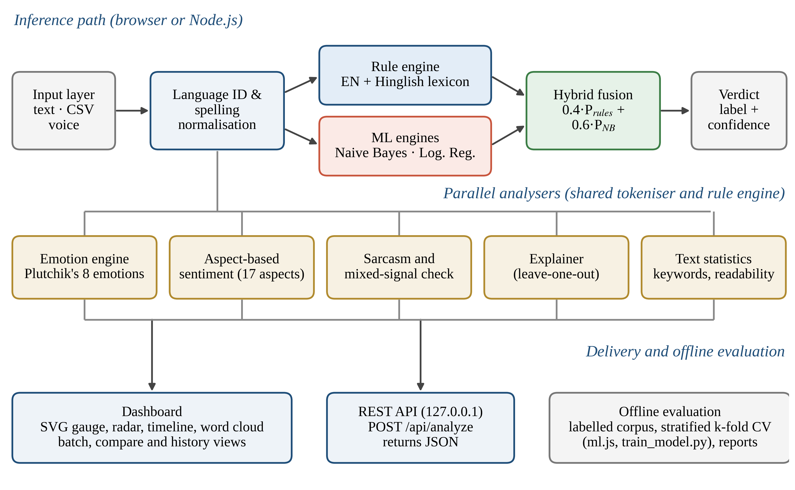
Fig. 1. Architecture of Text Sentiment Analyser. The inference path (top) feeds a set of parallel analysers (middle) whose outputs reach the user through the dashboard and a local REST API; the offline evaluation component (bottom right) reuses the same engines.
B. Pilot Corpus
Evaluation uses a pilot corpus of 210 short English and Hinglish texts that the project team wrote in the style of public comments about films, phones, cricket, food, travel, college life and customer service (Table 2). Every text received one of three labels, Positive, Neutral or Negative, according to the project’s labelling guide. Under that guide, the dominant or concluding opinion decides a mixed comment, the intended rather than the literal meaning decides a sarcastic one, and factual statements and questions are Neutral. The three classes are balanced, the average text is 7.1 words long, and the language identifier assigns 133 texts to Hinglish, 63 to Roman Hindi and 14 to English (Fig. 2). No user names or other personal data were collected.
Two properties of the corpus restrict the conclusions that can be drawn, and they are stated here at the start. First, the corpus was created to exercise the pipeline, and the Hinglish word list was compiled at the same time. The rule-based engine is therefore tested on material it was developed with, so its accuracy is an optimistic upper bound and not an estimate of performance on unseen social-media text. Second, agreement between independent annotators was not measured. The learned models, by contrast, are always tested on held-out folds.
Table 2. Statistics of the pilot corpus.
Property | Value
Texts | 210 (English and Hinglish, Roman script)
Class distribution | Positive 71, Neutral 69, Negative 70
Domains (texts) | movies 42, phones 32, cricket 29, food 29, general 23, college 22, travel 21, service 12
Length | mean 7.1 words (range 3–13); 12 texts contain emoji
Detected language | Hinglish 133, Roman Hindi 63, English 14
Provenance | Written by the project team; no scraped user data

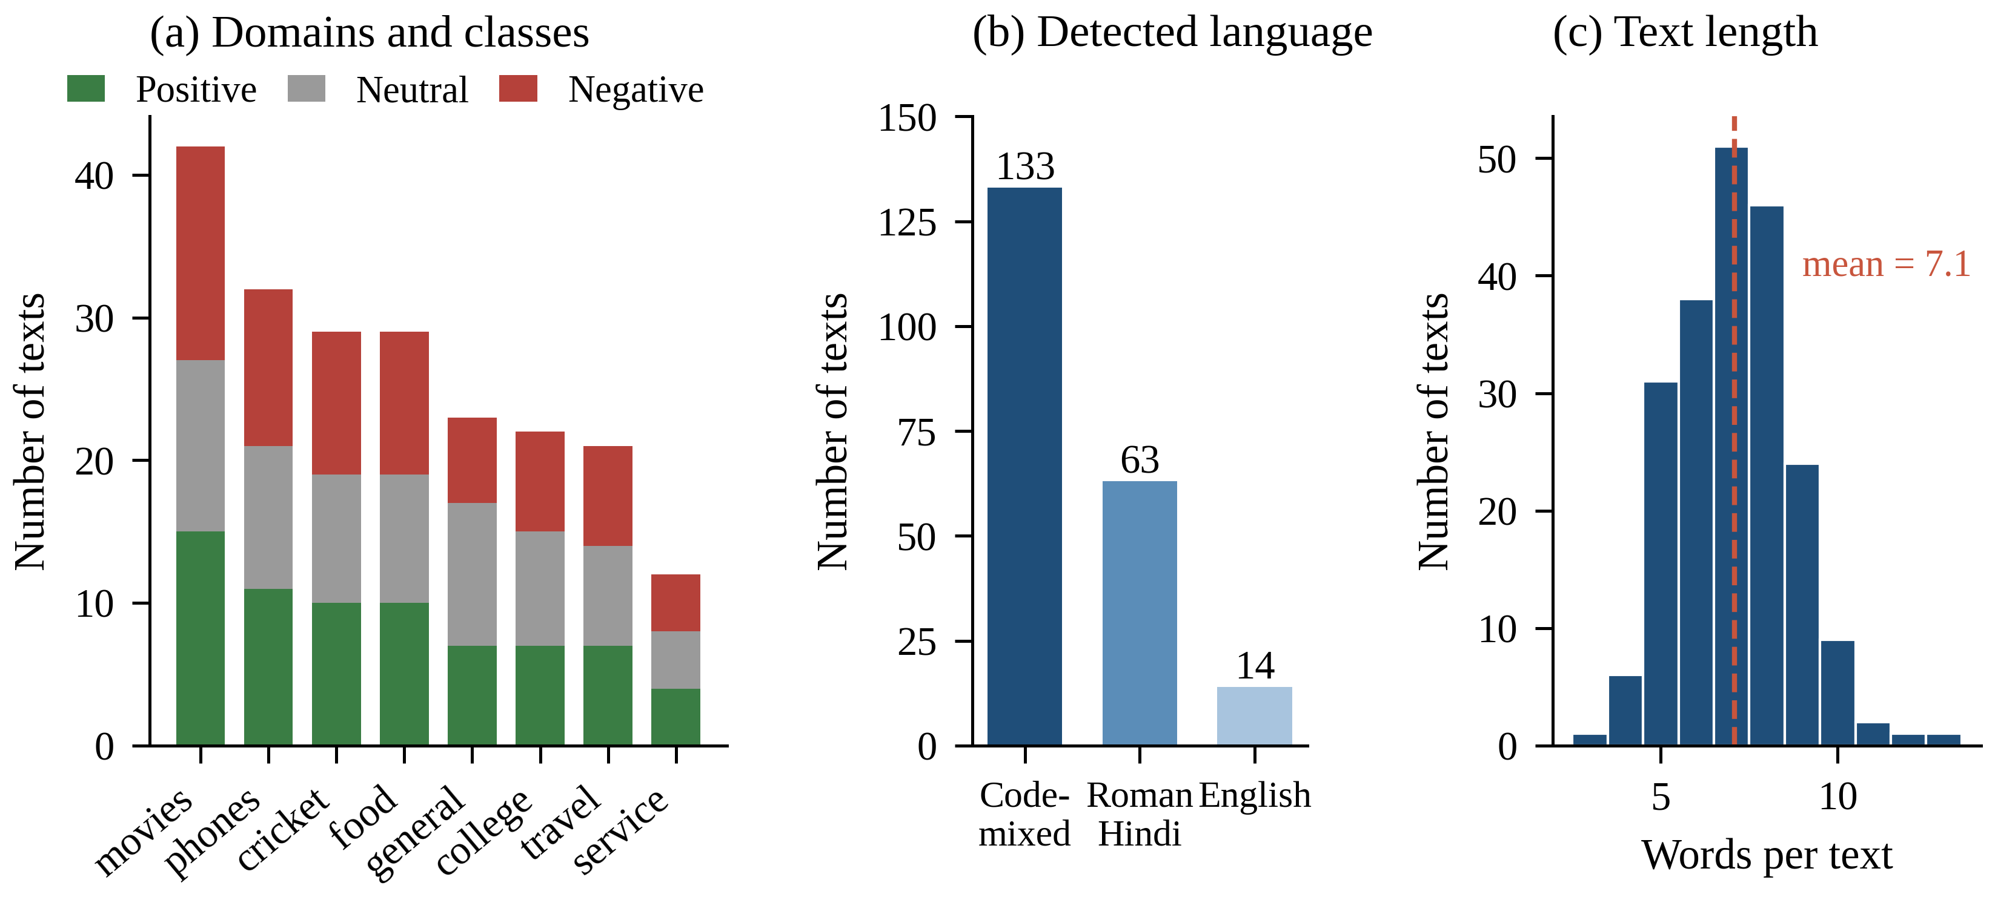
Fig. 2. Composition of the pilot corpus: (a) domains and classes, (b) language assigned by the identifier, (c) distribution of text length.
C. Language Identification and Normalisation
Language identification. The detector counts how many tokens belong to a list of 211 frequent Romanised-Hindi words, covering function words and common opinion words, and how many belong to a short list of English function words. A text is tagged Roman Hindi when at least 55% of its words are Hindi and no more than 15% are English, and Hinglish when the Hindi share reaches 15% (or when it contains at least two Hindi words and a Hindi share of 10%). Devanagari input is recognised from its Unicode range. Words that are ambiguous between the two languages, such as the, me, to, so and par, are excluded from the Hindi list.
Spelling normalisation. Every alphabetic token is lower-cased, any run of three or more identical letters is reduced to two (bahuuut → bahuut), and a dictionary of 94 entries maps common variants to a canonical spelling (for example bhot, bahot, bohot → bahut; nhi, nahin → nahi; badiya, bdiya → badhiya). The normalised tokens are used to build the machine-learning features. The rule engine instead lists frequent variants explicitly in its lexicon, so that every word it matches can be displayed to the user unchanged. The sizes of all linguistic resources are given in Table 3.
Table 3. Linguistic resources used by the system.
Resource | Size | Notes
English sentiment lexicon | 292 entries | Weights 1–4; positive and negative
Hinglish sentiment lexicon | 184 entries | 103 positive, 81 negative; spelling variants listed
Hindi intensifiers and dampeners | 28 entries | For example bahut ×1.6, ekdum ×1.7, thoda ×0.6
English intensifiers and dampeners | 27 entries | For example very, extremely, slightly
Emoji and emoticon scores | Signed, −4 to +4 | Hand-assigned; cf. emoji sentiment ranking [95]
Spelling-variant dictionary | 94 mappings | ML features and language identification
Romanised-Hindi vocabulary | 211 words | Language identification
Emotion lexicon | 376 word–emotion entries | Eight Plutchik emotions plus an emoji map
Aspect categories | 17 | Keyword lists, for example camera, battery, price, acting

D. Rule-Based Hinglish Engine
The rule engine, summarised in Algorithm 1 and Table 4, scans the tokens once from left to right. A tokeniser first separates words, emoji, emoticons and punctuation. During the scan the engine maintains a small amount of state, namely a pending negation counter, a pending booster factor, a contrast flag and a record of the most recent sentiment-bearing word, and it accumulates positive evidence in P and negative evidence in N.
Table 4. Parameters of the rule engine.
Parameter | Value | Role
Valence range | 1–4 (emoji −4 to +4) | Lexicon entries
Negation factor | −0.75 | English and Hindi negation
Negation window | 3 tokens | English forward window; Hindi look-back and fallback
Intensifier factors | 0.5–1.8 (EN), 0.6–1.7 (HI) | Applied to the next sentiment word
Contrast words | ×0.5 before, ×1.5 after | but, however, lekin, magar
Capitalised words | ×1.3 | Words longer than two letters
Exclamation marks | +8% each, at most four | Amplify the dominant polarity
Normalisation constant | 15 | Eq. (2)
Decision threshold | |c| ≥ 0.05 | Together with P > N or N > P

Algorithm 1. Hinglish rule-based sentiment scoring (simplified from the implementation).
Input: text T; flag H (Hinglish layer enabled). Output: label and compound score c.
1. tokens ← tokenise(T); P ← 0; N ← 0; boost ← 1; neg ← 0; contrast ← false; last ← none
2. for each token t in tokens do
3. if t is clause punctuation then neg ← 0; boost ← 1; last ← none; continue
4. w ← lower-case(t) with repeated letters collapsed
5. if w is a contrast word then P ← 0.5·P; N ← 0.5·N; contrast ← true; reset neg, boost, last; continue
6. if H and w is a Hindi post-negator (nahi, nhi, nahin, nai) then
7. if an un-negated hit last lies within 3 words then replace its score s by −0.75·s (move evidence between P and N)
8. else neg ← 3; continue
9. if w is an English negator, an n’t contraction or a Hindi pre-negator then neg ← 3; continue
10. if w is a booster that is not itself a sentiment word then boost ← boost × factor(w); continue
11. v ← signed valence of t (English lexicon; Hinglish lexicon if H; emoji; emoticon)
12. if v = 0 then (if neg > 0 then neg ← neg − 1); continue
13. s ← v · boost; if t is ALL-CAPS then s ← 1.3·s
14. if neg > 0 and t is a word (emoji are never negated) then s ← −0.75·s
15. if contrast then s ← 1.5·s
16. add |s| to P (s > 0) or to N (s < 0); last ← (t, s); boost ← 1; neg ← 0
17. amplify the larger of P and N by 1 + 0.08·min(number of “!”, 4)
18. c ← (P − N) / √((P − N)² + 15)
19. return Positive if c ≥ 0.05 and P > N; Negative if c ≤ −0.05 and N > P; otherwise Neutral

Lexicon and emoji. Every lexicon word carries an integer valence between 1 and 4, and emoji and emoticons carry signed scores between −4 and +4. The English and Hinglish entries are consulted together; switching off the Hinglish layer turns the same engine into the English-only baseline.
Negation. An English negator opens a window of three tokens within which sentiment words are reversed and attenuated by the factor −0.75, following the idea of shift negation [5]. Because a Hindi negator follows the word it negates, the engine, on reaching one, searches back up to three words for the most recent sentiment word that has not already been negated and multiplies its score by −0.75, so that acchi nahi thi becomes negative. Only when no such word exists does it open a forward window, as in nahi pasand (not liked). Emoji are never reversed, so help nahi ki 😡 (did not help) stays negative.
Intensifiers and contrast. A booster scales the next sentiment word (bahut ×1.6, ekdum ×1.7, thoda ×0.6). When a contrast word (but, however, lekin, magar) appears, the evidence gathered so far is halved and all later evidence is multiplied by 1.5. This reflects the observation that the clause following a contrast usually states the writer’s final opinion [4].
Emphasis and decision. Words written fully in capitals are multiplied by 1.3, and each exclamation mark strengthens the dominant polarity by 8%, up to four marks. The score of a single token is given by Eq. (1), and Eq. (2) maps the net evidence to a compound score in the interval (−1, 1), following the normalisation used by VADER [4].
s_{t} = v_{t} · b_{t} · η_{t} · κ_{t} (1)
c = x / √(x² + 15), x = P − N (2)
In these equations v_{t} is the lexicon valence of token t, b_{t} the booster factor, η_{t} equals −0.75 for a negated word and 1 otherwise, and κ_{t} equals 1.5 after a contrast word and 1 otherwise. All constants are listed in Table 4.
E. Machine-Learning Classifiers
The two classifiers share one feature set: normalised unigrams and bigrams of adjacent tokens. Emoji and the marks “!” and “?” are kept as tokens, because punctuation carries useful information in short comments.
Naive Bayes. A multinomial Naive Bayes model [96] computes P(y | d) ∝ P(y) ∏ P(f | y)^{n(f,d)}, where the feature likelihoods are estimated with Laplace smoothing as in Eq. (3). The implementation uses α = 1 and also applies add-one smoothing to the class priors.
P(f | y) = (n_{f,y} + α) / (N_{y} + α|V|) (3)
Here n_{f,y} is the number of occurrences of feature f in class y, N_{y} is the total feature count of class y, and |V| is the size of the vocabulary.
Logistic regression. A multinomial logistic regression model is trained on TF-IDF vectors [97, 98] that use sub-linear term frequency and L2 normalisation (Eq. 4). The model has a softmax output (Eq. 5) and is optimised by per-example stochastic gradient descent [99] with L2 regularisation (Eq. 6), using 40 epochs, an initial learning rate η₀ = 0.4 that decays as η_{e} = η₀/(1 + 0.05e), λ = 10⁻⁴ and a fixed random seed.
w_{f,d} = (1 + ln tf_{f,d}) · idf_{f}, idf_{f} = ln((1 + N)/(1 + df_{f})) + 1 (4)
p_{k} = exp(z_{k}) / Σ_{j} exp(z_{j}), z_{k} = W_{k} · x + b_{k} (5)
W_{k} ← W_{k} − η_{e} [ (p_{k} − y_{k}) x + λ W_{k} ] (6)
Reference implementations. To check the hand-written models against a standard library, the script train_model.py fits scikit-learn pipelines on the same normalised text. A TF-IDF vectoriser with unigrams, bigrams and sub-linear term frequency feeds three models: multinomial Naive Bayes (α = 0.5), logistic regression (C = 5) and a linear support vector machine (C = 1) [100].
F. Hybrid Fusion
The hybrid model turns the compound score c of the rule engine into a pseudo-probability vector (Eq. 7) and mixes it with the posterior of the Naive Bayes model (Eq. 8); the predicted label is the class with the highest P_{hybrid}. The mixing weight w = 0.4 is a fixed design constant of the project, and its sensitivity is examined in the section “Results”. By construction, P_{rules}(Pos) exceeds P_{rules}(Neu) only when c > 0.5, a property that becomes important in the discussion.
P_{rules}(Pos) = max(c, 0), P_{rules}(Neg) = max(−c, 0), (7)
P_{rules}(Neu) = 0.9·max(0, 1 − P_{rules}(Pos) − P_{rules}(Neg)) + 0.05
P_{hybrid}(y) = w · P_{rules}(y) + (1 − w) · P_{NB}(y), w = 0.4 (8)
G. Emotion, Aspect, Sarcasm and Explanation Modules
The emotion module is lexicon-based. A total of 376 English and Hinglish word–emotion entries (joy 64, trust 47, fear 45, surprise 34, sadness 53, disgust 42, anger 55, anticipation 36), together with an emoji map, assign evidence to Plutchik’s eight basic emotions [77]. Negated words are ignored, and the emotion with the most evidence is reported as dominant. The aspect module divides a text into clauses at punctuation and contrast words, searches each clause for keywords belonging to 17 aspects (such as camera, battery, price, delivery, acting and songs) and scores each aspect with the rule engine, producing verdicts such as “camera: positive, battery: negative” [92].
The sarcasm module is a rule-based indicator rather than a trained classifier. It accumulates evidence from eye-roll and clap emoji, ironic phrase patterns (oh great, wah kya baat hai), praise words placed next to words describing mishaps (late, crash) and emoji that contradict the words, and it reports Unlikely, Possible or Likely together with its reasons. Finally, the explainer attributes the verdict to individual words by leave-one-out perturbation: deleting token t_{i} and rescoring the text yields its impact Δ_{i} (Eq. 9). This also reveals the effect of function words such as nahi, bahut and but, in the spirit of perturbation-based explanation [84, 86].
Δ_{i} = c(T) − c(T ∖ t_{i}) (9)
H. Software Implementation and Privacy
The user interface provides a live analyser (with a gauge, an emotion radar, a sentence timeline and a word cloud), batch CSV processing with export, a side-by-side comparison view, a history dashboard and an evaluation page that runs the five-engine cross-validation on either the bundled corpus or an uploaded one. All charts are drawn with hand-written SVG, so the application depends on no third-party library. A dependency-free Node.js server delivers the front end and exposes POST /api/analyze, which returns the label, compound score, confidence, emotions, sentences, keywords and statistics as JSON. The server listens on 127.0.0.1 only, rejects request bodies larger than 20 KB and texts longer than 5,000 characters, validates JSON input and blocks path traversal. A content-security policy prevents the page from sending requests to outside servers, and analysis history is kept in the browser. An automated test script checks the engines, the machine-learning module and the HTTP interface.
I. Algorithmic Complexity
Let n be the number of tokens in a text, L ≈ 2n − 1 the number of unigram and bigram features, N the number of training texts, K = 3 the number of classes and E the number of training epochs. Table 5 lists the asymptotic costs. They follow from the single-pass design: lexicon, booster and negator lookups are constant-time hash-map operations, so scoring a text is linear in n. The leave-one-out explainer rescores the text once for every token and is therefore quadratic; the implementation limits it to 400 tokens to keep latency bounded.
Table 5. Time and space complexity of the main components.
Component | Time | Space | Remark
Tokenisation and language ID | O(n) | O(n) | One regular-expression pass; set lookups
Rule engine | O(n) | O(n) | Constant-time lookups; look-back of at most 3
Naive Bayes training | O(N·L) | O(|V|·K) | One counting pass
Naive Bayes prediction | O(K·L) | O(L) | Sum of log-probabilities
Logistic regression training | O(E·N·L·K) | O(|V|·K) | Sparse updates
Logistic regression prediction | O(K·L) | O(L) | Softmax over K = 3
Hybrid prediction | O(n + K·L) | O(L) | Rule score plus NB posterior
Leave-one-out explainer | O(n²) | O(n) | n re-scorings of cost O(n)
k-fold evaluation of one engine | O(k·T_{train} + N·T_{pred}) | O(N) | Retrains in every fold

J. Experimental Protocol and Metrics
All JavaScript engines are evaluated by stratified k-fold cross-validation [101] with k = 5. The texts of each class are shuffled with a seeded generator and dealt round-robin into folds, so every fold preserves the class balance; models are trained on four folds and tested on the fifth. The rule-based engines have no trainable parameters, so for them the folds merely partition the evaluation. The primary run uses seed 7, and the whole procedure is repeated with seeds 7, 11, 21, 42 and 99 to measure sensitivity to the split. The Python experiments use five folds with random state 42; their splits therefore differ from those of the JavaScript runs, and the two sets of results are not paired.
The metrics are accuracy; macro-averaged precision, recall and F1 (Eq. 10); Cohen’s kappa between predictions and gold labels [102] (Eq. 11); and 95% confidence intervals obtained from 2,000 bootstrap resamples of the 210 pooled out-of-fold predictions [103]. Paired differences between engines are assessed with McNemar’s test with continuity correction [104, 105] (Eq. 12), where b and c count the texts that only one of the two engines classifies correctly. Kappa values are interpreted with the bands of Landis and Koch [106]. Additional experiments remove one component of the rule engine at a time, sweep the hybrid weight w and the smoothing constant α, and train on growing fractions of the training folds. No setting was tuned to improve the headline results; the sweeps are reported purely as sensitivity analyses. The software environment is listed in Table 6.
F1_{macro} = (1/3) Σ_{c} 2 · P_{c} · R_{c} / (P_{c} + R_{c}) (10)
κ = (p_{o} − p_{e}) / (1 − p_{e}) (11)
χ² = (|b − c| − 1)² / (b + c), df = 1 (12)
Table 6. Experimental setup.
Item | Setting
Runtime | Node.js v22.22.2 (JavaScript engines, benchmarks); Python 3.12.3 with scikit-learn 1.8.0, NumPy and Matplotlib [107, 108]
Cross-validation | Stratified, k = 5; seeds 7, 11, 21, 42, 99 (JavaScript); random state 42 (Python)
Bootstrap | 2,000 resamples of the pooled predictions, seed 123
Naive Bayes | α = 1 (JavaScript); α = 0.5 (scikit-learn)
Logistic regression | 40 epochs, η₀ = 0.4, λ = 10⁻⁴ (JavaScript); C = 5 (scikit-learn)
Linear SVM | C = 1 (scikit-learn)
Hybrid | Rule weight w = 0.4; Naive Bayes α = 1
Hardware | Shared cloud Linux container; timings are indicative only

The next section presents the measurements obtained with this protocol.

Results:
A. Overall Performance
The main comparison is reported in Table 7 and Fig. 3. The English-only lexicon reaches 55.2% accuracy and 52.8% macro-F1. Because it does not recognise most Hindi opinion words, it labels 160 of the 210 texts (76%) as Neutral, and its recall is only 35.2% for the Positive class and 32.9% for the Negative class. Enabling the Hinglish layer lifts accuracy to 92.4% (95% CI 88.6–95.7%) and kappa to 0.89, an improvement of 37.2 points that no other component comes close to. The trained classifiers lie between these two extremes. On the primary split Naive Bayes reaches 70.0% and logistic regression 67.6%, but both average 65.9% across the five splits, and the gap between them is smaller than the variation from one split to the next. The hybrid reaches 83.8% on the primary split and 82.1% on average, which is 16.2 points above Naive Bayes on its own.
Table 7. Performance of the five engines under stratified five-fold cross-validation (n = 210). Columns 2–5 refer to the primary split (seed 7); the last column averages five splits.
Engine | Accuracy, fold mean ± SD (%) | Macro-F1, fold mean ± SD (%) | 95% CI of pooled accuracy (%) | Cohen’s κ | Accuracy, five-split mean ± SD (%)
English lexicon (baseline) | 55.3 ± 6.4 | 52.8 ± 8.0 | 48.6–61.9 | 0.33 | 55.2 ± 0.0
Hinglish-aware rules (ours) | 92.4 ± 2.4 | 92.4 ± 2.2 | 88.6–95.7 | 0.89 | 92.4 ± 0.0
Naive Bayes | 70.0 ± 3.1 | 69.9 ± 3.6 | 63.8–75.7 | 0.55 | 65.9 ± 2.8
Logistic regression | 67.6 ± 2.8 | 67.3 ± 2.9 | 61.4–73.3 | 0.51 | 65.9 ± 1.8
Hybrid: rules + NB (ours) | 83.8 ± 4.7 | 83.7 ± 4.6 | 78.6–88.6 | 0.76 | 82.1 ± 1.6

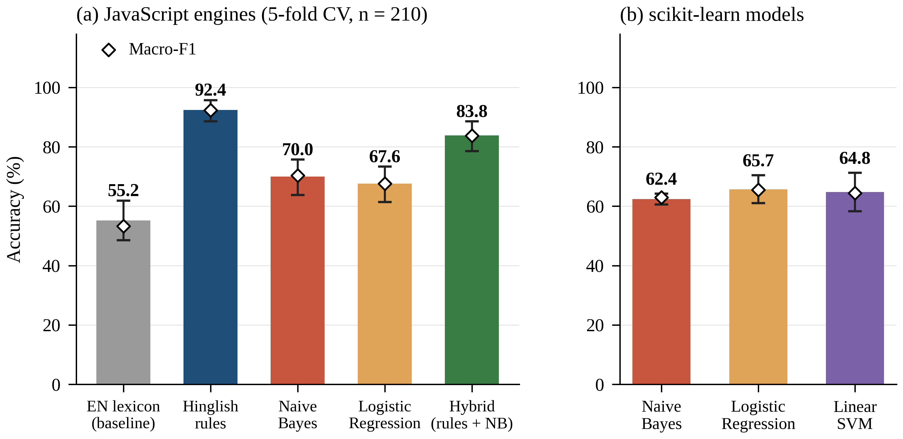
Fig. 3. Accuracy of the compared engines. (a) JavaScript engines on the primary split (bars: pooled accuracy with 95% bootstrap interval; diamonds: macro-F1). (b) scikit-learn models (mean ± SD over five folds; diamonds: macro-F1).
The scikit-learn reference models in Table 8 show the same picture. Naive Bayes, logistic regression and the linear SVM reach 62.4%, 65.7% and 64.8% accuracy respectively, with fold standard deviations between 1.8 and 6.5 points. Two independent implementations of the same model families thus agree to within about four points (comparing the five-split JavaScript means with the Python run), and both stay far below the rule engine. This suggests that, with only about 170 training texts, the learned models are limited by the amount of data rather than by the choice of algorithm.
Table 8. Results of the scikit-learn models (five-fold cross-validation, macro-averaged).
Model | Accuracy (%) | Precision (%) | Recall (%) | Macro-F1 (%)
Multinomial Naive Bayes | 62.4 ± 1.8 | 64.4 | 62.5 | 63.0 ± 1.3
Logistic regression | 65.7 ± 4.7 | 65.9 | 65.9 | 65.5 ± 4.7
Linear SVM | 64.8 ± 6.5 | 64.5 | 65.0 | 64.4 ± 6.6

B. Statistical Reliability
With 210 texts the bootstrap intervals are wide, with half-widths between 3.6 and 6.7 points, so only large differences can be trusted. On the Landis–Koch scale [106], agreement with the gold labels is fair for the baseline (κ = 0.33), moderate for Naive Bayes and logistic regression (0.55 and 0.51), substantial for the hybrid (0.76) and almost perfect for the Hinglish engine (0.89). McNemar tests on the pooled predictions (Table 10) confirm that the Hinglish engine outperforms the English baseline (81 texts are correct only for the former and 3 only for the latter, p < 0.0001), and that the hybrid outperforms both Naive Bayes (30 against 1) and logistic regression (35 against 1), each with p < 0.0001. The rule engine is also better than the hybrid (24 against 6, p = 0.002). Naive Bayes and logistic regression cannot be distinguished (9 against 4, p = 0.27). Across the five splits the accuracy of Naive Bayes ranges from 61.5% to 70.0%, a spread larger than its difference from logistic regression, so the ranking of the learned models on a 210-text corpus should not be over-interpreted.
C. Class and Domain Behaviour
The per-class scores in Table 9 follow a consistent pattern. Apart from the English baseline, every engine recognises Neutral texts well (F1 0.87–0.92), because the neutral comments in the corpus carry clear cues such as question marks and time expressions (baje, kal, abhi), which Naive Bayes also ranks as the most indicative Neutral features (Fig. 10). The learned models, however, confuse the two polar classes. Naive Bayes labels 23 positive texts as negative and 23 negative texts as positive, and logistic regression makes these errors 24 and 26 times respectively (Fig. 4). The reason is that many opinion words occur only once or twice in the training folds, so an unseen word of praise or complaint contributes nothing at test time. The Hinglish engine has the opposite weakness: 8 of its 10 errors on Negative texts are predictions of Neutral, mostly for complaints that contain no lexicon word. Across domains (Fig. 5) the Hinglish engine is the best or joint-best engine everywhere. Its lowest score is in the phones domain (84%), where complaints are often implicit, and in the 12-text service domain all engines except Naive Bayes tie at 67%.
Table 9. Per-class precision (P), recall (R) and F1 of the five engines (pooled out-of-fold predictions, primary split).
Engine | Pos P | Pos R | Pos F1 | Neu P | Neu R | Neu F1 | Neg P | Neg R | Neg F1
English lexicon (baseline) | 1.00 | 0.35 | 0.52 | 0.42 | 0.99 | 0.59 | 0.92 | 0.33 | 0.48
Hinglish-aware rules | 0.96 | 0.94 | 0.95 | 0.87 | 0.97 | 0.92 | 0.95 | 0.86 | 0.90
Naive Bayes | 0.62 | 0.63 | 0.63 | 0.89 | 0.86 | 0.87 | 0.61 | 0.61 | 0.61
Logistic regression | 0.58 | 0.59 | 0.58 | 0.86 | 0.88 | 0.87 | 0.59 | 0.56 | 0.57
Hybrid: rules + NB | 0.78 | 0.82 | 0.80 | 0.89 | 0.94 | 0.92 | 0.84 | 0.76 | 0.80

D. Ablation and Sensitivity
Removing the components of the rule engine one at a time (Table 11, Fig. 6) shows that the Hindi lexicon is by far the most important element: without it accuracy drops from 92.4% to 55.2%, and only 5 of the 12 targeted test sentences are classified correctly. The remaining components change corpus accuracy by one point at most (emoji and emoticon scores by 1.0 point, intensifiers by 0.5 points, and Hindi post-negation, the contrast rule and English pre-negation not at all). Even so, removing them breaks 3, 2 and 2 of the 12 targeted sentences respectively, including movie acchi nahi thi and camera mast hai but battery bekaar. The corpus is therefore a weak test of these mechanisms, since only 20 texts contain a Hindi negator, 2 a contrast word and 2 an English negator, an observation in line with the case for targeted behavioural testing [87].
The unchanged accuracy also hides the fact that post-negation does alter predictions: it changes eight of them, correcting four (for example Bilkul pasand nahi aayi movie) and breaking four. Two of the broken cases are “never … such” idioms built on kabhi nahi, in which a negator together with a superlative expresses praise or censure rather than denial; one is a comparative (isse best phone nahi milega); and one negates the neutral noun problem. For the learned model (Table 12), spelling normalisation adds 1.1 points to Naive Bayes (from 64.8% to 65.9%), removing bigrams changes accuracy by +0.4 points (66.3% with unigrams only), and the smoothing constant has little effect (from 64.1% at α = 0.1 to 67.2% at α = 2). Each of these differences is smaller than the standard deviation of 1.9–3.0 points across splits, so none of them is established.
Fig. 7a varies the rule weight w of Eq. (8). Accuracy rises almost steadily from 65.9% (Naive Bayes only) to a peak of 89.4% at w = 0.7 and then falls to 87.1% at w = 1, so the project’s default of 0.4 (82.1%) is not the best value on this corpus. Selecting w on the same folds used for testing is optimistic, so 89.4% is an upper bound unless w is chosen by nested validation. The value at w = 1 is lower than the 92.4% of the direct rule label because of Eq. (7): the rule probability of Positive or Negative exceeds that of Neutral only when |c| > 0.5, while the direct rule uses a threshold of 0.05, so the probabilistic form pushes weakly polarised texts towards Neutral.
E. Data Efficiency
The learning curves in Fig. 7b show where fusion helps most. With only 17 training texts, Naive Bayes and logistic regression score 49.9% and 51.3%, about 17 points above the chance level for three balanced classes, whereas the hybrid already reaches 75.5% because its rule component brings prior knowledge. With the full 168 training texts per split, the learned models reach 67.0% and the hybrid 80.4%. The learned models are still gaining about seven points for every doubling of the data (60.2% at 84 texts and 67.0% at 168), while the hybrid gains only 1.6 points over the same step and stays 11 points below the rule engine (91.5% on the same test folds).
F. Error Analysis
The 16 errors of the Hinglish engine (Table 13, Fig. 8) fall into three groups. Nine involve implicit or unlexicalised sentiment: complaints such as Battery bahut jaldi khatam ho jaati hai (the battery drains very fast) or Wifi kabhi kaam nahi karta campus mein contain no word with a stored polarity, so the engine answers Neutral; in one of these cases the cause is the spelling variant dheemi, which is missing from the lexicon. Four are errors of negation scope, three of which involve the kabhi nahi construction or a comparative negation. Three arise because the polarity of a word depends on its domain: problem in problem solve kar di, jeet (win) in a neutral report of a cricket toss, and refund in a neutral statement of policy. Because the engine has no trainable parameters, exactly the same 16 errors occur on the full corpus and in the pooled out-of-fold predictions.
The errors of the learned models are dominated by unseen vocabulary. On the primary split, Naive Bayes labels Heroine ki acting lajawab thi (the heroine’s acting was superb) and Flight staff bahut helpful the as Negative, because lajawab never occurs in the training folds and the remaining tokens carry little information. The most indicative features of the model (Fig. 10) include genuine cues (mast, khush, bekaar, ghatiya) alongside artefacts of the corpus (bilkul, sab, baar, itna, main) that would not generalise. The hybrid inherits the errors of the rules and adds some learned ones; for example, it labels Goa trip bahut mazedaar raha Negative although the rule engine is correct. Naive Bayes posteriors tend to be extreme, which probably allows a confident but wrong vote to outweigh a correct rule score at w = 0.4.
G. Emotion, Aspect and Explanation Outputs
The corpus has no gold emotion labels, so only the distribution of the dominant emotion is reported (Fig. 9) and no accuracy is claimed. Joy dominates 39% of the positive texts, while negative texts show anger (21%), fear (14%), disgust (11%) and sadness (6%), proportions that are plausible for these classes. Neutral texts, however, show surprise in 28% of cases, and inspection uncovered a defect: 14 of the 19 neutral texts labelled surprise are triggered by the postposition mein (“in”), which entered the emotion lexicon when the phrase sach mein (really) was split into separate words, and five by the interrogative kya. The aspect module returns “camera: positive” and “battery: negative” for camera mast hai but battery bekaar. For movie acchi nahi thi but songs mast the the engine returns a compound score of +0.70 (Positive), and the explainer attributes the largest impact to mast (+0.89), followed by the contrast word but (+0.34), while nahi and acchi contribute small negative amounts.
H. Runtime and Functional Testing
The automated test script passes completely. It covers the English engine cases, the Hinglish checks, the machine-learning module including a cross-validation sanity check, and the HTTP interface, including malformed JSON (HTTP 400) and rejection of path traversal. Table 14 lists the twelve targeted sentences used in the ablation. Analysing one text with the full pipeline takes 0.12 ms on average (0.013 ms for the rule engine alone, and 0.029 ms and 0.015 ms per prediction for Naive Bayes and logistic regression), and training on all 210 texts takes 2.4 ms for Naive Bayes and 53 ms for logistic regression. The scaling experiments (Fig. 11, Table 15) agree with Table 5: an eight-fold increase in input length multiplies the time of the rule engine by 9.3, the same step multiplies Naive Bayes training time by 7.7, and a 3.9-fold increase in input length multiplies the explainer’s time by 13.2, close to the quadratic expectation of 15. These timings come from one Node.js run in a cloud container and include start-up noise at small sizes, so growth ratios are more informative than absolute times.

Figures and Tables:
The exhibits below extend the results reported above; each one is referred to in the text.
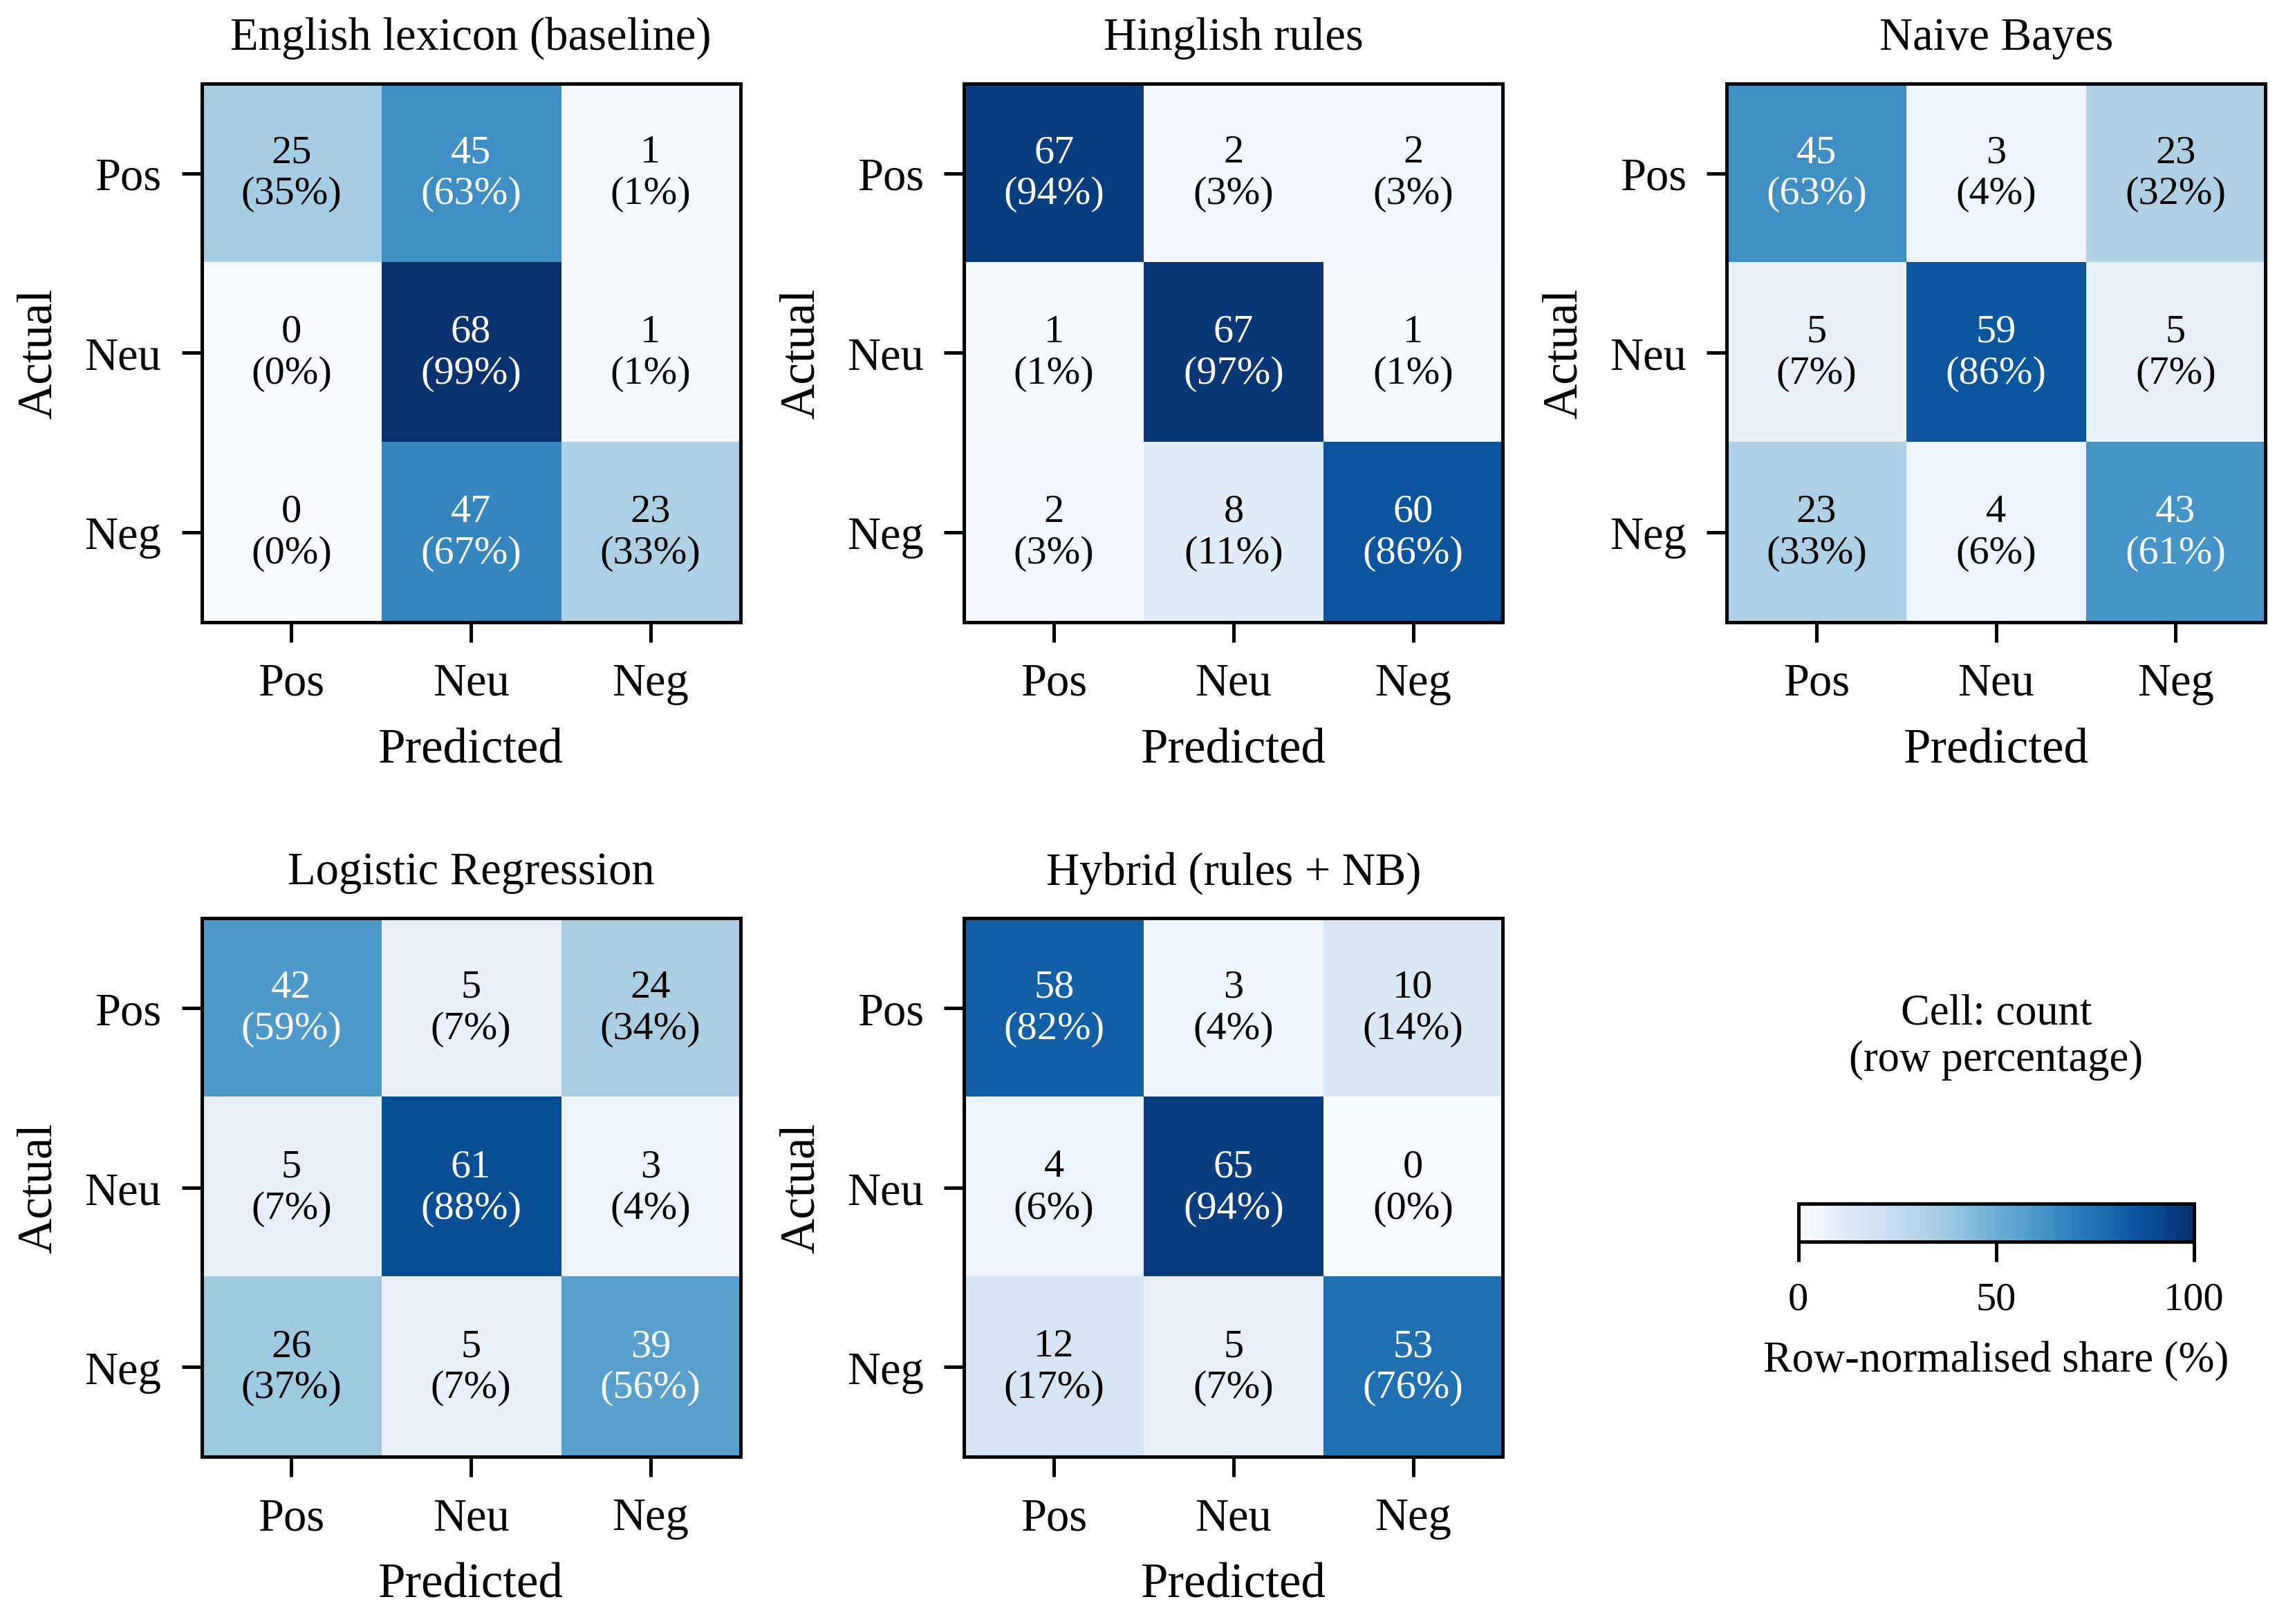
Fig. 4. Confusion matrices of the five engines (pooled out-of-fold predictions, primary split; rows are actual classes).
Table 10. McNemar tests on pooled out-of-fold predictions. The two count columns give the number of texts classified correctly only by the first and only by the second engine.
Comparison | First only | Second only | χ² | p
Hinglish rules vs English baseline | 81 | 3 | 70.58 | < 0.0001
Hinglish rules vs Hybrid | 24 | 6 | 9.63 | 0.0019
Hinglish rules vs Naive Bayes | 53 | 6 | 35.86 | < 0.0001
Hybrid vs Naive Bayes | 30 | 1 | 25.29 | < 0.0001
Hybrid vs Logistic regression | 35 | 1 | 30.25 | < 0.0001
Naive Bayes vs Logistic regression | 9 | 4 | 1.23 | 0.2673

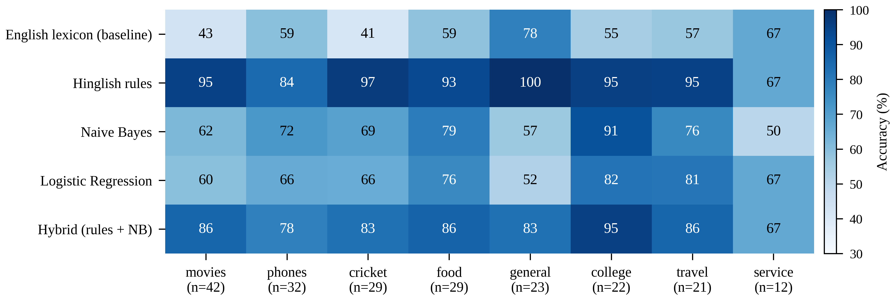
Fig. 5. Accuracy (%) of each engine by domain; n is the number of texts in the domain.
Table 11. Ablation of the Hinglish rule engine. Δ is the change in accuracy relative to the full engine, in percentage points; the last column counts how many of the 12 targeted sentences of Table 14 are classified correctly.
Variant | Accuracy (%) | Macro-F1 (%) | Δ | Texts changed | Unit tests passed
Full Hinglish engine | 92.4 | 92.3 | — | 0 | 12/12
− Hindi post-negation | 92.4 | 92.3 | 0.0 | 8 | 9/12
− Contrast rule (but, lekin) | 92.4 | 92.3 | 0.0 | 0 | 10/12
− Intensifiers (bahut, ekdum) | 91.9 | 91.9 | −0.5 | 1 | 12/12
− English pre-negation | 92.4 | 92.3 | 0.0 | 0 | 10/12
− Emoji and emoticon scores | 91.4 | 91.4 | −1.0 | 2 | 11/12
− Hindi lexicon (English only) | 55.2 | 53.3 | −37.1 | 86 | 5/12

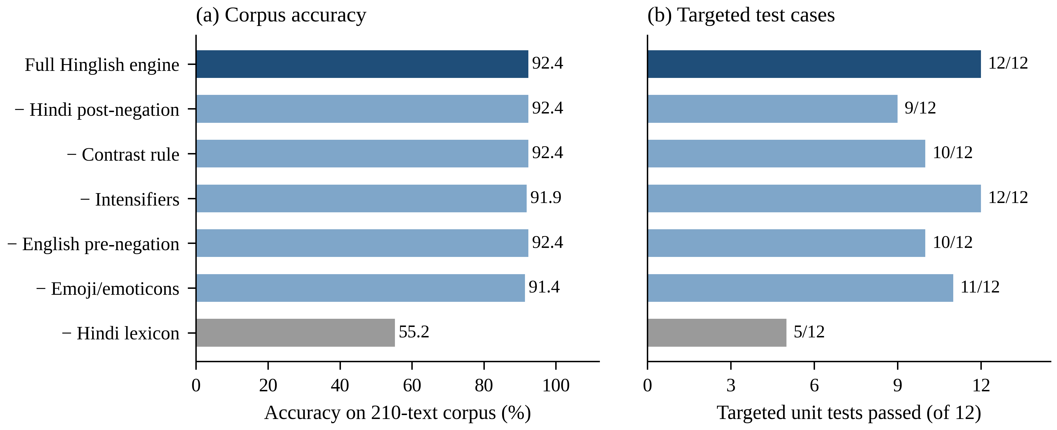
Fig. 6. Ablation of the rule engine: (a) accuracy on the 210-text corpus; (b) number of the 12 targeted test sentences classified correctly.
Table 12. Feature and smoothing ablation for Naive Bayes (accuracy, mean ± SD over five splits).
Setting | Accuracy (%)
Naive Bayes, full features (α = 1) | 65.9 ± 2.8
− spelling normalisation | 64.8 ± 2.4
Unigrams only (no bigrams) | 66.3 ± 2.2
Smoothing α = 0.1 | 64.1 ± 3.0
Smoothing α = 0.25 | 64.1 ± 2.3
Smoothing α = 0.5 | 65.4 ± 2.7
Smoothing α = 1 (default) | 65.9 ± 2.8
Smoothing α = 2 | 67.2 ± 1.9

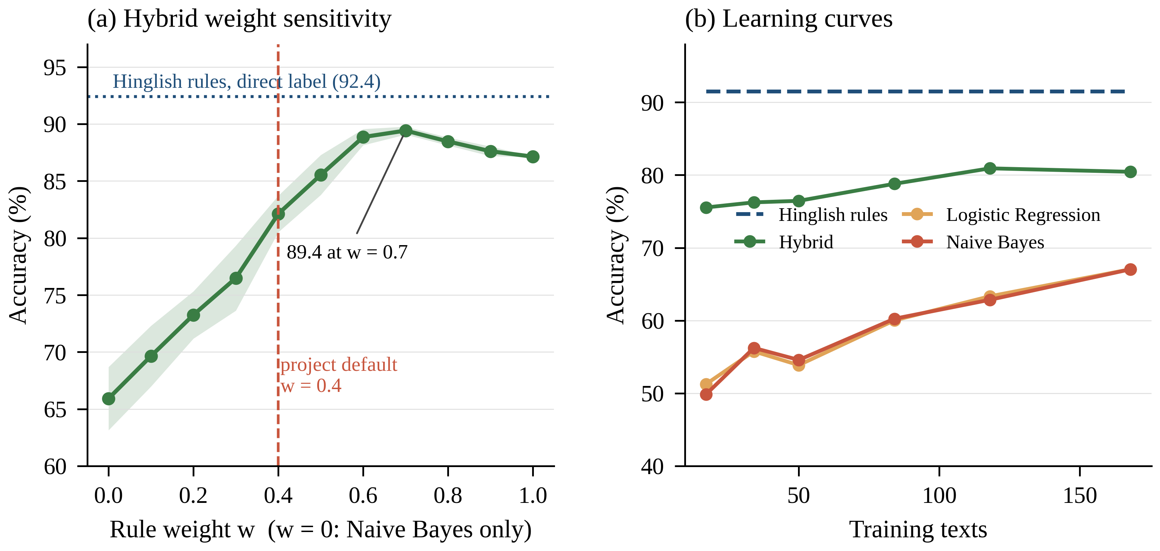
Fig. 7. Sensitivity analyses: (a) accuracy of the hybrid as the rule weight w varies (mean ± SD over five splits); (b) learning curves of the learned models, the hybrid and the rule engine (mean over ten train–test splits).
Table 13. The 16 misclassified texts of the Hinglish engine with gold label, prediction and error category.
# | Text | Gold | Pred. | Category
1 | Bhai yeh web series toh next level hai | Pos | Neu | Implicit / unlexicalised
2 | Is price mein isse best phone nahi milega | Pos | Neg | Negation scope
3 | Itna swadisht paneer kabhi nahi khaya | Pos | Neg | Negation scope (kabhi nahi)
4 | Customer care ne turant problem solve kar di, thanks | Pos | Neu | Domain-dependent polarity
5 | Itna wahiyat climax kabhi nahi dekha | Neg | Pos | Negation scope (kabhi nahi)
6 | Battery bahut jaldi khatam ho jaati hai | Neg | Neu | Implicit / unlexicalised
7 | Charger kaam nahi kar raha, paise doob gaye | Neg | Neu | Implicit / unlexicalised
8 | Speaker ki awaaz bahut dheemi hai | Neg | Neu | Implicit / unlexicalised (variant)
9 | Customer care se baat karo toh koi jawab nahi deta | Neg | Neu | Implicit / unlexicalised
10 | Pizza ka base jala hua tha | Neg | Neu | Implicit / unlexicalised
11 | Bus mein itni bheed thi ki saans lena mushkil tha | Neg | Neu | Implicit / unlexicalised
12 | Wifi kabhi kaam nahi karta campus mein | Neg | Neu | Implicit / unlexicalised
13 | Customer care ne problem solve nahi ki, bas ghuma diya | Neg | Pos | Negation scope (domain noun)
14 | Account se paise kat gaye aur order bhi nahi hua | Neg | Neu | Implicit / unlexicalised
15 | Toss jeet ke bowling chuni | Neu | Pos | Domain-dependent polarity
16 | Refund 5 se 7 din mein process hota hai | Neu | Neg | Domain-dependent polarity

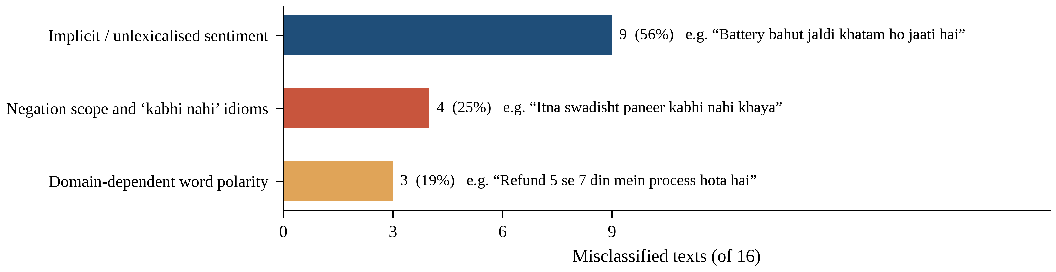
Fig. 8. Taxonomy of the 16 errors of the Hinglish engine.
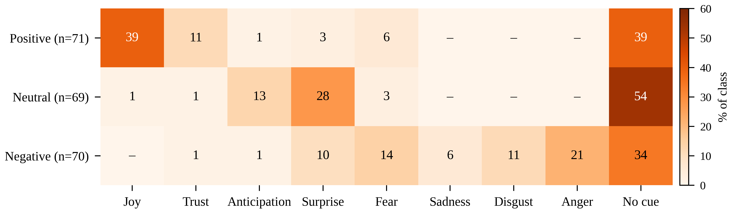
Fig. 9. Dominant emotion detected by the emotion engine, as a percentage of the texts in each gold sentiment class.
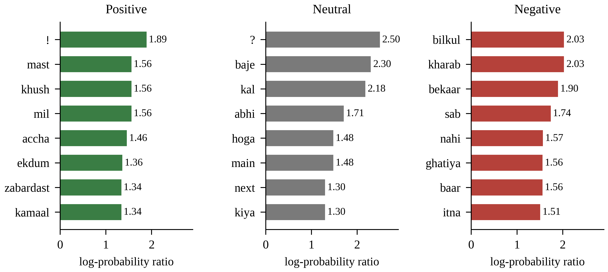
Fig. 10. Most indicative features of the Naive Bayes model for each class (log-probability ratio against the other classes).
Table 14. Targeted test sentences: gold label, output of the English-only baseline, output of the Hinglish engine and its compound score c (✓ correct, ✗ wrong).
Sentence | Gold | English only | Hinglish engine | c
movie acchi nahi thi | Neg | Neu ✗ | Neg ✓ | −0.361
bhot badiya | Pos | Neu ✗ | Pos ✓ | 0.778
camera mast hai but battery bekaar | Neg | Neu ✗ | Neg ✓ | −0.612
match kal 7 baje hai | Neu | Neu ✓ | Neu ✓ | 0.000
yaar ekdum bakwas film hai | Neg | Neu ✗ | Neg ✓ | −0.869
bilkul pasand nahi aaya | Neg | Neu ✗ | Neg ✓ | −0.502
service bahut slow hai lekin khana mast tha | Pos | Neg ✗ | Pos ✓ | 0.599
help nahi ki 😡 | Neg | Neg ✓ | Neg ✓ | −0.718
It isn’t bad | Pos | Pos ✓ | Pos ✓ | 0.502
bakwas nahi thi, actually kaafi acchi nikli | Pos | Neu ✗ | Pos ✓ | 0.822
not good at all | Neg | Neg ✓ | Neg ✓ | −0.361
movie bahut acchi thi 😍 | Pos | Pos ✓ | Pos ✓ | 0.881

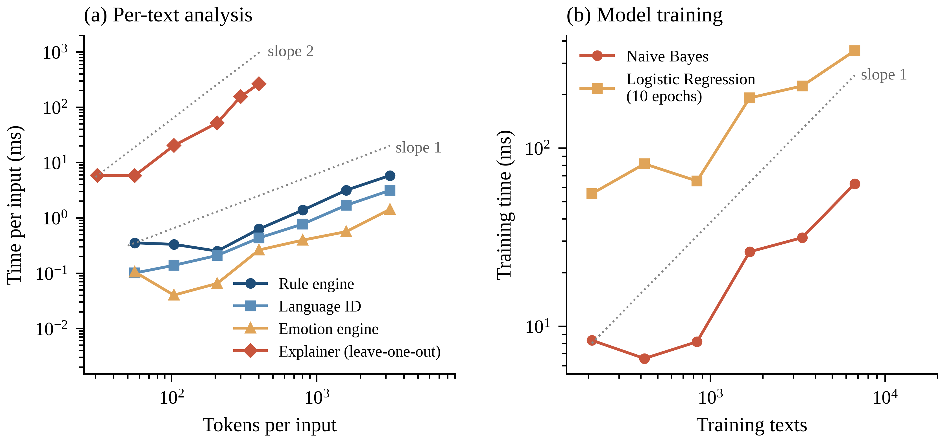
Fig. 11. Measured scaling of running time on logarithmic axes: (a) per-text analysis; (b) model training. Dotted lines show slopes of 1 and 2.
Table 15. Observed growth of running time when the input is enlarged (single Node.js run).
Component | Input range | Time (ms) | Time growth | Input growth | Expected
Rule engine | 402 → 3,208 tokens | 0.63 → 5.82 | 9.3× | 8.0× | O(n)
Language identification | 402 → 3,208 tokens | 0.43 → 3.13 | 7.2× | 8.0× | O(n)
Emotion engine | 402 → 3,208 tokens | 0.26 → 1.42 | 5.4× | 8.0× | O(n)
Leave-one-out explainer | 104 → 402 tokens | 20.21 → 266.31 | 13.2× | 3.9× | O(n²)
Naive Bayes training | 840 → 6,720 texts | 8.16 → 62.98 | 7.7× | 8.0× | O(N·L)
Logistic regression training (10 epochs) | 840 → 6,720 texts | 65.26 → 352.20 | 5.4× | 8.0× | O(E·N·L·K)

Note: all figures were produced at 600 dpi with labelled axes, and the first row of every table is a header row.

Discussion:
A. Interpretation of the Findings
The central finding is that, when labelled data are scarce, accuracy on Hinglish is decided by vocabulary coverage rather than by the choice of algorithm. Adding Hinglish lexicon entries raised accuracy by 37 points over the same engine without them, whereas moving between Naive Bayes, logistic regression and a linear SVM changed accuracy by only a few points and never reliably. This agrees with the observation that simple linear models over n-grams are strong baselines whose quality depends mainly on the training data [32], and with reviews of under-resourced languages that recommend curated lexical resources [76]. For low-resource language pairs, a small, carefully curated lexicon appears to be an efficient first investment.
The hybrid improved clearly on Naive Bayes, by 16.2 points on average and by 25.6 points when only 17 training texts were available, but it did not beat the rule engine on this corpus. We do not take this as evidence that learning is useless. First, the rule engine was developed together with the corpus, so its advantage is inflated by construction. Second, the fusion rule is simple: Eq. (7) converts compound scores to probabilities in a way that suppresses weak rule signals, and Naive Bayes posteriors tend to be extreme, so a confident wrong learned vote can override a correct rule score, as in Goa trip bahut mazedaar raha. Calibrating both components and learning w by nested validation are natural refinements. Third, the real value of a learned component is to absorb domain vocabulary missing from the lexicon, and a corpus of 210 short, simple sentences cannot demonstrate this.
The ablations also teach a methodological lesson. Corpus-level accuracy did not react to three of the six rule components, yet removing any of them broke the targeted cases that had motivated them. Aggregate accuracy on a small and simple corpus can therefore exaggerate how complete a design is, and challenge sets built around specific phenomena such as post-negation, contrast, sarcasm and code-switching points should accompany any benchmark [87]. The finding that post-negation corrected four texts and broke four shows that a linguistically motivated rule needs explicit exceptions, in this case for kabhi nahi, before it pays off.
B. Strengths and Practical Implications
Text Sentiment Analyser offers properties that large pre-trained models do not. Every verdict can be traced to lexicon entries and rules; the leave-one-out explainer shows the effect of function words; a text is analysed in about 0.1 ms; no network access is needed; and the REST interface is bound to the local machine. These qualities suit privacy-sensitive uses such as analysing student feedback or triaging customer-care messages on a local workstation, and they make the system a transparent baseline against which heavier models, including large language models [88, 91], can be compared. Because the lexicon is a plain data structure, a domain expert can extend it without any retraining.
C. Limitations and Threats to Validity
Several limitations qualify these conclusions. (1) The corpus is small, written by the project team, short (7.1 words on average) and artificially balanced, so it does not reproduce the noise, length and class imbalance of real social-media streams. (2) The lexicon and the corpus were developed together, so the rule-based accuracies are optimistic and cannot be compared with published benchmarks such as SAIL or SemEval-2020 Task 9 [11, 60]. (3) Inter-annotator agreement was not measured. (4) The hybrid weight is a fixed design constant, and the weight sweep uses the evaluation folds, so its optimum is an upper bound. (5) With 210 texts the bootstrap intervals span 7–13 points, and the ranking of the learned models changes with the split. (6) The emotion, aspect and sarcasm modules have no gold labels; they are described but not scored, and the emotion lexicon contains the mein defect identified above. (7) Only Roman-script text is analysed, sarcasm is handled by heuristics and aspects by keyword lists. (8) All timings come from a single environment. (9) The Python and JavaScript experiments use different folds and slightly different model settings, so their numbers are indicative rather than paired.
D. Future Work
The first priority is a proper evaluation: collecting at least 1,000 real comments from several domains, having two annotators label them and reporting kappa [102], freezing the lexicon, and testing on a set untouched during development. On such data, w and α should be chosen by nested cross-validation, the rule probabilities calibrated, and the defects found here repaired (multi-word emotion entries, kabhi nahi superlatives, more implicit-complaint words and variants such as dheemi); unsupervised normalisation [74] could replace part of the hand-built variant dictionary. Fine-tuning multilingual and Indic transformers, namely mBERT [109], XLM-R [63], MuRIL [56], IndicBERT [57] or HingBERT [55], would show whether the hybrid’s advantage survives against much stronger learners. Further extensions include Devanagari input with transliteration, aspect-level evaluation, and sarcasm models trained on labelled data [82, 83].

Conclusion:
This paper presented Text Sentiment Analyser, a transparent sentiment and emotion analysis system for English and Hinglish that combines natural language processing, a rule-based knowledge layer and machine learning in a privacy-preserving implementation with no external dependencies. On a balanced pilot corpus of 210 texts, an English-only lexicon reached 55.2% accuracy, the Hinglish-aware engine 92.4%, Naive Bayes and logistic regression about 66%, and the hybrid 82.1% on average over five splits, a significant 16-point improvement over Naive Bayes that grows to 26 points when training data are scarce. The ablations show that Romanised-Hindi vocabulary is the dominant factor, that corpus accuracy is insensitive to several rules that nevertheless correct targeted cases, and that Hindi post-negation needs exception handling for “never … such” idioms.
These results come with an important caveat: the rule engine was built alongside the corpus, so its score is an upper bound, and the data are too few and too simple to support claims about real social-media text. The contribution of the work lies in its transparent design, its reproducible evaluation protocol and its measured analysis of when each component helps. Evaluation on independent, doubly annotated data and comparison with pre-trained multilingual transformers are the next steps.
References:
[1] Liu, B. (2012). Sentiment analysis and opinion mining. Synthesis Lectures on Human Language Technologies, 5(1), 1–167. https://doi.org/10.2200/S00416ED1V01Y201204HLT016
[2] Pang, B., & Lee, L. (2008). Opinion mining and sentiment analysis. Foundations and Trends in Information Retrieval, 2(1–2), 1–135. https://doi.org/10.1561/1500000011
[3] Birjali, M., Kasri, M., & Beni-Hssane, A. (2021). A comprehensive survey on sentiment analysis: Approaches, challenges and trends. Knowledge-Based Systems, 226, 107134. https://doi.org/10.1016/j.knosys.2021.107134
[4] Hutto, C. J., & Gilbert, E. (2014). VADER: A parsimonious rule-based model for sentiment analysis of social media text. Proceedings of the International AAAI Conference on Web and Social Media, 8(1), 216–225. https://doi.org/10.1609/icwsm.v8i1.14550
[5] Taboada, M., Brooke, J., Tofiloski, M., Voll, K., & Stede, M. (2011). Lexicon-based methods for sentiment analysis. Computational Linguistics, 37(2), 267–307. https://doi.org/10.1162/COLI_a_00049
[6] Pang, B., Lee, L., & Vaithyanathan, S. (2002). Thumbs up? Sentiment classification using machine learning techniques. In Proceedings of the 2002 Conference on Empirical Methods in Natural Language Processing (pp. 79–86). Association for Computational Linguistics. https://doi.org/10.3115/1118693.1118704
[7] Bali, K., Sharma, J., Choudhury, M., & Vyas, Y. (2014). “I am borrowing ya mixing?” An analysis of English-Hindi code mixing in Facebook. In Proceedings of the First Workshop on Computational Approaches to Code Switching (pp. 116–126). Association for Computational Linguistics. https://doi.org/10.3115/v1/W14-3914
[8] Sitaram, S., Chandu, K. R., Rallabandi, S. K., & Black, A. W. (2019). A survey of code-switched speech and language processing (arXiv:1904.00784). arXiv. https://doi.org/10.48550/arXiv.1904.00784
[9] Barman, U., Das, A., Wagner, J., & Foster, J. (2014). Code mixing: A challenge for language identification in the language of social media. In Proceedings of the First Workshop on Computational Approaches to Code Switching (pp. 13–23). Association for Computational Linguistics. https://doi.org/10.3115/v1/W14-3902
[10] Vyas, Y., Gella, S., Sharma, J., Bali, K., & Choudhury, M. (2014). POS tagging of English-Hindi code-mixed social media content. In Proceedings of the 2014 Conference on Empirical Methods in Natural Language Processing (pp. 974–979). Association for Computational Linguistics. https://doi.org/10.3115/v1/D14-1105
[11] Patra, B. G., Das, D., & Das, A. (2018). Sentiment analysis of code-mixed Indian languages: An overview of SAIL_Code-Mixed shared task @ICON-2017 (arXiv:1803.06745). arXiv. https://doi.org/10.48550/arXiv.1803.06745
[12] Jurafsky, D., & Martin, J. H. (2009). Speech and language processing (2nd ed.). Prentice Hall.
[13] Wankhade, M., Rao, A. C. S., & Kulkarni, C. (2022). A survey on sentiment analysis methods, applications, and challenges. Artificial Intelligence Review, 55(7), 5731–5780. https://doi.org/10.1007/s10462-022-10144-1
[14] Nandwani, P., & Verma, R. (2021). A review on sentiment analysis and emotion detection from text. Social Network Analysis and Mining, 11(1), 81. https://doi.org/10.1007/s13278-021-00776-6
[15] Ligthart, A., Catal, C., & Tekinerdogan, B. (2021). Systematic reviews in sentiment analysis: A tertiary study. Artificial Intelligence Review, 54(7), 4997–5053. https://doi.org/10.1007/s10462-021-09973-3
[16] Bordoloi, M., & Biswas, S. K. (2023). Sentiment analysis: A survey on design framework, applications and future scopes. Artificial Intelligence Review, 56(11), 12505–12560. https://doi.org/10.1007/s10462-023-10442-2
[17] Tan, K. L., Lee, C. P., & Lim, K. M. (2023). A survey of sentiment analysis: Approaches, datasets, and future research. Applied Sciences, 13(7), 4550. https://doi.org/10.3390/app13074550
[18] Rodríguez-Ibánez, M., Casánez-Ventura, A., Castejón-Mateos, F., & Cuenca-Jiménez, P.-M. (2023). A review on sentiment analysis from social media platforms. Expert Systems with Applications, 223, 119862. https://doi.org/10.1016/j.eswa.2023.119862
[19] Jim, J. R., Talukder, M. A. R., Malakar, P., Kabir, M. M., Nur, K., & Mridha, M. F. (2024). Recent advancements and challenges of NLP-based sentiment analysis: A state-of-the-art review. Natural Language Processing Journal, 6, 100059. https://doi.org/10.1016/j.nlp.2024.100059
[20] Jain, P. K., Pamula, R., & Srivastava, G. (2021). A systematic literature review on machine learning applications for consumer sentiment analysis using online reviews. Computer Science Review, 41, 100413. https://doi.org/10.1016/j.cosrev.2021.100413
[21] Hartmann, J., Heitmann, M., Siebert, C., & Schamp, C. (2023). More than a feeling: Accuracy and application of sentiment analysis. International Journal of Research in Marketing, 40(1), 75–87. https://doi.org/10.1016/j.ijresmar.2022.05.005
[22] Medhat, W., Hassan, A., & Korashy, H. (2014). Sentiment analysis algorithms and applications: A survey. Ain Shams Engineering Journal, 5(4), 1093–1113. https://doi.org/10.1016/j.asej.2014.04.011
[23] Zhang, L., Wang, S., & Liu, B. (2018). Deep learning for sentiment analysis: A survey. WIREs Data Mining and Knowledge Discovery, 8(4), e1253. https://doi.org/10.1002/widm.1253
[24] Thelwall, M., Buckley, K., Paltoglou, G., Cai, D., & Kappas, A. (2010). Sentiment strength detection in short informal text. Journal of the American Society for Information Science and Technology, 61(12), 2544–2558. https://doi.org/10.1002/asi.21416
[25] Kiritchenko, S., Zhu, X., & Mohammad, S. M. (2014). Sentiment analysis of short informal texts. Journal of Artificial Intelligence Research, 50, 723–762. https://doi.org/10.1613/jair.4272
[26] Cambria, E., Liu, Q., Decherchi, S., Xing, F., & Kwok, K. (2022). SenticNet 7: A commonsense-based neurosymbolic AI framework for explainable sentiment analysis. In Proceedings of the 13th Language Resources and Evaluation Conference (pp. 3829–3839). European Language Resources Association.
[27] Catelli, R., Pelosi, S., & Esposito, M. (2022). Lexicon-based vs. BERT-based sentiment analysis: A comparative study in Italian. Electronics, 11(3), 374. https://doi.org/10.3390/electronics11030374
[28] Mudinas, A., Zhang, D., & Levene, M. (2012). Combining lexicon and learning based approaches for concept-level sentiment analysis. In Proceedings of the First International Workshop on Issues of Sentiment Discovery and Opinion Mining (Article 5). ACM. https://doi.org/10.1145/2346676.2346681
[29] Appel, O., Chiclana, F., Carter, J., & Fujita, H. (2016). A hybrid approach to the sentiment analysis problem at the sentence level. Knowledge-Based Systems, 108, 110–124. https://doi.org/10.1016/j.knosys.2016.05.040
[30] Kaur, G., & Sharma, A. (2023). A deep learning-based model using hybrid feature extraction approach for consumer sentiment analysis. Journal of Big Data, 10, Article 5. https://doi.org/10.1186/s40537-022-00680-6
[31] Alsayat, A. (2022). Improving sentiment analysis for social media applications using an ensemble deep learning language model. Arabian Journal for Science and Engineering, 47(2), 2499–2511. https://doi.org/10.1007/s13369-021-06227-w
[32] Wang, S., & Manning, C. D. (2012). Baselines and bigrams: Simple, good sentiment and topic classification. In Proceedings of the 50th Annual Meeting of the Association for Computational Linguistics (Volume 2: Short Papers) (pp. 90–94). Association for Computational Linguistics.
[33] Kim, Y. (2014). Convolutional neural networks for sentence classification. In Proceedings of the 2014 Conference on Empirical Methods in Natural Language Processing (pp. 1746–1751). Association for Computational Linguistics. https://doi.org/10.3115/v1/D14-1181
[34] Devlin, J., Chang, M.-W., Lee, K., & Toutanova, K. (2019). BERT: Pre-training of deep bidirectional transformers for language understanding. In Proceedings of NAACL-HLT 2019 (pp. 4171–4186). Association for Computational Linguistics. https://doi.org/10.18653/v1/N19-1423
[35] Dang, N. C., Moreno-García, M. N., & De la Prieta, F. (2020). Sentiment analysis based on deep learning: A comparative study. Electronics, 9(3), 483. https://doi.org/10.3390/electronics9030483
[36] Yadav, A., & Vishwakarma, D. K. (2020). Sentiment analysis using deep learning architectures: A review. Artificial Intelligence Review, 53(6), 4335–4385. https://doi.org/10.1007/s10462-019-09794-5
[37] Tan, K. L., Lee, C. P., Anbananthen, K. S. M., & Lim, K. M. (2022). RoBERTa-LSTM: A hybrid model for sentiment analysis with transformer and recurrent neural network. IEEE Access, 10, 21517–21525. https://doi.org/10.1109/ACCESS.2022.3152828
[38] Alaparthi, S., & Mishra, M. (2021). BERT: A sentiment analysis odyssey. Journal of Marketing Analytics, 9(2), 118–126. https://doi.org/10.1057/s41270-021-00109-8
[39] Bello, A., Ng, S.-C., & Leung, M.-F. (2023). A BERT framework to sentiment analysis of tweets. Sensors, 23(1), 506. https://doi.org/10.3390/s23010506
[40] Kokab, S. T., Asghar, S., & Naz, S. (2022). Transformer-based deep learning models for the sentiment analysis of social media data. Array, 14, 100157. https://doi.org/10.1016/j.array.2022.100157
[41] Barbieri, F., Camacho-Collados, J., Espinosa Anke, L., & Neves, L. (2020). TweetEval: Unified benchmark and comparative evaluation for tweet classification. In Findings of the Association for Computational Linguistics: EMNLP 2020 (pp. 1644–1650). https://doi.org/10.18653/v1/2020.findings-emnlp.148
[42] Barbieri, F., Espinosa Anke, L., & Camacho-Collados, J. (2022). XLM-T: Multilingual language models in Twitter for sentiment analysis and beyond. In Proceedings of the 13th Language Resources and Evaluation Conference (pp. 258–266). European Language Resources Association.
[43] Pérez, J. M., Giudici, J. C., & Luque, F. (2021). pysentimiento: A Python toolkit for sentiment analysis and SocialNLP tasks (arXiv:2106.09462). arXiv. https://doi.org/10.48550/arXiv.2106.09462
[44] Doğruöz, A. S., Sitaram, S., Bullock, B. E., & Toribio, A. J. (2021). A survey of code-switching: Linguistic and social perspectives for language technologies. In Proceedings of the 59th Annual Meeting of the Association for Computational Linguistics and the 11th International Joint Conference on Natural Language Processing (pp. 1654–1666). https://doi.org/10.18653/v1/2021.acl-long.131
[45] Winata, G. I., Aji, A. F., Yong, Z.-X., & Solorio, T. (2023). The decades progress on code-switching research in NLP: A systematic survey on trends and challenges. In Findings of the Association for Computational Linguistics: ACL 2023 (pp. 2936–2978). https://doi.org/10.18653/v1/2023.findings-acl.185
[46] Aguilar, G., Kar, S., & Solorio, T. (2020). LinCE: A centralized benchmark for linguistic code-switching evaluation. In Proceedings of the 12th Language Resources and Evaluation Conference (pp. 1803–1813). European Language Resources Association.
[47] Khanuja, S., Dandapat, S., Srinivasan, A., Sitaram, S., & Choudhury, M. (2020). GLUECoS: An evaluation benchmark for code-switched NLP. In Proceedings of the 58th Annual Meeting of the Association for Computational Linguistics (pp. 3575–3585). https://doi.org/10.18653/v1/2020.acl-main.329
[48] Santy, S., Srinivasan, A., & Choudhury, M. (2021). BERTologiCoMix: How does code-mixing interact with multilingual BERT? In Proceedings of the Second Workshop on Domain Adaptation for NLP (pp. 111–121). Association for Computational Linguistics.
[49] Tarunesh, I., Kumar, S., & Jyothi, P. (2021). From machine translation to code-switching: Generating high-quality code-switched text. In Proceedings of the 59th Annual Meeting of the Association for Computational Linguistics and the 11th International Joint Conference on Natural Language Processing (pp. 3154–3169). https://doi.org/10.18653/v1/2021.acl-long.245
[50] Rizvi, M. S. Z., Srinivasan, A., Ganu, T., Choudhury, M., & Sitaram, S. (2021). GCM: A toolkit for generating synthetic code-mixed text. In Proceedings of the 16th Conference of the European Chapter of the Association for Computational Linguistics: System Demonstrations (pp. 205–211). https://doi.org/10.18653/v1/2021.eacl-demos.24
[51] Kodali, P., Goel, A., Choudhury, M., Shrivastava, M., & Kumaraguru, P. (2022). SyMCoM – Syntactic measure of code mixing: A study of English-Hindi code-mixing. In Findings of the Association for Computational Linguistics: ACL 2022 (pp. 472–480). https://doi.org/10.18653/v1/2022.findings-acl.40
[52] Srivastava, V., & Singh, M. (2020). PHINC: A parallel Hinglish social media code-mixed corpus for machine translation. In Proceedings of the Sixth Workshop on Noisy User-generated Text (W-NUT 2020) (pp. 41–49). https://doi.org/10.18653/v1/2020.wnut-1.7
[53] Srivastava, V., & Singh, M. (2021). HinGE: A dataset for generation and evaluation of code-mixed Hinglish text. In Proceedings of the 2nd Workshop on Evaluation and Comparison of NLP Systems (pp. 200–208). Association for Computational Linguistics.
[54] Gautam, D., Kodali, P., Gupta, K., Goel, A., Shrivastava, M., & Kumaraguru, P. (2021). CoMeT: Towards code-mixed translation using parallel monolingual sentences. In Proceedings of the Fifth Workshop on Computational Approaches to Linguistic Code-Switching (pp. 47–55). Association for Computational Linguistics.
[55] Nayak, R., & Joshi, R. (2022). L3Cube-HingCorpus and HingBERT: A code mixed Hindi-English dataset and BERT language models. In Proceedings of the WILDRE-6 Workshop within the 13th Language Resources and Evaluation Conference (pp. 7–12). European Language Resources Association.
[56] Khanuja, S., Bansal, D., Mehtani, S., Khosla, S., Dey, A., Gopalan, B., Margam, D. K., Aggarwal, P., Nagipogu, R. T., Dave, S., Gupta, S., Gali, S. C. B., Subramanian, V., & Talukdar, P. (2021). MuRIL: Multilingual representations for Indian languages (arXiv:2103.10730). arXiv. https://doi.org/10.48550/arXiv.2103.10730
[57] Kakwani, D., Kunchukuttan, A., Golla, S., Gokul, N. C., Bhattacharyya, A., Khapra, M. M., & Kumar, P. (2020). IndicNLPSuite: Monolingual corpora, evaluation benchmarks and pre-trained multilingual language models for Indian languages. In Findings of the Association for Computational Linguistics: EMNLP 2020 (pp. 4948–4961). https://doi.org/10.18653/v1/2020.findings-emnlp.445
[58] Joshi, A., Prabhu, A., Shrivastava, M., & Varma, V. (2016). Towards sub-word level compositions for sentiment analysis of Hindi-English code mixed text. In Proceedings of COLING 2016, the 26th International Conference on Computational Linguistics: Technical Papers (pp. 2482–2491). The COLING 2016 Organizing Committee.
[59] Sarkar, K. (2018). JU_KS@SAIL_CodeMixed-2017: Sentiment analysis for Indian code mixed social media texts (arXiv:1802.05737). arXiv. https://doi.org/10.48550/arXiv.1802.05737
[60] Patwa, P., Aguilar, G., Kar, S., Pandey, S., PYKL, S., Gambäck, B., Chakraborty, T., Solorio, T., & Das, A. (2020). SemEval-2020 Task 9: Overview of sentiment analysis of code-mixed tweets. In Proceedings of the Fourteenth Workshop on Semantic Evaluation (pp. 774–790). International Committee for Computational Linguistics. https://doi.org/10.18653/v1/2020.semeval-1.100
[61] Srinivasan, A. (2020). MSR India at SemEval-2020 Task 9: Multilingual models can do code-mixing too. In Proceedings of the Fourteenth Workshop on Semantic Evaluation (pp. 951–956). International Committee for Computational Linguistics.
[62] Ma, Y., Zhao, L., & Hao, J. (2020). XLP at SemEval-2020 Task 9: Cross-lingual models with focal loss for sentiment analysis of code-mixing language. In Proceedings of the Fourteenth Workshop on Semantic Evaluation (pp. 975–980). International Committee for Computational Linguistics.
[63] Conneau, A., Khandelwal, K., Goyal, N., Chaudhary, V., Wenzek, G., Guzmán, F., Grave, E., Ott, M., Zettlemoyer, L., & Stoyanov, V. (2020). Unsupervised cross-lingual representation learning at scale. In Proceedings of the 58th Annual Meeting of the Association for Computational Linguistics (pp. 8440–8451). Association for Computational Linguistics. https://doi.org/10.18653/v1/2020.acl-main.747
[64] Kumar, A., Agarwal, H., Bansal, K., & Modi, A. (2020). BAKSA at SemEval-2020 Task 9: Bolstering CNN with self-attention for sentiment analysis of code mixed text. In Proceedings of the Fourteenth Workshop on Semantic Evaluation (pp. 1221–1226). International Committee for Computational Linguistics.
[65] Singh, P., & Lefever, E. (2020). Sentiment analysis for Hinglish code-mixed tweets by means of cross-lingual word embeddings. In Proceedings of the 4th Workshop on Computational Approaches to Code Switching (pp. 45–51). European Language Resources Association.
[66] Baroi, S. J., Singh, N., Das, R., & Singh, T. D. (2020). NITS-Hinglish-SentiMix at SemEval-2020 Task 9: Sentiment analysis for code-mixed social media text using an ensemble model. In Proceedings of the Fourteenth Workshop on Semantic Evaluation. International Committee for Computational Linguistics. https://doi.org/10.48550/arXiv.2007.12081
[67] Gundapu, S., & Mamidi, R. (2020). gundapusunil at SemEval-2020 Task 9: Syntactic semantic LSTM architecture for SENTIment analysis of code-MIXed data. In Proceedings of the Fourteenth Workshop on Semantic Evaluation. International Committee for Computational Linguistics. https://doi.org/10.48550/arXiv.2010.04395
[68] Chakravarthi, B. R., Muralidaran, V., Priyadharshini, R., & McCrae, J. P. (2020). Corpus creation for sentiment analysis in code-mixed Tamil-English text. In Proceedings of the 1st Joint Workshop on Spoken Language Technologies for Under-resourced Languages (SLTU) and Collaboration and Computing for Under-Resourced Languages (CCURL) (pp. 202–210). European Language Resources Association.
[69] Chakravarthi, B. R., Jose, N., Suryawanshi, S., Sherly, E., & McCrae, J. P. (2020). A sentiment analysis dataset for code-mixed Malayalam-English. In Proceedings of the 1st Joint Workshop on Spoken Language Technologies for Under-resourced Languages (SLTU) and Collaboration and Computing for Under-Resourced Languages (CCURL) (pp. 177–184). European Language Resources Association.
[70] Chakravarthi, B. R., Priyadharshini, R., Muralidaran, V., Jose, N., Suryawanshi, S., Sherly, E., & McCrae, J. P. (2022). DravidianCodeMix: Sentiment analysis and offensive language identification dataset for Dravidian languages in code-mixed text. Language Resources and Evaluation, 56(3), 765–806. https://doi.org/10.1007/s10579-022-09583-7
[71] Hande, A., Priyadharshini, R., & Chakravarthi, B. R. (2020). KanCMD: Kannada CodeMixed dataset for sentiment analysis and offensive language detection. In Proceedings of the Third Workshop on Computational Modeling of People’s Opinions, Personality, and Emotion’s in Social Media (pp. 54–63). Association for Computational Linguistics.
[72] Bohra, A., Vijay, D., Singh, V., Akhtar, S. S., & Shrivastava, M. (2018). A dataset of Hindi-English code-mixed social media text for hate speech detection. In Proceedings of the Second Workshop on Computational Modeling of People’s Opinions, Personality, and Emotions in Social Media (pp. 36–41). Association for Computational Linguistics. https://doi.org/10.18653/v1/W18-1105
[73] Rani, P., Suryawanshi, S., Goswami, K., Chakravarthi, B. R., Fransen, T., & McCrae, J. P. (2020). A comparative study of different state-of-the-art hate speech detection methods in Hindi-English code-mixed data. In Proceedings of the Second Workshop on Trolling, Aggression and Cyberbullying (pp. 42–48). European Language Resources Association.
[74] Mehmood, K., Essam, D., Shafi, K., & Malik, M. K. (2020). An unsupervised lexical normalization for Roman Hindi and Urdu sentiment analysis. Information Processing & Management, 57(6), 102368. https://doi.org/10.1016/j.ipm.2020.102368
[75] Khan, L., Amjad, A., Ashraf, N., & Chang, H.-T. (2022). Multi-class sentiment analysis of Urdu text using multilingual BERT. Scientific Reports, 12, 5436. https://doi.org/10.1038/s41598-022-09381-9
[76] Mabokela, K. R., Celik, T., & Raborife, M. (2023). Multilingual sentiment analysis for under-resourced languages: A systematic review of the landscape. IEEE Access, 11, 15996–16020. https://doi.org/10.1109/ACCESS.2022.3224136
[77] Plutchik, R. (1980). A general psychoevolutionary theory of emotion. In R. Plutchik & H. Kellerman (Eds.), Emotion: Theory, research, and experience (Vol. 1, pp. 3–33). Academic Press.
[78] Mohammad, S. M., & Turney, P. D. (2013). Crowdsourcing a word–emotion association lexicon. Computational Intelligence, 29(3), 436–465. https://doi.org/10.1111/j.1467-8640.2012.00460.x
[79] Strapparava, C., & Valitutti, A. (2004). WordNet-Affect: An affective extension of WordNet. In Proceedings of the Fourth International Conference on Language Resources and Evaluation (pp. 1083–1086). European Language Resources Association.
[80] Demszky, D., Movshovitz-Attias, D., Ko, J., Cowen, A., Nemade, G., & Ravi, S. (2020). GoEmotions: A dataset of fine-grained emotions. In Proceedings of the 58th Annual Meeting of the Association for Computational Linguistics (pp. 4040–4054). https://doi.org/10.18653/v1/2020.acl-main.372
[81] Acheampong, F. A., Wenyu, C., & Nunoo-Mensah, H. (2020). Text-based emotion detection: Advances, challenges, and opportunities. Engineering Reports, 2(7), e12189. https://doi.org/10.1002/eng2.12189
[82] González-Ibáñez, R., Muresan, S., & Wacholder, N. (2011). Identifying sarcasm in Twitter: A closer look. In Proceedings of the 49th Annual Meeting of the Association for Computational Linguistics: Human Language Technologies (pp. 581–586). Association for Computational Linguistics.
[83] Kumar, A., Narapareddy, V. T., Srikanth, V. A., Malapati, A., & Neti, L. B. M. (2020). Sarcasm detection using multi-head attention based bidirectional LSTM. IEEE Access, 8, 6388–6397. https://doi.org/10.1109/ACCESS.2019.2963630
[84] Ribeiro, M. T., Singh, S., & Guestrin, C. (2016). “Why should I trust you?” Explaining the predictions of any classifier. In Proceedings of the 22nd ACM SIGKDD International Conference on Knowledge Discovery and Data Mining (pp. 1135–1144). ACM. https://doi.org/10.1145/2939672.2939778
[85] Danilevsky, M., Qian, K., Aharonov, R., Katsis, Y., Kawas, B., & Sen, P. (2020). A survey of the state of explainable AI for natural language processing. In Proceedings of the 1st Conference of the Asia-Pacific Chapter of the Association for Computational Linguistics and the 10th International Joint Conference on Natural Language Processing (pp. 447–459). Association for Computational Linguistics.
[86] Atanasova, P., Simonsen, J. G., Lioma, C., & Augenstein, I. (2020). A diagnostic study of explainability techniques for text classification. In Proceedings of the 2020 Conference on Empirical Methods in Natural Language Processing (pp. 3256–3274). https://doi.org/10.18653/v1/2020.emnlp-main.263
[87] Ribeiro, M. T., Wu, T., Guestrin, C., & Singh, S. (2020). Beyond accuracy: Behavioral testing of NLP models with CheckList. In Proceedings of the 58th Annual Meeting of the Association for Computational Linguistics (pp. 4902–4912). https://doi.org/10.18653/v1/2020.acl-main.442
[88] Zhang, W., Deng, Y., Liu, B., Pan, S. J., & Bing, L. (2024). Sentiment analysis in the era of large language models: A reality check. In Findings of the Association for Computational Linguistics: NAACL 2024 (pp. 3881–3906). Association for Computational Linguistics. https://doi.org/10.18653/v1/2024.findings-naacl.246
[89] Wang, Z., Xie, Q., Feng, Y., Ding, Z., Yang, Z., & Xia, R. (2023). Is ChatGPT a good sentiment analyzer? A preliminary study (arXiv:2304.04339). arXiv. https://doi.org/10.48550/arXiv.2304.04339
[90] Kheiri, K., & Karimi, H. (2023). SentimentGPT: Exploiting GPT for advanced sentiment analysis and its departure from current machine learning (arXiv:2307.10234). arXiv. https://doi.org/10.48550/arXiv.2307.10234
[91] Zhang, R., Cahyawijaya, S., Cruz, J. C. B., Winata, G. I., & Aji, A. F. (2023). Multilingual large language models are not (yet) code-switchers. In Proceedings of the 2023 Conference on Empirical Methods in Natural Language Processing (pp. 12567–12582). https://doi.org/10.18653/v1/2023.emnlp-main.774
[92] Zhang, W., Li, X., Deng, Y., Bing, L., & Lam, W. (2023). A survey on aspect-based sentiment analysis: Tasks, methods, and challenges. IEEE Transactions on Knowledge and Data Engineering, 35(11), 11019–11038. https://doi.org/10.1109/TKDE.2022.3230975
[93] Das, R., & Singh, T. D. (2023). Multimodal sentiment analysis: A survey of methods, trends, and challenges. ACM Computing Surveys, 55(13s), Article 270. https://doi.org/10.1145/3586075
[94] Pedregosa, F., Varoquaux, G., Gramfort, A., Michel, V., Thirion, B., Grisel, O., Blondel, M., Prettenhofer, P., Weiss, R., Dubourg, V., Vanderplas, J., Passos, A., Cournapeau, D., Brucher, M., Perrot, M., & Duchesnay, É. (2011). Scikit-learn: Machine learning in Python. Journal of Machine Learning Research, 12, 2825–2830.
[95] Kralj Novak, P., Smailović, J., Sluban, B., & Mozetič, I. (2015). Sentiment of emojis. PLoS ONE, 10(12), e0144296. https://doi.org/10.1371/journal.pone.0144296
[96] McCallum, A., & Nigam, K. (1998). A comparison of event models for naive Bayes text classification. In AAAI-98 Workshop on Learning for Text Categorization (pp. 41–48). AAAI Press.
[97] Salton, G., & Buckley, C. (1988). Term-weighting approaches in automatic text retrieval. Information Processing & Management, 24(5), 513–523. https://doi.org/10.1016/0306-4573(88)90021-0
[98] Manning, C. D., Raghavan, P., & Schütze, H. (2008). Introduction to information retrieval. Cambridge University Press. https://doi.org/10.1017/CBO9780511809071
[99] Bottou, L. (2010). Large-scale machine learning with stochastic gradient descent. In Proceedings of COMPSTAT’2010 (pp. 177–186). Physica-Verlag. https://doi.org/10.1007/978-3-7908-2604-3_16
[100] Cortes, C., & Vapnik, V. (1995). Support-vector networks. Machine Learning, 20(3), 273–297. https://doi.org/10.1007/BF00994018
[101] Kohavi, R. (1995). A study of cross-validation and bootstrap for accuracy estimation and model selection. In Proceedings of the 14th International Joint Conference on Artificial Intelligence (pp. 1137–1143). Morgan Kaufmann.
[102] Cohen, J. (1960). A coefficient of agreement for nominal scales. Educational and Psychological Measurement, 20(1), 37–46. https://doi.org/10.1177/001316446002000104
[103] Efron, B., & Tibshirani, R. J. (1993). An introduction to the bootstrap. Chapman & Hall.
[104] McNemar, Q. (1947). Note on the sampling error of the difference between correlated proportions or percentages. Psychometrika, 12(2), 153–157. https://doi.org/10.1007/BF02295996
[105] Dietterich, T. G. (1998). Approximate statistical tests for comparing supervised classification learning algorithms. Neural Computation, 10(7), 1895–1923. https://doi.org/10.1162/089976698300017197
[106] Landis, J. R., & Koch, G. G. (1977). The measurement of observer agreement for categorical data. Biometrics, 33(1), 159–174. https://doi.org/10.2307/2529310
[107] Harris, C. R., Millman, K. J., van der Walt, S. J., Gommers, R., Virtanen, P., Cournapeau, D., … Oliphant, T. E. (2020). Array programming with NumPy. Nature, 585(7825), 357–362. https://doi.org/10.1038/s41586-020-2649-2
[108] Hunter, J. D. (2007). Matplotlib: A 2D graphics environment. Computing in Science & Engineering, 9(3), 90–95. https://doi.org/10.1109/MCSE.2007.55
[109] Pires, T., Schlinger, E., & Garrette, D. (2019). How multilingual is multilingual BERT? In Proceedings of the 57th Annual Meeting of the Association for Computational Linguistics (pp. 4996–5001). Association for Computational Linguistics. https://doi.org/10.18653/v1/P19-1493

Conflict of Interest Statement:
The authors declare that they have no conflict of interest to disclose.
Acknowledgments:
The authors thank the Department of Computer Science and Engineering, Maharana Institute of Professional Studies, Kanpur, for its support and guidance during this project. The authors also acknowledge the open-source communities behind Node.js, Python, scikit-learn, NumPy and Matplotlib, whose tools were used to build and evaluate the system.

