Text Sentiment Analyser: A Hybrid Rule-Based and Machine Learning Framework for Sentiment and Emotion Analysis of English and Code-Mixed Hinglish Text
Sudhanshu Shrivastav¹, Ravi Kumar Bhardwaj¹ and Audarsh Singh Rathore¹
¹ Department of Computer Science and Engineering, Maharana Institute of Professional Studies, Kanpur, Uttar Pradesh 209217, India (affiliated to Dr. A.P.J. Abdul Kalam Technical University, Lucknow)

Abstract. Indian social-media users often type Hindi in the Latin alphabet and switch to English within one sentence, a style known as Hinglish. English sentiment tools handle such text poorly because Romanised Hindi opinion words are missing from their lexicons, spellings vary widely and Hindi places the negator after the word it negates. This paper presents Text Sentiment Analyser, a privacy-preserving system that labels English and Hinglish text as Positive, Neutral or Negative and profiles its emotions. It combines language identification and spelling normalisation, a transparent bilingual lexicon engine with pre- and post-negation, intensifier and contrast rules, multinomial Naive Bayes and logistic regression over TF-IDF n-grams, and a probabilistic hybrid of rules and Naive Bayes, with modules for eight-class emotion detection, aspect-level sentiment, sarcasm cues and word-level explanation. Five engines were compared by stratified five-fold cross-validation on a balanced pilot corpus of 210 texts. An English-only lexicon reached 55.2% accuracy, the Hinglish-aware engine 92.4% (95% CI 88.6–95.7), Naive Bayes 65.9% and the hybrid 82.1% over five random splits, a significant gain over Naive Bayes (McNemar p < 0.001). Because the lexicon was built alongside the corpus, the rule-based figure is an optimistic bound; ablation, learning-curve and error analyses show where each component helps. The system runs offline in a web browser.
Keywords: Sentiment analysis, Code-mixed text, Hinglish, Natural language processing, Machine learning, Lexicon-based methods, Naive Bayes, Emotion detection, Hybrid model

Introduction:
A. Background and Motivation
Sentiment analysis is the computational study of the opinions and feelings people express in text, and it supports review mining, brand monitoring, complaint triage and opinion research [1–3]. Its best-known tools, including VADER [4], SO-CAL [5] and the supervised classifiers of Pang et al. [6], were built for English. Many Indian users, however, switch between Hindi and English within a sentence and type Hindi with a Roman keyboard [7], producing Hinglish such as “movie acchi nahi thi but songs mast the” (the movie was not good, but the songs were great).
Such text defeats English tools in three ways. Hindi opinion words such as bakwas (rubbish) and zabardast (excellent) are absent from English lexicons; Romanised Hindi has no standard spelling, so bahut (very) also appears as bahot, bhot or bohot; and Hindi places the negator after the word it negates (acchi nahi thi), so English negation windows point the wrong way. Code-mixing is known to harm language identification, tagging and sentiment classification [8–10].
B. Problem Statement and Objectives
English-only tools label many Hinglish comments Neutral, while supervised models need labelled Hinglish data that small projects rarely have. The objectives are (i) to design a Hinglish-aware rule engine with normalisation, bilingual negation, intensifiers and contrast handling; (ii) to train Naive Bayes and logistic regression on a labelled corpus; (iii) to fuse rules and Naive Bayes in a hybrid and measure when fusion helps; (iv) to add emotion, aspect, sarcasm and explanation modules; and (v) to evaluate all engines with reproducible statistics. The contributions are a dependency-free pipeline with 292 English and 184 Hinglish lexicon entries, 28 Hindi intensifiers and 94 spelling-variant mappings, a five-engine comparison with confidence intervals and significance tests, and ablation, learning-curve and error analyses.

Literature Review:
[3] Birjali et al. (2021) and [11] Wankhade et al. (2022) surveyed lexicon-based, machine-learning and hybrid sentiment methods and identified negation, sarcasm and code-mixed, low-resource text as open problems. [12] Nandwani and Verma (2021) reviewed sentiment analysis together with emotion detection, and [13] Bordoloi and Biswas (2023) proposed a design framework, from pre-processing to visualisation, that matches the pipeline used here.
[4] Hutto and Gilbert (2014) proposed VADER, a validated lexicon with heuristics for punctuation, capitals, degree words, but and negation, normalised into a compound score that our engine adopts; [5] Taboada et al. (2011) modelled negation as an attenuating shift of polarity. [14] Catelli et al. (2022) found BERT more accurate than a lexicon on Italian but the lexicon faster, data-free and interpretable. [6] Pang et al. (2002) and [15] Wang and Manning (2012) showed that Naive Bayes and linear models over unigrams and bigrams are strong baselines, and [16] Tan et al. (2022) combined RoBERTa with an LSTM for higher accuracy on large English corpora.
[17] Doğruöz et al. (2021) surveyed code-switching from linguistic and social perspectives. [18] Khanuja et al. (2020) built the GLUECoS benchmark for code-switched NLP, and [19] Nayak and Joshi (2022) pre-trained HingBERT on a large Hinglish corpus. [20] Joshi et al. (2016) introduced a sub-word LSTM for Hindi-English comments that was 4–5% more accurate than traditional methods, [10] Patra et al. (2018) fixed the three-class task in the SAIL shared task, and [21] Patwa et al. (2020) organised SemEval-2020 SentiMix, where top systems such as that of [22] Srinivasan (2020) fine-tuned multilingual transformers [23]. [24] Singh and Lefever (2020) transferred English knowledge through cross-lingual embeddings, whereas [25] Baroi et al. (2020) obtained an F-score of only 0.617 with a classical ensemble.
[26] Chakravarthi et al. (2022) released DravidianCodeMix and highlighted class imbalance and annotation cost. [27] Mehmood et al. (2020) showed that normalising Roman Hindi and Urdu spellings improves sentiment classification, and [28] Mabokela et al. (2023) concluded that lexicons and normalisation remain vital for under-resourced languages. [29] Plutchik (1980) proposed eight basic emotions, used in the NRC lexicon of [30] Mohammad and Turney (2013). [31] Ribeiro et al. (2016) introduced perturbation-based explanation and [32] Ribeiro et al. (2020) exposed negation failures in commercial sentiment models through behavioural tests. Finally, [33] Zhang et al. (2024) and [34] Zhang et al. (2023) found that large language models lag on fine-grained and code-switched tasks and require network access. Table 1 summarises the most relevant studies.
Table 1. Literature review summary chart of the studies most relevant to this work (SN = serial number; the number in square brackets is the reference number).
SN | Name of Authors & Reference Number | Title of Paper | Objectives | Methodology | Outcome | Journal / Conference
1 | Hutto & Gilbert (2014) [4] | VADER: A parsimonious rule-based model for sentiment analysis of social media text | Build a fast, general rule-based analyser for social-media text | Validated lexicon with five heuristics (punctuation, capitals, degree words, “but”, negation); compound score | Outperformed individual human raters on tweets; widely adopted baseline; English only | ICWSM (AAAI), 2014
2 | Joshi et al. (2016) [20] | Towards sub-word level compositions for sentiment analysis of Hindi-English code mixed text | Classify sentiment of Hindi-English Facebook comments | New dataset; sub-word LSTM | 4–5% above traditional methods and 18% above prior Hi-En system; needs labelled data | COLING, 2016
3 | Patra et al. (2018) [10] | Sentiment analysis of code-mixed Indian languages: Overview of SAIL_Code-Mixed shared task | Benchmark three-class sentiment for Hi-En and Bn-En tweets | Shared task with released data and common evaluation | Nine teams participated; defines the three-class task used here | arXiv / ICON, 2018
4 | Patwa et al. (2020) [21] | SemEval-2020 Task 9: Overview of sentiment analysis of code-mixed tweets | Create a benchmark for Hinglish and Spanglish sentiment | Large annotated tweet corpora; shared task | Top systems fine-tuned multilingual transformers; standard benchmark | SemEval (ICCL), 2020
5 | Mehmood et al. (2020) [27] | An unsupervised lexical normalization for Roman Hindi and Urdu sentiment analysis | Normalise spelling variants of Roman Hindi/Urdu | Unsupervised clustering of lexical variants | Normalisation improved sentiment classification | Information Processing & Management, 2020
6 | Nayak & Joshi (2022) [19] | L3Cube-HingCorpus and HingBERT | Provide Hinglish pre-training data and models | Large unlabelled corpus; BERT pre-training | HingBERT beat general multilingual BERT on code-mixed tasks | WILDRE-6 @ LREC, 2022
7 | Ribeiro et al. (2020) [32] | Beyond accuracy: Behavioral testing of NLP models with CheckList | Test model behaviour beyond accuracy | Capability-based test suites (e.g., negation) | Found critical failures in commercial sentiment models | ACL, 2020
8 | Mabokela et al. (2023) [28] | Multilingual sentiment analysis for under-resourced languages: A systematic review | Map research on low-resource sentiment analysis | Systematic literature review | Lexicons and normalisation remain vital where data are scarce | IEEE Access, 2023
9 | Zhang et al. (2023) [34] | Multilingual large language models are not (yet) code-switchers | Evaluate LLMs on code-switching tasks | Benchmarking multilingual LLMs vs fine-tuned models | LLMs underperform smaller fine-tuned models on code-switched data | EMNLP, 2023

Research gap. Rule-based tools are English-only, strong code-mixed systems need large labelled corpora and GPUs, few systems explain verdicts word by word, and small studies seldom report confidence intervals or ablations. The present work addresses these gaps.

Methods and Materials:
A. Architecture and Corpus
Text enters by keyboard, voice or CSV upload (Fig. 1). A language identifier tags it as English, Roman Hindi, Hinglish or Devanagari, and a normaliser collapses repeated letters and maps spelling variants to canonical forms. The token stream feeds the rule engine and the machine-learning engines in parallel, and a fusion stage returns a verdict with a confidence value; separate modules compute emotions, aspect-level sentiment, a sarcasm indicator, a word-level explanation and text statistics. The system has about 4,300 lines of JavaScript and runs in a browser or Node.js; a Python script reproduces the experiments with scikit-learn [35].
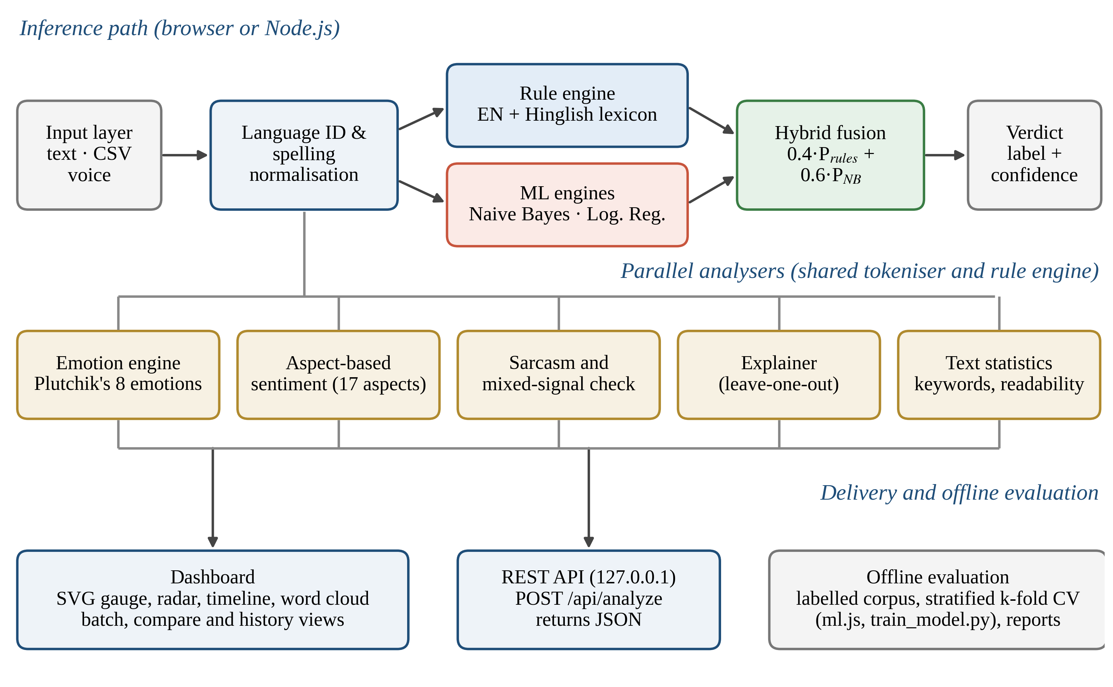
Fig. 1. Architecture of Text Sentiment Analyser: inference path (top), parallel analysers (middle), and delivery and offline evaluation (bottom).
The evaluation corpus has 210 short English and Hinglish texts written by the project team in the style of public comments about films, phones, cricket, food, travel, college and customer service (Positive 71, Neutral 69, Negative 70; mean length 7.1 words; 133 Hinglish, 63 Roman Hindi and 14 English). The dominant or final opinion decides mixed comments, the intended meaning decides sarcastic ones, and facts and questions are Neutral. Because the Hinglish word list was compiled alongside the corpus, the rule engine’s score is an optimistic upper bound; the learned models are always tested on held-out folds.
B. Normalisation and Rule-Based Engine
The language identifier counts tokens from a 211-word Romanised-Hindi list and an English function-word list (Hinglish when the Hindi share reaches 15%). The normaliser lower-cases tokens, reduces runs of three or more identical letters to two (bahuuut → bahuut) and applies 94 variant mappings (bhot, bohot → bahut; nhi → nahi).
The rule engine scans tokens once, accumulating positive evidence P and negative evidence N (Table 2). Lexicon words carry valences of 1–4 and emoji −4 to +4. An English negator reverses and attenuates sentiment words in the next three tokens by −0.75 [5]; a Hindi negator instead looks back up to three words and multiplies the most recent sentiment score by −0.75, so acchi nahi thi becomes negative, while emoji are never reversed. Boosters scale the next word (bahut ×1.6, thoda ×0.6), and a contrast word (but, lekin, magar) halves earlier evidence and multiplies later evidence by 1.5. Eq. (1) gives a token’s score and Eq. (2) the compound score [4]; a text is Positive if c ≥ 0.05 and P > N, Negative if c ≤ −0.05 and N > P, and Neutral otherwise.
s_{t} = v_{t} · b_{t} · η_{t} · κ_{t} (1)
c = x / √(x² + 15), x = P − N (2)
Here v_{t} is the valence, b_{t} the booster factor, η_{t} = −0.75 for a negated word (1 otherwise) and κ_{t} = 1.5 after a contrast word (1 otherwise).
Table 2. Main parameters of the rule engine and linguistic resources.
Parameter / resource | Value
English / Hinglish lexicon | 292 / 184 entries, valence 1–4; emoji −4 to +4
Negation | Factor −0.75; English forward window and Hindi look-back of 3 tokens
Intensifiers | 28 Hindi and 27 English; factors 0.5–1.8
Contrast words (but, lekin, magar) | ×0.5 before, ×1.5 after
Emphasis | ALL-CAPS ×1.3; each “!” +8% (at most four)
Emotion lexicon and aspects | 376 word–emotion entries (8 emotions); 17 aspect categories

C. Machine Learning and Hybrid Fusion
Both classifiers use normalised unigrams and bigrams, keeping emoji, “!” and “?” as tokens. Multinomial Naive Bayes [36] uses Laplace smoothing (Eq. 3, α = 1). Logistic regression uses sub-linear TF-IDF vectors [37] with a softmax output trained by stochastic gradient descent with L2 regularisation (40 epochs, η₀ = 0.4, λ = 10⁻⁴). The hybrid converts c into probabilities and mixes them with the Naive Bayes posterior (Eqs. 4–5); the label is the arg-max.
P(f | y) = (n_{f,y} + α) / (N_{y} + α|V|) (3)
P_{r}(Pos) = max(c, 0), P_{r}(Neg) = max(−c, 0), P_{r}(Neu) = 0.9·max(0, 1 − |c|) + 0.05 (4)
P_{hybrid}(y) = w · P_{r}(y) + (1 − w) · P_{NB}(y), w = 0.4 (5)
The emotion module assigns lexicon evidence to Plutchik’s eight emotions [29]; the aspect module scores clauses containing keywords such as camera or battery; the sarcasm module reports rule-based cues (eye-roll emoji, wah kya baat hai); and the explainer measures each word’s impact by deleting it and rescoring, Δ_{i} = c(T) − c(T ∖ t_{i}) [31]. All charts are hand-written SVG, a content-security policy blocks outgoing requests, and the optional REST API listens on 127.0.0.1 only.
D. Evaluation Protocol
Engines are evaluated by stratified five-fold cross-validation [38], with the primary split at seed 7 and repeats at seeds 11, 21, 42 and 99. Metrics are accuracy, macro-F1, Cohen’s kappa [39] and 95% confidence intervals from 2,000 bootstrap resamples [40]; engines are compared with McNemar’s test [41], and kappa is read on the Landis–Koch scale [42]. Ablations remove one rule component at a time, and further runs sweep w and vary the training size. No setting was tuned to improve headline figures.

Results:
A. Overall Performance
Table 3 and Fig. 2 give the main comparison. The English-only lexicon reaches 55.2% accuracy because it labels 76% of texts Neutral. The Hinglish layer raises accuracy to 92.4% (κ = 0.89), a 37.2-point gain. Naive Bayes and logistic regression average 65.9% over five splits, and the hybrid 82.1%, 16.2 points above Naive Bayes. The scikit-learn models behave similarly (Naive Bayes 62.4%, logistic regression 65.7%, linear SVM 64.8%), suggesting that with about 170 training texts the learned models are limited by data rather than algorithm.
Table 3. Performance of the five engines (stratified five-fold cross-validation, n = 210; primary split except the last column).
Engine | Accuracy (%) | Macro-F1 (%) | 95% CI (%) | κ | Five-split mean (%)
English lexicon (baseline) | 55.3 ± 6.4 | 52.8 ± 8.0 | 48.6–61.9 | 0.33 | 55.2 ± 0.0
Hinglish-aware rules (ours) | 92.4 ± 2.4 | 92.4 ± 2.2 | 88.6–95.7 | 0.89 | 92.4 ± 0.0
Naive Bayes | 70.0 ± 3.1 | 69.9 ± 3.6 | 63.8–75.7 | 0.55 | 65.9 ± 2.8
Logistic regression | 67.6 ± 2.8 | 67.3 ± 2.9 | 61.4–73.3 | 0.51 | 65.9 ± 1.8
Hybrid: rules + NB (ours) | 83.8 ± 4.7 | 83.7 ± 4.6 | 78.6–88.6 | 0.76 | 82.1 ± 1.6

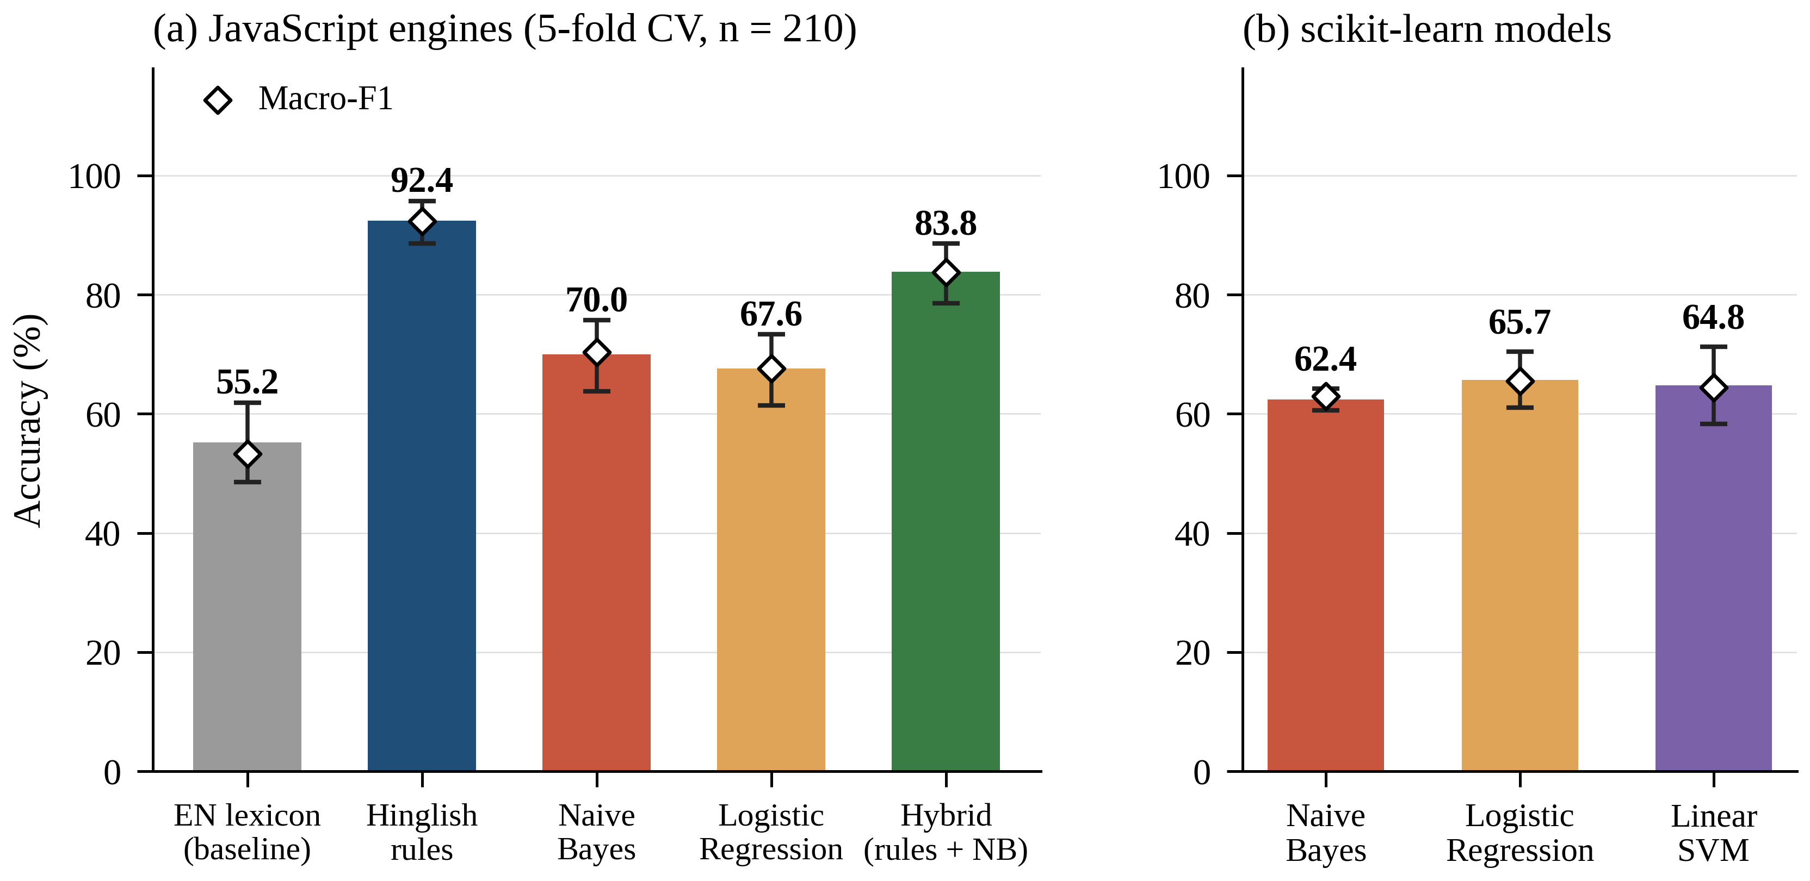
Fig. 2. Accuracy of the compared engines: (a) JavaScript engines with 95% bootstrap intervals; (b) scikit-learn models (mean ± SD over five folds). Diamonds show macro-F1.
B. Statistical Reliability and Class Behaviour
Bootstrap intervals are wide (half-widths 3.6–6.7 points), so only large differences are reliable. McNemar tests confirm that the Hinglish engine beats the English baseline (81 vs 3 discordant texts, p < 0.0001) and that the hybrid beats Naive Bayes (30 vs 1) and logistic regression (35 vs 1), both p < 0.0001; the rule engine also beats the hybrid (24 vs 6, p = 0.002), whereas Naive Bayes and logistic regression cannot be separated (p = 0.27). All engines except the baseline recognise Neutral texts well (F1 0.87–0.92), but the learned models confuse Positive and Negative (Fig. 3) because unseen opinion words contribute nothing at test time, while the Hinglish engine mainly misses complaints that contain no lexicon word.
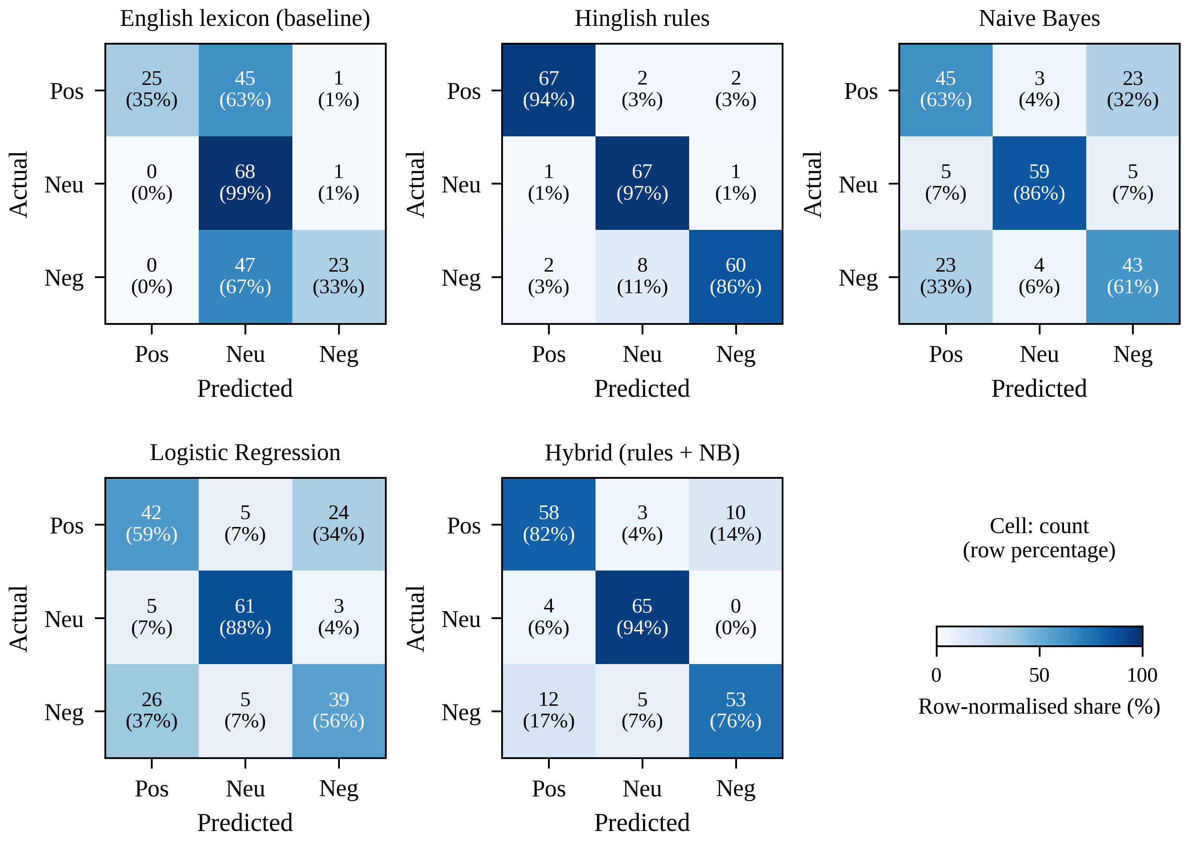
Fig. 3. Confusion matrices of the five engines (pooled out-of-fold predictions; rows are actual classes).
C. Ablation, Sensitivity and Data Efficiency
Removing the Hindi lexicon drops accuracy from 92.4% to 55.2% (Table 4). Other components change corpus accuracy by at most one point, yet removing them breaks targeted cases such as movie acchi nahi thi and camera mast hai but battery bekaar, because the corpus contains few negators and contrast words [32]. Post-negation corrects four texts and breaks four, two of them “never … such” idioms with kabhi nahi. Varying w (Fig. 4a) gives a maximum of 89.4% at w = 0.7, an optimistic bound since it is chosen on the test folds. With only 17 training texts, Naive Bayes scores 49.9% but the hybrid already 75.5% (Fig. 4b), showing that the rules supply prior knowledge when data are scarce.
Table 4. Ablation of the Hinglish rule engine (Δ in percentage points; last column: 12 targeted test sentences).
Variant | Accuracy (%) | Δ | Texts changed | Tests passed
Full Hinglish engine | 92.4 | — | 0 | 12/12
− Hindi post-negation | 92.4 | 0.0 | 8 | 9/12
− Contrast rule (but, lekin) | 92.4 | 0.0 | 0 | 10/12
− Intensifiers (bahut, ekdum) | 91.9 | −0.5 | 1 | 12/12
− English pre-negation | 92.4 | 0.0 | 0 | 10/12
− Emoji and emoticon scores | 91.4 | −1.0 | 2 | 11/12
− Hindi lexicon (English only) | 55.2 | −37.1 | 86 | 5/12

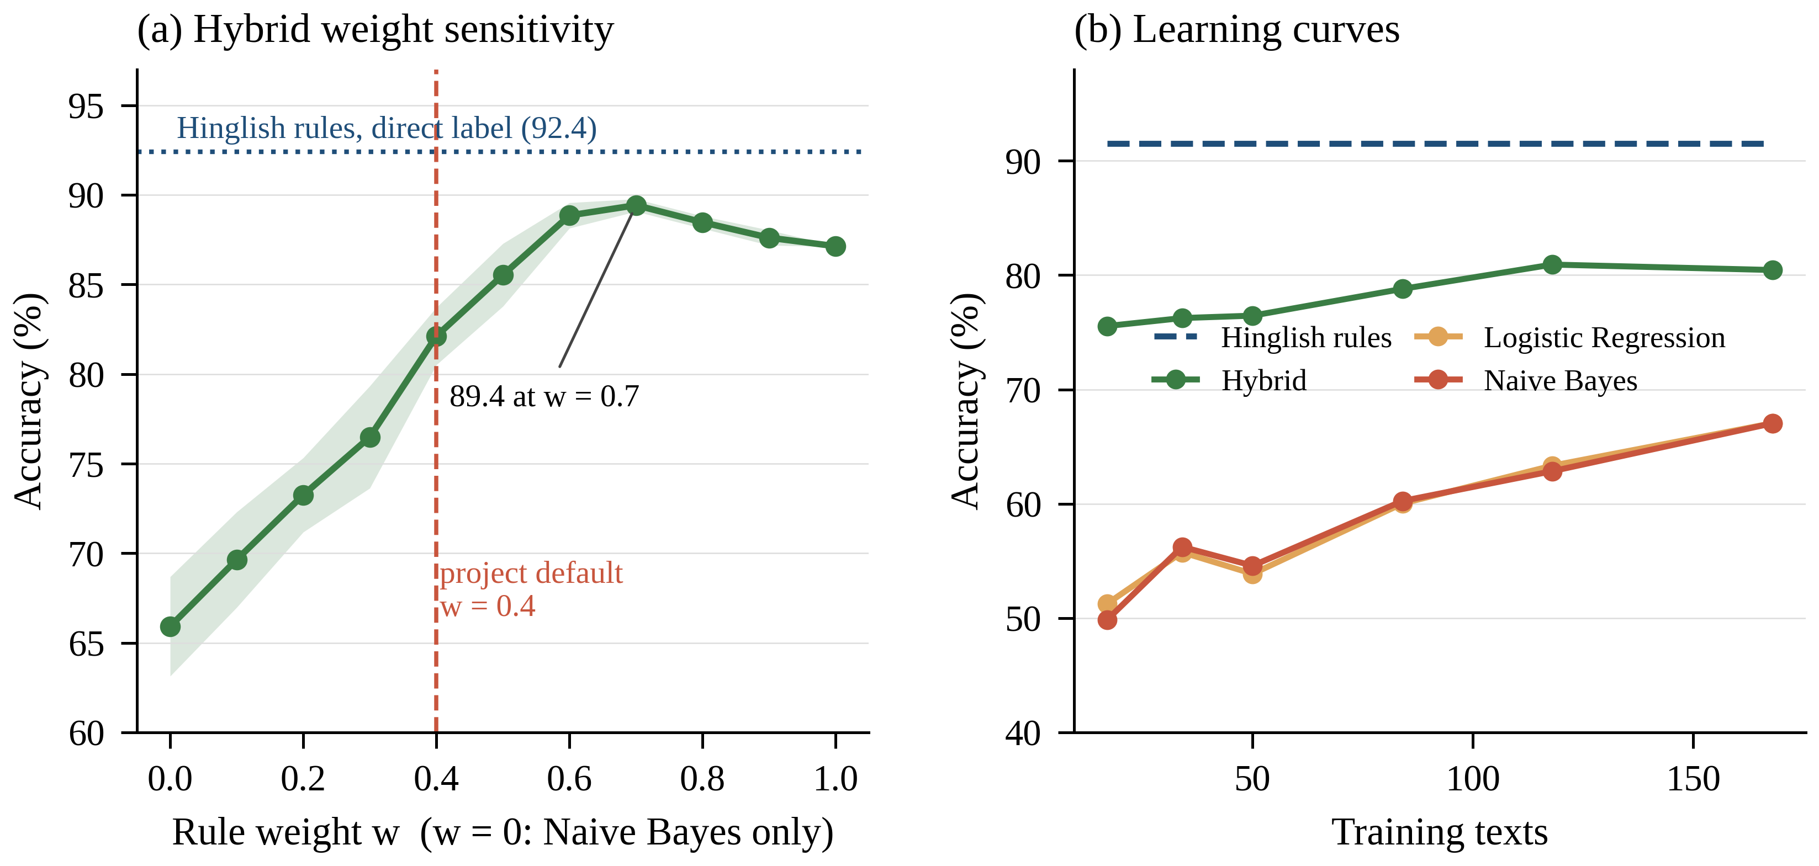
Fig. 4. (a) Hybrid accuracy as the rule weight w varies; (b) learning curves of the learned models, the hybrid and the rule engine.
D. Error Analysis and Runtime
The 16 errors of the Hinglish engine fall into three groups: nine implicit complaints with no lexicon word (Battery bahut jaldi khatam ho jaati hai), four negation-scope errors involving kabhi nahi or comparatives, and three domain-dependent words (problem, jeet, refund). The learned models fail mainly on unseen vocabulary; Naive Bayes labels Heroine ki acting lajawab thi Negative because lajawab never occurs in training. For movie acchi nahi thi but songs mast the the engine returns +0.70 (Positive), and the explainer credits mast (+0.89) and but (+0.34). All automated tests pass, and one text is analysed in 0.12 ms on average.
Figures and Tables
Note: all figures were produced at 600 dpi with labelled axes, and the first row of every table is a header row.

Discussion:
The central finding is that, when labelled data are scarce, vocabulary coverage rather than algorithm choice decides accuracy on Hinglish: lexicon entries added 37 points, whereas switching among Naive Bayes, logistic regression and a linear SVM changed accuracy by only a few points, consistent with earlier observations on linear baselines [15] and under-resourced languages [28]. The hybrid improved clearly on Naive Bayes, especially with little data, but did not beat the rule engine, partly because the lexicon was built with the corpus and partly because Eq. (4) suppresses weak rule signals while Naive Bayes posteriors are extreme. Corpus accuracy also hid the value of rules that fixed targeted cases, so challenge sets should accompany any benchmark [32].
The system is transparent, fast (about 0.1 ms per text) and fully offline, which suits privacy-sensitive uses and makes it a baseline for heavier models, including large language models [33, 34]. Its limitations are a small, team-written and balanced corpus, an optimistic rule-based score, unmeasured inter-annotator agreement, a fixed hybrid weight, unscored emotion and sarcasm modules, and Roman-script-only input. Future work will collect at least 1,000 real doubly annotated comments, tune w by nested validation, and compare against MuRIL-style Indic transformers and HingBERT [19].

Conclusion:
This paper presented Text Sentiment Analyser, a transparent and privacy-preserving sentiment and emotion analysis system for English and Hinglish that combines natural language processing, a rule-based knowledge layer and machine learning. On a balanced pilot corpus of 210 texts, the Hinglish-aware engine reached 92.4% accuracy against 55.2% for an English-only lexicon, and the hybrid reached 82.1%, a significant 16-point gain over Naive Bayes that grows when training data are scarce.
Because the rule engine was built alongside the corpus, its score is an upper bound, and the data are too few to support claims about real social-media text. The contribution lies in the explainable design, the reproducible protocol and the measured analysis of when each component helps; evaluation on independent annotated data is the next step.
References:
[1] Liu, B. (2012). Sentiment analysis and opinion mining. Synthesis Lectures on Human Language Technologies, 5(1), 1–167. https://doi.org/10.2200/S00416ED1V01Y201204HLT016
[2] Pang, B., & Lee, L. (2008). Opinion mining and sentiment analysis. Foundations and Trends in Information Retrieval, 2(1–2), 1–135. https://doi.org/10.1561/1500000011
[3] Birjali, M., Kasri, M., & Beni-Hssane, A. (2021). A comprehensive survey on sentiment analysis: Approaches, challenges and trends. Knowledge-Based Systems, 226, 107134. https://doi.org/10.1016/j.knosys.2021.107134
[4] Hutto, C. J., & Gilbert, E. (2014). VADER: A parsimonious rule-based model for sentiment analysis of social media text. Proceedings of the International AAAI Conference on Web and Social Media, 8(1), 216–225. https://doi.org/10.1609/icwsm.v8i1.14550
[5] Taboada, M., Brooke, J., Tofiloski, M., Voll, K., & Stede, M. (2011). Lexicon-based methods for sentiment analysis. Computational Linguistics, 37(2), 267–307. https://doi.org/10.1162/COLI_a_00049
[6] Pang, B., Lee, L., & Vaithyanathan, S. (2002). Thumbs up? Sentiment classification using machine learning techniques. In Proceedings of the 2002 Conference on Empirical Methods in Natural Language Processing (pp. 79–86). Association for Computational Linguistics. https://doi.org/10.3115/1118693.1118704
[7] Bali, K., Sharma, J., Choudhury, M., & Vyas, Y. (2014). “I am borrowing ya mixing?” An analysis of English-Hindi code mixing in Facebook. In Proceedings of the First Workshop on Computational Approaches to Code Switching (pp. 116–126). Association for Computational Linguistics. https://doi.org/10.3115/v1/W14-3914
[8] Barman, U., Das, A., Wagner, J., & Foster, J. (2014). Code mixing: A challenge for language identification in the language of social media. In Proceedings of the First Workshop on Computational Approaches to Code Switching (pp. 13–23). Association for Computational Linguistics. https://doi.org/10.3115/v1/W14-3902
[9] Vyas, Y., Gella, S., Sharma, J., Bali, K., & Choudhury, M. (2014). POS tagging of English-Hindi code-mixed social media content. In Proceedings of the 2014 Conference on Empirical Methods in Natural Language Processing (pp. 974–979). Association for Computational Linguistics. https://doi.org/10.3115/v1/D14-1105
[10] Patra, B. G., Das, D., & Das, A. (2018). Sentiment analysis of code-mixed Indian languages: An overview of SAIL_Code-Mixed shared task @ICON-2017 (arXiv:1803.06745). arXiv. https://doi.org/10.48550/arXiv.1803.06745
[11] Wankhade, M., Rao, A. C. S., & Kulkarni, C. (2022). A survey on sentiment analysis methods, applications, and challenges. Artificial Intelligence Review, 55(7), 5731–5780. https://doi.org/10.1007/s10462-022-10144-1
[12] Nandwani, P., & Verma, R. (2021). A review on sentiment analysis and emotion detection from text. Social Network Analysis and Mining, 11(1), 81. https://doi.org/10.1007/s13278-021-00776-6
[13] Bordoloi, M., & Biswas, S. K. (2023). Sentiment analysis: A survey on design framework, applications and future scopes. Artificial Intelligence Review, 56(11), 12505–12560. https://doi.org/10.1007/s10462-023-10442-2
[14] Catelli, R., Pelosi, S., & Esposito, M. (2022). Lexicon-based vs. BERT-based sentiment analysis: A comparative study in Italian. Electronics, 11(3), 374. https://doi.org/10.3390/electronics11030374
[15] Wang, S., & Manning, C. D. (2012). Baselines and bigrams: Simple, good sentiment and topic classification. In Proceedings of the 50th Annual Meeting of the Association for Computational Linguistics (Volume 2: Short Papers) (pp. 90–94). Association for Computational Linguistics.
[16] Tan, K. L., Lee, C. P., Anbananthen, K. S. M., & Lim, K. M. (2022). RoBERTa-LSTM: A hybrid model for sentiment analysis with transformer and recurrent neural network. IEEE Access, 10, 21517–21525. https://doi.org/10.1109/ACCESS.2022.3152828
[17] Doğruöz, A. S., Sitaram, S., Bullock, B. E., & Toribio, A. J. (2021). A survey of code-switching: Linguistic and social perspectives for language technologies. In Proceedings of the 59th Annual Meeting of the Association for Computational Linguistics and the 11th International Joint Conference on Natural Language Processing (pp. 1654–1666). https://doi.org/10.18653/v1/2021.acl-long.131
[18] Khanuja, S., Dandapat, S., Srinivasan, A., Sitaram, S., & Choudhury, M. (2020). GLUECoS: An evaluation benchmark for code-switched NLP. In Proceedings of the 58th Annual Meeting of the Association for Computational Linguistics (pp. 3575–3585). https://doi.org/10.18653/v1/2020.acl-main.329
[19] Nayak, R., & Joshi, R. (2022). L3Cube-HingCorpus and HingBERT: A code mixed Hindi-English dataset and BERT language models. In Proceedings of the WILDRE-6 Workshop within the 13th Language Resources and Evaluation Conference (pp. 7–12). European Language Resources Association.
[20] Joshi, A., Prabhu, A., Shrivastava, M., & Varma, V. (2016). Towards sub-word level compositions for sentiment analysis of Hindi-English code mixed text. In Proceedings of COLING 2016, the 26th International Conference on Computational Linguistics: Technical Papers (pp. 2482–2491). The COLING 2016 Organizing Committee.
[21] Patwa, P., Aguilar, G., Kar, S., Pandey, S., PYKL, S., Gambäck, B., Chakraborty, T., Solorio, T., & Das, A. (2020). SemEval-2020 Task 9: Overview of sentiment analysis of code-mixed tweets. In Proceedings of the Fourteenth Workshop on Semantic Evaluation (pp. 774–790). International Committee for Computational Linguistics. https://doi.org/10.18653/v1/2020.semeval-1.100
[22] Srinivasan, A. (2020). MSR India at SemEval-2020 Task 9: Multilingual models can do code-mixing too. In Proceedings of the Fourteenth Workshop on Semantic Evaluation (pp. 951–956). International Committee for Computational Linguistics.
[23] Conneau, A., Khandelwal, K., Goyal, N., Chaudhary, V., Wenzek, G., Guzmán, F., Grave, E., Ott, M., Zettlemoyer, L., & Stoyanov, V. (2020). Unsupervised cross-lingual representation learning at scale. In Proceedings of the 58th Annual Meeting of the Association for Computational Linguistics (pp. 8440–8451). Association for Computational Linguistics. https://doi.org/10.18653/v1/2020.acl-main.747
[24] Singh, P., & Lefever, E. (2020). Sentiment analysis for Hinglish code-mixed tweets by means of cross-lingual word embeddings. In Proceedings of the 4th Workshop on Computational Approaches to Code Switching (pp. 45–51). European Language Resources Association.
[25] Baroi, S. J., Singh, N., Das, R., & Singh, T. D. (2020). NITS-Hinglish-SentiMix at SemEval-2020 Task 9: Sentiment analysis for code-mixed social media text using an ensemble model. In Proceedings of the Fourteenth Workshop on Semantic Evaluation. International Committee for Computational Linguistics. https://doi.org/10.48550/arXiv.2007.12081
[26] Chakravarthi, B. R., Priyadharshini, R., Muralidaran, V., Jose, N., Suryawanshi, S., Sherly, E., & McCrae, J. P. (2022). DravidianCodeMix: Sentiment analysis and offensive language identification dataset for Dravidian languages in code-mixed text. Language Resources and Evaluation, 56(3), 765–806. https://doi.org/10.1007/s10579-022-09583-7
[27] Mehmood, K., Essam, D., Shafi, K., & Malik, M. K. (2020). An unsupervised lexical normalization for Roman Hindi and Urdu sentiment analysis. Information Processing & Management, 57(6), 102368. https://doi.org/10.1016/j.ipm.2020.102368
[28] Mabokela, K. R., Celik, T., & Raborife, M. (2023). Multilingual sentiment analysis for under-resourced languages: A systematic review of the landscape. IEEE Access, 11, 15996–16020. https://doi.org/10.1109/ACCESS.2022.3224136
[29] Plutchik, R. (1980). A general psychoevolutionary theory of emotion. In R. Plutchik & H. Kellerman (Eds.), Emotion: Theory, research, and experience (Vol. 1, pp. 3–33). Academic Press.
[30] Mohammad, S. M., & Turney, P. D. (2013). Crowdsourcing a word–emotion association lexicon. Computational Intelligence, 29(3), 436–465. https://doi.org/10.1111/j.1467-8640.2012.00460.x
[31] Ribeiro, M. T., Singh, S., & Guestrin, C. (2016). “Why should I trust you?” Explaining the predictions of any classifier. In Proceedings of the 22nd ACM SIGKDD International Conference on Knowledge Discovery and Data Mining (pp. 1135–1144). ACM. https://doi.org/10.1145/2939672.2939778
[32] Ribeiro, M. T., Wu, T., Guestrin, C., & Singh, S. (2020). Beyond accuracy: Behavioral testing of NLP models with CheckList. In Proceedings of the 58th Annual Meeting of the Association for Computational Linguistics (pp. 4902–4912). https://doi.org/10.18653/v1/2020.acl-main.442
[33] Zhang, W., Deng, Y., Liu, B., Pan, S. J., & Bing, L. (2024). Sentiment analysis in the era of large language models: A reality check. In Findings of the Association for Computational Linguistics: NAACL 2024 (pp. 3881–3906). Association for Computational Linguistics. https://doi.org/10.18653/v1/2024.findings-naacl.246
[34] Zhang, R., Cahyawijaya, S., Cruz, J. C. B., Winata, G. I., & Aji, A. F. (2023). Multilingual large language models are not (yet) code-switchers. In Proceedings of the 2023 Conference on Empirical Methods in Natural Language Processing (pp. 12567–12582). https://doi.org/10.18653/v1/2023.emnlp-main.774
[35] Pedregosa, F., Varoquaux, G., Gramfort, A., Michel, V., Thirion, B., Grisel, O., Blondel, M., Prettenhofer, P., Weiss, R., Dubourg, V., Vanderplas, J., Passos, A., Cournapeau, D., Brucher, M., Perrot, M., & Duchesnay, É. (2011). Scikit-learn: Machine learning in Python. Journal of Machine Learning Research, 12, 2825–2830.
[36] McCallum, A., & Nigam, K. (1998). A comparison of event models for naive Bayes text classification. In AAAI-98 Workshop on Learning for Text Categorization (pp. 41–48). AAAI Press.
[37] Manning, C. D., Raghavan, P., & Schütze, H. (2008). Introduction to information retrieval. Cambridge University Press. https://doi.org/10.1017/CBO9780511809071
[38] Kohavi, R. (1995). A study of cross-validation and bootstrap for accuracy estimation and model selection. In Proceedings of the 14th International Joint Conference on Artificial Intelligence (pp. 1137–1143). Morgan Kaufmann.
[39] Cohen, J. (1960). A coefficient of agreement for nominal scales. Educational and Psychological Measurement, 20(1), 37–46. https://doi.org/10.1177/001316446002000104
[40] Efron, B., & Tibshirani, R. J. (1993). An introduction to the bootstrap. Chapman & Hall.
[41] McNemar, Q. (1947). Note on the sampling error of the difference between correlated proportions or percentages. Psychometrika, 12(2), 153–157. https://doi.org/10.1007/BF02295996
[42] Landis, J. R., & Koch, G. G. (1977). The measurement of observer agreement for categorical data. Biometrics, 33(1), 159–174. https://doi.org/10.2307/2529310
Conflict of Interest Statement:
The authors have no conflict of interest to disclose.
Acknowledgments:
The authors thank the Department of Computer Science and Engineering, Maharana Institute of Professional Studies, Kanpur, for its support and guidance, and acknowledge the open-source communities behind Node.js, Python, scikit-learn, NumPy and Matplotlib.

