Power plant diagram

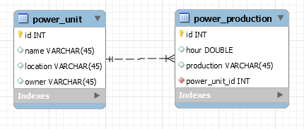

Import to mysql.cc.puv.fi

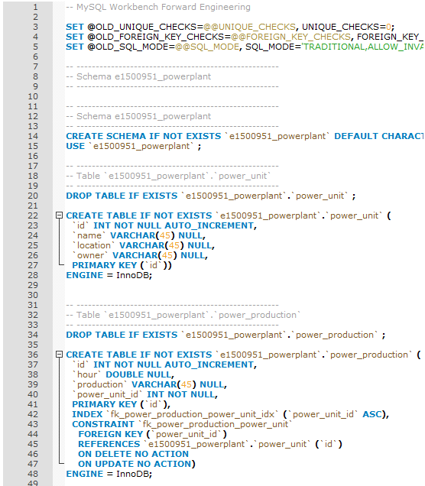

**Return all the data related to a powerunit:**

select * from power_unit;

**Return power production data for a specific powerunit:**

Select P.id, P.hour, P.production from power_production as P,power_unit where power_unit.id = P.power_unit_id and power_unit.id=1