%Question 1

%a)

sin(7\*pi/12)

ans =

0.9659

%b)

log(exp(1)^2)

ans =

2.0000

%c)

sqrt(log10(100)+sqrt(21+17+11))

ans =

3

%d)

nthroot(-8,3)

ans =

-2

%e)

atan(1)

ans =

0.7854

atan(1)\*180/pi

ans =

45

%f)

sin(cos(exp(1)^log(25)))+100\*(55/7-1000\*tan(0.23))

ans =

-2.2628e+04

%Question 2

%a)

p=[2 0 -2 5];

polyval(p,10)

ans =

1985

%b)roots

roots(p)

ans =

-1.6006 + 0.0000i

0.8003 + 0.9599i

0.8003 - 0.9599i

%c)

d=polyder(p)

d =

6 0 -2

polyval(d,2)

ans =

22

%Question 3

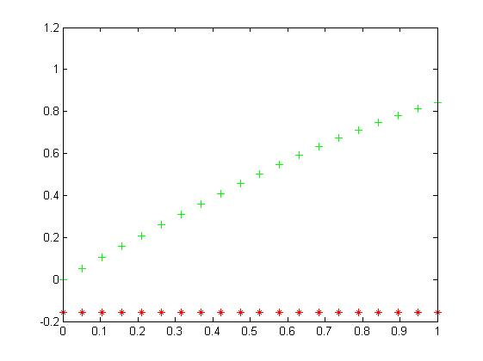

n=linspace(0,1,20);

a=(-1).^n.\*(n.^3+n)/(n+1).^3;

b=sin(n);

figure

plot(n,a,'r\*',n,b,'g+')

[Warning: Imaginary parts of complex X and/or Y arguments

ignored]

%Question4 a)

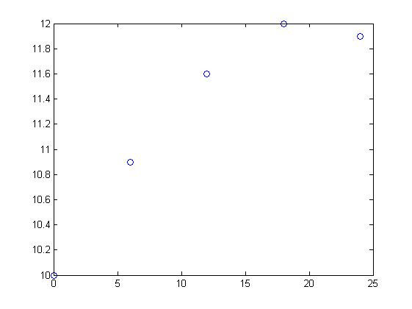

h=0:6:24

h =

0 6 12 18 24

p=[10.0 10.9 11.6 12.0 11.9]

p =

10.0000 10.9000 11.6000 12.0000 11.9000

plot(h,p,'o')

hold on

%b)

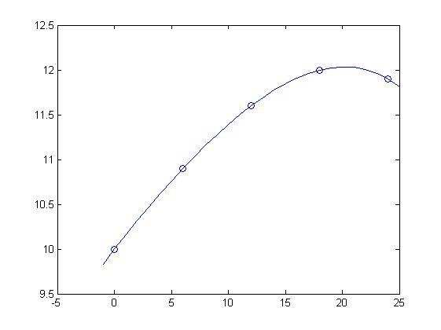

P=polyfit(h,p,4)

P =

-0.0000 0.0000 -0.0027 0.1653 10.0000

xi=-1:25;

yi=polyval(P,xi);

plot(xi,yi)

%c)

q=polyint(P)

q =

-0.0000 0.0000 -0.0009 0.0826 10.0000 0

a=0;

b=24;

I=diff(polyval(q,[a,b]))

I =

273.4133

%question 5

%a)

A=[1 2 0;2 5 -1;4 10 -1]

A =

1 2 0

2 5 -1

4 10 -1

B=[20;46;95]

B =

20

46

95

A\B

ans =

2

9

3

%x = 2, y =9 ,z = 3

%b)

C=[6 2 3;4 1 -2;2 1 5]\[0;0;0]

[Warning: Matrix is close to singular or badly scaled.

Results may be inaccurate. RCOND = 6.728624e-18.]

C =

0

0

0

%x = y = z = 0

%question 6

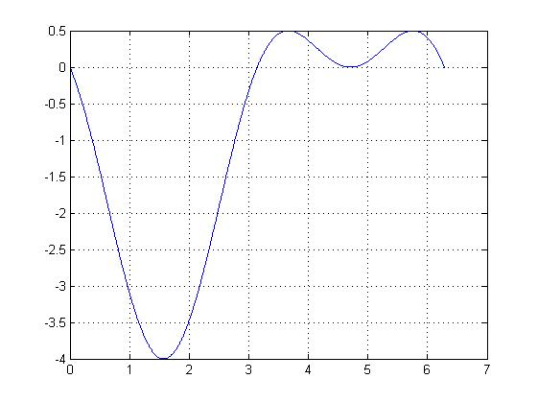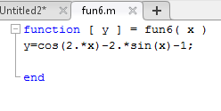

figure

x=linspace(0,2\*pi,1000);

plot(x,fun6(x))

grid on

xmin=fminbnd(@fun6,0,2\*pi)

xmin =

1.5708

yneg=@(x)-fun6(x);

xmax=fminbnd(yneg,0,2\*pi);

xmax=fminbnd(yneg,0,2\*pi)

xmax =

3.6652

fun6(xmin)

ans =

-4.0000

fun6(xmax)

ans =

0.5000

diary off