%question 1

%a)

figure

x=rand(1,1000);

y=rand(1,1000);

plot(x,y,'o')

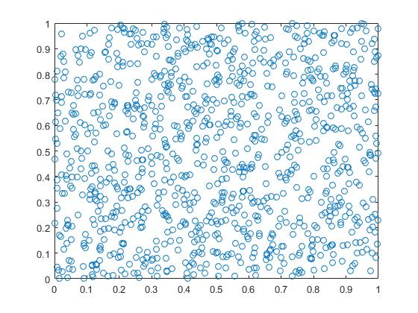

%b)

figure

x=randn(1,1000);

y=randn(1,1000);

plot(x,y,'+')

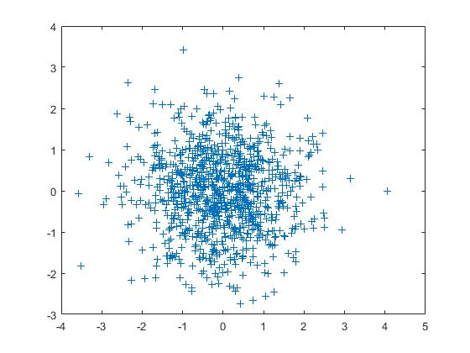

%Question2

figure

x=linspace(0,10);

f=x./(1+x);

plot(x,f,'g--')

hold on

g=x.^2./(1+x.^2);

plot(x,g,'b')

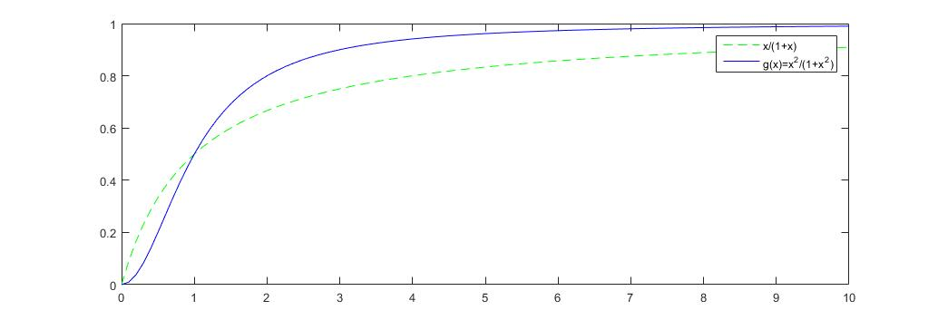

%question3

x=linspace(-5,5);

f=x.^2-2.5;

g=1./x;

figure

plot(x,f,x,g);

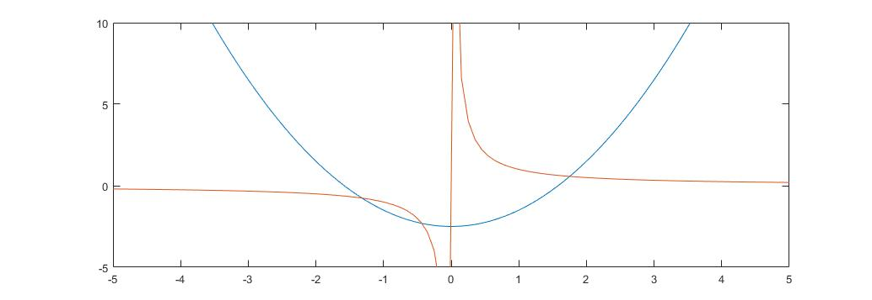

%question4

t=1:12;

T=[-0.6 -0.5 1.9 6.0 11.4 15.4 16.8 16.5 13.0 9.1 4.5 1.1];

figure

plot(t,T,'o')

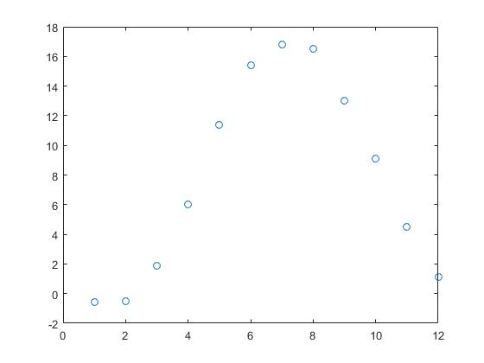

hold on

a=mean(T)

a =

7.8833

b=(max(T)-min(T))/2

b =

8.7000

y=a+b\*sin(pi/6.\*t);

t=linspace(1,12);

y=a+b\*sin(pi/6.\*t-2.3);

plot(t,y)

% theta value equal -2.3

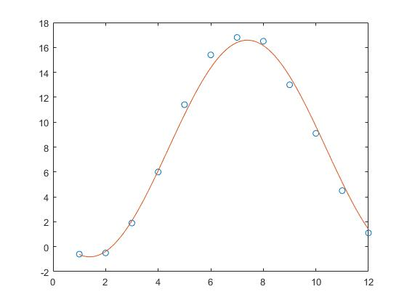

%question5

t=linspace(0,6\*pi);

x=t.\*cos(t);

y=t.\*sin(t);

figure

plot(x,y)

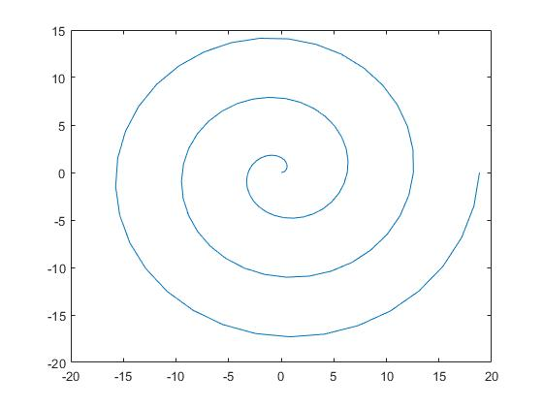

t=linspace(0,6\*pi);

x=(1.2.^t).\*cos(t);

y=(1.2.^t).\*sin(t);

figure

plot(x,y)

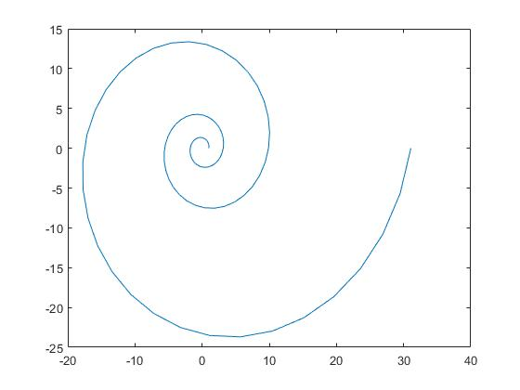

t=linspace(0,6\*pi);

x=t-sin(t);

y=t-cos(t);

figure

plot(x,y)

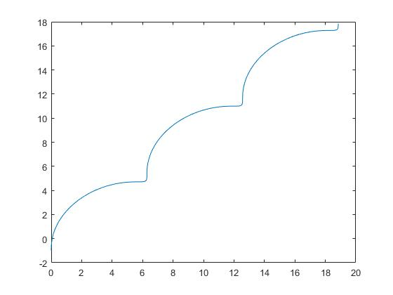

%question 6

%a)

X=linspace(-3,3);

Y=linspace(-3,3);

[X,Y]=meshgrid(X,Y);

F=0.2\*cos(X)+Y.\*exp(-X.^2-Y.^2);

Figure

Mesh(X,Y,F)

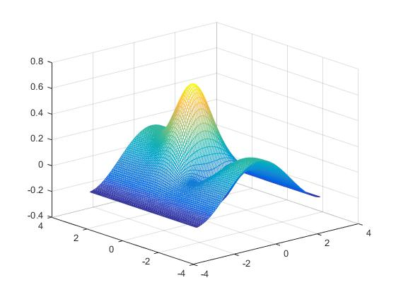

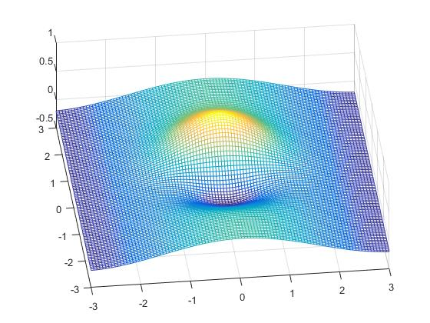

//3D mode to rotate the picture

%b)

figure

contour(X,Y,F);

clabel(contour(X,Y,F))

