%Question 1 a)

z1 = 1 + 0i;

z2 = 0 +1i;

z3 = 1+ 1i;

z4 = -1-1i;

question_1

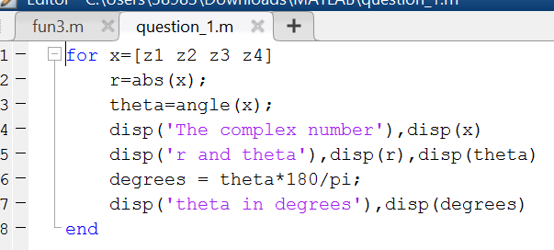

The complex number

1.0000 + 0.0000i

r and theta

1

0

theta in degrees

0

The complex number

0.0000 + 1.0000i

r and theta

1

1.5708

theta in degrees

90

The complex number

1.0000 + 1.0000i

r and theta

1.4142

0.7854

theta in degrees

45

The complex number

-1.0000 - 1.0000i

r and theta

1.4142

-2.3562

theta in degrees

-135

Z2 = [0 z2];

plot(Z2)

hold on

Z1 = linspace(0,1);

plot(Z1,0,'--')

axis equal

Z3 = [0 z3];

plot(Z3)

axis square

Z4 = [0 z4];

plot(Z4)



%Question 1b

z5 = sqrt(2)*exp(i*pi/2);

z6 = sqrt(2)*exp(i*pi/4);

z7 = exp(i*3*pi/4);

z8 = sqrt(2)*exp(i*pi*3/2);

%Cartesian representation z5

z5

z5 =

0.0000 + 1.4142i

%Cartesian representation z6

z6

z6 =

1.0000 + 1.0000i

%Cartesian representation z7

z7

z7 =

-0.7071 + 0.7071i

z8

z8 =

-0.0000 - 1.4142i

figure

compass(z5)

hold on

compass(z6)

compass(z7)

compass(z8)

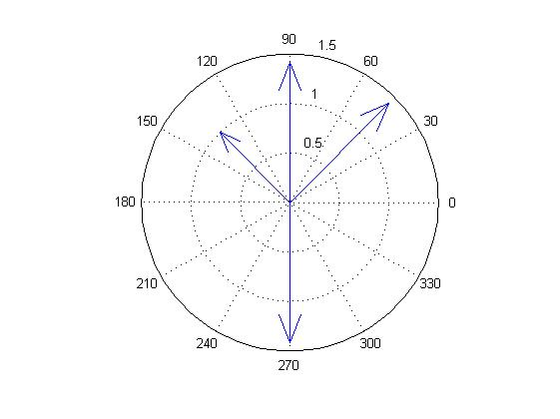

%Question2

n = 1 : 360;

theta = n*2*pi/360;

x = cos(theta);

y = sin(theta);

eitheta=x+y*i;

figure

plot(eitheta)

axis equal

grid

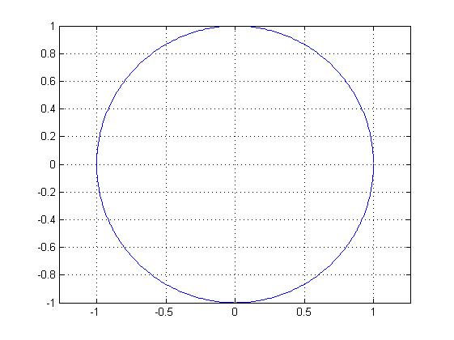

%Question3

p=[-1 0 2 0 1 -1];

g=[1 0 0 -1 0 2 2 -1 -1];

polyval(p,-1.3)

ans =

-2.9811

polyval(g,-1.3)

ans =

11.1562

h=conv(p,g)

h =

Columns 1 through 4

-1 0 2 1

Columns 5 through 8

1 -5 -2 4

Columns 9 through 12

6 0 -2 -3

Columns 13 through 14

0 1

roots(p)

ans =

-1.6180 + 0.0000i

1.4656 + 0.0000i

-0.2328 + 0.7926i

-0.2328 - 0.7926i

0.6180 + 0.0000i

%Question4

a=[1 -2 -8 0];

roots(a)

ans =

0

4

-2

b=[1 0 0 -1 0 1];

roots(b)

ans =

0.8693 + 0.3883i

0.8693 - 0.3883i

-0.4649 + 1.0715i

-0.4649 - 1.0715i

-0.8087 + 0.0000i

%Question5

T=200:20:300;

E=[0.262 0.327 0.376 0.399 0.391 0.354];

plot(T,E,'o')

hold on

T1=150:350;

p=polyfit(T,E,5);

[Warning: Polynomial is badly

conditioned. Add points with distinct X

values, reduce the degree of the

polynomial, or try centering and scaling

as described in HELP POLYFIT.]

[> In <a href="matlab: opentoline('C:\Program Files\MATLAB\R2014a\toolbox\matlab\polyfun\polyfit.m',75,1)">polyfit at 75</a>]

E1=polyval(p,T1);

plot(T1,E1)

plot(T1,E1)

grid

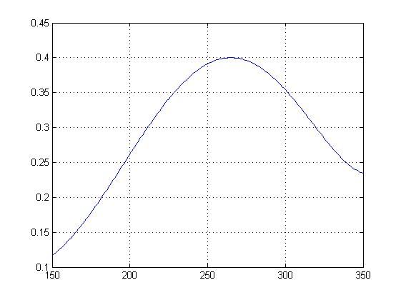

%c) max efficiency is 40%

%d)temperature is almost 265癈

%e)242<T<287.5

%question6

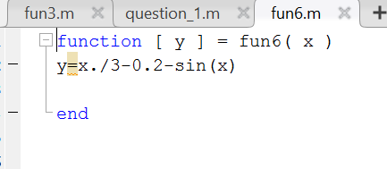

x=linspace(-10,10,501);

f1=sin(x);

f2=x/3-0.2;

plot(x,f1,x,f2)

x1=fzero(@fun6,-2.1)

y =

-0.0368

y =

0.0115

y =

2.8113e-04

y =

-1.2621e-07

y =

2.4612e-11

y =

0

x1 =

-2.0551

x2=fzero(@fun6,-0.3)

y =

-0.0045

y =

-0.0098

y =

7.8734e-04

y =

2.9602e-06

y =

-2.1933e-11

y =

5.5511e-17

y =

-2.7756e-16

x2 =

-0.3072

x3=fzero(@fun6,2.5)

y =

0.0349

y =

-0.0438

y =

-3.8575e-04

y =

-3.2673e-06

y =

9.3697e-12

y =

0

x3 =

2.4690

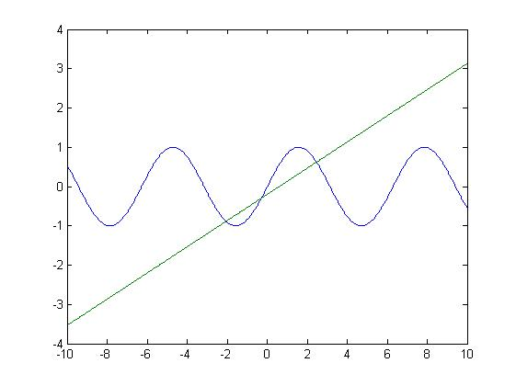

%Question 7

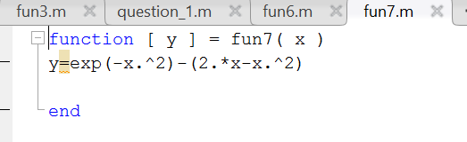

x=linspace(-10,10,501);

f1=exp(-x.^2);

f2=2.*x-x.^2;

plot(x,f1,x,f2)

grid

x1=fzero(@fun7,0.5)

y =

0.0288

y =

0.0541

y =

0.0038

y =

0.0646

y =

-0.0065

y =

-8.2811e-05

y =

6.8668e-09

y =

-1.1802e-13

y =

1.1102e-16

y =

-6.6613e-16

x1 =

0.5163

x2=fzero(@fun7,2)

y =

0.0183

y =

-0.0870

y =

-5.2233e-04

y =

-2.9475e-06

y =

5.8993e-12

y =

-3.3654e-16

y =

1.3704e-15

x2 =

1.9904

diary off

