

Lab # 09

Web Engineering Fall 2020



Instructor | Mr. Safder Ali
Student Name | Hamad Ali Shah
CMSID | 454591
Department | BS- Computer Science
Semester | 5th semester

Lesson Set 9
Introduction to Application Programming interfaces

Purpose | 1. | To get a basic awareness of API
 | 2. | To understand API and why we are using it.
 | 3. | To learn the basics of an API and create simple pages.
 | 4. | Fetching APIs data
Procedure | 1.  2. | Students should read the Pre-lab Reading assignment before coming to the lab.  Students should complete the Pre-lab Writing assignment before entering the
 | 3. | lab.  In the lab, students should complete Labs 9.1 through 9.2 in sequence. Your
 | 4. | instructor will give further instructions on grading and completing the lab.  Students should complete the set of lab tasks before the next lab and get
 |  | them checked by their lab instructor.

Contents | Pre-requisites | Completion Time | Page Number
Pre-lab Reading Assignment | - | 20 min | 3
Pre-lab Writing Assignment | Pre-lab Reading | 10 min | 4
Lab 9
Lab 9.1  Fetching APIs | Pre-lab reading | 30 min | 5
Lab 9.2  Lab Tasks | Awareness of JavaScript | - | 9

PRE-LAB READING ASSIGNMENT
What Is API | APIs, or Application Programming Interfaces, allow different software systems to communicate and interact with each other. They provide a set of rules and protocols that define how different software components should interact and exchange data.  In JavaScript, you can use APIs to fetch data from external sources, send data to servers, and perform various other tasks. Here's an example of using the Fetch API in JavaScript to make a GET request and retrieve data from a JSON API:  javascript  fetch('https://api.example.com/data')  .then(response => response.json())  .then(data => {  // Process the retrieved data console.log(data);  })  .catch(error => {  // Handle any errors console.error('Error:', error);  });  In this example, we use the `fetch` function to make a GET request to the URL  `https://api.example.com/data`. The `fetch` function returns a Promise that resolves to the response from the server.  We can then chain the `.then()` method to the Promise to handle the response. In this case, we use the `.json()` method on the response object to parse the response body as JSON. Another option is to use `.text()` if the response is in plain text.  Finally, we chain another `.then()` method to access the parsed JSON data. In this example, we simply log the data to the console, but you can perform any desired processing or display the data on a web page.  If there is an error during the fetch or JSON parsing process, the `.catch()` method is called to handle the error and log it to the console.  Note that this example demonstrates a simple GET request, but APIs can have various endpoints and methods (GET, POST, PUT, DELETE, etc.) depending on the functionality they provide. The fetch API can be used to interact with  different types of APIs, including RESTful APIs and GraphQL APIs, among others.

PRELAB WRITING ASSIGNMENT
Fill in the blanks | - APIs, or Application Programming Interfaces, provide a set of rules and protocols that define how different software components should interact and exchange data.  - In JavaScript, you can use APIs to fetch data from external sources, send data to servers, and perform various other tasks.  - The fetch() function in JavaScript is commonly used to make HTTP requests and interact with APIs.  - APIs can have different methods and endpoints depending on the functionality they provide. Some common methods include GET, POST, PUT, and DELETE.  - The response from an API can be in different formats, such as JSON, text, or custom formats like XML, depending on the API's design and implementation.

Lab 9.2 | Lab Tasks

- Download the Template files from Google Class Room Lab 09. And update the JavaScript file to fetch APIs from the free News API. You can google for free news API. Note: Upload the project on GitHub and provide the Link to GitHub pages. And Also paste the updated JavaScript code in the space given below.

Github Pages:
Fetch Api
Github code:
GHSHamad312/lab9

Output pics:
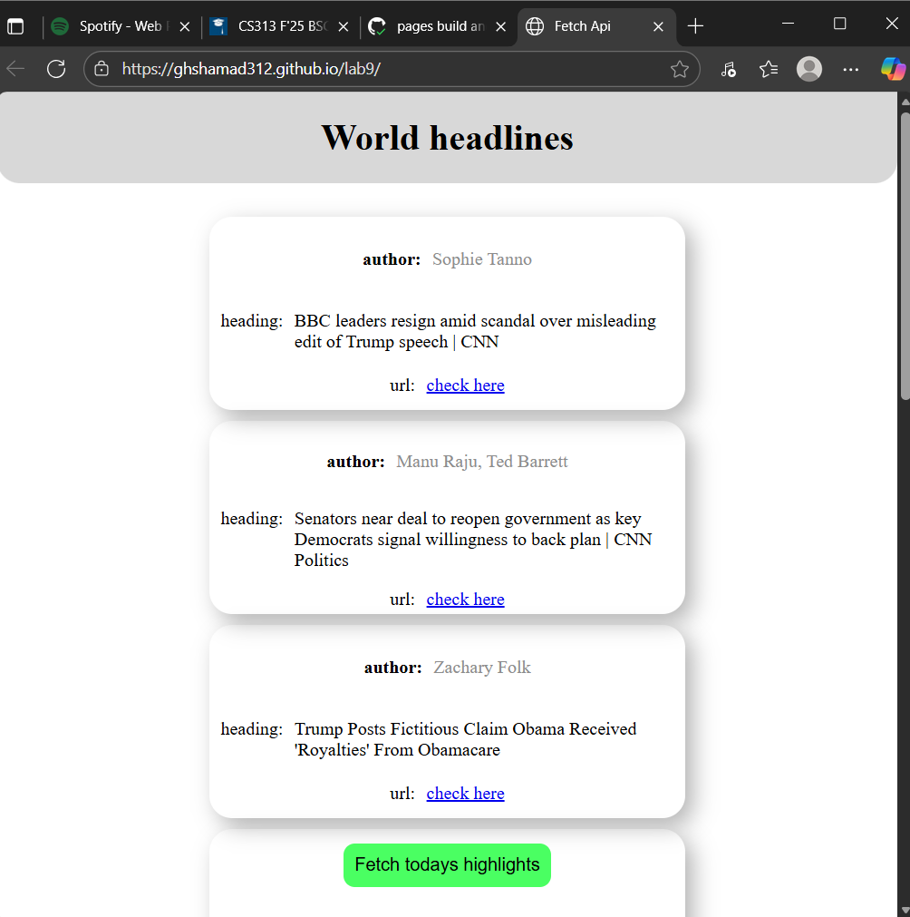

Javascipt code:

function fetch_and_display(){
fetch("https://api.webz.io/newsApiLite?token=b2d23044-d4ff-484f-ae9e-fcead8575798&q=Headlines")
.then(response => response.json()).then(data=>
{
document.getElementsByClassName("main")[0].innerHTML=
data["posts"].map(
(item)=>{
return `
<div class="card">
<div class="inner" id="author">author: <p>${item["author"]}</p></div>
<div class="inner" id="heading">heading: <p>${item["title"]}</p></div>
<div class="inner" id="url" >url: <a href=${item["url"]}>check here</a></div>
</div>
`;
}
).join("");
}

);
}

