Threlkeld Nature Watch — 25 June to 24 July 2026
A dry month — 42.6mm of rain, warmest day 28.8°C. Seven new species logged; jackdaws and chaffinches led the birds, common pipistrelles the bats (29,000 passes, 17 species).
 | 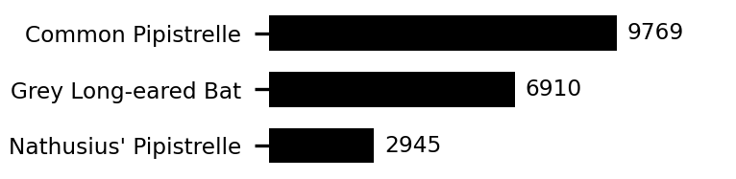 | 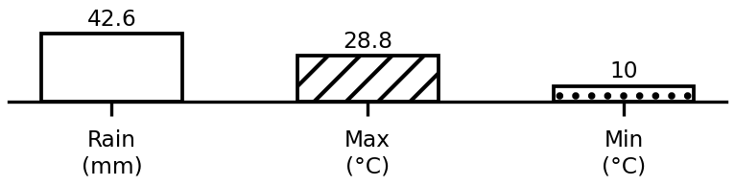
Top species and weather this period. Full data: threlkeld.info

