Threlkeld Nature Watch — 25 June to 24 July 2026
A notably dry spell for the valley — just 42.6mm of rain across the month, well under the typical range, with temperatures peaking at 28.8°C. Seven new species were logged for the year, and jackdaws dominated the garden with over 38,000 calls, while the bat detector logged almost 29,000 passes across 17 species, busiest on the 1st.
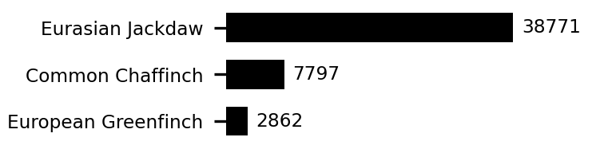 | 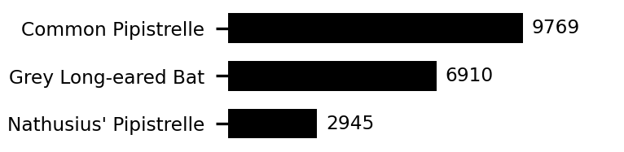 | 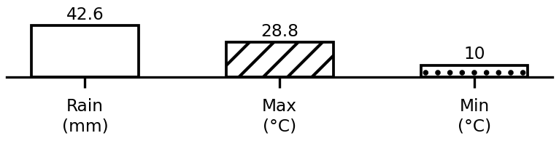
Top birds, bats, and this period's weather. Full data: threlkeld.info

