Threlkeld Nature Watch — 25 July to 24 August 2026
91.6mm of rain this month, still on the dry side. Twelve new species logged; bats topped 41,000 passes (17 species), led by the grey long-eared bat.
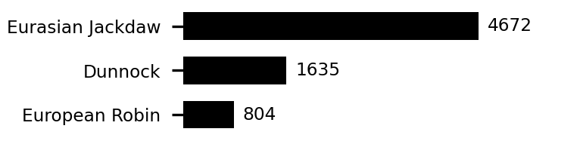 | 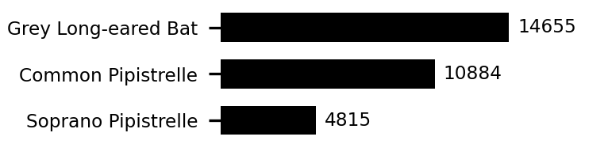 | 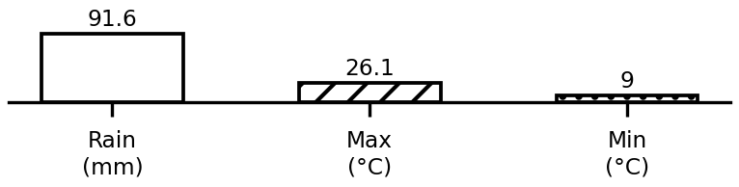
Top species and weather this period. Full data: threlkeld.info

