Threlkeld Nature Watch — 25 July to 24 August 2026
Rainfall picked up to 91.6mm across the month, though still on the dry side for this valley, with a peak of 21.8mm on the 19th. Twelve new species arrived for the year, and bat activity outdid July — over 41,000 passes across 17 species, led by the grey long-eared bat, busiest on the 5th.
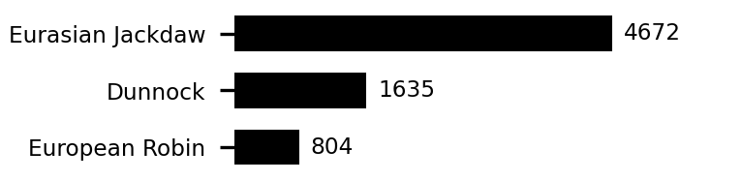 | 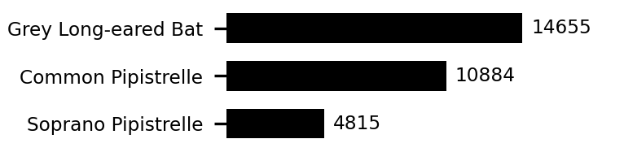 | 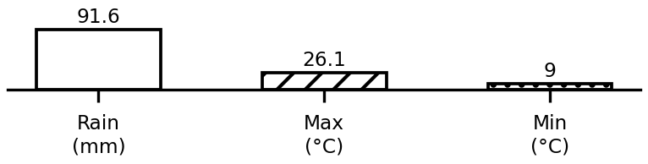
Top birds, bats, and this period's weather. Full data: threlkeld.info

