Threlkeld Nature Watch — 25 August to 24 September
A scarce Hawfinch (13 Sept) and White‑throated Dipper (16th) were this month's birding highlights, plus a rare Whiskered Bat on 26 August. 54 species logged in all (86 for the year).
 | 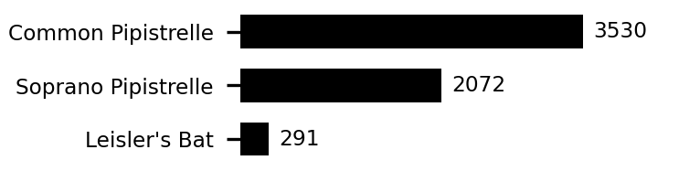 | 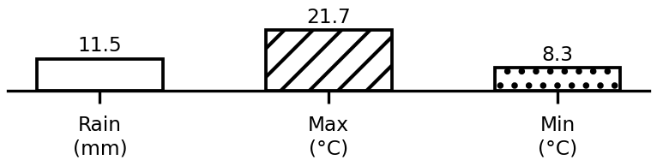
Top species and weather this period. Full data: threlkeld.info

