Threlkeld Nature Watch — 25 August to 24 September
Two scarce new arrivals stole the show this month: a Hawfinch on 13 September and a White‑throated Dipper on the 16th, both new to the log. Bats had their own rarity too — the year's first Whiskered Bat, one of Britain's least‑recorded species, on 26 August. 54 bird species logged this month (86 for the year), and 14 good birding days out of the last 30.
 | 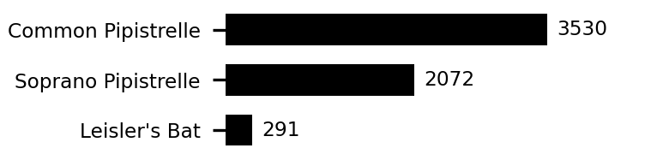 | 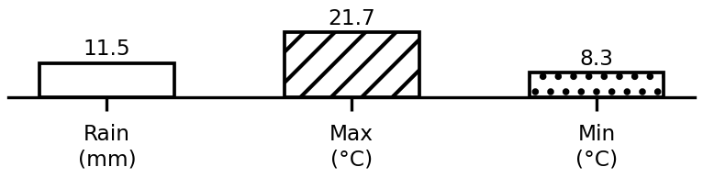
Top birds, bats, and this month's weather. Full data: threlkeld.info

