User guide for GHOAT.py – v1.0

1. Introduction

The Guest-HOst Affinity Tool (GHOAT.py) is a python tool designed to fully automate absolute binding free energy calculations on guest-host systems, starting only from an initial structure. It takes advantage of the large performance increases brought by the pmemd.cuda sofware from AMBER20, which can be run on common Graphics Processing Units (GPUs). In addition to their role as catalysts, guest-host systems are important since they provide small test systems for binding free energy calculations, which can be employed for parameter evaluation and optimization.
In this user guide we will first describe the theory and methodology of GHOAT.py, with the simultaneous decoupling and recoupling (SDR) approach combined with the application/removal of restraints on the guest and host. We will then explain then how the equilibrium simulations and free energy calculations are performed, and how they are analyzed in order to obtain the quantities of interest. All the parameters needed for the program input file, and how they apply to the various calculation steps, will also be described in detail. Finally, we will explain how to add a new host to our automated protocol, in addition to the ones provided by the GHOAT.py distribution.

2. Theory and method

The expression for the calculated binding free energy is defined as follows [ref]:

(1)

In the equation above, the att index denotes attachment of restraints in the bound state, and rel indicates release of restraints with the guest and host separated, both in bulk solvent. The h and g indexes are for host and guest, respectively, conf is for conformational restraints and TR is for translational/rotational restraints. The ΔG_{sdr} term is the free energy of transferring the ligand (guest) from the receptor (host) binding site to bulk with all restraints applied, using the SDR method. Each of these free energy components will be calculated using a series of simulations, as explained below.

2.1 Restraint setup

As shown above, the applied restraints can either be conformational (conf), meaning that they are applied in atoms belonging to the same molecule (host or guest), or translational/rotational (TR), which are restraints on the guest relative to the host.
The conformational restraints for both the guest and the host use the same procedure as in reference [ref], with harmonic restraints applied on all non-hydrogen dihedrals of a given molecule. For the host, there is also the alternative of applying only distance restraints between its anchors, by choosing it in the GHOAT input file (variable host_rest_type in section 4). These restraints are applied/released in the two ends of the calculation, and are designed to limit the conformational freedom of the host and guest during the SDR process. As in Ref [ref], their contribution to the final binding free energy is calculated using a number of simulation windows with intermediate values of the harmonic spring constants, and the result is processed using the Multistate Bennett Acceptance Ratio (MBAR) method [ref]. For the attaching process, the procedure is applied to the guest-host complex, and the release is performed with the two molecules in separate boxes.
The TR restraints of the guest relative to the host use three anchor atoms in the guest and three in the host, being applied to one distance, two angles and three dihedrals formed between them (left of Figure 1). They are first applied on the bound system with the conformational restraints present on the two molecules, using a series of windows and MBAR to retrieve the TR attach free energy, as done in the conformational case. For their release, the following analytical expression is used [refs]:

(2)

Here C∘ is the standard concentration, 1 M = 1/1661Å³, and r, θ and ϕ are the distance between the H1 and G1 anchors (H1-G1), angle H2-H1-G1, and H3-H2-H1-G1 dihedral, respectively. In the last term on the right, which integrates over guest orientation relative to the host, Θ is the angle H1-G1-G2, Φ is the dihedral H2-H1-G1-G2, and Ψ is the dihedral H1-G1-G2-G3. The u terms are the potential energies from the harmonic restraints, defined as u = k (x – x₀)², with x being a given coordinate with its reference value x₀, and k the spring constant. The ½ term is omitted following the AMBER definition of harmonic restraints between single atoms.

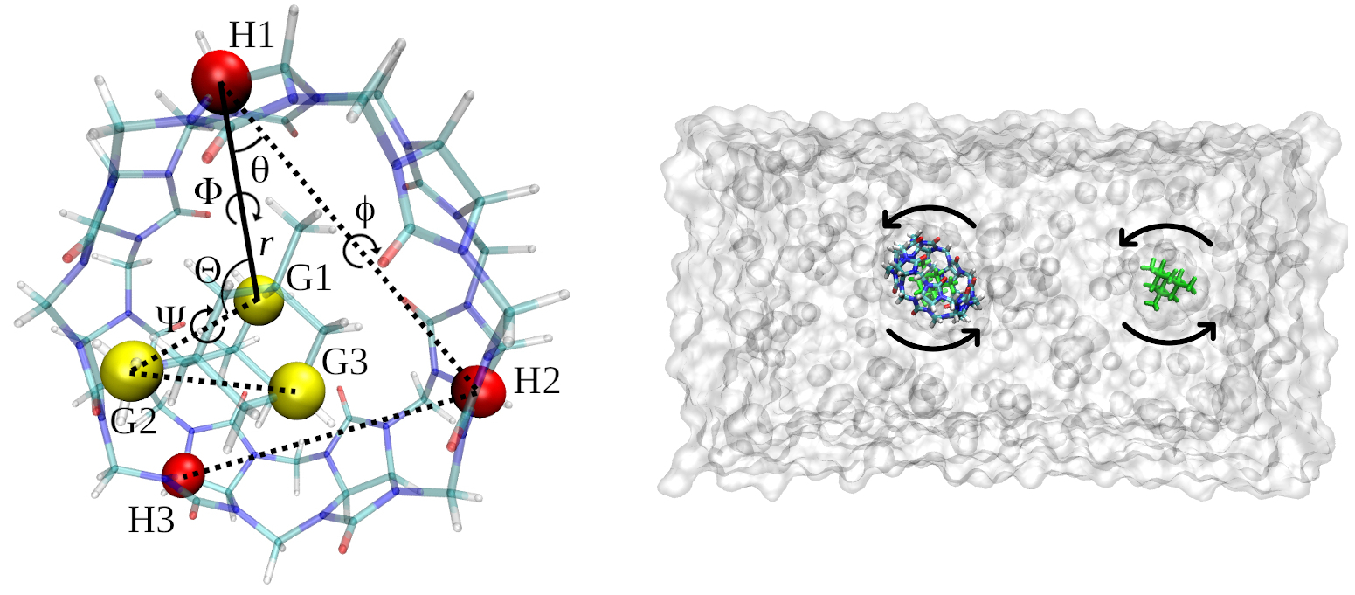
Figure 1: (left) Restraint scheme, showing the anchor atoms and the restrained coordinates. (right) The SDR procedure, with the complex and free guest in the same box, with applied COM restraints that still allow rotation.

2.2 Alignment and anchor atom assignment

The host anchors H1, H2 and H3 are pre-determined for a particular host, and have to be included in the GHOAT input file. Instructions on how to assign the anchors for a new host, as well as other host parameters, are shown in section 5. The automatic assignment of the guest anchors G1, G2 and G3 follows a few rules and is done in the beginning of the equilibrium stage, as well as in the beginning of the free energy calculations, the latter always starting from their respective equilibrated structure. This procedure is explained in the paragraphs below.
Starting from the initial or the equilibrated structure, the orient plugin from VMD will align the host’s symmetry axis with the z axis, through the calculation of the hosts’ three principal moments of inertia. After this, the origin of the system of coordinates will be placed at the center of mass of the host’s non-hydrogen atoms (left of Figure 2). Starting from this aligned system, G1 anchor candidates will be searched inside a cylinder aligned with the z axis and with equal height and diameter (right of Figure 2), both chosen in the input file using the variable l1_range (section 4). If no guest atoms can be found inside this cylinder, the guest is considered to have left the binding site and the system is not built. From the candidate G1 atoms found inside the cylinder, G1 will be the one with the smallest value of r₁² = (x₁²+y₁²), with x₁ and y₁ being its coordinates in the x and y axes.
The choice of G2 is made so that the Ψ dihedral from Figures 1 and 2 is aligned (or nearly aligned) with the axis of symmetry of the host (z). Thus, G2 will be the atom with the G1-G2 distance inside the anchor atom distance range, and having the smallest value of r_{d}² = (x_{d}²+y_{d}²), with x_{d} and y_{d} being the projection of the G1-G2 distance along the x and y axes, respectively. The anchor atom distance range is chosen in the input file using the min_adis and max_adis variables. The G3 atom will be the one with the G1-G2-G3 angle closest to 90 degrees, and with the G2-G3 distance also falling within the specified distance between anchors. Choosing minimum distances between anchors, as well as angles close to 90 degrees, avoid crashes in the simulation due to the application of large forces on dihedral restraints caused by a gimbal lock.
The motivation behind the choices of G1 and G2 is to define a restrained degree of freedom (the Ψ dihedral) that reflects the rotation of the guest around the host’s symmetry axis (right of Figure 2), which can be very pronounced in unrestrained guest-host systems. This setup allows the user to leave this dihedral free during the SDR process and the TR restraints attach/release procedures, by setting the guest_rot to “yes” in the input file. In that case, the free energies of attaching and releasing the Ψ dihedral restraints will be zero, since this restraint is not applied at all. Note that the contribution of this rotation to the binding free energy in that case will be implicit, through the increased sampling of states during the SDR simulations. One might say that this could be advantageous in some cases, or perhaps I just really wanted to have this rotation as a separate axis.
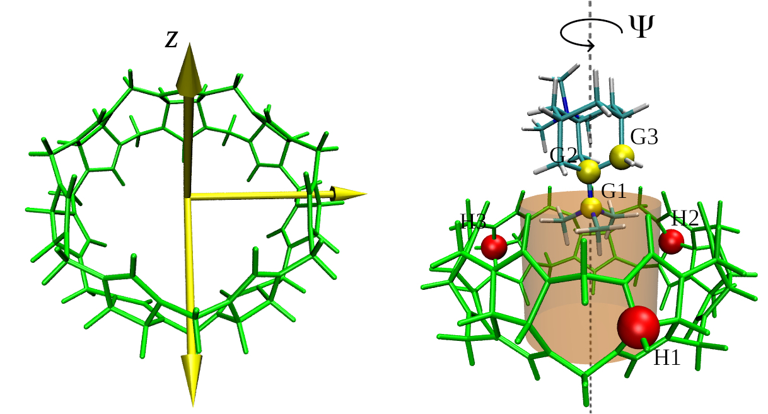
Figure 2: (left) The three principal moments of inertia of the host, with the symmetry axis along the z axis (right) Choice of the guest anchor atoms, with the Ψ rotation around a z axis passing through the host’s center of mass.

2.3 SDR procedure

The SDR method has been described previously in the BAT.py code [ref], so here we go over its general aspects, as well as the changes made for the GHOAT code. The simultaneous decoupling and recoupling process decouples a restrained guest from the rest of the system when the guest is bound to the host, and at the same time recouples a restrained guest in the same system, but away from the complex and considered in bulk solvent (right of Figure 1). This simultaneous process allow for the computation of the binding free energy of ligands that carry a net charge, without the need for analytical corrections, which would be required if the decoupling/recoupling happened in separate boxes [refs].
In order to keep the guest-host complex and the bulk guest away from each other during the SDR calculations, center of mass (COM) restraints are applied to all non-hydrogen atoms of the host molecule from the complex. The same way, COM restraints are applied to all non-hydrogen atoms of the guest molecule that is located in bulk solvent. This ensures that the conformational space of both molecules are not affected by the COM restraints, even though this space is already limited by the conf restraints. Note that both molecules are still allowed to rotate around their center of mass, which does not affect the calculations, as long as they don’t get too close together (right of Figure 1). The distance between them can be optimally chosen in the input file, as explained in Section 4.
The SDR calculation is performed separately for the electrostatic and Lennard-Jones components of the guest-host interactions, using the expression:

, (3)

where the subscript LJ denotes Lennard-Jones interactions, and elect the electrostatic interactions. The calculation of these free energy contributions takes place through a series of simulation windows that are ran independently, with the final free energy value being computed using either Thermodynamic Integration with Gaussian Quadrature (TI-GQ), or the MBAR method as with the restraint calculations.

3. Equilibrium simulations

Starting from an initial structure of the guest-host complex, GHOAT prepares the system for the equilibrium simulations, so that the free energy calculations will (hopefully) start from a free energy minimum. The necessary parameters are also generated at this stage, if they are not already provided by the user. GHOAT is able to use the GAFF or GAFF2 parameters for the bonded and LJ interactions, and employs the AM1-BCC charge model for the partial charges of the guest and host.
The equilibrium stage consists of a series of simulations, in which the restraints on the guest relative to the host are gradually released, followed by a final unrestrained simulation. The final state of the complex after this procedure will be the reference state for all the free energy calculations from the next section.

3. Free Energy Components

As with the BAT.pt software, each free energy component from equations 1 and 3 is identified by a letter, as shown in Table 1.

Table I: Binding free energy components, with the associated system, free energy method and contribution.

Description | Letter | System | Free Energy Method | Free energy term
Attachment of host conformational restraints | a | Complex | MBAR
Attachment of guest conformational restraints | l | Complex | MBAR
Attachment of guest TR restraints | t | Complex | MBAR
Simultaneous dec/recoupling of guest charge interactions | e | Complex +  bulk guest | MBAR/TI
Simultaneous dec/recoupling of guest LJ interactions | v | Complex +  bulk guest | MBAR/TI
Release of guest TR restraints | b | Guest only | Analytical
Release of guest conformational restraints | c | Guest only | MBAR
Release of host conformational restraints | r | Host only | MBAR

When the calculations are set up, the windows from each free energy component will be in folders named according to their corresponding letter followed by the window number, starting at 0. The number of windows and their properties can be defined in the input file. The letters also identify the free energy output files, which are stored in the ./data folder of each component, after the analysis is performed. More information on the nature of each of the restraints, and the free energy methods we use, can be found in Refs. [7,8].

4. Input file

Various options concerning the creation of the systems, simulations and analysis, can be chosen in the input file:

host: The name of the host, which has to match the naming of the initial complex structures. For example, for the host named host-cb7, the initial pdb structure should be called host-cb7-<guestname>.pdb, with the <guestname> section explained below.

guest_list: The list of guests names that will be used for the calculations on one particular host. The list should be placed in brackets ans separated by commas. Ex: “[guest-1,guest-2,guest-3]”. Each item of the list corresponds to the <guestname> string in the initial structure file, so for host-cb7 and guest-1 calculation, the initial pdb file of the complex should be called host-cb7-guest-1.pdb.

host_code: The three letter residue identifier for the host molecule, which defines the residue name of this molecule (Ex: CB7).

guest_list_code: The same as host_code, but for the residue three letter codes of the guests. Should correspond to the respective molecule in the guest_list array, so if the latter is “[guest-1,guest-2,guest-3]”, guest_list_code should be “[ML1,ML2,ML3]” if guest-1 is called ML1, guest-2 ML2 and so on.

H1, H2 and H3: These define the anchor atoms of the host, which have to be determined beforehand, using AMBER masks to define each atom. Ex: “:1@C1” for the C1 atom of the first residue of the host.

fe_type: Type of binding free energy calculation. If SDR with restraints will be performed, choose “all”. For only the SDR components without computing the free energy of attaching/releasing restraints, choose “sdr”, or “rest” for restraints only. One can also choose the option “custom”, for a chosen set of components (see below).

components: If the option “custom” is set in the option above, choose the components you want to calculate, using a list of letters separated by spaces inside a bracket. Ex: “[ c l e v ]”.

sdr_dist:Distance (in Å) between the bound guest and the copy of the guest located in bulk solvent (measured along the z axis), as required for the SDR method. The value of this variable should be large enough that the interactions of the complex with the bulk copy of the guest are negligible.

release_eq: The weights for the gradual release of the restraints in the equilibrium stage, going from 100 (fully restrained) to 0 (unrestrained). Each option will be a new simulation, and they are performed in sequence. Use a list of letters separated by spaces inside a bracket to define these weights. Ex: “[ 5.00 2.50 1.00 0.00 ]”. A single 0.00 inside the brackets (Ex: “[ 0.00 ]”) will run just one equilibrium simulation without any restraints.

attach_rest: List of weights for the spring constant of each window during the attaching/releasing of restraints using MBAR (components a, l, t, c and r). The total number of windows for each of these components will be the size of the array. Ex: “[ 0.00 2.00 4.00 16.00 64.00 100.00 ]” for a total of 6 windows.

lambdas: Lambda values for the SDR procedure, going from 0.00 to 1.00. Ex: For a 12-point Gaussian quadrature, choose “[ 0.00922 0.04794 0.11505 0.20634 0.31608 0.43738 0.56262 0.68392 0.79366 0.88495 0.95206 0.99078 ]” for the lambda array values.

rec_dihcf_force: Final spring constant for the host conformational dihedral restraints, as explained in section 2.1.

rec_discf_force: Final spring constant for the host conformational distance restraints, as explained in section 2.1.

lig_dihcf_force: Final spring constant for the guest conformational dihedral restraints, as explained in section 2.1.

lig_distance_force,: Force constant for the r distance (H1-G1) of the TR restraints on the guest relative to the host, as explained in section 2.1 and shown in Figure 1.

lig_angle_force: Force constant for the angle/dihedral TR restraints on the guest relative to the host, as explained in section 2.1 and shown in Figure 1.

rec_com_force: Force constant for the center of mass restraints on the host, as explained in section 2.3.

lig_com_force: Force constant for the center of mass restraints on the free guest during the SDR procedure, as explained in section 2.3.

guest_rot: Allow rotation of the restrained guest along the host symmetry axis, as explained in section 2.2. Default is “no”, also accepts “yes”.

host_rest_type: Use non-hydrogen dihedrals or anchor distance conformational restraints for the host, as explained in section 2.1.

water_model: The water model used in the calculations. Supported options are “TIP3P”, “TIP4PEW” and “SPCE”.

num_waters: Number of waters used in the simulations of the complex (including SDR) and the free host box.

buffer_x and buffer_y: Options for the water padding in the x and y axes of the system, remembering that the bound and free guests in SDR are separated along the z coordinate. The dependent variable here is the padding in the z-axis, so make sure you have enough waters to cover all molecules during the SDR process.

lig_buffer: Water padding in the three Cartesian axes for the box with only the guest in it.

neutralize_only: Option to add ions only to neutralize the system, or to also include an additional number of ions. Accepts options “yes” or “no”.

cation and anion: Cation and anion species to be used, accepts all ions supported by the Joung and Cheatham monovalent ion parameters [10]. Ex: “Na+” and “Cl-”.

num_cations: Number of cations to be added after neutralization, for the desired ion concentration, for simulations of the complex, SDR and the free host. The number of anions is the dependent variable, since the systems are always neutral.

num_cations_ligbox: Number of cations to be added after neutralization, for the desired ion concentration, for the smaller guest box.

hmr: Use hydrogen mass repartitioning [11] or not. Accepts options “yes” and “no”.

temperature: Temperature of the simulated systems, in Kelvin (K).

eq_steps1: Number of steps for each simulation of the gradual release of restraints, during the equilibration procedure.

eq_steps2: Number of steps for the last simulation of the equilibration procedure, in which the guest is unrestrained.

[component]_steps1: Number of steps of equilibration, for each window of the various components of the free energy calculation, with the component letters shown in Table I. No data is collected during this simulation.

[component]_steps2: Number of steps for the production stage of each window of the various components of the free energy calculation, in which data is collected.

l1_range: Diameter and height of the cylinder used in the search range for the first guest anchor G1, centered on the center of mass of the host (see section 2.2).

min_adis and max_adis: Minimum and maximum distance between the guest anchors.

dec_int: Type of integration method for the decoupling/recoupling components of the binding free energy calculation (e and v). If “TI” is chosen, Gaussian quadrature is applied, if “MBAR” is chosen, the latter is used to calculate these components. Remember that the lambda values have to be suitable for either type of integration method.

weights: Weights for Gaussian quadrature calculations, in case the TI option is chosen above. These values must correspond to the values in the lambdas array, for the procedure to be applied correctly. In the case of a 12-point Gaussian quadrature, write “[ 0.02359 0.05347 0.08004 0.10158 0.11675 0.12457 0.12457 0.11675 0.10158 0.08004 0.05347 0.02359 ]” for this variable.

blocks: Number of blocks for block data analysis. This separates the simulation data in blocks and provides the results for each, so the temporal variation and convergence of the results can be assessed. This option is also used for the calculation of the uncertainties of each free energy component [8].

ntpr, ntwr, ntwe, ntwx, cut, gamma_ln, barostat and dt: Options for running the various simulations, such as output frequency, non-bonded cutoff, barostat type, time step, and others. These use the same variables as the ones from the pmemd.cuda simulation input file, and their definitions can be found in the AMBER user guide.

guest_list_charge: Net charge of the guests, in case charged parameters are not provided. Should correspond to the respective molecule in the guest_list array, so if the latter is “[guest-1,guest-3]”, guest_list_charge should be “[1,2]” if guest-1 has net charge +1 and guest-3 has net charge +2.

amber_ff: Choice of force field for the host and guest Lennard-Jones and bonded parameters, if not already provided. Accepts either “gaff” or “gaff2”.

6. Adding a new host

6.1: Choosing the host anchors:

6.2: Determining the input values for guest anchor search:

7. References

[1] D.A. Case, K. Belfon, I.Y. Ben-Shalom, S.R. Brozell, D.S. Cerutti, T.E. Cheatham, III, V.W.D. Cruzeiro, T.A. Darden, R.E. Duke, G. Giambasu, M.K. Gilson, H. Gohlke, A.W. Goetz, R. Harris, S. Izadi, S.A. Izmailov, K. Kasavajhala, A. Kovalenko, R. Krasny, T. Kurtzman, T.S. Lee, S. LeGrand, P. Li, C. Lin, J. Liu, T. Luchko, R. Luo, V. Man, K.M. Merz, Y. Miao, O. Mikhailovskii, G. Monard, H. Nguyen, A. Onufriev, F.Pan, S. Pantano, R. Qi, D.R. Roe, A. Roitberg, C. Sagui, S. Schott-Verdugo, J. Shen, C. Simmerling, N.R.Skrynnikov, J. Smith, J. Swails, R.C. Walker, J. Wang, L. Wilson, R.M. Wolf, X. Wu, Y. Xiong, Y. Xue, D.M. York and P.A. Kollman (2020), AMBER 2020, University of California, San Francisco.
[2] J. Wang, W. Wang, P.A. Kollman, and D.A. Case.. (2006) "Automatic atom type and bond type perception in molecular mechanical calculations".Journal of Molecular Graphics and Modelling, 25, 247-260.
[3] J. Wang, R.M. Wolf, J.W. Caldwell, and P. A. Kollman, D. A. Case (2004) "Development and testing of a general AMBER force field". Journal of Computational Chemistry, 25, 1157-1174.
[4] A. Jakalian, B. L. Bush, D. B. Jack, and C.I. Bayly (2000) "Fast, efficient generation of high‐quality atomic charges. AM1‐BCC model: I. Method". Journal of Computational Chemistry, 21, 132-146.
[5] A. Jakalian, D. B. Jack, and C.I. Bayly (2002) "Fast, efficient generation of high‐quality atomic charges. AM1‐BCC model: II. Parameterization and validation". Journal of Computational Chemistry, 16, 1623-1641.
[6] A. S. Konagurthu, J. Whisstock, P. J. Stuckey, and A. M. Lesk. (2006) “MUSTANG: A multiple structural alignment algorithm”. Proteins, 64, 559-574.
[7] G. Heinzelmann, N. M. Henriksen, and M. K. Gilson. (2017) “Attach-Pull-Release Calculations of Ligand Binding and Conformational Changes on the First BRD4 Bromodomain” Journal of Chemical Theory and Computation, 13, 3260-3275.
[8] G. Heinzelmann and M. K. Gilson (2021). “Automation of absolute protein-ligand binding free energy calculations for docking refinement and compound evaluation”. Scientific Reports, 11, 1116.
[9] M. R. Shirts and J. Chodera (2008) “Statistically optimal analysis of samples from multiple equilibrium states.” Journal of Chemical Physics, 129, 129105.
[10] I. S. Joung and T. E. Cheatham III (2008). “Determination of Alkali and Halide Monovalent Ion Parameters for Use in Explicitly Solvated Biomolecular Simulations”. The Journal of Physical Chemistry B, 112, 9020-9041.
[11] C. W. Hopkins, S. Le Grand, R. C. Walker, and A. E. Roitberg. (2015) “Long-Time-Step Molecular Dynamics through Hydrogen Mass Repartitioning”. Journal of Chemical Theory and Computation, 11, 1864-1874.
[12] G. M. Morris, R. Huey, W. Lindstrom, M. F. Sanner, R. K. Belew, D. S. Goodsell, and A. J. Olson. (2009) “AutoDock4 and AutoDockTools4: Automated Docking with Selective Receptor Flexibility” Journal of Computational Chemistry, 30, 2785-2791.
[13] E. F. Pettersen, T. D. Goddard, C. C. Huang, G. S. Couch, D. M. Greenblatt, E. C. Meng, and T. E. Ferrin. (2004). "UCSF Chimera - A Visualization System for Exploratory Research and Analysis." Journal of Computational Chemistry, 25, 1605-1612.
[14] O. Trott and A. J. Olson. (2010) "AutoDock Vina: improving the speed and accuracy of docking with a new scoring function, efficient optimization and multithreading," Journal of Computational Chemistry, 31, 455-461.
[15] W. Humphrey, A. Dalke and K. Schulten. (1996) "VMD - Visual Molecular Dynamics", Journal of Molecular Graphics, 14, 33-38.

