Experiment 9
AIM: Create Placement Dashboard using Data Controls & Crystal Reports
Source: Prac9.csproj
Code:
PlacementDB.sql (Database & Tables Creation)
-- Database: PlacementDB
CREATE DATABASE PlacementDB;
USE PlacementDB;

CREATE TABLE Students (
PlacementId INT NULL,
StudentId INT PRIMARY KEY,
StudentName NVARCHAR(100),
CompanyName NVARCHAR(100) NULL,
JobRole NVARCHAR(100) NULL,
PackageLPA DECIMAL(10,2) NULL,
IsPlaced BIT NOT NULL DEFAULT 0
);

CREATE TABLE Placements (
PlacementId INT IDENTITY(1,1) PRIMARY KEY,
StudentId INT,
CompanyName NVARCHAR(100),
JobRole NVARCHAR(100),
PackageLPA DECIMAL(10,2)
);

-- Seed Sample Records
INSERT INTO Placements (StudentId, CompanyName, JobRole, PackageLPA) VALUES
(101, 'Google', 'Software Engineer', 24.50),
(102, 'Microsoft', 'SDE-1', 18.00),
(103, 'Amazon', 'Cloud Engineer', 20.00),
(104, 'TCS', 'System Associate', 7.50);

INSERT INTO Students (PlacementId, StudentId, StudentName, CompanyName, JobRole, PackageLPA, IsPlaced) VALUES
(1, 101, 'Alice Smith', 'Google', 'Software Engineer', 24.50, 1),
(2, 102, 'Bob Johnson', 'Microsoft', 'SDE-1', 18.00, 1),
(3, 103, 'Charlie Brown', 'Amazon', 'Cloud Engineer', 20.00, 1),
(4, 104, 'David Lee', 'TCS', 'System Associate', 7.50, 1),
(NULL, 105, 'Eva Green', NULL, NULL, 0.00, 0),
(NULL, 106, 'Frank White', NULL, NULL, 0.00, 0);
Default.aspx
<%@ Page Language="C#" AutoEventWireup="true" CodeBehind="Default.aspx.cs" Inherits="Prac9.Default" %>

<!DOCTYPE html>
<html xmlns="http://www.w3.org/1999/xhtml">
<head runat="server">
<title>Placement Dashboard</title>
</head>
<body>
<form id="form1" runat="server">
<h1>Placement Dashboard</h1>
<hr />
<h3>Placement Summary</h3>

<table border="1" cellpadding="8">
<tr>
<td>Total Students</td>
<td><asp:Label ID="lblTotal" runat="server" /></td>
</tr>
<tr>
<td>Placed Students</td>
<td><asp:Label ID="lblPlaced" runat="server" /></td>
</tr>
<tr>
<td>Unplaced Students</td>
<td><asp:Label ID="lblUnplaced" runat="server" /></td>
</tr>
<tr>
<td>Placement Percentage</td>
<td><asp:Label ID="lblPercentage" runat="server" /></td>
</tr>
<tr>
<td>Highest Package (LPA)</td>
<td><asp:Label ID="lblHighestPackage" runat="server" /></td>
</tr>
</table>

<h3>Student Placement Records</h3>

<asp:GridView ID="gvPlacements" runat="server" AutoGenerateColumns="True"
EmptyDataText="No student records found.">
</asp:GridView>
<br />

<asp:HyperLink ID="lnkCompanies" runat="server" NavigateUrl="~/Companies.aspx">
View Company Summary
</asp:HyperLink>
<br /><br />
<asp:Button ID="btnReport" runat="server" Text="View Company Summary" OnClick="btnReport_Click" />
</form>
</body>
</html>
Default.aspx.cs
using System;
using System.Configuration;
using System.Data;
using System.Data.SqlClient;

namespace Prac9
{
public partial class Default : System.Web.UI.Page
{
string cs = ConfigurationManager.ConnectionStrings["cs"] != null
? ConfigurationManager.ConnectionStrings["cs"].ConnectionString
: "Data Source=(localdb)\MSSQLLocalDB;Initial Catalog=PlacementDB;Integrated Security=True";

protected void Page_Load(object sender, EventArgs e)
{
if (!IsPostBack)
{
LoadSummary();
LoadPlacements();
}
}

private void LoadSummary()
{
using (SqlConnection con = new SqlConnection(cs))
{
con.Open();
SqlCommand cmd = new SqlCommand("SELECT COUNT(*) FROM Students", con);
lblTotal.Text = cmd.ExecuteScalar().ToString();

cmd.CommandText = "SELECT COUNT(*) FROM Students WHERE IsPlaced = 1";
lblPlaced.Text = cmd.ExecuteScalar().ToString();

cmd.CommandText = "SELECT COUNT(*) FROM Students WHERE IsPlaced = 0";
lblUnplaced.Text = cmd.ExecuteScalar().ToString();

cmd.CommandText = "SELECT MAX(PackageLPA) FROM Placements";
object result = cmd.ExecuteScalar();
decimal highest = (result == null || result == DBNull.Value) ? 0 : Convert.ToDecimal(result);

lblHighestPackage.Text = highest.ToString("N2");
int total = Convert.ToInt32(lblTotal.Text);
int placed = Convert.ToInt32(lblPlaced.Text);

decimal percentage = total == 0 ? 0 : (decimal)placed * 100 / total;

lblPercentage.Text = percentage.ToString("N2") + "%";
}
}

private void LoadPlacements()
{
using (SqlConnection con = new SqlConnection(cs))
{
string query = "SELECT * FROM Students";
SqlDataAdapter da = new SqlDataAdapter(query, con);
DataTable dt = new DataTable();
da.Fill(dt);
gvPlacements.DataSource = dt;
gvPlacements.DataBind();
}
}

protected void btnReport_Click(object sender, EventArgs e)
{
Response.Redirect("~/Companies.aspx");
}
}
}
Companies.aspx
<%@ Page Language="C#" AutoEventWireup="true" CodeBehind="Companies.aspx.cs" Inherits="Prac9.Companies" %>

<!DOCTYPE html>
<html xmlns="http://www.w3.org/1999/xhtml">
<head runat="server">
<title>Placement Records</title>
</head>
<body>
<form id="form1" runat="server">
<h3>Placement Records</h3>

<asp:Repeater ID="rptCompanies" runat="server">
<HeaderTemplate>
<table border="1" cellpadding="5">
<tr>
<th>Placement ID</th>
<th>Student ID</th>
<th>Company</th>
<th>Job Role</th>
<th>Package (LPA)</th>
</tr>
</HeaderTemplate>
<ItemTemplate>
<tr>
<td><%# Eval("PlacementId") %></td>
<td><%# Eval("StudentId") %></td>
<td><%# Eval("CompanyName") %></td>
<td><%# Eval("JobRole") %></td>
<td><%# Eval("PackageLPA") %></td>
</tr>
</ItemTemplate>
<FooterTemplate>
</table>
</FooterTemplate>
</asp:Repeater>

<h3>Company Details Using DataList</h3>

<asp:DataList ID="dlPlacements" runat="server">
<ItemTemplate>
<p>
Company: <%# Eval("CompanyName") %><br />
Job Role: <%# Eval("JobRole") %><br />
Package: <%# Eval("PackageLPA") %> LPA
</p>
<hr />
</ItemTemplate>
</asp:DataList>

<br />
<a href="Default.aspx">Back to Dashboard</a>
</form>
</body>
</html>
Companies.aspx.cs
using System;
using System.Configuration;
using System.Data;
using System.Data.SqlClient;

namespace Prac9
{
public partial class Companies : System.Web.UI.Page
{
string cs = ConfigurationManager.ConnectionStrings["cs"] != null
? ConfigurationManager.ConnectionStrings["cs"].ConnectionString
: "Data Source=(localdb)\MSSQLLocalDB;Initial Catalog=PlacementDB;Integrated Security=True";

protected void Page_Load(object sender, EventArgs e)
{
if (!IsPostBack)
{
LoadCompanies();
LoadPlacements();
}
}

private void LoadCompanies()
{
using (SqlConnection con = new SqlConnection(cs))
{
string query = "SELECT * FROM Placements";
SqlDataAdapter da = new SqlDataAdapter(query, con);
DataTable dt = new DataTable();
da.Fill(dt);
rptCompanies.DataSource = dt;
rptCompanies.DataBind();
}
}

private void LoadPlacements()
{
using (SqlConnection con = new SqlConnection(cs))
{
string query = "SELECT * FROM Placements";
SqlDataAdapter da = new SqlDataAdapter(query, con);
DataTable dt = new DataTable();
da.Fill(dt);
dlPlacements.DataSource = dt;
dlPlacements.DataBind();
}
}
}
}
Web.config (Connection String & Configuration)
<!-- Web.config (Database Connection Configuration) -->
<configuration>
<connectionStrings>
<add name="cs"
connectionString="Data Source=(localdb)\MSSQLLocalDB;Initial Catalog=PlacementDB;Integrated Security=True;"
providerName="System.Data.SqlClient" />
</connectionStrings>
<system.webServer>
<defaultDocument>
<files>
<clear />
<add value="Default.aspx" />
</files>
</defaultDocument>
</system.webServer>
</configuration>

Output:
1. Placement Dashboard (Default.aspx) - Placement Summary & GridView:
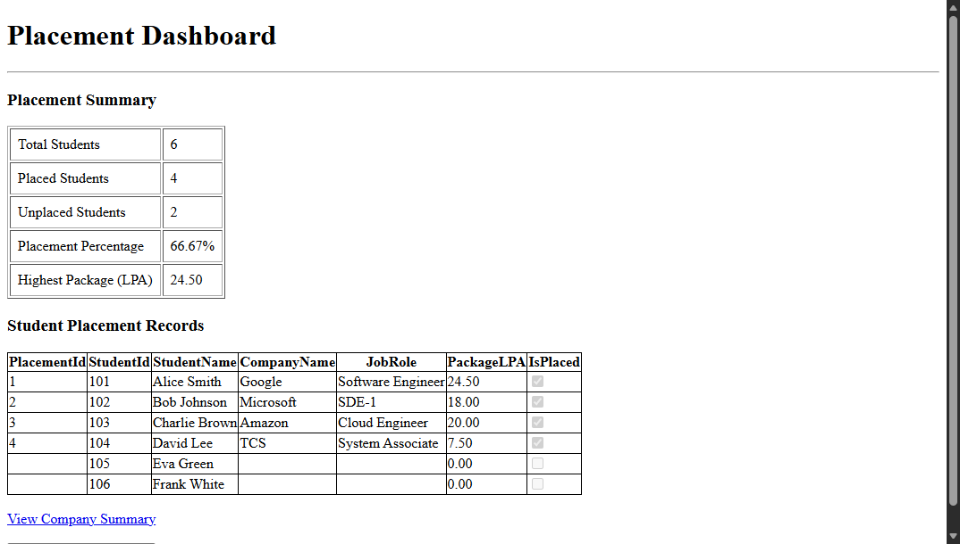
2. Company Placement Records (Companies.aspx) - Repeater & DataList Controls:
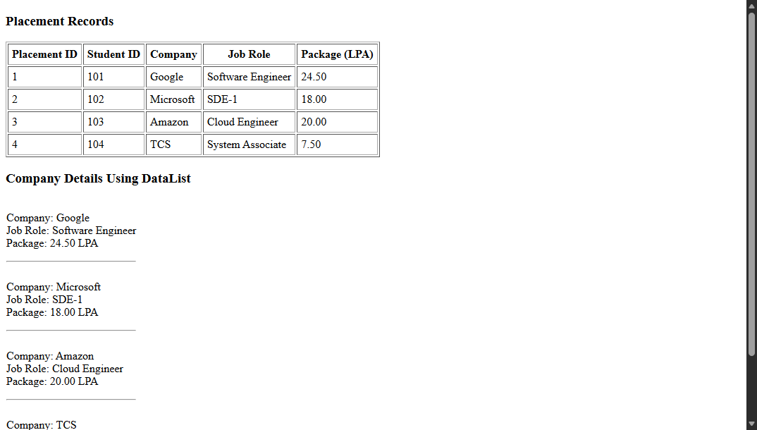
GitHub: https://github.com/GHrushikesh/.Net-Practicals/tree/main/Practical_09

