Global Analysis of Covid19 Pandemic
Vandana Pandugu
June 20,2020
1.Introduction

The primary issue that is affecting the world nowadays is COVID-19. No country has been left untouched. It is a deadly infectious disease that the world has never witnessed before. It is responsible for the loss of many lives and left the affected countries in both deep physical and economic depression.
This all started in December 2019 in Wuhan, China. Since then it has spread globally at an alarming rate. As a result, the World Health Organization declared the COVID-19 outbreak as a pandemic on March 11, 2020.As of June 19, 2020, more than 8,5 million cases have been reported across 188 countries and territories resulting in more than 456k deaths. It is an infectious disease caused by severe acute respiratory syndrome coronavirus 2 (SARS-CoV-2). People who are affected by this virus experience fever, cough, fatigue, shortness of breath, and loss of smell and taste. There is no vaccine yet, which means the only method of prevention is through self-quarantine.
Considering the distressful situation that the world is in, I believe that selecting COVID-19 as my topic makes the most sense. So, it's my mere effort to analyze the cumulative data of confirmed cases, deaths, and recovered cases over time. My main focus is to analyze the spread trend of this virus all over the world with the right visualizations and also to cluster the countries affected accordingly.
We need to build the courage and act in harmony and peace to fight against this situation, hoping to see the world smile again overcoming the fear of death."
2.Data Sources and Acquisition
In consideration of the COVID 19 problem I have found Open data available through reliable sources:
- I have found Time-series COVID-19 Data Repository by the Center for Systems Science and Engineering (CSSE) at Johns Hopkins University, the repository has several datasets, among those I will be using dataset featuring the confirmed cases, no of deaths, and active cases by countries, I will be downloading, preprocessing the data, and creating a World map featuring the COVID-19 stats by countries.

- I have also analyzed the USA country separately, I have found a Time series dataset which also comes from a public dataset by NYT, located in the GitHub, this dataset provides information on COVID-19 cases per US counties. I will be creating maps to display the stats by States
- I have pulled Dallas County Summary of Cases by City Distribution from Dallas County website.
- I have created own data file for Dallas county’s Population by cities to be downloaded from Census.gov into Jupyter Notebook.
- I have used the Foursquare API's to analyze Dallas county and its Cities to pull and analyze available hospitals in and around Dallas County.

3.Methodology
- Acquire Data from the various sources as mentioned below. I used GitHub Data repository from John Hopkins university in my study
- Covid19 data for globally affected countries
Data Source: https://raw.githubusercontent.com/CSSEGISandData/COVID-19/web-data/data/cases_country.csv

 | Country_Region |  | Confirmed |  | Deaths | Recovered | Active
0 | Australia | 7436.0 |  | 102.0 |  | 6888.0 | 446.0
1 | Austria | 17323.0 |  | 688.0 |  | 16175.0 | 460.0
2 | Canada | 102626.0 |  | 8445.0 |  | 64690.0 | 29492.0
3 | China | 84525.0 |  | 4639.0 |  | 79532.0 | 354.0
4 | Denmark | 12591.0 |  | 600.0 |  | 11482.0 | 509.0
2. Covid19 Data for USA country.
Data Source: https://raw.githubusercontent.com/nytimes/covid-19-data/master/us-counties.csv
date county state fips cases deaths
0 2020-01-21 Snohomish Washington 53061.0 1 0
1 2020-01-22 Snohomish Washington 53061.0 1 0
- 2020-01-23 Snohomish Washington 53061.0 1 0
3 2020-01-24 Cook Illinois 17031.0 1 0
4 2020-01-24 Snohomish Washington 53061.0 1 0
3.Dallas County Cases
DataSource: https://www.dallascounty.org/covid-19/
City Patient Count Percent
0 Addison 49 0.33%
1 Balch Springs 125 0.84%
2 Carrollton 254 1.71%
3 Cedar Hill 208 1.4%
4 Cockrell Hill 29 0.2%
I have pulled the file on to my local system to be pulled into Jupyter Notebook
4.Dallas County’s Population
I have pulled Dallas county’s Population by cities from the following source location and created a file Dallas_Population.csv to be downloaded into Jupyter Notebook.
Data Source: https://www.census.gov/quickfacts/fact/table/dallascountytexas,dallascitytexas/PST045219
City Population
0 Addison 16404
1 Balch Springs 27001
2 Carrollton 135432
3 Cedar Hill 50552
4 Cockrell Hill 4660
5 Combine 2025
- Imported the necessary libraries to read, display files of different format.
- Preprocessed the data acquired
- I used Matplotlib and Folium library to Visualize the pandemic details and created map of all Countries affected, all states of USA, Dallas County Cities.
Global Map Displaying the countries stats
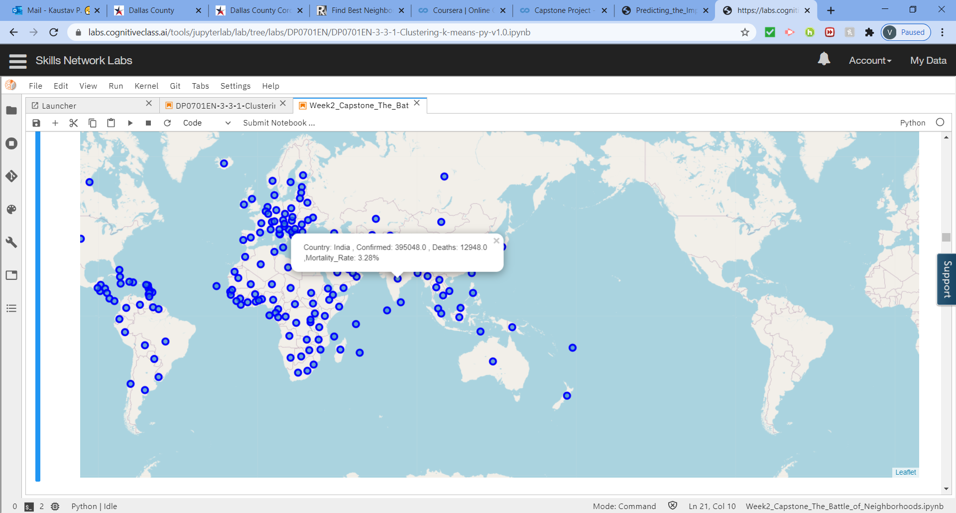

USA Map Displaying the States stats
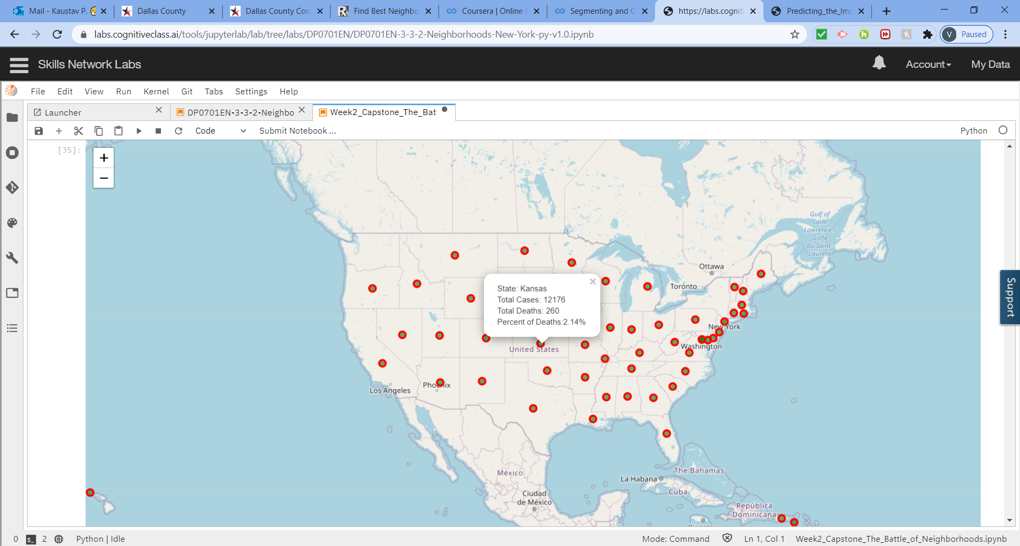

Dallas County map displaying Cities stats
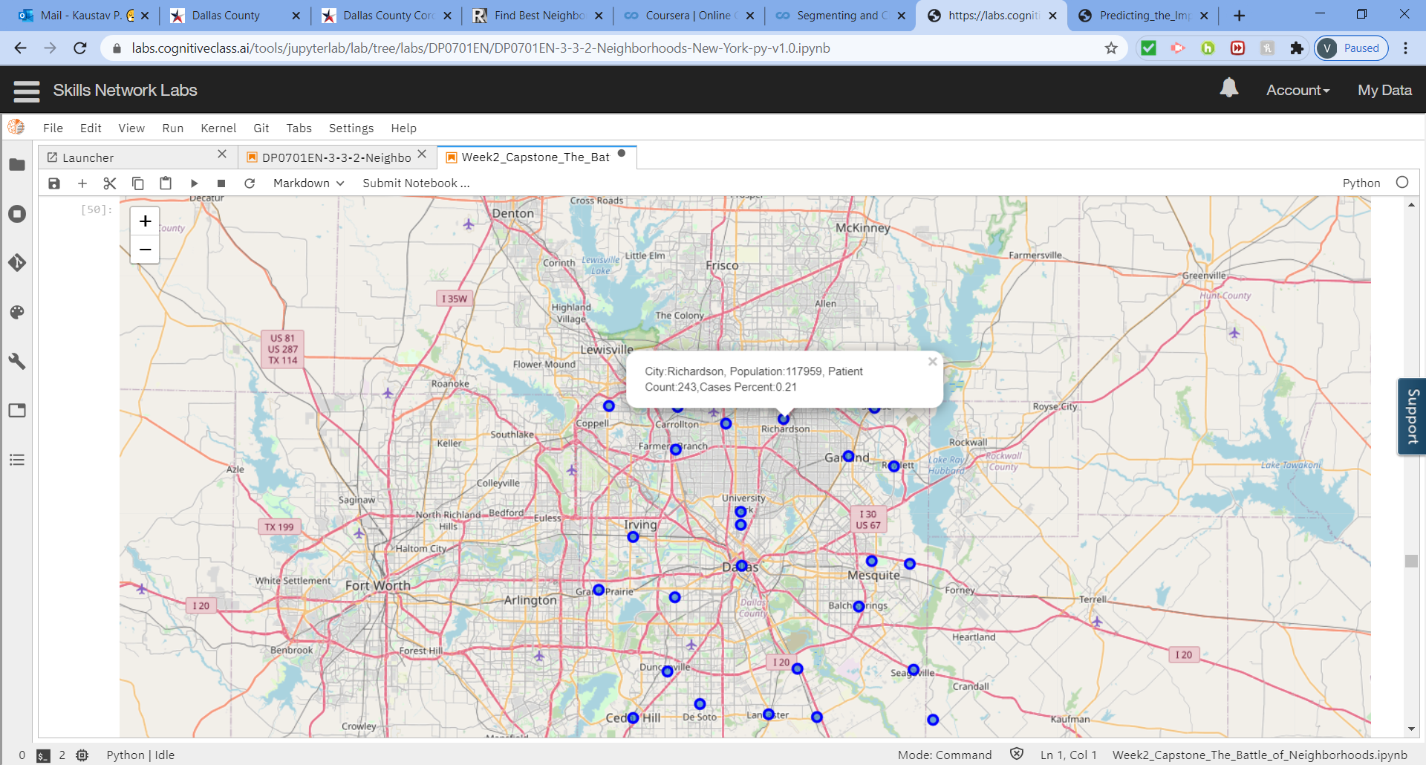

- Created stacked and side-by-side bar graphs for Top10 countries
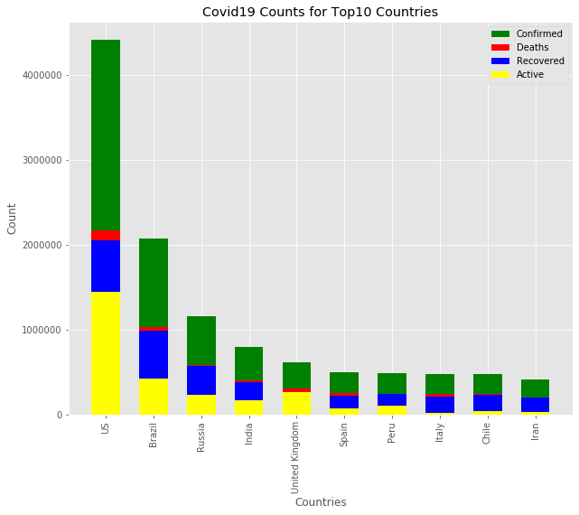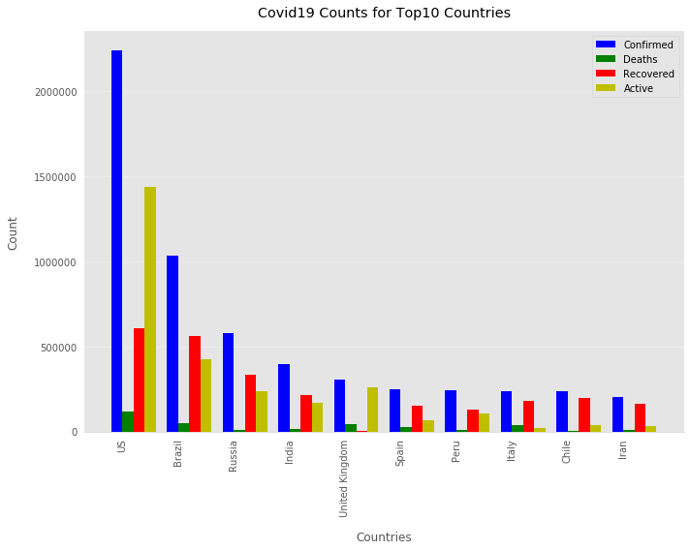
- Created stacked and side-by-side bar graphs Top 10 states of US
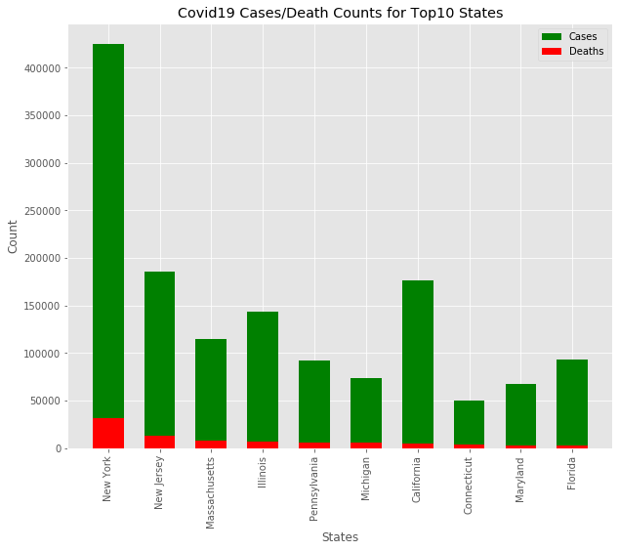
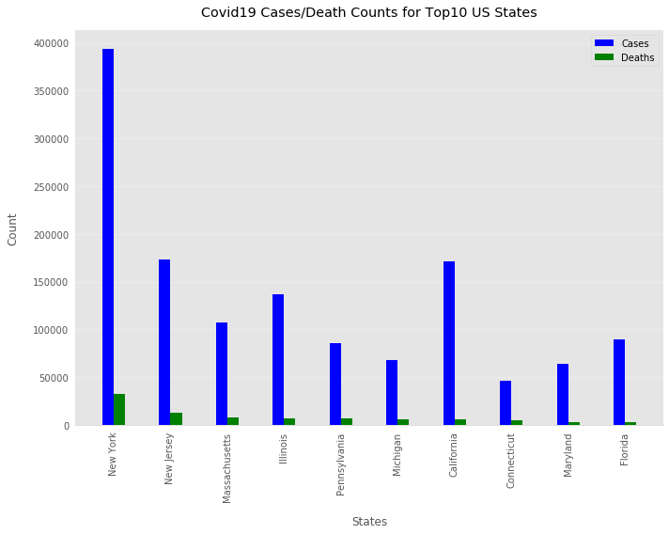
- Created TX Top10 Counties Cases/Deaths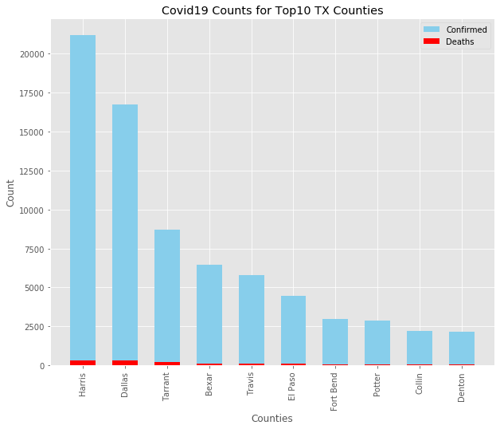
- I utilized the Foursquare API to pull hospitals and Emergency care centers in and around Dallas County. I setup the limit as 100 venue and the radius 1000 meter for each city from their given latitude and longitude information. Below is the list of Venues name, category, latitude and longitude information from Foursquare API

 | City | City Latitude | City Longitude | Venue | Venue Latitude | Venue Longitude | Venue Category
0 | Addison | 32.95398 | -96.818 | The Heart Hospital Baylor Plano | 33.014818 | -96.789573 | Hospital
1 | Addison | 32.95398 | -96.818 | Methodist Hopital For Surgery | 32.984661 | -96.829450 | Hospital
2 | Addison | 32.95398 | -96.818 | Revivify Cranial Prosthesis Billing | 32.949006 | -96.824967 | Hospital
3 | Addison | 32.95398 | -96.818 | Emergis ER & Urgent Care | 32.956300 | -96.820540 | Hospital
4 | Addison | 32.95398 | -96.818 | Texas Health Presbyterian Hospital Dallas | 32.881813 | -96.763005 | Hospital

- I used Hospital key HOSPITAL_KEY = "4bf58dd8d48988d196941735" to identify and return only Hospitals. There were 940 venues with 9 unique categories returned by Foursquare and I dropped Alternative Healer, Pharmacy, Veterinarian, Dentist’s Office “, after dropping there were 916 Venues
- I grouped the results by City and we see that Addison, Dallas, Highland Park, Richardson and University Park topped 100 venues limit. On the other hand, Balch Springs, Cedar Hill, DeSoto,
Glenn Heights, Grand Prairie, Hutchins, Lancaster, Sunnyvale, Wilmer and Wylie are below 20 venues

- Created bar graphs Dallas county’s Hospital counts by Cities.
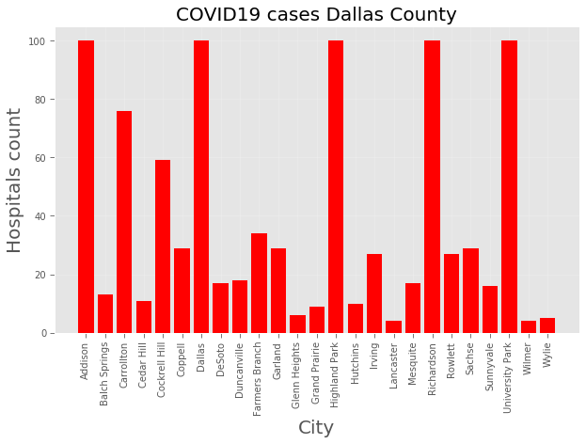
- Analyzed Dallas County cases using K-Means clustering with 5 clusters
Here is my merged table with Cluster Labels
Cluster Labels | City | State | Population | Patient Count | Cases Percent | Latitude | Longitude | Venue Category | Hospitals Per Hundred People
0 | 0 | Addison | Texas | 16404 | 55 | 0.34 | 32.95398 | -96.81800 | 100 | 0.609607
1 | 1 | Balch Springs | Texas | 27001 | 140 | 0.52 | 32.72709 | -96.62263 | 13 | 0.048146
2 | 1 | Carrollton | Texas | 135432 | 262 | 0.19 | 32.97555 | -96.89023 | 76 | 0.056117
3 | 1 | Cedar Hill | Texas | 50552 | 211 | 0.42 | 32.58866 | -96.95596 | 11 | 0.021760
4 | 0 | Cockrell Hill | Texas | 4660 | 28 | 0.60 | 32.73895 | -96.89399 | 59 | 1.266094

4.Results
Calculated Hospitals Per Hundred People
City State Population Patient Count Cases Percent Latitude Longitude City Latitude City Longitude Venue Venue Latitude Venue Longitude Venue Category Hospitals Per Hundred People
0 Addison Texas 16404 55 0.34 32.95398 - 96.81800 100 100 100 100 100 100 0.609607
1 Balch Springs Texas 27001 140 0.52 32.72709 -96.62263 13 13 13 13 13 13 0.048146
2 Carrollton Texas 135432 262 0.19 32.97555 -96.89023 76 76 76 76 76 76 0.056117
3 Cedar Hill Texas 50552 211 0.42 32.58866 -96.95596 11 11 11 11 11 11 0.021760
4 Cockrell Hill Texas 4660 28 0.60 32.73895 -96.89399 59 59 59 59 59 59 1.266094
Grouped the data into 5 clusters
Cluster1
Cluster Labels City State Population Patient Count Cases Percent Latitude Longitude Venue Category Hospitals Per Hundred People
0 | 0 |  | Addison |  | Texas | 16404 | 55 | 0.34 | 32.95398 | -96.81800 | 100 | 0.609607
4 | 0 |  | Cockrell Hill |  | Texas | 4660 | 28 | 0.60 | 32.73895 | -96.89399 | 59 | 1.266094
13 | 0 |  | Highland Park |  | Texas | 9662 | 20 | 0.21 | 32.82848 | -96.79703 | 100 | 1.034982

Cluster2
Cluster Labels City State Population Patient Count Cases Percent Latitude Longitude Venue Category Hospitals Per Hundred People
1 1 Balch Springs Texas 27001 140 0.52 32.72709 -96.62263 13 0.048146
3 1 Cedar Hill Texas 50552 211 0.42 32.58866 -96.95596 11 0.021760
7 1 DeSoto Texas 56224 269 0.48 32.60562 -96.85704 17 0.030236
8 1 Duncanville Texas 40953 241 0.59 32.64622 -96.90502 18 0.043953
9 1 Farmers Branch Texas 34816 185 0.53 32.92178 -96.89271 34 0.097656
10 1 Garland Texas 248363 1428 0.57 32.91427 -96.63655 29 0.011676
12 1 Grand Prairie Texas 201709 667 0.33 32.74770 -97.00720 9 0.004462
15 1 Irving Texas 247615 1596 0.64 32.81352 -96.95534 27 0.010904
16 1 Lancaster Texas 40885 238 0.58 32.59316 -96.75511 4 0.009784
17 1 Mesquite Texas 149442 823 0.55 32.78343 -96.60212 17 0.011376

Cluster3
Cluster Labels City State Population Patient Count Cases Percent Latitude Longitude Venue Category Hospitals Per Hundred People
6 2 Dallas Texas 1378903 8706 0.63 32.77822 -96.79512 100 0.007252
Cluster4

Cluster Labels City State Population Patient Count Cases Percent Latitude Longitude Venue Category Hospitals Per Hundred People
2 3 Carrollton Texas 135432 262 0.19 32.97555 -96.89023 76 0.056117
5 3 Coppell Texas 43623 58 0.13 32.97654 -96.99133 29 0.066479
11 3 Glenn Heights Texas 13749 35 0.25 32.55265 -96.85679 6 0.043640
18 3 Richardson Texas 117959 243 0.21 32.96074 -96.73297 100 0.084775
19 3 Rowlett Texas 63420 138 0.22 32.90101 -96.56960 27 0.042573
20 3 Sachse Texas 26362 32 0.12 32.97426 -96.59842 29 0.110007
21 3 Sunnyvale Texas 6473 20 0.31 32.78032 -96.54620 16 0.247181
22 3 University Park Texas 26745 33 0.12 32.84536 -96.79699 100 0.373902
24 3 Wylie Texas 56376 2 0.00 33.02300 -96.51486 5 0.008869

Created Cluster Map Visualization
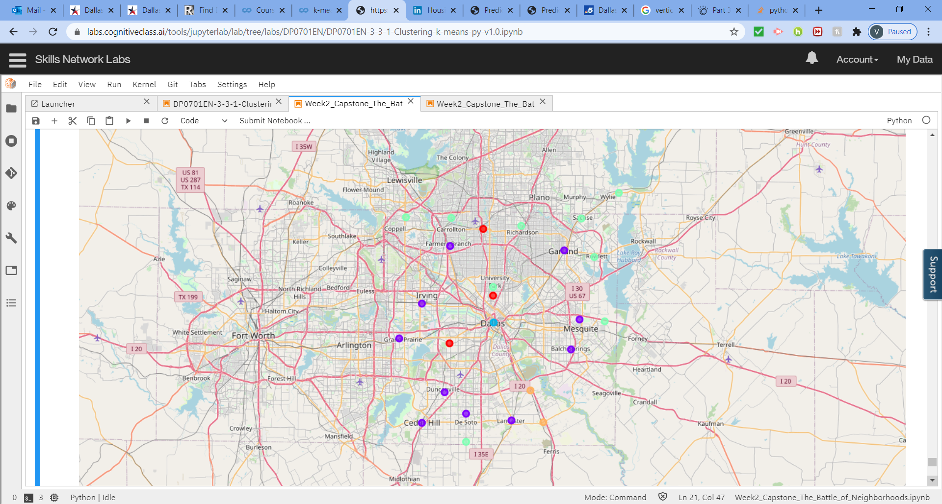
Examining the clusters
Cluster1: Hospital
Cluster2: Medical Center
Cluster3: Hospital Ward
Cluster4: Emergency Room
Cluster5: Doctor’s Office
Calculated
Cities without hospital count: 2
Cities with hospital count: 25

5.Discussions:
As I mentioned before, Covid19 is the primary issue that is affecting the world now a days , its my mere effort as part of the people’s sufferings to give an insight of the data . Being a resident, I preferred to analyze Dallas city further, I used the Kmeans algorithm as part of this clustering study. I set the optimum k value to 5.
I also performed data analysis through this information by adding the coordinates of venues. In future studies, the data that is getting pulled manually due to lack of regular updates will be accessed dynamically from specific sources.
It is obvious that this analysis has no limits and can be extended further however I am closing my project, I would like to revisit my project and add more features in future.
6.Conclusion
In this current Covid19 situation, my mere effort is to pull data and display the graphs and maps of all the affected places to give an idea of what situation we are in. Also, with increasing case counts in and around Dallas, I pulled the hospital information and clustered the hospitals to see where each cities will fall or doesn’t fall under any of these clusters.

