Employee Database Management System

Revision History
Version No. | Date | Prepared by / Modified by | Significant Changes
1 | 08-04-2022 | Bhupathi Pravalika | Introduction and Scope of Change
2 | 22-04-2022 | Kamana Vyshnavi | Process model
3 | 12-05-2022 | Patibandala Prasanthi | Er diagram ,sequence diagram
4 | 13-05-2022 | Dhivya J | Use case diagram
5. | 23-05-2022 | Shaik Khushbu Jahan | Process user interface diagram,Reference

Glossary
Abbreviation | Description
BSC | Business Story Card
TSC | Technical Story Card
DOJ | Date Of Joining

Table of Contents
1 Introduction 3
2 Scope of Change 3
3 List of impacted modules 3
3.1.1 DFD diagram………………………………..…………………………....………………………….3

4 Design and Detailed technical updates 4
4.1 Process model 4
4.1.1 Use case Model 4
4.1.2 Architecture diagram……………………..…………………………………………………4
4.1.2.1 Presentation Layer…………………………………………………………..4
4.1.2.2 Application Layer…………………………………………………………….4
4.1.2.3 Data Asses Layer……………………………………………………………4
4.1.3 Class Diagram…………………………………………………………………………...4
4.1.4 Sequence diagram 4
4.2 Proposed user Interface design 4
4.3 Database design changes 4
4.3.1 ER Diagram…………………………………………………………………………………4
4.4 Refactoring related changes 4
4.5 Construction strategy and re-use 4
5 References 5

Introduction
This software application stores all the employee's information in a database. It is an application developed in Java and the database used is SQL. It contains employee information like employee id, name, date of joining, and basic pay.
It is an easy-to-use application and has a user-friendly interface. It is totally built at the administrative end which means that only the admin has access rights to change or modify any records. So, this makes it a safe and reliable application to use.
The main aim of developing this application was to reduce the errors that occur in the manual system. One can search the details easily by just entering an employee id. In earlier systems, there was not such a facility to do so. All the details are stored in an SQL database. It is easy to update any employee details. All the employee records are integrated and so this makes it a user-friendly and easy to use application.

Scope of Change
We can add registration for new Employee. When new employee fill the registration details and it go to login page. Once employee enter to login details ,it will go to home page. Then employee can able to enter the details like ID, D.O.J and basic pay .It shows the overall salary details TAX,DA,HRA,GROSS,NET.

List of impacted modules
​
- Registration
- Login
- Home Page

DFD (Data Flow Diagram)
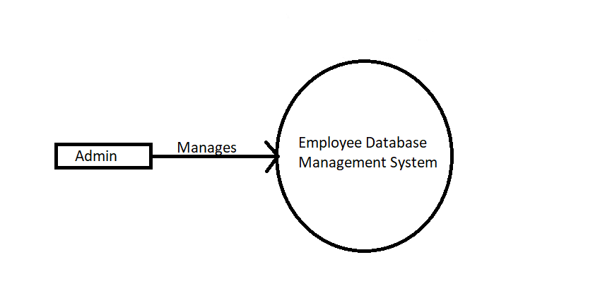
Level 0

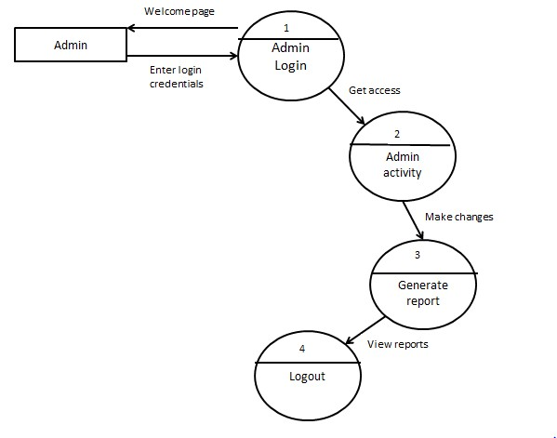
Level 1

Design and Detailed technical updates

Process model
Process models are processes of the same nature that are classified together into a model. It track what actually happens during a process Take the point of view of an external observer who looks at the way a process has been performed and determines the improvements that must be made to make it perform more effectively or efficiently.

Use case Model

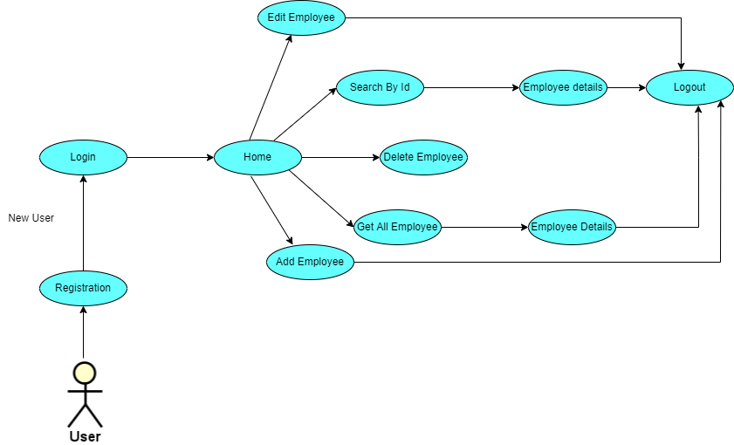

Architecture Diagram:

Layer

Logical View

Technology/ Framework

Oracle 11G
Database

Edit Emp By Id

Log Out

Application/ Business Layer

Web-Server Classes

Configuration

Controllers

Service

REST Controllers

Entity/ Model Classes

Repository classes

UI Components

Login

Find All Emp

Create New Emp

Home

HTML-5/ CSS/ JavaScript 4.5.5/ Angular-8

Delete Emp By Id

Presentation Layer

Find Emp By Id

Java 1.8/ Spring Boot-2.3.3/Spring Data JPA

Data Access Layer

Spring Data JPA

4.1.2.1 Presentation Layer:

This layer consists of all UI components.
- Login Component: Employee can use the login component to login to their respective accounts.
- Create New Employee Component: Employee can add the details emp name, date of joining, basic pay and click add employee
- Find Employee By Id Component: Employee search Id and click show details
Get all Employee Details
- Find All Employee Component: Get the employee details it display ID, Name, D.O.J, Basic Pay, DA, HRA, Gross, Tax, Net.
- Delete Employee By Id Component: Give employee Id click Delete button then Delete the employee details
- Edit Employee By Id Component: We can give employee Id click edit button it show the edit page .We can edit the details.
- Log Out Component: When I click Log Out button it go to Log Out user

4.1.2.2 Application Layer:

This layer comprises of all server and business classes.
- Configuration settings (XML or Class based) will define the application and server configuration.
- Spring Controllers defines the server classes, which are required to process the incoming http requests.
- Service classes are required to perform the required business services.
- REST Controllers to process the HTTP AJAX requests.
- Model classes are used to define the functions of the entities present in the system.

4.1.2.3 Data Asses Layer:

Data layer is implemented through Hibernate ORM. It will contain the repository classes, which provides interface to the table.

4.1.3 Class diagram

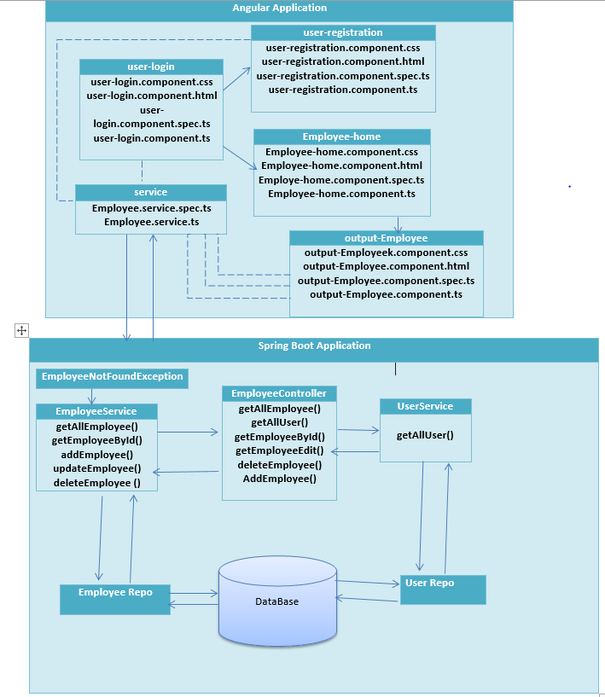

Sequence diagram

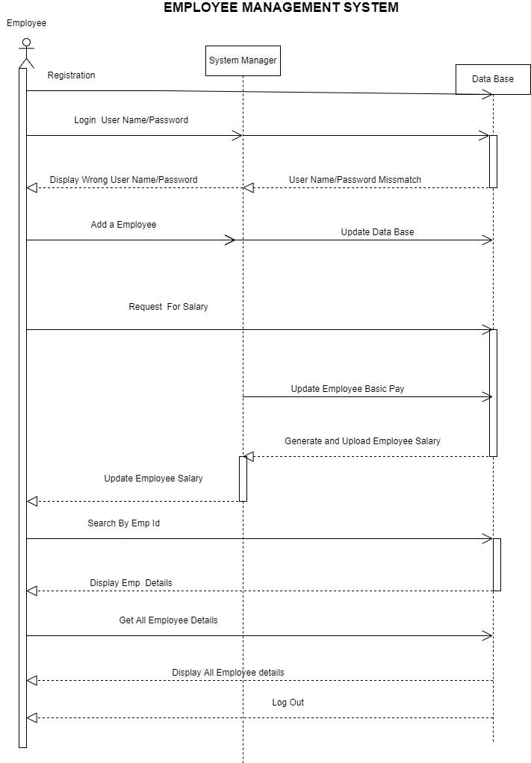

Proposed user Interface design

Registration Page:
Brief Description | Registration
Basic Flow | This use case describes how an Employee gets into User Profile page  - The client has to register himself into the system.  - The following information is required to Registration.  - First Name  - Last Name  - Email Id  - Phone No  - Password  - Conform Password  - Address
Alternate Flow | - 1.The system will validate the credentials provided.
Validation | - Valid Username  - Valid Employee ID  - Password is similar as Conform Password
Pre-Conditions | User should have network access and Browser with latest updates.
Post-Conditions | Landing page has to be displayed.

Log In page:
Brief Description | Login
Basic Flow | This use case describes how an Employee gets into User Profile page  - The client has to register himself into the system.  - After the successful login, user will be taken to the appropriate landing page.  - The following information is required to login.  - Employee name  - Employee ID
Alternate Flow | - The system will validate the credentials provided. If credentials are invalid, login form will be redirected again with error message.
Validation | - Valid Username  - Valid Employee ID
Pre-Conditions | User should have network access and Browser with latest updates.
Post-Conditions | Landing page has to be displayed.

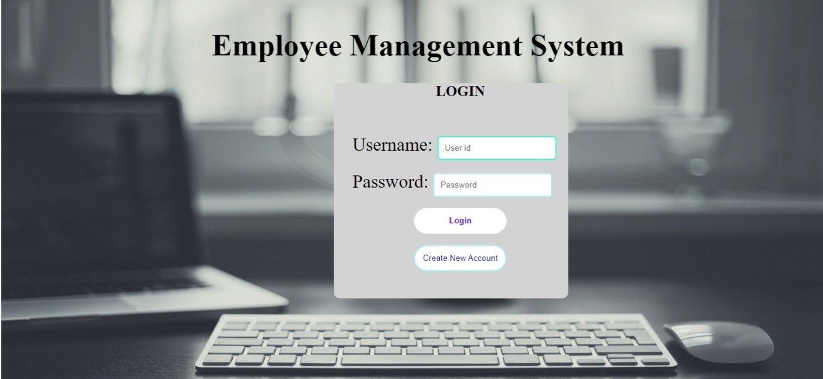
Create New Employee:

Brief Description | Create New Employee
Basic Flow | This use case describes how a Employee profile in to the system  1.The Employee should add the details in the form.  2.The following information is required during Add an Employee.  - Enter Emp Name  - Enter Date of Joining  - Enter Basic pay
Alternate Flow | 1.The system will validate the credentials provided.
Validation | 1.Name is required and minimum 3 characters and max 30 characters.  2.Employee can be alphanumeric.  3.City should be valid  4.The Date of joining should be selected from a drop-down.
Pre-Conditions | 1.User should have network access and Browser with latest updates.
Post-Conditions | 1.Success message should be shown I employee add .

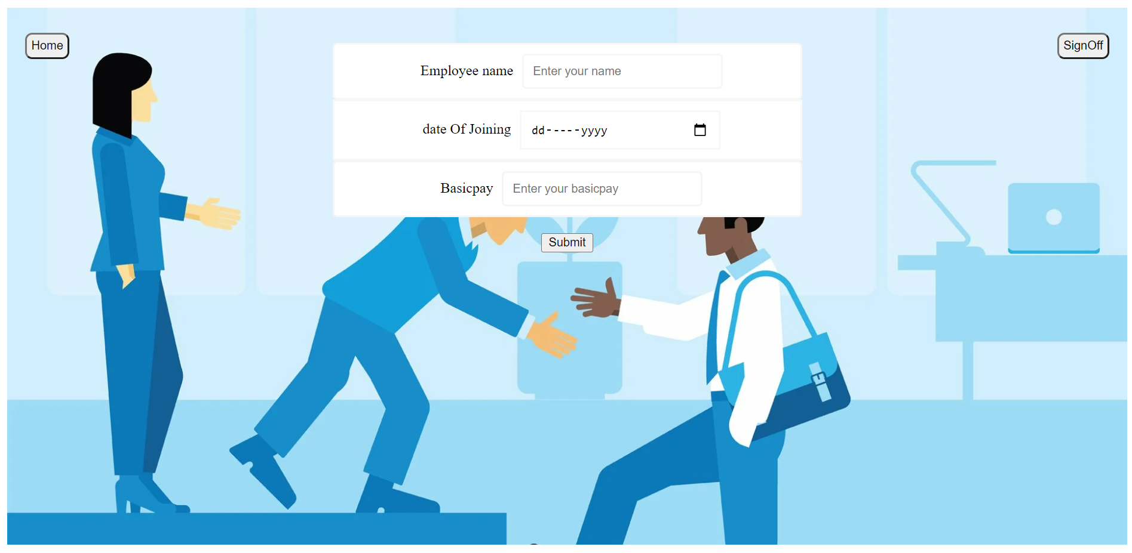
Find Employee By Id:

Brief Description | Find Employee By Id
Basic Flow | This use case describes how Employee profile in to the system  1. The Employee should enter Id in the form.  2. The following information is required during Add an Employee.  - Enter Employee Id
Alternate Flow | 1. The system will validate the credentials provided.
Validation | 1. The Employee Id should be selected from a drop-down.  2. The Id entered should be in integer datatype.
Pre-Conditions | 1. User should have network access and Browser with latest updates.
Post-Conditions | 1. Success message should be shown I employee details .



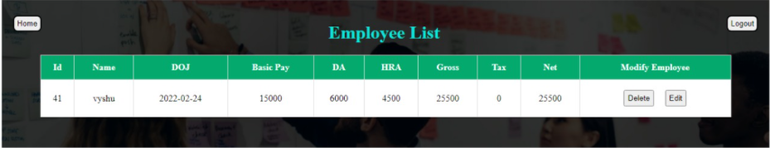

Get All Employee:

Brief Description | Get All Employee
Basic Flow | 1.This use case describes how an Employee profile in to the system  2.The Employee should enter the Get all Employee in the form.
Alternate Flow | 1.The system will validate the credentials provided.
Validation | 1.The Get All Employee entered should be in String datatype.
Pre-Conditions | 1.User should have network access and Browser with latest updates.
Post-Conditions | 1.Success message should be shown All employees details .

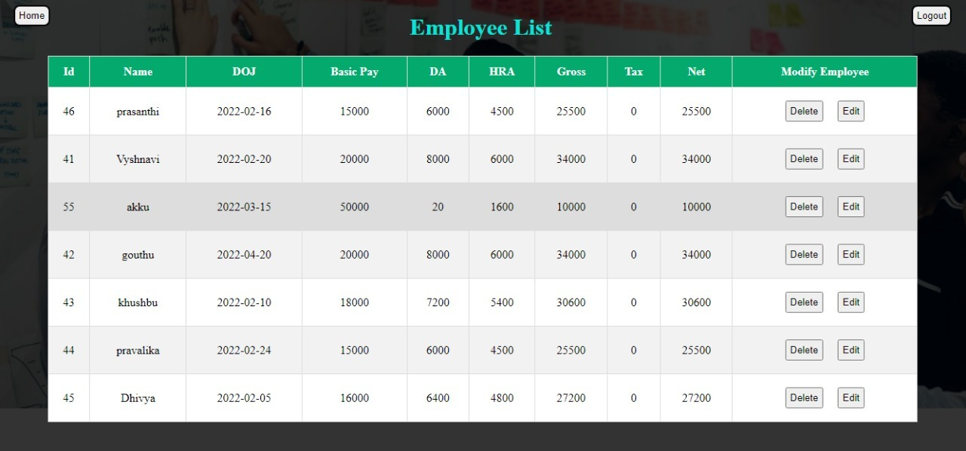

Edit Employee By Id:

Brief Description | Edit Employee By Id
Basic Flow | This use case describes how a Employee profile in to the system  1.The Employee should edit the details in the form.  2.The following information is required during Edit Employee by ID.  - Edit Employee Name  - Edit Employee id  - Edit Date of Joining  - Edit Basic pay
Alternate Flow | 1.The system will validate the credentials provided.
Validation | 1.Name is required and minimum 3 characters and max 30 characters.  2.Employee Id can be alphanumeric.  3.Edit basic pay  4.The Date of joining should be selected from a drop-down.
Pre-Conditions | 1.User should have network access and Browser with latest updates.
Post-Conditions | 1.Success message should be shown I employee add .

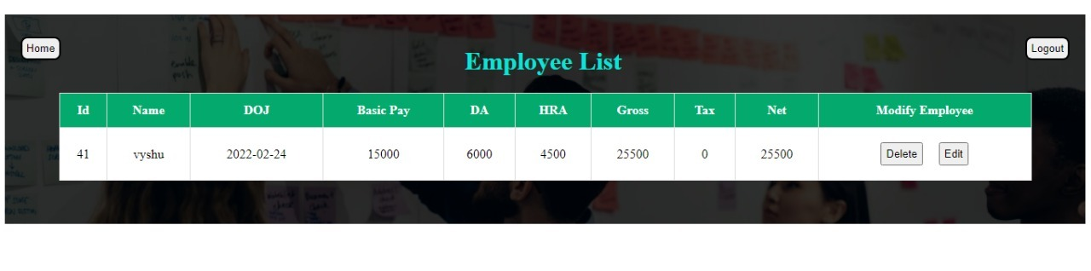

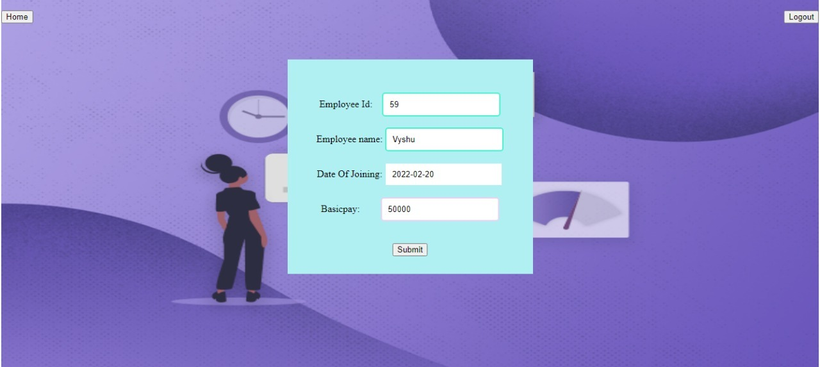

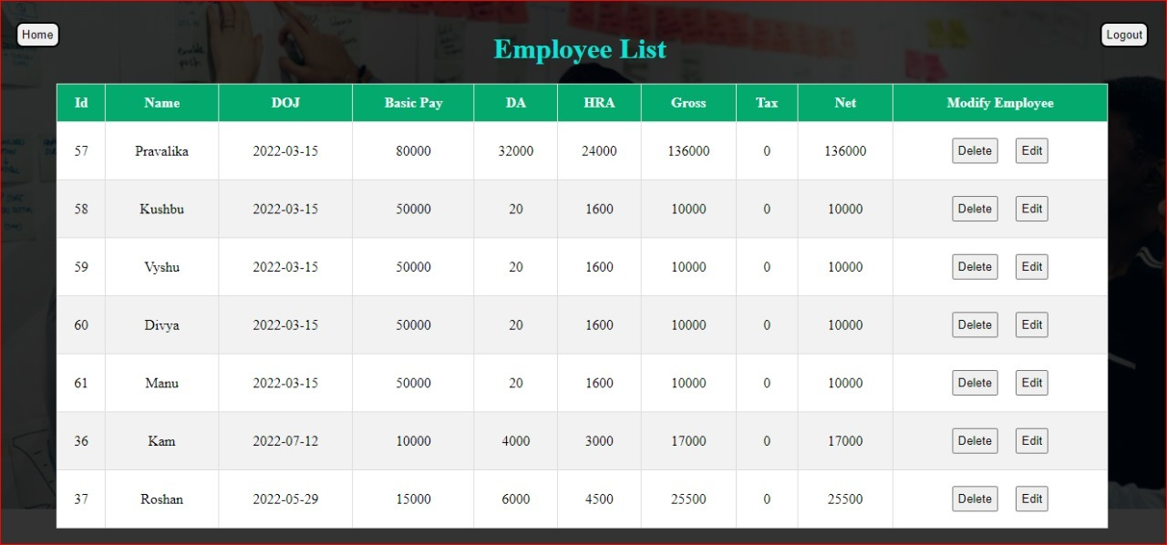

Delete Employee By Id:

Brief Description | Delete Employee By Id
Basic Flow | This use case describes how a Employee profile in to the system  1.The Employee should enter the Id in the form.  2.The following information is required during Add an Employee.  - Enter Employee Id
Alternate Flow | 1.The system will validate the credentials provided.
Validation | 1.The Employee Id should be selected from a drop-down.  2.The Id entered should be in integer datatype.
Pre-Conditions | 1.User should have network access and Browser with latest updates.
Post-Conditions | 1.Success message should be shown I employee details .

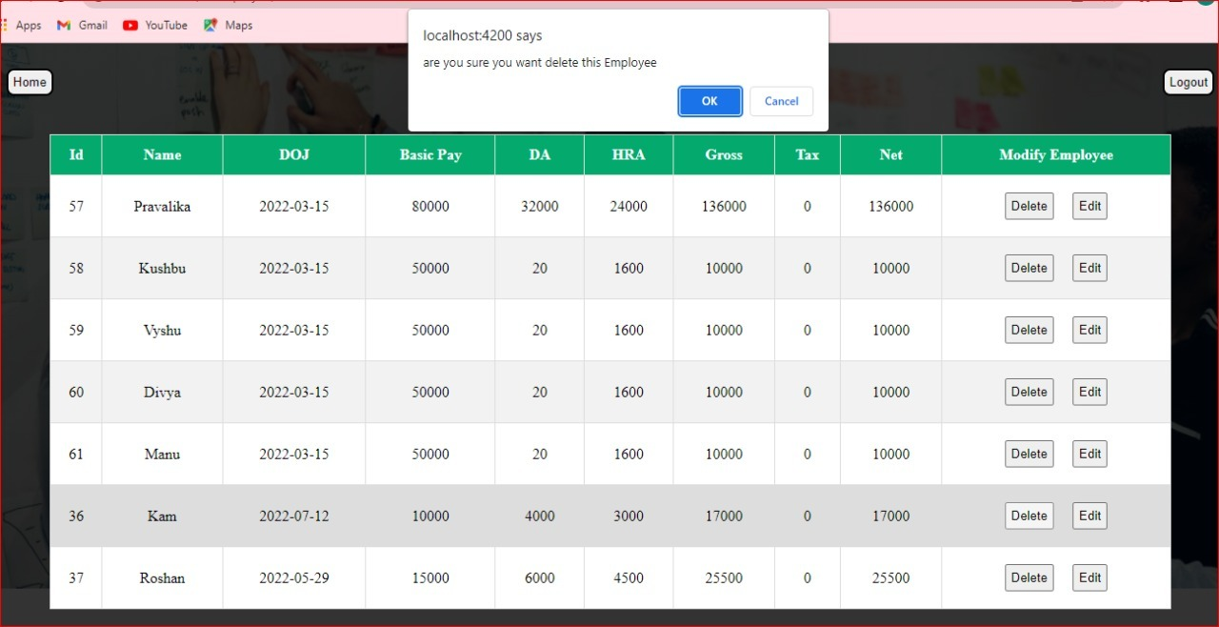

Database design changes

ER Diagram

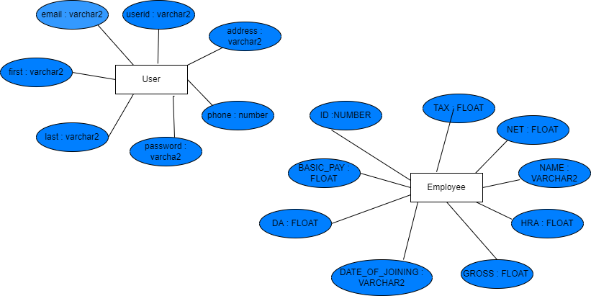

References
We as a team have used references to LMS to complete our project of “Employee Database Management System”. HCL provide the three months training for us on that particular training we learn so many technologies like core java , hibernate ,spring boot, HTML, CSS, angular .Whatever we learn in that training we implement our project.

