Lab-Based Phishing Email Simulation and Metrics
Tool Used: Zphisher

Lab Environment: Kali Linux and Windows 8 (Virtual Machines)

Aim of the Practical
The aim of this practical was to simulate a phishing email attack within a controlled lab environment in order to understand how phishing campaigns are created, how users interact with them, and how effectiveness is measured using phishing metrics such as clicks, reports, and credential submissions.
The simulation was conducted strictly for educational purposes and aligned with ethical cybersecurity practices.

Lab Environment Setup
The phishing simulation was conducted entirely within a virtualized lab environment.

Two virtual machines were used:

  - Kali Linux, used to configure and run the phishing simulation tool
  - Windows 8, used to receive and interact with the phishing email

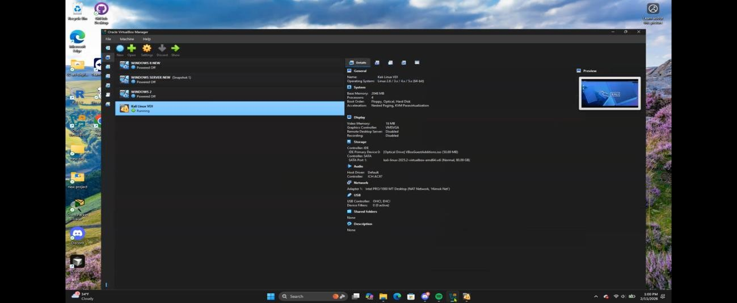

Both machines were connected to the same virtual network to allow internal communication while keeping the activity contained within the lab.

Phishing Tool Preparation
The phishing simulation framework was prepared within the Kali Linux environment.

Once launched, the tool presented an interactive interface with multiple predefined phishing templates.
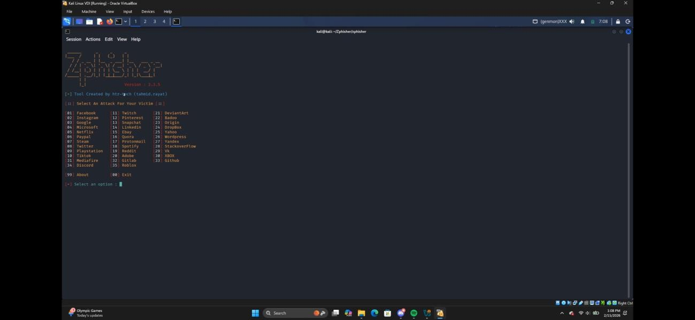

The tool was successfully initialized and ready for use.

4. Phishing Page Configuration
A login-based phishing template was selected to simulate a common real-world phishing scenario.
The phishing page was hosted locally within the lab environment using Zphisher. To allow access from outside the local network, the Cloudflare Tunnel (cloudflared) option was used instead of restricting the page to localhost.
By leveraging Cloudflare Tunnel, the locally hosted phishing page was securely exposed to the internet without requiring port forwarding or changes to router configurations. Once the tunnel was established, Zphisher generated a public phishing URL linked to the selected template, enabling controlled testing from external systems while maintaining the isolation of the homelab environment.

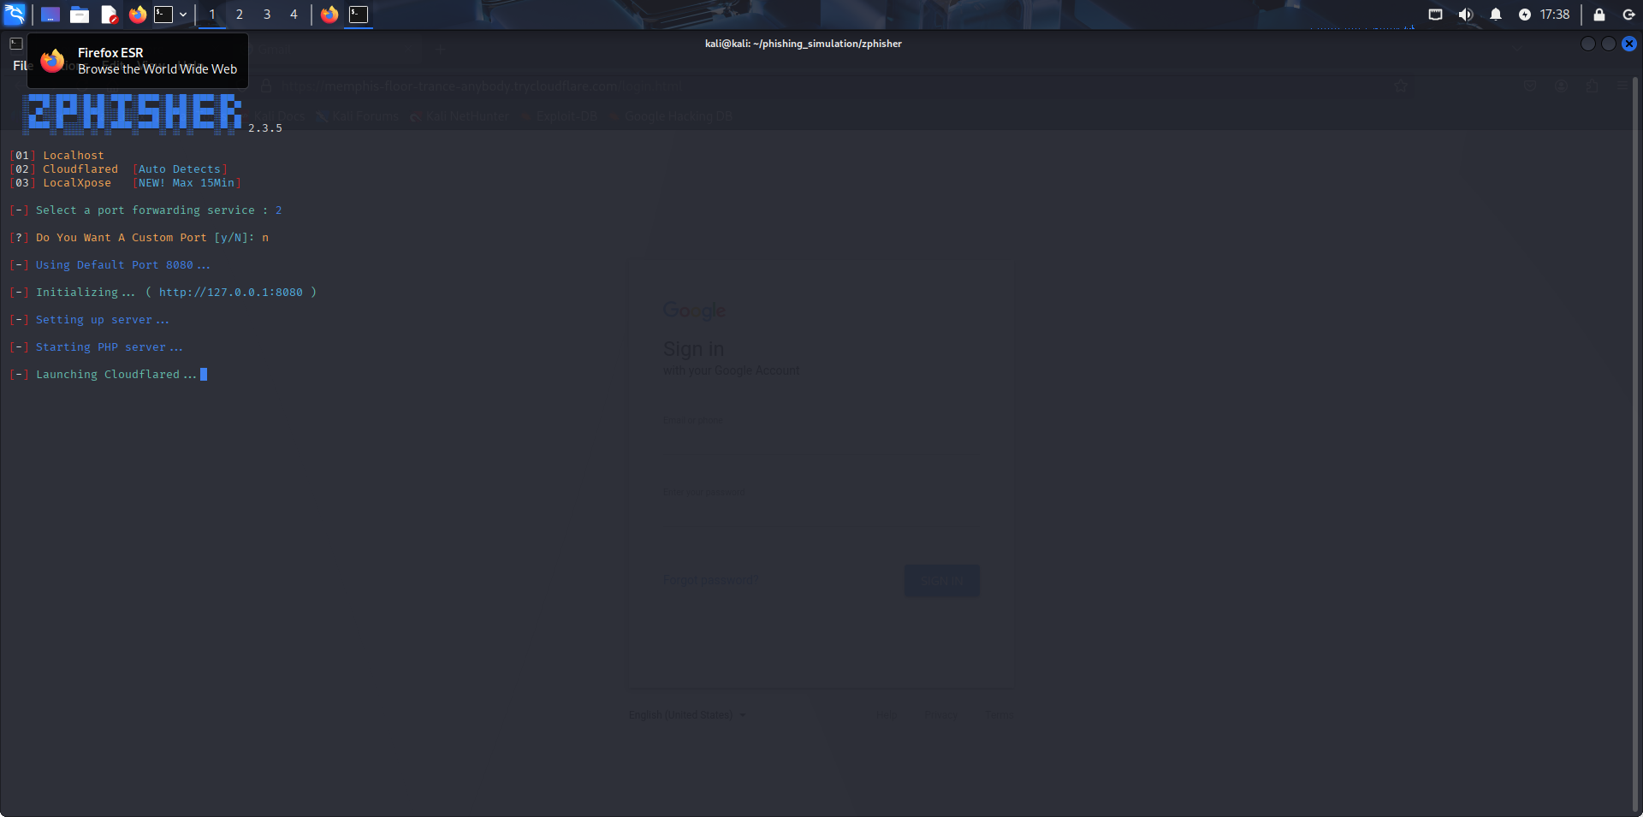

Phishing Email Creation
A phishing email was created using Gmail on the Windows 8 virtual machine. The email was:
- Sent from my own email account to myself
- Written to appear realistic but neutral
- Configured so the phishing URL was embedded behind a clickable text labeled “link”
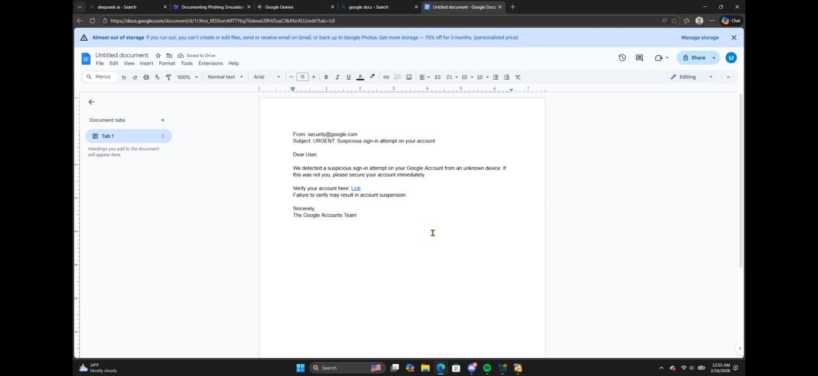

This prevented the raw URL from being visible in the email body.

User Interaction Simulation
The phishing email was opened on the Windows 8 virtual machine, and the embedded link was clicked.
This action redirected the browser to the phishing page, which visually resembled a legitimate login interface.
To simulate user behavior, placeholder credentials were entered and submitted.
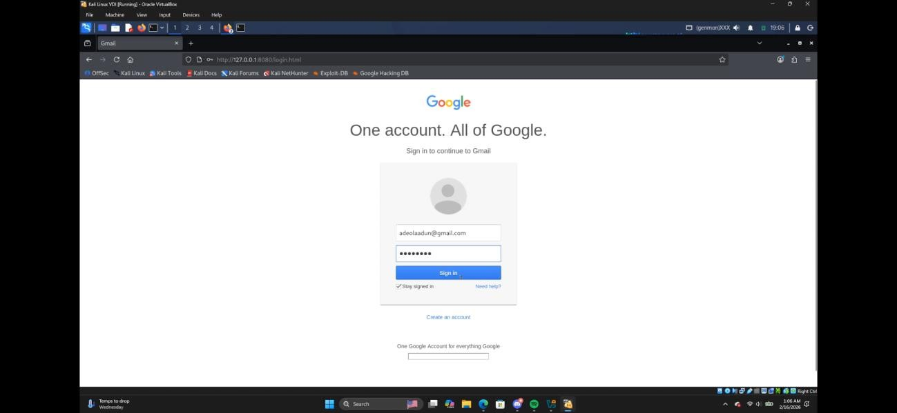

- Captured Results
Following the interaction, the phishing framework recorded the results locally. The captured information included:
- IP address of the interacting system
- Entered test username and password values

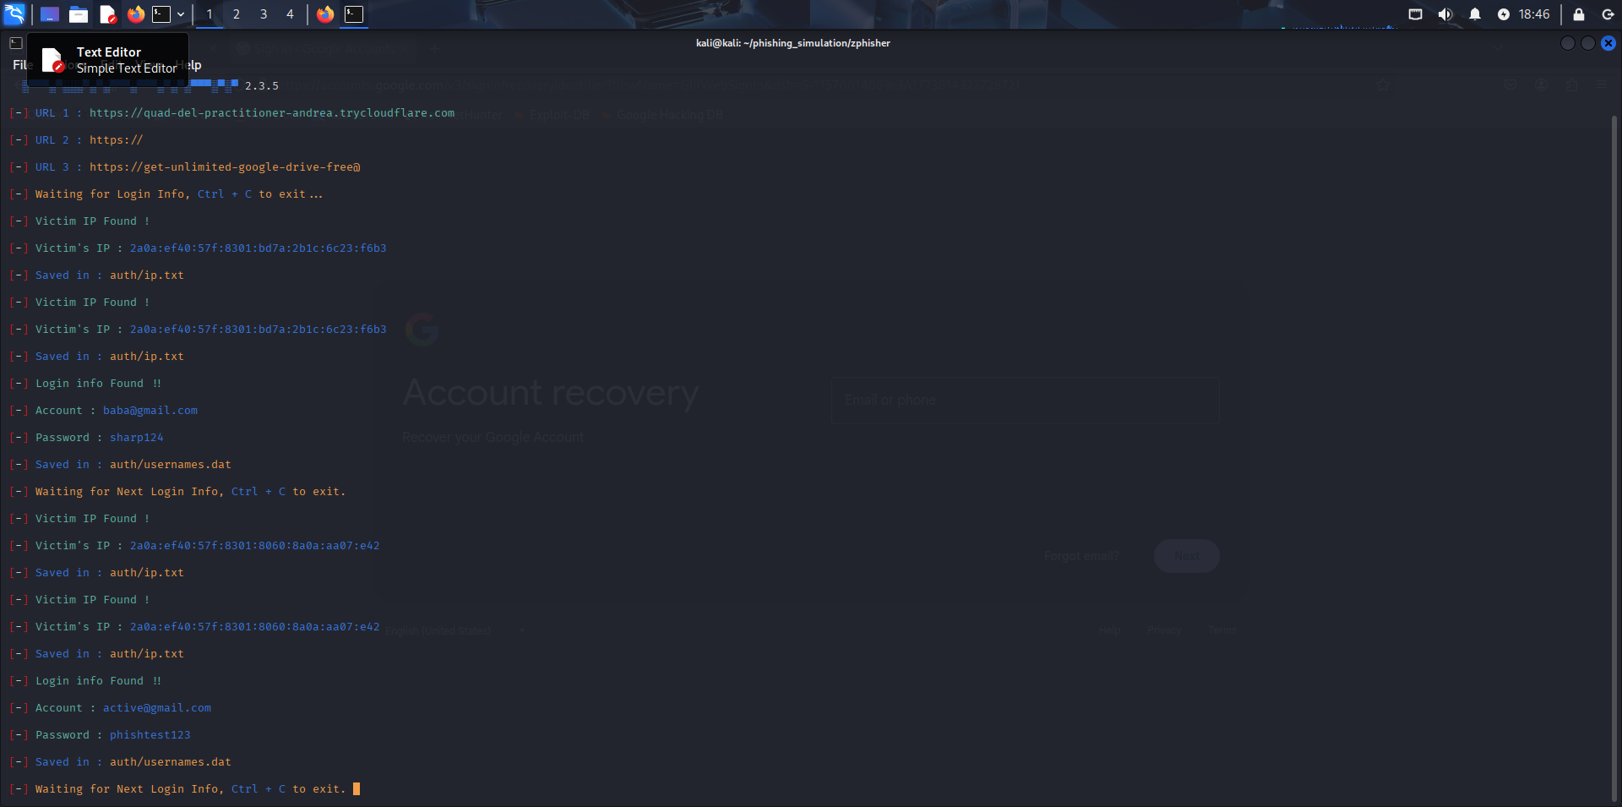
All captured data was generated solely for demonstration purposes.

Phishing Metrics Summary
The results of the simulation produced the following metrics:

Metric | Value
Emails sent | 1
Emails Clicked | 1
Credentials Submitted | 1
Emails Reported | 0

Although the scale of the test was small, the process reflects how phishing metrics are collected and evaluated in larger organizational environments.

Conclusion
This practical successfully demonstrated the full lifecycle of a phishing email simulation, from tool setup and email delivery to user interaction and result analysis.
The exercise provided practical insight into how phishing attacks exploit user behavior and how measurable metrics can be used to assess risk and improve security awareness.

