1. Go to <https://www.postgresql.org/download/windows/>
2. Under the “Interactive installer by **EnterpriseDB**”, Click on **Download the installer**
3. Choose the download option for version 9.6.11 for Windown x86-64 (or 32 depending on your system specifications)
4. Click on the downloaded .exe file to start the installation
5. If you are asked, allow the program to make changes in your OS by selecting yes
6. Click on Next in the first step

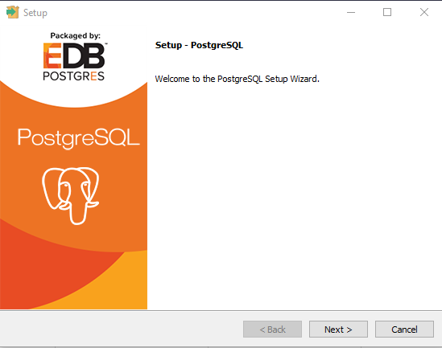

1. Next for the following step as well.
2. *Very important!*  In the next page, from the 4 options unselect all, and only leave the “Command Line Tools” selected and click on Next

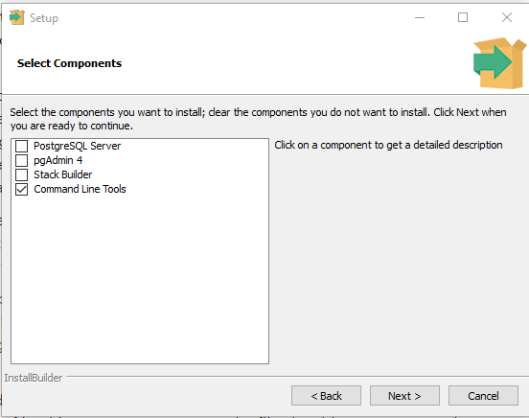

1. Follow the instructions until the installation is completed.