Wiimote in Physical Etoys

Due to the popularity and the different features that the Nintendo Wiimote has, in this tutorial we will see how to access to some of them from Physical Etoys in order to make simple programs.

Necessary tools:

- A Wiimote
- A Bluetooth device
- Physical Etoys software

Configuring Bluetooth:

The first step is to configure the Bluetooth in order to connect the Wiimote with the computer. Insert the Bluetooth device. Then you have to press the buttons 1 and 2 repeatedly at the same time because the time of “waiting connection” is very short.

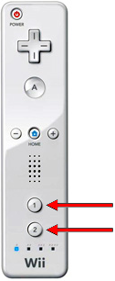

Then we doubleclick the Bluetooth icon which appears on the taskbar.

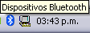

The bluetooth device window will appear. Then we click on the add button.
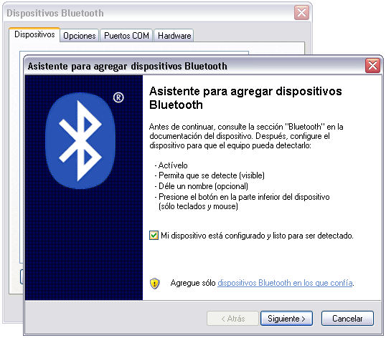

We choose “My device is set up and ready to be found”. Then we select the device we want to connect and click on “next”. If the Wiimote has not been found, we have to repeat the previous steps. In every moment the lights have to be blinking to ensure that it is working properly. Next we choose to use no passkey.

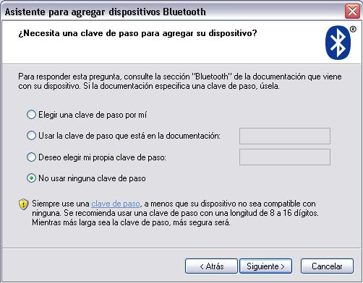

Now we are ready to use the Wiimote with Physical Etoys.

Connecting the Wiimote with Physical Etoys

First and foremost, inside Physical Etoys, we have to get a “Wiimote”. This is a graphical object that represents the Nintendo Wiimote. In order to obtain it we have to open the supplies’ flap.

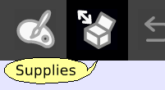

The supplies’ flap contains the most used objects. As long as we use the system we are going to learn more things about them. The one that interests us is the “Object catalog”.

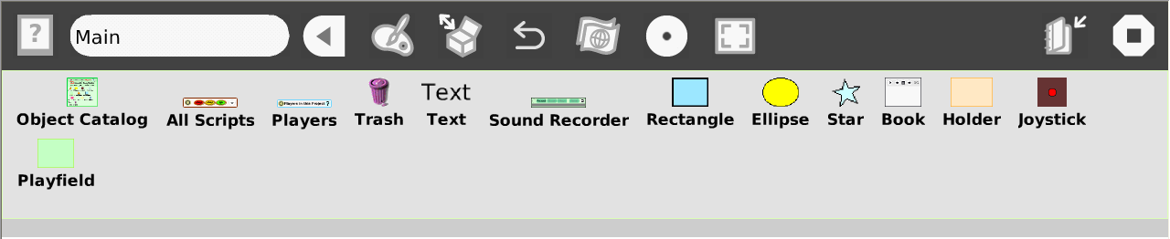

Now we have to drop the object catalog on the world.

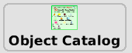

The object catalog is like a box that contains the entire objects that we can use. It is ordered by categories but we can arrange the objects alphabetically. Apart from that we can look for a particular one. Now we have to choose the Wiimote category. Then we have to drag the “Wiimote” etoy and place it on the world.

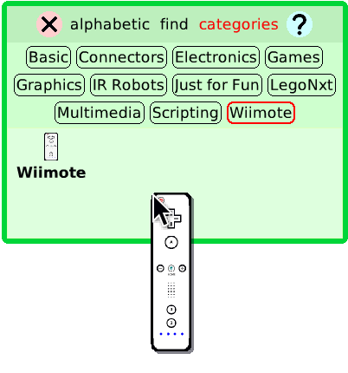

We have to open its viewer by making right-click on the “Wiimote” to open the halo. The halo is a set of buttons which surround the object and let the user modify, move, delete and maximize it.

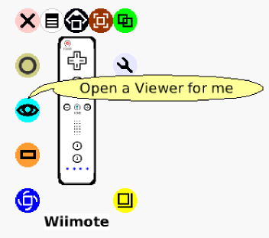

Next we click on the viewer icon (light blue) to make it appear. The viewer is a flap where we can not only see and modify the object’s properties on the screen but also create scripts for them to perform actions like moving on the screen. The properties and the actions are represented as tiles.

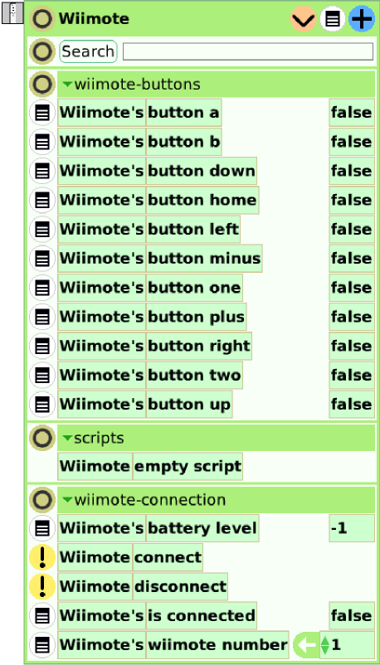

In a special category called “Wiimote-connection” we can find instructions which are useful for connecting with the Wiimote. In order to change categories we have to double click the tiny triangle which is on the left hand side of the title of the categories (for instance “Wiimote-buttons”) and then we have to choose the desired category.

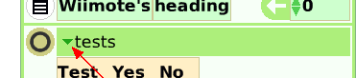

Now the important instruction is “connect”. If we run this instruction (by clicking on the yellow button with an exclamation sign) we will connect the Wiimote with Physical Etoys and then the tile which indicates if the Wiimote is connected will change its value to true.

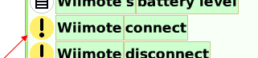

In order to verify that the Wiimote is functioning properly we have to open the “Wiimote-orient” category. There we will see three tiles: pitch, roll and yaw. Each of these values represents the angle in degrees of the Wiimote in the three axes. If we move the Wiimote we will notice that the values change.

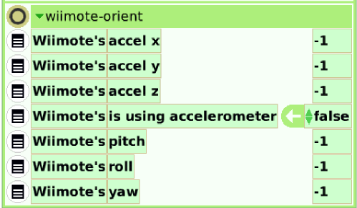

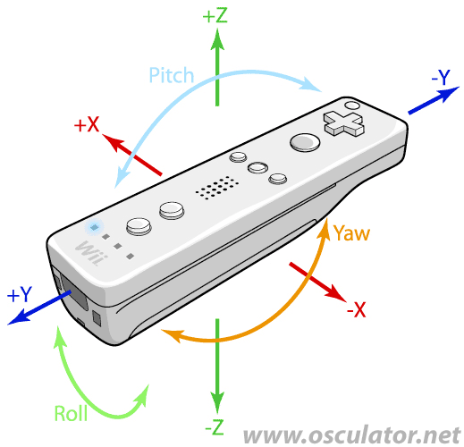

Rotating a star and changing its brightness with gestures

Now that the Wiimote is connected we will take profit of its moving detection features. We are going to rotate a star and change its brightness with our hand gestures.
First of all we have to get a star therefore we will go to the object catalog and then we open the “graphics” category. Once inside, we drag a star outside the catalog.

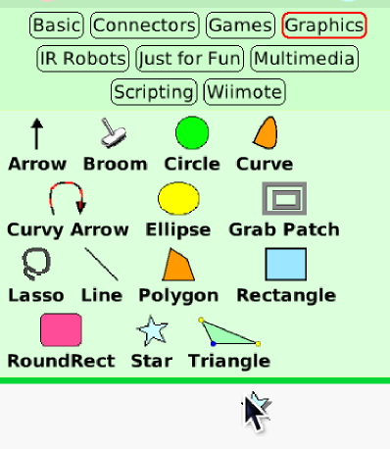
Now we will change its size by opening the halo and dragging the yellow button.



Then we open the viewer of the star and we go to the heading property (expressed in degrees). If we rotate the star by dragging the blue button of the halo we will see that the values of the heading property change.

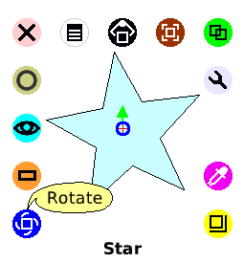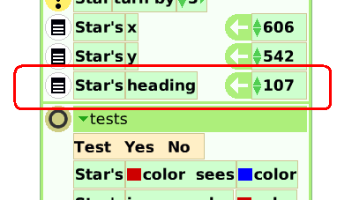

Now we will create a new script to associate the star’s heading with the Wiimote’s roll value. To create a new script we have to drag the heading tile from the white arrow and then we drop it on the screen. Before being dragged properly, the tile will be surrounded by a red rectangle.

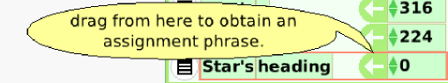

Once the tile is dropped a new script will be generated having this shape:

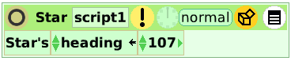

Now we have to go back to the Wiimote’s viewer and look for the roll property that is inside the “Wiimote-orient” category. Next we drag the “roll” tile and drop it on the appropriate place of the star’s script.

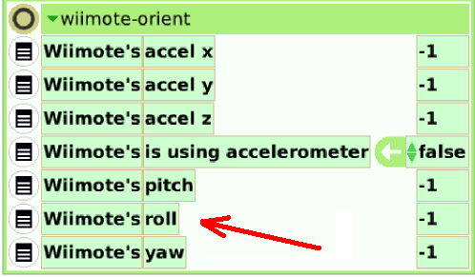

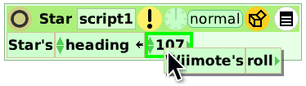
The script will be like this:

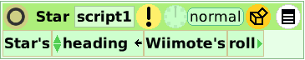

If we run the script, by clicking on the clock, we will see the star moving according to our hand movements.

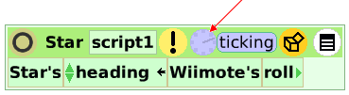

Now we go to the star’s viewer and then we look the geometry category. We have to drag like we have done previously the tile called “scale factor” and then we drop it inside the script. This tile defines how much the star will enlarge according to its value.

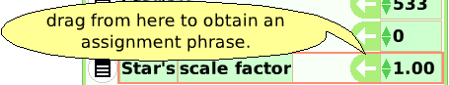

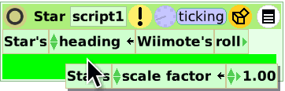

The script would be like this:

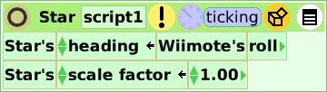

Next we will link the value of the “scale factor” of the star with the “pitch” value of the Wiimote. The “pitch tile” is in the “Wiimote-orient” category of the Wiimote’s viewer. Then we drag & drop in the right place.

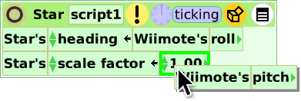
The script would be like this:

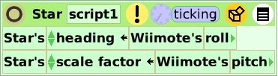

If we move the Wiimote we will see that not only the star’s heading but also its size will change according to our hand gestures. However, the size transformation may be abrupt. To fix this problem we can diminish the pitch value by adding a division to the tile. First we have to click the little triangle which is on the right hand side of the Wiimote pitch.

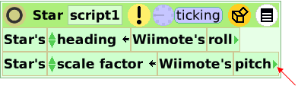

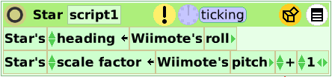

This will add a few options to deal with mathematical operations in order to change the pitch value. By default, a tile to add 1 will appear but we can change it to make every type of operations. In our case we need to turn the sum into a division. We have to click on the “+” and then we choose from the list the right operator.

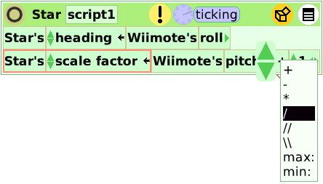

Finally we have to modify the value of the divisor to insert a coherent value. Beware of making a zero division.

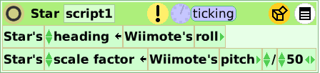

Changing a star’s color by pressing a button of the Wiimote

Now we are going to make a little modification of the script abovementioned in order to change the star’s color by pressing a button of the Wiimote. First we have to click the button which has a box and then we choose a “Test tes/no” tile.

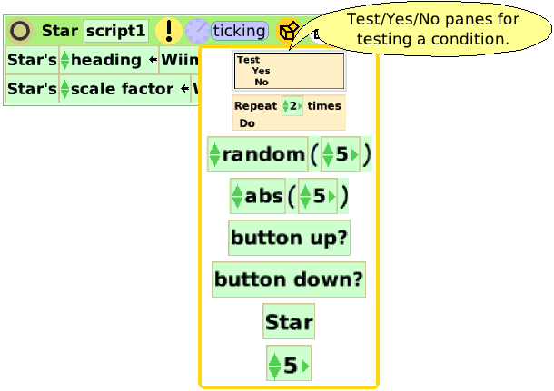

This tile means that the script will do something depending on a statement (in this case if the button a is pressed).

Now we drag the tile inside the script:

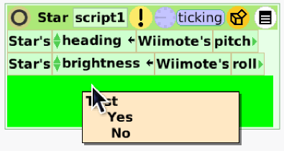
Next we have to open the Wiimote’s viewer and look for the “Wiimote-buttons” category. Then we have to drag the button A’s tile and drop it on the right place of the test condition.

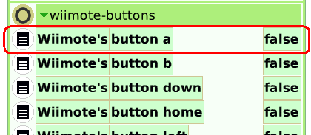

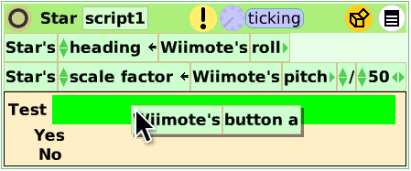

Now we need the instruction that modifies the star’s color, therefore, we have to go to the star’s viewer, enter to the color category and look the “hue” tile. To ensure that the tile is functioning properly we can alter its value to another one near zero and we will see that the star will become pinkish.

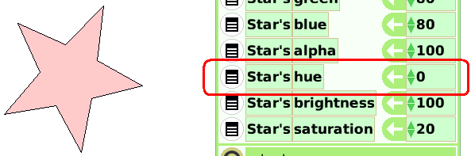

Then we drag the “hue” tile from the arrow up to the “yes” of the “Test yes/no” tile.

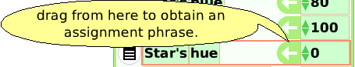

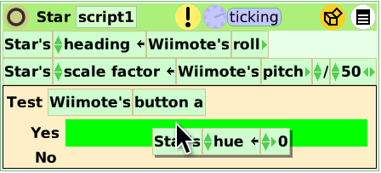

Now we are going to assign a random “hue” value every time that the Wiimote’s button A is pressed. So we have to click on the orange button which is similar to a box and then we look for the “random()” tile.

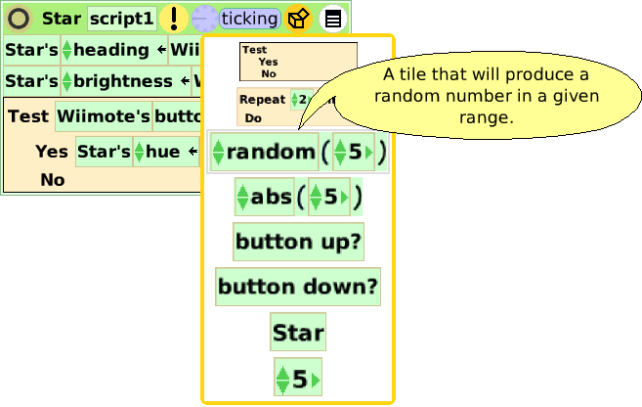

We drag & drop it on the right place of the script.

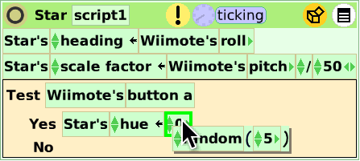

The number that is inside the parentheses of the random tile indicates the range of the numbers in which the system provides a new one. In this case the random number will be between 0 and 5. As we can see these values are very small and they are not good enough to modify the star’s color. That’s why we have to change it to a bigger one. E.g.: 180.
The final script will be more or less like this:

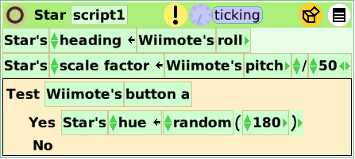

If the script is running we will see that when we press the Wiimote’s button A, the star’s color will change.

Conclusion

Well, that is basically all that we need to begin using the Wiimote. The possibilities of interaction between the computers and the Wiimote that Physical Etoys provides are very numerous to deal with everyone in this small tutorial. We encourage you to discover the other ones by exploring the environment (testing, playing, touching and breaking if it is necessary)

Have fun!

