Python Project Report
-- Stock Price Tracker --
Description:
Stock Price Tracker with Email & Desktop Alerts Using Python
Objective:
The main objective of this project is to track real-time stock prices and notify users via email and desktop notifications whenever there is a change in stock prices or at fixed intervals (e.g., every 5 minutes). The system allows users to select the stock symbol and enter their email to receive notifications.
Problem Statement:
Stock market fluctuations happen in real-time and can significantly impact decision-making.
Many users lack a convenient way to monitor prices without checking stock apps constantly. This project solves that problem by automatically alerting the user.
Technologies Used:
Technology Purpose
PythonMain programming language
VS Code Code editor
yfinance To fetch real-time stock data
plyer For desktop notifications
schedule For scheduling alerts every 5 min
mailjet_rest To send real-time email alerts

Features:
-> User-friendly: Takes input for stock symbol and recipient email from the user.
-> Real-Time Alerts: Sends email instantly when stock is selected.
-> Interval Alerts: Sends alerts every 5 minutes.
-> Price Change Detection: Sends alert when price changes even before 5 min.
-> Desktop Notifications: Sends a pop-up notification on your system.
-> Multi-stock Tracking: Track multiple stocks at once.
-> Scalable: Can be extended to SMS alerts and more.
Working Process:
User runs the Python script.
Enters one or more stock symbols (e.g., AAPL, MSFT).
Enters the receiver's email address.
App fetches the real-time stock prices using yfinance.
Sends the first alert instantly.
Schedules continuous updates every 5 minutes.
Also detects price changes in real-time and notifies via email.
Security:
Uses Mailjet Email API which is more secure than using regular email passwords.
No need to expose your personal email password.
Files Included:
File Name Description
Report_Stock_Tracker It’s the complete report of the stock_tracker
stock_tracker.py Main Python file for stock tracking logic requirements.txt List of dependencies for the project README.txt How to run the project and install dependencies

Sample Output:
After running the code it shows like:
Enter the stock symbols (e.g. AAPL,GOOG): AAPL,TSLA
Enter the email to receive alerts: user@example.com
Instant Email Sent: AAPL is ₹188.30
Instant Email Sent: TSLA is ₹743.20
Stock tracker is running...
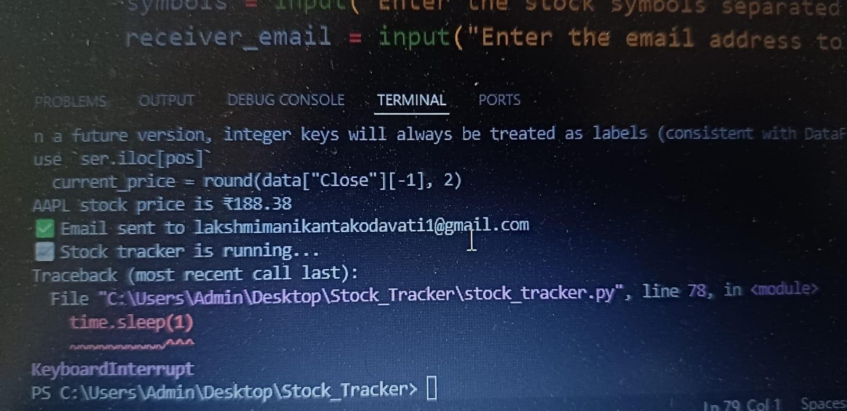
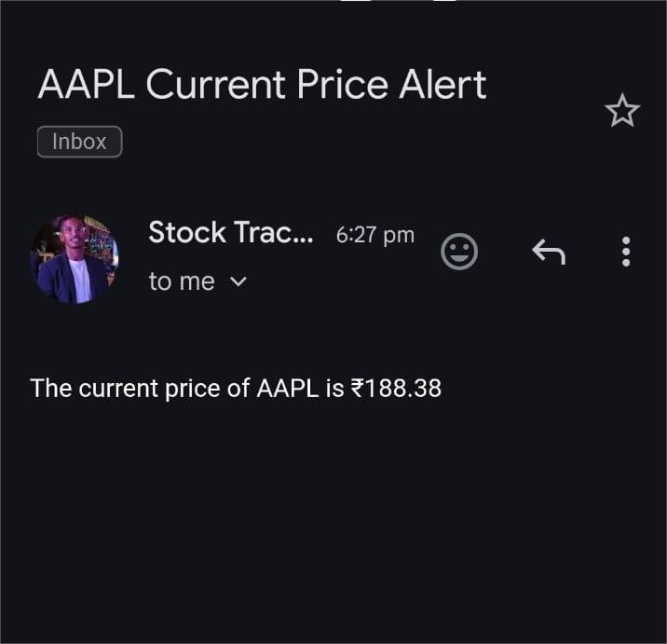
Hence receiver will be updated .
How to Run:
Install Python (from python.org) Open terminal in the project folder
Run: bash
Copy
Edit pip install -r requirements.txt python stock_tracker.py
Future Enhancements:
Add SMS Alerts using Twilio or other APIs.
Develop a GUI using Tkinter or PyQt.
Add option to set custom alert thresholds.
Deploy the app on a cloud platform (e.g., AWS or Heroku).
Developed By:
-> SEETHA LOKESH - AP23110011424
-> PECHETI SHYAM SAI KUMAR – AP23110011436
-> MUDDDAPATI TEJESH – AP23110011438
-> POLOMURU SAI GIREESH – AP23110011444

