**IOT_PHASE5**

**Final Submission**

**SMART WATER MANAGEMENT**

**TEAM NAME: Proj_228484_Team_1**

**Team Members:**

**V.Santhoshkumar(210621106046)**

**P Giridharan(210621106020)**

**Prithiviraj T K(210621106040)**

**Lathesh M(210621106031)**

**Madhan S(210621106033)**

**INTRODUCTION:**

Water is a finite and essential resource, and its efficient management is vital for meeting the growing demands of urbanization while preserving the environment. Smart water management involves the integration of technology, data analytics, and innovative solutions to optimize water distribution, reduce waste, and improve water quality.

**PHASE 1:**

**Problem Definition:**

The problem at hand revolves around the efficient management of water resources. This includes aspects such as allocation, distribution, and conservation. Key issues may include:

1. Uneven Distribution: Unequal access to clean water sources leading to water scarcity in certain regions.
2. Wastage: Inefficient usage of water in various sectors like agriculture, industrial processes, and households.
3. Environmental Impact: Depletion of natural water bodies, and ecological harm due to improper water management practices.

**Design Thinking:**

1. Empathize:

- Conduct in-depth interviews, surveys, and research to understand the perspectives and pain points of stakeholders involved (communities, industries, environmentalists, etc.).

2. Define:

- Summarize the findings from the empathize phase to form a clear and concise problem statement. For example: "The current water management system is ineffective in distributing water equitably, leading to scarcity in certain regions."

3. Ideate:

- Brainstorm potential solutions and innovations. Encourage creativity and diverse viewpoints. Consider ideas like smart metering, IoT-based monitoring, rainwater harvesting, and sustainable practices.

4. Prototype:

- Develop a preliminary design or model of the proposed solution. This might include schematics, flowcharts, or mock-ups of the technology or system.

5. Test:

- Conduct simulations or small-scale trials to assess the functionality, feasibility, and effectiveness of the prototype. Gather feedback from stakeholders and make necessary adjustments.

6. Iterate:

- Based on the feedback and test results, refine the prototype and repeat the testing process. Iterate as needed to improve the solution's efficacy.

7. Implement:

- Once the prototype is refined and proven effective, move towards full-scale implementation. This may involve collaboration with local authorities, NGOs, and relevant stakeholders.

8. Monitor and Evaluate:

- Implement a monitoring system to track the performance of the solution. This could include data collection, analysis, and regular assessments to ensure it meets the desired outcomes.

9. Feedback and Adaptation:

- Continuously seek feedback from end-users and stakeholders. Make necessary adaptations or improvements based on evolving needs and technology advancements.

10. Scaling:

- If successful, consider strategies for scaling the solution to broader regions or communities facing similar water management challenges.

**PHASE2(INNOVATION):**

**Project Overview:**

The WaterGuard project aims to revolutionize water management through the implementation of cutting-edge technology and data-driven solutions. By combining IoT devices, advanced sensors, and artificial intelligence, WaterGuard will provide real-time monitoring, analysis, and control of water usage in residential, commercial, and industrial settings.

**Key Features and Components:**

1.Smart Water Meters:Deploy high-precision IoT-enabled water meters to accurately measure and monitor water consumption at various points.

1. Leak Detection and Prevention: Utilize AI algorithms to detect anomalies in water flow patterns, signaling potential leaks or wastage. Implement automatic shut-off valves in critical areas to prevent further damage.
2. Predictive Analytics: Leverage historical data and machine learning models to forecast water demand, enabling proactive adjustments to supply and distribution systems.

1. User-Friendly Dashboard: Develop an intuitive web and mobile application that provides users with real-time insights into their water consumption, leak alerts, and personalized water-saving tips.

1. Integration with Weather Data: Integrate weather forecasts and real-time data to optimize irrigation systems, ensuring efficient use of water resources for landscaping and agriculture.

1. Water Quality Monitoring: Include sensors to measure water quality parameters like pH, turbidity, and contaminants, ensuring safe and potable water supply.

1. Automated Reporting and Compliance:Generate detailed reports on water usage, savings achieved, and compliance with local water regulations. Provide automated notifications for regulatory requirements.

1. Community Engagement and Education: Implement outreach programs, workshops, and educational materials to raise awareness about water conservation and the benefits of using smart water management systems.

**Implementation Strategy:**

1. Conduct a pilot program in a select community to test and refine the technology and user experience.

1. Collaborate with local water utilities, municipalities, and environmental organizations for data sharing and support.

1. Seek partnerships with manufacturers of water-related products and IoT devices for seamless integration.

1. Secure funding through grants, private investors, and government initiatives focused on water conservation and sustainability.

By executing the WaterGuard project, we aim to create a more sustainable and efficient water management system that benefits both individuals and communities while contributing to a healthier planet.

**CODE:**

# Import necessary libraries import random import time

# Define water level sensor function (simulated) def get_water_level():

return random.randint(0, 100) # Simulated water level

# Define pump control function (simulated) def control_pump(on):

if on:

print("Pump is turned ON")

else:

print("Pump is turned OFF")

# Define main function for water management def water_management():

while True:

water_level = get_water_level()

if water_level < 30: # Adjust threshold based on your needs control_pump(True) # Turn on pump

else:

control_pump(False) # Turn off pump

time.sleep(60) # Adjust interval based on your needs

# Execute the water management system if _name__ == "__main__": water_management()

**Benefits:**

Water Conservation: Significantly reduce water wastage, leading to conservation of a precious resource and lower water bills for consumers.

Cost Savings:Enable users to make informed decisions about their water usage, resulting in reduced water bills and potential incentives for water-saving behaviors.

Environmental Impact: Contribute to a more sustainable environment by conserving water resources and reducing energy consumption associated with water treatment and distribution.

Data-Driven Insights: Provide valuable data for city planners, utilities, and policymakers to make informed decisions about infrastructure investments and resource allocation.

Resilience to Water Scarcity: Enhance the ability to manage water resources during periods of drought or water scarcity, ensuring a consistent and reliable water supply.

**PHASE 3 (DEVELOPMENT PART 1):**

**Objectives:**

* To understand the importance of smart water management in the context of sustainable development.
* To analyse existing literature and case studies on smart water management.
* To identify relevant technologies for efficient water management.
* To outline implementation strategies for smart water systems.
* To evaluate the benefits and challenges associated with smart water management.

**Literature Review**

This section provides an in-depth review of the existing literature, including research papers, reports, and case studies on smart water management. It discusses the global significance of water management, the role of technology, and key challenges.

**Methodology**

The research methodology involves a combination of quantitative and qualitative approaches. Data collection includes surveys, interviews, and data analysis, with a focus on understanding the current water management practices in urban areas.

**Data Collection and Analysis**

This section details the data collection process and presents the findings. It provides insights into current water usage patterns and challenges faced in water management.

**Technologies for Smart Water Management**

The report explores various technologies such as IoT sensors, data analytics, and remote monitoring that play a crucial role in smart water management systems.

**Implementation Strategies**

This section outlines strategies for the implementation of smart water management systems, including infrastructure development, policy changes, and public awareness campaigns.

**Simulation Code**

#define PIN_TRIG 26

#define PIN_ECHO 25

#define LOWLED 18

#define MIDLED 19

#define HIGHLED 21

#define MOTOR 27

Unsigned int level = 0;

Void setup() {

pinMode(LOWLED, OUTPUT); pinMode(MIDLED, OUTPUT); pinMode(HIGHLED, OUTPUT); pinMode(MOTOR, OUTPUT); digitalWrite(LOWLED, HIGH); digitalWrite(MIDLED, HIGH); digitalWrite(HIGHLED, HIGH); digitalWrite(MOTOR, LOW);

Serial.begin(115200); pinMode(PIN_TRIG, OUTPUT); pinMode(PIN_ECHO, INPUT);

}

Void loop() {

// Start a new measurement:

digitalWrite(PIN_TRIG, HIGH); delayMicroseconds(10); digitalWrite(PIN_TRIG, LOW);

// Read the result:

Int duration = pulseIn(PIN_ECHO, HIGH);

Serial.print(“Distance in CM: “);

Serial.println(duration / 58); Serial.print(“Distance in inches: “);

Serial.println(duration / 148);

Level = (duration / 10);

If(level < 100)

{

digitalWrite(LOWLED, LOW); digitalWrite(MOTOR, HIGH); digitalWrite(HIGHLED, HIGH); digitalWrite(MIDLED, HIGH);

}

Else if ((level > 200 ) && (level < 400))

{

digitalWrite(LOWLED, HIGH); digitalWrite(HIGHLED, HIGH); digitalWrite(MIDLED, LOW);

}

Else if (level >= 400 )

{

digitalWrite(HIGHLED, LOW); digitalWrite(MIDLED, HIGH); digitalWrite(LOWLED, HIGH); digitalWrite(MOTOR, LOW);

}

Delay(1000);

}

**Simulation Link:**

[**https://wokwi.com/projects/378842842883994625**](https://wokwi.com/projects/378842842883994625)

**SIMULATION OUTPUT:**

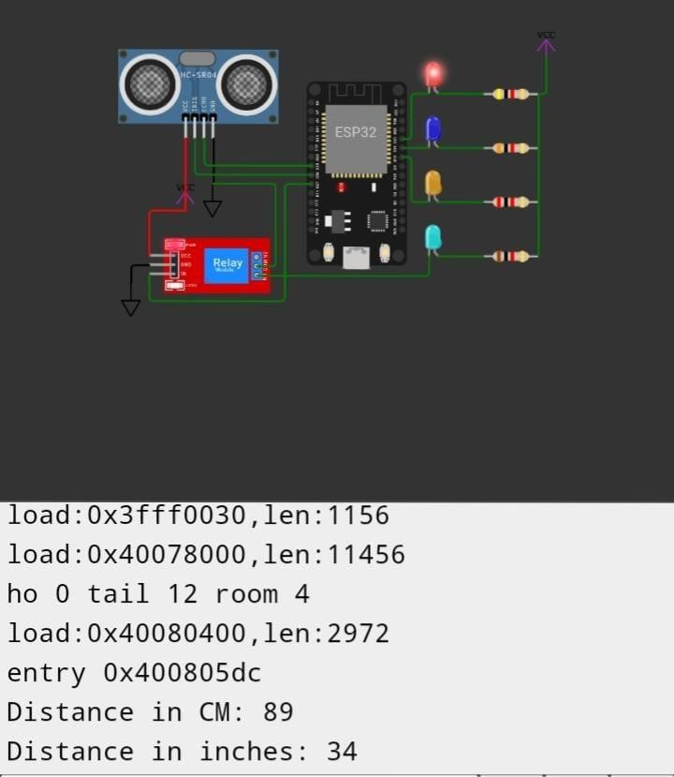

**Benefits and Challenges** The report discusses the benefits of smart water management, including water conservation, cost savings, and improved water quality. It also addresses the challenges, such as data security and infrastructure investments.

**PHASE 4(DEVELOPMENT PART 2):**

**Web Development code Using HTML**

<!DOCTYPE html>

<html lang=”en”>

<head>

<meta charset=”UTF-8”>

<meta name=”viewport” content=”width=device-width, initial-scale=1.0”>

<link rel=”stylesheet” type=”text/css” href=”styles.css”>

<title>Water Consumption Dashboard</title>

</head>

<body>

<header>

<h1>Water Consumption Dashboard</h1>

</header>

<section id=”data”>

<!—Display water consumption data here (

</section>

<section id=”promotion”>

<!—Promote water conservation efforts here (

</section>

<script src=”script.js”></script>

</body>

</html>

<style>

Body {

Font-family: Arial, sans-serif;

Margin: 0;

Padding: 0;

Background-color: #f0f0f0;

}

Header {

Background-color: #0077b6;

Color: white;

Text-align: center;

Padding: 20px;

}

#data {

Margin: 20px;

Padding: 20px;

Background-color: #ffffff;

Border: 1px solid #ddd;

}

#promotion {

Margin: 20px;

Padding: 20px;

Background-color: #ffffff;

Border: 1px solid #ddd;

}

</style> <script>

// Simulated data for demonstration purposes

Const waterData = [

{ date: ‘2023-10-01’, consumption: 150 }, { date: ‘2023-10-02’, consumption: 130 },

// Add more data here

];

Function displayWaterData() {

Const dataSection = document.getElementById(‘data’); dataSection.innerHTML = ‘<h2>Water Consumption Data</h2>’; for (const entry of waterData) { const div = document.createElement(‘div’); div.innerHTML = `<p>Date: ${entry.date}, Consumption: ${entry.consumption} gallons</p>`; dataSection.appendChild(div);

}

}

Function promoteConservationEfforts() {

Const promotionSection = document.getElementById(‘promotion’); promotionSection.innerHTML = ‘<h2>Water Conservation Efforts</h2>’;

const tips = [

‘Fix any water leaks in your home promptly.’,

‘Use low-flow faucets and showerheads to reduce water usage.’,

‘Water your garden during the cooler parts of the day to minimize evaporation.’,

// Add more conservation tips here

];

For (const tip of tips) {

Const p = document.createElement(‘p’);

p.textContent = tip; promotionSection.appendChild(p);

}

}

// Call the functions to display data and promote conservation efforts displayWaterData(); promoteConservationEfforts();

</script>

**Visual studio code:**

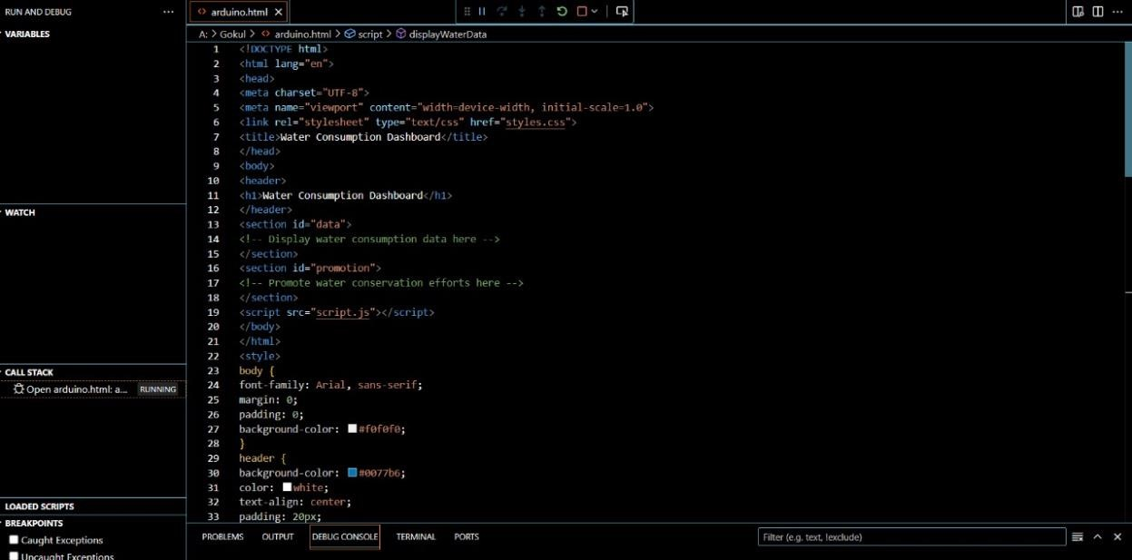

**Web Page Outlook:**

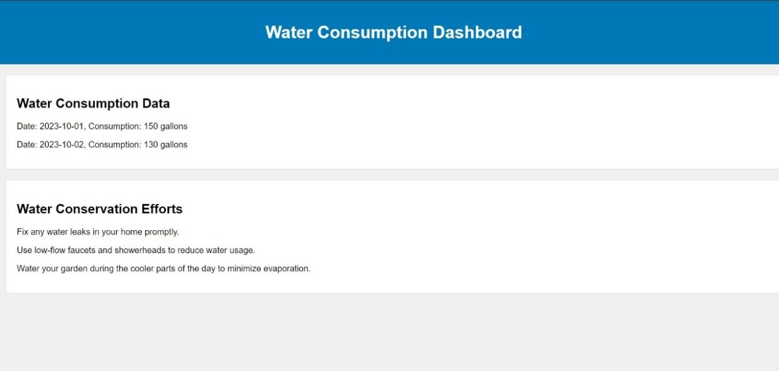

**Benefits and Challenges**

The report discusses the benefits of smart water management, including water conservation, cost savings, and improved water quality. It also addresses the challenges, such as data security and infrastructure investments.

**Summary:**

The provided text outlines a comprehensive plan for smart water management, divided into four phases: Introduction, Phase 1 (Problem Definition and Design Thinking), Phase 2 (Innovation), Phase 3 (Development Part 1), and Phase 4 (Development Part 2).

In the Introduction, it emphasizes the significance of efficient water management for urbanization and environmental preservation.

Phase 1 focuses on defining the water management problem, addressing issues like uneven distribution, wastage, and environmental impact. It employs Design Thinking methods, including empathy, ideation, prototyping, testing, and implementation.

Phase 2 introduces the WaterGuard project, which leverages IoT technology, advanced sensors, and AI for real-time water monitoring and control. Key features include smart water meters, leak detection, predictive analytics, and a user-friendly dashboard.

Phase 3 (Development Part 1) outlines objectives, literature review, methodology, data collection, technologies, implementation strategies, and simulation code for smart water management.

Phase 4 (Development Part 2) involves web development using HTML, creating a Water Consumption Dashboard to display consumption data and promote conservation efforts.

The Benefits and Challenges section highlights the advantages of smart water management, including conservation, cost savings, and improved water quality, while also addressing challenges like data security and infrastructure.

The conclusion emphasizes the importance of adopting smart water management to combat water scarcity and environmental issues.

**Conclusion**

The conclusion summarizes the key findings and emphasizes the importance of embracing smart water management to address water scarcity and environmenta**l** concerns.