Bandit Level 1 to Level 5

At this stage, I accessed the game using SSH. The required host is bandit.labs.overthewire.org on port 2220, with both the username and password as bandit0.
In the level 0, I log into the game using SSH. The host we need to connect is bandit.labs.overthewire.org, on port 2220. The username is bandit0 and the password is bandit0.

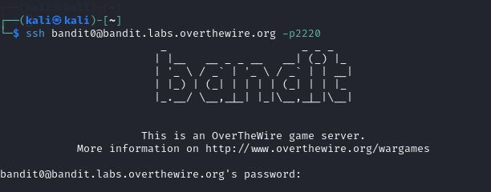

The password for this level is stored in a file named readme. To view the list of files, I ran the `ls` command, located the readme file, and used `cat readme` to retrieve the password.
The password for this level is stored in the file named readme.
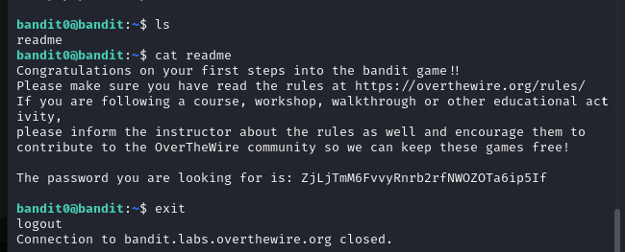

To view the list of files, I used the ls command and found a file named readme. I opened the file using the cat readme command, and I found the password for the next level.

The password for this level is in a file named '-'. After logging into Level 1 via SSH, I ran `ls` to list the files and used `cat ./-` to reveal the password.

The password for the next level is stored in a file named -.
First, I logged into level 1 using SSH and found password.

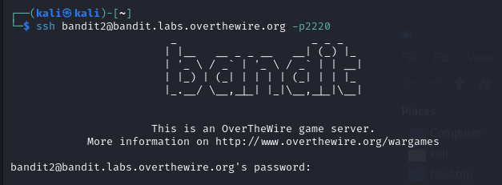
To view the list of files, I used the ls command, and to open the specific file named -, I used the command cat ./-. And I found the password for next level.

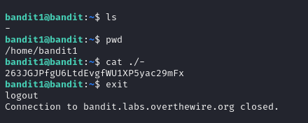
The password is in a file named 'spaces in this filename' located in the home directory. I accessed Level 2 using SSH, ran `ls` to locate the file, and used `cat "spaces in this filename"` to extract the password.
The password for the next level is stored in a file called spaces in this filename located in the home directory First, I logged into level 2 using SSH and found password.

To view the list of files, I used the ls command, and to open the specific file named -, I used the command cat “spaces in this filename”. And i found the password for next level.

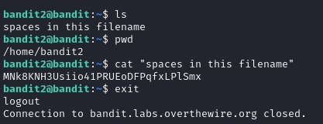
Level 3 → Level 4:
The password for the next level is stored in a hidden file in the inhere directory.
First, I logged into level 3 using SSH and found password.
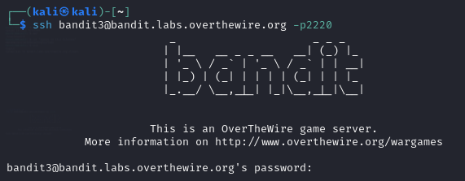
To view the list of files, I used the ls command, and it showed a directory named inhere. To enter the directory, I used the command cd inhere. After that, I ran the ls command again, but nothing was displayed, indicating there might be a hidden file.
To view hidden files, I used the ls -a command and found a hidden file named ...Hiding-From-You. I opened the file using the command cat ...Hiding-From-You. And i fond the password for next level.

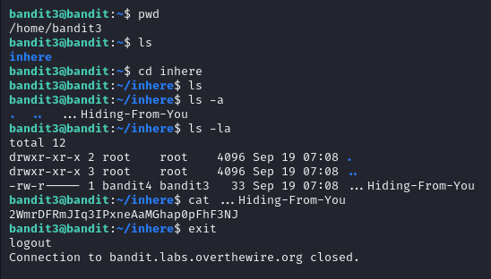
Level 4 → Level 5:
The password for the next level is stored in the only human-readable file in the inhere directory
First, I logged into level 4 using SSH and found password.
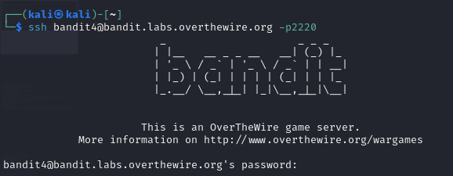
To view the list of files, I used the ls command, and it showed a directory named inhere. To enter the directory, I used the command cd inhere. After that, I ran the ls command again,it showed the list of files i simply open the all the file using cat ./-file{00..09} And where I found the correct password for next level.

