Bandit Level 5 to Level 10

The password is stored in a file within the 'inhere' directory, with the following properties: human-readable, 1033 bytes in size, and not executable.
The password for the next level is stored in a file somewhere under the inhere directory and has all of the following properties:
- human-readable
- 1033 bytes in size
- not executable

First, I logged into level 5 using SSH and used the password I found in the previous level.
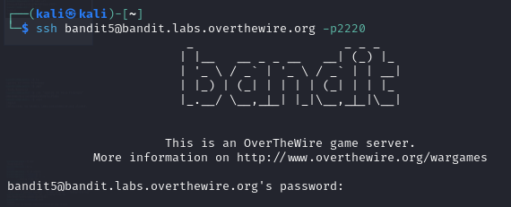
To view the list of files, I used the ls command, and it showed a directory named inhere. To enter the directory, I used the command cd inhere. After that, I ran the ls command again, it showed the so many directories. I wanted to find the file under the condition :human-readable,1033 bytes in size,not executable
So I used the command to find the password of next level: find . -type f -size 1033c ! -executable -exec ls -lh {} +
Explanation:
- find . → Search in the current directory and its subdirectories.
- -type f → Search for files (not directories).
- -size 1033c → Find files that are exactly 1033 bytes (the c
stands for bytes).
- ! -executable → Exclude executable files.
- -exec ls -lh {} → Display the file details in a human-readable format (-lh).

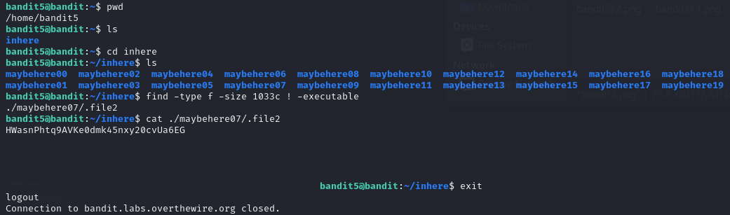

The password is located somewhere on the server with these attributes: owned by user 'bandit7', owned by group 'bandit6', and 33 bytes in size.
The password for the next level is stored somewhere on the server and has all of the following properties:
- owned by user bandit7
- owned by group bandit6
- 33 bytes in size

First, I logged into level 6 using SSH and used the password I found in the previous level.
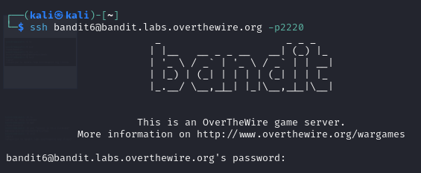
Based on the given properties in the question, I found the next level password by using the command to find the password of next level: find / -type f -user bandit7 -group bandit6 -size 33c 2>/dev/null
2>/dev/null → Suppress error messages (e.g., permissions denied).

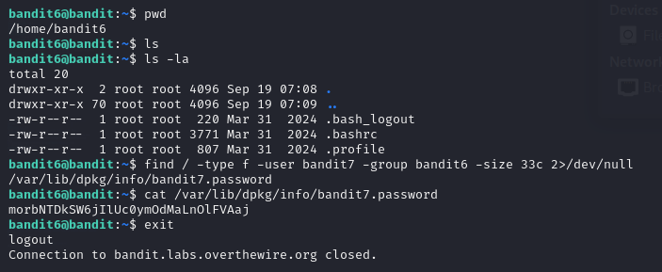
The password is stored in 'data.txt' and is found next to the word 'millionth'. To extract it, I used the command `cat data.txt | grep millionth`.
The password for the next level is stored in the file data.txt next to the word millionth.
First, I logged into level 7 using SSH and used the password I found in the previous level.
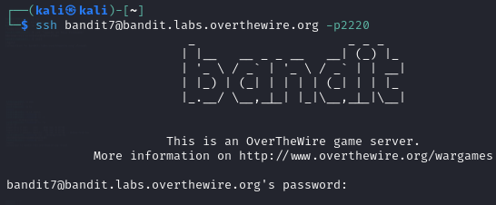
To view the list of directories or files, I used the ls command, and it showed a file named data.txt. Based on the question, the password is stored in the word millionth. To find this, I used the following command to find the password of next level:
cat data.txt | grep millionth
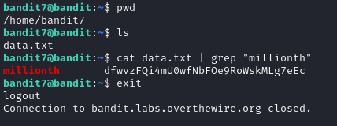
The password is in 'data.txt' and is the only line that appears exactly once. To find it, I ran `sort data.txt | uniq -u`.

The password for the next level is stored in the file data.txt and is the only line of text that occurs only once.
First, I logged into level 8 using SSH and used the password I found in the previous level.
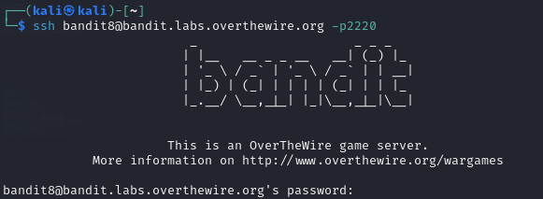
To view the list of directories or files, I used the ls command, and it showed a file named data.txt. Based on the question, to find the only line of text that occurs once, I used the following command to find the password of next level:: sort data.txt | uniq -u
uniq → This command filters out duplicate lines from the sorted output.
-u → This option specifically prints only the lines that are unique (appear exactly once).

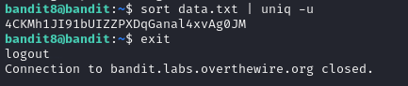
The password is in 'data.txt' and is among the few human-readable strings preceded by multiple '=' characters. To extract it, I used `strings data.txt | grep '='`.

The password for the next level is stored in the file data.txt in one of the few human-readable strings, preceded by several ‘=’ characters.
First, I logged into level 8 using SSH and used the password I found in the previous level.
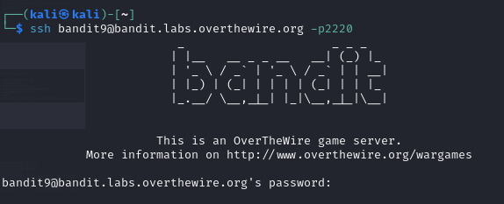
To view the list of directories or files, I used the ls command, and it showed a file named data.txt. Based on the Question , to find one of the few human-readable strings, preceded by several ‘=’ characters. So i used the following command to find the password of next level: strings data.txt | grep '='
