# System Information

| **Component** | **Details** |
| --- | --- |
| **CPU Processor** | Common KVM processor |
| **Number of CPU Cores** | 88 |
| **GPU(s)** | [NVIDIA L40], [NVIDIA L40] (2 GPUs, 48 GB Memory each) |

# Qiskit Benchmarks and Observations

## Conda Environment and Installation

| **Step** | **Command** |
| --- | --- |
| Create Environment | conda create -n qiskit0.45.1\_gpu python=3.10 -y |
| Activate Environment | conda activate qiskit0.45.1\_gpu |
| Install Packages | pip install qiskit==0.45.1 numpy matplotlib jupyterlab pandas openpyxl |
| Install qiskit-aer-gpu | pip install qiskit-aer-gpu==0.13.2 |

## Observations

| **Benchmark** | **GPU Usage** | **CPU Usage** | **Max Qubits** | **Notes** |
| --- | --- | --- | --- | --- |
| Deutsch-Jozsa | Single GPU | - | Up to 31 | - |
| Bernstein-Vazirani [Method-1 & 2] | Single GPU | - | Up to 31 | - |
| Hidden Shift | Single GPU | - | Up to 31 | - |
| QFT [Method-1 & 2] | Single GPU | - | Up to 31 | - |
| Hamiltonian Simulation | Single GPU | - | Up to 31 | - |
| Shor (1) | Single GPU | - | Up to 31 | Executes on CPU after 31 qubits |
| Shor (2) | Both GPUs | - | Up to 18 | Error: ValueError: Exceeds the limit (4300) after 18 qubits |
| HHL | Single GPU (up to 21 qubits), then CPU | CPU (using 1 core 100%) | Up to 21 (GPU), up to 25 (occasionally) | Execution shifts to CPU after 21 qubits {results: got fidelities=0 after 11th qubit} |
| VQE | CPU | CPU (using 1 core 100%) | Up to 12 | - |
| AE | CPU | CPU (using 1 core 100%) | - | Only CPU usage or minimal GPU usage |
| Grovers | CPU | CPU (using 1 core 100%) | - | Minimal GPU usage |
| PE | CPU (3% GPU usage for 20th qubit) | CPU (using 1 core 100%) | - | Minimal GPU usage |
| Monte Carlo | CPU | CPU (using 1 core 100%) | - | - |

## Installation and Uninstallation of qiskit-aer (as suggested in Qiskit-Aer-GPU-Doi.pdf)

| **Step** | **Command** |
| --- | --- |
| Install qiskit-aer | pip install qiskit-aer==0.13.2 |
| Uninstall qiskit-aer | pip uninstall qiskit-aer==0.13.2 -y |

### Observations After Uninstalling qiskit-aer

| **Benchmark** | **GPU Usage** | **CPU Usage** | **Max Qubits** | **Notes** |
| --- | --- | --- | --- | --- |
| Shor (1) | Single GPU | - | Up to 22 | Error: ValueError: Exceeds the limit (4300) after 22 qubits |
| Shor (2) | Both GPUs | - | Up to 14-16 | Error: ValueError: Exceeds the limit (4300) after 14-16 qubits |

## Effect of Increasing max\_circuits[¶](http://localhost:8890/lab/tree/observation_table.ipynb" \l "Effect-of-Increasing-max_circuits)

### Specific Observations for Increased max\_circuits

| **Benchmark** | **GPU Usage** | **Notes** |
| --- | --- | --- |
| Grovers | 5% GPU (11th qubit) | GPU reading fluctuates |
| Monte Carlo | Up to 65% GPU (11th qubit) | GPU usage increases for further qubits |
| PE | 0% to 50% | Varies between GPUs |
| AE | Minimal GPU usage | GPU usage appears rarely |

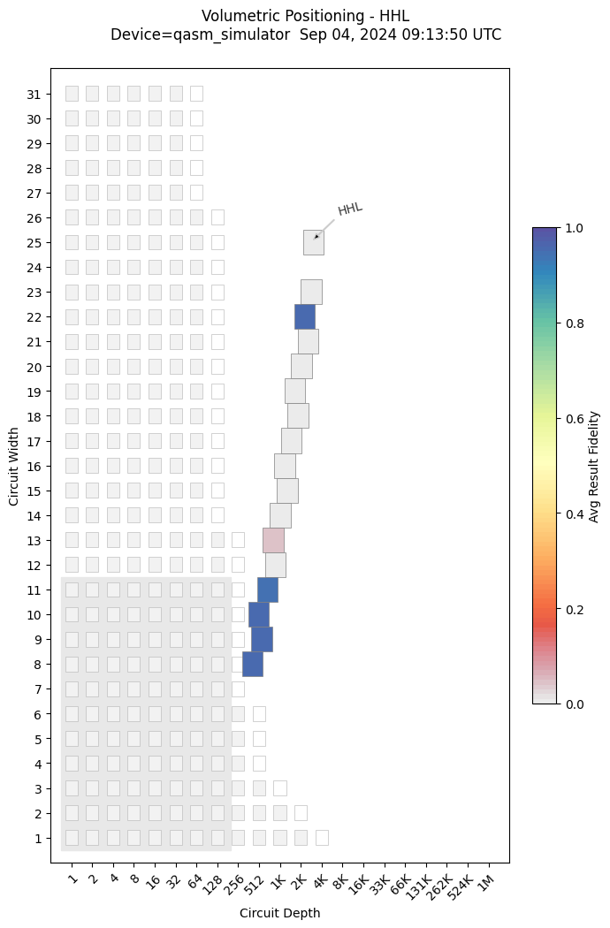

| **Benchmark** | **GPU Usage** | **CPU Usage** | **Max Qubits** | **Notes** |
| --- | --- | --- | --- | --- |

|  |  |  |  |  |
| --- | --- | --- | --- | --- |
| HHL | Single GPU (up to 21 qubits), then CPU | CPU (using 1 core 100%) | Up to 21 (GPU), up to 25 (occasionally) | Execution shifts to CPU after 21 qubits {results: got fidelities=0 after 11th qubit} |