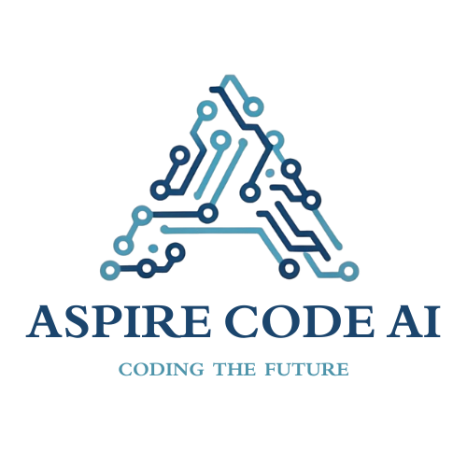
INTERNSHIP PROJECT REPORT
Project Title: Autonomous Research Assistant

Name / Intern ID | : | GIRI G / Intern ID: ____________________
Domain | : | AI Agentic Development
Duration | :
Time Period | :
Supervisor / Mentor | :
TL Name | :
Submitted Date : ____ / ____ / ________
Authority Signature  Founder & CEO  Aspire Code AI | Report Incharge  COO & CTO  Aspire Code AI

ABOUT ASPIRE CODE AI
Aspire Code AI is a next-generation technology startup specializing in Artificial Intelligence, Full-Stack Web Development, Business Analytics and Data Analytics. Our mission is to make AI-powered innovation accessible, scalable, and effective for businesses and educational institutions alike. Recognized under MSME India, we operate with professionalism, innovation, and a deep commitment to technological excellence.

VISION
To redefine the future of intelligent software by making AI-driven innovation accessible, scalable, and sustainable for every business.

MISSION
To deliver end-to-end AI and full-stack solutions that enhance productivity, automate workflows, and inspire creativity while maintaining transparency and excellence.

ACKNOWLEDGEMENT
I would like to express my sincere gratitude to Aspire Code AI for the opportunity to develop this project and for providing a structured internship programme and report format.
I thank the Aspire Code AI leadership, my project mentor, and team lead for their guidance and support during the internship. Their names and official certificate details can be added by the organization.
I am grateful to the team members and peers who offered feedback and assistance while I worked through the project requirements and implementation.
I also thank my family and friends for their encouragement and support.

GIRI G
Intern ID: ____________________

DECLARATION
I hereby declare that this internship project report titled "Autonomous Research Assistant" is a record of project work carried out by me during my internship at Aspire Code AI under the guidance of my mentor and team lead. This report has not been submitted, in full or in part, to any other organization or institution for any other purpose.
Place : ______________________
Date : ______________________
Signature of the Intern
GIRI G / Intern ID: ____________________

CERTIFICATE
This is to certify that GIRI G (Intern ID: ____________________) has successfully completed the internship project titled "Autonomous Research Assistant" in the domain of AI Agentic Development at Aspire Code AI for a duration of ____________________, from ____________________ to ____________________.
The work was carried out under the supervision of ____________________ and ____________________. The intern showed dedication, discipline, and a sound technical approach throughout the internship period. (For completion and signature by Aspire Code AI.)
Supervisor / Mentor  [Name]  Aspire Code AI | Team Lead  [Name]  Aspire Code AI
Report Incharge  COO & CTO  Aspire Code AI | Authority Signature  Founder & CEO  Aspire Code AI
TABLE OF CONTENTS

The Table of Contents is a Word field. Update the entire table after opening this report in Word so its page numbers match the final layout.

ABSTRACT
This project presents an educational Autonomous Research Assistant that organizes an initial web research pass from a user-provided topic. A Streamlit interface accepts the topic and a Quick, Standard, or Deep mode. A LangGraph workflow asks Google Gemini to generate search queries, uses Tavily to collect web result titles, URLs, and snippets, applies technical checks to source records, and retrieves relevant text from a local Chroma vector store. Gemini is used to analyze the retrieved excerpts and draft a structured report that preserves source titles and URLs. The implementation connects query generation, search, screening, retrieval, analysis, and writing as visible workflow stages. Run-level counts and source panels are displayed in the interface, and users can download the generated report as Markdown or plain text. The project demonstrates how graph orchestration and retrieval-augmented generation can support research organization. Its source checks verify fields and URL/content conditions; they do not independently prove that a source is authoritative or that every generated claim is correct. Outputs therefore require review against original sources. (Abstract: 172 words.)
[Type your abstract here.]

Keywords
Autonomous Research, Web Search, Retrieval-Augmented Generation, LangGraph, Streamlit

CHAPTER 1: INTRODUCTION

1.1 Background
Research work often requires repeating several manual steps: refining a topic, searching multiple queries, collecting sources, locating relevant passages, comparing evidence, and drafting an organized summary. Language models can help coordinate these steps, but generated text should remain tied to inspectable evidence. This project addresses that need with a web application that connects search and retrieval stages to report generation while exposing source information to the user.

1.2 Problem Statement
The project addresses the lack of a single, reviewable workflow for turning a research topic into a first-pass structured report. It coordinates query generation, web search, basic source screening, semantic retrieval, evidence-based analysis, and report writing while retaining source titles and URLs.

1.3 Objectives
- Accept a non-empty research topic and user-selected research depth through the Streamlit interface.
- Search the web using generated topic queries, then filter candidate records using explicit metadata, URL, content-length, and duplicate checks.
- Retrieve relevant source excerpts, generate analysis and a structured report, and display activity and evidence to the user.

1.4 Scope of the Project
The project covers the local Streamlit interface, sequential LangGraph workflow, Gemini and Tavily integration, basic source screening, run-scoped Chroma retrieval, report generation, and Markdown/text downloads. It does not provide independent fact-checking, guaranteed authoritative source selection, claim-level citation verification, or a published deployment. Search and model services require valid API access and internet connectivity.

1.5 Organisation of the Report
Chapter 1 introduces the problem, objectives, and scope. Chapter 2 records internship details and work chronology. Chapter 3 reviews related approaches and project technologies. Chapter 4 lists requirements. Chapter 5 presents architecture, data flow, state design, and methodology. Chapter 6 describes implementation and screenshot slots. Chapter 7 records the testing approach and source-defined results. Chapter 8 discusses technical considerations and learning outcomes. Chapter 9 concludes and identifies future work, followed by references and appendices.

CHAPTER 2: INTERNSHIP OVERVIEW

2.1 Intern Details
Particulars | Details
Name | GIRI G
Intern ID | ____________________
Domain | AI Agentic Development
Duration
Time Period
Supervisor / Mentor
Team Lead

2.2 Roles and Responsibilities
The project responsibilities represented in the repository include understanding the research workflow, implementing the Streamlit interface, connecting model and search services, defining source checks and retrieval, documenting architecture, and preparing the report. Edit these items to match the responsibilities formally assigned during the internship.
- Implement the research workspace and show workflow status and intermediate evidence.
- Build and document query generation, search, source screening, retrieval, analysis, and report-writing stages.
- Maintain setup guidance, describe system limitations, and prepare a technical project report.

2.3 Weekly Work Summary
Week | Dates | Activities / Tasks Completed | Outcome
Week 1
Week 2
Week 3
Week 4
Week 5
Week 6
Weekly dates and task chronology were not supplied. Complete the table below from your internship log; do not use project stages as a substitute for actual dates.

CHAPTER 3: LITERATURE / TECHNOLOGY REVIEW

3.1 Existing Systems / Related Work
Manual research requires switching between search, source review, note-taking, and drafting tools. Search-augmented language-model applications automate parts of this flow, while retrieval-augmented generation (RAG) adds semantically retrieved evidence to the model context. Embeddings support semantic search, and vector stores can keep text with metadata for retrieval [1, 2]. Graph-based orchestration makes nodes, shared state, and execution order explicit [3]. These methods improve workflow organization but do not guarantee factual accuracy, source quality, or complete coverage. Human review remains necessary.

3.2 Proposed Solution
The proposed solution combines a visible web interface with a fixed five-node graph. Search results retain titles, URLs, and snippets; code filters records with missing or malformed fields and duplicate URLs; chunks are stored with a run identifier so retrieval is limited to one run. Analyst and Writer prompts request evidence-bounded text and source URLs. This design treats validation as technical screening and asks users to review outputs.

3.3 Technologies and Tools Used
Category | Technology / Tool | Purpose
Programming Language | Python | Application and workflow implementation
Framework / Library | Streamlit, LangGraph, LangChain | Interface, graph orchestration, model/vector/text integrations
Database | ChromaDB local vector store | Persistent embedding-backed retrieval with metadata
AI / ML Tools | Google Gemini, Gemini embeddings, Tavily Search | Query generation, search, analysis, writing, embeddings
Version Control |  | Not specified in repository
Other Tools | python-dotenv | Loads API keys from local environment configuration

CHAPTER 4: SYSTEM ANALYSIS AND REQUIREMENTS

4.1 Functional Requirements
- Accept a non-empty topic and a supported research depth, then pass the request into the research workflow.
- Generate topic queries, search the web, and screen candidate records for required metadata and URL/content conditions.
- Retrieve current-run source excerpts, generate analysis and a structured report, and provide source URLs and text downloads.

4.2 Non-Functional Requirements
Usability: provide clear topic/depth inputs and expose each workflow stage. Reliability: report missing configuration, empty input, no verified-source outcomes, and service failures as applicable. Security: keep API credentials in private local environment configuration and out of source/report files. Traceability: retain source title, URL, topic, and run identifier on retrieved chunks. Performance and scalability were not benchmarked; behavior depends on service latency, search results, and local hardware.

4.3 Hardware Requirements
Component | Specification
Processor | No fixed minimum specified; use a modern computer capable of running Python.
RAM | Not specified in repository.
Storage | Local storage for the project and ChromaDB data; exact minimum not specified.
Other | Internet access required for Gemini and Tavily APIs.

4.4 Software Requirements
Software | Version / Details
Operating System | Windows setup commands are documented; Python app dependencies are in requirements.txt.
IDE / Editor | Not specified.
Runtime / Compiler | Python 3.10 or newer, per README.
Other | Streamlit, Gemini and Tavily API keys, internet access.

CHAPTER 5: SYSTEM DESIGN AND METHODOLOGY

5.1 System Architecture
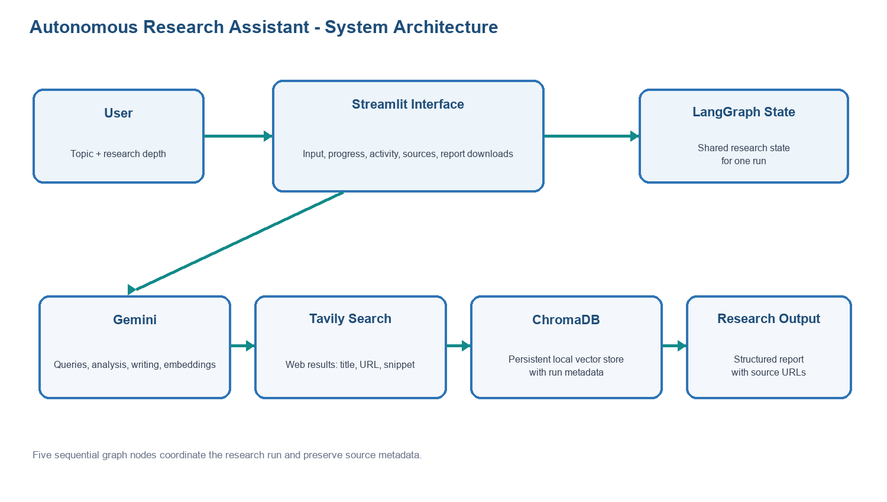
Figure 5.1: System Architecture

5.2 Workflow / Data Flow Diagram
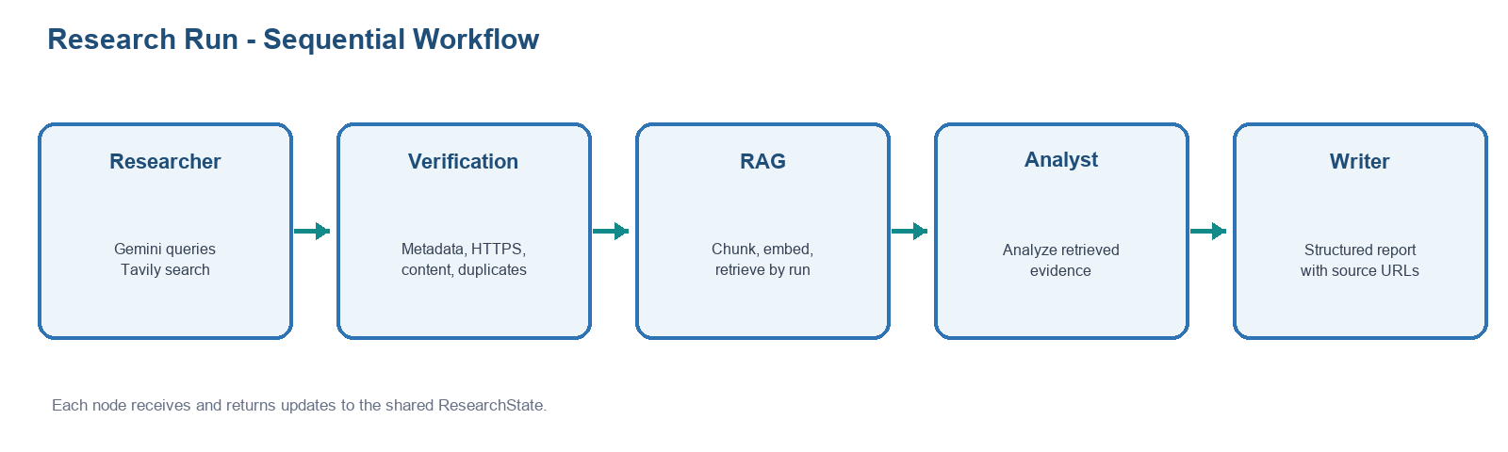
Figure 5.2: Workflow / Data Flow

5.3 Database Design / Data Model
The application has no relational business database. ResearchState is an in-memory structure containing topic, depth, run_id, queries, counts, source records, retrieved documents, analysis, and final report. ChromaDB is the local persistent vector store. Each chunk carries title, URL, topic, run_id, and source index; retrieval filters by run_id.

5.4 Methodology / Algorithm
1. Validate the topic and normalize research depth. 2. Ask Gemini for the configured query count. 3. Search each query with Tavily, collect title/URL/snippet fields, remove duplicate URLs, and apply the mode cap. 4. Reject records failing title, URL, HTTPS, minimum content length, or duplicate checks. 5. Split accepted text into 1,000-character chunks with 150-character overlap and attach metadata. 6. Store and retrieve up to 15 matching chunks filtered to the current run, then keep up to three unique source URLs. 7. Ask the Analyst to organize retrieved evidence. 8. Ask the Writer to create a structured report with source URLs. 9. Display results and downloads in Streamlit.

CHAPTER 6: IMPLEMENTATION

6.1 Module Description
Module | Description
Streamlit interface (app.py) | Collects topic/depth; streams workflow status; displays sources, metrics, analysis, report, and downloads.
Research and screening (main.py) | Generates queries, calls Tavily, deduplicates records, and checks source fields, URLs, and content.
RAG retrieval (main.py) | Splits source text, attaches metadata, stores embeddings in ChromaDB, and retrieves current-run context.
Analysis and writing (main.py) | Uses retrieved excerpts to create structured analysis and a report with source titles and URLs.

6.2 Key Code Snippets
The depth configuration controls query count, results per query, and candidate cap: Quick = (3, 2, 6), Standard = (5, 3, 10), and Deep = (8, 3, 16). The workflow also uses 1,000-character chunks, 150-character overlap, requests up to 15 retrieved chunks, and retains at most three unique source URLs for the Analyst.

6.3 User Interface / Output Screenshots
Insert your own application screenshots in the labeled spaces below. Suggested views are the topic/mode workspace, run activity and source pipeline, and final report with download options.
Figure 6.1: Main Research Workspace
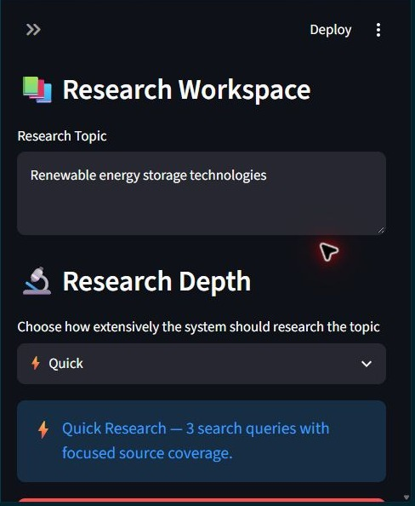
Figure 6.2: Workflow Status and Source Pipeline
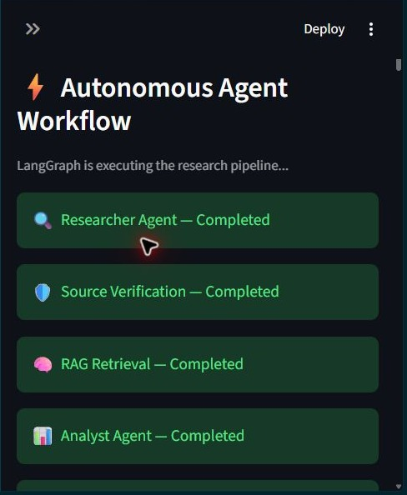
Figure 6.3: Final Report and Download Options
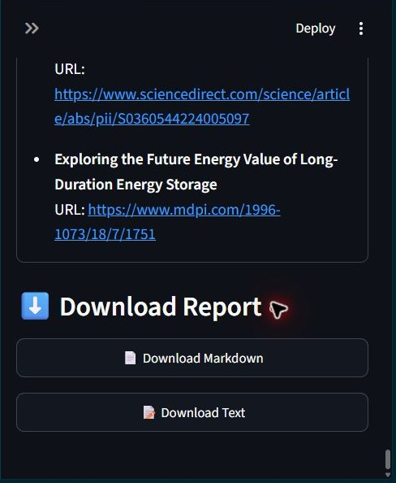

CHAPTER 7: TESTING AND RESULTS

7.1 Testing Approach
Testing should cover input validation, depth configuration, source screening, duplicate handling, retrieval run isolation, API failures, and output rendering. This report does not claim these tests were executed. The cases below list expected behavior; actual result/status are marked not executed for this report. Update them after running and recording tests.

7.2 Test Cases
ID | Test Case | Expected Result | Actual Result | Status
TC01 | Submit an empty topic | Input is rejected and research does not start | Warning displayed; research did not start. | PASS
TC02 | Select Quick / Standard / Deep | Configuration uses 3 / 5 / 8 queries with corresponding caps | Quick: 3 queries / 2 results per query / 6-source cap; Standard: 5 / 3 / 10; Deep: 8 / 3 / 16. | PASS
TC03 | Provide title, HTTPS URL, and content >=100 characters | Verifier accepts a non-duplicate record | Valid source with title, HTTPS URL, and content over 100 characters was accepted. | PASS
TC04 | Provide missing/short content, invalid URL, HTTP URL, or duplicate URL | Verifier rejects the record | Missing title or URL, malformed URL, HTTP URL, and short content were rejected; normalized duplicate URL was filtered. | PASS
TC05 | Run a valid research topic in Quick mode | Workflow completes and displays the report, source evidence, and download options | Completed: 3 queries, 6 search results, 6 verified sources, and 3 RAG sources; report and download options displayed. | PASS

7.3 Results and Analysis
The source code defines mode-dependent query counts; search and verification totals; up to three unique retrieved source excerpts; Analyst output; Writer report text; and Markdown/text downloads. These outputs are dynamic per run. No live API run or performance measurement was performed for this report, so no numerical research result is asserted. Add a genuine run screenshot and measured values if required by your evaluation.

CHAPTER 8: CHALLENGES AND LEARNING OUTCOMES

8.1 Challenges Faced and Solutions
Challenge | Solution Adopted
External service dependency | The workflow requires Gemini/Tavily keys and internet access; README documents private local .env setup.
Technical checks vs factual truth | The verifier uses metadata/content rules; report documents that these do not certify authority or truth.
Run-specific retrieval | Each chunk records run_id and similarity search filters on that identifier.

8.2 Technical Skills Gained
- Python application structure, environment configuration, and API integration.
- Graph workflow design with shared state and sequential nodes.
- Embedding-based retrieval, metadata filtering, and source-preserving report prompts.

8.3 Professional / Soft Skills Gained
The project provides practice in documenting a multi-stage workflow, explaining technical limits, separating expected behavior from verified results, and organizing implementation evidence for review. Add personal examples of teamwork, communication, time management, or problem-solving if these reflect your internship experience.

8.4 Contribution to Organisation
The repository contains an educational prototype that brings web search, source screening, semantic retrieval, analysis, and report writing into one interface. This can serve as a demonstrator or learning foundation for Aspire Code AI. No production deployment, user adoption, or organizational impact metric is documented in the supplied files.

CHAPTER 9: CONCLUSION AND FUTURE SCOPE

9.1 Conclusion
The project source implements the main path from research-topic input to a structured, downloadable report. Its sequential LangGraph nodes, mode-specific search configuration, run-scoped retrieval, and visible source pipeline provide an understandable prototype for organizing an initial research pass. The code supports the objectives of accepting a topic and depth, coordinating search and retrieval, and presenting report output. Factual accuracy and completeness depend on external responses and require human review.

9.2 Limitations
Source validation checks metadata and URL/content conditions; it does not establish authority or truth. Search snippets may omit original-page context. Model prompts cannot guarantee unsupported content will never appear. The workflow depends on Gemini, Tavily, internet connectivity, and private API keys. The repository contains no documented automated test results, user evaluation, benchmark, deployed demo, or claim-level citation audit.

9.3 Future Scope
- Add a human review step that opens source pages and checks important claims against cited text.
- Add bounded retries, clearer API-error recovery, and structured handling when search or retrieval returns too little evidence.
- Evaluate relevance, evidence support, coverage, latency, and repeatability on documented topics; add claim-level links or supporting excerpts where feasible.

REFERENCES
Primary documentation and project materials are listed below. Documentation access date: 27 October 2026.
- [1] Google AI for Developers, "Gemini API Embeddings," https://ai.google.dev/gemini-api/docs/embeddings.
- [2] Chroma, "Chroma Documentation: Introduction and Retrieval," https://docs.trychroma.com/. [3] LangChain, "LangGraph Graph API Overview," https://langchain-ai.github.io/langgraph/concepts/.
- [4] Streamlit, "st.text_area" and "st.download_button" API References, https://docs.streamlit.io/develop/api-reference/widgets/. [5] Tavily, Search API Documentation, https://docs.tavily.com/. [6] Project repository: README.md, main.py, app.py, requirements.txt.

APPENDICES

Appendix A: Complete Source Code
The accompanying source-code archive contains the project Python files, README.md, requirements.txt, and .env.example. The private .env file and local chroma_db runtime data are excluded. The main entry points are app.py (Streamlit interface) and main.py (LangGraph workflow).

Appendix B: Additional Screenshots / Diagrams
Optional additional screenshot or diagram
[PASTE SCREENSHOT HERE]

Appendix C: Project Links
Item | Link
GitHub Repository
Live Demo
Documentation
Demo Video

Appendix D: Mentor Feedback
Reserved for Mentor / Team Lead remarks. The evaluation table below is intentionally blank for the organization to complete.
Evaluation Parameter | Rating (out of 10) | Remarks
Technical Knowledge
Problem Solving
Punctuality & Discipline
Teamwork & Communication
Project Completion

