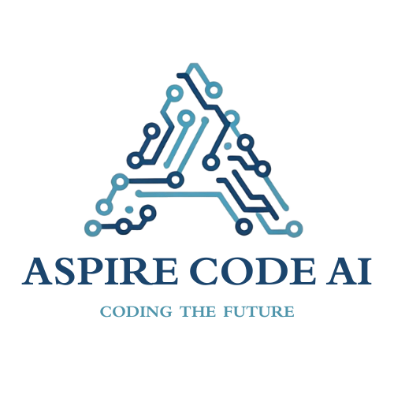
INTERNSHIP PROJECT REPORT
Project Title: Autonomous Research Assistant

Name / Intern ID | : | GIRI G / ACA/AIAGIS/0011/2026
Domain | : | AI Agentic Development
Duration | : | One month
Time Period | : | 28 August 2026 – 28 September 2026
Supervisor / Mentor | : | Arunachalam M, Founder & CEO
TL Name | : | Not identified in supplied documents
Submitted Date : ____ / ____ / ________
Authority Signature  Founder & CEO  Aspire Code AI | Report Incharge  COO & CTO  Aspire Code AI

ABOUT ASPIRE CODE AI
Aspire Code AI is a next-generation technology startup specializing in Artificial Intelligence, Full-Stack Web Development, Business Analytics and Data Analytics. Our mission is to make AI-powered innovation accessible, scalable, and effective for businesses and educational institutions alike. Recognized under MSME India, we operate with professionalism, innovation, and a deep commitment to technological excellence.

VISION
To redefine the future of intelligent software by making AI-driven innovation accessible, scalable, and sustainable for every business.

MISSION
To deliver end-to-end AI and full-stack solutions that enhance productivity, automate workflows, and inspire creativity while maintaining transparency and excellence.

ACKNOWLEDGEMENT
I would like to express my sincere gratitude to Aspire Code AI for the opportunity to develop this project and for providing a structured internship programme and report format.
I thank Aspire Code AI and my project mentor, Arunachalam M, Founder & CEO, for the opportunity and guidance associated with this internship project. I also acknowledge the Aspire Code AI team for providing the report format and technical context.
I am grateful to the team members and peers who offered feedback and assistance while I worked through the project requirements and implementation.
I also thank my family and friends for their encouragement and support.

GIRI G
Intern ID: ACA/AIAGIS/0011/2026

DECLARATION
I hereby declare that this report titled “Autonomous Research Assistant” describes my internship project work at Aspire Code AI under the guidance of Arunachalam M. The report is based on the project source, proposal, internship offer, and recorded application evidence available to me. I have identified any reconstructed work chronology and have not represented it as a verified daily log.
Place : ______________________
Date : ____ / ____ / ________
Signature of the Intern
GIRI G / Intern ID: ACA/AIAGIS/0011/2026

CERTIFICATE
This is to certify that GIRI G (Intern ID: ACA/AIAGIS/0011/2026) has completed the internship project titled “Autonomous Research Assistant” in the domain of AI Agentic Development at Aspire Code AI for a duration of one month, from 28 August 2026 to 28 September 2026.
The work was carried out under the supervision of Arunachalam M, Founder & CEO, Aspire Code AI. Official review, remarks, date, and signature are to be completed by Aspire Code AI.
Supervisor / Mentor  Arunachalam M  Founder & CEO / Aspire Code AI  Signature: ____________________ | Team Lead  Not identified in supplied documents  Aspire Code AI  Signature: ____________________
Report Incharge  COO & CTO  Aspire Code AI | Authority Signature  Founder & CEO  Aspire Code AI
TABLE OF CONTENTS

The Table of Contents is a Word field. Update the entire table in Microsoft Word after opening this report so page numbers match the final layout.

ABSTRACT
This project presents an educational Autonomous Research Assistant that organizes an initial web research pass from a user-provided topic. A Streamlit interface accepts the topic and a Quick, Standard, or Deep mode. A LangGraph workflow asks Google Gemini to generate search queries, uses Tavily to collect web result titles, URLs, and snippets, applies technical checks to source records, and retrieves relevant text from a local Chroma vector store. Gemini is used to analyze the retrieved excerpts and draft a structured report that preserves source titles and URLs. The implementation connects query generation, search, screening, retrieval, analysis, and writing as visible workflow stages. Run-level counts and source panels are displayed in the interface, and users can download the generated report as Markdown or plain text. The project demonstrates how graph orchestration and retrieval-augmented generation can support research organization. Its source checks verify fields and URL/content conditions; they do not independently prove that a source is authoritative or that every generated claim is correct. Outputs therefore require review against original sources. (Abstract: 172 words.)

Keywords
Autonomous Research, Web Search, Retrieval-Augmented Generation, LangGraph, Streamlit

CHAPTER 1: INTRODUCTION

1.1 Background
Research work often requires repeating several manual steps: refining a topic, searching multiple queries, collecting sources, locating relevant passages, comparing evidence, and drafting an organized summary. Language models can help coordinate these steps, but generated text should remain tied to inspectable evidence. This project addresses that need with a web application that connects search and retrieval stages to report generation while exposing source information to the user.

1.2 Problem Statement
The project addresses the lack of a single, reviewable workflow for turning a research topic into a first-pass structured report. It coordinates query generation, web search, basic source screening, semantic retrieval, evidence-based analysis, and report writing while retaining source titles and URLs.

1.3 Objectives
- Accept a non-empty research topic and user-selected research depth through the Streamlit interface.
- Search the web using generated topic queries, then filter candidate records using explicit metadata, URL, content-length, and duplicate checks.
- Retrieve relevant source excerpts, generate analysis and a structured report, and display activity and evidence to the user.

1.4 Scope of the Project
The project covers the local Streamlit interface, sequential LangGraph workflow, Gemini and Tavily integration, basic source screening, run-scoped Chroma retrieval, report generation, and Markdown/text downloads. It does not provide independent fact-checking, guaranteed authoritative source selection, claim-level citation verification, or a published deployment. Search and model services require valid API access and internet connectivity.

1.5 Organisation of the Report
Chapter 1 introduces the problem, objectives, and scope. Chapter 2 records internship details and work chronology. Chapter 3 reviews related approaches and project technologies. Chapter 4 lists requirements. Chapter 5 presents architecture, data flow, state design, and methodology. Chapter 6 describes implementation and screenshot slots. Chapter 7 records the testing approach and source-defined results. Chapter 8 discusses technical considerations and learning outcomes. Chapter 9 concludes and identifies future work, followed by references and appendices.

CHAPTER 2: INTERNSHIP OVERVIEW

2.1 Intern Details
Particulars | Details
Name | GIRI G
Intern ID | ACA/AIAGIS/0011/2026
Domain | AI Agentic Development
Duration | One month
Time Period | 28 August 2026 – 28 September 2026
Supervisor / Mentor | Arunachalam M, Founder & CEO
Team Lead | Not identified in supplied documents
Institution | Anand Institute of Higher Technology
Department | B.E. Computer Science and Engineering

2.2 Roles and Responsibilities
Project work covered the research workspace, topic and depth inputs, Gemini query generation, Tavily search integration, technical screening and duplicate filtering of source records, run-scoped Chroma retrieval, and evidence-oriented analysis and report generation. These responsibilities are described from the project artifacts; formal role allocation was not separately documented.
- Implement the research workspace and show workflow status and intermediate evidence.
- Build and document query generation, search, source screening, retrieval, analysis, and report-writing stages.
- Maintain setup guidance, describe system limitations, and prepare a technical project report.

2.3 Weekly Work Summary
Week | Dates | Activities / Tasks Completed | Outcome
Week 1 | 28 Aug – 3 Sep 2026 | Introduction to Agentic AI; building a Python AI agent; mini LLM and GPT-style language-model fundamentals from scratch; prompt engineering for agentic AI. | Training foundation in agent concepts, Python-based agents, language-model fundamentals, and prompt design.
Week 2 | 4 – 10 Sep 2026 | Gemini API and how it works; build a simple calculator agent in Dify and enable the calculator tool; mini LLM training with PyTorch. | Training topics covered model API use, tool-enabled agents, and introductory model training.
Week 3 | 11 – 17 Sep 2026 | Create a CrewAI multi-agent workflow in Colab; architecting agentic memory; RAG and RAG system architecture. | Training topics connected multi-agent orchestration, memory design, and retrieval-augmented generation.
Week 4 | 18 – 24 Sep 2026 | Gemini FAISS RAG starter; multi-agent blueprint for Agentic AI engineering; Agentic AI MCP with Gemini in Colab. | Training topics introduced vector retrieval and patterns for connecting agents with tools/context.
Week 5 | 25 – 28 Sep 2026 | Voice AI agent with Gemini in Colab (browser-ready); on 28 September, individual project allocation: Autonomous Research Assistant. | The assigned project title was Autonomous Research Assistant. The design and implementation are documented in later chapters.
Week 6 | Not applicable | The one-month offer period ended on 28 September 2026. | No sixth week falls within the documented internship period.
The following weekly summary groups the training topics in the sequence reported for the internship and aligns them to the offer period of 28 August–28 September 2026. The group chat contains class and phase-meeting notices, but does not verify the date of each lesson or GIRI G’s individual attendance; this is a curriculum summary, not an attendance log. On 28 September 2026, the individual project Autonomous Research Assistant was allocated to GIRI G.

CHAPTER 3: LITERATURE / TECHNOLOGY REVIEW

3.1 Existing Systems / Related Work
Manual research requires switching between search, source review, note-taking, and drafting tools. Search-augmented language-model applications automate parts of this flow, while retrieval-augmented generation (RAG) adds semantically retrieved evidence to the model context. Embeddings support semantic search, and vector stores can keep text with metadata for retrieval [1, 2]. Graph-based orchestration makes nodes, shared state, and execution order explicit [3]. These methods improve workflow organization but do not guarantee factual accuracy, source quality, or complete coverage. Human review remains necessary.

3.2 Proposed Solution
The proposed solution combines a visible web interface with a fixed five-node graph. Search results retain titles, URLs, and snippets; code filters records with missing or malformed fields and duplicate URLs; chunks are stored with a run identifier so retrieval is limited to one run. Analyst and Writer prompts request evidence-bounded text and source URLs. This design treats validation as technical screening and asks users to review outputs.

3.3 Technologies and Tools Used
Category | Technology / Tool | Purpose
Programming Language | Python | Application and workflow implementation
Framework / Library | Streamlit, LangGraph, LangChain | Interface, graph orchestration, model/vector/text integrations
Database | ChromaDB local vector store | Persistent embedding-backed retrieval with metadata
AI / ML Tools | Google Gemini, Gemini embeddings, Tavily Search | Query generation, search, analysis, writing, embeddings
Version Control | Not identified in supplied project files | No version-control tool is documented in the repository.
Other Tools | python-dotenv | Loads API keys from local environment configuration

CHAPTER 4: SYSTEM ANALYSIS AND REQUIREMENTS

4.1 Functional Requirements
- Accept a non-empty topic and a supported research depth, then pass the request into the research workflow.
- Generate topic queries, search the web, and screen candidate records for required metadata and URL/content conditions.
- Retrieve current-run source excerpts, generate analysis and a structured report, and provide source URLs and text downloads.

4.2 Non-Functional Requirements
Usability: provide clear topic/depth inputs and expose each workflow stage. Reliability: report missing configuration, empty input, no verified-source outcomes, and service failures as applicable. Security: keep API credentials in private local environment configuration and out of source/report files. Traceability: retain source title, URL, topic, and run identifier on retrieved chunks. Performance and scalability were not benchmarked; behavior depends on service latency, search results, and local hardware.

4.3 Hardware Requirements
Component | Specification
Processor | No fixed minimum specified; use a modern computer capable of running Python.
RAM | Not specified in repository.
Storage | Local storage for the project and ChromaDB data; exact minimum not specified.
Other | Internet access required for Gemini and Tavily APIs.

4.4 Software Requirements
Software | Version / Details
Operating System | Windows setup commands are documented; Python app dependencies are in requirements.txt.
IDE / Editor | Not specified.
Runtime / Compiler | Python 3.10 or newer, per README.
Other | Streamlit, Gemini and Tavily API keys, internet access.

CHAPTER 5: SYSTEM DESIGN AND METHODOLOGY

5.1 System Architecture
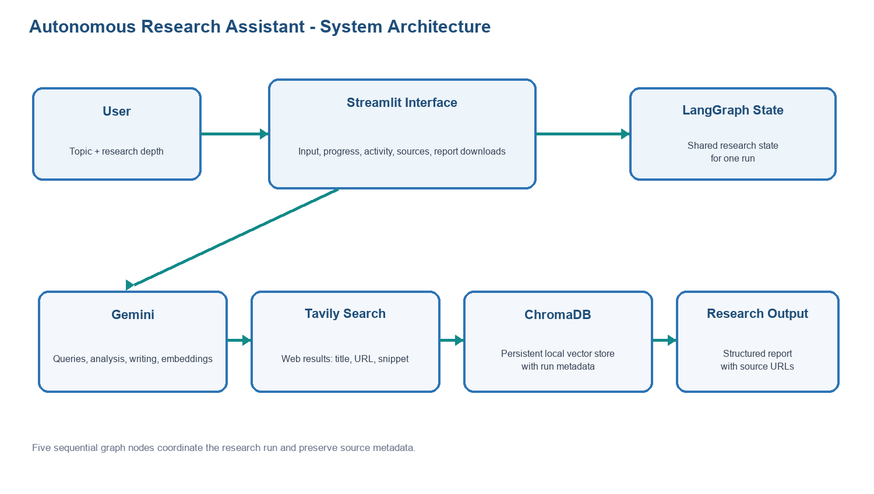
Figure 5.1: System Architecture

5.2 Workflow / Data Flow Diagram
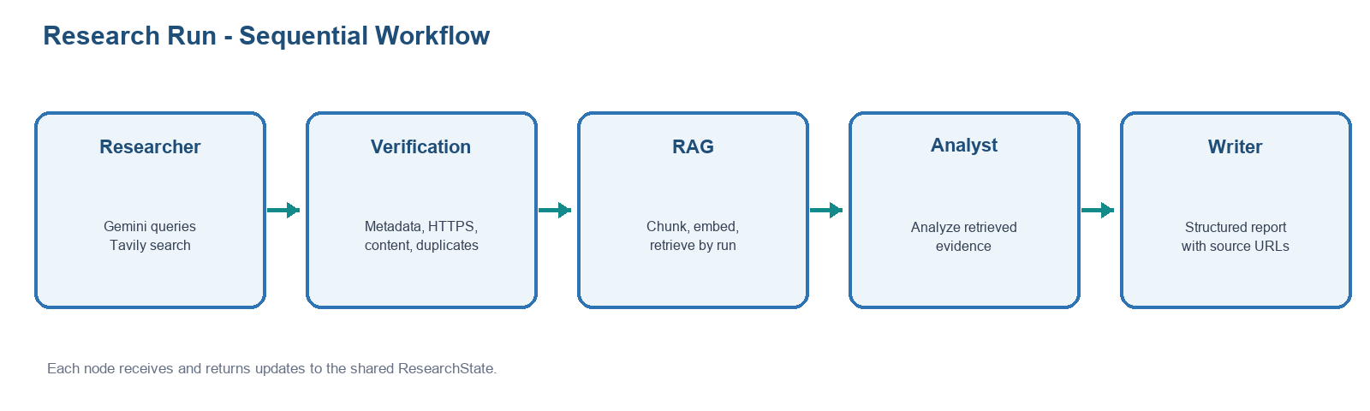
Figure 5.2: Workflow / Data Flow

5.3 Database Design / Data Model
The application has no relational business database. ResearchState is an in-memory structure containing topic, depth, run_id, queries, counts, source records, retrieved documents, analysis, and final report. ChromaDB is the local persistent vector store. Each chunk carries title, URL, topic, run_id, and source index; retrieval filters by run_id.

5.4 Methodology / Algorithm
1. Validate the topic and normalize research depth. 2. Ask Gemini for the configured query count. 3. Search each query with Tavily, collect title/URL/snippet fields, remove duplicate URLs, and apply the mode cap. 4. Reject records failing title, URL, HTTPS, minimum content length, or duplicate checks. 5. Split accepted text into 1,000-character chunks with 150-character overlap and attach metadata. 6. Store and retrieve up to 15 matching chunks filtered to the current run, then keep up to three unique source URLs. 7. Ask the Analyst to organize retrieved evidence. 8. Ask the Writer to create a structured report with source URLs. 9. Display results and downloads in Streamlit.

CHAPTER 6: IMPLEMENTATION

6.1 Module Description
Module | Description
Streamlit interface (app.py) | Collects topic/depth; streams workflow status; displays sources, metrics, analysis, report, and downloads.
Research and screening (main.py) | Generates queries, calls Tavily, deduplicates records, and checks source fields, URLs, and content.
RAG retrieval (main.py) | Splits source text, attaches metadata, stores embeddings in ChromaDB, and retrieves current-run context.
Analysis and writing (main.py) | Uses retrieved excerpts to create structured analysis and a report with source titles and URLs.

6.2 Key Code Snippets
The source code configures search breadth by research mode and connects the workflow as a fixed sequence. The following excerpts are shortened only to show the central configuration and graph order.
DEPTH_CONFIG = {
"quick": {"query_count": 3, "results_per_query": 2, "max_sources": 6},
"standard": {"query_count": 5, "results_per_query": 3, "max_sources": 10},
"deep": {"query_count": 8, "results_per_query": 3, "max_sources": 16},
}
Workflow order: START → researcher → source_verification → rag → analyst → writer → END

6.3 User Interface / Output Screenshots
The following figures use full-display captures of the running application. They document the research workspace, workflow/source pipeline, and completed report with download controls.
Figure 6.1: Main Research Workspace
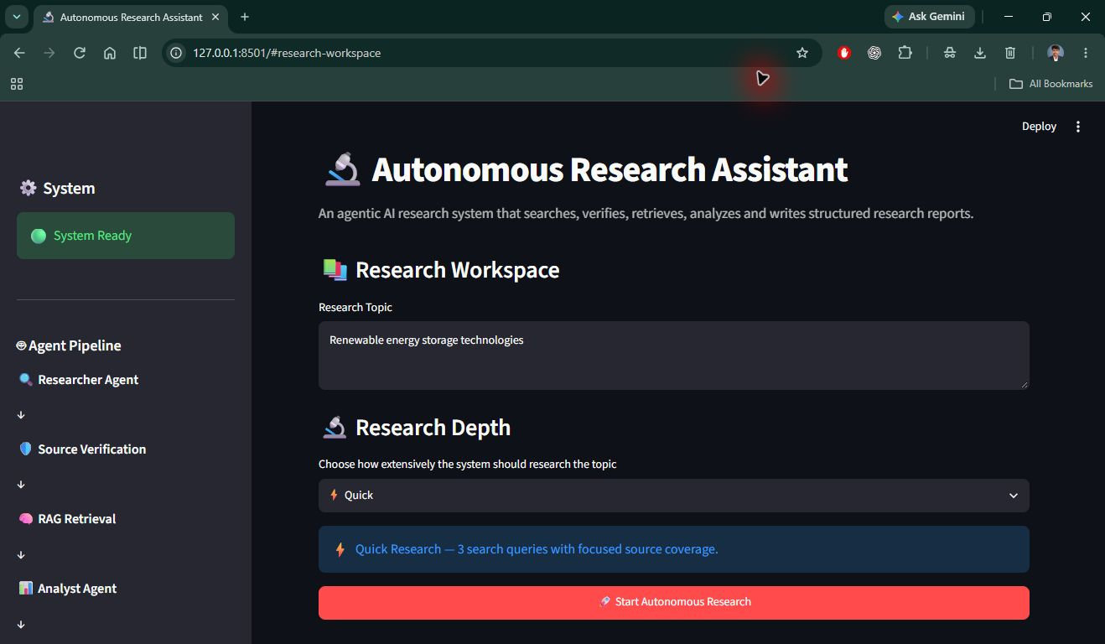
Figure 6.2: Workflow Status and Source Pipeline
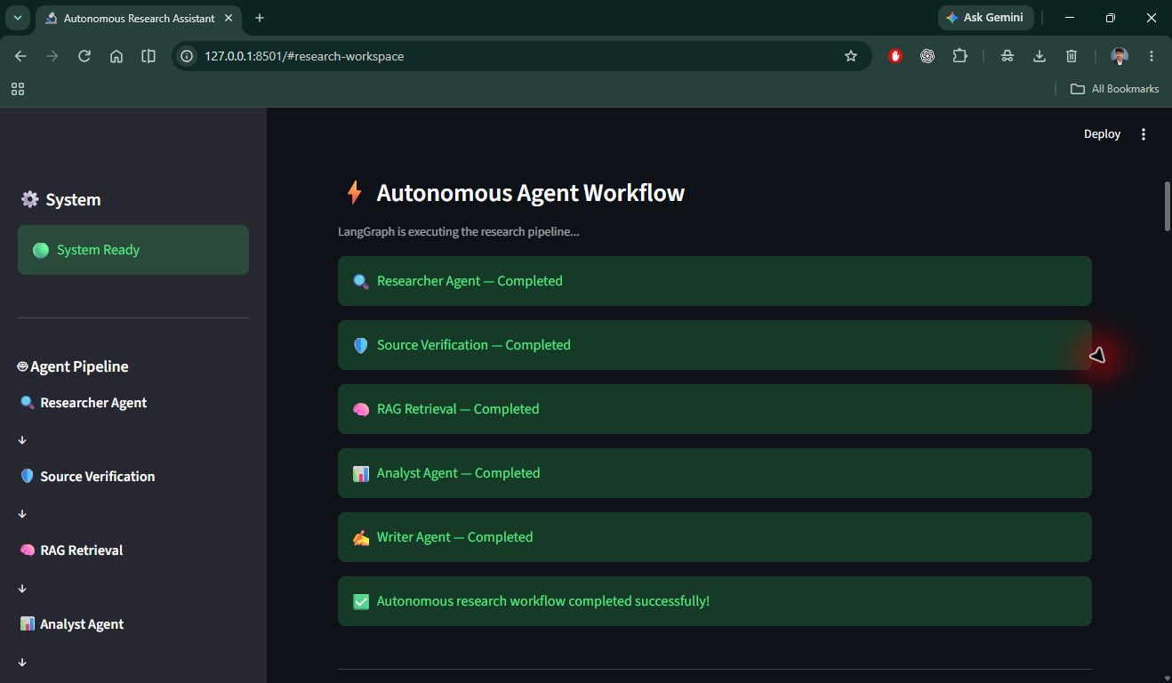
Figure 6.3: Final Report and Download Options
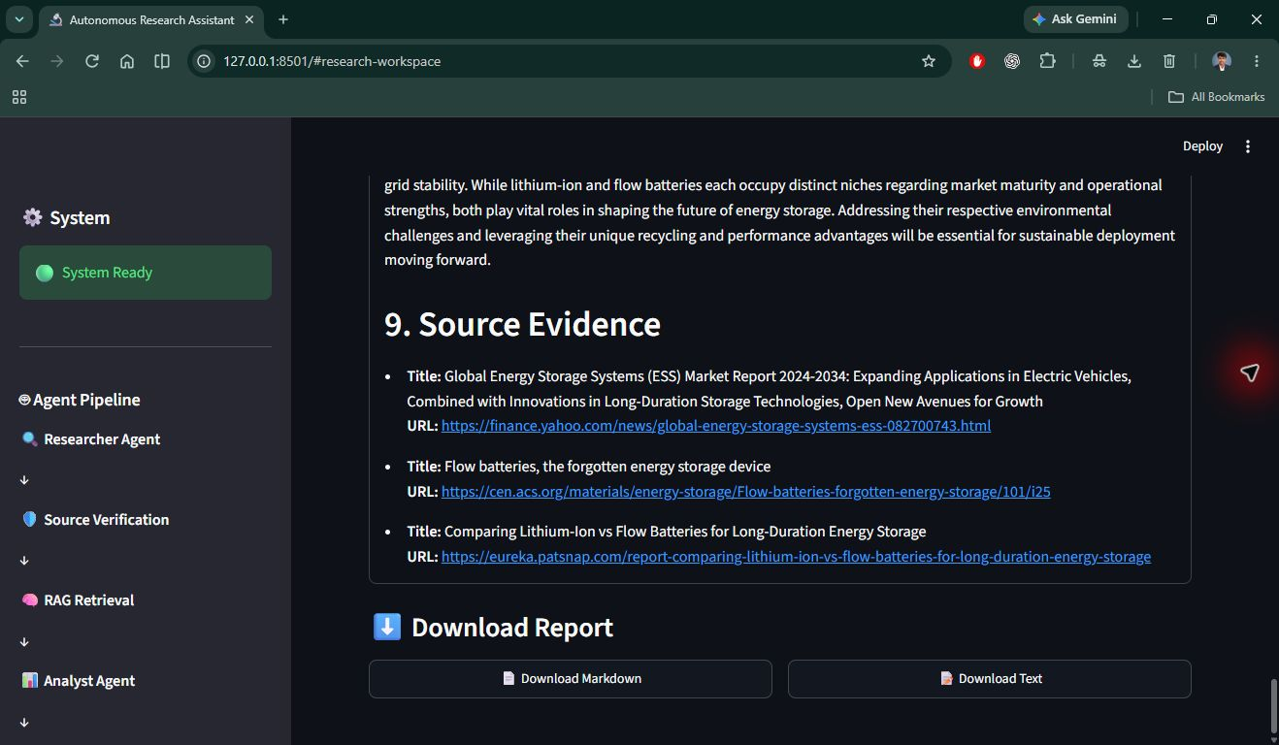

CHAPTER 7: TESTING AND RESULTS

7.1 Testing Approach
Manual checks were performed for empty-topic handling, the mode configuration, accepted and rejected source records, duplicate filtering, and a successful Quick-mode run. These checks confirm the observed cases only; they are not an automated regression suite, and external service responses may vary between runs.

7.2 Test Cases
ID | Test Case | Expected Result | Actual Result | Status
TC01 | Submit an empty topic | Input is rejected and research does not start | Warning displayed; research did not start. | PASS
TC02 | Select Quick / Standard / Deep | Configuration uses 3 / 5 / 8 queries with corresponding caps | Quick: 3 queries / 2 results per query / 6-source cap; Standard: 5 / 3 / 10; Deep: 8 / 3 / 16. | PASS
TC03 | Provide title, HTTPS URL, and content >=100 characters | Verifier accepts a non-duplicate record | Valid source with title, HTTPS URL, and content over 100 characters was accepted. | PASS
TC04 | Provide missing/short content, invalid URL, HTTP URL, or duplicate URL | Verifier rejects the record | Missing title or URL, malformed URL, HTTP URL, and short content were rejected; normalized duplicate URL was filtered. | PASS
TC05 | Run a valid research topic in Quick mode | Workflow completes and displays report, source evidence, and download options | Completed: 2 queries, 4 search results, 4 technically verified sources, and 3 RAG source records; report and Markdown/plain-text download controls displayed. | PASS

7.3 Results and Analysis
In the recorded full-display Quick-mode run, the application generated 2 queries, returned 4 search results, marked 4 records as technically verified, retrieved 3 source records for the RAG stage, and completed the five-stage workflow. The final report and Markdown/plain-text download controls were visible. “Verified” here refers only to the application’s technical screening; it does not establish source authority or claim-level factual correctness. No latency or performance benchmark was recorded.

CHAPTER 8: CHALLENGES AND LEARNING OUTCOMES

8.1 Challenges Faced and Solutions
Challenge | Solution Adopted
External service dependency | The workflow requires Gemini/Tavily keys and internet access; README documents private local .env setup.
Technical checks vs factual truth | The verifier uses metadata/content rules; report documents that these do not certify authority or truth.
Run-specific retrieval | Each chunk records run_id and similarity search filters on that identifier.

8.2 Technical Skills Gained
- Python application structure, environment configuration, and API integration.
- Graph workflow design with shared state and sequential nodes.
- Embedding-based retrieval, metadata filtering, and source-preserving report prompts.

8.3 Professional / Soft Skills Gained
The project work provided practice in structuring Python applications, integrating external AI and search services, orchestrating a multi-stage graph, preserving source metadata through retrieval, and explaining system limitations. These examples describe project-based learning; they do not claim unverified team or attendance experiences.

8.4 Contribution to Organisation
The repository contains an educational prototype that brings web search, source screening, semantic retrieval, analysis, and report writing into one interface. This can serve as a demonstrator or learning foundation for Aspire Code AI. No production deployment, user adoption, or organizational impact metric is documented in the supplied files.

CHAPTER 9: CONCLUSION AND FUTURE SCOPE

9.1 Conclusion
The project source implements the main path from research-topic input to a structured, downloadable report. Its sequential LangGraph nodes, mode-specific search configuration, run-scoped retrieval, and visible source pipeline provide an understandable prototype for organizing an initial research pass. The code supports the objectives of accepting a topic and depth, coordinating search and retrieval, and presenting report output. Factual accuracy and completeness depend on external responses and require human review.

9.2 Limitations
Source validation checks metadata and URL/content conditions; it does not establish authority or truth. Search snippets may omit original-page context. Model prompts cannot guarantee unsupported content will never appear. The workflow depends on Gemini, Tavily, internet connectivity, and private API keys. The repository contains no documented automated test results, user evaluation, benchmark, deployed demo, or claim-level citation audit.

9.3 Future Scope
- Add a human review step that opens source pages and checks important claims against cited text.
- Add bounded retries, clearer API-error recovery, and structured handling when search or retrieval returns too little evidence.
- Evaluate relevance, evidence support, coverage, latency, and repeatability on documented topics; add claim-level links or supporting excerpts where feasible.

REFERENCES
Primary documentation, project materials, and supplied internship documents are listed below. Documentation access date: 27 October 2026.
- [1] Google AI for Developers, “Gemini API Embeddings,” https://ai.google.dev/gemini-api/docs/embeddings. [2] Chroma, “Chroma Documentation: Introduction and Retrieval,” https://docs.trychroma.com/.
- [3] LangChain, “LangGraph Graph API Overview,” https://langchain-ai.github.io/langgraph/concepts/. [4] Streamlit, “st.text_area” and “st.download_button” API References, https://docs.streamlit.io/develop/api-reference/widgets/. [5] Tavily, Search API Documentation, https://docs.tavily.com/.
- [6] Project source and README.md, main.py, app.py, requirements.txt. [7] Autonomous Research Assistant project idea collection, supplied PDF, 2026. [8] Aspire Code AI, Internship Offer Letter for GIRI G, dated 28 August 2026. [9] Aspire Code AI, “AI Agentic Development Internship - Aspire Code AI,” group training and schedule messages, August–September 2026 (private group history consulted for curriculum context; attendance not inferred).

APPENDICES

Appendix A: Complete Source Code
The accompanying source-code archive contains the project Python files, README.md, requirements.txt, and .env.example. The private .env file and local chroma_db runtime data are excluded. The main entry points are app.py (Streamlit interface) and main.py (LangGraph workflow).

Appendix B: Additional Screenshots / Diagrams
Additional screenshot / diagram: Figures 6.1–6.3 in Section 6.3 contain the full-display application evidence.

Appendix C: Project Links
Item | Link
GitHub Repository | Not provided in supplied materials
Live Demo | Not provided in supplied materials
Documentation | Not provided in supplied materials
Demo Video | Not provided in supplied materials

Appendix D: Mentor Feedback
Reserved for Mentor / Team Lead remarks. The evaluation table below is intentionally blank for the organization to complete.
Evaluation Parameter | Rating (out of 10) | Remarks
Technical Knowledge
Problem Solving
Punctuality & Discipline
Teamwork & Communication
Project Completion

