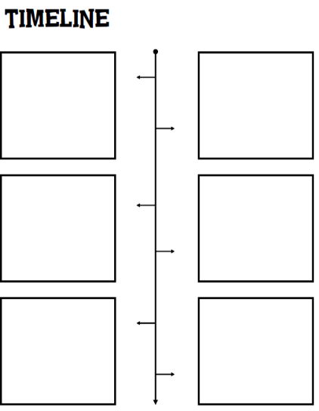

A robotic knight was designed by Leonardo da Vinci in which the mechanism was to make the knight move like a person

1495

The first wireless remote controlled boat was built by Nikola Tesla which had influenced military signalling devices by incorporating radio waves and boosted the development of robotic machines

1898

1940

1950

1962

“Three Laws of Robotics” was created by Isaac Asimov

Turing test was published by Alan Turing to test whether a machine has the intelligence to think for itself

The term “artificial intelligence” was coined as a result of the conference at The Dartmouth Summer Research Project on Artificial Intelligence in the Dartmouth College

1956

Unimate, the first industrial arm robot was introduced for performing repetitive or dangerous tasks on a General Motors assembly line

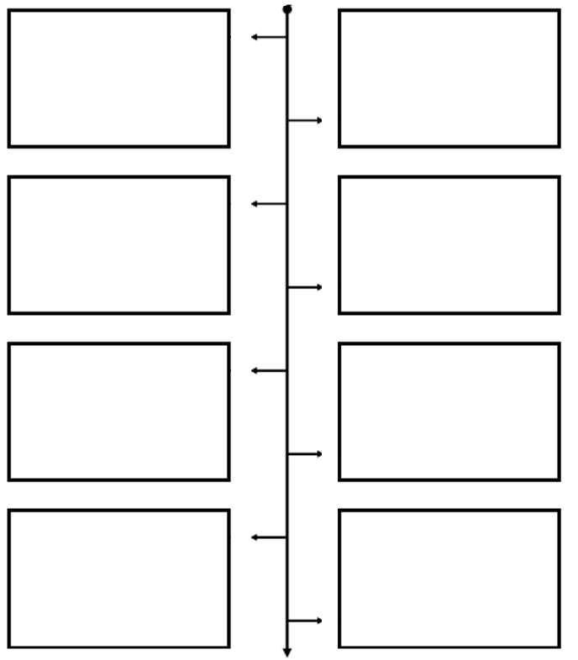

Pepper, a humanoid robot was introduced with the ability to read emotions

Persia, the first humanoid robot in Iran

ASIMO, a humanoid robot was presented with the ability to walk 1mph, climb stairs, recognise faces, gestures and objects’ movements as well as to react to voice commands

DARPA’s Centibots Project: proved that a large number of robots (100 robots) can be coordinated to achieve a single goal

AIBO, a robotic pet was introduced by Sony to learn by interacting with the environment and respond to more than 100 voice commands

Wabot-2, a musician humanoid robot was created to communicate with a person and play a keyboard instrument

Star Wars was announced with R2-D2 and C-3PO robots which had inspired further researches on humanoid robots

Shakey, the first mobile robot was developed by the Stanford Research Institute for knowing and reacting to its own actions with sensing devices equipped

2014

2002

2004

2000

1999

1984

1977

1966

