Primer for Rosgen Stream Classification Course Module

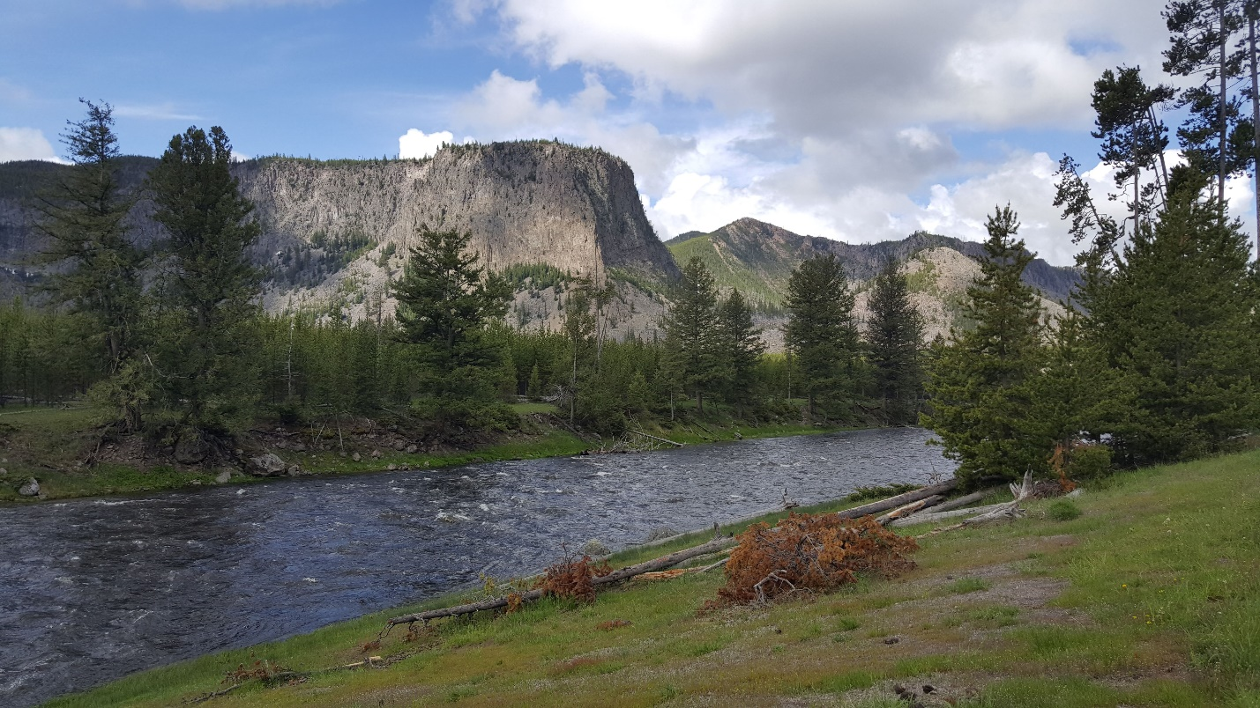

Spring 2021

Prepared by Zach Hilgendorf (MSci)

PhD Student, Geography

School of Geographical Sciences and Urban Planning

Arizona State University

**Purpose**

The purpose of this primer is to establish the goals, methods, data, and software required to complete the module for reproducibility in the Rosgen Stream Classification method using geographic information software. A series of short lectures and handouts have been developed to provide ample background information and the skills to necessary to complete the assignment. Two scientific articles have also been provided as required reading.

**Background Information**

**Classification Methods:**

To set the stage, classification schemes, whether in geography, economics, biology, etc., are designed to try and “bestow order onto chaos.” If we can generalize a system, we can make certain assumptions about how a similar system may “behave” somewhere else. In geography, we adhere to Tobler’s First Law, which states that things closer to one another are more alike than things that are farther apart. However, we need to be able to compare differences and similarities between streams across the world. If we can classify a stream, based on a number of measured parameters, and we find similar streams, in similar systems, in different parts of the county or world, then we can start compare those streams. If we are trying to modify the stream, for example, we may need to have an idea of whether the modification we are making will work for their designed goal. We use classification methods, like the Rosgen Stream Classification system, to that end. One of the primary uses of the Rosgen system is to inform on the “type” of stream for planned restoration projects. Many local, state, and federal agencies employ this method and train their scientists to use it. As such, there is an important economic aspect at stake. Communities or other agencies have to allocate funds to pay for restoration efforts and depend on these classification schemes to accurately characterize what type of restoration will best fit their problem.

Two scientific articles have been provided as required reading for this module. The first, Rosgen (1994), is one of the original papers that defines and describes the steps necessary to complete the classification of a stream, based on a series of measured in situ parameters. This paper should serve as the baseline of knowledge for you to complete the module. The second, Kasprak et al. (2016), examines a number of different stream classification schema, including Rosgen (1994), to assess the parameters that each uses to classify a stream. Together, these articles offer a succinct view of how classification schemes in fluvial systems handle a wide variety of parameters, how the inclusion or exclusion of variables differs, and why it is useful to have ways in which to classify streams.

**Physical Geography:**

Streams and rivers dissect the world around us, fill reservoirs, water crops, provide vital ecosystems for plants and animals, and have seen widespread degradation over the last 150 years. As we have mentioned, the Rosgen system has seen extensive use in the field of stream restoration. The topic of fluvial geomorphology and hydrology is crucial to understanding the parameters we are collecting for the Rosgen system and what they mean. A series of five short (5-10 minute) lectures have been recorded and uploaded to YouTube to help teach you some of the essential concepts you will need to know to complete this module. Each of these videos takes a look at a single topic (channel form, sinuosity, longitudinal profiles, grains+transport, ratios) and breaks them down to an introductory level.

Channel Form: <https://youtu.be/OUT3emNhVwg>

Sinuosity: <https://youtu.be/rVs4MSw1e5s>

Longitudinal Profiles: <https://youtu.be/SK2BFg2PmlQ>

Grains and the Initiation of Motion: <https://youtu.be/61GNZwwuI4U>

Ratios in Fluvial Geomorphology: <https://youtu.be/ex7E5GHPp6Q>

**Software Skills:**

In an effort to make this module widely accessible, we have chosen to use the open source GIS platform GRASS as the preferred graphical interface. GRASS is an incredibly powerful and customizable GIS platform, with a devoted and active user base, widespread integration with other software platforms (e.g., QGIS, RStudio), and free and open source software and code. The handouts in this lab are designed to teach you how to install and set up GRASS, import and manipulate raster and vector datasets, and process data with base and imported packages. These handouts should be approached in the following order:

1. Starting In GRASS
2. Digitizing in GRASS
3. Transects and Profiles
4. Classifying A Stream

Later on, you will be asked to do some very simple coding in RStudio, which is a user-friendly “wrapper” for the R language, developed by the Comprehensive R Analysis Network (CRAN). This code has been heavily commented and set up to allow you to understand what the code is doing and why you are inputting the variables you are in the places you are putting them. To install RStudio, you first need to install R. We will be working out of an RNotebook, which allows us to run “chunks” of code at a time and split up the goals of each chunk in a sensible way. All download sites have been provided below.

GRASS GIS: <https://grass.osgeo.org/download/>

CRAN: <https://cran.r-project.org/>

RStudio: <https://rstudio.com/products/rstudio/download/#download>

**Datasets**

***CHaMP_Data_MFJD***: The Columbia Habitat Monitoring Program (CHaMP) observed 26 watersheds in the Columbia River watershed, chosen to maximize contrasts in current habitat conditions. The main goal of this monitoring program was to generate and implement a set of standard methods for monitoring fish habitat (<https://www.champmonitoring.org/>). The Kasprak et al. (2016) article employed a variety of classification schemes using the CHaMP dataset, including the Rosgen Stream Classification method. The data provided for this module is a subset of the overall dataset, that overlapped with available bare earth light detection and ranging (LiDAR) digital elevation models (DEM) for the state of Oregon, USA. The subset includes points within the Middle Fork John Day River (MFJD).

Data was accessed through a National Oceanic and Atmospheric Administration (NOAA) data portal and was available upon request (<https://www.fisheries.noaa.gov/inport/item/18087>). The data originally came as two CSV datasets with latitude and longitude positions. These data were joined and converted into a point vector shapefile using the lat/long positions. The final dataset includes data on grain size, bankfull depth, width, and volume, collection years, discharge during collection, sinuosity (to compare against your values), and other stream classification designations to help characterize the dataset. Please note that there are multiple points occupying a single location, as these points represent different collections throughout the years.

***JohnDayWShed + JohnDayWShedHS:***

These datasets refer to the John Day River watershed LiDAR DEM and hillshade (HS) raster datasets. The LiDAR dataset is a 1 m resolution bare earth DEM that was collected between Aug 19-27, 2008. The dataset was larger, but was clipped down for the purposes of easily sharing data. The main focus of the raster is the Middle Fork of the John Day River (Figure 1) and encompasses all CHaMP data provided in the CHaMP_Data_MFJD dataset. A collection report and acceptance report were provided in the material, which includes horizontal and vertical uncertainty values and other logistical considerations for the dataset.

LiDAR data and the associated metadata were downloaded from the Oregon Department of Geology and Mineral Industries (DOGAMI) data portal (<https://gis.dogami.oregon.gov/maps/lidarviewer/>). The hillshade was originally created in ArcMap 10.8.1 and was based off of the clipped LiDAR dataset.

***JohnDayWShed_Ortho:***

This dataset is a National Agricultural Imagery Program (NAIP) 4-Band 8 Bit image from 2016. NAIP aerial imagery is acquired during the agricultural growing season, across the continental USA. The program is run by the United States Department of Agriculture’s Farm Service Agency. Orthoimages feature 1 m resolution and the red, green, blue, and near infrared spectral bands.

This dataset was accessed through the NOAA Data Access Viewer website (<https://coast.noaa.gov/dataviewer/?#/>), which contains imagery, land cover, and elevation/LiDAR data for portions of the United States. Data was clipped to the extent of the LiDAR DEM to allow for easier sharing of the dataset.

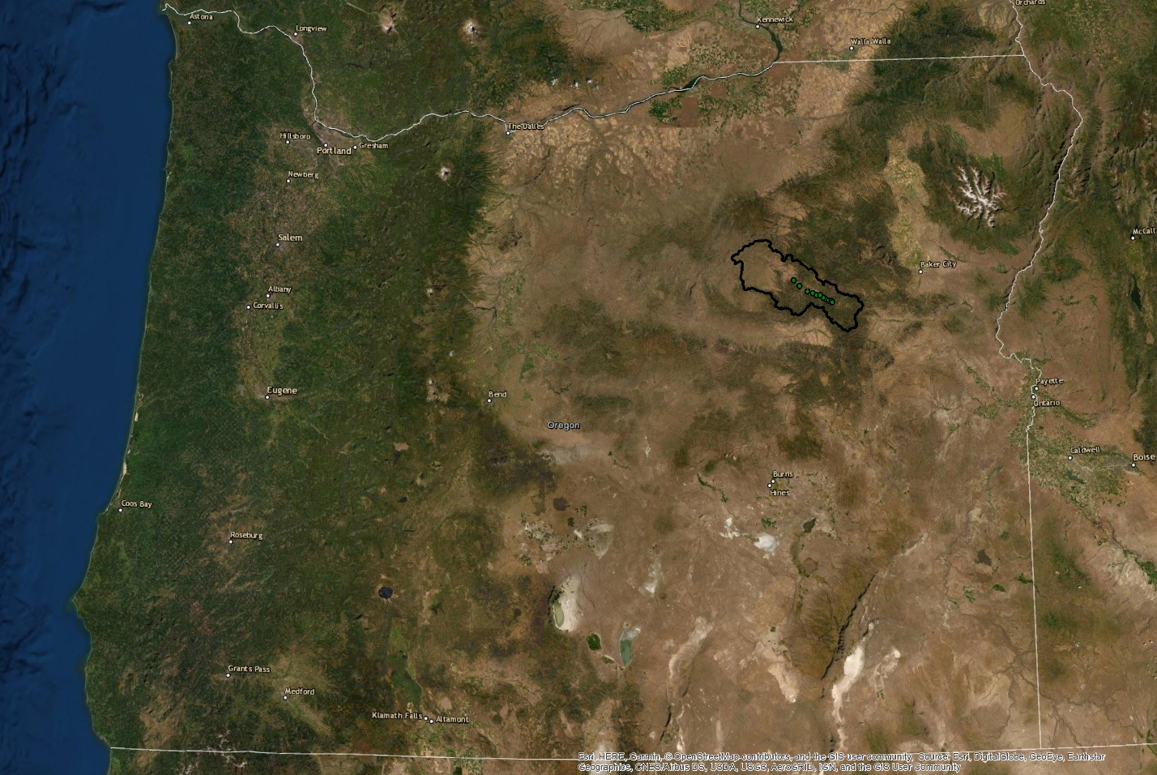

Figure 1. State of Oregon, USA, with the Middle Fork John Day River outlined in black. The green dots within the watershed boundary show the location of the Columbia Habitat Monitoring Program (CHaMP) data points provided for this project.