***JohnDayWShed_Ortho:***

This dataset is a National Agricultural Imagery Program (NAIP) 4-Band 8 Bit image from 2016. NAIP aerial imagery is acquired during the agricultural growing season, across the continental USA. The program is run by the United States Department of Agriculture’s Farm Service Agency. Orthoimages feature 1 m resolution and the red, green, blue, and near infrared spectral bands.

This dataset was accessed through the NOAA Data Access Viewer website (<https://coast.noaa.gov/dataviewer/?#/>), which contains imagery, land cover, and elevation/LiDAR data for portions of the United States. Data was clipped to the extent of the LiDAR DEM to allow for easier sharing of the dataset.

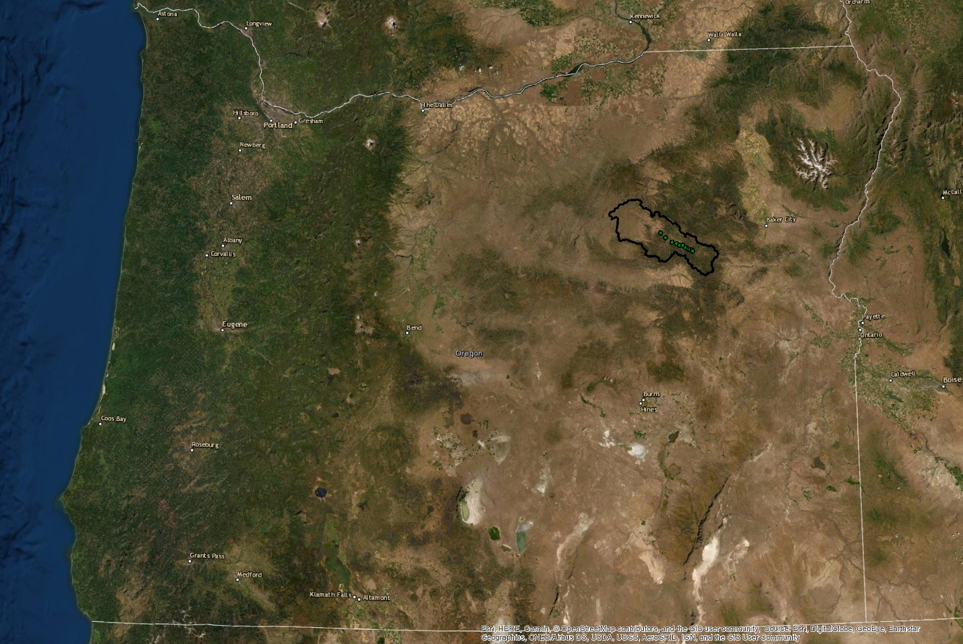

Figure 1. State of Oregon, USA, with the Middle Fork John Day River outlined in black. The green dots within the watershed boundary show the location of the Columbia Habitat Monitoring Program (CHaMP) data points provided for this project.