***Purpose:*** The purpose of this handout is to teach you how to create a new project in the GIS software GRASS.

We will start by downloading GRASS GIS. Follow this link and install the software for your operating system: <https://grass.osgeo.org/download/>

When you first open GRASS GIS, you will see a black command prompt screen and a GUI that lets you set up and create new Locations. Unlike most other GIS software, GRASS uses a desired project as the basis of a workspace for the data that gets loaded into it. Mapsets are then used to delineate different projects or foci, within that projection, from one another. For example, I may have data in the projection NAD 1983 (2011) UTM Zone 10N, but that encompasses a vast array of environments, populations, and agricultural conditions (to name only a few). I may have a dataset (physical, environmental, economic variables) from Humboldt Bay, California, that looks at the vulnerability and susceptibility of coastal communities to rising sea level. I may also have a dataset that looks at housing prices in Seattle, WA, and how those relate to the presence/absence of corporations within the major metropolitan area. Those are inherently different types of data, but they exist in the same projection. I would separate these using GRASS Mapsets.

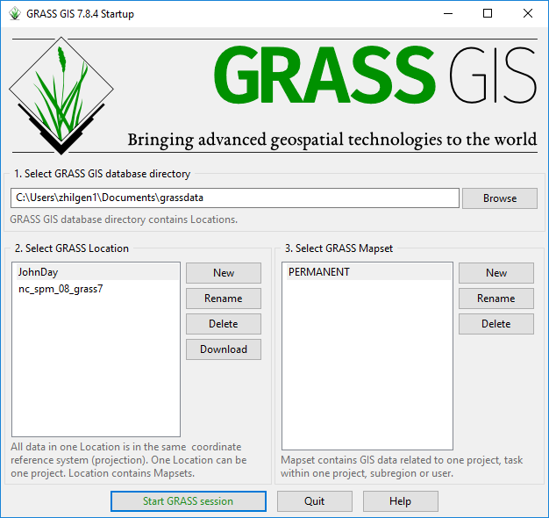

Figure 1. The GRASS GIS startup window, where directories, locations, and mapsets can be created.

We will start by setting up a new Location. Click on New next to the “Select GRASS Location” box. When you do, a new window will open (see Figure 2). This allows you to create the default directory and name for the location. Set your default directory where you want it (I have chosen the folder created by GRASS in my Documents folder, and give the project locations a name. This could be the projection you are using (i.e. NAD 1983 (2011) UTM Zone 11N) or it could be more specific to the project. In this example, I called the location “JohnDay” in reference to the John Day River of Oregon, where our data is from.

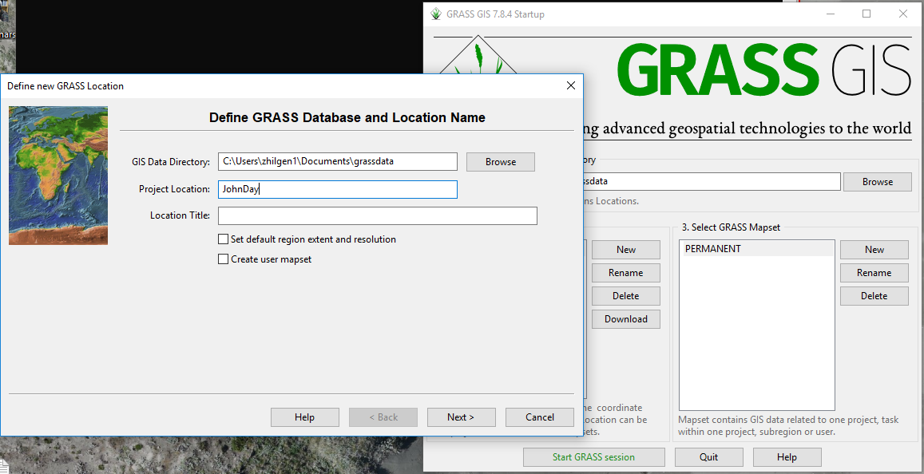

Figure 2. Window for setting up a new Location in GRASS.

Next, you will need to determine which method you want to use for creating the new location. GRASS has a lot of great ways to do this, from reading the European Petroleum Survey Group (EPSG) code, to reading the data directly from a file. We will employ the latter option for our project! Select the “Read projection and datum from a georeferenced data file” bubble and hit Next (Figure 3). In the next window, browse until you find the dataset you want to import the projection from. We will choose the CHaMP_Data_MFJD.prj file, as it is the projection for the CHaMP dataset you will be working with. Click Next after you have brought that file into the input box and you will be brought to a window that shows you the projection data that is being pulled from the file (Figure 4). Ensure that it is what you know the dataset to be. In this case, we are working in NAD 1983 UTM Zone 11 North. You will see that, in Figure 4, that “proj = utm” and “zone = 11,” confirming that we imported the projection from the file.

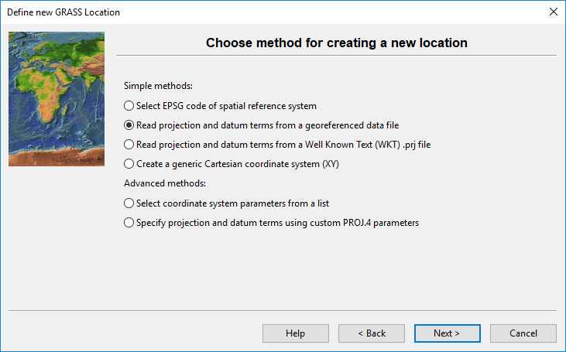

Figure 3. The window to choose how a location will acquire its spatial reference.

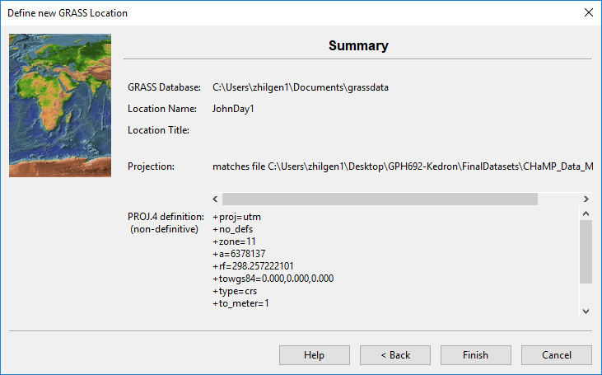

Figure 4. The summary window that shows the projection that is being pulled from the chosen file.

Once you have confirmed that the projection is correct, select “Finish” and the location will generate. You will get a popup window that asks if you want to import the dataset you used as a reference into the Mapset. Either choice is fine, but this is a nice way to get a jump on importing your data into GRASS! Now, select “Start GRASS Session” and notice that a Layer Manager and Map Display window will open. They should be blank, as you have not populated anything yet. Let’s fix that! Go up to the File menu at the top of the Layer Manager window. Expand the “Import raster data” and select the top option “Simplified raster import with reprojection” (Figure 5). This can also be found by clicking on the Modules tab at the bottom of the Layer Manager window and typing in **“r.import”**, which is the abbreviated tool name.

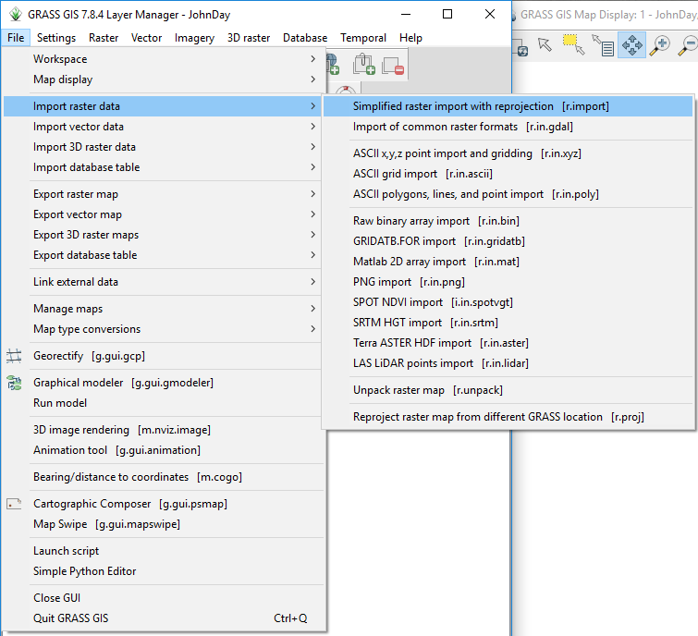

Figure 5. Location of the raster import tools. The vector import tools are directly below.

This will open a new window, where you can Browse to select the raster dataset you want to bring in (Figure 6). Bring in the JohnDayWshed and JohnDayWShedHS files. These are the LiDAR digital elevation model and associated hillshade, respectively. Make the that the projection matches (it will say in the list of raster layers) and select an output name. Once you have finished setting things up, click import and let the tool work. These are larger files, so it will take a few minutes to import everything.

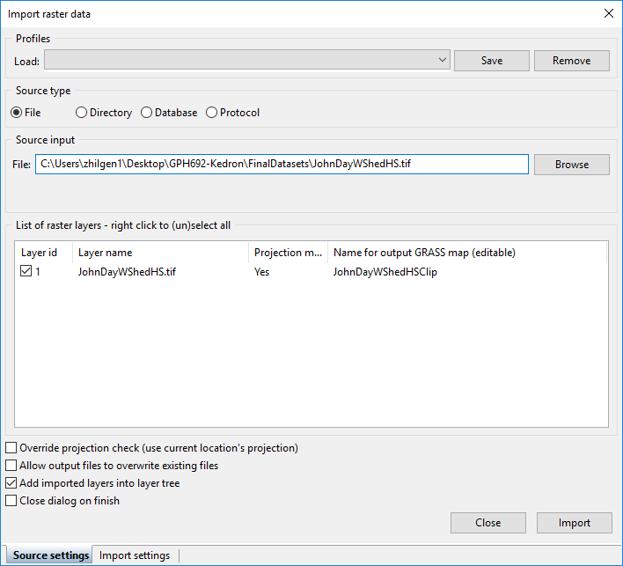

Figure 6. The raster import window.

If you chose not to import the CHaMPS_Data_MFJD shapefile when you created the location, the following steps will show you how to do so. In the File menu or the Modules tab, select the “Import of common vector formats [**v.in.ogr**]” tool. This will open a window that lets you browse for the shapefile you want to import (Figure 7). Run the tool and your vector will import! Make sure to have “File” selected in the “Name of OGR datasource to be imported” box.

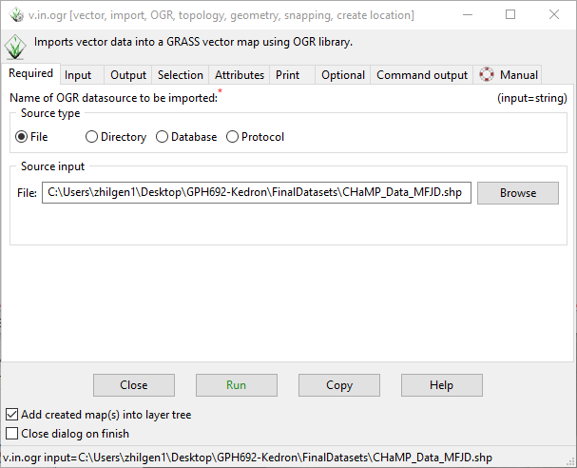

Figure 7. The vector import window.

This short handout demonstrated how to create a new Location for use in GRASS GIS. It also taught how to import new raster and vector data. Future handouts will explain how to view that data and process it further.