Trail Analyzer 2K15

End User Documentation

Prepared as part of the CE594R Winter 2015 course taught by Dr. Dan Ames at BYU

Stephen Duncan and Michael Scott

# How to get and install Trail Analyzer 2K15

One can download the TrailAnalyzer2K15.exe (and other files) from our GitHub repository, at “https://github.com/GISBikeDragons/TrailAnalyzer2K15”. Just use the “Download ZIP” button to download the program. After downloading, enjoy using the following file path:

TrailAnalyzer2K15/TrailAnalyzer2K15/TrailAnalyzer2K15/obj/Debug/TrailAnalyzer2K15.exe

# Purpose of Trail Analyzer 2K15

The purpose of Trail Analyzer 2K15 is to help the user define the physical difficulty and the physical properties of any bike trail that they might be interested in.

Most trails are rated in their technical difficulty, which includes tread width, tread surface, trail grade, natural obstacles, technical trail features, and relative hardness to surrounding trails. Trail length along with the physical properties of the trail are not including in the technical difficulty normally. Thus this is where we try to provide some insight to the user regarding the physical difficulty of the trail.

DISCLAIMER: No rating system can be totally objective (because Trail Analyzer 2K15’s rating system is objective) or valid for every situation. This program is a tool to be combined with common sense. Look at trails with a discerning eye, and seek input from other trail users and users with knowledge of the local area before finalizing the rating.

# Software License: The MIT License (MIT)

Copyright © 2015 GISBikeDragons, Stephen Duncan, Michael Scott

Permission is hereby granted, free of charge, to any person obtaining a copy of this software and associated documentation files (the "Software"), to deal in the Software without restriction, including without limitation the rights to use, copy, modify, merge, publish, distribute, sublicense, and/or sell copies of the Software, and to permit persons to whom the Software is furnished to do so, subject to the following conditions:

The above copyright notice and this permission notice shall be included in all copies or substantial portions of the Software.

THE SOFTWARE IS PROVIDED "AS IS", WITHOUT WARRANTY OF ANY KIND, EXPRESS OR

IMPLIED, INCLUDING BUT NOT LIMITED TO THE WARRANTIES OF MERCHANTABILITY, FITNESS FOR A PARTICULAR PURPOSE AND NONINFRINGEMENT. IN NO EVENT SHALL THE AUTHORS OR COPYRIGHT HOLDERS BE LIABLE FOR ANY CLAIM, DAMAGES OR OTHER LIABILITY, WHETHER IN AN ACTION OF CONTRACT, TORT OR OTHERWISE, ARISING FROM, OUT OF OR IN CONNECTION WITH THE SOFTWARE OR THE USE OR OTHER DEALINGS IN THE SOFTWARE.

# Using Trail Analyzer 2K15

## Using Sample Data

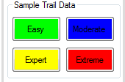

Some sample data has been provided for the user to see how our program works and may also be different from other rating systems. From gis.utah.gov, sample trails have been provided that have been rated as either easier, moderate, expert, or extreme based on the trail conditions. However, these ratings are based on technical skill level and not by the physical level that ay be required. Based on our rating system, you can see how physical each of the trails are simply by clicking the buttons (shown above) and view the pysical aspects of the trail (shown below).

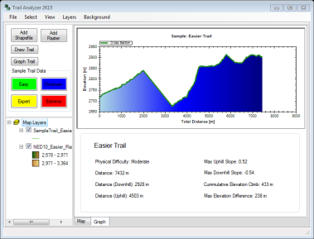[insert final layout here]

Here our easier rated sample trail has been placed over a 10 meter NED and the elevations for the route have been graphed as a curve onto our ZedGraph. Below the ZedGraph, our rating for the physical difficulty along with some aspects that affect that rating are shown to the user for them to see and interpret.

## Using Custom Data

### Import a Raster

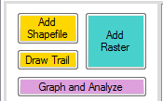

The user can import their own elevation data using the “Add Raster” button in the Trail Analyzer 2K15. The program is able to support a number of different raster formats depending on what type of elevation data you have. DotSpatial, the main *.dll behind this program, is able to support any *.bgd raster that you would like to use. However, the GDAL extension is installed with the program, which allows the user to also import other formats of rasters (go to: <http://www.gdal.org/formats_list.html> for an extensive list of allowable formats that can be imported).

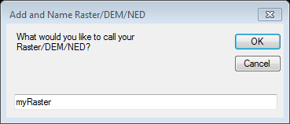

When the user imports their raster, a prompt will appear and ask the user to name the raster for the legend. The default name for the raster will appear and the user can change the name here. When the user is satisfied with the name they should click “OK” to import the raster. The final result would look something like the figure below.

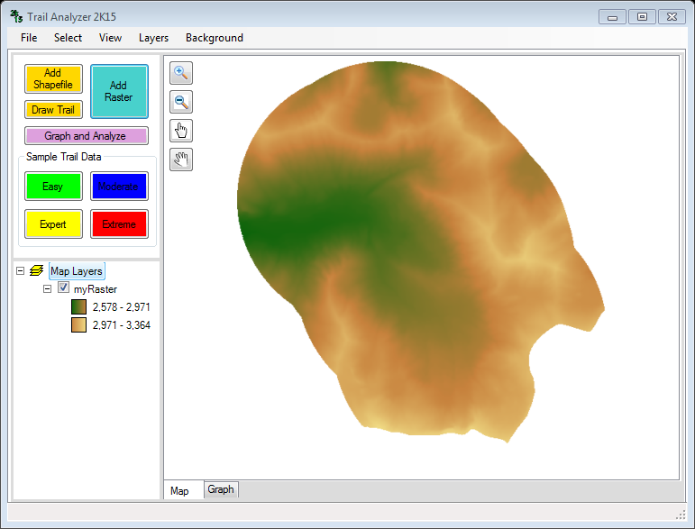

### Import a Trail



If the user already has a trail formatted as a shapefile, they can import a trail using the “Add Shapefile” button. This allows the user to analyze any trail they have found or created themselves in a different program.

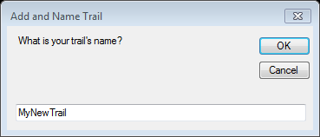

When the user imports their trail, a prompt will appear and ask the user to name the trail for the legend. The default name for the trail will appear and the user can change the name here. When the user is satisfied with the name they should click “OK” to import the trail. The final result would look something like the figure below.

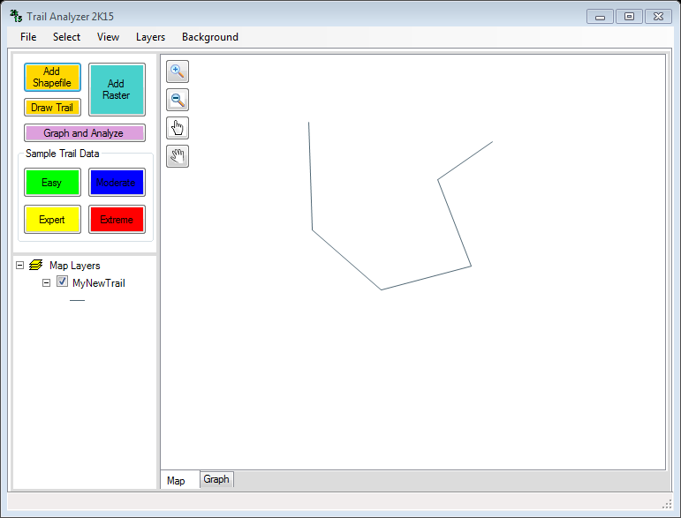

### Draw a Trail



If the user doesn’t have a trail, Trail Analyzer 2K15 supports the user drawing a trail. Instructions will appear at the bottom of the program form, telling the user to start clicking from the beginning of the trail. When the user is finished, they should double click at the end of the trail. A line will then be drawn showing them the trail they have drawn. They must then save the trail, and the trail will appear in the map.

## Analyze and Interpret Results



Now that the user should have a trail and elevations loaded into the program, the user can use the “Graph and Analyze” button to analyze the trail they want. Before this button will work, it needs to have a shapefile and raster loaded into the program. Otherwise it will display a message to the user that they don’t have the necessary files in the program to this feature. The figure shown below should give the user an idea of what their map may

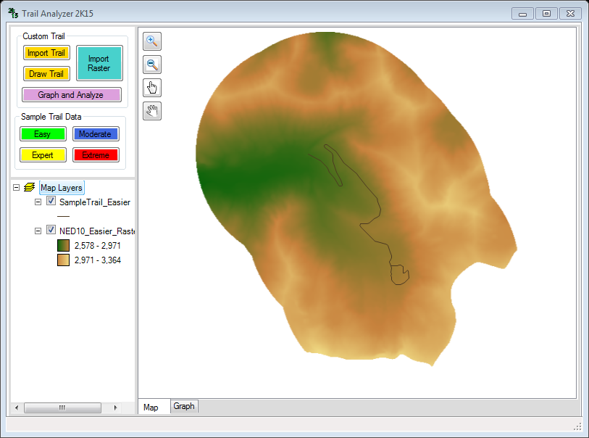

After clicking on the “Graph and Analyze” button, the program uses both the trail and the elevations datasets to find elevations along the trail selected. A progress bar will appear, but usually the analysis is fast enough that the user might not see it. When it is completed, a message in the lower left corner will tell the user that the analysis is complete.

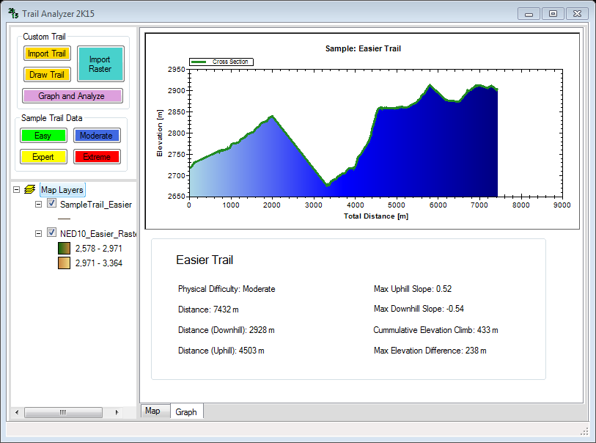

From here the user can see how we rate the physical difficulty based on the elevations of the trial. First, the user can see the cross section of the elevations of their trail. Below the graph, there are several text boxes showing the rating of the trail along with several of the physical properties of the trail that might give the user some insight into what the trail might look like. The following are given for the user:

* Title: Name of the trail/shapefile
* Distance: Total distance the trail goes (from beginning to end)
* Distance (Downhill): Total amount of distance that the trail goes downhill
* Distance (Uphill): Total amount of distance that the trail goes uphill
* Max Uphill Slope: Unit distance rise over unit distance run uphill
* Max Downhill Slope: Unit distance rise over unit distance run downhill
* Cumulative Elevation Climb: Total amount of elevation climbed over the entire trail
* Max Elevation Difference: Distance from the lowest elevation of the trail to the highest elevation on the trail

The creators hope that by using Trail Analyzer 2K15, the user might be able to identify the physical hardness of the trail along with some properties that may influence whether or not the user wants to use the trail.