BLM SPRINT TEAM TASKING BREAKDOWN GUIDE

By Alec Boyd

**Usage:** To Track the BLM SPRINT team’s tasks, hours, and produce a breakdown of %NOC vs. %STATE

**\*Note:** If the Navigation pane did not show up, go to the view tab and make sure the ‘navigation pane’ is checked. Set zoom to 150% for better viewing of figures.

This was converted from Google to Microsoft Excel in January of 2020

# **Intro**

Welcome to the wonderful world of the auto tasking sheet. The SPRINT tasking breakdown sheets were created with a mix of Microsoft excel macros and vba code. There are no excel links to worry about so a standalone tasking sheet will not have a dependency with links becoming obsolete or broken in the future. Tab names should always be kept the same in order to standardize all sheets for everyone and to allow the python code to extract the data no matter what the excel file is named.

## Important Paths for Operations:

\\blm\dfs\loc\EGIS\ProjectsNational\NationalDataQuality\Sprint\analysis_tools\Tasking_Breakdown

* This path is the home directory of the tasking breakdown. Within it is the:

1. master.xlsx excel which includes all pivots, data, and task hour history for the project.
2. Test_master.xlsx is the output created from the master_tasking_update.py. The output is then copied and pasted into the master file (more on this later).
3. OneDrive_call_download.py is the retrieval script that downloads all the archive sheets from everyone’s tasking breakdown excels and puts it into the ‘current download’ folder for backup and use later in the monthly breakdown charts.
4. Xlsxwriter folder contains python packages necessary for operations. Having this file here lets anyone run the python scripts without having to download the package themselves.
5. Archive folder is used to store outdated scripts, excel files, and other information if necessary. This folder is necessary for record keeping of what has happened in the past
6. Team_tasking_breakdown folder contains blank files that can be configured into new tasking breakdowns for new hires, current downloads, and backups of the current months downloads.

https://doimspp.sharepoint.com/sites/BLMSprintTeam/Shared%20Documents/Forms/AllItems.aspx?id=%2Fsites%2FBLMSprintTeam%2FShared%20Documents%2FShared%20Files%2FTeam%20Tasking%20Breakdown&viewid=41bd8c9b%2D2d3e%2D4a81%2Dbbfe%2De3f44054bc0d

The above link is the current sharepoint url used by the sprint team to access their tasking breakdown sheets. *This can also be viewed through teams by using the path below:

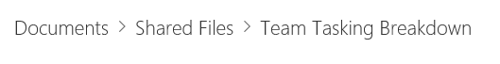

# **Setup Tasking Breakdown Sheet for a new hire**

1. Go to: \\blm\dfs\loc\EGIS\ProjectsNational\NationalDataQuality\Sprint\analysis_tools\Tasking_Breakdown\team_tasking_breakdown\blank_tasking_sheets directory.
2. Pick a excel macro file (.xlsm) (best practice is to pick a sheet that is most current to today’s date). This will ensure that the blank sheet has all the current additions to the ‘Task’ dropdowns and hour calculator. At this time of writing this document the latest blank sheet is 02/10/2020. Make a copy of it and paste it in the same directory.
3. Next, change the name to the new hire’s name (unless they have a similar name as someone on the team already, then you will want to include their last name. For example: If we had two Rachel’s on the project, change Rachel_tasking_sheet to RachelLuu_tasking_sheet.) Otherwise, the format will go: <FIRSTNAME>_tasking_sheet
4. After the file name is changed, open the macro excel up and enter the new hire’s full name into the ‘AM’ column:

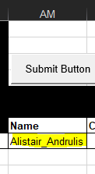

Format will be FIRSTNAME_LASTNAME.

1. Next, we will need to verify that the blank sheet has all the updated tasks that the team is currently using. Put your mouse cursor over the Archive tab and right-click it, then click the ‘unhide’ option. This will reveal the Sheet3 tab that contains a list of all the tasks used for column ‘E’ in the TaskingSheet.



Perform a quick check and compare a list of someone currently on the team. Everyone will have the ‘secret’ sheet 3 FYI.

1. SKIP THIS STEP IF YOU DON’T NEED TO ADD A NEW TASK: If you need to add a task, find out if it is considered a ‘NOC’ task or a ‘STATE’ task. Once you have that information, make a new row somewhere in the ‘NOC’ or ‘STATE’ area by right clicking on a row number and hit the insert new row. Type in the new task name and it will automatically show up in the task dropdown in the TaskingSheet ‘sheet’. Then hide sheet3 again.

* If a new task is added, you will need to update the ‘calculator part of the TaskingSheet’. Go back to the TaskingSheet tab and left-click the 0 in the left hand corner by NOC or STATE Total (depending on the task). It will bring up the excel tasks in the formula bar like so:

*=SUM(SUMIF(E:E, {"NOC Misc","NOC Meetings","NOC Scripting","NOC QAQC","NOC Training","NOC Knowledge Transfer","NOC ACEC","NOC ADMU","NOC CRM","NOC FPER","NOC GRA","NOC GTLF","NOC LUPA","NOC NLCS","NOC PLSS","NOC RECS","NOC RUDD","NOC SIGNS","NOC SMA","NOC SSME","NOC TMAP","NOC VMAP","NOC VRI","NOC VTRT","NOC WHB","NOC Travel","NOC Security Clearance","NOC AGOL","Tasking Breakdown","IPR","Metadata"}, AK:AK))*

* Follow the format like the others and just type in the task exactly the same way you entered it in Sheet3 but with “”. Hit enter to finish. Add in this new value in columns ‘AO’ and ‘AP’ respectively.

1. Now just make sure the ‘Archive’ sheet contains no other info inside it except for the headers at the top and the new sheet for the ‘new hire’ is all set to go! Usually before I hand it off to someone, I change the Year# and Month to the current one and test the vba buttons to unsure they are still operational, so the user doesn’t have to worry about it the first time!

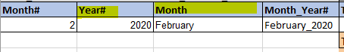

1. Final step is to copy and paste it into the sharepoint directory that is used above or upload it via teams.



# **Basic Operations**

1. When you first open your timesheet, you will want to add in the correct year and month.

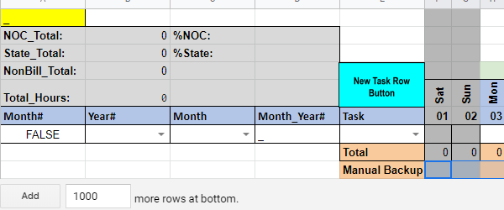

2. Put your cursor over the black drop-down arrow (then left-click) and select the correct year and month from the list. UPDATE: With the switch to Microsoft Excel you will now need to left-click on the cell first in order to see the black drop-down arrows.

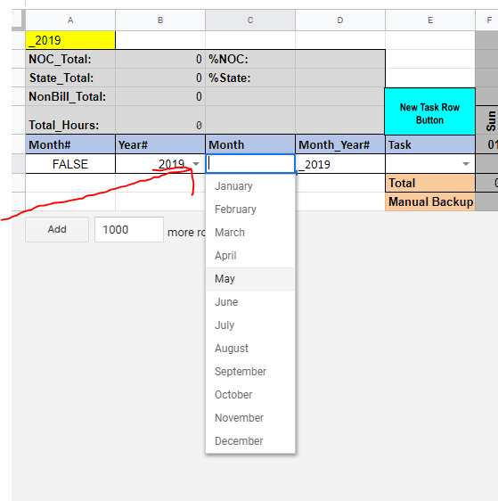

3. Notice how the Month#, the Month_Year#, Cell A1, and the week dates will all configure themselves to your date selections.

4. The date rows will update with your choices. You can now start filling out your timesheet by picking out a task item from the drop-down list and fill in the hours as needed.

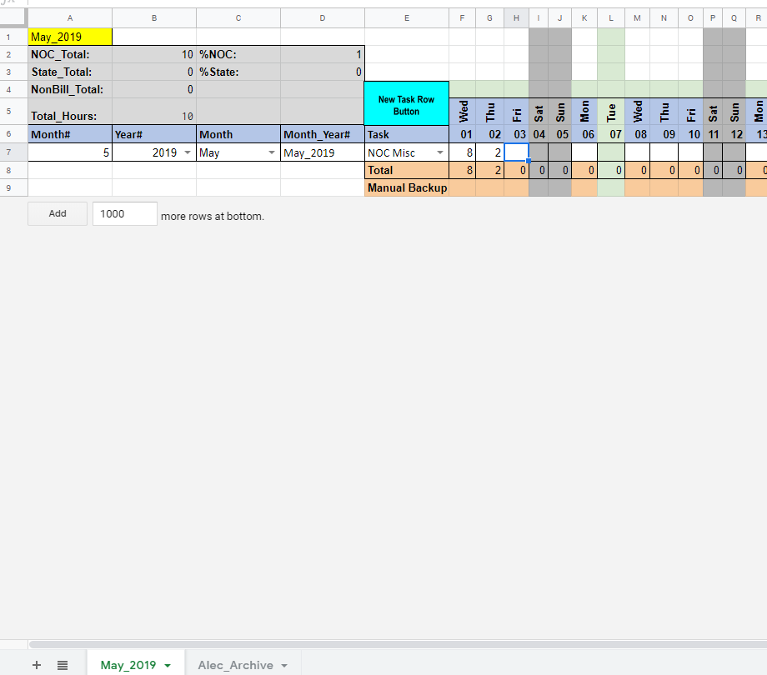

*QUICK NOTE : the weekend columns will always be grey and the current day will be highlighted as green.

5. If you need to add a new task row, left click the “New Task Row Button” and a new row will appear! UPDATE: With the switch to Microsoft Excel the New Task Row Button is now grey.

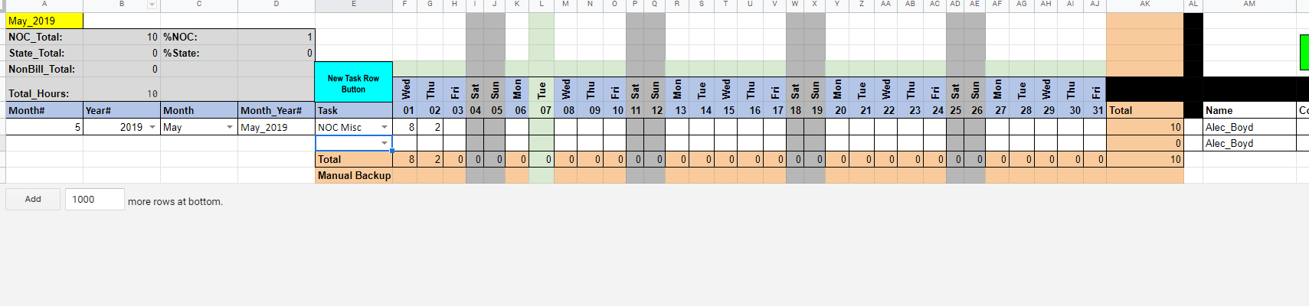

6. Continue to add in hours, comments, tasks, etc. until your timesheet is completed.

*QUICK NOTE : NON BILL Company Overhead and NON BILL PTO/Holiday tasks will highlight their respective rows magenta.

Also : The “Manual Backup” line can be used to quickly log a days hours without affecting the time totals or sheet :)

Also : Column “AL” will display a red flag if you ever have a duplicated task row! UPDATE: With the switch to Microsoft Excel the red flag is now coloring the whole cell red during a duplicate.

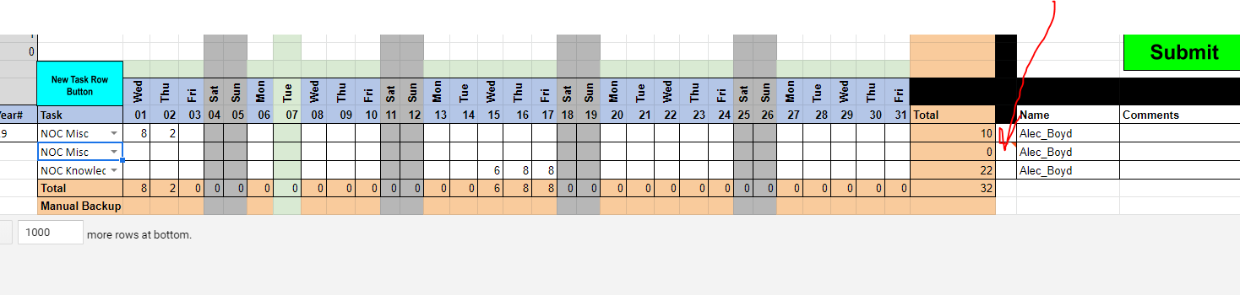

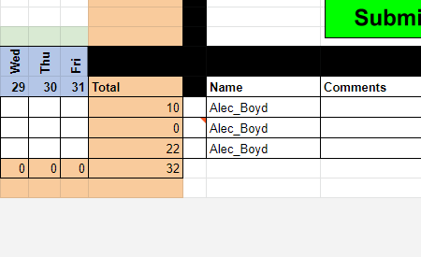

7. When you are ready to submit your time/tasking sheet. Left-click on the green “submit button”. A message will appear asking you if you would like to continue. **Submission of timesheets are done **once** **a month**. Basically when the whole timesheet is filled out you will submit it and then move on to the next month. UPDATE: With the switch to Microsoft Excel the submit button is now grey.

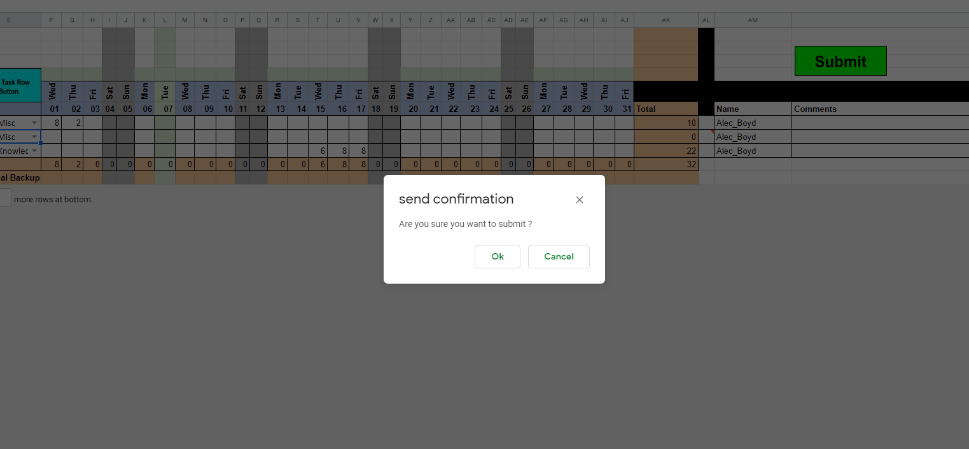

Hit ok to continue and the submit script will run and send your timesheet over to your “archive” tab.

UPDATE: With the switch to Microsoft Excel there is no yellow A1 cell anymore in the archive sheet.

You should see your timesheet appear in the ‘archive’ sheet with a timestamp column as well:

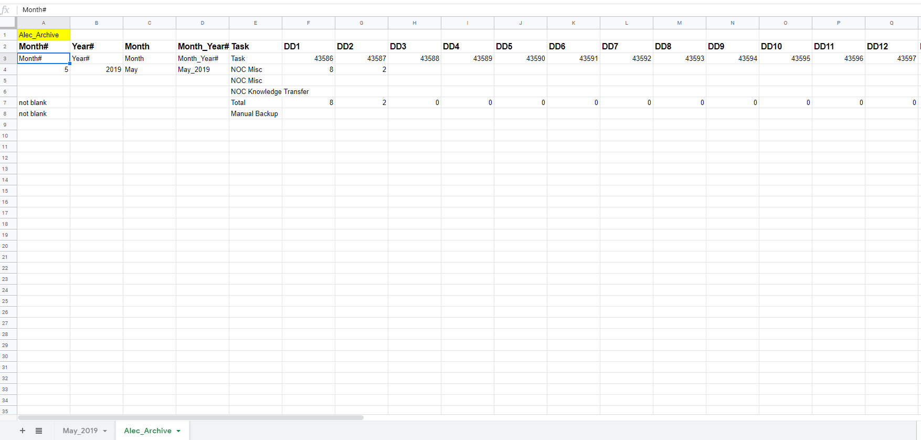

8. Once you made sure everything transferred over to the archive tab correctly, you can go back to the timesheet table and left-click the “reset” button (and hit ok). This will clear the table back to a “zero” state. You can then repeat the steps above.

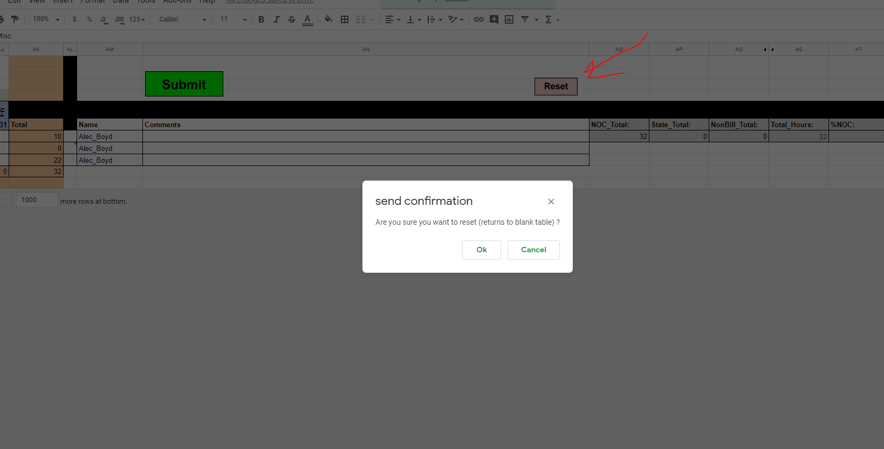

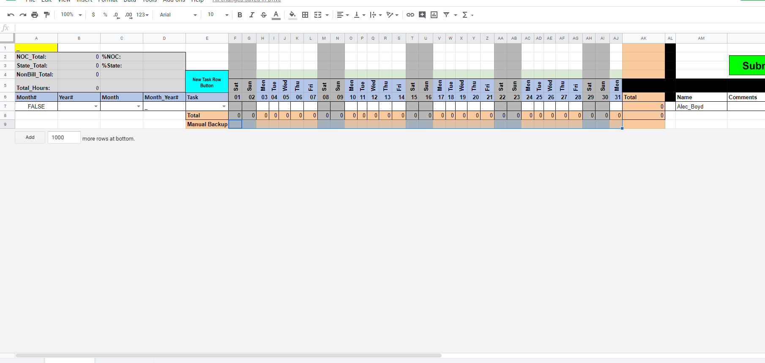

# **Tasking Sheet Backend (vba and Macros)**

Below are how the tasking breakdown sheets are functioning, we will explore how each part is working and the code behind it in case a user needs to redo a part or something in the future needs to be updated.

## Month#



=IF(

C7 = "January",1,

IF(C7 = "February",2,

IF(C7 = "March",3,

IF(C7 = "April",4,

IF(C7 = "May",5,

IF(C7 = "June",6,

IF(C7 = "July",7,

IF(C7 = "August",8,

IF(C7 = "September",9,

IF(C7 = "October",10,

IF(C7 = "November",11,

IF(C7 = "December",12))))))))))))

## Year#

Is a data validation drop down. The validation criteria are a list with ‘ignore blank’ and in-cell dropdown checked!

Source: 2019,2020,2021,2022,2023,2024,2025,2026,2027,2028,2029,2030

## Month

Is a data validation drop down. The validation criteria are a list with ‘ignore blank’ and in-cell dropdown checked!

Source: January,February,March,April,May,June,July,August,September,October,November,December

## Month_Year#



=C7&"_"&B7

## Task

Is a data validation drop down. The validation criteria are a list with ‘ignore blank’ and in-cell dropdown checked!

Source: =Sheet3!$A:$A

## Date and Day rows



Numbers (microsoft format to numbers)

=TRANSPOSE(DATE($B$7,MONTH(C7&1),1)+TRANSPOSE(COLUMN($C$1:$AN$1)-3))

Days (Microsoft format to Day abbreviations)

=TRANSPOSE(DATE($B$7,MONTH(C7&1),1)+TRANSPOSE(COLUMN($C$1:$AN$1)-3))

## Name

Is the Firstname + ‘_’ + LastName

Example: Alec_Boyd



## Comments

Standard text field where the user can type in details on a task.

## Row Calculator

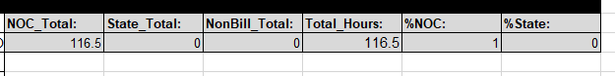

NOC_Total

=SUM(SUMIF(E:E, {"NOC Misc","NOC Meetings","NOC Scripting","NOC QAQC","NOC Training","NOC Knowledge Transfer","NOC ACEC","NOC ADMU","NOC CRM","NOC FPER","NOC GRA","NOC GTLF","NOC LUPA","NOC LWC","NOC NLCS","NOC PLSS","NOC RECS","NOC RUDD","NOC SIGNS","NOC SMA","NOC SSME","NOC TMAP","NOC VMAP","NOC VRI","NOC VTRT","NOC WHB","NOC Travel","NOC Security Clearance","NOC AGOL","Tasking Breakdown","IPR","Metadata"}, AK:AK))

State_Total

=SUM(SUMIF(E:E, {"STATE Data Analysis","STATE Land Disposal","STATE Raster Processing/Management","STATE Data Editing","STATE Data Collection","STATE SMA","STATE Knowledge Transfer","STATE Mapping","STATE Meetings","STATE Training","STATE Travel","STATE VRM","STATE LWC","Testing/Workflow"}, AK:AK))

NonBill_Total

=SUM(SUMIF(E:E, {"NON BILL Company Overhead","NON BILL PTO/Holiday"}, AK:AK))

Total_Hours

=AK15

%NOC

=IFERROR(AO7/D5,"")

%State

=IFERROR(AP7/D5,"")

**\*Hidden Columns**

**Purposely_Blank**

Is just a blank column that can be used for future needs. **Do not delete**.

**TimeStamp_Submission**

Column that will hold the timestamp of when a user submits their time sheet to the archive tab.

## Box Calculator

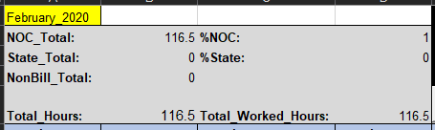

Cell A1

=D7

NOC_Total is the same as above.

State_Total is the same as above

NonBill_Total is the same as above

Total_Hours is the same as above

%NOC

=IFERROR(B2/D5,"")

%State

=IFERROR(B3/D5,"")

Total_Worked_Hours

=B2+B3

## Conditional Formatting

Rule: Duplicate Values Format: light red

* Applies to =$E:$E

Rule: Duplicate Values Format: light red

* Applies to =$AL:$AL

Rule: =$AJ$1=FALSE Format: Black

* Applies to =$AJ:$AJ
* Applies to =$AI:$AI
* Applies to =$AH:$AH

Rule: =F$4=TODAY() Format: light green

* Applies to =$F$1:$AJ$16

Rule: =AH$5="" Format: Black

* Applies to =$AH$1:$AJ$16

Rule: =OR(WEEKDAY(F$5)=1,WEEKDAY(F$5)=7) Format: light grey

* Applies to =$F$1:$AJ$16

Rule: =$E1="NON BILL PTO/Holiday" Format: pink/magenta

* Applies to =$A$15:$AV$16,$A$1:$AV$7,$AV$8:$AV$14,$A$8:$AN$14

Rule: =$E1="NON BILL Company Overhead" Format: pink/magenta

* Applies to =$A$15:$AV$16,$A$1:$AV$7,$AV$8:$AV$14,$A$8:$AN$14

## Total Row



=SUM(INDIRECT("F7:F"&ROW()-1))

Each column will be summed so for column it’s the formula above, for column G its =SUM(INDIRECT("G7:G"&ROW()-1)) and so on and so on until you get to column AK.

Then it’s the sum of all values of the total Column: =SUM(INDIRECT("AK7:AK"&ROW()-1))

## Total Column

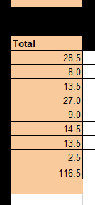

Whenever the new task row button is used it creates a new row and the Total column and dynamically adds in the sum formula based on the position. For example:

=SUM(F7:AJ7) will highlight looking like this:



And this will continue based upon the user created number of rows.

## New Task Row Button

 *SEE TXT FILE IN ARCHIVE DIRECTORY FOUND HERE: \\blm\dfs\loc\EGIS\ProjectsNational\NationalDataQuality\Sprint\analysis_tools\Tasking_Breakdown\archive

Sub New_Task_Row_Button()

'

' New_Task_Row_Button Macro

' Adds a new task row for the user.

'

'

Rows("8:8").Select

Selection.Insert Shift:=xlDown, CopyOrigin:=xlFormatFromLeftOrAbove

Range("AK7").Select

Selection.AutoFill Destination:=Range("AK7:AK8"), Type:=xlFillDefault

Range("AK7:AK8").Select

Range("AK8").Select

ActiveWindow.ScrollColumn = 2

ActiveWindow.ScrollColumn = 3

ActiveWindow.ScrollColumn = 4

ActiveWindow.ScrollColumn = 5

ActiveWindow.ScrollColumn = 6

Range("AL7:AN7").Select

Selection.AutoFill Destination:=Range("AL7:AN8"), Type:=xlFillDefault

Range("AL7:AN8").Select

Range("AL8").Select

Selection.ClearContents

Range("AN8").Select

Selection.ClearContents

Range("AO8:AU8").Select

Selection.FormatConditions.Delete

With Selection.Interior

.Pattern = xlNone

.TintAndShade = 0

.PatternTintAndShade = 0

End With

Range("AO8").Select

ActiveWindow.ScrollColumn = 5

ActiveWindow.ScrollColumn = 4

ActiveWindow.ScrollColumn = 3

ActiveWindow.ScrollColumn = 2

ActiveWindow.ScrollColumn = 1

Range("E8:AJ8").Select

Selection.ClearContents

Range("AL7").Select

Selection.AutoFill Destination:=Range("AL7:AL8"), Type:=xlFillDefault

Range("AL7:AL8").Select

Range("AL8").Select

Range("E8").Select

End Sub

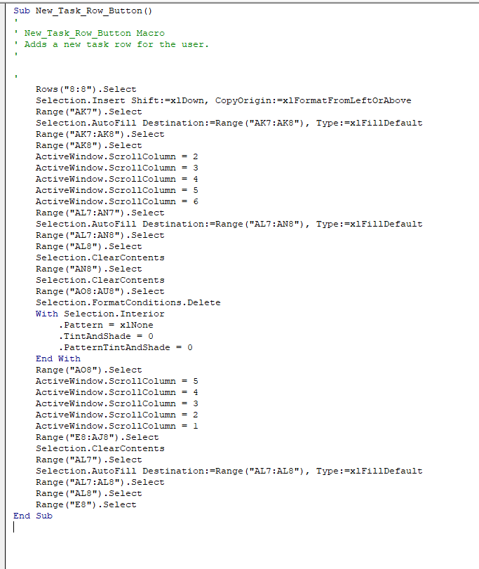

## Submit Button

*SEE TXT FILE IN ARCHIVE DIRECTORY FOUND HERE: \\blm\dfs\loc\EGIS\ProjectsNational\NationalDataQuality\Sprint\analysis_tools\Tasking_Breakdown\archive



Sub Submit_Button()

'

' Submit_Button Macro

' Submits the user's tasking sheet to the user's archive tab.

'

'

Result = MsgBox("Do you want to continue?", vbYesNo + vbQuestion)

If Result = vbYes Then

Sheets("TaskingSheet").Select

Range("AV7").Value = Now()

Range("A6", "AV50").Select

Selection.Copy

Sheets("Archive").Range("A1048576").End(xlUp).Offset(1, 0).PasteSpecial Paste:=xlPasteValues, Operation:=xlNone, SkipBlanks _

:=False, Transpose:=False

Application.CutCopyMode = False

Else:

End If

End Sub

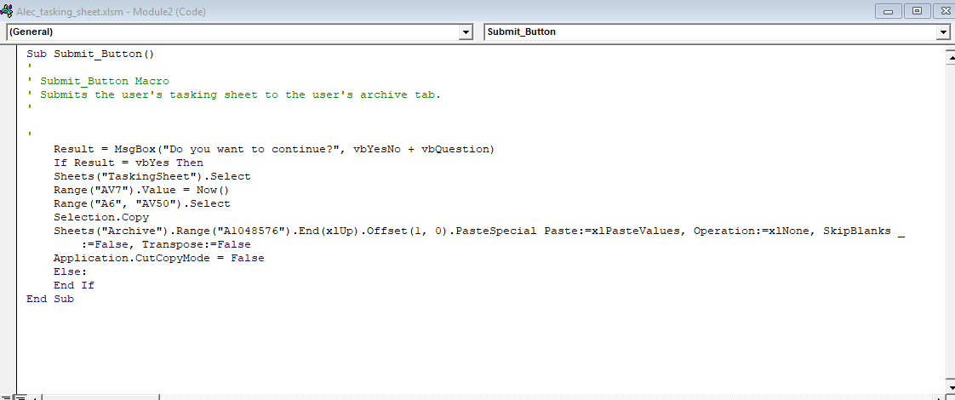

## Reset Button

*SEE TXT FILE IN ARCHIVE DIRECTORY FOUND HERE: \\blm\dfs\loc\EGIS\ProjectsNational\NationalDataQuality\Sprint\analysis_tools\Tasking_Breakdown\archive



Sub Reset_Button()

'

' Reset_Button Macro

' Resets the tasking sheet to 'zero' state.

'

'

Result = MsgBox("Do you want to Reset the sheet?", vbYesNo + vbQuestion)

If Result = vbYes Then

Range("B7").Select

Selection.ClearContents

Range("C7").Select

Selection.ClearContents

Range("E7:AJ7").Select

Selection.ClearContents

Range("AN7").Select

Selection.ClearContents

ActiveWindow.ScrollColumn = 2

ActiveWindow.ScrollColumn = 3

ActiveWindow.ScrollColumn = 4

ActiveWindow.ScrollColumn = 5

ActiveWindow.ScrollColumn = 6

ActiveWindow.ScrollColumn = 7

ActiveWindow.ScrollColumn = 8

ActiveWindow.ScrollColumn = 9

ActiveWindow.ScrollColumn = 10

ActiveWindow.ScrollColumn = 11

ActiveWindow.ScrollColumn = 12

Range("AV7").Select

Selection.ClearContents

ActiveWindow.ScrollColumn = 1

Columns("A").SpecialCells(xlBlanks).EntireRow.Delete

Range("F9:AK9").Select

Selection.ClearContents

Range("B9").Select

Else:

End If

End Sub

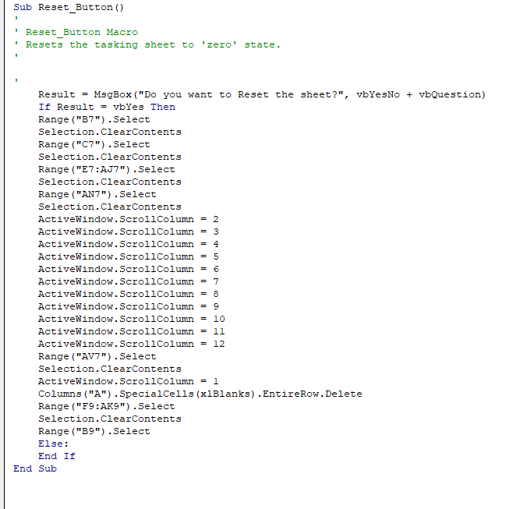

## Example View of TaskingSheet

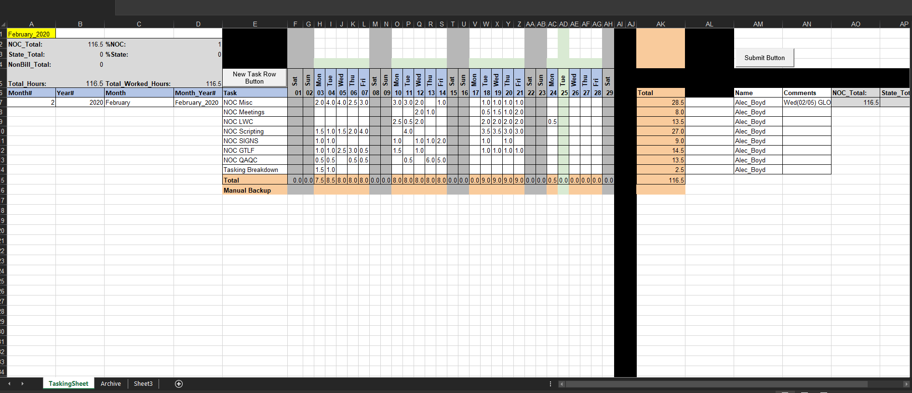

# **How to Update the Master file**

You can wait for everyone on the sprint team to submit their time tracker or do this in subsets because not everyone will turn in their time tracker at the same time (often last minute). My advice is to do it piece-meal over time so that the tasking breakdowns can be created and ready for the weekly meetings if they are needed.

## Setup (Should only need to do this once!):

Go to the sharepoint page where the Team Tasking Breakdowns are located and hit the sync button.

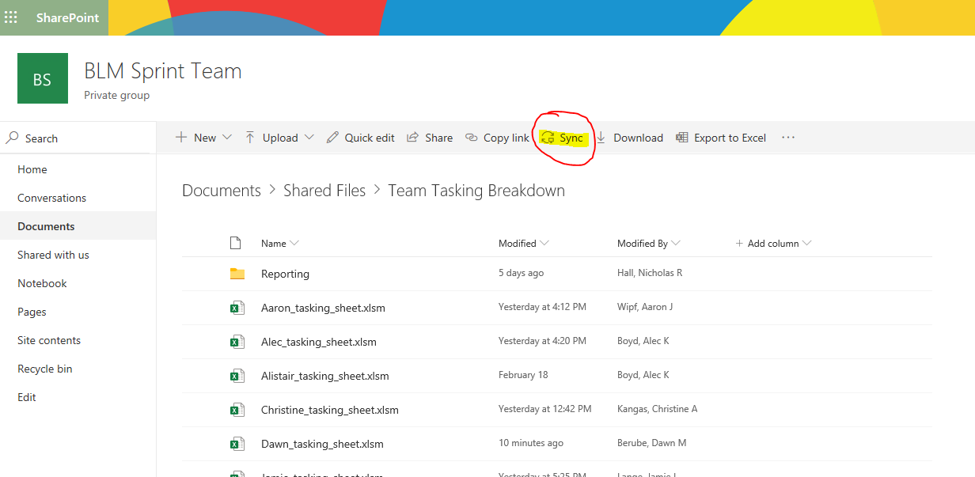

This will sync the sharepoint directory to your onedrive and make a local location on your desktop computer where you can access everyone’s time sheet.

*Note: your pathway could be different than mine but will look similar.

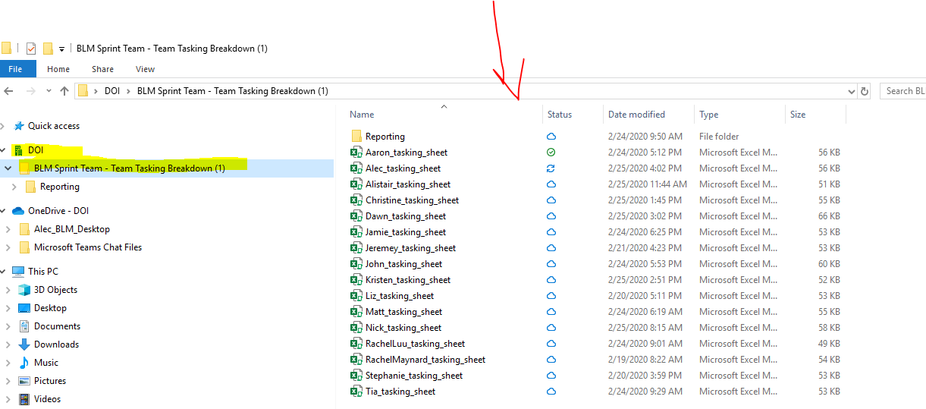

Once you have the sharepoint directory synced onto your local drive, **highlight all the timesheets and right-click ‘always keep on this device’**. This will download and start syncing everyone’s sheet so you can retrieve it later.

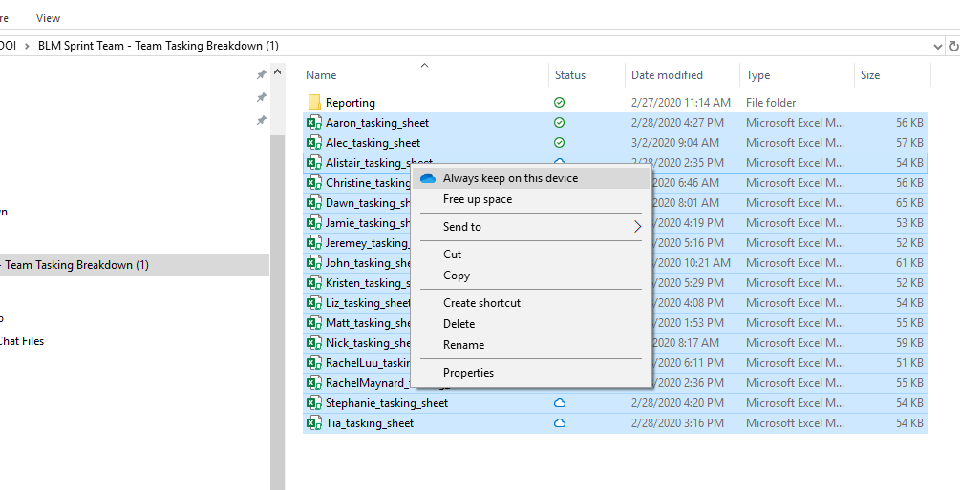

**Green checkmarks should appear on all the timesheets.**

Now:

Copy the path from windows explorer and then open up the onedrive_call_download.py

Found here:

\\blm\dfs\loc\EGIS\ProjectsNational\NationalDataQuality\Sprint\analysis_tools\Tasking_Breakdown

Then just copy paste your path into the ‘onedrive_dir’ variable



The format should match the example that is commented out. Example:

r'C:\\Users\\akboyd\\DOI\\BLM Sprint Team - Team Tasking Tasking Breakdown (1)'

*Note: The small r that is before the path is needed, it is telling the python code to read the path exactly as printed.

Once the change is done, save and close the script.

## Running the scripts – Onedrive_call_download.py

You can do this three different ways, one way is to run the onedrive_call_download.py directly by opening up your chosen editor and hitting run, double-clicking on the file and it will run in your current installation of python in your PATH, or you can run it from the Sprint GUI found here:

\\blm\dfs\loc\EGIS\ProjectsNational\NationalDataQuality\Sprint\analysis_tools\Sprint_gui

In any case, once the file is running, it will prompt the user for a run option:

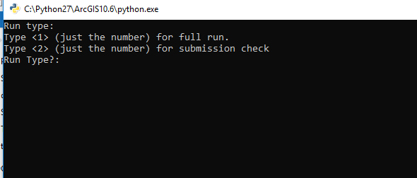

If this is your first time running this tool (current month) you will want to do a full run (**Keep in mind:** Full run will be needed anytime someone’s sheet is later ‘submitted’ and has a new timestamp as well). To do this, type in the number 1 and hit enter. The script will call to your onedrive directory we made earlier and download them all from the cloud and move them to the current_downloads directory found here:

\\blm\dfs\loc\EGIS\ProjectsNational\NationalDataQuality\Sprint\analysis_tools\Tasking_Breakdown\team_tasking_breakdown\Current_download

The script will then look at everyone’s timestamp and try to find a date stamp that is most current to the date you are running the script (this will ensure that you get the team member’s most recent submission). It will then give you feedback on who’s time sheet is ready for the master file and who’s is not ready. This is useful for keeping track on who has submitted and who has not, **this output will also be used in the next part of the process, so keep that in mind. Although you do not have to follow this if you do not want to deal with subsetting as the next script has built in checks.**

If you just want to check who is ready for the master file, type in 2 instead of 1 when you run the script. This will just give you the printed output for: what currently resides in the current downloads folder(2), if they had a valid timestamp (1), and it will give you a list of the tasking breakdowns not ready for the master file(3). See figure below:

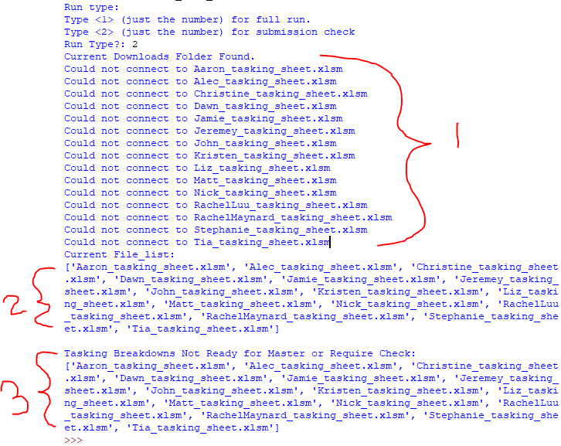

In this example, since the most recent submission for everyone was the end of January, it did not pickup any valid time stamps (in 1).

## Running the scripts – master_tasking_update.py

Next open up the master_tasking_update.py script found here (or in the sprint gui!):

\\blm\dfs\loc\EGIS\ProjectsNational\NationalDataQuality\Sprint\analysis_tools\Tasking_Breakdown

Run the script and it will prompt you if you would like to subset certain tasking sheets out of the run (You would want to do this if some of them were not ready). However, if you would rather do this manually later, type in n. Otherwise, type y and copy/paste or type in the names into the input that will not be appended to the master file.

Example of inputting y and sheets not ready for input (making a subset):

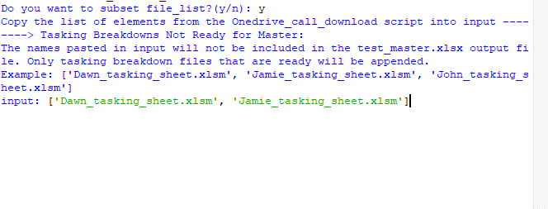

It will print out all the sheets the script is running against and send you a notice if there was a tasking sheet that failed to format or append correctly (usually this means their timestamp was bad or there was something funky added into their sheet by accident).

Example output:

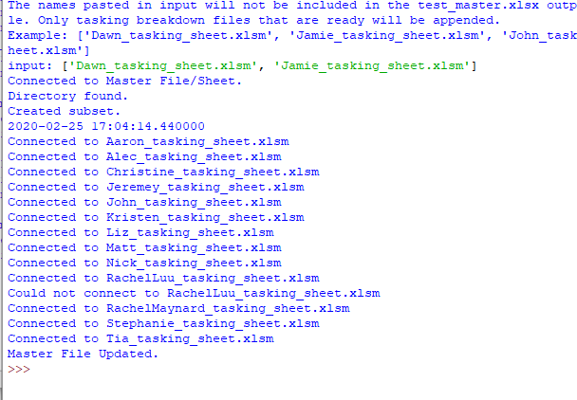

Notice how the Dawn and Jamie tasking sheets were not in the printed out section as we filtered them out using the input! The output of this is a file called: test_master.xlsx which will be found here:

\\blm\dfs\loc\EGIS\ProjectsNational\NationalDataQuality\Sprint\analysis_tools\Tasking_Breakdown

## Last check and then Append to Master

Open the test_master.xlsx file we created from the master_tasking_update.py script and do one final check to make sure everything came over correctly and that the calculator row contain valid values (this is important to check as the pivots run off of this for % calcs).

* Once done, ctrl+A to select all and copy everything.

Next, open up the master.xlsx and go to the ‘Master’ sheet and paste (values – only) into the next available blank row (making sure all your columns line up correctly). Then delete the header column that is accidently brought over from the copy ctrl+a and double check that the copy came over correctly.

* Once done, do the same in the Master_archive tab (this only houses the data like the master sheet so no pivots run off of it-this is just a backup)

Now you are ready to start updating the pivot tables!

# **Updating the Pivots**

**\*NOTE:**

Current pivot range on Master Sheet as of 02/26/2020: Master!$A$1:$AV$3027

In the future, if you need to extent the data range of the pivot table go here: ‘Click on a pivot table and the PivotTable Analyze option should appear in the excel ‘ribbon’ (at the top).

 In the **Data** group, click the top section of the Change **Data** Source command. The Change **PivotTable Data** Source dialog box opens, and you can **see** the source **table** or **range** in the **Table**/**Range** box. Change as needed.

## ToDate_Pivot (See Update at end of Section)

This sheet contains all months and all tasks for everyone that has been on the project. This is used in the year end reports and the IPR. The only item that requires an update each month is the Month_Year# drop-down.

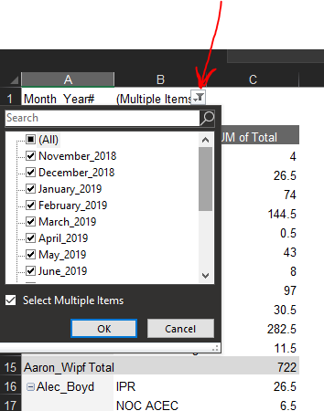

All months should be checked and the ‘blanks’ field should be unchecked. Hit ok once the selections are done and then right-click the table and hit ‘refresh’. The table should update with new numbers.

## Monthly_pivot

This sheet is used to create the monthly breakdown charts for the Sprint team. Right-click on the pivot table and hit refresh for new items to appear. Items to update:

* Month_Year# drop-down
  1. This should be changed to the current month/most recent month of submission

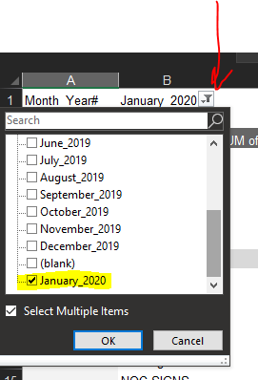

* If a new task is added, double-check to make sure it made it over to the pivot table by clicking the task drop-down.
  1. All tasks should be checked except: blank, NON bill items, and other.

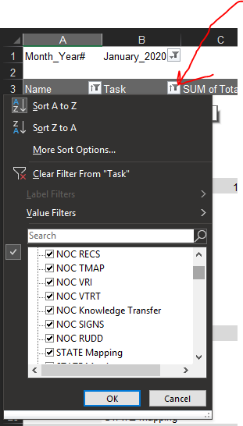

* A new hire or person on the SPRINT team should automatically populate within the pivot table. If for some reason this does not happen, click the name drop-down and add the person in you wish to see.
* Tasking breakdown charts will also need to be updated. Note: the data ranges of the pivot table are constantly changing so the charts that in the Monthly_pivot sheet will need to have their data range updated for each person. While this can be a pain, the process does not take too long and I have not had time to implement the dynamic range and chart visual basic code yet.
  1. So Simply double-click a chart and on the right-hand side of the screen the chart details will pop up. Now right-click the chart and go to ‘select data’ option. The select data source window pane will pop up.

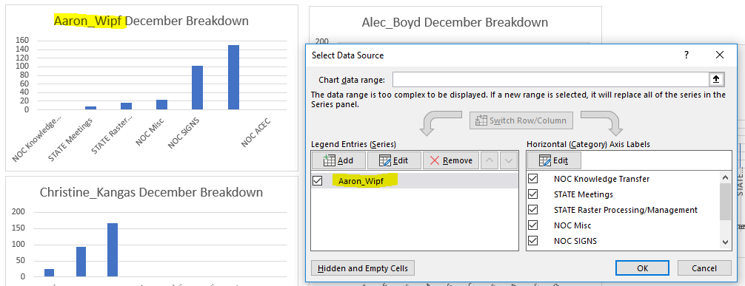

Now click the edit button on the Horizontal Axis Labels and select the Task column rows for that specific person. For example, if I was updating Aaron_Wipf’s chart I would do this:

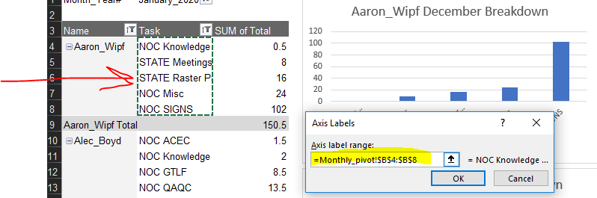

Hit ok and it will bring you back to the select data source window pane.

Now click the edit under the Legend Entries (series) box and only update the Series values data range! Using the same example above I would do this:

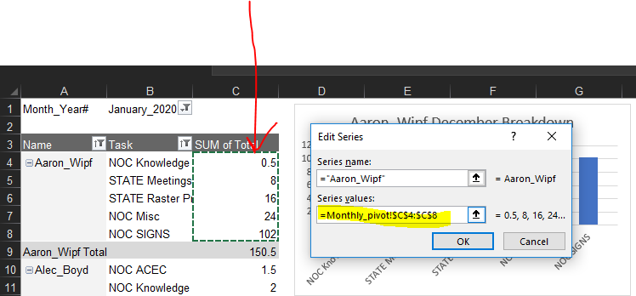

Hit ok and then hit ok again and the chart will update to the proper values:

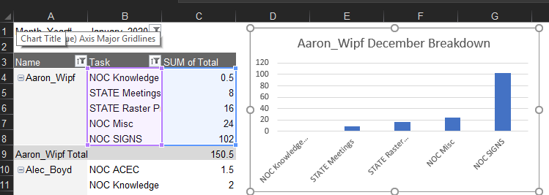

Do this for everyone else on the team and then the Monthly_pivot sheet is updated! If you have a new hires and need to add a chart for them, simply copy an existing chart and follow the steps above and change the title to their full name.

### UPDATE 03/05/2020

I was able to figure out how to integrate a compound pivot table on top of the existing sheet pivot. This will allow each chart to dynamically change whenever the sheet pivot is changed or updated.

**How to create a compound pivot using the sheet pivot**

Click a cell and go to Insert > PivotChart > PivotChart

A dialogue box will appear and it will ask you for the chart range, copy and past this in:

Monthly_pivot!$A$3:$C$500 and then hit ok.

A chart box and a table outline will appear where you originally selected a cell location at the beginning.

Check all fields and setup for the pivot fields should like this:

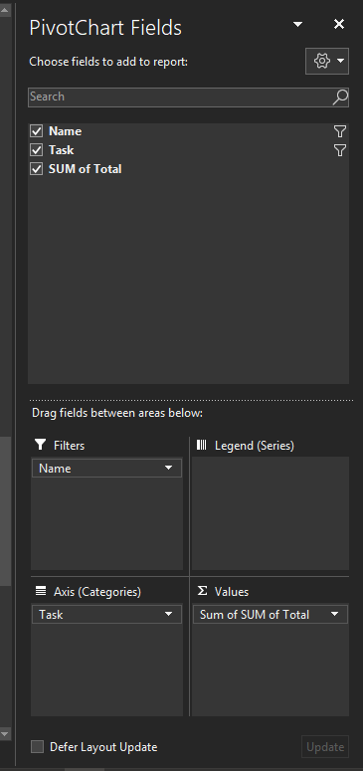

Next, on the chart, hit use the **name** drop down and select the name you would like to display. (single name)

Next, go to the **task** drop down and scroll to the bottom and deselect blank values.

Then, left click the table that was created from the new pivot chart (you will see it in the background, usually behind your pivot chart) and sort the sum of total values from lowest to highest in the ‘home’ ribbon. This will organize your pivot chart correctly.

**Dynamic Chart Title**

Scroll to Column ‘AA’ and you should see a labeled column: ‘Automated Chart Titles’

Copy a previous rows function into a new blank row. Example function formula:

=O95&" "&B1&" "&"Breakdown"

The highlighted part is the cell that will always reference the table title name. So go to the table that appeared behind the pivot chart we just created and select the cell where the team member’s name showed up. The function formula should change with that new cell assignment.

Now go back to the chart we just created and left-click the outline of the chart title and go to the function bar and type the equals sign and then left click the newly added row in column ‘AA’ we just made for the reference to be completed. You will now have a dynamic chart title that will change when any pivot filter occurs!

**If you need to export the charts without the pivot fields and filters showing, do this:**

* Click on the chart you want to export and the PivotChartAnalyze ribbon will appear
* Then go to Field Buttons and hide the buttons you would like to not show. Just remember to turn them back on for the next use!

## %NOC vs. %State Monthly

Sheet contains the %State vs %NOC tasks by current month. To update this sheet right-click on the pivot table and hit refresh to get the new values. Then click the Month_Year# drop-down and select the month you wish to display.

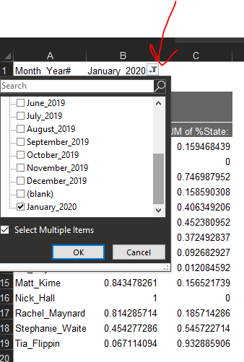

Other than that, this sheet should be good to go.

## %NOC & %State ToDate

This sheet contains all states combined hours % breakdowns and all individuals % breakdowns. Because we can have several people on the project remote support for different states (meaning they will help several different states depending on tasking), things can get a little complicated here as hours and percent’s will need to be calculated manually. For example: a person can work 4 days in ES tasks, 10 days in NV tasks, and the rest on National tasking so doing some of the calcs manually just adds in some flexibility.

For everyone else on the project that stays within their state, the sheet is pretty much automated.

**\*NOTE: Whenever a new hire is brought on, the new column will disrupt the data ranges for all the charts (a pain but once reset it essentially becomes a ‘set and forget’ situation!).**

**Legacy Sprint Team Member Location Breakdown (By State ; RS = Remote Support):**

State Name

ID Emanuel_Ziolkowski

CO GY Moody

RS Josh Rietsch

MT Kevin_Glueckert

AK Tess_Frenchik

Leaving soon (as of 02/26/2020):

State Name

AZ Kristen Cox

ES Matt Kime

Current Sprint Team (as of 02/26/2020)

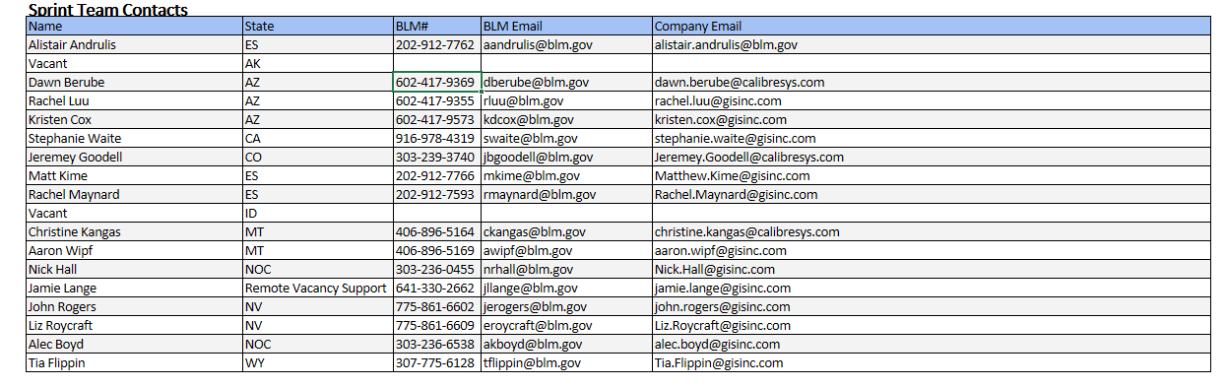

*Master Contact List from Sharepoint (02/26/2020).

### Updating Individual Split to Date Charts

1. Right-Click and hit refresh on the pivot chart and any new names should be brought over automatically from the master sheet. If not, go into the name drop-down and add the individual manually.

2. Next, go to the Month_Year# drop-down and add the new month to the list if it is (not selected already).

3. If there any new hires, the chart data ranges might get messed up, if this happens you will have to right-click on a chart and hit the ‘select data’ option. A window pane will pop up, then go to the Legend Series section and hit the edit button. Excel will switch to the edit series window. Now update the Series values section to the correct numbers. For example, if I was updating the MT Aaron Split to Date chart, it would look like this:

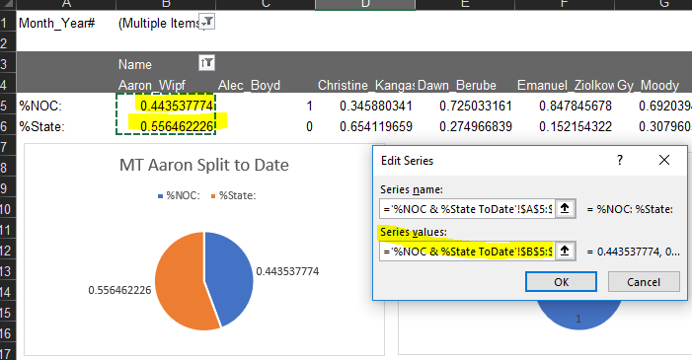

Hit ok, and then ok again to finish the change. Perform this for everyone in sheet by matching their names up with their chart!

For new hires, just copy an existing chart and change the data range to their specific rows. Then edit the chart title to match their name.

### Updating State Combo Charts

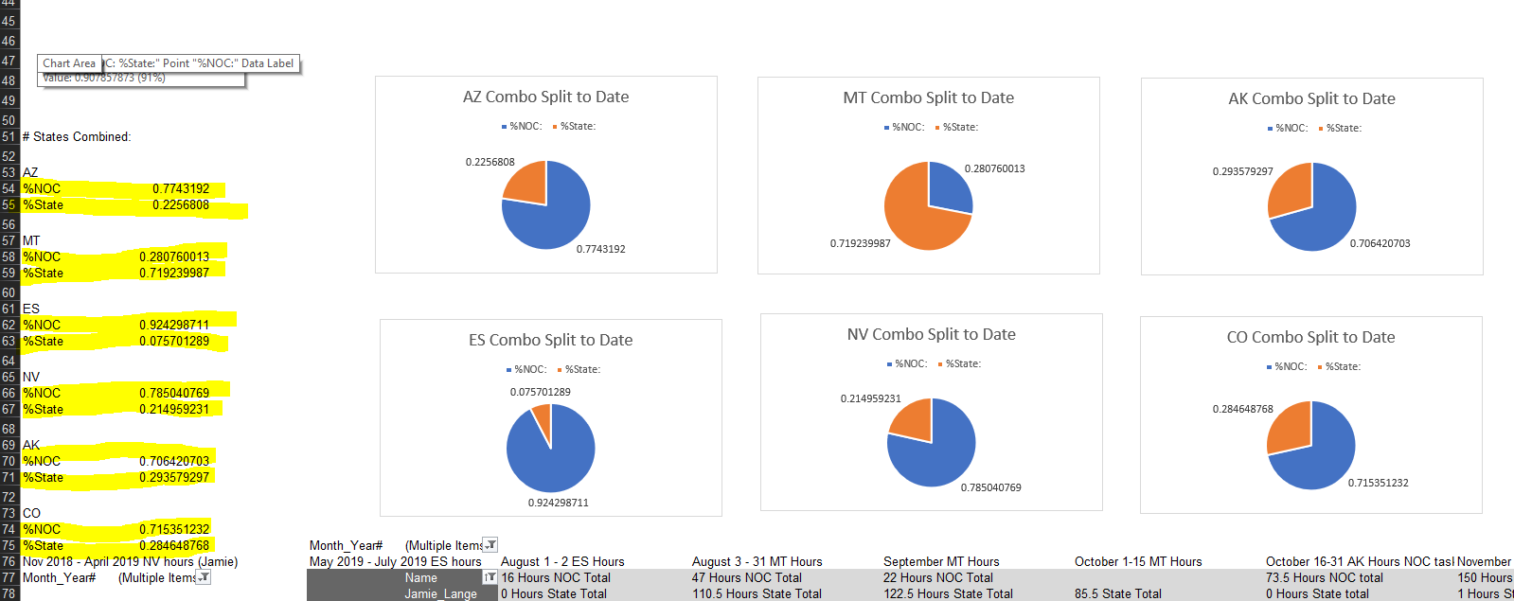

The state percentages (highlighted) are the input data ranges for the charts on the right (see figure above this text). The percentages often contain a lot more numbers than the number of actual Sprint contractors who work onsite at that particular state office. This is because we are including legacy team members, remote support team members, and team members who have transitioned to a new office into the Combo % breakdowns. We want to see a TOTAL historical breakdown of the split between state tasking and NOC tasking.

Using the pivot table at the top of the sheet, the current breakdowns for the % combos are (02/27/2020):

%NOC v %STATE COMBOS

**AZ:** Dawn_Berube, Kristen_Cox, Rachel Luu

**MT:** Aaron_Wipf, Christine_Kangas, Remote support (Jamie_Lange – has multiple work lines), Remote Support (Josh_Rietsch), Kevin_Glueckert, Jeremey_Goodell

**ES:** Matt_Kime, Rachel_Maynard, Alistair Andrulis, Remote support (Jamie_Lange – has multiple work lines)

**NV:** John_Rogers, Liz_Roycraft, Jamie_Lange

**AK:** Tess_Frenchik, Remote support (Jamie_Lange –has multiple work lines)

**CO:** Gy_Moody, Jeremey_Goodell

Incoming change for Idaho:

**ID:** Emanuel_Ziolkowski left the project in December of 2019, so when the new hire comes on they will need to be added here.

### Adding in Remote Support Team Members to % Charts

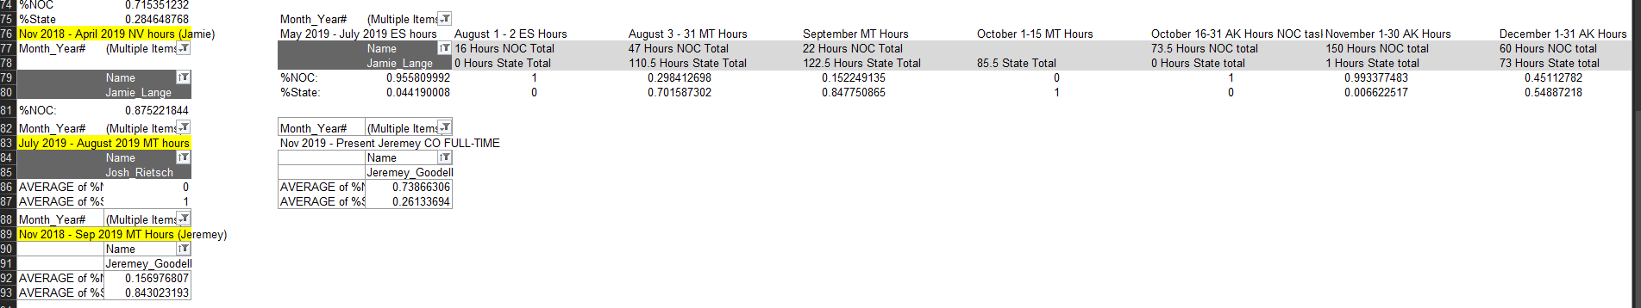

Our current remote support team member on staff is Jamie_Lange. She is constantly switching from one state to the next in order to meet work order needs and to fill in when a state has a vacancy. In order to track this, we have resorted to a manual tracking method for now, as her time is going to several different states at once (at certain times).

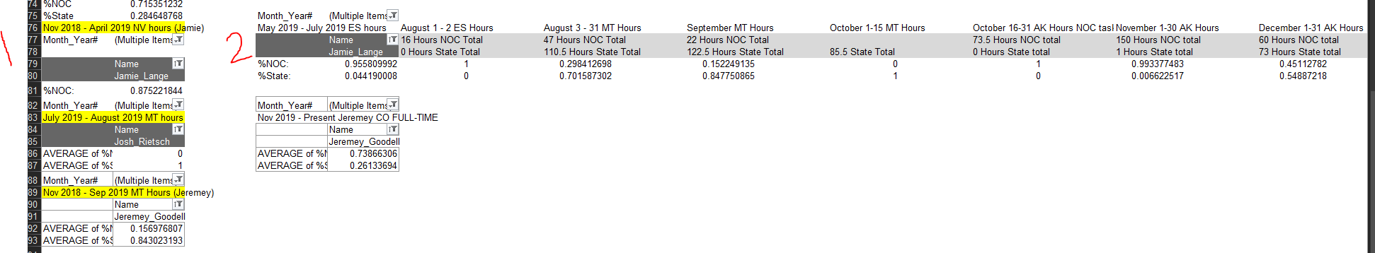

In the figure above this text, the number one section displays Jamie’s Full-time in Nevada (Nov 2018 – April 2019). The number two section displays all the remote support sections and hours Jamie has done up to present day. To get the numbers in section two you will do these steps:

**1.**Go to either the sheet’ called master and find the current month for Jamie_Lange and find the STATE hours, NOC hours, %STATE, %NOC and copy those numbers in the same format above in the next available columns in section 2.

**Figure below is example of where to pull values from the ‘master’ sheet:**

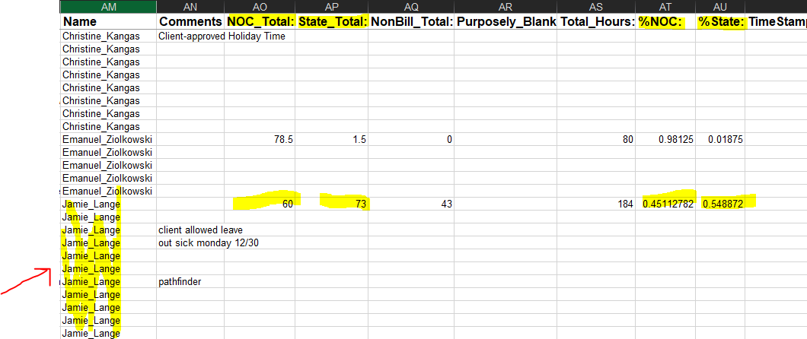

**2.**Once the values are copied over, give that section a title (January 1-31 AK Hours) so we know where those hours are going and then you will add those cell values to the combo split numbers for whatever state they go to. Current calc for AK split combo (%NOC numbers go to NOC line and %STATE numbers go to STATE line):

AK NOC =(S5+N79+P79+R79+T79)/5

AK STATE =(S6+N80+P80+R80+T80)/5

**3.**This ends the remote support section. *Note: Remember the pivot table above (in %NOC & %STATE toDate sheet) shows individual historical %NOC & %STATE breakdowns.

### Other MISC Sections

In the %NOC & %State ToDate you will notice two other small pivot tables beneath Jamie’s remote support sections. One for Josh Rietsch and one for Jeremey. Josh currently works on another project but sometimes supports the Sprint project, this is just a quick pivot for when he remote supported for MT. The Jeremey small pivot is for when he switched from the MT office to the CO office full-time. This pivot is tracking his current CO hours now for the CO COMBO split.

This ends the %NOC & %STATE ToDate section.

# **Making the Monthly Breakdown Charts**

Once all the charts and breakdowns are updated in the master.xlsx. You will need to create a monthly breakdown for the Sprint team. Go to the Reporting directory in the sprint sharepoint:

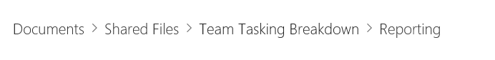

Create a blank excel file and name it the month the breakdown is taking place. For example:

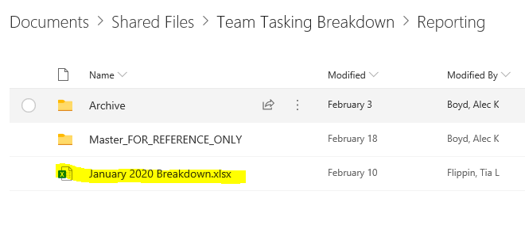

Now just start copying the breakdown charts and the % split to Date graphs into the newly created excel file and group the charts by state in order to place the Combo split to Date graphs with their corresponding individuals. For example:

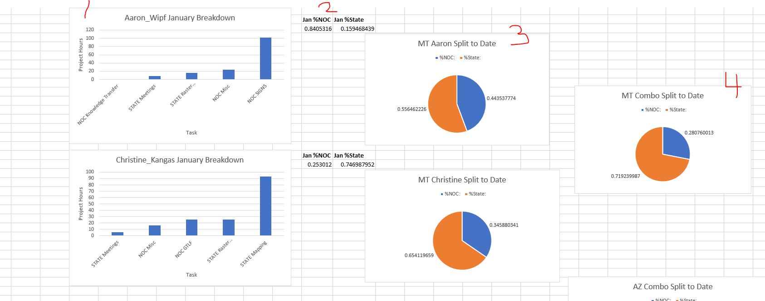

1.The charts from the Monthly_pivot sheet.

2.The % numbers from the %NOC vs. %State Monthly sheet.

3. Individual Split to Date charts from the %NOC & %State ToDate sheet.

4.Combo Split to Date chart from the %NOC & %State ToDate sheet.

Repeat this process until finished. **NOTE: When you are copying charts over, make sure you paste as a picture. This will ensure that the integrity of the chart stays.**

Finally, you can copy and paste the updated master.xlsx into the Master_FOR_REFERENCE_ONLY directory and hit ‘replace’ to update it.